**Load document  
Calvin Hong - 431518**

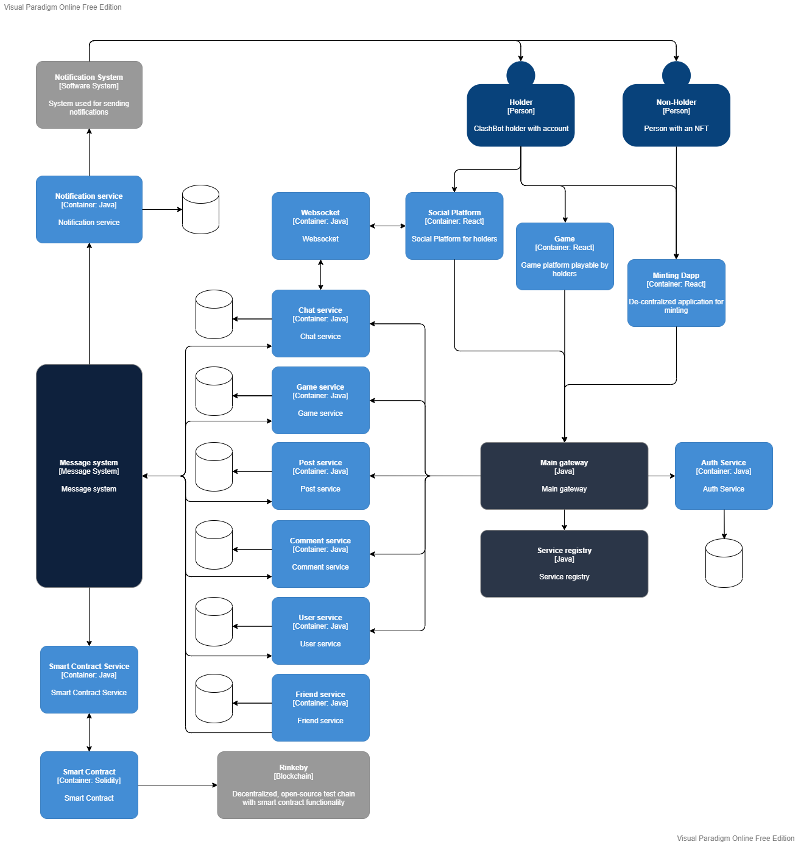The blockchain allegedly originated from Japan. For this reason, the population of Japan was taken for the load document as the peak scenario. The current population of Japan (2022) is around 125.5 million.

Figure C2 diagram ClashBots project

**Minting Dapp**

The minting Dapp only has the functionality to mint NFT’s. Besides this, it cannot do anything else.

Usually, each NFT Collection starts out with 10.000 items. This creates a scarcity which stimulates users to mint. In theory, it is possible to create a collection with millions, but this removes this stimulation, which results in users not minting because there is no exclusivity. The following scenario is unlikely, but possible.

|  |  |  |  |
| --- | --- | --- | --- |
| **Request title** | **Req per user** | **Total requests per day** | **Graph** |
| Mint | 1 | 125.5 million |  |

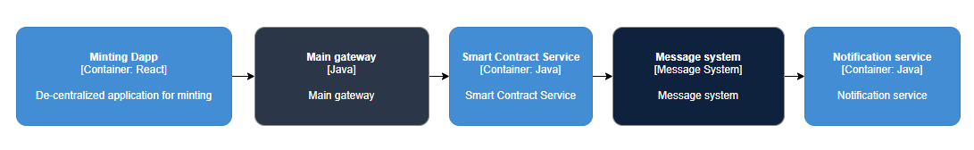

|  |  |  |  |
| --- | --- | --- | --- |
| **Request title** | **Base** | **Average per second** | **peak** |
| Mint | 0 | 1.483,5 | 95.000.000 |

|  |  |  |
| --- | --- | --- |
| **Request title** | **Component** | **Total requests per day** |
| Mint | Main gateway | 125.5 million |
| Contract service | 125.5 million |
| Message system | 125.5 million |
| Notification system | 125.5 million |

**Social platform**

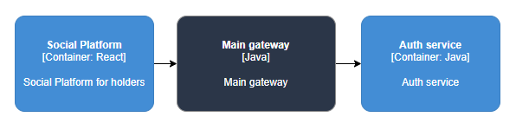The social platform is meant for holders (people with an NFT) to communicate with each other. While non-holders can also use this application, holders will have special perks. The main functionalities will be chatting and posts.

|  |  |  |  |
| --- | --- | --- | --- |
| **Request title** | **Req per user** | **Total requests per day** | **Graph** |
| Login | 1.5 | 188.25 million |  |

|  |  |  |  |
| --- | --- | --- | --- |
| Register | 1 | 125.5 million |  |

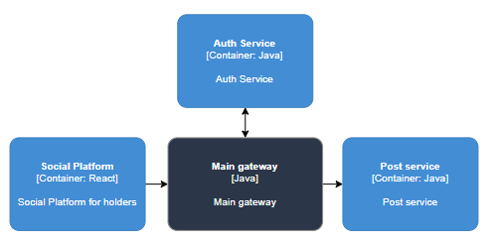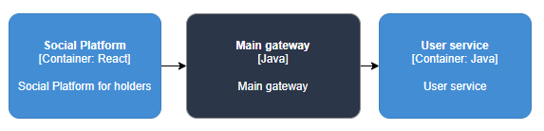

|  |  |  |  |
| --- | --- | --- | --- |
| Post | 2 | 251 million |  |



|  |  |  |  |
| --- | --- | --- | --- |
| Like post | 15 | 1.9 billion |  |

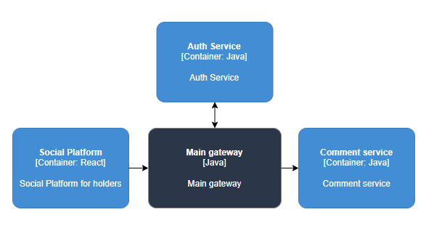

|  |  |  |  |
| --- | --- | --- | --- |
| Comment | 5 | 627.5 million |  |



|  |  |  |  |
| --- | --- | --- | --- |
| Like comment | 5 | 627.5 million |  |

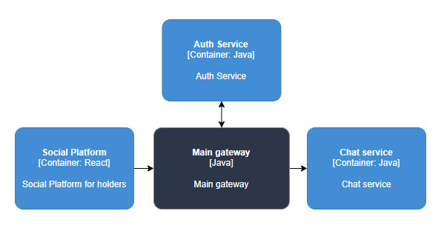

|  |  |  |  |
| --- | --- | --- | --- |
| Chat | 10 | 1.3 billion |  |

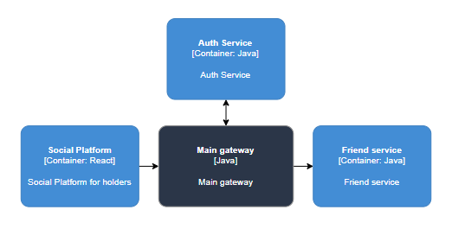

|  |  |  |  |
| --- | --- | --- | --- |
| Add friend | 1 | 125.5 million |  |

|  |  |  |  |
| --- | --- | --- | --- |
| Remove friend | 0.5 | 62.75 million |  |



|  |  |  |  |
| --- | --- | --- | --- |
| **Request title** | **Base** | **Average** | **peak** |
| Login | 10.000.000 | 2.225,7 | 65.000.000 |
| Register | 5.000.000 | 1.483,5 | 35.000.000 |
| Post | 17.500.000 | 2.966,9 | 100.000.000 |
| Like post | 22.500.000 | 22.458,6 | 1.235.000.000 |
| Comment | 15.000.000 | 7.417,3 | 407.875.000 |
| Like comment | 7.500.000 | 7.417,3 | 411.666.666,7 |
| Chat | 20.000.000 | 15.366,4 | 845.000.000 |
| Add friend | 7.500.000 | 1.483,5 | 62.750.000 |
| Remove friend | 3.750.000 | 741,7 | 31.375.000 |

|  |  |  |
| --- | --- | --- |
| **Component** | **Request titles** | **Total requests per day** |
| Main gateway | Login  Register  Post  Like post  Comment  Like comment  Chat  Add friend  Remove friend | 5.208.000.000 |
| Auth service | Login  Register  Post  Like post  Comment  Like comment  Chat  Add friend  Remove friend | 5.208.000.000 |
| User service | Register | 125.500.000 |
| Post service | Post  Like post | 2.151.000.000 |
| Comment service | Comment  Like comment | 1.255.000.000 |
| Chat service | Chat | 1.300.000.000 |
| Friend service | Add friend  Remove friend | 188.250.000 |

**Game**

|  |  |  |  |
| --- | --- | --- | --- |
| **Request title** | **Req per user** | **Total requests per day** | **Graph** |
| Login | 1.5 | 188.25 million |  |



|  |  |  |  |
| --- | --- | --- | --- |
| Register | 1 | 125.5 million |  |

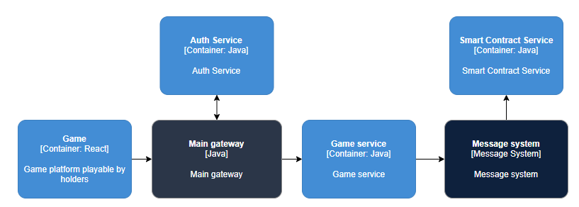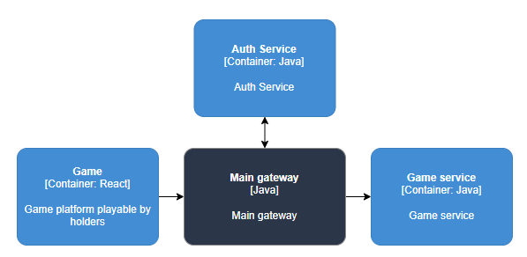

|  |  |  |  |
| --- | --- | --- | --- |
| Start game | 2.5 | 313,8 million |  |

|  |  |  |  |
| --- | --- | --- | --- |
| Buy Item | 2 | 251 million |  |



|  |  |  |  |
| --- | --- | --- | --- |
| **Request title** | **Base** | **Average** | **peak** |
| Login | 10.000.000 | 2.225,2 | 65.000.000 |
| Register | 5.000.000 | 1.483,5 | 35.000.000 |
| Start game | 15.000.000 | 3.709,,2 | 203.970.000 |
| Buy Item | 12.500.000 | 2.966,9 | 163.150.000 |

|  |  |  |
| --- | --- | --- |
| **Component** | **Request titles** | **Total requests per day** |
| Main gateway | Login  Register  Start game  Buy Item | 879.550.000 |
| Mesage system | Buy Item | 565.800.000 |
| Auth service | Login  Register  Start game  Buy Item | 879.550.000 |
| User service | Register | 125.500.000 |
| Game service | Start game  Buy Item | 565.800.000 |
| Contract service | Start game  Buy Item | 565.800.000 |

**Total**

|  |  |
| --- | --- |
| **Component** | **Total amount** |
| Gateway | 6.213.050.000 |
| Message system | 691.300.000 |
| Auth service | 6.213.050.000 |
| User service | 251.000.000 |
| Friend service | 188.250.000 |
| Post service | 2.151.000.000 |
| Comment service | 1.255.000.000 |
| Chat service | 1.300.000.000 |
| Game service | 565.800.000 |
| Contract service | 565.800.000 |