**“ELIFESURE: An Online Recruitment System**

**for Allianz PNB Life Insurance Inc.**

**in MIMAROPA”**

A Research/Capstone Project

Presented to the Faculty of the

College of Computer Studies

**MINDORO STATE UNIVERSITY**

Calapan City Campus

Masipit, Calapan City, Oriental Mindoro

In Partial Fulfillment

of the Requirements for the Degree

**BACHELOR OF SCIENCE IN INFORMATION TECHNOLOGY**

by

**Caibal, Lester M.**

**Escalera, Jandel L.**

**Ramos, Jef**

December 2024

**TABLE OF CONTENTS**

|  |  |  |  |  |
| --- | --- | --- | --- | --- |
| **TITLE** | | | | **PAGE** |
| **TITLE PAGE** | | | | i |
| **TABLE OF CONTENTS** | | | | ii |
| **LIST OF FIGURES** | | | | iii |
| **LIST OF TABLES** | | | | **v** |
| **LIST OF APPENDICES** | | | |  |
|  | | | |  |
| **CHAPTER** | | | |  |
|  | **I. INTRODUCTION** | | |  |
|  |  | Project Context | | 1 |
|  |  | Objectives of the Study | | 3 |
|  |  | Scope and Limitations of the Study | | 4 |
|  |  | Significance of the Study | | 5 |
|  |  | Conceptual Framework | | 7 |
|  |  | Definition of Terms | | 8 |
|  | **II. REVIEW OF RELATED LITERATURE/ SYSTEM** | | |  |
|  |  | Local | | 10 |
|  |  | Foreign | | 16 |
|  | **III. METHODOLOGY** | | |  |
|  |  | Development Method | | 21 |
|  |  | Gantt Chart | | 24 |
|  |  | Requirements Specifications | | 25 |
|  |  |  | Functional Requirements | 26 |
|  |  |  | User Interface | 28 |
|  |  |  | Hardware Interface | 29 |
|  |  |  | Software Interface | 29 |
|  |  |  | Security Requirements | 30 |
|  |  | Technical Background | | 30 |
|  |  |  | Hardware Specifications | 31 |
|  |  |  | Software Specifications | 32 |
|  |  | System Analysis and Design | | 33 |
|  |  |  | System Overview | 33 |
|  |  |  | System Architecture | 35 |
|  |  | Use Case Diagram | | 36 |
|  |  | Activity Diagram | | 37 |
|  |  | Data Flow Diagram (DFD) | | 39 |
|  |  |  | Context Diagram/Level 0 | 39 |
|  |  |  | Diagram 0/Level 1 | 40 |
|  |  | Database Schema | | 41 |
|  |  | Testing and Evaluation | | 42 |
|  |  | Participant of the Study | | 43 |
|  |  | Likert Scale | | 43 |
|  |  | Implementation Plan | | 44 |
|  | **IV. RESULTS AND DISCUSSION** | | |  |
|  |  | Presentation of System Output | | 45 |
|  |  | Evaluation of the System | | 59 |
|  |  | Implementation Results | | 71 |
|  | **V. SUMMARY, CONCLUSION AND RECOMMENDATION** | | | |
|  |  | Summary | | 72 |
|  |  | Conclusions | | 73 |
|  |  | Recommendations | | 74 |
| **BIBLIOGRAPHY** | | | | 75 |
| **APPENDICES** | | | |  |
|  |  |  |  |  |

|  |  |  |
| --- | --- | --- |
| **LIST OF FIGURES** | | |
| **Number** | **Title** | **Page** |
| 1 | ELifeSure Conceptual Framework | 7 |
| 2 | Agile Model | 21 |
| 3 | User Interface | 28 |
| 4 | System Architecture | 34 |
| 5 | Use Case for ELifeSure | 36 |
| 6  7  8  9  10  11  12  13  14  15  16  17  18  19  20  21  22  23  24  25  26  27  28  29  30 | Activity Diagram  Context Diagram  DFD Level 0  Database Schema  Admin Dashboard  Account Management  Application Forms  Agent Promotion Side  Schedule  Agent Management  Applicant Management  Reports  Mapping  Create Plan Offer  Admin Setting  User Dashboard  User E-Signature  User Schedule  User Other File  User Agent View  User Profile Setting  User Form  Client Dashboard  Client Payment History  Client Schedule | 37  38  39  40  45  45  46  47  47  48  49  49  50  51  51  52  53  53  54  55  55  56  57  57  58 |

|  |  |  |
| --- | --- | --- |
| **LIST OF TABLES** | | |
| **Number** | **Title** | **Page** |
| 1 | Gantt Chart | 25 |
| 2 | Functional Requirements | 26 |
| 3 | Hardware Specification | 31 |
| 4 | Software Specification | 32 |
| 5 | Respondents of the Study | 43 |
| 6  7  8  9  10  11  12  13  14  15  16  17  18 | Likert’s Scale  Implementation Plan  Functionality Suitability  Performance Efficiency  Usability  Reliability  Performance Expectancy  Effort Expectancy  Facilitating Conditions  Facilitating Conditions  Summary Results of the ISO Evaluation  Summary Results of the UTAUT Evaluation  Implementation Results | 43  44  60  61  62  63  64  65  67  68  69  70  71 |

|  |  |  |
| --- | --- | --- |
| **LIST OF APPENDICES** | | |
| **Appendix** | **Title** | **Page** |
| A |  |  |
| B |  |  |
| C |  |  |
| D |  |  |
| E |  |  |
| F |  |  |

**CHAPTER I**

**INTRODUCTION**

This chapter will address priority things of the study which should be considered properly for implementing it successfully.

**Project Context**

Industries are always being changed by digital technology. Society is greatly affected since it forms the way individuals get information, relate to one another and how people operate in this society. Research study criticality in terms of doing the research involves requesting and gather information from the users directly. The research problem chosen is supported by the project context thus demonstrating that the researchers can handle challenges involved with it. For example, difficulties associated with handling paper-based documents have been pointed out. Researchers mention problems including risks involved such as inconvenience that arises when visiting applicants’ homes to collect their personal details among others that make recruitment processes more complicated. An ELifeSure for Insurance and Investment Agency in MIMAROPA is intended to address certain challenges identified within the local setting.

The title’s choice is due to the problems noted with managing paper-based documents in the recruitment process. The main concern is that handling hard copy documents is complicated and unsafe thereby requiring people to visit other homes for essential information. In recruiting, making the process modern is good for improving productivity and having a less risks or problems. Opting for an ELifeSure accepts attempts aimed at conforming actual service search strategies with current industry requirements. This method increases productivity while satisfying modern needs thereby enhancing the reputation of a company or organization as well. Focusing on MIMAROPA makes it a locally formed tool which can be customized to serve specific needs and particularities within this locality. There were various factors evaluated before designing and implementing an ELifeSure, which include geographical distance problems, unsafe paper-based procedures, no good services specifically designed to improve clients’ experiences as well as customer satisfaction among others. It assures stakeholders that they will not encounter any difficulties in using this technology because it mainly focuses on them rather than other systems that only have a general purpose.

**Objectives of the Study**

The main objective of this study is to design and develop ELifeSure: An Online Recruitment System for Allianz PNB Life Insurance Inc.

Specifically, this study is aimed to:

1. develop a web-based platform where agents and applicants can fill out forms digitally, with an integrated option for electronic signatures to authenticate the documents;
2. create a user management dashboard that allows administrators to view, add, update, or remove users, with access levels for agents and applicants.
3. integrate a mapping feature to visualize and manage user locations, allowing administrators to assign representatives to specific regions;
4. implement a form-based system that automatically collects data and generates periodic reports on available members, including filtering and sorting capabilities; and
5. add a feature that uses data to predict how many new agents and applicants might join each month. This will help administrators plan better and make smarter decisions about recruiting.

**Scope and Limitations of the Study**

The study seeks to create Recruitment System for Allianz PNB Life Insurance Inc. The system primarily focuses to improve the efficiency of the process by the user roles which are administrators, agents, clients and applicants. Administrators are important individuals who supervise the entire recruiting workflow since they have the authority to add or register applicants and use the system for recruitment. Agents engage with the system in a targeted way, concentrating on their unique contributions to the recruiting part. The purpose, however, is to improve on the experience applicants have by letting them view requirements, submit and at the same time, modify their background data using the online platform. The system will use SMS notifications to keep applicants updated on their application status and important news. Agents can also earn awards for their performance, which helps motivate and recognize their hard work and add for their credentials. This promotes a dynamic and accessible application process.

The study has some limitations that could affect the results. It relies on having good internet access, which may be a problem in some rural areas of MIMAROPA where connections can be slow or unreliable. Not all users may be comfortable with technology, making it hard for some applicants to use the online system. There are also concerns about data security, as personal information must be protected, and any breaches could cause issues. Additionally, since the study focuses only on the MIMAROPA region, the findings might not apply to other areas with different needs. Finally, the time frame of the study is limited, which means it might not capture the long-term effects of using the ELifeSure.

**Significance of the study**

This study will conduct a system with accessible features that will increase the efficiency of all recruitment activities.

The study will be considered beneficial to the following:

**Applicants -** The ELifeSure is a portal that helps the applicants in a lot of ways. The website will be accessible to the applicants that will be easy for them to use. This opens up a new and easier way in recruiting applicants.

**Insurance and Investment Agencies -** Recruiting new applicants will be processed more easily. It will also be more efficient which will be useful for the company. It increases the competitiveness of the agency in the market. This could result to a more successful business.

**IT Experts -** IT professionals/experts that are working on the same kind of system will have a hands-on experience in developing a platform where it is only for online recruitments.

**Business Professionals -** Professionals in business management might have a lot of opportunities using the system as basis, they can have new tactical strategies for their businesses in effectively and efficiently engaging applicants.

**Clients -** Clients benefit from ELifeSure by being notified by their transactions and important information on their accounts. They could also view their history transactions.

**Researchers -** The developers of the ELifeSure and also the programmers will get a lot of experience and credibility on them. They will have gain not just experience but also possible opportunities on their successful system.

**Future Researchers -** ELifeSure can serve as a reference that will help researchers working on the same platform. It also offers a lot of usable ideas and example of successful implementation and how it became successful in the investment and insurance sectors.

**Conceptual Framework**

The conceptual framework for a ELifeSure in the investment and insurance fields helps to understand how to make the process better and easier. By using technology and organizing information, researchers can find the right agents and applicants more quickly and communicate with them better, making sure that the recruitment process meets the special needs of these industries.

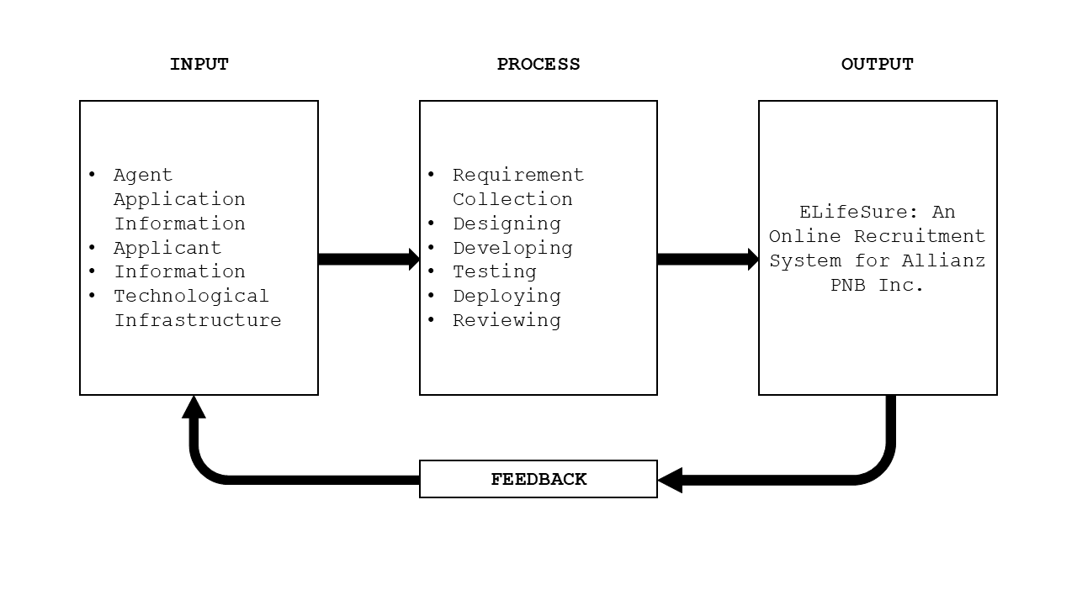

**Figure 1. ELifeSure Conceptual Framework**

Figure 1 represents the relationships and sequences between these elements, showing how the input is processed through several stages to produce the desired output, which is the ELifeSure for the specified agency.

**Definition of Terms**

To facilitate clarity, researchers break down the following terms:

**Metrics** - is a quantifiable measure used to assess and analyze the performance and effectiveness of the ELifeSure.

**Niche** - is the specific skill set or job market focus of the ELifeSure.

**Digital Technology** - is the utilization of electronic devices, software, and online resources to facilitate, and enhance several processes within the ELifeSure.

**Recruitment System** - is an integrated set of processes, tools, and technologies designed to manage and optimize the recruitment process.

**Overshooting** - is the situation where the number of applicants exceeds the available positions.

**Toolset** - is a collection of software tools and applications integrated into the ELifeSure to perform various tasks such as applicant tracking and evaluation.

**Social media** - is utilized for postings, employer branding, and reaching potential applicants through platforms like Twitter, and Facebook.

**Data-Backed Hiring** - relies on the analysis of data and metrics to make informed decisions throughout the engaging process.

**Online Platform** - is a web-based interface or application that facilitates various recruitment activities, including application submission, communication between agents and applicants, and the management of the workflow.

**Electronic Forms** - is a digital document that replace traditional paper-based forms in the recruitment process.

**Database** - is structured collection of data stored electronically, candidate profiles, and other relevant details.

**CHAPTER II**

**REVIEW OF RELATED LITERATURE/SYSTEM**

This chapter presents the review of related literature that provides the researchers a strong foundation for the study.

**Local Literature/System**

The paper proposes an automated Online Job Finder system using Microsoft Access (MS Access) for fresh graduates, unemployed individuals, and companies in the Philippines. The system allows applicants to input their details conveniently, upload their information, and automatically match them with suitable companies based on their preferences. It also enables applicants to verify the authenticity of the company. The database system aims to provide a more efficient and convenient way for both job seekers and companies to find suitable matches, especially during the pandemic and with the advancement of technology. (Dela Paz et al., 2020)

The study explores the adoption of E-recruitment in human resource management, focusing on the Z generation. E-recruitment is a web-based HR software that assists in the hiring process, reducing financial burdens and improving administrative efficiency. The data was collected from 230 respondents and analyzed using the PLS structure equation model. The results showed that the expectation of positive results affects E-recruitment retrieval. The findings offer valuable insights into E-recruitment's implications in the era of Industry 4.0.(Grimaldo et al., 2020)

In the context of the industry technological revolution, organizations are swiftly embracing digital trends, with E-recruitment emerging as a notable innovation in human resource management. E-recruitment, a web-based HR software, leverages technology to enhance the hiring process, aiming to reduce financial burdens, improve administrative efficiency, and access a broader talent pool. This study collected 230 data points from purposively selected Generation Z respondents and employed the PLS structural equation model to assess the adoption of E-recruitment technology by this demographic. The results indicate that positive expectations significantly impact the adoption of E-recruitment. The findings offer valuable insights and recommendations, shedding light on the implications of E-recruitment in the contemporary era of Industry. (Jayabalan et al., 2019)

This chapter examines the role of Information and Communication Technology (ICT) in employee recruitment and selection during the COVID-19 pandemic. It highlights the importance of online platforms, identifies challenges, and suggests strategies for improvement. Strategies include enhancing data privacy, utilizing business intelligence, adopting work-from-home arrangements, and integrating ICT into post-pandemic operations. (Jalagat & Aquino, 2022)

The article highlights the importance of recruitment in today's competitive labor market and the rise of E-recruitment, which allows companies to post job opportunities online, receive resumes, and engage with applicants via email. Key success factors include value-added services, cost-effectiveness, speed, customized solutions, relationship-building with human resources managers, and promotion of corporate branding. However, the article acknowledges its limitations and disadvantages, using case studies to analyze the pros and cons of E-recruitment and its growing significance in company recruitment processes. (Kruteeka & Monica, 2018)

The increasing use of Artificial Intelligence (AI) in recruitment is transforming the recruitment process, but the perception of AI from the candidate's perspective is limited. This study investigates applicants' experiences and perceptions of AI-enabled recruitment. Results show that applicants perceive AI technology positively in hiring processes, with reduced response time being the most significant benefit. However, the biggest drawbacks of AI in recruitment include lack of nuance in human judgment, low accuracy and reliability, and immature technology. (Automation in Recruitment: A New Frontier, 2018)

Monroe Consulting Group hosted a webinar on Recruitment: New Normal, discussing the recruitment market landscape in the Philippines. The event, attended by 100 participants, discussed the impact of the pandemic on businesses and the need for a proactive approach. The webinar discussed industries thriving during the pandemic, such as e-commerce, online education, and financial technology, and sectors recovering from the pandemic. The webinar also highlighted the benefits of digital recruitment, including fewer interview rounds and a larger talent pool. Speakers included Jennifer Tan, Maria Ysabel Bordador, Ismael Fisco, James Allan To, and Mario Glenn Isic. (The New Normal: The Philippines Recruitment Market | Monroe Consulting Group, 2020)

Online recruitment activity in the Philippines is expected to remain positive for the rest of the year due to favorable economic conditions, according to employment website Monster.com. The Philippines has seen a spike in hiring activity at the start of the year, partly due to the positive investor outlook on the country's macroeconomic fundamentals. The inflow of foreign direct investments (FDIs) has allowed businesses to expand and create job opportunities. The move of businesses and organizations to take advantage of opportunities using digital technologies is also expected to drive online hiring activity. The Philippines is expected to witness an increase in its gross domestic product by $8 billion due to digital transformation. (Online Recruitment Seen to Remain Positive, 2018)

E-hiring sentiment in the Philippines increased in Q4 due to economic recovery, with strong growth numbers of 15%, 15%, and 14% year-on-year for October, November, and December. IT, Telecom/ISP, and BFSI sectors led the growth, with HR & Admin professionals leading the way. The Monster Employment Index (MEI) shows HR & Admin professionals led annual growth in online demand, while Finance & Accounts talent experienced surging demand. (Intelligence: Online Hiring in Philippines Increases Fifteen Percent in 2019 Q4, Shows Study by Job Search Platform Monster, 2019)

Recruitment agencies are becoming increasingly essential for companies looking to hire the right employees. With their extensive network and experience, they can efficiently filter and choose candidates, saving time and resources. Recruitment agencies also offer exclusive access to job openings and can assist job seekers in finding their ideal jobs. They can help applicants through online platforms or by forming partnerships with their clients. They also help companies find suitable positions for their employees, ensuring they become top performers. Hiring recruitment agencies also saves companies from costs associated with the hiring process, such as pre-employment testing, drug screening, and background investigations. This allows companies to focus on other important aspects of their businesses. (Importance of Recruitment Agencies, 2023)

The pandemic has led to a shift from face-to-face interviews to virtual ones, causing concern among companies. In May 2020, Philippines government urged companies to conduct virtual interviews using video conferencing and Skype. Online recruitment uses digital technology to virtualize hiring processes. In August 2020, 9 out of 10 Filipino employers laid off staff, resulting in 13% needing to hire new people. Employers must stay updated on digital trends and match suitable candidates for company growth. (Normalising E-recruitment and Why You Should Join the Trend, Now, 2023)

Employment recruitment in the Philippines is allegedly collusion between recruitment agencies and lenders, resulting in high recruitment fees and predatory lending. Authorities are failing to address this issue, despite numerous complaints. (Philippines: Recruitment Agencies and Lenders Allegedly Collude to Exploit Migrant Workers, Amid Lack of Govt. Action to Tackle Abuse, 2023)

**Foreign Literature/System**

Based on the study of (Bhosale et al., 2021), it examines the prevalence of electronic recruitment in HR professionals' practices. It discusses the evaluation of e-recruitment for organizational growth and the sourcing of the right candidates at the right time and cost. This study explores the positive effects of online recruitment on organizations and its impact on finding eligible candidates.

The development of a Smart Recruitment System using machine learning algorithms for an organization to attract potential and talented candidates. The system aims to save time the recruitment process (Shendage et al., 2019).

As explained by (Hotwani et al., 2019), it examined informal and formal recruiting practices in external labor markets and found that quality was a stronger motivator than cost for informal recruiting. It focused on e-recruitment and highlighted that internet platforms, such as career websites, could be a cost-effective alternative to multiple newspaper ads for small companies.

Ramadhani et al. (2019) underscores the importance of recruitment for organizations and posit that web development can enhance efficiency and speed in the recruitment process while reducing costs.

Blumenberg et al. (2019) echo the logistical advantages, citing the ease of placing ads on websites or sending automatic messages over the internet.

As determined by (Hashiyana et al., 2021), he note the utilization of internet-based recruitment methods by some companies, emphasizing the need for a proper understanding to avoid errors. The review concludes that online recruitment is an effective and innovative method for hiring, providing a faster and more efficient approach to collecting human resources for organizations.

Lee et al. (2021) highlights the role of recruitment agencies as intermediaries connecting companies with potential applicants, conducting remote interviews and assessments.

In the opinion of (Ho and Henry, 2021), stress the security advantages of a portal exclusive to applicants scouted by employers, addressing concerns related to fraudulent activities in online portals. The logistical simplicity of online recruitment methods, as compared to offline methods, is emphasized by Ho and Henry (2021).

Based on the study of (Prasetyaningtyas et al. ,2022), it emphasizes the challenges in the traditional recruitment process, citing the abundance of labor involved. The introduction of online systems is presented as a solution, simplifying the process for both employers and applicants.

Moseson et al. (2020) discusses the substantial benefits of virtual recruitment in the context of technological advancements, allowing hospitality organizations to rely on digital efforts for applicant attraction.

Karaoglu et al. (2022) highlight the impact of sociodemographic factors, such as age, race, education, and income, on online job searching. Acknowledging the disparities, the review suggests that online recruitment techniques should consider these inequalities to promote diversity.

As stated by (Aljuaid, 2021), he discusses the contribution of an AI-based e-recruitment system that can assess the experience, qualifications, and suitability of candidates applying for specific jobs. It emphasizes the need for efficient recruitment strategies to recruit employees with high potential and execute talent management strategies.

Malki and Atlam (2021) argue that applying to companies using traditional paper forms is ineffective, contributing to the development of online recruitment systems.

As stated by (Chuks et al., 2019), he discusses the contribution of an AI-based e-recruitment system that can assess the experience, qualifications, and suitability of candidates applying for specific jobs. It emphasizes the need for efficient recruitment strategies to recruit employees with high potential and execute talent management strategies.

**Synthesis**

The way recruitment systems work has changed a lot, moving from traditional paper-based methods to modern online systems that use the latest technology like the internet and artificial intelligence (AI). E-recruitment, which is an online hiring tool, has made big changes in the job market by simplifying the hiring process for both applicants and companies. Research from different countries, including the Philippines, shows that e-recruitment not only makes hiring easier but also lowers costs and allows more candidates to apply for jobs. The rise of online recruitment platforms was increased by the COVID-19 pandemic, which created a need for virtual interviews and remote practices. Although AI-powered HR systems can speed up interviews and make job assessments more accurate, there are still concerns about their reliability and the fact that they lack a human touch. Recruitment agencies still act an important role by acting as middlemen in the hiring process, so their importance has not disappeared. It is important that only people with verified identities can access secure online platforms. While digital recruiting has some downsides, like the digital divide and social factors that can make job searching online difficult, it is clear that web-based recruitment is a growing trend. It offers clear benefits in terms of speed, cost savings, and accessibility.

**CHAPTER III**

**METHODOLOGY**

The purpose of this chapter is to introduce the methodology implemented in development process which will include wide coverage of the components of the process.

**Development Method**

This is about how researchers took Agile method for the projects which they worked on small tasks they allow to be included in big ones, making them doable. The researchers will do much from elements of requirements to review in a cycle of short bursts. After every improvement they show the client what is their current progress.

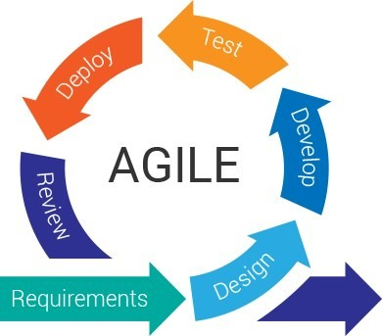

**Figure 2. Agile Model**

**1. Requirements**

In this initial phase, the researchers collect detailed information regarding the client's needs. This includes understanding the objectives of the recruitment system and identifying specific features required by the agency. Key functionalities include account management for agents and applicants, and secure data handling. The researchers also document the separate roles and permissions required for Admin, Agent, Client and Applicant users.

**2. Design**

After gathering the requirements, the researchers focus on designing the system. This involves creating layouts, wireframes, and system architecture that illustrate the organization of information, user interaction points, and the relationships between different system components.

**3. Develop**

During the development phase, the researchers utilize front-end and back-end frameworks to build the system. The front-end includes the user interface, while the back-end handles data processing and database connections. Essential features include the admin's capability to approve accounts, the agents’ ability to submit data, and the functionalities for applicants to upload necessary documents. This stage involves coding, ensuring secure authentication, and creating tools for agents to track their commissions based on client engagement.

**4. Test**

Once the system has been developed, testing is conducted to identify any errors or bugs. The researchers evaluate each function to ensure it operates as intended and confirms that user roles can access only their designated areas. Testing also includes validating the functionality of scheduling and file uploads to ensure they work effortlessly.

**5. Deploy**

After successful testing, the system is deployed into the agency's operational environment, making it available for user interaction. Deployment includes configuring the system on the client’s servers and ensuring that all files and data are correctly integrated. This phase enables agents, admins, and applicants to log in and execute their respective tasks effectively.

**6. Review**

Following deployment, the system undergoes a continuous review process to monitor performance and address any developing issues. The researchers collect feedback from users, identifies areas for improvement, and implements necessary updates. This review phase is key for maintaining the system's effectiveness and ensuring it continues to meet the developing needs of the agency.

**Gantt Chart**

The Gantt Chart in this section presents the details of the planning and time schedules of the project. The schematic of the project has all the development stages from planning up to the accomplishment mapped in this chart.

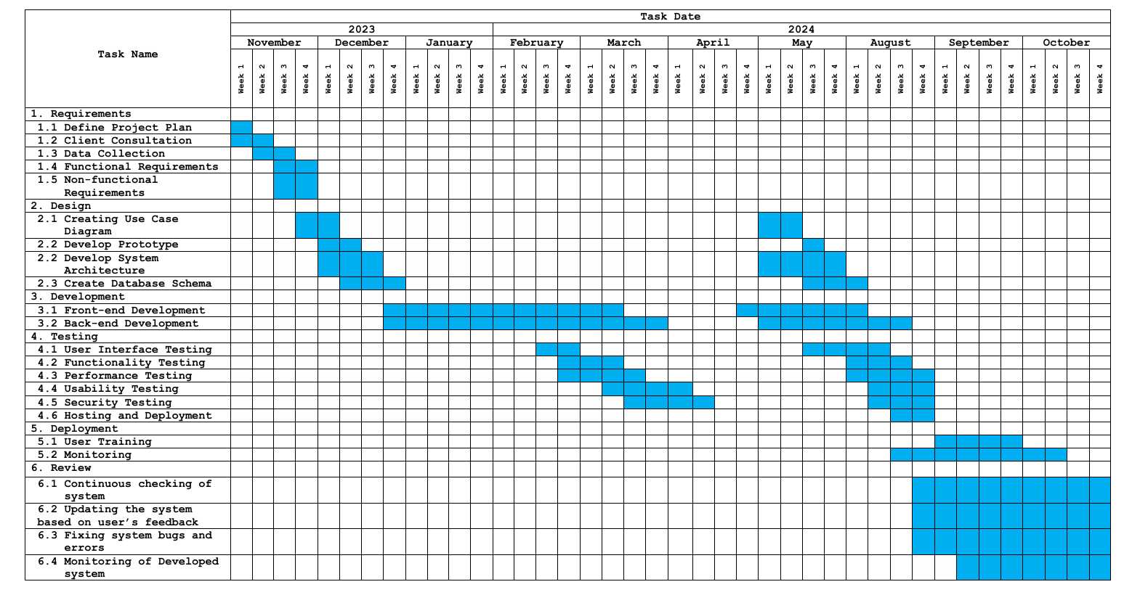**Table 1. Gantt Chart**

|  |  |  |
| --- | --- | --- |
| **Legends:** |  | = Done |

Table 1 shows the project’s Gantt Chart, which outlines the different stages of development. It tracks the weekly progress made in building the system. The requirements phase is set to start in the first week of October 2023, and the testing phase, including deployment and system maintenance, will finish by the fourth week of November 2024.

**Requirements Specifications**

The requirements specifications for the online recruitment system include the functional requirements, user interface, software interface, hardware interface, and security interface. The specs highlight the required functions, connection points, and security components that the system needs to be able so as to be made dependable and also safe.

**Functional Requirements**

The functional requirements will determine the system performance, highlight the actions that must be taken and suggest the policies needed for the system being done effectively. With such good exposure, the system and the data tail leading to work outputs are demonstrated which involves the presentation of the system. The fact is that researchers need to have the system talk with the team members' directly where the personnel should up-to-date the functioning requirements and validate the system by making sure it as responding to what exactly had the request.

**Table 2. Functional Requirements**

|  |  |
| --- | --- |
| **Features** | **Description** |
| 1. User Authentication | Apply secure user authentication for admin, agents, and applicants. Account creation, login, and resetting password. |
| 2. Administrator Dashboard | Develop a dashboard for administrator to visually monitor user activity, agent and applicant data, and recruitment metrics. |
| 3. Data Management | Enable administrator to view, manage, and add agent accounts, implement a review process for applicant data, and facilitate data transfer to agents. |
| 4. Overview Display | Provide administrator with an overview feature displaying the total number of agents, applicants, and relevant recruitment data. |
| 5. Profile Management | Allows administrator, agents, and applicants to manage personal information and account settings. |
| 6. Document Handling | Enable administrators to download applicant forms and documents as PDF files for record-keeping. |
| 7. Integrated Messaging | Facilitate communication between admin, applicants and agents through the integrated messaging system. |
| 8. Notification | Notification to notify admin of new messages, incoming applicants, and other activity. |
| 9. Search and Filtering | Search and filtering to help admin easily find information about agents and applicants. |
| 10. Employee Recruitment Dashboard | Create employee dashboards to visually track user metrics and performance data. |
| 11. Secure Data Viewing | Enable agents to securely view personal information, application forms, and status of recruited applicants. |
| 12. Account Management for Agents | Giving an access for agents to manage their account like profile information and changes when it comes to their password. |
| 13. Online Application Form | Provide a form in online for applicants to fill out personal and professional information. |
| 14. Document Upload | Allow applicants to upload documents and any images for their application. |
| 15. Financial Adviser Selection | Enable applicants to browse and select an agent from a list of available FAs. |
| 16. Application Save and Modify | Allow applicants to save their work and return to the application later for modifications. |
| 17. Submission Mechanism | Provide a submission mechanism for applicants to formally submit their completed application to the system. |
| 18. Plan Selection | Users should be able to view available insurance plans, select the one that suits their needs, and purchase it through the system. |

Table 2 shows that the ELIFESURE: An Online Recruitment System for Allianz PNB Life Insurance Inc. in MIMAROPA features consists of user authentication, administrator dashboard, data management, overview display, profile management, document handling, integrated messaging, notification system, and search and filtering.

**User Interface**

The user interface happens to be the main element in online recruitment as it supports interactions between the systems and the user. The user interface should be so designed as if it is easy to use and friend ties to a user with an appealing look. System should be presented in a simple and understandable way highlighting its i.e. functions.

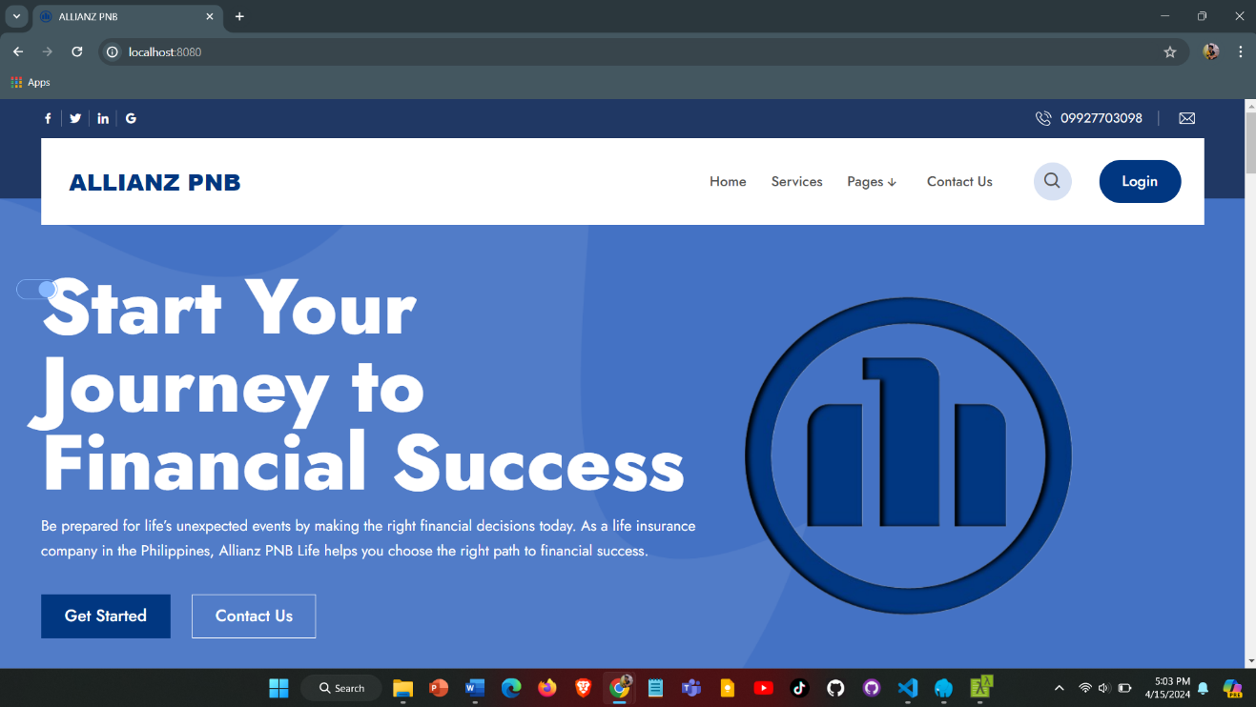

**Figure 3. User Interface**

Figure 3 shows the user interface of the system. It includes the main elements that users will see when they interact with the platform. The interface is designed to be simple and easy to navigate, allowing users to quickly access different features.

**Hardware Interface**

The hardware interface defines the logical and physical composition of the interface between the software and hardware components. The it specifies the hardware components and their parameters to ensure that the system operates successfully. Enumeration covers the actuators, the processor, 16 GB RAM memory, the 256GB SSD storage, and network architecture.

**Software Interface**

The user interface will establish the current windows 8 to 11 operating system used, the database or other databases, external tools and libraries the system will utilize, and the built-in commercial components which will support the system. It encompasses specifics about the software programs and their respective versions that were employed in system design and testing.

**Security Requirements**

Security measures are among factor of major importance in order to keep the system is available and the private data is protected only by authorized users only. Security requirements shall conform to data protection and recruitment registration procedures so that the system and the data of the system remains confidential, integral and available.

**Technical Background**

An outlook section that is directed towards the technical aspects of the project gives the technical background by detailing inventories of hardware and software. This data gives the specific/detailed definition of an entity in an easy-understandable manner for the developers. It covers the information concerning the names of the hardware components, the operating system, the programming languages, frameworks and the tools used in the system build and deployment for online recruitment.

**Hardware Specifications**

Hardware Specifications means technical descriptions of hardware items, their components and functions. Consideration of the hardware elements which will ensure the efficiency and functionality of the project is a must. The table below presents the different hardware components and their recommended specifications:

**Table 3. Hardware Specification**

|  |  |  |  |  |  |
| --- | --- | --- | --- | --- | --- |
| **Hardware** | **Function** | | **Specifications** | | **Unit** |
| **Minimum** | **Recommended** |
| CPU and Memory | | Efficient handling of loads | At least 16GB RAM | At least 16GB RAM | 1 |
| Storage | | Faster data access | 256GB SSD | 512GB SSD | 1 |
| Network Infrastructure | | Reliable and high-speed internet connectivity | Integrated dedicated 4G LTE modem | Integrated dedicated 4G LTE modem | N/A |
| Laptop | | Development workstation with connectivity | Intel Core i3 processor, 16GB DDR4 RAM, 128GB SSD, | Intel Core i5 processor, 16GB DDR4 RAM, 512GB SSD, | 1 |

Table 3 outlines the hardware requirements for the system, recommending at least 16GB RAM, a 256GB SSD (preferably 512GB), a built-in 4G LTE modem for internet, and a laptop with at least an Intel Core i3 processor, though an Intel Core i5 is ideal for better performance.

**Software Specifications**

Software Specifications are of vital importance for the correct mobilization and connectivity of the online recruitment system. The table below presents the minimum and recommended specifications for various software components:

**Table 4. Software Specification**

|  |  |  |
| --- | --- | --- |
| **Component** | **Minimum**  **Specifications** | **Recommended**  **Specifications** |
| Operating System | Windows 8 64 bit | Windows 10 or Latest |
| Code Igniter | CodeIgniter 4.0 | CodeIgniter 5 or newer |
| Visual Studio Code | Visual Studio Code 1.40 | Visual Studio Code 1.50.1 or Latest |
| Web Browser | Google Chrome | Google Chrome or Any Web Browser |
| Web Server | Laragon 4.0.16 | Laragon 6.0 |
| Web Hosting | Hostinger | Hostinger |
| Database  (phpMyAdmin) | 1 Database | 2-3 Available Databases |
| MySQL | 5.1 | 5.6 or Latest |

As shown on the Table 4, it outlines the minimum and recommended specifications for various software components required for the online recruitment system. It consists of a set of explanations such as this is about the operating system, Code Igniter framework, Visual Studio Code, web browser, web server, web hosting as well as database. By defining these software specs, the online recruitment platform is able to work with necessary software pieces and perform the intended function.

**System Analysis and Design**

In the analysis and design of the system, I determined the requirements, developed diagrams of the major components and their functions, and provided directions for the development and deployment of the online recruitment system.

**System Overview**

The "ELIFESURE: Online Recruitment System for Allianz PNB Life Insurance Inc. in MIMAROPA" is a simple web-based platform that helps make the recruitment process easier for insurance and investment agencies in the MIMAROPA region. The system helps manage agents, applicants, and clients all in one place. Agents can log in only after they get an account from an administrator. Once they are approved, agents can start recruiting applicants. Applicants can only register if they have been referred by an agent or they can register directly to the system. After registering, applicants can fill out and send their application forms, which the administrator reviews. Both applicants and agents need to complete the required Allianz forms as part of the process. The administrator can now manage these forms and review their accounts to approve or reject the applications. For clients, the system lets them register, log in, and choose insurance plans that suit their needs. The admin keeps track of all applications and makes sure everything is running well. The system also sends notifications to agents, applicants, and clients to keep everyone updated on their status. The platform is designed to be easy to use, with features that help the admin make quick decisions. It runs on secure servers to make sure it's always available for everyone involved in the recruitment process.

**System Architecture**

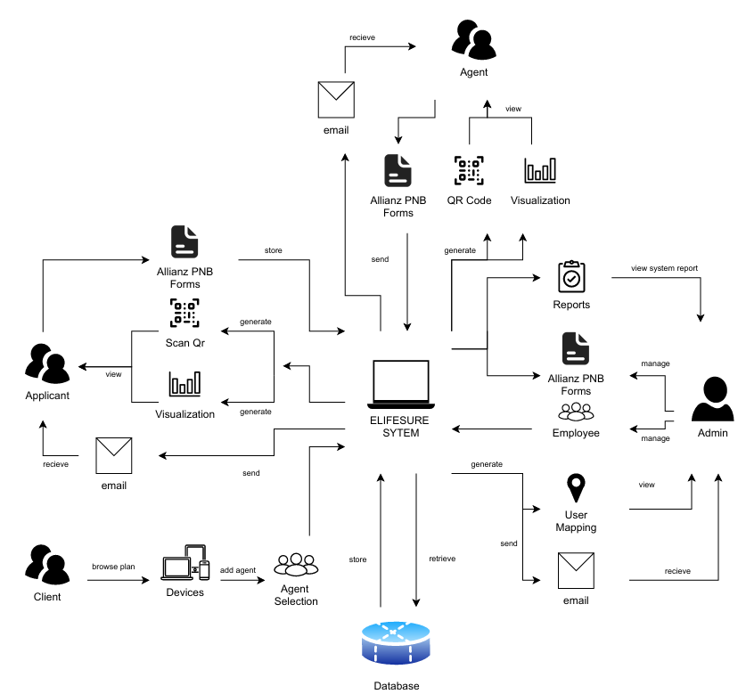A system architecture shows the representation and structure of the system.

**Figure 4. System Architecture**

Figure 4 shows that the admin is in charge of working by requesting display of a candidate information, catering for varied components such as the reports, the selections of candidates, the control and maintenance, and the user management. Follows that way, the Agent acts as an intermediary between candidates and the System which enables to keep them informed concerning the selection process status. However, the User interacts with the system to handle their forms. System is a hub which is between established communication channels between Admin, Agents, and Applicants. It is the one that updates the selection processes for Agents, and Forms Admins’ requests for reports and applicant management, thus facilitating and organizing in general all functions of the application management system.

**Use Case Diagram**

Figure 5 serves as an outline of how these stakeholders all interact with and complement each other in carrying out functions within the system. The more researchers gets into the details of this chart, the better understand what responsibility each role has and how it is related to other roles, giving insight on how all these pieces fit together in a system that works smoothly across an entire organization.

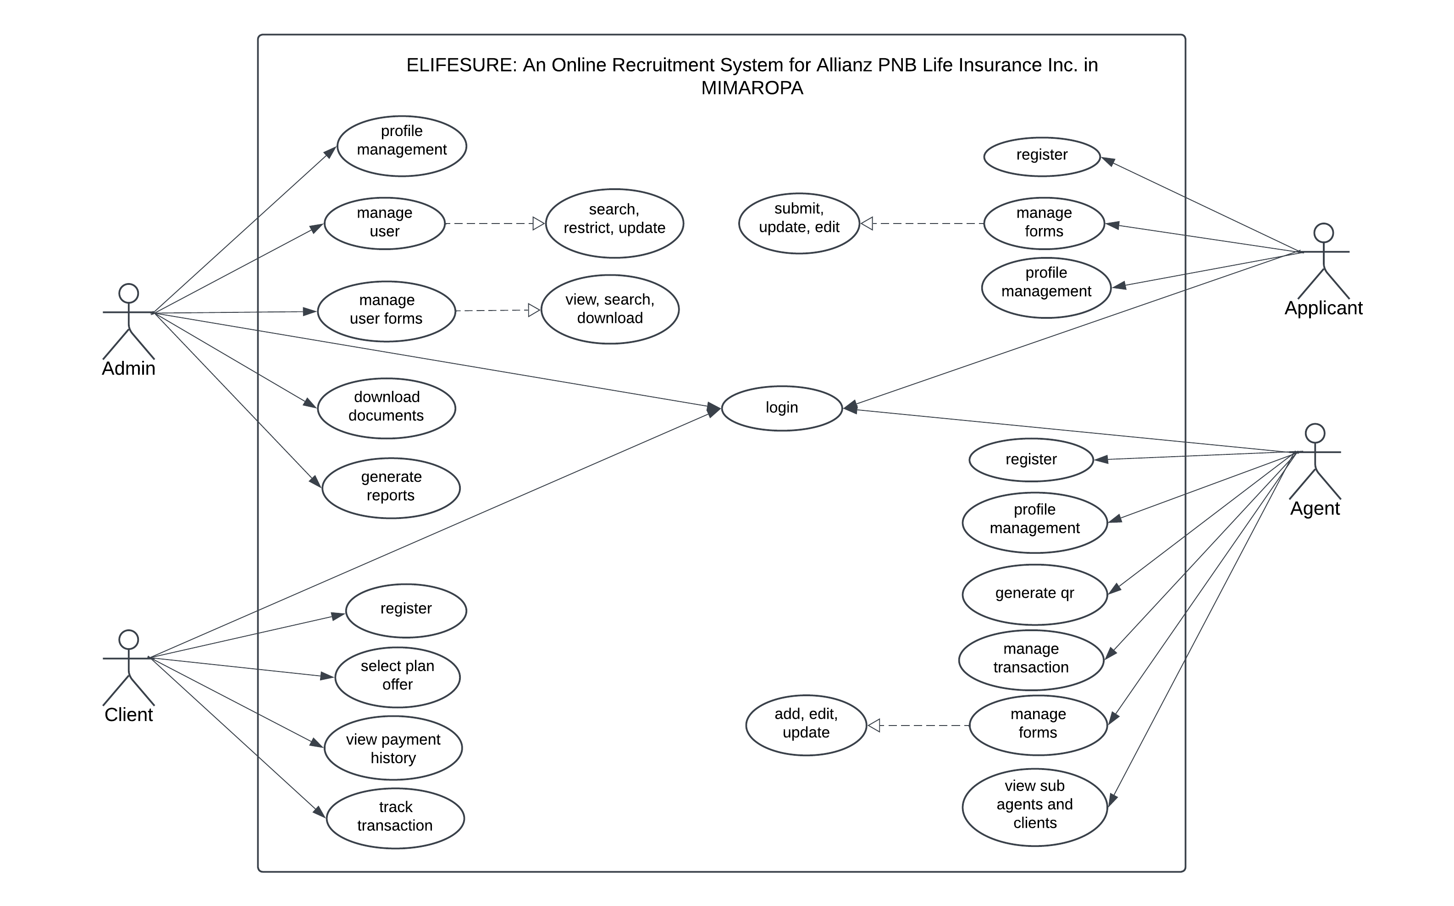

**Figure 5. Use Case for ELifeSure**

Figure 5 shows the roles of the Administrator, Agent, and the Applicants to be executed in the whole process of the system.

**Activity Diagram**

This part of the document presents the flow of the project using an object-oriented flowchart. Its purpose is to capture the dynamic behavior of the system. It focuses on the execution and flow of the behavior of a system instead of implementation.

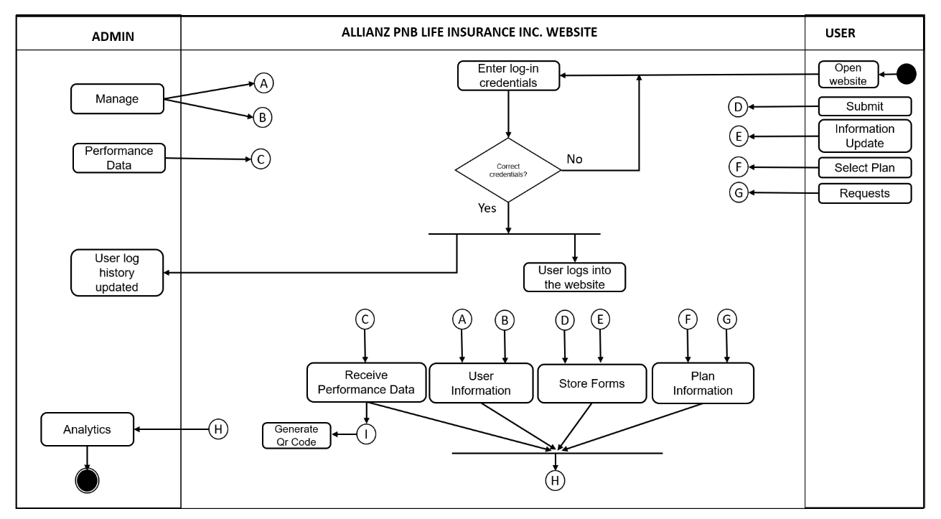

**Figure 6. Activity Diagram**

Figure 6 shows, the activity diagram of the system wherein the applicants will register then login their accounts and they will fill-up the forms and the information will be sent directly to the administrator. The administrator will then review their information and makes the decision if the applicant is valid for interview, the administrator will make an appointment and then the system will notify the applicant for the interview and the applicant will confirm it. The administrator will then conduct the interview, after the interview the administrator will again decide if the applicant is good for the job, if the applicant is accepted, the administrator will update the applicant’s status, the system will send the notification to the applicant and the applicant will confirm it.

**Data Flow Diagram (DFD)**

The data flow diagram, which functions similarly to a map to depict the information flow for all system processes, is presented next.

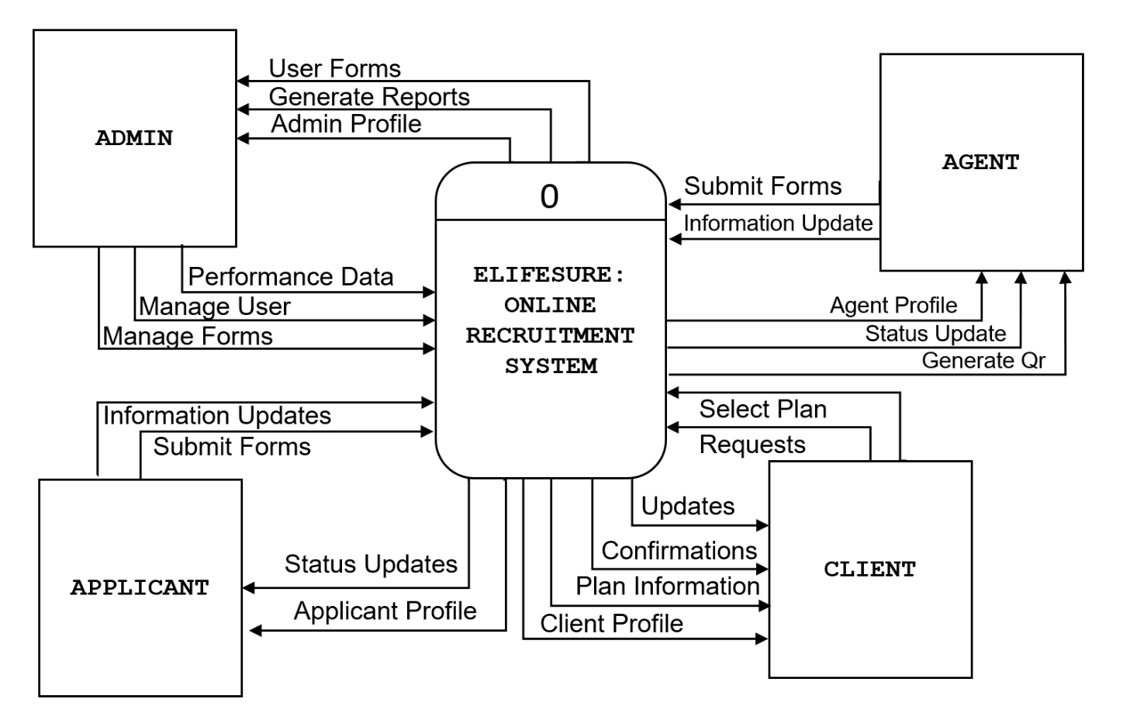**Context Diagram**

**Figure 7. Context Diagram**

The figure 7 shows how the system will be developed concerning the different fields in which they are part for specification into the users that will make use of it.

**Diagram 0**

The Diagram 0 of ELIFESURE: An Online Recruitment System for Allianz PNB Life Insurance Inc. in MIMAROPA shows the flow of information to visualize the process of the project.

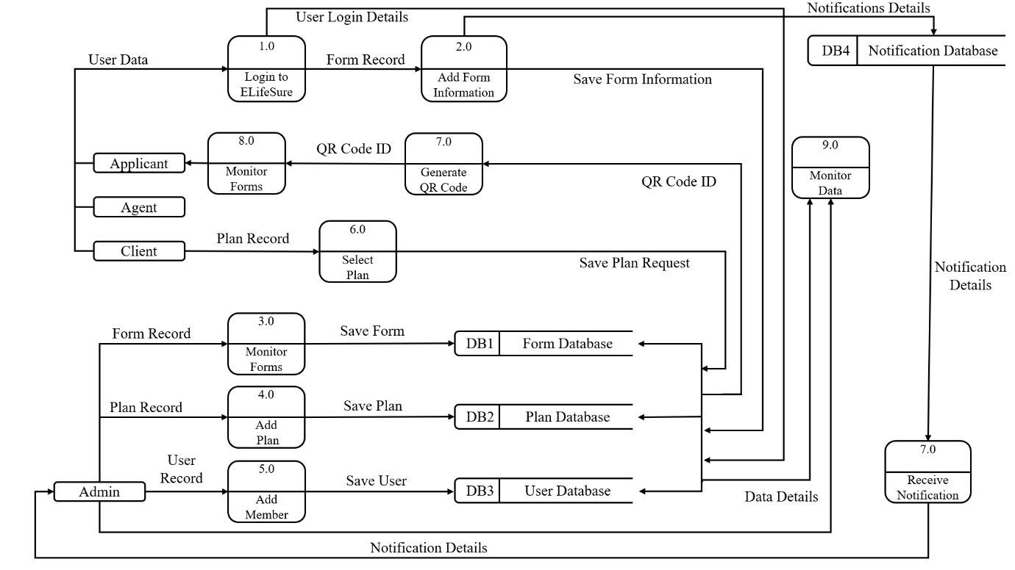

**Figure 8: DFD Level 0**

Figure 8 DFD Level 0 illustrates the interactions and data flows between the Admin, Agents, Clients and Applicants.

**Database Schema**

The design of the system turned out to be the most crucial in the projects development. At this stage, the system's entity’s traits were described, mostly in relation to definitions. This made it simply for the user to assess and understand the properties which came with these existing things. The system design phase allowed the detailed description of the dataset of the study. The entities were revealed and the features were exhibited.

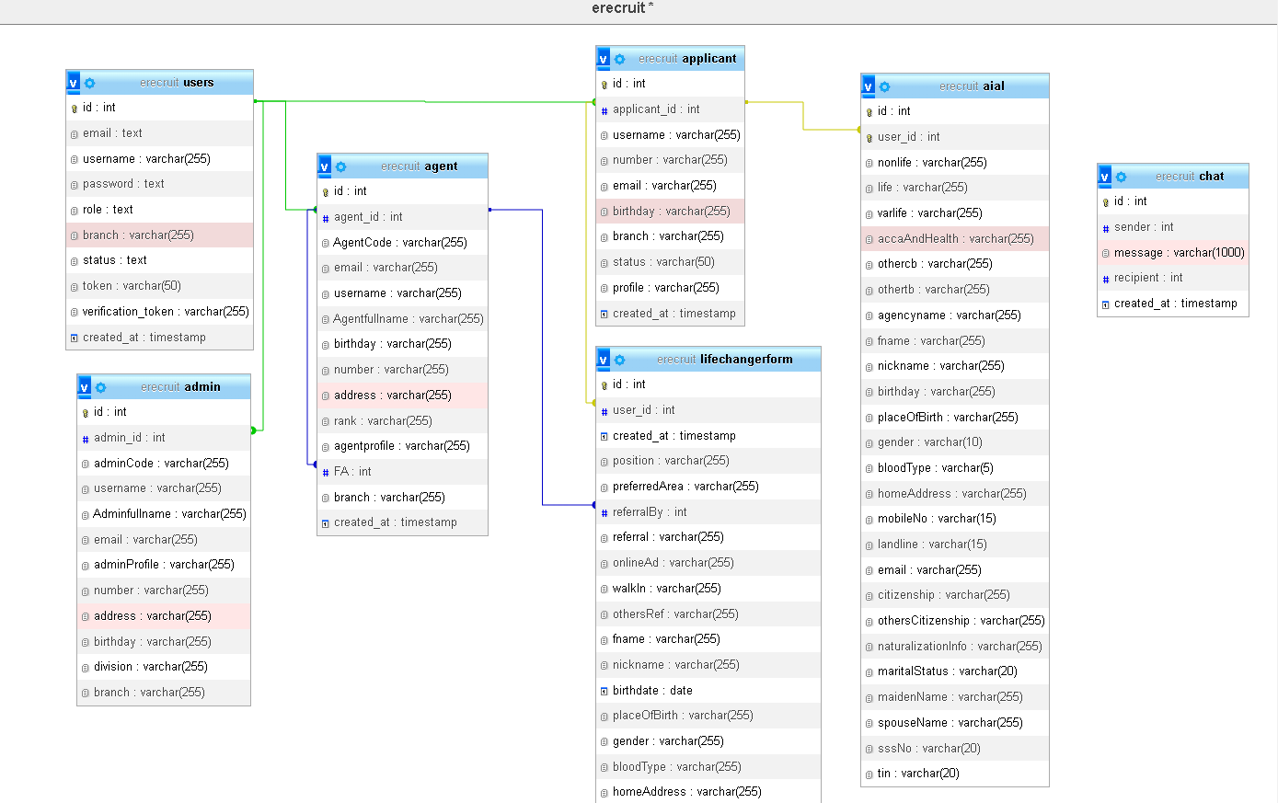

**Figure 9. Database schema**

Figure 9 shows the structure of the E-recruitment database, where all the basic tables are connected using primary and foreign keys. Primary keys are unique identifiers for each record in a table, ensuring that each entry is distinct. Foreign keys, on the other hand, link tables together by referencing the primary key of another table. This setup helps establish relationships between the tables. The database schema illustrates how these tables are organized and connected, which makes it easier to manage and manipulate data. This structure helps maintain data consistency and accuracy, making the system more efficient and reliable.

**Testing and Evaluation**

This period affords researchers the best time for system testing and complete mounting to ensure maximum functionality. Researchers enhance the system's ability of providing whole of service spectrum by several improvements. Researchers are persistently striving for better as we attribute great importance to upgrading the system up to the level of maximum functionality and convenience. The critical thing that relies on here is being properly and rapidly entirely quality control program. This is the place that clients get to tell how much individuals behind the creation and development of a site have concentrated or vibrated to make the site more friendly.

**Participants of the Study**

The respondents to the study were composed of the administrator, applicants, agents.

**Table 5. Respondents of the Study**

|  |  |
| --- | --- |
| **Respondents** | **Number of respondents** |
| Administrator | 1 |
| Applicants | 12 |
| Agents | 30 |
| Clients | 2 |
| IT Experts | 5 |
| **Total** | **50** |

Table 5 shows the respondents of the study, including the number of each category respondents

**Data Gathering Instrument**

The respondent to the study took part in the survey through the use of the questionnaires which had been provided for them by the researchers. The respondent's collected data would be verified to help in knowing the kind of information which people want to access in the website. Rating scale questionnaire were used by the researchers as tool, Likert scale being a method was applied to collect data from the respondents.

**Table 6. Likert’s Scale**

|  |  |  |
| --- | --- | --- |
| **Scale** | **Range** | **Verbal Interpretation** |
| 4 | 3.50-4.00 | Strongly Agree |
| 3 | 2.50-3.49 | Agree |
| 2 | 1.50-2.49 | Disagree |
| 1 | 1.00-1.49 | Strongly Disagree |

**Implementation Plan**

The system developed by the researchers will begin to attract people, and strategy for implementation will also be proposed. Sule wants to explore the possibility that he is also born again along with the system and accordingly the documentation will be handed over. It will cover from how to apply the system updates, which one has to oversee, to maintenance. The letter should be agreement that the system is given unreservedly to the user starting from this moment and that researchers won’t take responsibility for updating and system maintenance. In the case of the referendum being positive the researchers would like to have various strategies involved.

**Table 7. Implementation Plan**

|  |  |  |  |
| --- | --- | --- | --- |
| **Activities** | **No. of days to complete** | **Start Date** | **End Date** |
| Meeting with the Client | 25 days | November 5, 2023 | November 30, 2023 |
| Deployment Approval | 10 days | September 4, 2024 | September 14, 2024 |
| System Deployment and Monitoring Period | 16 days | September 14, 2024 | September 30, 2024 |
| System Evaluation | 27 days | October 1, 2024 | October 28, 2024 |

**Chapter IV**

**RESULTS AND DISCUSSION**

This chapter sums up and reviews the research findings. It gives a clear overview of the data collected, explains it using basic statistical methods, and answers the main research questions.

**Presentation of System Output**

This section highlights how the system presents its output, similar to the importance of a good user interface when designing a website. To make sure the information is easy to understand and helps users in their analysis or decision-making, the results are shared through clear summaries and visuals like graphs or charts.

**Admin Side**

The illustrations show the user interface designed for administrators, giving them great control and management options. With full access, administrators can easily manage and monitor different parts of the system, making sure everything runs smoothly.

|  |
| --- |
|  |
| **Figure 10. Admin Dashboard** |
| Figure 10 shows virtualization when it comes to applicants and agents. It can be seen here how many applicants and agents have already entered the system. Agents and applicant data as well as top recruiters can be seen on the admin dashboard. |
|  |
| **Figure 11. Account Management** |
| Admin has the ability to control client, applicant, and agent accounts. They can make changes to these accounts by deciding whether a user is active or not active, as shown in Figure 11. This means the admin can restrict access to the system if needed, either by activating or deactivating user accounts. |

|  |
| --- |
|  |
| **Figure 12. Application Forms** |
| The admin can view the forms of agents and applicants, where this information can also be managed as shown in figure 12. Here, they can download all applications of applicants and agents, along with all information entered by users in these forms. This feature helps the admin keep track of all submissions and ensure that the data is organized and up to date. |

|  |
| --- |
|  |
| **Figure 13. Agent Promotion Side** |
| Figure 13 illustrates how the admin can manage agent promotions within the system. On the agent promotion side, the admin has the ability to promote agents with a high recruitment history, where their achievements and the recruits they have brought in can be viewed. |

|  |
| --- |
|  |
| **Figure 14. Schedule** |
| In Schedule Management, as shown in figure 14, the admin can enter information about meetings or any events to update users if there are any additional details needed regarding the schedule and meetings. |

|  |
| --- |
|  |
| **Figure 15. Agent Management** |
| In the Agent Management section, as shown in Figure 15, the admin can see all the agents that have already been added to the system. This allows the admin to easily check how many agents are in the system. The admin can view each agent's details and get an idea of the total number of agents currently active in the system. This section helps the admin keep track of all agents and manage them effectively. |

|  |
| --- |
|  |
| **Figure 16. Applicant Management** |
| Similar to the management of agents, as illustrated in figure 16 there is also applicant management where the admin can review the total number of applicants recruited by agents. |

|  |
| --- |
|  |
| **Figure 17. Reports** |
| Figure 17 shows the reports, where the admin can see information about agents, applicants, top recruiters, and awardees. This allows the admin to monitor progress within the system. The admin can generate reports to track how well agents and applicants are doing, see who the top recruiters are. These reports help the admin stay updated and manage the system more effectively. |

|  |
| --- |
|  |
| **Figure 18. Mapping** |
| Figure 18 shows the mapping of the number and locations of agents and applicants who have entered the system. This visual representation helps administrators track where agents and applicants are located, making it easier to manage recruitment efforts and optimize coverage in different areas. |

|  |
| --- |
|  |
| **Figure 19. Create Plan Offer** |
| Figure 19 shows the admin has the ability to add new plans to show clients the services or plans they are offering. |

|  |
| --- |
|  |
| **Figure 20. Admin Setting** |
| Figure 20 shows an admin profile or admin settings where an admin can manipulate or monitor their information in an account or system to update any missing details or make necessary changes. |

**User Side**

The following illustrations display the interface designed for clients, applicants, and agents, personalized to their specific needs. For clients, the system is user-friendly, allowing them to explore various insurance and investment options, and track their investments with ease. Applicants benefit from a simple, interface where they can quickly submit their applications, upload required documents, and monitor their application status. Agents have tools to assist clients in selecting insurance or investment plans, manage applications, all while efficiently handling multiple client requests to ensure smooth operations.

|  |
| --- |
|  |
| **Figure 21. User Dashboard** |
| Figure 21 shows an overview or dashboard of an agent, which displays the commissions and the number of sub-agents, applicants, and clients they have recruited. |
|  |
| **Figure 22. User E-Signature** |
| Figure 22 shows where agents can fill out an e-signature so that the signatures created can be applied to forms and other parts of the system as needed. |
|  |
| **Figure 23. User Schedule** |
| In the User Schedule, as shown in figure 23, you can see the progress or schedule created by the admin, including any events or meetings related to their organization or corporation. Here, agents can view the tasks that need to be completed as shared by the admin. |

|  |
| --- |
|  |
| **Figure 24. User Other File** |
| Figure 24 shows the uploads section where applicants can upload various files or photos as requested by the admin for the information they need. Here, applicants can insert their files directly to the admin, allowing the admin to see what files have been submitted. |

|  |
| --- |
|  |
| **Figure 25. User Agent View** |
| In the User Agent View, as shown in figure 25, you can see the agents in the system where applicants can choose an agent who will serve as their referral. That agent will assist them in fulfilling the requirements needed for this corporation. |

|  |
| --- |
|  |
| **Figure 26. User Profile Setting** |
| Figure 26 shows the profile view of an applicant, where each user has their own profile management or settings management. Similar to the admin, users can edit their information in the system if they wish to update, delete, or manage it. |

|  |
| --- |
|  |
| **Figure 27. User Form** |
| Figure 27 shows the form that applicants and agents must fill out. However, before filling out the forms, one must first become an applicant, and through that process, they can then become an agent based on the forms and information provided in the system. |

|  |
| --- |
|  |
| **Figure 28. Client Dashboard** |
| Figure 28 shows the client dashboard, where policy information, claims management, contact information, and the insurance plans availed by a client can be seen. It also displays the billing and payment history that can be managed by the agent connected to a client. |

|  |
| --- |
|  |
| **Figure 29. Client Payment History** |
| In this payment history figure, the years, months, amounts paid, remarks, and receipts are displayed as shown in figure 29. An agent can upload a receipt here to verify that the client has indeed paid for their purchased plan. |

|  |
| --- |
|  |
| **Figure 30. Client Schedule** |
| The client also has a schedule, which shows the date of the schedule, time, meeting type, status, and when it will occur as shown in figure 30. This schedule is essential for clients to avoid any issues regarding the payment of their purchased plan. |

**Evaluation of the System**

After designing and evaluating our Insurance and Investment system, the study concludes with a thorough assessment across several key dimensions, including Functionality, Reliability, Performance, Usability, Security, Compatibility, and Maintainability. Feedback was gathered from 50 respondents, including clients, agents, applicants, and IT experts, through questionnaires. The responses were carefully analyzed and presented in tables providing a detailed interpretation of the system's overall evaluation and performance.

**Table 8. Functionality Suitability**

|  |  |  |  |
| --- | --- | --- | --- |
| **Functionality Suitability** | **Mean** | **Rank** | **Verbal Interpretation** |
| 1.1 The functions of system cover all the specified task and user objectives. | 3.34 | 3 | Agree |
| 1.2 The functions of system provide the correct results with the needed degree of precision. | 3.44 | 2 | Agree |
| 1.3 The functions of system facilitate the accomplishment of specified tasks and objectives. | 3.58 | 1 | Strongly Agree |
| **Overall Mean** | **3.45** |  | **Agree** |

Table 8 shows how well the system works in three main areas, covering all tasks, giving correct results, and helping users complete tasks. The average score is 3.45 which means most people think the system is good at what it’s supposed to do. The highest score 3.58 was for how well the system helps users finish tasks. Giving correct results scored a bit lower at 3.44, and covering all tasks got 3.34. Overall, the system does a good job, but it could be even better in some areas.

**Table 9. Performance Efficiency**

|  |  |  |  |
| --- | --- | --- | --- |
| **Performance Efficiency** | **Mean** | **Rank** | **Verbal Interpretation** |
| 2.1 The functions of system response and process the output on time to meet the user requirements. | 3.44 | 3 | Agree |
| 2.2 The resources used by the system, when performing its  functions, meet requirements | 3.52 | 1 | Strongly Agree |
| 2.3 The maximum limits of the product or system, parameter meet requirements. | 3.48 | 2 | Agree |
| **Overall Mean** | **3.48** |  | **Agree** |

Table 9 shows how well the system performs in terms of speed and resource use. It looks at three main areas whether the system responds on time, if it uses resources properly, and if it meets maximum limits. The average score is 3.48 which means users generally agree the system performs well. The highest score 3.52 is for how well the system uses resources, meaning it does a very good job in this area. Responding on time scored a bit lower at 3.44 and meeting maximum limits scored 3.48. Overall, the system is efficient and meets user needs, though there is room to improve in some areas.

**Table 10. Usability**

|  |  |  |  |
| --- | --- | --- | --- |
| **Usability** | **Mean** | **Rank** | **Verbal Interpretation** |
| 3.1 The system is appropriate for my needs. | 3.44 | 2.5 | Agree |
| 3.2 The use of system is effective and efficient in emergency situations. | 3.42 | 4.5 | Agree |
| 3.3 The system is easy to operate, control and appropriate to use. | 3.44 | 2.5 | Agree |
| 3.4 The system protects users against making errors. | 3.36 | 6 | Agree |
| 3.5 The user interface of the system enables pleasing and satisfying interaction for the user. | 3.42 | 4.5 | Agree |
| 3.6 The system can be used by people with the widest range of characteristics and  capabilities to achieve a specified goal in a specified context of use. | 3.46 | 1 | Agree |
| **Overall Mean** | **3.42** |  | **Agree** |

Table 10 shows how easy and helpful the system is to use. It checks six areas, like whether the system fits users' needs, is easy to use, works well in emergencies, and helps avoid mistakes. The average score is 3.42, which means most people agree the system is usable. The highest score 3.46 is for how well the system works for different kinds of users to achieve goals, showing it’s good for a variety of people. Both the system’s ease of use and how well it meets user needs scored 3.44, while helping to avoid errors scored slightly lower at 3.36. Overall, the system is accessible but has some areas where it could improve.

**Table 11. Reliability**

|  |  |  |  |
| --- | --- | --- | --- |
| **Reliability** | **Mean** | **Rank** | **Verbal Interpretation** |
| 4.1 The system meets needs for reliability under normal operation. | 3.36 | 4 | Agree |
| 4.2 The system is operational and accessible when required for use | 3.42 | 2.5 | Agree |
| 4.3 The system operates as intended despite the presence of hardware  or software faults | 3.46 | 1 | Agree |
| 4.4 When an interruption or a failure happened, the system can recover the data on the directly affected and re-establish the desired state of the system. | 3.42 | 2.5 | Agree |
| **Overall Mean** | **3.41** |  | **Agree** |

Table 11 shows how reliable the system is in different situations. It covers four areas which are meeting reliability needs, being available when needed, working even if there are problems, and recovering data if something goes wrong. The average score is 3.41, meaning users generally agree the system is reliable. The highest score 3.46 is for the system's ability to keep working even if there are hardware or software issues, showing it is trustworthy in tough situations. Being available when needed and recovering from interruptions both scored 3.42, while meeting general reliability needs scored 3.36. Overall, the system is reliable, with a few areas that could be strengthened.

**Table 12. Performance Expectancy**

|  |  |  |  |
| --- | --- | --- | --- |
| **Performance Expectancy** | **Mean** | **Rank** | **Verbal Interpretation** |
| 1.1 Using the system, my job would increase my productivity. | 3.38 | 5.5 | Agree |
| 1.2 Using the system would enhance my effectiveness on the job. | 3.34 | 8.5 | Agree |
| 1.3 Using the system would make it easier to do my job. | 3.62 | 1 | Strongly Agree |
| 1.4 I would find the system useful in my job. | 3.40 | 3.5 | Agree |
| 1.5 Using the system enables me to accomplish tasks more quickly. | 3.40 | 3.5 | Agree |
| 1.6 Using the system improves the quality of work I do. | 3.34 | 8.5 | Agree |
| 1.7 Using the system makes it easier to do my job. | 3.33 | 10 | Agree |
| 1.8 Using the system enhances my effectiveness on the job. | 3.38 | 5.5 | Agree |
| 1.9 If I will use the system I will increase my effectiveness on the job. | 3.36 | 7 | Agree |
| 1.10 If I will use the system I will spend less time on routing job tasks. | 3.42 | 2 | Agree |
| **Overall Mean** | **3.40** |  | **Agree** |

Table 12 shows how well the system helps people do their jobs. It looks at areas like increasing productivity, making work easier, and saving time. The average score is 3.40, which means most people agree the system is useful for their work. The highest score 3.62 was given for how much easier the system makes the job, showing this is its best feature. Saving time on routine tasks scored 3.42, and making tasks quicker and more effective both scored 3.40. Other areas, like improving work quality and productivity, scored a bit lower but still agree. Overall, the system is seen as helpful for work, though there is area to make it even more effective.

**Table 13. Effort Expectancy**

|  |  |  |  |
| --- | --- | --- | --- |
| **Effort Expectancy** | **Mean** | **Rank** | **Verbal Interpretation** |
| 2.1 Learning to operate the system would be easy for me. | 3.46 | 5 | Agree |
| 2.2 I would find it easy to get the system to do what I want it to do. | 3.40 | 6 | Agree |
| 2.3 My interaction with the system is clear and understandable. | 3.50 | 4 | Strongly Agree |
| 2.4 My interaction with the system would be clear and understandable. | 3.52 | 2.5 | Strongly Agree |
| 2.5 I would find the system to be flexible to interact with. | 3.38 | 7 | Agree |
| 2.6 Using the system don’t take too much time from my normal duties. | 3.34 | 10 | Agree |
| 2.7 Working with the system is so simple, it is not difficult to understand what is going on | 3.54 | 1 | Strongly Agree |
| 2.8 Using the system involves lesser time doing mechanical operations (e.g., data input) | 3.52 | 2.5 | Strongly Agree |
| 2.9 My interaction with the system is clear and understandable. | 3.36 | 8.5 | Agree |
| 2.10 I believe that it is easy to get the system to do what I want it to do. | 3.36 | 8.5 | Agree |
| **Overall Mean** | **3.44** |  | **Agree** |

Table 13 shows how easy it is to use the system. It focuses on how simple it is to learn, interact with, and get the system to do what users want. The average score is 3.44, which means most people agree that the system is easy to use. The highest score 3.54 is for how simple it is to work with the system, indicating that users find it straightforward to understand. Scores of 3.52 were given for how clear and understandable interactions with the system are. Learning to operate the system scored 3.46, while finding the system flexible and using it without taking too much time scored slightly lower at 3.34. Overall, the system is seen as accessible, but there are still some areas that could be improved.

**Table 14. Facilitating Conditions**

|  |  |  |  |
| --- | --- | --- | --- |
| **Facilitating Conditions** | **Mean** | **Rank** | **Verbal Interpretation** |
| 3.1 I have control over using the system. | 3.54 | 1 | Strongly Agree |
| 3.2 I have the resources necessary to use the system. | 3.38 | 8 | Agree |
| 3.3 I have the knowledge necessary to use the system. | 3.40 | 7 | Agree |
| 3.4 Given the resources, opportunities and knowledge it takes to use the system, it would be easy for me to use the system. | 3.42 | 6 | Agree |
| 3.5 Guidance was available to me in the selection of the system. | 3.44 | 4.5 | Agree |
| 3.6 Specialized instruction concerning the system was available to me. | 3.36 | 9 | Agree |
| 3.7 A specific person (or group) is available for assistance with system difficulties. | 3.34 | 10 | Agree |
| 3.8 Using the system is compatible with all aspects of my work. | 3.46 | 3 | Agree |
| 3.9 I think that using the system fits well with the way I like to work. | 3.44 | 4.5 | Agree |
| 3.10 Using the system fits into my work style. | 3.52 | 2 | Strongly Agree |
| **Overall Mean** | **3.43** |  | **Agree** |

Table 14 shows how well users feel supported when using the system. It looks at areas like control over using the system, having the right resources and knowledge, and getting help when needed. The average score is 3.43, meaning most people agree that they have good support. The highest score 3.54 is for having control over how they use the system, which shows users feel confident in their ability to operate it. Using the system fits well with their work style scored 3.52, representing it matches their preferences. Having resources and knowledge scored 3.38 and 3.40, while guidance and assistance were rated slightly lower at 3.44 and 3.34. Overall, users feel they have the support needed to use the system effectively, but there are some areas that could be improved.

**Table 15. Facilitating Conditions**

|  |  |  |  |
| --- | --- | --- | --- |
| **Facilitating Conditions** | **Mean** | **Rank** | **Verbal Interpretation** |
| 4.1 Using the system is a good idea. | 3.48 | 2.5 | Agree |
| 4.2 Using the system is a wise idea. | 3.44 | 5.5 | Agree |
| 4.3 I like the idea of using the system. | 3.38 | 9 | Agree |
| 4.4 I find using the system to be enjoyable. | 3.46 | 4 | Agree |
| 4.5 The actual process of using the system is pleasant. | 3.40 | 7.5 | Agree |
| 4.6 I have fun using the system. | 3.44 | 5.5 | Agree |
| 4.7 The system makes work more interesting. | 3.48 | 2.5 | Agree |
| 4.8 Working with the system is fun. | 3.52 | 1 | Strongly Agree |
| 4.9 I like working with the system. | 3.40 | 7.5 | Agree |
| 4.10 I look forward to those aspects of my job that require me to use the system. | 3.26 | 10 | Agree |
| **Overall Mean** | **3.42** |  | **Agree** |

Table 15 shows how much users enjoy and value using the system. It covers ten areas, such as whether using the system is a good idea, if it is enjoyable, and if it makes work more interesting. The average score is 3.42, which means most users agree that using the system is positive. The highest score 3.52 is for how much fun users have while working with the system, showing it is seen as an enjoyable experience. Scores of 3.48 were given for using the system being a good and interesting idea. Other areas, like liking the system and finding it enjoyable, scored between 3.38 and 3.46. The lowest score 3.26 was for looking forward to using the system in work tasks. Overall, users find the system enjoyable and helpful, but there are still some aspects that could be improved to increase interest.

**Table 16. Summary Results of the ISO Evaluation**

|  |  |  |  |
| --- | --- | --- | --- |
| **Items** | **Mean** | **Rank** | **Verbal Interpretation** |
| 1. Functional Sustainability | 3.45 | 2 | Agree |
| 1. Performance Efficiency | 3.48 | 1 | Agree |
| 1. Usability | 3.42 | 3 | Agree |
| 1. Reliability | 3.41 | 4 | Agree |
| **Overall Mean** | **3.46** |  | **Agree** |

Table 16 summarizes the results of the ISO evaluation in four areas which are Functional Sustainability, Performance Efficiency, Usability, and Reliability. The average score is 3.46, which means most users agree that the system works well. The highest score 3.48 is for Performance Efficiency, indicating that the system performs effectively. Functional Sustainability scored 3.45, Usability scored 3.42, and Reliability scored 3.41, all showing agreement that these areas are satisfactory. Overall, the system is seen as reliable and accessible, meeting the needs of its users.

**Table 17. Summary Results of the UTAUT Evaluation**

|  |  |  |  |
| --- | --- | --- | --- |
| **Items** | **Mean** | **Rank** | **Verbal Interpretation** |
| 1. Performance Expectancy | 3.40 | 4 | Agree |
| 1. Effort Expectancy | 3.44 | 1 | Agree |
| 1. Facilitating Conditions | 3.43 | 2 | Agree |
| 1. Behavioral Intention | 3.42 | 3 | Agree |
| **Overall Mean** | **3.48** |  | **Agree** |

Table 17 shows the results of the UTAUT evaluation in four areas which are Performance Expectancy, Effort Expectancy, Facilitating Conditions, and Behavioral Intention. The overall average score is 3.48, meaning most users agree that the system is good. The highest score 3.44 is for Effort Expectancy, which means users find it easy to use the system. Facilitating Conditions scored 3.43, showing users feel supported when using the system. Performance Expectancy and Behavioral Intention both scored 3.40 and 3.42, respectively, indicating users believe the system helps them perform well and intend to use it. Overall, the system is viewed positively, with users feeling comfortable and confident using it.

**Table 18. Implementation Results**

|  |  |  |  |  |
| --- | --- | --- | --- | --- |
| **Activities** | **Targeted Date** | **Progress Notes** | **Outcome** | **Remarks** |
| Discussion with the Client | November 5, 2023 | Completed | The system’s required functions have been gathered and documented. | The needed functions and requirements have been discussed. |
| Letter for Deployment | September 2, 2024 | Approved | The system was deployed successfully. | None |
| System Deployment and Monitoring Period | September 4, 2024 | Few Patches | Various issues and bugs were resolved. | The system was deployed successfully. |
| Demonstration of System to the Users | September 14, 2024 | Completed | The system was successfully demonstrated to the users. | None |
| Evaluation of System | October 30, 2024 | Completed | The users evaluated the system. | None |

Table 18 shows the outcomes of the implementation activities and demonstrates that the system deployment and process were effective in putting the system requirements and testing procedures into effect.

**CHAPTER V**

**SUMMARY, CONCLUSION AND RECOMMENDATION**

In this chapter, researchers summarize the research on the ELifeSure: An Online Recruitment System for Allianz PNB Life Insurance Inc. in the MIMAROPA region. Researchers will look at the main findings, draw conclusions based on the research, and give recommendations for future improvements and uses of the system.

**Summary**

The research aimed to solve problems in the recruitment process especially in the MIMAROPA area. The study pointed out the problems of using old paper-based recruitment methods, like how hard it is to gather personal information from applicants and manage all the paperwork.

The researchers created ELifeSure that makes the process easier and more accessible. Researchers used an Agile development approach which allowed for updates and feedback from people involved. The system was designed to be accessible, so both users and administrator could navigate it without trouble.

The results showed that the new system improved the recruitment process a lot. It provided clear information and good management tools for administrator. Using visual tools like graphs, charts, Allianz PNB Forms helped users make better decisions which met the main goals of the research.

**Conclusions**

The researchers have drawn several conclusions and observations during the development of the ELifeSure for Allianz PNB Life Insurance Inc. The ELifeSure system was developed to make recruiting faster and more organized for administrators, agents, clients, and applicants. The following key points summarize the findings:

1. The digital forms and electronic signature feature made it easier for agents and applicants to complete their paperwork online, making the recruitment process faster and more efficient. This reduced the need for physical documents, saving time and resources for everyone involved.

2. The user management dashboard allowed administrators to effectively manage the system, making it simple to add, update, or remove users based on their roles. By having controlled access levels, agents and applicants were only able to access the information they needed, enhancing both security and usability.

3. The system includes a map that shows where users are located, so administrators can assign agents to specific areas for better coverage. This makes it easier to manage recruiting and was successfully completed within the scheduled timeline.

4. The system automatically collects information and generates reports on available members, with filters to make sorting data easier. This feature helps administrators keep track of recruitment details and was finished within the planned timeframe.

5. The system uses past data to predict how many new agents and applicants will join each month. By having an estimate of potential new agents and applicants, this helps administrators plan ahead by knowing how many people to expect, so they can adjust their resources accordingly.

**Recommendations**

1. Future researchers can add video tutorials to the ELifeSure system. These videos can help users learn how to use the platform and fill out their applications easily, making the process smoother for everyone.

2. Future researchers can add multi-language support to the ELifeSure system. This way, people who speak different languages can use the platform more comfortably, making it easier for agents and applicants to understand and use the system.

3. Future researchers can add geographic heat maps to the system. These maps can show where recruitment is most active, helping administrators assign agents to the right areas. This can improve planning and make recruiting more effective.

4. Future researchers can make it so reports are automatically created and sent out on a schedule. This will help administrators get updates on recruitment without having to make the reports manually, saving time and effort.

5. Future researchers can develop a special dashboard that predicts what resources will be needed based on past data. This can help administrators plan better and make sure they have enough resources for future recruitment needs.

**BIBLIOGRAPHY**

Aljuaid, A. (2021). *Artificial Intelligence Based E-Recruitments System: A Case Study on Recruiters of Bangladesh*.

Bhosale, C., & Gurav, P. (2021). *Employee Recruitment System: Analysing the Effectiveness of Online Recruitment*. www.ijrpr.com

Blumenberg, C., Menezes, A. M. B., Gonçalves, H., Assunção, M. C. F., Wehrmeister, F. C., & Barros, A. J. D. (2019). How different online recruitment methods impact on recruitment rates for the web-based coortesnaweb project: A randomised trial. *BMC Medical Research Methodology*, *19*(1), 1–9. <https://doi.org/10.1186/s12874-019-0767-z>

Chuks Okolie, U., & Irabor, I. (2019). *E-Recruitment: Practices, Opportunities and Challenges. The changing face of recruitment and selection in human resource management.*

*DOLE readies department order governing online recruitment platforms*. (n.d.). Retrieved December 5, 2023, from <https://www.cnnphilippines.com/news/2020/5/29/DOLE-readies-department-order-governing-online-recruitment-platforms.html>

Edirisinghe, S. M. (2020). *Recruitment Management System*. <https://dl.ucsc.cmb.ac.lk/jspui/bitstream/123456789/4486/1/2017%20MIT%20017.pdf>

Grace, M., Ventura, G., & Bringula, R. P. (201920). *Effectiveness of Online Job Recruitment System: Evidence from the University of the East*. www.IJCSI.org

Hotwani, S., & Chandure, O. (2019). STUDY PAPER ON E-RECRUITMENT. In *Internatio nal Journal of Research In Science & Engineering e*.

Ho, D., & Henry, A. (2021). Constraints imposed on the creative cover letter writing by digital online job advertisements. *Australian Journal of Applied Linguistics*, *4*(3), 132–148. <https://doi.org/10.29140/ajal.v4n3.513>

*Job hunt tough for graduates of ‘pandemic generation’ Inquirer News*. (n.d.). Retrieved December 5, 2023, from <https://newsinfo.inquirer.net/1755172/job-hunt-tough-for-graduates-of-pandemic-generation>

*Jobs recovery seen as market reopens | Philippine News Agency*. (n.d.). Retrieved December 5, 2023, from <https://www.pna.gov.ph/index.php/articles/1166432>

Karaoglu, G., Hargittai, E., & Nguyen, M. H. (2022). Inequality in online job searching in the age of social media. *Information Communication and Society*, *25*(12), 1826–1844. <https://doi.org/10.1080/1369118X.2021.1897150>

Kmail, A. B., Maree, M., Belkhatir, M., & Alhashmi, S. M. (2016). An automatic online recruitment system based on exploiting multiple semantic resources and concept-relatedness measures. *Proceedings - International Conference on Tools with Artificial Intelligence, ICTAI*, *2016*-*January*, 620–627. <https://doi.org/10.1109/ICTAI.2015.95>

Intelligence: Online Hiring in Philippines Increases Fifteen Percent in 2019 Q4, Shows Study by Job Search Platform Monster. (2019). Intelligence: Online Hiring in Philippines Increases Fifteen Percent in 2019 Q4, Shows Study by Job Search Platform Monster. <https://www.adobomagazine.com/philippine-news/intelligence-online-hiring-in-philippines-increases-fifteen-percent-in-2019-q4-shows-study-by-job-search-platform-monster/>

Lee, L., Guzzo, R. F., Madera, J. M., & Guchait, P. (2021). Examining Applicant Online Recruitment: The Use of Fictitious Websites in Experimental Studies. *Cornell Hospitality Quarterly*, *62*(1), 76–88. <https://doi.org/10.1177/1938965520965223>

Malki, Z., Atlam, E., Malki, Z., & Atlam, E. (2021). Graduate Students and Companies Web Based E-Recruitment System. *Journal of Computer and Communications*, *9*(9), 71–84. https://doi.org/10.4236/JCC.2021.99005

Moseson, H., Kumar, S., & Juusola, J. L. (2020). Comparison of study samples recruited with virtual versus traditional recruitment methods. *Contemporary Clinical Trials Communications*, *19*, 100590. <https://doi.org/10.1016/j.conctc.2020.100590>

*Most PH job seekers now prefer hybrid, remote work setup | Inquirer News*. (n.d.). Retrieved December 5, 2023, from <https://newsinfo.inquirer.net/1737214/most-ph-job-seekers-now-prefer-hybrid-work-setup>

Obipi , I. O., & Kalio, N. (2018). Recruitment Management System and Employee Procurement in the Oil and Gas Sector in Nigeria. *International Journal of Human Resource Management and Research*, *8*(2), 7–18. https://doi.org/10.24247/ijhrmrapr20182

*Online recruitment seen to remain positive | Philstar.com*. (n.d.). Retrieved December 5, 2023, from <https://www.philstar.com/business/2018/06/24/1827269/online-recruitment-seen-remain-positive>

*Philippines: Recruitment agencies and lenders allegedly collude to exploit migrant workers, amid lack of govt. action to tackle abuse. (2023, December 5).* [*https://www.business-humanrights.org/en/latest-news/philippines-recruitment-agencies-and-lenders-collude-to-exploit-migrant-workers-amid-lack-of-govt-action-to-tackle-abuse/*](https://www.business-humanrights.org/en/latest-news/philippines-recruitment-agencies-and-lenders-collude-to-exploit-migrant-workers-amid-lack-of-govt-action-to-tackle-abuse/)

Prasetyaningtyas, S. W., Sim, M., Triantoro, B. H., & Allen, A. (2022). THE USE OF EMPLOYER BRANDING DIMENSIONS TO ATTRACT FRESH GRADUATES. *Jurnal Bisnis Dan Manajemen*, *23*(1), 3–15. <https://doi.org/10.24198/JBM.V23I1.891>

Ramadhani, F., & Zarlis, M. (n.d.). *Analysis of e-Recruitment System Design*. https://doi.org/10.17706/ijeeee.2019.9.1.38-45

Ronaldo  A. Manalo, Chin  Uy, & Jun  R. Grimaldo. (2020). UTILIZATION OF E-RECRUITMENT TOOLS AS PERCEIVED BY RECRUITERS AND JOB APPLICANTS. *Luz y Saber*, *14*(1 and 2), 1–1. <https://ejournals.ph/article.php?id=17160>

Rosoiu, O., & Popescu, C. (n.d.). *E-recruiting Platforms: Features that Influence the Efficiency of Online Recruitment Systems*. https://doi.org/10.12948/issn14531305/20.2.2016.05

Samoli, C. (2021, May 20). *How management systems drive value in business operations*. Monday.com Blog. https://monday.com/blog/project-management/management-systems/

Sehgal, V. K., Jagtiani, A., Shah, M., Sharma, A., Jaiswal, A., & Mehta, D. (2018). Job portal-A web application for geographically distributed multiple clients. *Proceedings - 1st International Conference on Artificial Intelligence, Modelling and Simulation, AIMS*, 199–204. <https://doi.org/10.1109/AIMS.38>

Shendage, S., Shinde, T., Govilkar, K., & Chavan, J. (2019). Issue 6 www.jetir.org (ISSN-2349-5162). *JETIR1906B57 Journal of Emerging Technologies and Innovative Research*, *6*.