**“E-Recruit: An Online Recruitment System**

**for Insurance and Investment Agency**

**in Mindoro”**

A Research/Capstone Project

Presented to the Faculty of the

College of Computer Studies

**MINDORO STATE UNIVERSITY**

Calapan City Campus

Masipit, Calapan City, Oriental Mindoro

In Partial Fulfillment

of the Requirements for the Degree

**BACHELOR OF SCIENCE IN INFORMATION TECHNOLOGY**

Caibal, Lester M.

Escalera, Jandel L.

Ramos, Jef

November 2023

**TABLE OF CONTENTS**

|  |  |  |  |
| --- | --- | --- | --- |
| **Chapter 1. Introduction** | | |  |
|  | **Project Context ……………………………………………………………………………** | | **1** |
|  | **Objectives of the Study ………………………………………………………** | | **2** |
|  | **Scope and Limitations of the Study …………………………** | | **4** |
|  | **Significance of the Study …………………………………………………** | | **4** |
|  | **Conceptual Framework ………………………………………………………………** | | **6** |
|  | **Definition of Terms …………………………………………………………………** | | **6** |
| **Chapter 2. Review of Related Literature** | | |  |
|  | **Local ………………………………………………………………………………………………………** | | **11** |
|  | **Foreign …………………………………………………………………………………………………** | | **19** |
|  |  | |  |
|  |  |  |  |
|  |  |  |  |
|  |  |  |  |
|  |  |  |  |
|  |  |  |  |

**CHAPTER 1**

**INTRODUCTION**

In this chapter, researcher will delve into the essential aspects of the project that provide a comprehensive foundation for the project ahead.

**Project Context**

Digital technology is continuously evolving and reshaping industries. It has a huge impact on society because it influences the way people access information, communicate, and how people move in this society. In the research context, the critical aspect of conducting the research study involves soliciting information directly from the targeted users. The project context serves as a robust justification for selecting the research problem, emphasizing the researcher's capacity to address challenges. For instance, challenges in managing paper-based documents have been identified. Researchers note difficulties due to inherent risks, including the inconvenience of visiting applicants' residences to collect essential information, thereby introducing complexities to the recruitment process. An Online Recruitment System for Insurance and Investment Agency in Mindoro is crafted with the aim of addressing specific challenges identified in the local context.

The choice of this title is driven by the observed issues associated with managing paper-based documents in the recruitment process. The primary issue to address is the complexity and risk involved in handling physical documents, leading to inconveniences like visiting applicants' residences for crucial information. It is imperative to address this issue to modernize the recruitment process, enhancing efficiency and reducing potential risks and inconveniences. The choice to put in place an online recruitment system is an indication of an effort to bring modern recruitment methods in line with industry trends. This approach improves productivity while also meeting modern standards, which benefits the agency's reputation. The focus on Mindoro ensures a localized approach, tailoring the system to the unique needs and circumstances of the region. The Online Recruitment System is designed and implemented with consideration for several factors, including geographical difficulties, security issues, inefficiencies in paper-based processes, and the chance to improve stakeholder experiences. By taking a localized approach, it is ensured that the system is a focused solution that connects with the community it serves, rather than merely a generic one.

**Objectives**

The study aims to develop and design an online recruitment system for insurance and investment agents in Mindoro, that will help the employer and applicants of Mindoro to make their transactions faster and easier. The main objective of this study is to improve the overall recruitment experience and become more accurate and efficient.

Specifically, this study is intended to:

1. Implement an online platform for agent applications that accepts electronic forms and signatures.
2. Improve the agent hiring process by giving applicants easy access to online resources and support.
3. Having a more efficient way of screening and interview scheduling through online.
4. Improve the experience of the applicant by providing them a user-friendly platform when applying.
5. Make a database of potential candidates for future openings.
6. Ensure the system follows the data protection and recruitment regulations.

**Scope and Limitations of the Study**

The strategic identification of the potential and constraints inherent in the local context led to the decision to concentrate this study on developing an online recruitment system for insurance and investment agents in Mindoro, Philippines. The use of an online recruitment system is a proactive approach to modernize operations within the insurance and investment sector, which is a crucial business in the economy. The study's focus on Mindoro recognizes the significance of system customization to the local specifics, guaranteeing that the solution is not only standardized but also in line with the complexities of the regional insurance and investment landscape.

The study seeks to improve the efficiency of the hiring process by highlighting the three unique user roles: administrators, agents, and candidates. Administrators are important individuals who supervise the entire recruiting workflow since they have the authority to add or register applicants and use the system for recruitment. Agents engage with the system in a targeted way, concentrating on their unique contributions to the recruiting pipeline, thanks to the purposeful restriction of their access to the recruitment module. The system is intended to improve the applicant experience by providing applicants with the ability to not only view requirements but also submit and modify their background information via the online platform. This promotes a dynamic and user-friendly application process.

**Significance of the study**

**Insurance and investment agencies:**

The recruitment process can become more effective and economical for the agencies, which will expedite the placement of competent applicants. Consequently, this boosts the agency's overall production and makes it more competitive in the market.

**Job Seekers**

Applicants have access to an application process that is clear and easy to use. The online recruitment system enhances the whole experience by giving people a place to look at job openings, apply easily, and get timely updates on the status of their applications.

**Information Technology Experts**

IT professionals who work on the online recruitment system's creation and upkeep have hands-on experience creating and overseeing a platform that is customized to meet the unique requirements of investment and insurance companies. Their abilities are improved, and their professional development is aided by this exposure.

**Business Management Professionals**

Professionals in business management might get an understanding of the tactical benefits of using technology in hiring procedures. The report makes a case for how these technological advancements support overarching corporate objectives and improve organizational management.

**Researchers**

The E-Recruit system's developers and programmers can feel good about helping to simplify the hiring procedures for investment and insurance companies. By gaining hands-on experience in the design and implementation of specialized systems, they improve their technical proficiency and increase their marketability in the software development industry.

**Future Researchers**

This study can serve as a reference for researchers working on online recruitment platforms in the future. It provides a useful illustration of effective implementation in the insurance and investment industries, assisting future researchers in planning and carrying out comparable studies in various settings.

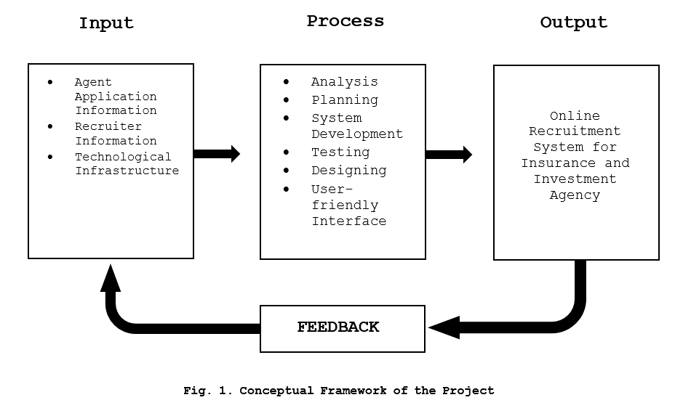**Concept of the Study**

**Figure 1. Conceptual Framework of the Project**

Figure 1, represents the relationships and sequences between these elements, showing how the input is processed through various stages to produce the desired output, which is the Online Recruitment System for the specified agency.

**Definition of Terms**

To facilitate comprehension and enhance clarity, researcher break down and explain the following terms:

**Metrics** - is a quantifiable measure used to assess and analyze the performance and effectiveness of the Online Recruitment System.

**Niche** - is the specific skill set or job market focus of the Online Recruitment System.

**Digital Technology** - is the utilization of electronic devices, software, and online resources to facilitate, and enhance various processes within the Online Recruitment System.

**Recruitment System** - is an integrated set of processes, tools, and technologies designed to manage and optimize the end-to-end recruitment and hiring process. It typically includes functionalities for posting job vacancies, collecting applications, screening candidates, and managing the overall hiring workflow.

**Overshooting** - is the situation where the number of applicants exceeds the available positions.

Toolset - is a collection of software tools and applications integrated into the Online Recruitment System to perform various tasks such as applicant tracking and evaluation.

**Social Media** - is utilized for postings, employer branding, and reaching potential applicants through platforms like Twitter, and Facebook.

**Data-Backed Hiring** - relies on the analysis of data and metrics to make informed decisions throughout the hiring process.

**Online Platform** - is a web-based interface or application that facilitates various recruitment activities, including application submission, communication between agents and applicants, and the management of the hiring workflow.

**Electronic Forms** - is a digital document that replace traditional paper-based forms in the recruitment process.

**Database** - is structured collection of data stored electronically, candidate profiles, and other relevant details.

**CHAPTER 2**

**REVIEW OF RELATED LITERATURES**

In this chapter, researcher explore existing studies to provide a solid foundation for understanding the context and significance of the current study.

**Local**

The paper proposes an automated Online Job Finder system using Microsoft Access (MS Access) for fresh graduates, unemployed individuals, and companies in the Philippines. The system allows applicants to input their details conveniently, upload proof of their information, and automatically match them with suitable companies based on their preferences. It also enables applicants to verify the authenticity of the company. The database system aims to provide a more efficient and convenient way for both job seekers and companies to find suitable matches, especially during the pandemic and with the advancement of technology. (Dela Paz et al., 2020)

The study explores the adoption of E-recruitment in human resource management, focusing on the Z generation. E-recruitment is a web-based HR software that assists in the hiring process, reducing financial burdens and improving administrative efficiency. The data was collected from 230 respondents and analyzed using the PLS structure equation model. The results showed that the expectation of positive results affects E-recruitment retrieval. The findings offer valuable insights into E-recruitment's implications in the era of Industry 4.0.(Grimaldo et al., 2020)

In the context of the industry 4.0 technological revolution, organizations are swiftly embracing digital trends, with E-recruitment emerging as a notable innovation in human resource management. E-recruitment, a web-based HR software, leverages technology to streamline and enhance the hiring process, aiming to reduce financial burdens, improve administrative efficiency, and access a broader talent pool. This study collected 230 data points from purposively selected Generation Z respondents and employed the PLS structural equation model to assess the adoption of E-recruitment technology by this demographic. The results indicate that positive expectations significantly impact the adoption of E-recruitment. The findings offer valuable insights and recommendations, shedding light on the implications of E-recruitment in the contemporary era of Industry 4.0.(Jayabalan et al., 2019)

This chapter examines the role of Information and Communication Technology (ICT) in employee recruitment and selection during the COVID-19 pandemic. It highlights the importance of online platforms, identifies challenges, and suggests strategies for improvement. Strategies include enhancing data privacy, utilizing business intelligence, adopting work-from-home arrangements, and integrating ICT into post-pandemic operations. (Jalagat & Aquino, 2022)

The article explores the role of recruitment agencies and governmental entities in shaping migration trajectories in the Philippine migration industry. It highlights their influence on directionality, spatiality, and marketing strategies, particularly for domestic workers. The study emphasizes the institutionalization of migration flows driven by economic and protection rationalities, and the importance of ensuring employer-employee matches. It also highlights the significance of age, religion, and marital status in shaping migrants' marketability and meeting employers' expectations. (Debonneville, 2021)

The article highlights the importance of recruitment in today's competitive labor market and the rise of E-recruitment, which allows companies to post job opportunities online, receive resumes, and engage with applicants via email. Key success factors include value-added services, cost-effectiveness, speed, customized solutions, relationship-building with human resources managers, and promotion of corporate branding. However, the article acknowledges its limitations and disadvantages, using case studies to analyze the pros and cons of E-recruitment and its growing significance in company recruitment processes. (Kruteeka & Monica, 2018)

The study investigates the impact of digitalization on Moroccan companies' recruitment attractiveness using structural equation models using the PLS approach. The research involved 74 companies across different sectors and found positive relationships between management support, digitalization, and recruitment performance. The results showed that management support, digitalization, and recruitment performance were positively related. The model was predictive in nature, with a Q² value of 0.884 for scanning and 0.937 for performance. The GoF value of 1.388 ensured the model's validity. However, jobseeker behavior and competitive intensity did not affect recruitment performance, with p-values exceeding the threshold of 0.05. The study highlights the importance of addressing digitalization in Moroccan companies' recruitment strategies. (Mohamed et al., 2022)

The increasing use of Artificial Intelligence (AI) in recruitment is transforming the recruitment process, but the perception of AI from the candidate's perspective is limited. This study investigates applicants' experiences and perceptions of AI-enabled recruitment. Results show that applicants perceive AI technology positively in hiring processes, with reduced response time being the most significant benefit. However, the biggest drawbacks of AI in recruitment include lack of nuance in human judgment, low accuracy and reliability, and immature technology. (Automation in Recruitment: A New Frontier, 2018)

The Philippines' job market has seen a 4% month-on-month growth in online hiring activity compared to December 2022, according to the found it Insights Tracker. The healthcare sector has seen an 11% monthly growth, indicating a revival in the job market. Other sectors that are growing include Logistics, Retail, Hospitality, and IT/Telecom. Positive hiring trends are observed in BFSI, BPO/ITES, Engineering, and Advertising sectors. High demand for professionals in marketing, communication, sales, and business development is also evident. The healthcare industry, along with roles in Purchase/Logistics/Supply Chain, Customer Service, HR & Admin, and Finance & Accounts, is also contributing to the demand. Digital marketing initiatives and AI deployment are also contributing to hiring in related sectors. (2023)

Monroe Consulting Group hosted a webinar on Recruitment: New Normal, discussing the recruitment market landscape in the Philippines. The event, attended by 100 participants, discussed the impact of the pandemic on businesses and the need for a proactive approach. The webinar discussed industries thriving during the pandemic, such as e-commerce, online education, and financial technology, and sectors recovering from the pandemic. The webinar also highlighted the benefits of digital recruitment, including fewer interview rounds and a larger talent pool. Speakers included Jennifer Tan, Maria Ysabel Bordador, Ismael Fisco, James Allan To, and Mario Glenn Isic. (The New Normal: The Philippines Recruitment Market | Monroe Consulting Group, 2020)

Online recruitment activity in the Philippines is expected to remain positive for the rest of the year due to favorable economic conditions, according to employment website Monster.com. The Philippines has seen a spike in hiring activity at the start of the year, partly due to the positive investor outlook on the country's macroeconomic fundamentals. The inflow of foreign direct investments (FDIs) has allowed businesses to expand and create job opportunities. The move of businesses and organizations to take advantage of opportunities using digital technologies is also expected to drive online hiring activity. The Philippines is expected to witness an increase in its gross domestic product by $8 billion due to digital transformation. (Online Recruitment Seen to Remain Positive, 2018)

E-hiring sentiment in the Philippines increased in Q4 due to economic recovery, with strong growth numbers of 15%, 15%, and 14% year-on-year for October, November, and December. IT, Telecom/ISP, and BFSI sectors led the growth, with HR & Admin professionals leading the way. The Monster Employment Index (MEI) shows HR & Admin professionals led annual growth in online demand, while Finance & Accounts talent experienced surging demand. (Intelligence: Online Hiring in Philippines Increases Fifteen Percent in 2019 Q4, Shows Study by Job Search Platform Monster, 2019)

Recruitment agencies are becoming increasingly essential for companies looking to hire the right employees. With their extensive network and experience, they can efficiently filter and choose candidates, saving time and resources. Recruitment agencies also offer exclusive access to job openings and can assist job seekers in finding their ideal jobs. They can help applicants through online platforms or by forming partnerships with their clients. They also help companies find suitable positions for their employees, ensuring they become top performers. Hiring recruitment agencies also saves companies from costs associated with the hiring process, such as pre-employment testing, drug screening, and background investigations. This allows companies to focus on other important aspects of their businesses. (Importance of Recruitment Agencies, 2023)

The pandemic has led to a shift from face-to-face interviews to virtual ones, causing concern among companies. In May 2020, Malaysia's government urged companies to conduct virtual interviews using video conferencing and Skype. Online recruitment uses digital technology to virtualize hiring processes. In August 2020, 9 out of 10 Malaysian employers laid off staff, resulting in 13% needing to hire new people. Employers must stay updated on digital trends and match suitable candidates for company growth. (Normalising E-recruitment and Why You Should Join the Trend, Now, 2023)

Employment recruitment in the Philippines is allegedly collusion between recruitment agencies and lenders, resulting in high recruitment fees and predatory lending. Authorities are failing to address this issue, despite numerous complaints. (Philippines: Recruitment Agencies and Lenders Allegedly Collude to Exploit Migrant Workers, Amid Lack of Govt. Action to Tackle Abuse, 2023)

The Philippines' recruitment industry has evolved over the years, with over 10 million Filipinos working overseas. However, issues such as illegal recruitment, misrepresentation, and contract substitution have damaged the reputation of recruitment agencies. To prevent victims of illegal recruitment, it is essential to verify the legitimacy of recruitment agencies through the Philippine Overseas Employment Administration (POEA) website. This helps to ensure that Filipino workers are not exploited and that the country remains a significant service exporter. (RECRUITMENT AGENCIES' FUNCTION IN THE EMPLOYMENT INDUSTRY, 2023).

**Foreign**

Based on the study of (Bhosale et al., 2021), it examines the prevalence of electronic recruitment in HR professionals' practices. It discusses the evaluation of e-recruitment for organizational growth and the sourcing of the right candidates at the right time and cost. This study explores the positive effects of online recruitment on organizations and its impact on finding eligible candidates.

The development of a Smart Recruitment System using machine learning algorithms for an organization to attract potential and talented candidates. The system aims to save time the recruitment process (Shendage et al., 2019).

As explained by (Hotwani et al., 2019), it examined informal and formal recruiting practices in external labor markets and found that quality was a stronger motivator than cost for informal recruiting. It focused on e-recruitment and highlighted that internet platforms, such as career websites, could be a cost-effective alternative to multiple newspaper ads for small companies.

Ramadhani et al. (2019) underscores the importance of recruitment for organizations and posit that web development can enhance efficiency and speed in the recruitment process while reducing costs.

Blumenberg et al. (2019) echo the logistical advantages, citing the ease of placing ads on websites or sending automatic messages over the internet.

As determined by (Hashiyana et al., 2021), he note the utilization of internet-based recruitment methods by some companies, emphasizing the need for a proper understanding to avoid errors. The review concludes that online recruitment is an effective and innovative method for hiring, providing a faster and more efficient approach to collecting human resources for organizations.

Lee et al. (2021) highlights the role of recruitment agencies as intermediaries connecting companies with potential applicants, conducting remote interviews and assessments.

In the opinion of (Ho and Henry, 2021), stress the security advantages of a portal exclusive to applicants scouted by employers, addressing concerns related to fraudulent activities in online job portals. The logistical simplicity of online recruitment methods, as compared to offline methods, is emphasized by Ho and Henry (2021).

Based on the study of (Prasetyaningtyas et al. ,2022), it emphasizes the challenges in the traditional recruitment process, citing the abundance of labor involved. The introduction of online systems is presented as a solution, simplifying the process for both employers and applicants.

Moseson et al. (2020) discusses the substantial benefits of virtual recruitment in the context of technological advancements, allowing hospitality organizations to rely on digital efforts for applicant attraction.

Karaoglu et al. (2022) highlight the impact of sociodemographic factors, such as age, race, education, and income, on online job searching. Acknowledging the disparities, the review suggests that online recruitment techniques should consider these inequalities to promote diversity.

As stated by (Aljuaid, 2021), he discusses the contribution of an AI-based e-recruitment system that can assess the experience, qualifications, and suitability of candidates applying for specific jobs. It emphasizes the need for efficient recruitment strategies to recruit employees with high potential and execute talent management strategies.

Malki and Atlam (2021) argue that applying to companies using traditional paper forms is ineffective, contributing to the development of online recruitment systems.

As stated by (Chuks et al., 2019), he discusses the contribution of an AI-based e-recruitment system that can assess the experience, qualifications, and suitability of candidates applying for specific jobs. It emphasizes the need for efficient recruitment strategies to recruit employees with high potential and execute talent management strategies.

**CHAPTER 2**

**METHODOLOGY**

This chapter aims to provide a comprehensive overview of the methodology employed in the development process. This chapter aims to elucidate the structured approach taken to conceptualize, design, and implement the proposed system, ensuring clarity and effectiveness in its development lifecycle.

**Development Method**

This shows the researchers' utilization of Agile methodologies as frameworks for project development. This method places emphasis on breaking down large projects into smaller, easier-to-manage activities. Teams participate in all phases of the project lifecycle, from gathering requirements to design, coding, development, and testing, and the tasks are finished in short iterations. The client is presented with and given a demonstration of a working system at the end of this phase.

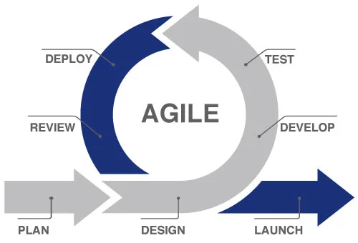

**Figure 5. SDLC Agile Model**

**Plan.** The researchers developed a comprehensive plan for the project, outlining the objectives, scope, and limitations of the study. Researchers also identified the challenges in the traditional recruitment process and proposed the development of an online recruitment system. The plan included an implementation strategy, timeline, and activities such as meetings with the client and system evaluation.

**Design.** The researchers focused on designing the graphical user interface (GUI) of the online recruitment system according to the needs of the client. Researchers determined the functions and features of the system and analyzed the design of the database schema and structure. The design phase also included creating a conceptual framework, system architecture, use case diagram, and activity diagram.

**Develop.** The researchers utilized Agile methodologies, specifically the SDLC Agile Model, for the development of the online recruitment system. They broke down the project into smaller, manageable activities and implemented the system based on the design specifications. This phase involved coding, programming, and creating the necessary features and functionalities of the system.

**Test.** Testing and evaluation were conducted to ensure the functionality, reliability, and usability of the online recruitment system. The researchers tested the system's features, user interface, data flow, and compatibility with different devices and browsers. Any errors or issues identified during testing were addressed and fixed to ensure a high-quality system.

**Deploy.** The online recruitment system was deployed by installing it on appropriate servers or hosting platforms and configuring it to be accessible to agents and applicants. The deployment phase also involved monitoring the system for any errors or updates on major features. The researchers obtained approval for system deployment and set a period for monitoring and addressing any issues that may arise.

**Review.** The system underwent a review phase where it was evaluated for its effectiveness and satisfaction of the client. The researchers conducted a system evaluation to ensure that the client was satisfied with the system's performance and functionality. Feedback from the client and users was gathered to make any necessary improvements or modifications to the system.

**Launch.** Once the system was reviewed and approved, it was officially launched and made available for use by insurance and investment agencies in Mindoro. Users were notified and onboarded, and training and support were provided to ensure a smooth transition from the traditional recruitment process to the new online system. The launch phase also involved updating the applicant's status and sending notifications to applicants.

**Gantt Chart**

In this section, Gantt Chart is presented to show the plans and schedules of the project timeline. All the development stages up to the completion of the project were documented in this chart. This helps the researchers to know the deadlines needed to accomplish and show breakthroughs in various tasks.

**Table 1. Gantt Chart**

|  |  |  |  |  |  |  |  |  |  |  |
| --- | --- | --- | --- | --- | --- | --- | --- | --- | --- | --- |
| **Task Name** | **Task Date** | | | | | | | | | |
| Oct | | | | Nov | | | | Dec | |
| Week 1 | Week 2 | Week 3 | Week 4 | Week 1 | Week 2 | Week 3 | Week 4 | Week 1 | Week 2 |
| **1.Planning** |  |  |  |  |  |  |  |  |  |  |
| 1.1 Conduct an interview |  |  |  |  |  |  |  |  |  |  |
| 1.2 Define project objectives |  |  |  |  |  |  |  |  |  |  |
| 1.3 Define project plan |  |  |  |  |  |  |  |  |  |  |
| 1.4 Approval of project plan |  |  |  |  |  |  |  |  |  |  |
| **2.Requirements Gathering** |  |  |  |  |  |  |  |  |  |  |
| 2.1 Data Collection |  |  |  |  |  |  |  |  |  |  |
| 2.2 Functional |  |  |  |  |  |  |  |  |  |  |
| 2.3 Non-Functional |  |  |  |  |  |  |  |  |  |  |
| **3.Design** |  |  |  |  |  |  |  |  |  |  |
| 3.1 Frontend software design |  |  |  |  |  |  |  |  |  |  |
| **4.Development** |  |  |  |  |  |  |  |  |  |  |
| 4.1 Back-end coding |  |  |  |  |  |  |  |  |  |  |
| 4.2 Front-end coding |  |  |  |  |  |  |  |  |  |  |
| **5.Testing** |  |  |  |  |  |  |  |  |  |  |
| 5.1 Functionality testing |  |  |  |  |  |  |  |  |  |  |
| 5.2 User interface testing |  |  |  |  |  |  |  |  |  |  |
|  | | | | | | | | | | |
| **Legends:** |  | | | | **Done** | | | | | |

**Requirements Specifications**

The requirements specifications for the online recruitment system include the functional requirements, user interface, software interface, hardware interface, and security interface. These specifications outline the necessary functions, interfaces, and security measures that the system must meet in order to be fully functional and secure.

**Functional Requirements**

The functional requirements define how the system should work and the processes and procedures that need to be followed to ensure its proper functioning. This includes the presentation of the system and how data is processed to produce functional outputs. It is important to discuss and document the functional requirements to ensure that the system meets the needs and expectations of the users.

**Table 2. Functional Requirements**

|  |  |
| --- | --- |
| **Features** | **Description** |
|  |  |
|  |  |
|  |  |
|  |  |
|  |  |

**User Interface**

The user interface is a crucial component of the online recruitment system as it facilitates interaction between the user and the system. The user interface should be designed in a way that is intuitive, user-friendly, and visually appealing. It should provide a clear and easy-to-understand presentation of the system's features and functionalities.

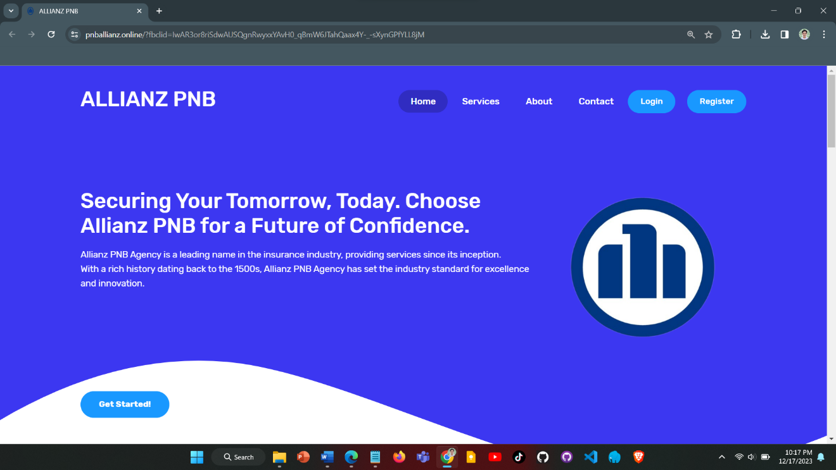

**Figure 3. User Interface**

**Hardware Interface**

The hardware interface specifies the logical and physical characteristics of the interface between the software and the hardware components of the system. It outlines the hardware requirements and specifications needed for the system to function properly. This includes details such as the processor, 16 GB RAM memory, 256GB SSD storage, and network infrastructure.

**Software Interface**

The software interface describes the interfaces between the system and other software components, such as the database, operating system like Windows 8 to 11, tools, libraries, and integrated commercial components. It includes information about the software applications and versions used in the development and operation of the system.

**Security Requirements**

Security requirements are essential to ensure that the system is accessed only by authorized individuals and that sensitive data is protected. This includes measures such as user authentication, data encryption, access control, and secure communication protocols. The security requirements should comply with data protection and recruitment regulations to ensure the confidentiality, integrity, and availability of the system and its data.

**Technical Background**

The technical background provides important information about the technical aspects of the project, including hardware and software specifications. This information helps define the requirements in a clear and understandable manner for developers. It includes details about the hardware components, operating system, programming languages, frameworks, and tools used in the development and deployment of the online recruitment system.

**Hardware Specifications**

Hardware Specifications refers to the technical descriptions of the hardware items, its components, and capabilities. It is essential to have the appropriate hardware components to ensure the completeness and functionality of the project. The table below presents the different hardware components and their recommended specifications:

**Table 3. Hardware Specification**

|  |  |  |  |  |
| --- | --- | --- | --- | --- |
| **Hardware** | **Function** | **Specifications** | | **Unit** |
| **Minimum** | **Recommended** |
| CPU and Memory | Efficient handling of loads | At least 16GB RAM | At least 16GB RAM | 1 |
| Storage | Faster data access | 256GB SSD | 512GB SSD | 1 |
| Network Infrastructure | Reliable and high-speed internet connectivity | Integrated dedicated 4G LTE modem | Integrated dedicated 4G LTE modem | N/A |
| Laptop | Development workstation with connectivity | Intel Core i5 processor, 16GB DDR4 RAM, 256GB SSD, | Intel Core i5 processor, 16GB DDR4 RAM, 512GB SSD, | 1 |

**Software Specifications**

Software Specifications are essential for the proper functioning and compatibility of the online recruitment system. The table below presents the minimum and recommended specifications for various software components:

**Table 4. Software Specification**

|  |  |  |
| --- | --- | --- |
| **Component** | **Minimum**  **Specifications** | **Recommended**  **Specifications** |
| Operating System | Windows 8 64 bit | Windows 10 or Latest |
| Code Igniter | CodeIgniter 4.0 | CodeIgniter 5 or newer |
| Visual Studio Code | Visual Studio Code 1.40 | Visual Studio Code 1.50.1 or Latest |
| Web Browser | Google Chrome | Google Chrome or Any Web Browser |
| Web Server | Laragon 4.0.16 | Laragon 6.0 |
| Web Hosting | Hostinger | Hostinger |
| Database  (phpMyAdmin) | 1 Database | 2-3 Available Databases |
| MySQL | 5.1 | 5.6 or Latest |

As shown on the Table (number), it outlines the minimum and recommended specifications for various software components required for the online recruitment system. It includes information about the operating system, Code Igniter framework, Visual Studio Code, web browser, web server, web hosting, and database. These software specifications ensure that the online recruitment system is compatible with the necessary software components and can function effectively.

**System Analysis and Design**

System analysis and design in this project involved understanding the requirements, planning the system's components and functionalities, and creating visual representations and specifications to guide the development and deployment of the online recruitment system.

**System Overview**

The "E-Recruit: An Online Recruitment System for Insurance and Investment Agency in Mindoro" is an online platform designed specifically for insurance and investment agencies in Mindoro, Philippines. It aims to analyze the recruitment process by providing a user-friendly interface for applicants and improving the overall hiring experience. The system allows applicants to register and login to their accounts, fill out application forms, and submit their information directly to the administrator. The administrator then reviews the information and decides whether to approve their application. If the applicant is accepted, the administrator updates their status and notifies the applicant. The system also includes features such as screening, and notifications to ensure a smooth and efficient recruitment process. The system architecture and design have been carefully planned and implemented, taking into consideration the unique needs and circumstances of the region. The system has undergone testing and evaluation to ensure its functionality, reliability, and usability. It has been deployed on appropriate servers or hosting platforms and is accessible to agents and applicants. The system also includes data-backed hiring, which utilizes data analysis and metrics to make informed decisions throughout the hiring process. The system aims to improve the efficiency of the recruitment process, provide a user-friendly platform for applicants, and comply with recruitment regulations.

**System Architecture**

A system architecture shows the representation and structure of the system.

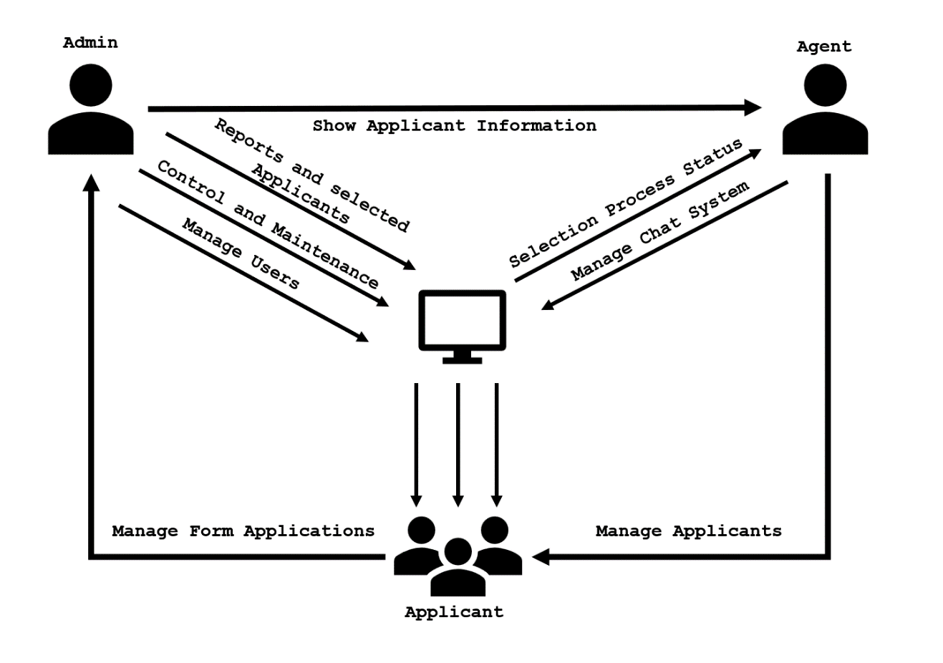

**Figure 2. System Architecture**

This figure shows that the admin initiates actions by requesting the display of applicant information, managing various aspects such as reports, selected applicants, control and maintenance, and user management. The Agent, in turn, manages applicants and communicates with the System to receive updates on the selection process status. Meanwhile, the Applicant interacts with the system to manage their form applications. The System, acting as a central hub, facilitates communication between Admin, Agents, and Applicants. It provides selection process updates to Agents and responds to Admin requests for reports, applicant management, and system control and maintenance, thereby arranging the overall functionality of the application management system.

**Use Case Diagram**

This illustration serves as an outline of how these stakeholders all interact with and complement each other in carrying out functions within the system. The more we get into the details of this chart, the better understand what responsibility each role has and how it is related to other roles, giving insight on how all these pieces fit together in a system that works smoothly across an entire organization.

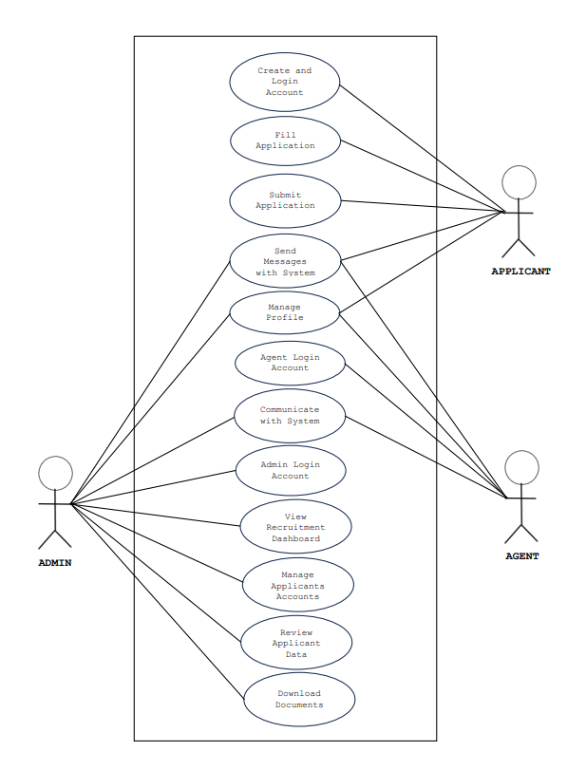

**Figure 3. UML Use-case Diagram**

Figure 3 shows the roles of the Administrator, Agent, and the Applicants to be executed in the whole process of the system.

**Activity Diagram**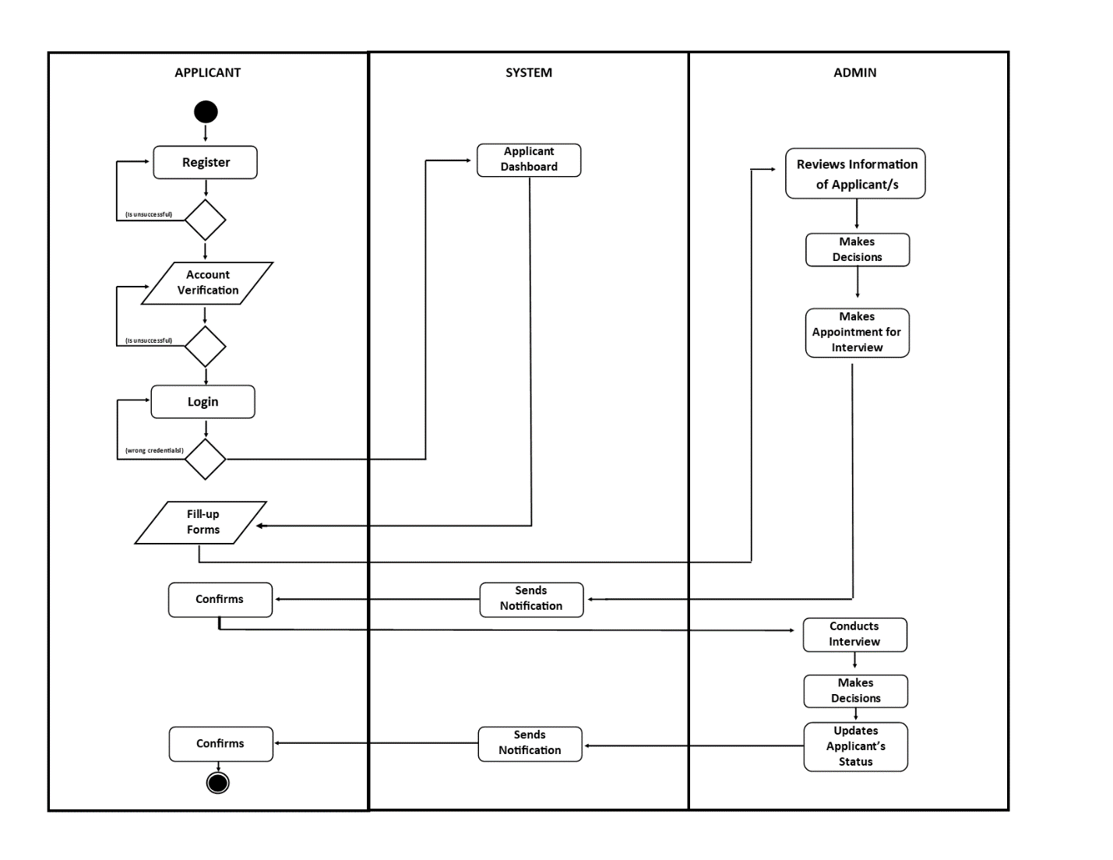

**Figure No.(Number) Activity Diagram**

Figure (number) shows, the activity diagram of the system wherein the applicants will register then login their accounts, after that they will fill-up the forms and the information will be sent directly to the administrator. The administrator will then review their information and makes the decision if the applicant is valid for interview, the administrator will make an appointment and then the system will notify the applicant for the interview and the applicant will confirm it. The administrator will then conduct the interview, after the interview the administrator will again decide if the applicant is good for the job, if the applicant is accepted, the administrator will update the applicant’s status, the system will send the notification to the applicant and the applicant will confirm it.

**Data Flow Diagram**

The data flow diagram, which functions similarly to a map to depict the information flow for all system processes, is presented next.

**Figure No. (Number) Context Diagram**

Figure (Number) shows the development on how the proposed system will work and function in the respective areas and specific users that they are designed to work on.

**Diagram 0**

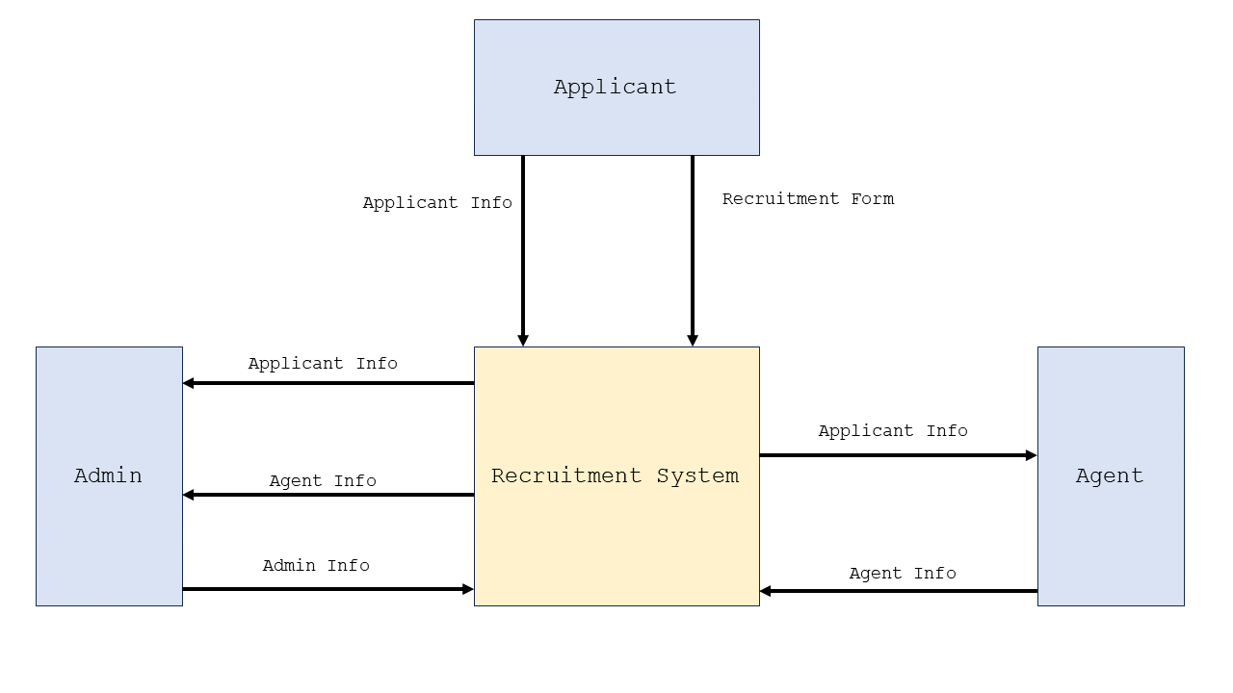

**Figure 3: DFD Level 0**

Figure 3: DFD Level 0 illustrates the interactions and data flows between the Admin, Agents, and Applicants.

**Database Schema**

The system design step was critical in the study's development. During this stage, the characteristics of the system's entities were clearly defined. This made it easier for the user to examine and comprehend the properties connected with these existing entities. The system design phase effectively gave a detailed description of the study's data, revealing features and information about the entities participating in the investigation.

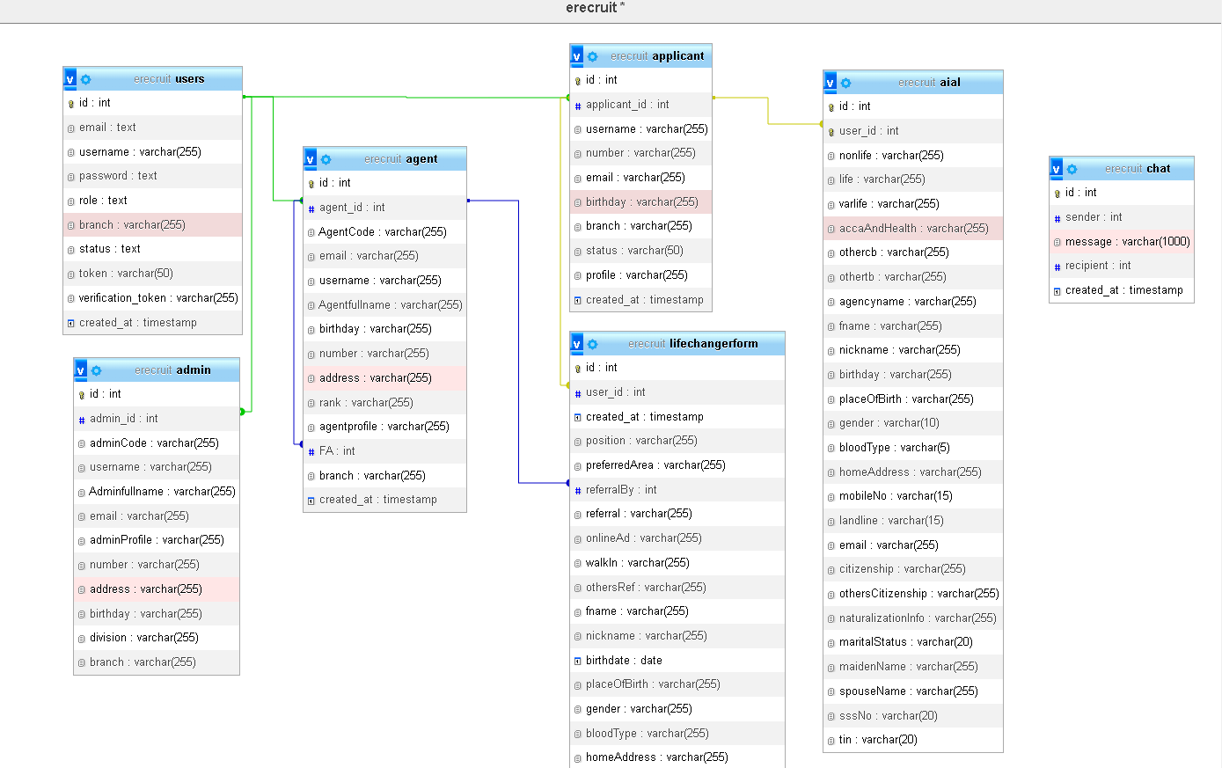

**Figure (number). Databased schema**

This diagram illustrates the structure of the E-recruitment database, showcasing the details of each table interconnected using primary keys and foreign keys that establish relationships between them. The primary keys serve as unique identifiers for each user or record in the table, while foreign keys create links between tables by referencing the primary key of another table. The diagram provides a visual representation of the database schema and the relationships between tables, enabling efficient data manipulation and maintenance while ensuring data consistency and accuracy.

**Testing and Evaluation**

This stage is critical for completing thorough system testing and guaranteeing effective installation. We improve the system's capacity to deliver a wide range of services through a series of enhancements. Our dedication to continuous improvement is constant as we concentrate improving the system's functionality and usefulness. To resolve any potential concerns and assure optimal performance, strict testing processes are used. This iterative process demonstrates our commitment to developing a resilient and user-friendly system.

**Participants of the Study**

The respondents to the study were composed of the administrator, applicants, agents.

**Table (number). Respondents of the Study**

|  |  |
| --- | --- |
| Respondents | Number of respondents |
| Administrator | 1 |
| Applicants | 25 |
| Agents | 10 |
| **Total** | **36** |

Table 5 shows the respondents of the study, including the number of each category respondents

**Data Gathering Instrument**

The respondents to the study completed questionnaires provided by the researchers in order to complete the survey. The respondent's collected data would be verified in order to create the information required for the website. The rating scale questionnaire was employed as an instrument by the researchers, who used the Likert scale to collect data from the respondents.

**Table (number). Linker Scale-type**

|  |  |  |
| --- | --- | --- |
| Scale | Range | Verbal Interpretation |
| 5 | 4.51-5.00 | Strongly Agree |
| 4 | 3.51-4.50 | Agree |
| 3 | 2.51-3.50 | Moderate Agree |
| 2 | 1.51-2.50 | Disagree |
| 1 | 1.00-1.50 | Strongly Disagree |

**Implementation Plan**

If the proposed system is adopted by certain people, the researchers have devised an implementation strategy. If this is the case, the system as well as its documentation will be turned over. It will be used as a guide for the client who will oversee system updates and maintenance. There should be a letter of agreement stating that the system is freely given to the user and that the researchers will not be responsible for the project's updating and maintenance. If the initiative is approved, the researchers are planning to conduct several strategies.

**Table (Number). Implementation Plan**

|  |  |  |
| --- | --- | --- |
| **Activities** | **Date** | **Progress Note** |
| Meeting with the Client | November 5, 2023 | Agreed in the Project Proposal |
| Deployment Approval | March 7, 2024 | Approved |
| System Deployment and Monitoring Period | July 30, 2024 | Few errors and updates on the major features |
| System Evaluation | September 15, 2024 | Client was satisfied |

**REFERENCES**

Aljuaid, A. (2021). *Artificial Intelligence Based E-Recruitments System: A Case Study on Recruiters of Bangladesh*.

Bhosale, C., & Gurav, P. (2021). *Employee Recruitment System: Analysing the Effectiveness of Online Recruitment*. www.ijrpr.com

Blumenberg, C., Menezes, A. M. B., Gonçalves, H., Assunção, M. C. F., Wehrmeister, F. C., & Barros, A. J. D. (2019). How different online recruitment methods impact on recruitment rates for the web-based coortesnaweb project: A randomised trial. *BMC Medical Research Methodology*, *19*(1), 1–9. <https://doi.org/10.1186/s12874-019-0767-z>

Chuks Okolie, U., & Irabor, I. (2019). *E-Recruitment: Practices, Opportunities and Challenges. The changing face of recruitment and selection in human resource management.*

*DOLE readies department order governing online recruitment platforms*. (n.d.). Retrieved December 5, 2023, from <https://www.cnnphilippines.com/news/2020/5/29/DOLE-readies-department-order-governing-online-recruitment-platforms.html>

Edirisinghe, S. M. (2020). *Recruitment Management System*. <https://dl.ucsc.cmb.ac.lk/jspui/bitstream/123456789/4486/1/2017%20MIT%20017.pdf>

Grace, M., Ventura, G., & Bringula, R. P. (201920). *Effectiveness of Online Job Recruitment System: Evidence from the University of the East*. www.IJCSI.org

Hotwani, S., & Chandure, O. (2019). STUDY PAPER ON E-RECRUITMENT. In *Internatio nal Journal of Research In Science & Engineering e*.

Ho, D., & Henry, A. (2021). Constraints imposed on the creative cover letter writing by digital online job advertisements. *Australian Journal of Applied Linguistics*, *4*(3), 132–148. <https://doi.org/10.29140/ajal.v4n3.513>

*Job hunt tough for graduates of ‘pandemic generation’ Inquirer News*. (n.d.). Retrieved December 5, 2023, from <https://newsinfo.inquirer.net/1755172/job-hunt-tough-for-graduates-of-pandemic-generation>

*Jobs recovery seen as market reopens | Philippine News Agency*. (n.d.). Retrieved December 5, 2023, from <https://www.pna.gov.ph/index.php/articles/1166432>

Karaoglu, G., Hargittai, E., & Nguyen, M. H. (2022). Inequality in online job searching in the age of social media. *Information Communication and Society*, *25*(12), 1826–1844. <https://doi.org/10.1080/1369118X.2021.1897150>

Kmail, A. B., Maree, M., Belkhatir, M., & Alhashmi, S. M. (2016). An automatic online recruitment system based on exploiting multiple semantic resources and concept-relatedness measures. *Proceedings - International Conference on Tools with Artificial Intelligence, ICTAI*, *2016*-*January*, 620–627. <https://doi.org/10.1109/ICTAI.2015.95>

Intelligence: Online Hiring in Philippines Increases Fifteen Percent in 2019 Q4, Shows Study by Job Search Platform Monster. (2019). Intelligence: Online Hiring in Philippines Increases Fifteen Percent in 2019 Q4, Shows Study by Job Search Platform Monster. <https://www.adobomagazine.com/philippine-news/intelligence-online-hiring-in-philippines-increases-fifteen-percent-in-2019-q4-shows-study-by-job-search-platform-monster/>

Lee, L., Guzzo, R. F., Madera, J. M., & Guchait, P. (2021). Examining Applicant Online Recruitment: The Use of Fictitious Websites in Experimental Studies. *Cornell Hospitality Quarterly*, *62*(1), 76–88. <https://doi.org/10.1177/1938965520965223>

Malki, Z., Atlam, E., Malki, Z., & Atlam, E. (2021). Graduate Students and Companies Web Based E-Recruitment System. *Journal of Computer and Communications*, *9*(9), 71–84. https://doi.org/10.4236/JCC.2021.99005

Moseson, H., Kumar, S., & Juusola, J. L. (2020). Comparison of study samples recruited with virtual versus traditional recruitment methods. *Contemporary Clinical Trials Communications*, *19*, 100590. <https://doi.org/10.1016/j.conctc.2020.100590>

*Most PH job seekers now prefer hybrid, remote work setup | Inquirer News*. (n.d.). Retrieved December 5, 2023, from <https://newsinfo.inquirer.net/1737214/most-ph-job-seekers-now-prefer-hybrid-work-setup>

Obipi , I. O., & Kalio, N. (2018). Recruitment Management System and Employee Procurement in the Oil and Gas Sector in Nigeria. *International Journal of Human Resource Management and Research*, *8*(2), 7–18. https://doi.org/10.24247/ijhrmrapr20182

*Online recruitment seen to remain positive | Philstar.com*. (n.d.). Retrieved December 5, 2023, from <https://www.philstar.com/business/2018/06/24/1827269/online-recruitment-seen-remain-positive>

*Philippines: Recruitment agencies and lenders allegedly collude to exploit migrant workers, amid lack of govt. action to tackle abuse. (2023, December 5).* [*https://www.business-humanrights.org/en/latest-news/philippines-recruitment-agencies-and-lenders-collude-to-exploit-migrant-workers-amid-lack-of-govt-action-to-tackle-abuse/*](https://www.business-humanrights.org/en/latest-news/philippines-recruitment-agencies-and-lenders-collude-to-exploit-migrant-workers-amid-lack-of-govt-action-to-tackle-abuse/)

Prasetyaningtyas, S. W., Sim, M., Triantoro, B. H., & Allen, A. (2022). THE USE OF EMPLOYER BRANDING DIMENSIONS TO ATTRACT FRESH GRADUATES. *Jurnal Bisnis Dan Manajemen*, *23*(1), 3–15. <https://doi.org/10.24198/JBM.V23I1.891>

Ramadhani, F., & Zarlis, M. (n.d.). *Analysis of e-Recruitment System Design*. https://doi.org/10.17706/ijeeee.2019.9.1.38-45

Ronaldo  A. Manalo, Chin  Uy, & Jun  R. Grimaldo. (2020). UTILIZATION OF E-RECRUITMENT TOOLS AS PERCEIVED BY RECRUITERS AND JOB APPLICANTS. *Luz y Saber*, *14*(1 and 2), 1–1. <https://ejournals.ph/article.php?id=17160>

Rosoiu, O., & Popescu, C. (n.d.). *E-recruiting Platforms: Features that Influence the Efficiency of Online Recruitment Systems*. https://doi.org/10.12948/issn14531305/20.2.2016.05

Samoli, C. (2021, May 20). *How management systems drive value in business operations*. Monday.com Blog. https://monday.com/blog/project-management/management-systems/

Sehgal, V. K., Jagtiani, A., Shah, M., Sharma, A., Jaiswal, A., & Mehta, D. (2018). Job portal-A web application for geographically distributed multiple clients. *Proceedings - 1st International Conference on Artificial Intelligence, Modelling and Simulation, AIMS*, 199–204. <https://doi.org/10.1109/AIMS.38>

Shendage, S., Shinde, T., Govilkar, K., & Chavan, J. (2019). Issue 6 www.jetir.org (ISSN-2349-5162). *JETIR1906B57 Journal of Emerging Technologies and Innovative Research*, *6*.

|  |
| --- |
| **Checked and Reviewed by:** |
|  |
| **Mr. Christian I. Cabrera** |
| **ITC311 - Facilitator** |