**Mark Neil S. Conde**

**BSIT3 B1**

1. List 3 protocols appearing in the protocol column in the unfiltered packet-listing window in step 7 above. Then, briefly describe the function of each protocol. (5pts)

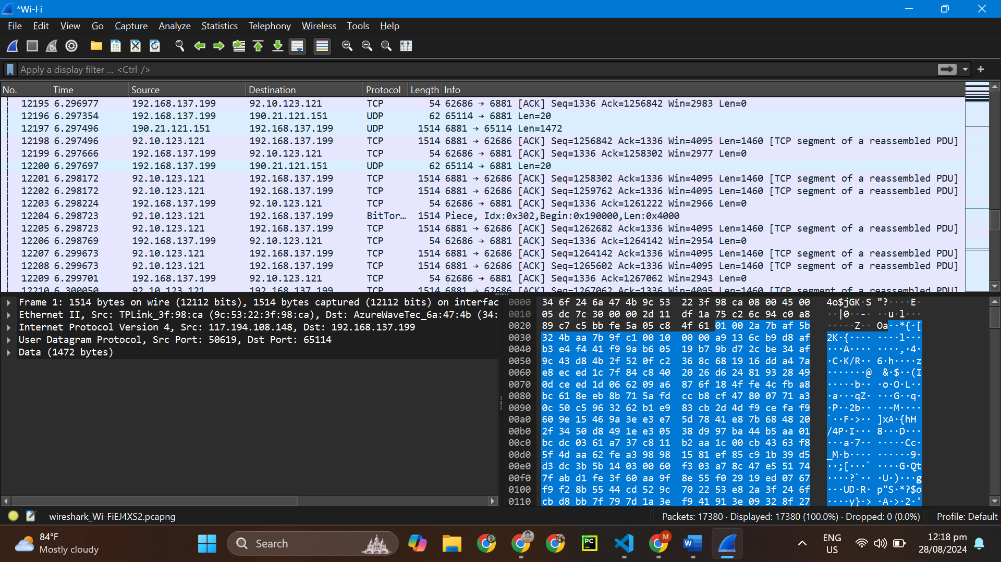

**TCP** is a connection-oriented protocol that ensures reliable data transmission between devices over a network. It establishes a connection between the sender and receiver before data transfer begins, ensuring that data packets are delivered in the correct order and without errors.

**UDP** is a connectionless protocol that allows for faster data transmission at the cost of reliability. Unlike TCP, it does not establish a connection before sending data, nor does it guarantee that packets will arrive in order or without errors.

**BitTorrent** is a peer-to-peer (P2P) file-sharing protocol that enables the distribution of files across multiple users (peers).

2. How long did it take from when the HTTP GET message was sent until the HTTP OK reply was received? (By default, the Time column value in the packet-listing window is the amount of time, in seconds, since Wireshark tracing began. To display the Time field in time-of-day format, select the Wireshark Viewpull down menu, select Time Display Format, then select Time-of-day.) (5 pts)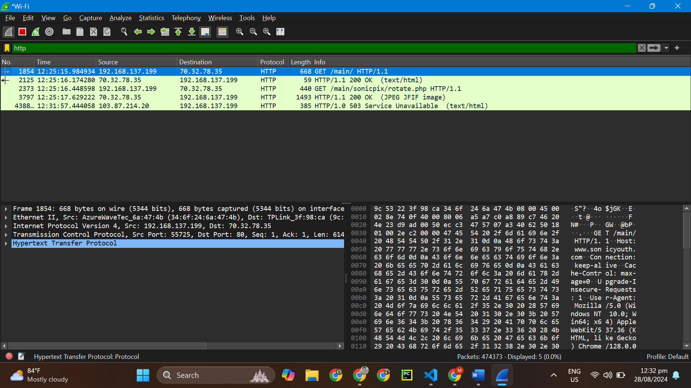

What is the Internet address of the gaia.cs.umass.edu (also known as www-net.cs.umass.edu)? What is the Internet address of your computer? (5 pts)

Filter the traffic to show only HTTP requests. How many HTTP GET requests are present? (5pts)