Title: Effectiveness and safety of oral anticoagulant use in dialysis patients with atrial fibrillation or atrial flutter in Hong Kong: a sequential target trial emulation

Abstract

Introduction
Atrial fibrillation (AF) and atrial flutter (AFL) are types of supraventricular arrhythmias associated with an increased risk of ischemic stroke. {Bizhanov et al., 2023 #91361} These conditions can result in the formation of blood clots within the atrium, which may subsequently travel to the brain, leading to cardiovascular morbidity and mortality. Given the elevated risk of thromboembolic events, guidelines recommend the long-term use of oral anticoagulants (OACs) in the general population with AF or AFL. {Hindricks et al., 2021 #46372} {Joglar et al., 2024 #254294} Agents such as warfarin and direct oral anticoagulants (DOACs), including dabigatran, rivaroxaban, apixaban, and edoxaban, are advised based on clinicians' discretion for high-risk patients with a CHA2DS2-VASc score of one or above.
AF and AFL are common in patients with kidney failure. AF incidence in this group ranges from 11.6% to 22.2% {Zimmerman et al., 2012 #212437} {Saran et al., 2017 #89521}, about 11 times higher than in the general population. {Go et al., 2001 #165854} AF and kidney failure together increase stroke or embolic risk by 1.8 to 2-fold. {Bonde et al., 2014 #105718} {Olesen et al., 2012 #198967} The heightened risk is likely due to shared cardiovascular risk factors like heart failure, hypertension, and diabetes. {Kyriakoulis et al., 2024 #50243} In dialysis patients with AF, both thromboembolic and bleeding risks are elevated, increasing mortality. {Zaman and Bhandari, 2019 #1832} This complicates OAC administration decisions.
Warfarin and DOACs' efficacy in dialysis patients is uncertain due to a lack of RCTs and conflicting observational studies. {De Vriese et al., 2016 #191628} Safety concerns and questionable OAC effectiveness in reducing stroke risk in dialysis patients led the KDIGO to advise against OAC use in AF patients on dialysis. {Wanner et al., 2018 #32223} The 2023 AHA guideline, on the other hand, suggested warfarin and apixaban as options, with a weak class 2B recommendation, implying a lack of clarity on effectiveness and safety. {Joglar et al., 2024 #254294} To further complicate the matter, a PD-first policy has been adopted for all patients with kidney failure requiring dialysis unless medically contraindicated in Hong Kong. Different dialysis modalities exhibit differences in removal rate, duration, pharmacokinetic profiles, and heparin use. {Amani et al., 2021 #7838}
In light of the ongoing debate regarding the use of OACs in PD patients with AF, this study aims to evaluate the safety and efficacy of OAC administration in PD patients using a population-based electronic medical database from Hong Kong.

Method

Study design
We emulated a target randomised controlled trial to evaluate the comparative effectiveness and safety of OAC initiators versus non-initiators in preventing stroke among peritoneal dialysis patients with incident atrial fibrillation or flutter from 2007 to 2022. This retrospective cohort study employed a sequential, propensity score-matched design to approximate randomisation, aligning with the target trial framework. The specification for emulation with observational data and the target trial is illustrated in Supplementary Table 1. Eligibility criteria were dynamically reassessed monthly and included individuals: 1) who underwent peritoneal dialysis, 2) with a diagnosis of atrial fibrillation or atrial flutter; and 3) without a history of stroke. From Jan 2007 to Dec 2022, a total of 191 sequential trials were conducted, each representing a monthly eligibility assessment window. Treatment assignment was determined by OAC initiation within one month preceding each trial. Those who had oral anticoagulants within one month before the index date were considered as initiators, while the others were treated as non-initiators. And those non-initiators in each trial will be eligible for the subsequent trials. Individuals were followed up from each index month until death, transplant, the end of 2022, or 3 years after the index month, whichever occurred first. The detailed illustration of the design was shown in Figure 1.
Figure 1. Sequential trial design for emulating a target trial on the impact of oral anticoagulants on incident stroke on individuals undergoing peritoneal dialysis
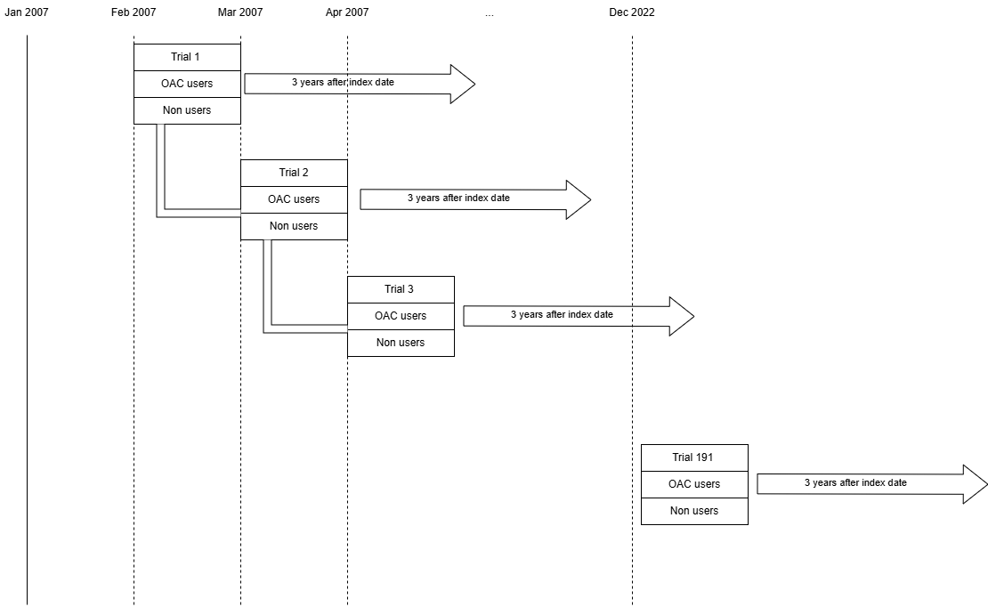

Data source
The Clinical Data Analysis and Reporting System (CDARS) is an electronic clinical database managed by the Hospital Authority (HA). More than seven million Hong Kong citizens have access to public healthcare services provided by HA. The CDARS stores records of demographic characteristics and clinical information, including clinical diagnoses, prescription details, laboratory tests, accident and emergency, inpatient, and outpatient visits, since 1995. In the CDARS, the patient records are anonymised, so that the patient's name and Hong Kong identification card number are not used. A unique patient reference number is generated for each patient to link all data sources and facilitate the retrieval of data.

Propensity score matching
Within each monthly trial, we performed 1:10 nearest-neighbour matching without replacement to balance baseline covariates between OAC initiators and non-initiators. The propensity score model incorporated: 1) demographic variables (age at index month and sex); 2) clinical factors (CHA₂DS₂-VASc score at index month, time since atrial fibrillation diagnosis to index month); 3) comorbidities (congestive heart failure, myocardial infarction, peripheral vascular disease, cerebrovascular disease, chronic obstructive pulmonary disease, dementia, paralysis, diabetes, mild liver disease, moderate-severe liver disease, ulcers, asthma, rheumatoid arthritis, malignancy, metastatic solid tumour, diabetes, hypertension, severe constipation); and 4) history of antiplatelet use before index date. Non-initiators can be matched to more than one initiator within each trial. In the intention-to-treat analysis, the drug switches will not be censored and will be kept in the analysis.

Outcome assessment
The primary outcome, evaluating the effectiveness of OAC, was a composite endpoint of ischemic stroke, haemorrhagic stroke, and all-cause mortality. Each component of the composite outcome was analysed individually in secondary analyses. Another composite outcome of bleeding events, including haemorrhagic stroke, gastrointestinal bleeding, and other bleeding events, is considered a safety outcome. All events were identified through validated ICD-9-CM codes. The codes used in this study are illustrated in the Supplementary Table 2.

Statistical analysis
The incidence of events was estimated using discrete hazards (pooled logistic) regression models adjusted for indicators of month of follow-up, a monthly updated time-varying history of antiplatelet use, and a product term between treatment and follow-up time. The imbalanced covariates after matching were included for double robust adjustment. The pooled logistic regression is a flexible method for estimating risks that considers time-varying confounders and is free from the proportional hazards assumption, which has been widely applied in recent decades. A nonparametric bootstrapping with 500 samples was used to construct a 95% confidence interval.
Stratified analyses by sex and age (65 as a cutoff) were conducted. Two sensitivity analyses were performed to evaluate the robustness of the estimation. First, we adjust the matching ratio from 1:10 to 1:4, using the nearest propensity scores within 0.2 standard deviations of the mean, to reconduct the primary analysis. Second, a five-year risk was estimated instead of a three-year risk.

Results

Characteristics of the study population
We identified 311,712 individuals with end-stage renal failure between 2007 and 2022, of whom 8,230 met eligibility criteria for emulating a target trial comparing OAC initiators versus non-initiators in peritoneal dialysis patients with atrial fibrillation (Flowchart of inclusion and exclusion was shown in Figure 2). Among eligible participants, 0.98% (81/8,230) were classified as OAC initiators. Patients’ demographics and comorbidities at baseline were shown in Table 1, and some imbalances were found: OAC initiators exhibited a shorter median interval from atrial fibrillation diagnosis to index date (17 vs. 364 days) and a higher prevalence of myocardial infarction (33.3% vs. 32.4%) compared to non-initiators.
After propensity score matching, the cohort included 84 OAC initiators and 836 non-initiators, with comparable age (median 66.67 vs. 67.95 years) and sex distribution (50% male in both groups). Most covariates were balanced except the time from atrial fibrillation diagnosis to the index date (median, 17 vs. 132 days), diabetes without chronic complication ( 1.2% vs 0.2%), and baseline antiplatelet use (17.3% vs. 23.4%).

Cumulative incidence rate difference between OAC initiators and non-initiators
Over a median of 357 days (Interquartile range: 90 – 540 days), the 3-year cumulative incidence of composite stroke is similar between OAC initiators and non-initiators [risk difference(RD): -0.03%, 95% CI: -0.18% to 0.11% ]. For the safety outcome of composite bleeding events, the cumulative incidence at 3 years is (RD: 0.12, 95%CI: -0.15 to 0.12). No statistically significant differences were found in the subgroup analysis of sex or age group. The cumulative incidence curves for the two groups are shown in Figure 3. Most stratified analyses shown a similar results, illustrated in table 2, except that there is a significant difference for composite stroke outcomes among male and females. Similar estimation could be found in all sensitivity analyses (Supplementary Table 3).

Figure 2. Flow chart of eligible patients of the target trial with end-stage renal failure patients who underwent peritoneal dialysis, a Hong Kong CDARS database for the public from 2007 to 2022
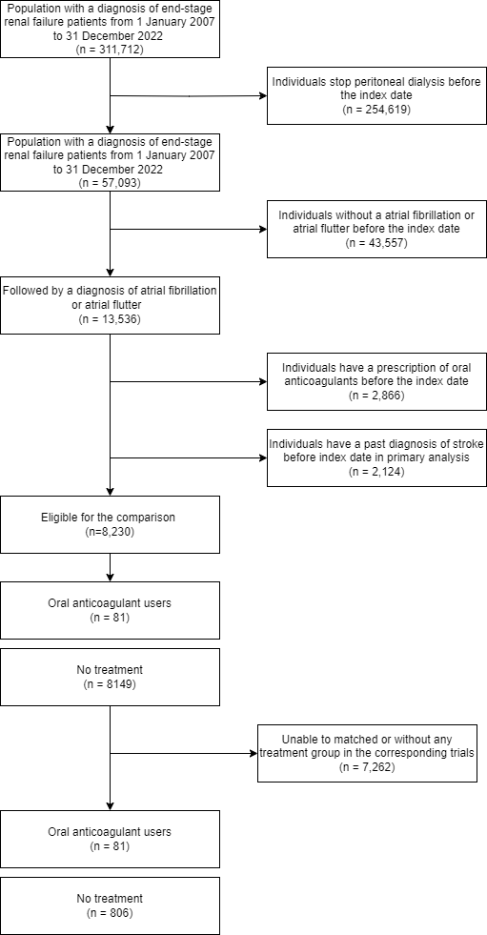

Table 1 Demographic information before and after the propensity score matching
Variables, n (%) | Before matching |  |  | After matching
 | Non-users  (N = 8149) | Users  (N = 81) | SMD | Non-users  (N = 806) | Users  (N = 81) | SMD
Follow-up period (median [IQR]) | 384.00 [162.00, 776.00] | 336.00 [157.00, 754.00] | 0.068 | 364.00 [141.50, 671.75] | 336.00 [157.00, 754.00] | 0.061
Sex, Male (%) | 4192 ( 51.4) | 41 ( 50.6) | 0.047 | 407 ( 50.5) | 41 ( 50.6) | 0.002
Age at index date (Years) (median [IQR]) | 68.13 [59.75, 75.75] | 66.06 [61.27, 73.08] | 0.027 | 67.56 [60.66, 75.31] | 66.06 [61.27, 73.08] | 0.006
Time from AF to Index date (Days) (median [IQR]) | 364.00 [152.00, 739.00] | 17.00 [8.00, 100.00] | 0.835 | 132.00 [59.00, 274.00] | 17.00 [8.00, 100.00] | 0.395
CHA₂DS₂-VASc Score (mean (SD)) | 3.23 (1.40) | 3.27 (1.41) | 0.030 | 3.28 (1.42) | 3.27 (1.41) | 0.006
Congestive Heart Failure | 2640 ( 32.4) | 27 ( 33.3) | 0.058 | 266 ( 33.0) | 27 ( 33.3) | 0.007
Myocardial infarction | 2640 ( 32.4) | 27 ( 33.3) | 0.313 | 266 ( 33.0) | 27 ( 33.3) | 0.007
Peripheral vascular disease | 1327 ( 16.3) | 23 ( 28.4) | 0.074 | 204 ( 25.3) | 23 ( 28.4) | 0.070
Cerebrovascular disease | 850 ( 10.4) | 6 ( 7.4) | 0.071 | 77 ( 9.6) | 6 ( 7.4) | 0.077
Chronic obstructive pulmonary disease | 521 ( 6.4) | 6 ( 7.4) | 0.113 | 53 ( 6.6) | 6 ( 7.4) | 0.033
Dementia | 1018 ( 12.5) | 7 ( 8.6) | 0.078 | 66 ( 8.2) | 7 ( 8.6) | 0.016
Paralysis | 145 ( 1.8) | 0 ( 0.0) | 0.133 | 1 ( 0.1) | 0 ( 0.0) | 0.050
Diabetes | 16 ( 0.2) | 0 ( 0.0) | 0.178 | 806 (100.0) | 81 (100.0) | <0.001
Mild liver disease | 4214 ( 51.7) | 49 ( 60.5) | 0.018 | 473 ( 58.7) | 49 ( 60.5) | 0.037
Moderate-severe liver disease | 171 ( 2.1) | 2 ( 2.5) | 0.035 | 24 ( 3.0) | 2 ( 2.5) | 0.031
Ulcers | 74 ( 0.9) | 1 ( 1.2) | 0.011 | 5 ( 0.6) | 1 ( 1.2) | 0.064
Asthma | 1166 ( 14.3) | 12 ( 14.8) | 0.102 | 118 ( 14.6) | 12 ( 14.8) | 0.005
Rheumatoid arthritis | 368 ( 4.5) | 2 ( 2.5) | 0.057 | 12 ( 1.5) | 2 ( 2.5) | 0.070
Malignancy | 57 ( 0.7) | 1 ( 1.2) | 0.048 | 7 ( 0.9) | 1 ( 1.2) | 0.036
Metastatic solid tumour | 725 ( 8.9) | 7 ( 8.6) | 0.069 | 50 ( 6.2) | 7 ( 8.6) | 0.093
Diabetes without chronic complication | 29 ( 0.4) | 1 ( 1.2) | 0.149 | 2 ( 0.2) | 1 ( 1.2) | 0.115
Diabetes with chronic complication | 3399 ( 41.7) | 39 ( 48.1) | 0.147 | 375 ( 46.5) | 39 ( 48.1) | 0.032
Hypertension | 2976 ( 36.5) | 35 ( 43.2) | 0.096 | 343 ( 42.6) | 35 ( 43.2) | 0.013
Severe constipation | 7081 ( 86.9) | 73 ( 90.1) | 0.146 | 696 ( 86.4) | 73 ( 90.1) | 0.117
Antiplatelet user history | 1920 ( 23.6) | 14 ( 17.3) | 0.161 | 189 ( 23.4) | 14 ( 17.3) | 0.154

Figure 3 Estimated risk of composite outcome (ischemic stroke, hemorraghic stroke, or all-cause mortality), all-bleeding events (hemorraghic stroke, GI bleeding, or other bleeding), ischemic stroke and haemorrhagic stroke incidence over 3 years, by oral anticoagulants drug used or not, in end-stage renal failure with peritoneal dialysis, HK CDARS data 2007- 2022
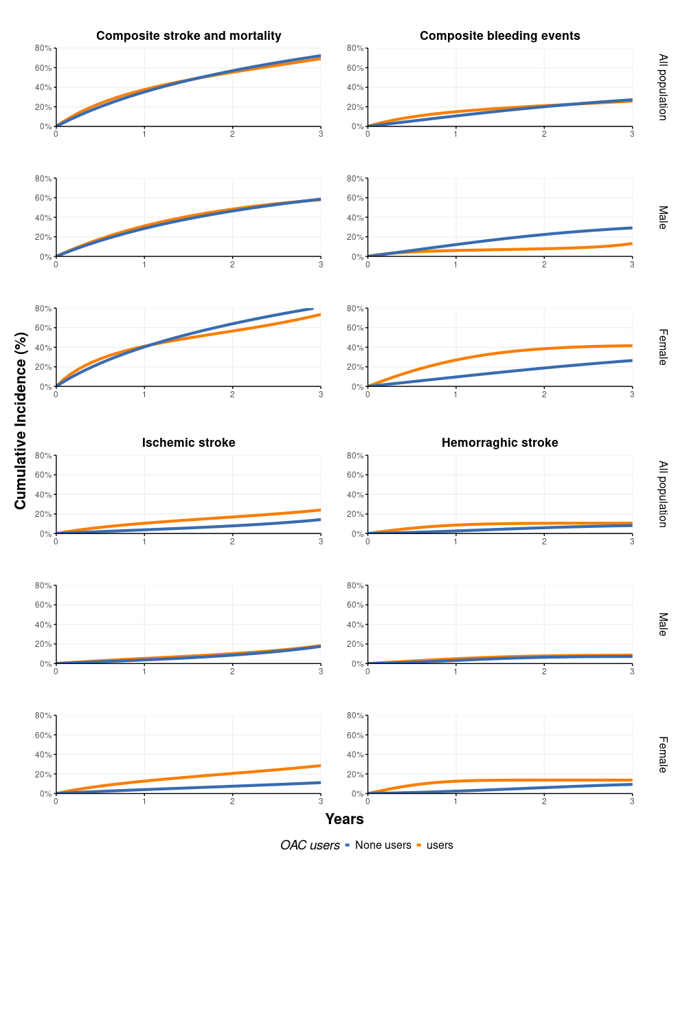

Table 2. Estimated 3-year risks of stroke in emulated target trials in end-stage renal failure with peritoneal dialysis, HK CDARS
 | Risk % (95% CI) |  | 3-year Risk difference (%)
 | non-initiators | OAC initiators
Composite stroke outcome (death and stroke)
Primary analysis | 0.72 (0.66, 0.80) | 0.69 (0.55, 0.83) | -0.03 (-0.18, 0.11)
By sex
Male | 0.59 (0.50, 0.69) | 0.58 (0.40, 0.75) | 1.02 (0.73, 1.25)
Female | 0.81 (0.72, 0.90) | 0.74 (0.51, 0.94) | 0.97 (0.75, 1.13)
By age (years old)
<65 | 0.61 (0.50, 0.73) | 0.73 (0.51, 0.91) | 0.12 (-0.11, 0.29)
>=65 | 0.75 (0.67, 0.83) | 0.65 (0.46, 0.83) | -0.10 (-0.29, 0.08)
Composite bleeding outcome (Hemorraghic stroke, GI and other bleeding)
Primary analysis | 0.27 (0.25, 0.30) | 0.26 (0.12, 0.40) | -0.01 (-0.15, 0.12)
By sex
Male | 0.29 (0.26, 0.33) | 0.13 (<0.01, 0.32) | -0.16 (-0.28, 0.03)
Female | 0.26 (0.24, 0.30) | 0.42 (0.21, 0.69) | 0.15 (-0.06, 0.43)
By age (years old)
<65 | 0.18 (0.16, 0.20) | 0.22 (0.10, 0.40) | 0.04 (-0.08, 0.22)
>=65 | 0.30 (0.27, 0.33) | 0.25 (0.11, 0.43) | -0.05 (-0.20, 0.12)
Ischemic stroke
Primary analysis | 0.14 (0.12, 0.16) | 0.24 (0.11, 0.40) | 0.10 (-0.03, 0.26)
By sex
Male | 0.18 (0.15, 0.20) | 0.18 (<0.01, 0.44) | 0.01 (-0.18, 0.27)
Female | 0.11 (0.08, 0.14) | 0.29 (0.09, 0.60) | 0.17 (-0.02, 0.48)
By age (years old)
<65 | 0.10 (0.07, 0.13) | 0.29 (0.08, 0.55) | 0.19 (-0.01, 0.44)
≥65 | 0.15 (0.13, 0.17) | 0.14 (0.02, 0.28) | -0.01 (-0.13, 0.13)
Haemorraghic stroke
Primary analysis | 0.08 (0.06, 0.10) | 0.11 (0.04, 0.18) | 0.02 (-0.04, 0.10)
By sex
Male | 0.07 (0.05, 0.11) | 0.09 (<0.01, 0.24) | 0.01 (-0.09, 0.16)
Female | 0.09 (0.07, 0.13) | 0.14 (0.06, 0.26) | 0.04 (-0.04, 0.18)
By age (years old)
<65 | 0.08 (0.05, 0.11) | 0.13 (0.03, 0.24) | 0.05 (-0.06, 0.17)
≥65 | 0.08 (0.06, 0.11) | 0.05 (<0.01, 0.11) | -0.03 (-0.08, 0.03)
All-cause mortality
Primary analysis | 0.71 (0.69, 0.72) | 0.65 (0.54, 0.77) | -0.05 (-0.16, 0.06)
By sex
Male | 0.72 (0.70, 0.74) | 0.71 (0.57, 0.86) | -0.01 (-0.15, 0.14)
Female | 0.68 (0.66, 0.70) | 0.57 (0.38, 0.73) | -0.11 (-0.30, 0.05)
By age (years old)
<65 | 0.53 (0.50, 0.55) | 0.58 (0.39, 0.77) | 0.05 (-0.14, 0.25)
≥65 | 0.75 (0.74, 0.77) | 0.68 (0.54, 0.83) | -0.07 (-0.21, 0.07)

Discussion
This is the first population-based study using a large electronic health record database to examine the risk of stroke and bleeding in PD patients with AF after OAC initiation in Hong Kong. The study has observed over 800 patients with newly diagnosed AF since the initiation of PD. It was observed that the majority of PD patients did not receive OAC after their AF diagnosis. The findings indicate that the initiation of OAC is not associated with an increased risk of stroke or mortality.
The existing literature on OAC treatment in dialysis patients presents mixed findings regarding its efficacy. Chan et al. identified a significantly higher risk of ischemic stroke associated with warfarin use in HD patients with AF compared to nonuse (HR, 1.81 [95% CI, 1.12-2.92]). {Chan et al., 2009 #125525} In contrast, Kim et al. (2024) observed an association between OACs and a reduced risk of ischemic stroke (HR, 0.61 [95% CI, 0.41-0.89]). {Kim et al., 2024 #66391} A Japanese prospective cohort study reported no significant association between warfarin use and the risk of ischemic stroke compared to no anticoagulation in patients undergoing HD or PD with chronic sustained AF (HR, 3.36 [95% CI, 0.67-16.66]). {Wakasugi et al., 2014 #205121} Furthermore, a meta-analysis of 11 observational studies involving a total of 25,407 dialysis patients with AF suggests that warfarin use did not reduce the risk of mortality. {Liu et al., 2015 #33754}
Recent network meta-analysis, which included nine studies with a cumulative sample size of 32,821 patients, has demonstrated that both apixaban (HR, 1.72 [95% CI, 1.72-2.78]) and warfarin (HR, 1.21 [95% CI, 1.06-1.38]) are linked to an increased risk of hemorrhagic stroke in patients undergoing dialysis with AF, in comparison to placebo. {Shen et al., 2023 #153355} Furthermore, several observational studies have documented a rise in bleeding events among patients in the OAC group. These studies were predominantly conducted in cohorts primarily undergoing HD {Lee et al., 2016 #126616; Tan et al., 2019 #228503; Wong et al., 2016 #1725}, which differs from PD due to the administration of low-molecular-weight heparin during HD sessions. The concurrent use of warfarin may further heighten the risk of bleeding in HD patients. However, our study did not observe such an increased risk among OAC initiators, which may indicate a potential lower bleeding risk associated with PD compared to HD.
In our study, a notably small proportion of patients with PD and newly diagnosed AF were prescribed OACs for stroke prevention. This percentage is considerably lower than those reported in previous population-based cohort studies, such as a Taiwanese study and a US study, which documented that 25.9% and 36.20% of dialysis patients with AF received OACs, respectively. {Pokorney et al., 2020 #222285} {See et al., 2021 #223377} The underutilisation of OACs in our cohort may be attributed to conservative prescribing practices in Hong Kong, stemming from the uncertain benefits of OACs and concerns regarding the increased bleeding risk associated with OACs in PD patients. {Fung et al., 2023 #173166} Additionally, the numerous drug-drug and drug-food interactions, the necessity for frequent INR monitoring, and the heightened risks of bleeding and calciphylaxis in dialysis patients {Niehues et al., 2024 #194544} further complicate the use of warfarin. The uncertain risk-benefit profiles of DOACs {Weber et al., 2019 #270803} and the determination of optimal dosing in dialysis patients {Joglar et al., 2024 #254294} may also contribute to the underutilisation of OACs in our study cohort.
Our study further confirmed the findings of previous studies, indicating no significant reduction in mortality risk associated with warfarin use in dialysis patients with AF. This lack of clear benefit, coupled with the potential increased risk of bleeding complications, underscores the complexity of anticoagulation management in this patient population. Further research, particularly randomised controlled trials, is needed to establish definitive guidelines for OAC use in dialysis patients with AF, taking into account individual patient characteristics and risk factors.
This study possesses multiple notable strengths. To the best of our knowledge, this is the first investigation examining the utilisation of OACs in newly diagnosed AF patients undergoing PD. The accuracy of all records within CDARS was thoroughly validated, rendering it a robust platform for conducting extensive post-marketing drug surveillance studies. {Wong et al., 2016 #4} {Man et al., 2017 #42519} Furthermore, this study employed a sequential design to align eligibility criteria, treatment strategy assignment, and the start of follow-up at time zero.
There are several limitations in this study. Firstly, the CDARS does not account for over-the-counter products obtained from non-HA pharmacies or physicians. Nevertheless, patients with chronic illnesses requiring long-term treatment frequently utilise HA services due to substantial medication cost subsidies. Consequently, the potential impact of unrecorded medications, such as the use of NSAIDs, is anticipated to be minimal. The second limitation concerns residual confounding, akin to other observational studies using electronic health records. This bias may be attributed to a restricted range of covariates included in the analysis due to data availability constraints. Factors such as alcohol history, smoking history, blood pressure, and hyperglycemia are risk factors for stroke and bleeding. Additionally, the time in the therapeutic range (TTR) was not included in the study.

Conclusion
In conclusion, the risks and benefits of OAC use in PD patients remain unclear. The use of OAC is not associated with a reduction in risk of stroke, bleeding or mortality.

References

Supplementary materials
Supplementary Table 1.Summary of the protocol of a target trial for studying the safety and effectiveness of oral coagulants in dialysis patients with atrial fibrillation or atrial flutter, and summary of the target trial is emulated using HK CDARS data.
Protocol component | Target trial | Emulation of the target trial using HK CDARS data
Eligibility criteria | People with end-stage renal failure undergoing peritoneal dialysis with a diagnosis of atrial fibrillation or atrial flutter aged 18 or older and who have not used oral coagulants. | The target trial is emulated using data in CDARS on people who were diagnosis with end-stage renal failure undergoing peritoneal dialysis with a newly diagnosis of atrial fibrillation or atrial flutter between 2007 and 2022. The emulation is performed using sequential trials approaches. At a given montly from 2007 to 2022, an individual is defined as meeting the eligibility criteria if they meet the following conditions:  - Age 18 or older;  - Still underwent peritoneal dialysis;  - With a diagnosis of atrial fibrillation or atrial flutter before index date;  - Without any OAC prescription record before two months till 1993;  - Without hemodialysis, renal transplant before  The first visit at which the trial emulation eligibility criteria are met in the available data is denoted 𝑘=0 and subsequent trial times are 𝑘=1,2,…. The maximum number of trial is 191, with 𝑘=191 corresponding to the index date of 2022-12-01.
Treatment strategies | (i) Do not start using OAC.  (ii) Start using OAC. | The treatment strategies of interest are as in the target trial. The individuals who start to receive OAC within one month before the index date are treated as OAC users, while those without started OAC are treated as OAC non-users.
Assignment procedures | Patients randomly assigned to either treatment strategy. | At each trial, an individual is an OAC user or non‐user. A propensity score matching was used to emulate the randomization of eligible person-trials at baseline, where the users and non-users were matched in a 1:10 ratio within each trial. The nearest neighbour propensity score matching without replacement, with a propensity score estimated using logistic regression of the treatment on the covariates. The matching factors included demographic characteristics (sex and age at index), and baseline commorbidities, in addition to the baseline antiplatelet use within each trial for the emulation.
Follow‐up period | Starts at randomization and ends at death, stop peritoneal dialysis, start of hemodialysis, or renal transplant, loss‐to follow‐up, or 3 years of follow‐up, whichever occurs first. | Follow‐up starts at each index date and ends at death or transplant, the end of 2022, or 3-years after index date, whichever occurs first.
Outcome | For safety events, ischemic stroke or death  For effectiveness, haemorrhagic stroke | As in the target trial.
Causal contrasts | Intention to treat effect. The patients will be assigned according to their assignment at baseline, no matter the change during follow-up.  Per protocol treatment effect. Marginal survival curves up to 11 years under the two treatment strategies, and corresponding marginal risk differences. For the marginal probabilities, the population of interest is individuals meeting the target trial eligibility criteria in 2018. | The causal contrasts of interest in the observational emulation is intention-to-treat as in the target trial. Estimation uses the propensity score matching approach and the approach of the sequential trial.

Supplementary Table 2. Regular expression codes for identifying the comorbidities or outcomes in this study
Description | Regex
Congestive Heart Failure | ^398.91|^402.[019]1|^404.[019][13]|^428
Myocardial infarction | ^410
Peripheral vascular disease | ^441|^443.9|^785.4|^V43.4
Cerebrovascular disease | ^43[0-8]
Chronic obstructive pulmonary disease | ^49[0-6]|^50[0-5]|^506.4
Dementia | ^290
Paralysis | ^342|^344.1
Diabetes | ^250
Chronic renal failure | ^58[2568]|^583.[012467]
Mild liver disease | ^571.[2456]
Moderate-severe liver disease | ^456.[012]|^572.[2348]
Ulcers | ^53[1-4]
Asthma | ^493
Rheumatoid arthritis | ^714
Malignancy | ^1[458][0-9]|^17[0124569]|^1[69][0-5]|^20[0-8]
Metastatic solid tumour | ^19[6-9]
Diabetes without chronic complication | ^250.[01237]
Diabetes with chronic complication | ^250.[456]
Hypertension | ^40[1-5]|^437.2
Severe Constipation | ^560.1|^560.30|^560.39|^560.9|^564.0|^569.83|^569.89
Bleeding Events | ^456.0^|456.20|^530.21|^530.7|^530.82|^531.[0246]|^532.[0246]|^533.[0246]|^534.[0246]|^537.8[34]|^562.0[23]|^562.1[23]|^569.3|^569.85|^578|^287.[89]|^596.7|^784.8|^599.7|^627.1|^459.0|^719.1|^786.3|^363.6|^376.32|^377.42|^729.92|^423.0|^801.[2378]|^803.[2378]|^804.[2378]|^800.[2378]|^85[23]|^43[0-2]
All stroke | ^43[0-6]|^444|^433.[012389]1|^43[46]|^437.[01]|^44[45]
Haemorraghic stroke | ^43[0-2]
GI Bleeding | ^456.0^|456.20|^530.21|^530.7|^530.82|^531.[0246]|^532.[0246]|^533.[0246]|^534.[0246]|^537.8[34]|^562.0[23]|^562.1[23]|^569.3|^569.85|^578
Other Bleeding | ^287.[89]|^596.7|^784.8|^599.7|^627.1|^459.0|^719.1|^786.3|^363.6|^376.32|^377.42|^729.92|^423.0|^801.[2378]|^803.[2378]|^804.[2378]|^800.[2378]|^85[23]

Supplementary Table 3. Results of sensitivity analysis
 | Risk, % (95% CI) |  |  |  | Risk difference,%
 | OAC non-users |  | OAC users
Composite outcome (ischemic, heamorraghic stroke and all-cause mortality)
Matching process adjustment | 0.67 (0.55, 0.83) |  | 0.70 (0.54, 0.83) |  | 0.03 (-0.16, 0.20)
Study period from 3 to 5 years | 0.85 (0.78, 0.91) |  | 0.80 (0.65, 0.92) |  | -0.05 (-0.19, 0.09)
Exposures assessment window change | 0.70 (0.69, 0.72) |  | 0.69 (0.55, 0.83) |  | -0.02 (-0.15, 0.12)
Composite outcome of bleeding
Matching process adjustment | 0.27 (0.25, 0.30) |  | 0.26 (0.12, 0.40) |  | -0.01 (-0.15, 0.12)
Study period from 3 to 5 years | 0.38 (0.35, 0.42) |  | 0.31 (0.16, 0.55) |  | -0.07 (-0.22, 0.15)
Exposures assessment window change | 0.27 (0.25, 0.30) |  | 0.26 (0.12, 0.40) |  | -0.01 (-0.15, 0.12)

Supplementary Figure 1. Eligibal participants in each trials included into the study

