TEAM PAYAMAN

ONLINE MERCH

EUNICE ESCONDE

VERNA LEONOR

DANICA PLAZO

JOHN MARCO JOVES

BSCS 3-A

**INTRODUCTION**

A lot of people around the world prefer to shop online and purchase products from brands and companies that they cannot find or not available in their area. These days, and with the assistance of the new innovation and the help of the internet, anywhere around the world people began to buy things online by just scrolling, searching and sitting in their homes. Buying things through online is a simple task to do. It is currently having a significant part in everyone's life particularly elderly people, as well as people busy with their work and do not have much time to stop by at the mall. On this trying time, many people are getting their needs through online shopping. It provides an entirely convenient service for its customers, by being able to save the item in the cart, and buy it later on. Because of the countless advantages and benefits of online shopping, masses of entrepreneur and aspiring businessperson are entering a world of online shopping.

Team Payaman is one of the top tier online sellers in the Philippines. The said team are originally created with famous vloggers on YouTube and eventually one of the members sell t-shirts and cap. Because of this, other members also started selling merch like beauty products, clothing, condiments, and stickers. The Team Payaman Merch Website tends to be more convenient to the team to promote and sell their products and aims to merge all the products in one ecommerce website.

**SCOPE AND DELIMITATION**

The researchers aim to develop a convenient and a *‘one-stop shop’* ordering website for Team Payaman Merch since they are using different social media to sell their products. The website focuses on the basic elements. The coverage of the study is to easily purchase of products of Team Payaman.

The intention of the study is to help and assist the customer to easily choose item what they want to order with less time and effort. The website includes different web pages. The first web pages enclose the HOME PAGE of the website that consist of trendy and most popular products. It also contains the social media accounts of the clothing line that may use to communicate for more detailed data about and how the services are set. The PRODUCT PAGE of the website that contains all the merch of the team, sorted according to the catalog. It is packed with basic contents such as product image, price, short details and an add to cart button. The ACCOUNT PAGE can be easily access and done by filling up the form with their personal information, such as username, email and password. The ABOUT PAGE comprises the brief information of the team and short quotation of the famous vlogger Lincoln Velasquez.

**DATA DICTIONARY**

|  |  |  |  |  |  |
| --- | --- | --- | --- | --- | --- |
|  | NAME | Quantity of Item | TYPE OF ITEM | DESCRIPTION | EXAMPLE |
| Seller | Seller ID | ∞ | Clothes | Identification of the Seller | 1234567890 |
| Seller Name | ∞ | Clothes | Name of the Seller | Juan Dela Cruz |
| Seller Email | ∞ | Clothes | Email address of the Seller | seller@00.com |
| CUSTOMER | Customer ID | 20 | Clothes | Identification of the Customer | 1234567890 |
| Customer Name | 30 | Clothes | Name of Customer | Emma Dela Cruz |
| Store | 1 | Clothes | Customer Store | Team Payaman |
| E-mail | ∞ | Clothes | E-mail address of the customer | Emmadelacruz0@.com |
| ITEM / PRODUCT | Product Id | ∞ | Clothes | Product Key | 1234567890 |
| Product Name | 5 | Clothes | Name of the Product | Payaman Merch |
| Manufactured | 1 | Clothes | Name of the Manufacturer:  Philippines | Philippines |
| Catalog | 5 | Clothes | Displays a clothing brand’s collection | T-shirts and accessories |
| Availability | Leans on | Clothes | Displays the availability of the item | Available / Out of stocks |
| Log In | Username | ∞ | Clothes | Identification used by a person | Juandelacruz123 |
| Password | ∞ | Clothes | String of characters used for authenticating a user | Abcde12345 |
| Add to Cart | Product | 10 | Clothes | Item in the cart | Giyang Merch |
| Refund | Product Name | 10 | Clothes | Name of the refunded product/s | Viyline Merch |
| Reason of Refund | 10 | Clothes | Stated reason when the user/buyer sends an item back. | Incorrect product or size |

**ENTITY RELATIONSHIP DIAGRAM**

**CUSTOMER**

**PAYMENT**

**CART**

**ONLINE SHOPPING PORTAL**

**PRODUCTS**

buys

**CART ITEM**

done for

Password

Total cost

Quantity

Product price

Product name

Product model

Product id

Added to

Made of

Total cost

Username

Username

Username

does

Belongs to

Address

Username

First name

Last name

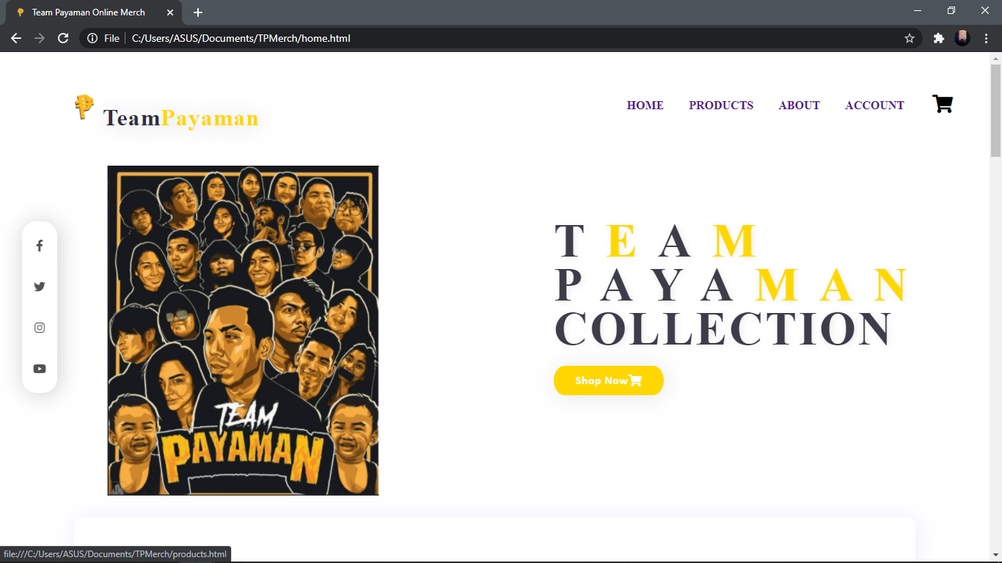**USER INTERFACE**

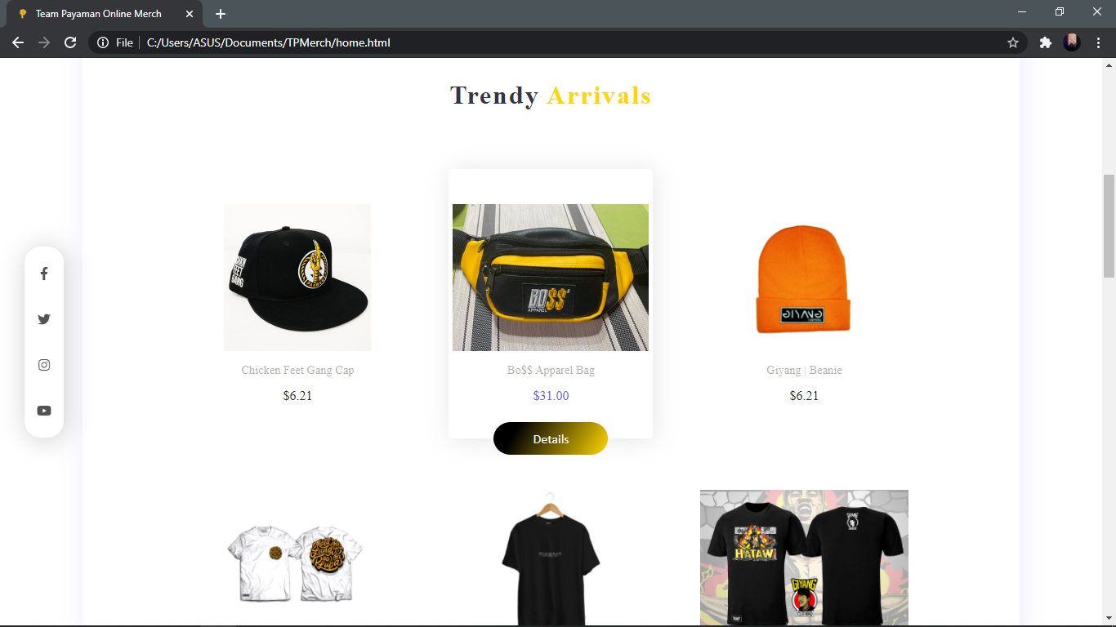

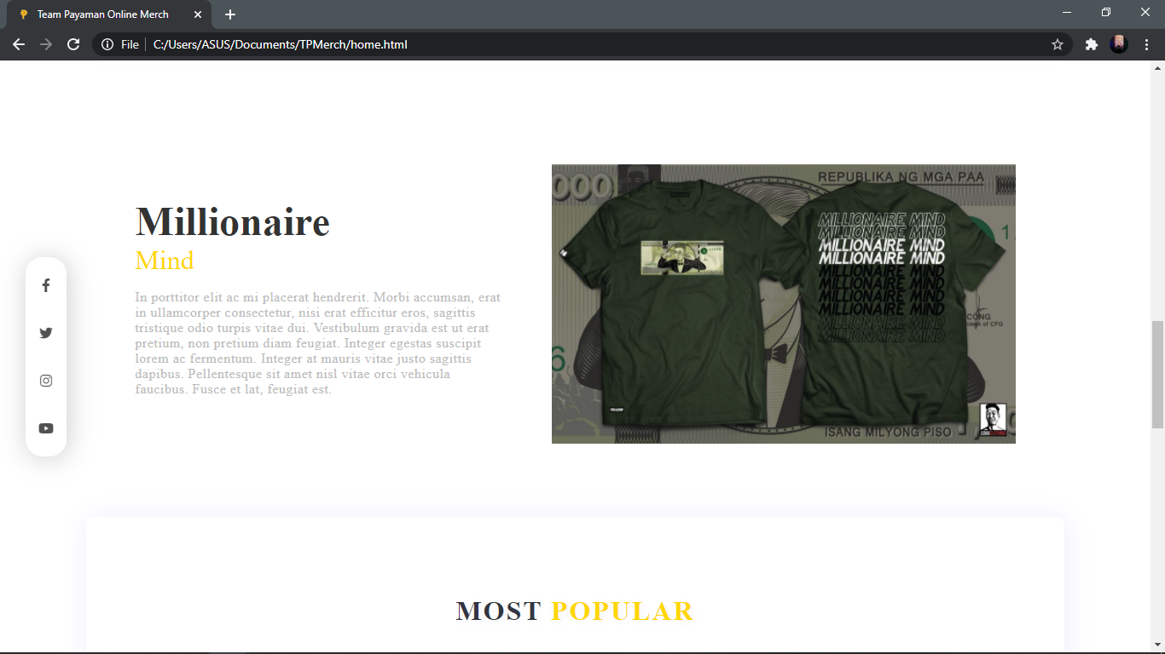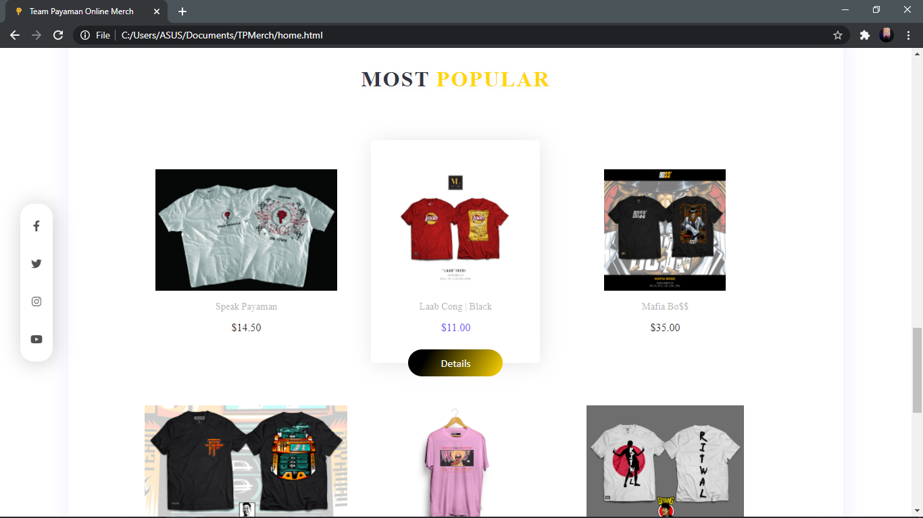

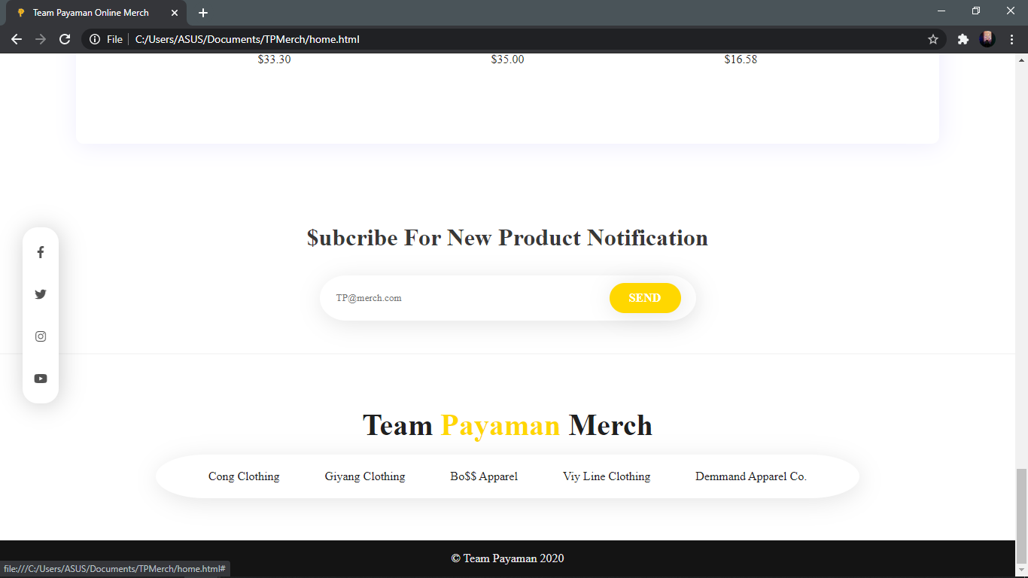

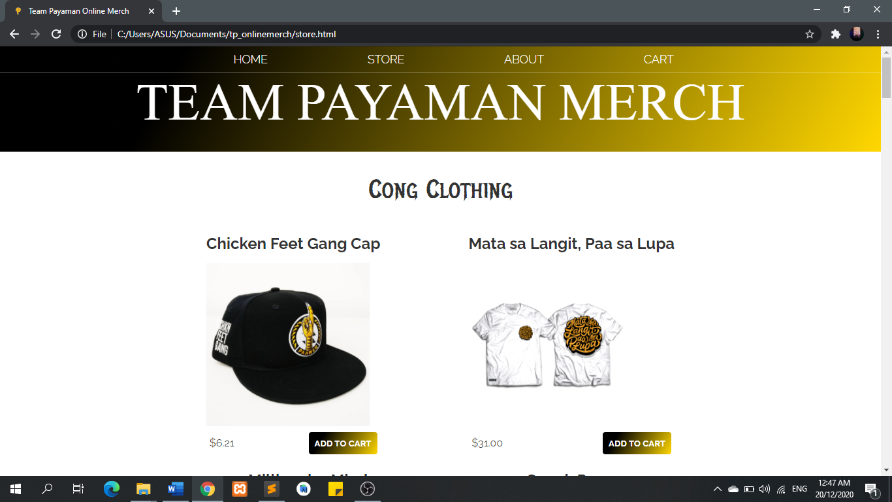

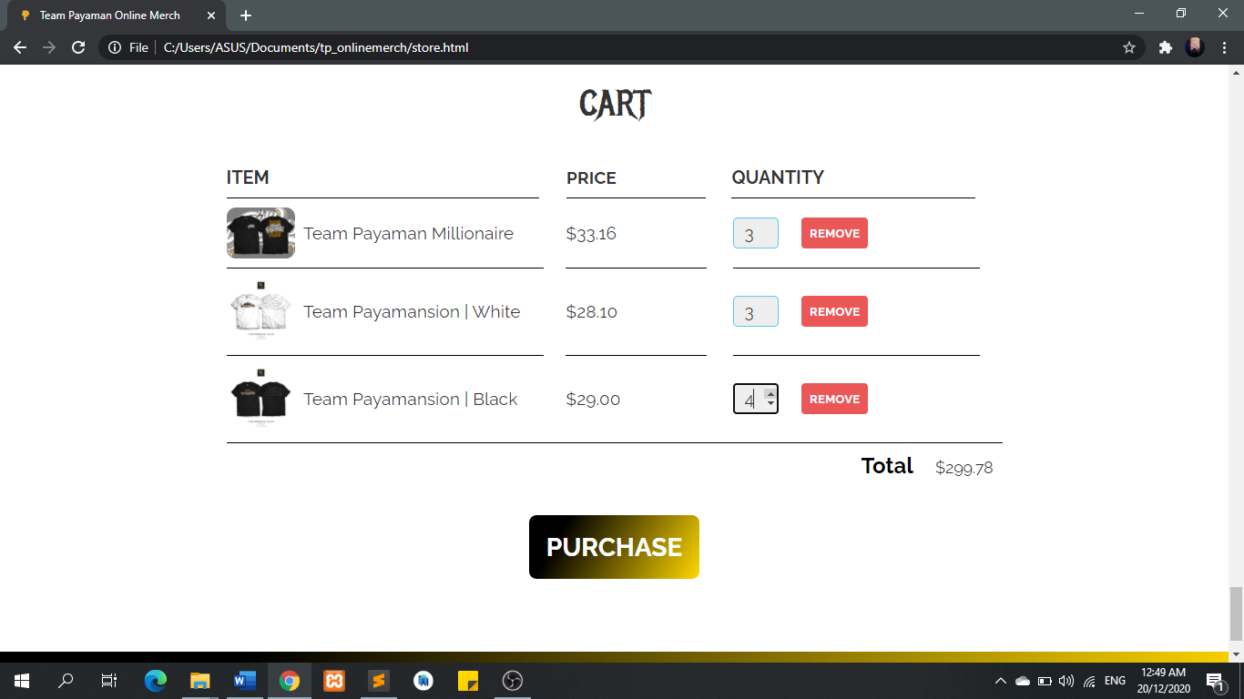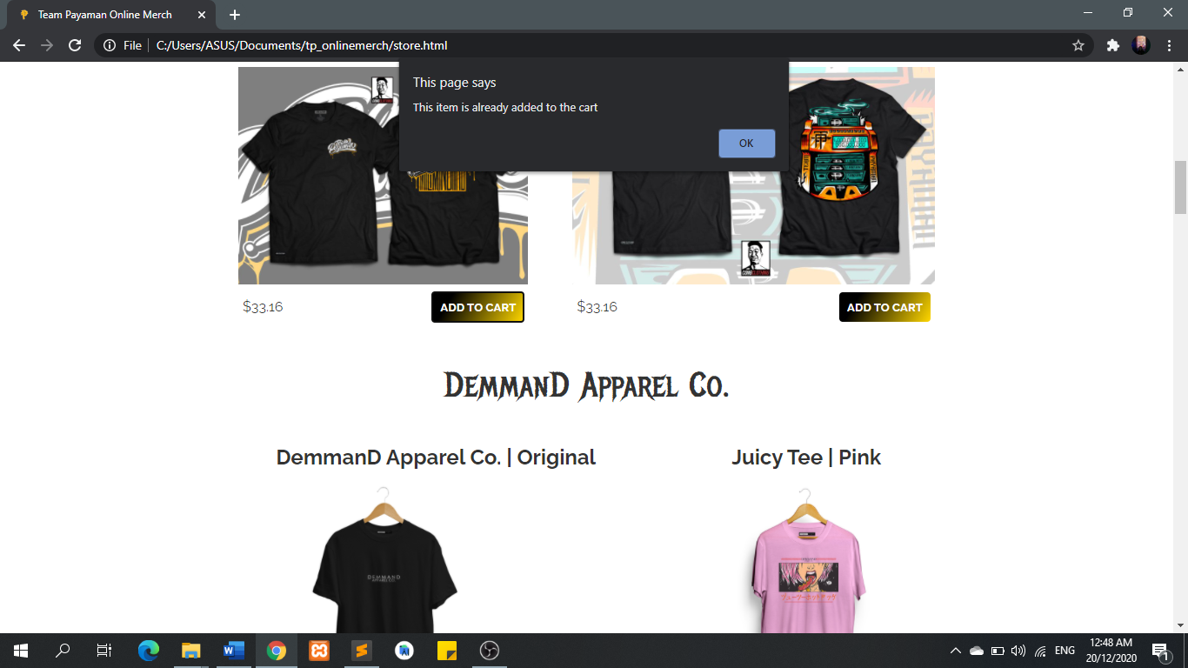

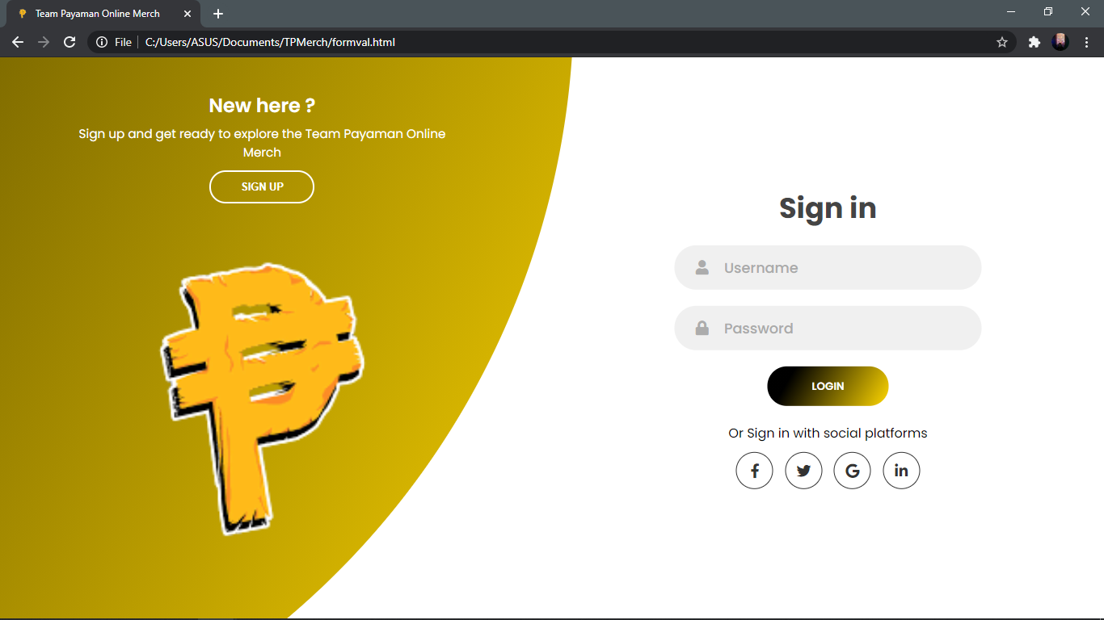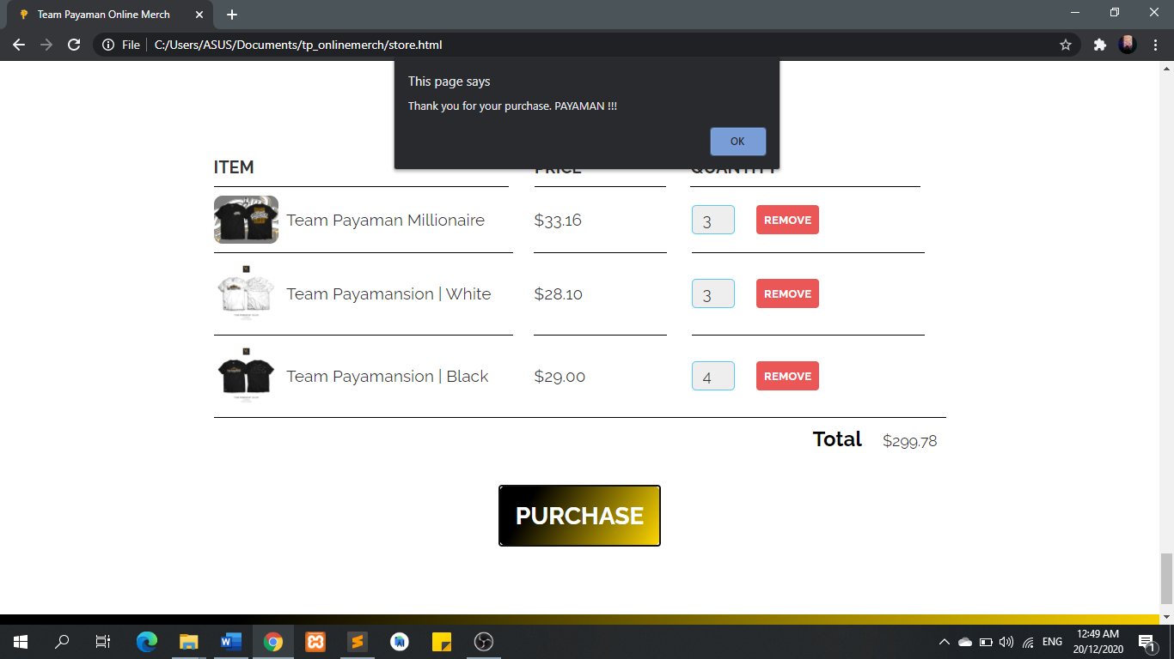

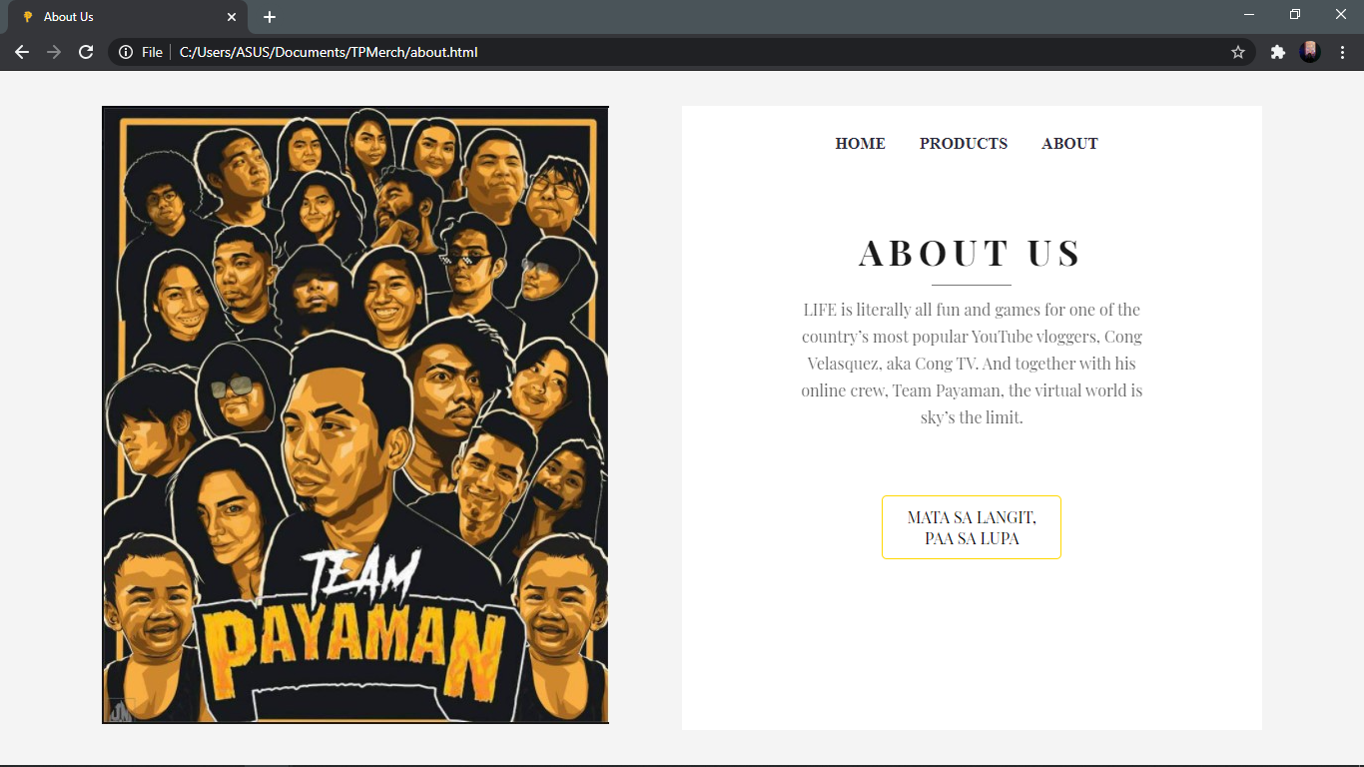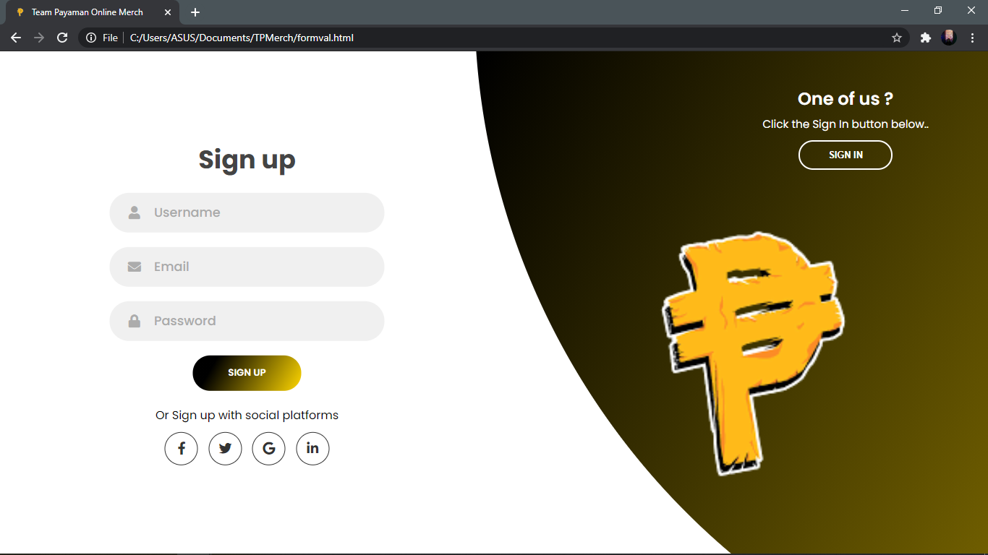

**SOURCE CODE**

**Home.html**

<!DOCTYPE html>

<html lang="en">

<html>

<head>

<meta charset="utf-8"/>

<title>Team Payaman Online Merch</title>

<link href="img/tplogo.png" rel="shortcut icon"/>

<link href="css/trystyle.css" rel="stylesheet" type="text/css"/>

<link rel="stylesheet" href="css/homestyle.css"/>

<script crossorigin="anonymous" src="https://kit.fontawesome.com/70a642cd7c.js"></script>

</head>

<body>

<section class="main">

<div class="logo">

<a href="home.html"><img src="img/tplogo.png" width="50px">Team<font>Payaman</font></a>

</div>

<div class="header">

<a href="home.html">HOME</a>

<a href="store.html">PRODUCTS</a>

<a href="about.html">ABOUT</a>

<a href="formval.html">ACCOUNT</a>

</div>

<div class="cart-icon">

<a class="cart-btn" href="#"><i class="fa fa-shopping-cart" style='font-size:25px'></i></a>

</div>

<div class="m-img">

<img alt="" src="img/maintp.jpg" />

</div>

<div class="m-text">

<h1>T<font>E</font>A<font>M</font><br>PAYA<font>MAN</font></h1>

<h2>CollectION</h2>

<a class="m-btn" href="products.html">Shop Now<i class="fas fa-shopping-cart"></i></a>

</div>

<div class="social">

<a href="https://www.facebook.com/congTVclothing/"><i class="fab fa-facebook-f"></i></a>

<a href="https://twitter.com/TheCongTV"><i class="fab fa-twitter"></i></a>

<a href="https://www.instagram.com/thecongtv/"><i class="fab fa-instagram"></i></a>

<a href="https://www.Youtube.com/lincolnvelasquez"><i class="fab fa-youtube"></i></a>

</div>

</section>

<section class="product">

<div class="p-heading">

<a name="products"></a>

<h3>Trendy <font>Arrivals</font></h3>

</div>

<div class="product-container">

<div class="p-box">

<img alt="1" src="img/cong/cong1.png" />

<p>Chicken Feet Gang Cap</p>

<a class="price" href="#">$6.21</a>

<a class="buy-btn" href="#">Details</a>

</div>

<div class="p-box">

<img alt="2" src="img/keng/keng1.jpg" />

<p>Bo$$ Apparel Bag</p>

<a class="price" href="#">$31.00</a>

<a class="buy-btn" href="#">Details</a>

</div>

<div class="p-box">

<img alt="3" src="img/giyang/giyang1.jpg" />

<p>Giyang | Beanie</p>

<a class="price" href="#">$6.21</a>

<a class="buy-btn" href="#">Details</a>

</div>

<div class="p-box">

<img alt="4" src="img/cong/cong2.png" />

<p>Mata sa Langit, Paa sa Lupa</p>

<a class="price" href="#">$12.44</a>

<a class="buy-btn" href="#">Details</a>

</div>

<div class="p-box">

<img alt="5" src="img/emman/emman1.png" />

<p>Demmand Original</p>

<a class="price" href="#">$33.16</a>

<a class="buy-btn" href="#">Details</a>

</div>

<div class="p-box">

<img alt="6" src="img/giyang/giyang2.jpg" />

<p>Giyang | Hataw</p>

<a class="price" href="#">$12.44</a>

<a class="buy-btn" href="#">Details</a>

</div>

</div>

</section>

<section class="our-brand">

<div class="brand-text">

<h3>Millionaire</h3>

<h4><font>Mind</font></h4>

<p>In porttitor elit ac mi placerat hendrerit. Morbi accumsan, erat in ullamcorper consectetur, nisi erat efficitur eros, sagittis tristique odio turpis vitae dui. Vestibulum gravida est ut erat pretium, non pretium diam feugiat. Integer egestas suscipit lorem ac fermentum. Integer at mauris vitae justo sagittis dapibus. Pellentesque sit amet nisl vitae orci vehicula faucibus. Fusce et lat, feugiat est.</p>

</div>

<div class="brand-img"><img src="img/cong/cong3.jpg" /></div>

</section>

<section class="product">

<div class="p-heading">

<h3>MOST <font>POPULAR</font></h3>

</div>

<div class="product-container">

<div class="p-box">

<img alt="1" src="img/cong/cong4.jpg" />

<p>Speak Payaman</p>

<a class="price" href="#">$14.50</a>

<a class="buy-btn" href="#">Details</a>

</div>

<div class="p-box">

<img alt="2" src="img/viy/viy1.jpg" />

<p>Laab Cong | Black</p>

<a class="price" href="#">$11.00</a>

<a class="buy-btn" href="#">Details</a>

</div>

<div class="p-box">

<img alt="3" src="img/keng/keng3.jpg" />

<p>Mafia Bo$$</p>

<a class="price" href="#">$35.00</a>

<a class="buy-btn" href="#">Details</a>

</div>

<div class="p-box">

<img alt="4" src="img/cong/cong6.jpg" />

<p>Team Payaman Million</p>

<a class="price" href="#">$33.30</a>

<a class="buy-btn" href="#">Details</a>

</div>

<div class="p-box">

<img alt="5" src="img/emman/emman2.jpg" />

<p>Demmand Apparel | Juicy Hotdog</p>

<a class="price" href="#">$35.00</a>

<a class="buy-btn" href="#">Details</a>

</div>

<div class="p-box">

<img alt="6" src="img/giyang/giyang3.jpg" />

<p>Giyang | Ritwal</p>

<a class="price" href="#">$16.58</a>

<a class="buy-btn" href="#">Details</a>

</div>

</div>

</section>

<section class="subcribe-container">

<h3>$ubcribe For New Product Notification</h3>

<div class="subcribe-input">

<input placeholder="TP@merch.com" type="email" />

<a class="subcribe-btn" href="#">Send</a>

</div>

</section>

<footer>

<h3>Team <font>Payaman </font>Merch</h3>

<ul class="footer-menu">

<li><a href="https://www.facebook.com/congTVclothing/">Cong Clothing</a></li>

<li><a href="https://www.facebook.com/GiyangClothing">Giyang Clothing</a></li>

<li><a href="https://www.facebook.com/bosskengapparel">Bo$$ Apparel</a></li>

<li><a href="https://www.facebook.com/ViyLine/">Viy Line Clothing</a></li>

<li><a href="https://www.facebook.com/DEMMAND">Demmand Apparel Co.</a></li>

</ul>

</footer>

<a class="copyright" href="#">&#169; Team Payaman 2020</a>

<script src="js/index.js"></script>

</body>

</html>

**Homestyle.css**

body{

margin:0px;

padding: 0px;

}

*{

box-sizing: border-box;

font-family: myriad pro;

}

a{

text-decoration:none;

}

ul{

list-style:none;

}

.main{

width:100%;

height: 100vh;

background-image: url("../images/poduct%20bg.png");

background-size:800px;

background-position: center;

position: relative;

}

.logo{

position: absolute;

left: 90px;

top: 50px;

}

.logo a{

font-family:poppins;

font-weight: bold;

color: #2f2e41;

font-size:2rem;

text-shadow: 2px 2px 30px rgba(0,0,0,0.2);

letter-spacing: 1px;

}

.logo font{

color:#FFD700;

}

.header {

position: absolute;

top: 63px;

right: 100px;

font-family: poppins;

font-weight: bold;

color: #2f2e41;

font-size:1rem;

padding: 1px;

}

.header a{

text-decoration: none;

margin: 15px;

}

.header a:hover {

color: #FFD700;

}

.side-box{

position: fixed;

right: 90px;

top: 50px;

width:170px;

height: 45px;

background-color: #FFFFFF;

display: flex;

justify-content:center;

align-items: center;

border-radius: 10% 10% 10% 10% / 50% 50% 50% 50%;

box-shadow: 2px 2px 30px rgba(167, 158, 245, 0.2);

box-sizing: border-box;

z-index: 1;

border:1px solid rgba(167, 158, 245, 0.1);

}

.search input{

width: 90px;

height: 20px;

border: none;

outline: none;

background-color: transparent;

color: #1F1F1F;

font-family: calibri;

font-size: 1rem;

padding: 0px 10px;

}

.search input::placeholder{

color: #1D1D1D;

font-weight:400;

letter-spacing: 2px;

font-size: 0.8rem;

font-family: poppins;

}

.search i{

margin: 0px auto;

}

.cart-icon{

text-align: right;

}

.cart-icon i{

margin-right: 50px;

margin-top: 58px;

text-align: right;

}

.cart-btn{

color:#000000;

}

.cart-btn:hover{

color: #FFD700;

transition: all ease 0.5s;

}

.m-img{

position:absolute;

left:15%;

top: 55%;

transform: translate(-15%,-50%);

}

.m-img img{

height:450px;

}

.m-text{

position: absolute;

top: 50%;

left:90%;

transform: translate(-90%,-50%);

}

.m-text h1,h2{

font-family:Roboto;

font-weight: bold;

margin: 0px;

line-height: 60px;

font-size: 4rem;

text-shadow: 2px 2px 10px rgba(0,0,0,0.08);

letter-spacing: 3px;

color:#3D3D4A;

text-transform: uppercase;

}

.m-text h1{

letter-spacing:28px;

}

.m-text h1 font,

.m-text h2 font{

color:#FFD700;

}

.m-btn{

width:150px;

height: 40px;

background-color: #2f2e41;

box-shadow: 2px 2px 30px rgba(0,0,0,0.1);

display: flex;

justify-content: center;

align-items: center;

border-radius: 10% 10% 10% 10% / 50% 50% 50% 50%;

margin-top: 20px;

color:#fff;

font-family: calibri;

font-weight: 600;

letter-spacing: 0.5px;

font-size: 1rem;

}

.m-btn:hover{

color:#FFFFFF;

background-color: #FFD700;

transition: all ease 0.5s;

}

.social a{

display: flex;

flex-direction: column;

justify-content: center;

align-items: center;

padding: 20px 15px;

}

.social{

position:fixed;

left: 30px;

top: 50%;

transform: translateY(-50%);

border-radius: 20px;

background-color: #FFFFFF;

box-shadow: 2px 2px 30px rgba(0,0,0,0.2);

padding: 5px 0px;

z-index: 1;

}

.social a i{

color:rgba(39,39,39,0.80);

}

.social a:hover .fa-facebook-f{

color: #3b5998;

}

.social a:hover .fa-twitter{

color: #00acee ;

}

.social a:hover .fa-instagram{

color: #3f729b ;

}

.social a:hover .fa-youtube{

color: #FF0000;}

.product{

width: 85%;

background-color: #FFFFFF;

box-shadow: 2px 2px 30px rgba(167, 158, 245, 0.2);

display: flex;

margin:30px auto;

flex-direction: column;

align-items: center;

padding:40px 20px;

margin-top: -60px;

position: relative;

background-image: url("../images/poduct bg.png");

background-size:1000px;

background-position: center;

border-radius: 10px;

}

.p-heading{

margin:20px;

text-shadow: 2px 2px 10px rgba(0,0,0,0.05);

}

.p-heading h3{

font-family: myriad pro;

font-weight: 700;

letter-spacing: 2px;

text-align: center;

font-size:2rem;

color:#323543;

}

.p-heading h3 font{

color:#FFD700;

}

.product-container{

display: flex;

justify-content: center;

align-items: center;

flex-wrap: wrap;

margin: 10px 0px;

width:100%;

}

.p-box{

width:250px;

height: 330px;

display: flex;

justify-content: center;

align-items: center;

flex-direction: column;

border-radius: 4px;

position: relative;

margin: 10px 30px;

}

.p-box img{

height:180px;

}

.p-box p{

color:#4d4d4d70;

font-family: myriad pro;

font-size: 0.9rem;

letter-spacing: 0.5;

}

.price{

color:#2c2c2c;

font-family: poppins;

font-size: 1rem;;

}

.buy-btn{

position: absolute;

width:140px;

height: 40px;

display: flex;

justify-content: center;

align-items: center;

font-family:calibri;

left: 50%;

bottom: -20px;

transform: translateX(-50%);

border-radius: 15% 15% 15% 15% / 50% 50% 50% 50%;

background:linear-gradient(120deg,#000000 20%,#FFD700);

color:#FFFFFF;

display: none;

animation: fade 0.2s;

}

.p-box:hover .buy-btn{

display: flex;

}

.p-box:hover{

box-shadow: 2px 2px 30px rgba(0,0,0,0.1);

background-color:#FFFFFF;

}

.p-box:hover .price{

color:#6b60ec;

transition: all ease 0.2s;

}

@keyframes fade{

0%{

opacity: 0;

}

100%{

opacity: 1;

}

}

.our-brand{

display: flex;

width: 85%;

margin:30px auto;

justify-content: space-around;

align-items: center;

padding:30px;

}

.brand-text{

width:40%;

font-family:myriad pro;}

.brand-img{

height: 500px;

width: 50%;

box-sizing: border-box;

}

.brand-img img{

width:100%;

height: 100%;

object-fit:contain;

}

.brand-text h3{

color:#333333;

font-weight: 700;

font-size:3rem;

margin:0px;

}

.brand-text h4{

color: #333333;

font-weight: 400;

font-size:2rem;

margin:0px;

}

.brand-text font{

color:#FFD700;

}

.brand-text p{

font-size: 1rem;

color:#bdbdbd;

letter-spacing: 0.5px;

}

.subcribe-container{

width:100%;

height:250px;

margin-bottom:30px;

display: flex;

flex-direction: column;

justify-content: center;

align-items: center;

border-bottom: 2px solid rgba(0,0,0,0.03);

}

.subcribe-container h3{

font-size: 2rem;

color: rgb(56, 56, 56);

}

.subcribe-input{

width:500px;

background-color: #fff;

border-radius: 7% 7% 7% 7% / 50% 50% 50% 50%;

height: 60px;

display: flex;

justify-content: center;

align-items: center;

padding:20px;

box-shadow: 2px 5px 30px rgba(0,0,0,0.1);

}

.subcribe-input input{

width:100%;

height: 40px;

border: none;

outline: none;

background-color: transparent;

}

.subcribe-btn{

width:120px;

height: 40px;

background-color: #202020;

border-radius: 20px;

color: #fff;

display: flex;

justify-content: center;

align-items: center;

text-transform: uppercase;

font-weight: bold;

box-shadow: 2px 2px 30px rgba(0,0,0,0.1);

font-size: 1rem;

}

.subcribe-btn:hover{

background-color:#FFD700;

transition: all ease 0.5s;

}

footer{

display: flex;

flex-direction: column;

justify-content: center;

align-items: center;

padding: 40px;

background-image: url("../images/poduct bg.png");

background-size:400px;

background-position: center;

border-radius: 10px;

}

footer h3{

font-size: 2.5rem;

color: #202020;

margin:0px;

}

footer h3 font{

color:#FFD700;

}

.footer-menu{

display: flex;

box-shadow: 2px 5px 30px rgba(0,0,0,0.1);

background-color: #fff;

border-radius: 7% 7% 7% 7% / 50% 50% 50% 50%;

justify-content: center;

align-items: center;

padding:5px 40px;

}

.footer-menu li a{

padding:5px 20px;

margin: 10px;

display: flex;

color:#202020;

}

.footer-menu li a:hover{

color:#FFD700;

}

.copyright{

color:#e7e7e7;

background-color: #141414;

display: flex;

justify-content: center;

align-items: center;

padding: 15px;

}

@media(max-width:1230px){

.m-img img{

height: 350px;

}

.m-text h1,h2{

font-size:3.5rem;

}

}

@media(max-width:1045px){

.main{

background-size: 600px;

}

.m-img{

display:none;

}

.m-text{

left:50%;

top:50%;

transform: translate(-50%,-50%);

}

.our-brand{

flex-direction:column-reverse;

}

.brand-text,.brand-img{

width:100%;

}

.brand-img{

height:300px;

margin:20px;

}

}

@media(max-width:600px){

.social{

display: none;

}

.logo{

left: 30px;

top:30px;

}

.logo a{

font-size: 1.4rem;;

}

.side-box{

right:30px;

top:30px;

}

.m-text{

overflow-wrap: break-word;

display: flex;

flex-direction: column;

margin:auto;

}

.m-text h1,h2{

font-size: 2.5rem;

line-height:40px;

margin:0px 20px;

letter-spacing: 10px;

}

.m-text h2{

font-size: 1.2rem;

}

.m-btn{

margin:0px 20px;

}

.product{

width:88%;

}

.p-box{

margin:20px 10px;

padding:10px 20px;

width:100%;

text-align: center;

}

.subcribe-input{

width:95%;

}

.subcribe-container h3{

font-size:1.4rem;

text-align: center;

}

.footer-menu{

width:100%;

margin:20px;

flex-wrap: wrap;

background-color:none;

box-shadow: none;

}

.footer-menu li a{

background-color:#fff;

border-radius: 20px;

box-shadow:2px 2px 30px rgba(0, 0, 0, 0.1) ;

padding:10px 30px !important;

}

.copyright {

text-align: center;

}

}

**Store.html**

<!DOCTYPE html>

<html>

<head>

<title>Team Payaman Online Merch</title>

<link href="img/tplogo.png" rel="shortcut icon"/>

<link rel="stylesheet" href="css/styles.css" />

<script src="js/app.js" async></script>

<link rel="stylesheet" href="https://cdnjs.cloudflare.com/ajax/libs/font-awesome/4.7.0/css/font-awesome.min.css">

</head>

<body>

<header class="main-header">

<nav class="main-nav nav">

<ul>

<li><a href="home.html">HOME</a></li>

<li><a href="store.html">STORE</a></li>

<li><a href="about.html">ABOUT</a></li>

<li><a href="#cart">CART</a></li>

</ul>

</nav>

<h1 class="band-name band-name-large">TEAM PAYAMAN MERCH</h1>

</header>

<section class="container content-section">

<h2 class="section-header">Cong Clothing</h2>

<div class="shop-items">

<div class="shop-item">

<span class="shop-item-title">Chicken Feet Gang Cap</span>

<img class="shop-item-image" src="img/cong/cong1.png">

<div class="shop-item-details">

<span class="shop-item-price">$6.21</span>

<button class="btn btn-primary shop-item-button" type="button">ADD TO CART</button>

</div>

</div>

<div class="shop-item">

<span class="shop-item-title">Mata sa Langit, Paa sa Lupa</span>

<img class="shop-item-image" src="img/cong/cong2.png">

<div class="shop-item-details">

<span class="shop-item-price">$31.00</span>

<button class="btn btn-primary shop-item-button"type="button">ADD TO CART</button>

</div>

</div>

<div class="shop-item">

<span class="shop-item-title">Millionaire Mind</span>

<img class="shop-item-image" src="img/cong/cong3.jpg">

<div class="shop-item-details">

<span class="shop-item-price">$33.16</span>

<button class="btn btn-primary shop-item-button" type="button">ADD TO CART</button>

</div>

</div>

<div class="shop-item">

<span class="shop-item-title">Speak Payaman</span>

<img class="shop-item-image" src="img/cong/cong4.jpg">

<div class="shop-item-details">

<span class="shop-item-price">$25.00</span>

<button class="btn btn-primary shop-item-button" type="button">ADD TO CART</button>

</div>

</div>

<div class="shop-item">

<span class="shop-item-title">Team Payaman Millionaire</span>

<img class="shop-item-image" src="img/cong/cong5.jpg">

<div class="shop-item-details">

<span class="shop-item-price">$33.16</span>

<button class="btn btn-primary shop-item-button" type="button">ADD TO CART</button>

</div>

</div>

<div class="shop-item">

<span class="shop-item-title">Team Payaman Million</span>

<img class="shop-item-image" src="img/cong/cong6.jpg">

<div class="shop-item-details">

<span class="shop-item-price">$33.16</span>

<button class="btn btn-primary shop-item-button" type="button">ADD TO CART</button>

</div>

</div>

</div>

</section>

<section class="container content-section">

<h2 class="section-header">DemmanD Apparel Co.</h2>

<div class="shop-items">

<div class="shop-item">

<span class="shop-item-title">DemmanD Apparel Co. | Original</span>

<img class="shop-item-image" src="img/emman/emman1.png">

<div class="shop-item-details">

<span class="shop-item-price">$12.00</span>

<button class="btn btn-primary shop-item-button" type="button">ADD TO CART</button>

</div>

</div>

<div class="shop-item">

<span class="shop-item-title">Juicy Tee | Pink</span>

<img class="shop-item-image" src="img/emman/emman2.jpg">

<div class="shop-item-details">

<span class="shop-item-price">$31.00</span>

<button class="btn btn-primary shop-item-button" type="button">ADD TO CART</button>

</div>

</div>

<div class="shop-item">

<span class="shop-item-title">DemmanD Apparel Co. | Neon Green</span>

<img class="shop-item-image" src="img/emman/emman3.jpg">

<div class="shop-item-details">

<span class="shop-item-price">$31.16</span>

<button class="btn btn-primary shop-item-button" type="button">ADD TO CART</button>

</div>

</div>

<div class="shop-item">

<span class="shop-item-title">Rising Sun Signature | White</span>

<img class="shop-item-image" src="img/emman/emman4.jpg">

<div class="shop-item-details">

<span class="shop-item-price">$45.00</span>

<button class="btn btn-primary shop-item-button" type="button">ADD TO CART</button>

</div>

</div>

<div class="shop-item">

<span class="shop-item-title">Juicy Tee | Gold</span>

<img class="shop-item-image" src="img/emman/emman5.jpg">

<div class="shop-item-details">

<span class="shop-item-price">$33.06</span>

<button class="btn btn-primary shop-item-button" type="button">ADD TO CART</button>

</div>

</div>

<div class="shop-item">

<span class="shop-item-title">Juicy Tee | Beige</span>

<img class="shop-item-image" src="img/emman/emman6.jpg">

<div class="shop-item-details">

<span class="shop-item-price">$33.06</span>

<button class="btn btn-primary shop-item-button" type="button">ADD TO CART</button>

</div>

</div>

</div>

</section>

<section class="container content-section">

<h2 class="section-header">Giyang Clothing</h2>

<div class="shop-items">

<div class="shop-item">

<span class="shop-item-title">Giyang | Beanie</span>

<img class="shop-item-image" src="img/giyang/giyang1.jpg">

<div class="shop-item-details">

<span class="shop-item-price">$6.21</span>

<button class="btn btn-primary shop-item-button" type="button">ADD TO CART</button>

</div>

</div>

<div class="shop-item">

<span class="shop-item-title">Giyang Tee | Hataw</span>

<img class="shop-item-image" src="img/giyang/giyang2.jpg">

<div class="shop-item-details">

<span class="shop-item-price">$31.00</span>

<button class="btn btn-primary shop-item-button" type="button">ADD TO CART</button>

</div>

</div>

<div class="shop-item">

<span class="shop-item-title">Giyang | Ritwal</span>

<img class="shop-item-image" src="img/giyang/giyang3.jpg">

<div class="shop-item-details">

<span class="shop-item-price">$31.16</span>

<button class="btn btn-primary shop-item-button" type="button">ADD TO CART</button>

</div>

</div>

<div class="shop-item">

<span class="shop-item-title">Giyang | Yin Yang</span>

<img class="shop-item-image" src="img/giyang/giyang4.jpg">

<div class="shop-item-details">

<span class="shop-item-price">$31.00</span>

<button class="btn btn-primary shop-item-button" type="button">ADD TO CART</button>

</div>

</div>

<div class="shop-item">

<span class="shop-item-title">Giyang | Long Tee</span>

<img class="shop-item-image" src="img/giyang/giyang5.jpg">

<div class="shop-item-details">

<span class="shop-item-price">$33.16</span>

<button class="btn btn-primary shop-item-button" type="button">ADD TO CART</button>

</div>

</div>

<div class="shop-item">

<span class="shop-item-title">Giyang | It's Tiiime!</span>

<img class="shop-item-image" src="img/giyang/giyang6.jpg">

<div class="shop-item-details">

<span class="shop-item-price">$33.06</span>

<button class="btn btn-primary shop-item-button" type="button">ADD TO CART</button>

</div>

</div>

</div>

</section>

<section class="container content-section">

<h2 class="section-header">Bo$$ Apparel</h2>

<div class="shop-items">

<div class="shop-item">

<span class="shop-item-title">Bo$$ Apparel | Original Bag</span>

<img class="shop-item-image" src="img/keng/keng1.jpg">

<div class="shop-item-details">

<span class="shop-item-price">$41.00</span>

<button class="btn btn-primary shop-item-button" type="button">ADD TO CART</button>

</div>

</div>

<div class="shop-item">

<span class="shop-item-title">Bo$$ Apparel | Crown</span>

<img class="shop-item-image" src="img/keng/keng2.jpg">

<div class="shop-item-details">

<span class="shop-item-price">$36.00</span>

<button class="btn btn-primary shop-item-button" type="button">ADD TO CART</button>

</div>

</div>

<div class="shop-item">

<span class="shop-item-title">Bo$$ Apparel | Mafia Bo$$</span>

<img class="shop-item-image" src="img/keng/keng3.jpg">

<div class="shop-item-details">

<span class="shop-item-price">$33.16</span>

<button class="btn btn-primary shop-item-button" type="button">ADD TO CART</button>

</div>

</div>

<div class="shop-item">

<span class="shop-item-title">Bo$$ Apparel | Viking Bo$$</span>

<img class="shop-item-image" src="img/keng/keng4.jpg">

<div class="shop-item-details">

<span class="shop-item-price">$39.50</span>

<button class="btn btn-primary shop-item-button" type="button">ADD TO CART</button>

</div>

</div>

<div class="shop-item">

<span class="shop-item-title">Bo$$ Apparel | Pirate Bo$$</span>

<img class="shop-item-image" src="img/keng/keng5.jpg">

<div class="shop-item-details">

<span class="shop-item-price">$35.16</span>

<button class="btn btn-primary shop-item-button" type="button">ADD TO CART</button>

</div>

</div>

<div class="shop-item">

<span class="shop-item-title">Bo$$ Apparel | Long Tee</span>

<img class="shop-item-image" src="img/keng/keng6.jpg">

<div class="shop-item-details">

<span class="shop-item-price">$34.16</span>

<button class="btn btn-primary shop-item-button" type="button">ADD TO CART</button>

</div>

</div>

</div>

</section>

<section class="container content-section">

<h2 class="section-header">ViyLine Clothing</h2>

<div class="shop-items">

<div class="shop-item">

<span class="shop-item-title">Laab | Red</span>

<img class="shop-item-image" src="img/viy/viy1.jpg">

<div class="shop-item-details">

<span class="shop-item-price">$16.00</span>

<button class="btn btn-primary shop-item-button" type="button">ADD TO CART</button>

</div>

</div>

<div class="shop-item">

<span class="shop-item-title">Laab | Black</span>

<img class="shop-item-image" src="img/viy/viy2.jpg">

<div class="shop-item-details">

<span class="shop-item-price">$16.00</span>

<button class="btn btn-primary shop-item-button" type="button">ADD TO CART</button>

</div>

</div>

<div class="shop-item">

<span class="shop-item-title">Team Payamansion | White</span>

<img class="shop-item-image" src="img/viy/viy3.jpg">

<div class="shop-item-details">

<span class="shop-item-price">$28.10</span>

<button class="btn btn-primary shop-item-button" type="button">ADD TO CART</button>

</div>

</div>

<div class="shop-item">

<span class="shop-item-title">Team Payamansion | Black</span>

<img class="shop-item-image" src="img/viy/viy4.jpg">

<div class="shop-item-details">

<span class="shop-item-price">$29.00</span>

<button class="btn btn-primary shop-item-button" type="button">ADD TO CART</button>

</div>

</div>

<div class="shop-item">

<span class="shop-item-title">VLTDRAINBOW</span>

<img class="shop-item-image" src="img/viy/viy5.jpg">

<div class="shop-item-details">

<span class="shop-item-price">$28.00</span>

<button class="btn btn-primary shop-item-button" type="button">ADD TO CART</button>

</div>

</div>

<div class="shop-item">

<span class="shop-item-title">VLTDPINK</span>

<img class="shop-item-image" src="img/viy/viy6.jpg">

<div class="shop-item-details">

<span class="shop-item-price">$25.00</span>

<button class="btn btn-primary shop-item-button" type="button">ADD TO CART</button>

</div>

</div>

</div>

</section>

<section class="container content-section">

<h2 id="cart" class="section-header">CART</h2>

<div class="cart-row">

<span class="cart-item cart-header cart-column">ITEM</span>

<span class="cart-price cart-header cart-column">PRICE</span>

<span class="cart-quantity cart-header cart-column">QUANTITY</span>

</div>

<div class="cart-items">

</div>

<div class="cart-total">

<strong class="cart-total-title">Total</strong>

<span class="cart-total-price">$0</span>

</div>

<button class="btn btn-primary btn-purchase" type="button">PURCHASE</button>

</section>

<footer class="main-footer">

<div class="container main-footer-container">

<h3 class="band-name">TEAM PAYAMAN</h3>

<ul class="nav footer-nav">

<a href="https://www.facebook.com/congTVclothing/"><i class="fa fa-facebook-f"></i></a>

<a href="https://twitter.com/TheCongTV"><i class="fa fa-twitter"></i></a>

<a href="https://www.instagram.com/thecongtv/"><i class="fa fa-instagram"></i></a>

<a href="https://www.Youtube.com/lincolnvelasquez"><i class="fa fa-youtube"></i></a>

</ul>

</div>

</footer>

</body>

</html>

**Styles.css**

@import url('https://fonts.googleapis.com/css?family=Raleway:300,400,700');

@import url("https://fonts.googleapis.com/css?family=Metal+Mania");

@font-face {

font-family: "Booter - Zero Zero";

src: url("Fonts/Booter - Zero Zero.woff") format("woff"),

url("Fonts/Booter - Zero Zero.woff2") format("woff2");

font-weight: normal;

font-style: normal;

}

* {

box-sizing: border-box;

font-family: Raleway;

color: #777;

}

html, body {

margin: 0;

padding: 0;

min-height: 100%;

scroll-behavior: smooth;

}

.nav ul {

margin: 0;

}

.nav li {

display: inline;

}

.nav a {

display: inline-block;

padding: .5em;

color: white;

text-decoration: none;

}

.main-nav {

text-align: center;

font-size: 1.1em;

font-weight: lighter;

border-bottom: 1px solid rgba(255, 255, 255, .3)

}

.main-nav li {

padding: 0 5%;

}

.nav a:hover {

background-color: rgba(255, 255, 255, .3)

}

.main-header {

background:linear-gradient(120deg,#000000 20%,#FFD700);

background-blend-mode: multiply;

background-size: cover;

padding-bottom: 30px;

}

.band-name {

text-align: center;

margin: 0;

font-size: 4em;

font-family: "Booter - Zero Zero";

font-weight: normal;

color: white;

}

.band-name-large {

font-size: 5em;

}

.content-section {

margin: 1em;

}

.container {

max-width: 900px;

margin: 0 auto;

padding: 0 1.5em;

}

.section-header {

font-family: "Metal Mania";

font-weight: normal;

color: #333;

text-align: center;

font-size: 2.5em;

}

.about-band-image {

float: left;

height: 200px;

width: 200px;

margin: 15px;

border-radius: 50%;

}

.main-footer {

background:linear-gradient(120deg,#000000 20%,#FFD700);

color: white;

padding: .25em 0;

}

.main-footer-container {

display: flex;

align-items: center;

}

.main-footer-container ul {

flex-grow: 1;

text-align: end;

}

.footer-nav li {

padding: 0 .5em;

}

.footer-nav img {

width: 30px;

height: 30px;

}

.btn {

text-align: center;

vertical-align: middle;

padding: .67em .67em;

cursor: pointer;

}

.btn-header {

margin: .5em 15% 2em 15%;

color: white;

border: 2px solid #2D9CDB;

background-color: rgba(255, 255, 255, .1);

border-radius: 0;

font-size: 1.5em;

font-weight: lighter;

padding-left: 2em;

padding-right: 2em;

}

.btn-header:hover {

background-color: rgba(255, 255, 255, .3);

}

.btn-play {

display: block;

margin: 0 auto;

color: #2D9CDB;

font-size: 4em;

border-radius: 50%;

width: 100px;

height: 100px;

padding: 0;

text-align: center;

}

.btn-primary {

color: white;

background:linear-gradient(120deg,#000000 20%,#FFD700);

border: none;

border-radius: .3em;

font-weight: bold;

}

.btn-primary:hover {

background-color: #2D9CDB;

}

.tour-row {

border-bottom: 1px solid black;

padding-bottom: 1em;

margin-bottom: 1em;

}

.tour-row:last-child {

border: none;

}

.tour-item {

display: inline-block;

padding-right: .5em;

}

.tour-date {

color: #555;

width: 11%;

font-weight: bold;

}

.tour-city {

width: 24%;

}

.tour-arena {

width: 42%;

}

.tour-btn {

max-width: 20%;

}

.shop-item {

margin: 10px;

}

.shop-item-title {

display: block;

width: 100%;

text-align: center;

font-weight: bold;

font-size: 1.5em;

color: #333;

margin-bottom: 15px;

}

.shop-item-image {

height: 250px;

}

.shop-item-details {

display: flex;

align-items: center;

padding: 5px;

}

.shop-item-price {

flex-grow: 1;

color: #333;

}

.shop-items {

display: flex;

flex-wrap: wrap;

justify-content: space-around;

}

.cart-header {

font-weight: bold;

font-size: 1.25em;

color: #333;

}

.cart-column {

display: flex;

align-items: center;

border-bottom: 1px solid black;

margin-right: 1.5em;

padding-bottom: 10px;

margin-top: 10px;

}

.cart-row {

display: flex;

}

.cart-item {

width: 45%;

}

.cart-price {

width: 20%;

font-size: 1.2em;

color: #333;

}

.cart-quantity {

width: 35%;

}

.cart-item-title {

color: #333;

margin-left: .5em;

font-size: 1.2em;

}

.cart-item-image {

width: 75px;

height: auto;

border-radius: 10px;

}

.btn-danger {

color: white;

background-color: #EB5757;

border: none;

border-radius: .3em;

font-weight: bold;

}

.btn-danger:hover {

background-color: #CC4C4C;

}

.cart-quantity-input {

height: 34px;

width: 50px;

border-radius: 5px;

border: 1px solid #56CCF2;

background-color: #eee;

color: #333;

padding: 0;

text-align: center;

font-size: 1.2em;

margin-right: 25px;

}

.cart-row:last-child {

border-bottom: 1px solid black;

}

.cart-row:last-child .cart-column {

border: none;

}

.cart-total {

text-align: end;

margin-top: 10px;

margin-right: 10px;

}

.cart-total-title {

font-weight: bold;

font-size: 1.5em;

color: black;

margin-right: 20px;

}

.cart-total-price {

color: #333;

font-size: 1.1em;

}

.btn-purchase {

display: block;

margin: 40px auto 80px auto;

font-size: 1.75em;

}

**App.js**

if (document.readyState == 'loading') {

document.addEventListener('DOMContentLoaded', ready)

} else {

ready()

}

function ready() {

var removeCartItemButtons = document.getElementsByClassName('btn-danger')

for (var i = 0; i < removeCartItemButtons.length; i++) {

var button = removeCartItemButtons[i]

button.addEventListener('click', removeCartItem)

}

var quantityInputs = document.getElementsByClassName('cart-quantity-input')

for (var i = 0; i < quantityInputs.length; i++) {

var input = quantityInputs[i]

input.addEventListener('change', quantityChanged)

}

var addToCartButtons = document.getElementsByClassName('shop-item-button')

for (var i = 0; i < addToCartButtons.length; i++) {

var button = addToCartButtons[i]

button.addEventListener('click', addToCartClicked)

}

document.getElementsByClassName('btn-purchase')[0].addEventListener('click', purchaseClicked)

}

function purchaseClicked() {

alert('Thank you for your purchase. PAYAMAN !!!')

var cartItems = document.getElementsByClassName('cart-items')[0]

while (cartItems.hasChildNodes()) {

cartItems.removeChild(cartItems.firstChild)

}

updateCartTotal()

}

function removeCartItem(event) {

var buttonClicked = event.target

buttonClicked.parentElement.parentElement.remove()

updateCartTotal()

}

function quantityChanged(event) {

var input = event.target

if (isNaN(input.value) || input.value <= 0) {

input.value = 1

}

updateCartTotal()

}

function addToCartClicked(event) {

var button = event.target

var shopItem = button.parentElement.parentElement

var title = shopItem.getElementsByClassName('shop-item-title')[0].innerText

var price = shopItem.getElementsByClassName('shop-item-price')[0].innerText

var imageSrc = shopItem.getElementsByClassName('shop-item-image')[0].src

addItemToCart(title, price, imageSrc)

updateCartTotal()

}

function addItemToCart(title, price, imageSrc) {

var cartRow = document.createElement('div')

cartRow.classList.add('cart-row')

var cartItems = document.getElementsByClassName('cart-items')[0]

var cartItemNames = cartItems.getElementsByClassName('cart-item-title')

for (var i = 0; i < cartItemNames.length; i++) {

if (cartItemNames[i].innerText == title) {

alert('This item is already added to the cart')

return

}

}

var cartRowContents = `

<div class="cart-item cart-column">

<img class="cart-item-image" src="${imageSrc}" width="100" height="100">

<span class="cart-item-title">${title}</span>

</div>

<span class="cart-price cart-column">${price}</span>

<div class="cart-quantity cart-column">

<input class="cart-quantity-input" type="number" value="1">

<button class="btn btn-danger" type="button">REMOVE</button>

</div>`

cartRow.innerHTML = cartRowContents

cartItems.append(cartRow)

cartRow.getElementsByClassName('btn-danger')[0].addEventListener('click', removeCartItem)

cartRow.getElementsByClassName('cart-quantity-input')[0].addEventListener('change', quantityChanged)

}

function updateCartTotal() {

var cartItemContainer = document.getElementsByClassName('cart-items')[0]

var cartRows = cartItemContainer.getElementsByClassName('cart-row')

var total = 0

for (var i = 0; i < cartRows.length; i++) {

var cartRow = cartRows[i]

var priceElement = cartRow.getElementsByClassName('cart-price')[0]

var quantityElement = cartRow.getElementsByClassName('cart-quantity-input')[0]

var price = parseFloat(priceElement.innerText.replace('$', ''))

var quantity = quantityElement.value

total = total + (price * quantity)

}

total = Math.round(total * 100) / 100

document.getElementsByClassName('cart-total-price')[0].innerText = '$' + total

}

**About.html**

<!DOCTYPE html>

<html>

<head>

<link href="img/tplogo.png" rel="shortcut icon"/>

<title>About Us</title>

<link rel="stylesheet" href="css/about.css">

<script src="https://kit.fontawesome.com/dbed6b6114.js" crossorigin="anonymous"></script>

</head>

<body>

<section>

<div class = "image">

<img src="img/maintp.jpg">

</div>

<div class="header">

<a href="home.html">HOME</a>

<a href="store.html">PRODUCTS</a>

<a href="about.html">ABOUT</a>

</div>

<div class = "content">

<h2>About Us</h2>

<span></span>

<p>LIFE is literally all fun and games for one of the country’s most popular YouTube vloggers, Cong Velasquez, aka Cong TV. And together with his online crew, Team Payaman, the virtual world is sky’s the limit.</p>

<ul class = "links">

<li><a href = "#">Mata sa langit, Paa sa lupa</a></li>

</ul>

</div>

</section>

</body>

</html>

**About.css**

@import url('https://fonts.googleapis.com/css2?family=Playfair+Display:wght@400;500;600;700&display=swap');

*{

box-sizing: border-box;

padding: 0;

margin: 0;

}

body{

font-family: 'Playfair Display', serif;

display: grid;

background-color: #f4f4f4;

align-content: center;

min-height: 100vh;

}

section{

display: grid;

grid-template-columns: 1fr 1fr;

min-height: 90vh;

width: 85vw;

margin: 0 auto;

}

.image{

background: url("") center/cover no-repeat;

}

.content{

background: #fff;

display: flex;

justify-content: center;

flex-direction: column;

align-items: center;

}

.content h2{

text-transform: uppercase;

font-size: 36px;

letter-spacing: 6px;

opacity: 0.9;

}

.content span{

height: 0.5px;

width: 80px;

background: #777;

margin: 10px 0;

}

.content p{

padding-bottom: 15px;

font-weight: 300;

opacity: 0.7;

width: 60%;

text-align: center;

margin: 0 auto;

line-height: 1.7;

}

.links{

margin: 50px 0;

}

.links li{

border: 0.5px solid #777;

list-style: none;

border-radius: 5px;

padding: 10px 15px;

width: 180px;

text-align: center;

}

.links li a{

text-transform: uppercase;

color: #777;

text-decoration: none;

}

.links li:hover{

border-color: #FFD700;

}

.links li:hover a{

color :#000000;

}

.vertical-line{

height: 30px;

width: 0.5px;

background: #777;

margin: 0 auto;

}

.icons{

display: flex;

padding: 15px 0;

}

.icons li{

display: block;

padding: 5px;

margin: 5px;

}

.icons li i{

font-size: 26px;

opacity: 0.8;

}

.icons li i:hover{

color: #06d6a0;

}

@media(max-width: 992px){

section{

grid-template-columns: 1fr;

width: 100%;

}

.image{

height: 100vh;

}

.content{

height: 100vh;

}

.content h2{

font-size: 20px;

margin-top: 50px;

}

.content span{

margin: 20px 0;

}

.content p{

font-size: 14px;

}

.links li a{

font-size: 14px;

}

.links{

margin: 5px 0;

}

.links li{

padding: 6px 10px;

}

.icons li i{

font-size: 15px;

}

}

.header {

position: absolute;

top: 63px;

right: 250px;

font-family: poppins;

font-weight: bold;

color: #2f2e41;

font-size:1rem;

padding: 1px;

}

.header a{

text-decoration: none;

margin: 15px;

color: #2f2e41;

}

.header a:hover {

color: #FFD700;

}

**Formval.html**

<!DOCTYPE html>

<html lang="en">

<head>

<meta charset="UTF-8" />

<title>Team Payaman Online Merch</title>

<link href="img/tplogo.png" rel="shortcut icon"/>

<script src="https://kit.fontawesome.com/64d58efce2.js"></script>

<link rel="stylesheet" href="css/formval.css" />

<title>Sign in & Sign up Form</title>

</head>

<body>

<div class="container">

<div class="forms-container">

<div class="signin-signup">

<form action="home.html" class="sign-in-form">

<h2 class="title">Sign in</h2>

<div class="input-field">

<i class="fas fa-user"></i>

<input type="text" placeholder="Username" />

</div>

<div class="input-field">

<i class="fas fa-lock"></i>

<input type="password" placeholder="Password" />

</div>

<input type="submit" id="loginbtn" value="Login" class="btn solid" />

<p class="social-text">Or Sign in with social platforms</p>

<div class="social-media"><a href="home.html"></a>

<a href="#" class="social-icon">

<i class="fab fa-facebook-f"></i>

</a>

<a href="#" class="social-icon">

<i class="fab fa-twitter"></i>

</a>

<a href="#" class="social-icon">

<i class="fab fa-google"></i>

</a>

<a href="#" class="social-icon">

<i class="fab fa-linkedin-in"></i>

</a>

</div>

</form>

<form action="#" class="sign-up-form">

<h2 class="title">Sign up</h2>

<div class="input-field">

<i class="fas fa-user"></i>

<input type="text" placeholder="Username" />

</div>

<div class="input-field">

<i class="fas fa-envelope"></i>

<input type="email" placeholder="Email" />

</div>

<div class="input-field">

<i class="fas fa-lock"></i>

<input type="password" placeholder="Password" />

</div>

<input type="submit" class="btn" value="Sign up" />

<p class="social-text">Or Sign up with social platforms</p>

<div class="social-media">

<a href="#" class="social-icon">

<i class="fab fa-facebook-f"></i>

</a>

<a href="#" class="social-icon">

<i class="fab fa-twitter"></i>

</a>

<a href="#" class="social-icon">

<i class="fab fa-google"></i>

</a>

<a href="#" class="social-icon">

<i class="fab fa-linkedin-in"></i>

</a>

</div>

</form>

</div>

</div>

<div class="panels-container">

<div class="panel left-panel">

<div class="content">

<h3>New here ?</h3>

<p>

Sign up and get ready to explore the Team Payaman Online Merch

</p>

<button class="btn transparent" id="sign-up-btn">

Sign up

</button>

</div>

<img src="img/tplogo.png" class="image" alt="" />

</div>

<div class="panel right-panel">

<div class="content">

<h3>One of us ?</h3>

<p>

Click the Sign In button below..

</p>

<button class="btn transparent" id="sign-in-btn">

Sign in

</button>

</div>

<img src="img/tplogo.png" class="image" alt="" />

</div>

</div>

</div>

<script src="js/formval.js"></script>

</body>

</html>

**Formval.css**

@import url("https://fonts.googleapis.com/css2?family=Poppins:wght@200;300;400;500;600;700;800&display=swap");

* {

margin: 0;

padding: 0;

box-sizing: border-box;

}

body,

input {

font-family: "Poppins", sans-serif;

}

.container {

position: relative;

width: 100%;

background-color: #fff;

min-height: 100vh;

overflow: hidden;

}

.forms-container {

position: absolute;

width: 100%;

height: 100%;

top: 0;

left: 0;

}

.signin-signup {

position: absolute;

top: 50%;

transform: translate(-50%, -50%);

left: 75%;

width: 50%;

transition: 1s 0.7s ease-in-out;

display: grid;

grid-template-columns: 1fr;

z-index: 5;

}

form {

display: flex;

align-items: center;

justify-content: center;

flex-direction: column;

padding: 0rem 5rem;

transition: all 0.2s 0.7s;

overflow: hidden;

grid-column: 1 / 2;

grid-row: 1 / 2;

}

form.sign-up-form {

opacity: 0;

z-index: 1;

}

form.sign-in-form {

z-index: 2;

}

.title {

font-size: 2.2rem;

color: #444;

margin-bottom: 10px;

}

.input-field {

max-width: 380px;

width: 100%;

background-color: #f0f0f0;

margin: 10px 0;

height: 55px;

border-radius: 55px;

display: grid;

grid-template-columns: 15% 85%;

padding: 0 0.4rem;

position: relative;

}

.input-field i {

text-align: center;

line-height: 55px;

color: #acacac;

transition: 0.5s;

font-size: 1.1rem;

}

.input-field input {

background: none;

outline: none;

border: none;

line-height: 1;

font-weight: 600;

font-size: 1.1rem;

color: #333;

}

.input-field input::placeholder {

color: #aaa;

font-weight: 500;

}

.social-text {

padding: 0.7rem 0;

font-size: 1rem;

}

.social-media {

display: flex;

justify-content: center;

}

.social-icon {

height: 46px;

width: 46px;

display: flex;

justify-content: center;

align-items: center;

margin: 0 0.45rem;

color: #333;

border-radius: 50%;

border: 1px solid #333;

text-decoration: none;

font-size: 1.1rem;

transition: 0.3s;

}

.social-icon:hover {

color: #4481eb;

border-color: #4481eb;

}

.btn {

width: 150px;

background:linear-gradient(120deg,#000000 20%,#FFD700);

border: none;

outline: none;

height: 49px;

border-radius: 49px;

color: #fff;

text-transform: uppercase;

font-weight: 600;

margin: 10px 0;

cursor: pointer;

transition: 0.5s;

}

.btn:hover {

background-color: #4d84e2;

}

.panels-container {

position: absolute;

height: 100%;

width: 100%;

top: 0;

left: 0;

display: grid;

grid-template-columns: repeat(2, 1fr);

}

.container:before {

content: "";

position: absolute;

height: 2000px;

width: 2000px;

top: -10%;

right: 48%;

transform: translateY(-50%);

background:linear-gradient(120deg,#000000 20%,#FFD700);

transition: 1.8s ease-in-out;

border-radius: 50%;

z-index: 6;

}

.image {

width: 100%;

transition: transform 1.1s ease-in-out;

transition-delay: 0.4s;

}

.panel {

display: flex;

flex-direction: column;

align-items: flex-end;

justify-content: space-around;

text-align: center;

z-index: 6;

}

.left-panel {

pointer-events: all;

padding: 3rem 17% 2rem 12%;

}

.right-panel {

pointer-events: none;

padding: 3rem 12% 2rem 17%;

}

.panel .content {

color: #fff;

transition: transform 0.9s ease-in-out;

transition-delay: 0.6s;

}

.panel h3 {

font-weight: 600;

line-height: 1;

font-size: 1.5rem;

}

.panel p {

font-size: 0.95rem;

padding: 0.7rem 0;

}

.btn.transparent {

margin: 0;

background: none;

border: 2px solid #fff;

width: 130px;

height: 41px;

font-weight: 600;

font-size: 0.8rem;

}

.right-panel .image,

.right-panel .content {

transform: translateX(800px);

}

.container.sign-up-mode:before {

transform: translate(100%, -50%);

right: 52%;

}

.container.sign-up-mode .left-panel .image,

.container.sign-up-mode .left-panel .content {

transform: translateX(-800px);

}

.container.sign-up-mode .signin-signup {

left: 25%;

}

.container.sign-up-mode form.sign-up-form {

opacity: 1;

z-index: 2;

}

.container.sign-up-mode form.sign-in-form {

opacity: 0;

z-index: 1;

}

.container.sign-up-mode .right-panel .image,

.container.sign-up-mode .right-panel .content {

transform: translateX(0%);

}

.container.sign-up-mode .left-panel {

pointer-events: none;

}

.container.sign-up-mode .right-panel {

pointer-events: all;

}

@media (max-width: 870px) {

.container {

min-height: 800px;

height: 100vh;

}

.signin-signup {

width: 100%;

top: 95%;

transform: translate(-50%, -100%);

transition: 1s 0.8s ease-in-out;

}

.signin-signup,

.container.sign-up-mode .signin-signup {

left: 50%;

}

.panels-container {

grid-template-columns: 1fr;

grid-template-rows: 1fr 2fr 1fr;

}

.panel {

flex-direction: row;

justify-content: space-around;

align-items: center;

padding: 2.5rem 8%;

grid-column: 1 / 2;

}

.right-panel {

grid-row: 3 / 4;

}

.left-panel {

grid-row: 1 / 2;

}

.image {

width: 200px;

transition: transform 0.9s ease-in-out;

transition-delay: 0.6s;

}

.panel .content {

padding-right: 15%;

transition: transform 0.9s ease-in-out;

transition-delay: 0.8s;

}

.panel h3 {

font-size: 1.2rem;

}

.panel p {

font-size: 0.7rem;

padding: 0.5rem 0;

}

.btn.transparent {

width: 110px;

height: 35px;

font-size: 0.7rem;

}

.container:before {

width: 1500px;

height: 1500px;

transform: translateX(-50%);

left: 30%;

bottom: 68%;

right: initial;

top: initial;

transition: 2s ease-in-out;

}

.container.sign-up-mode:before {

transform: translate(-50%, 100%);

bottom: 32%;

right: initial;

}

.container.sign-up-mode .left-panel .image,

.container.sign-up-mode .left-panel .content {

transform: translateY(-300px);

}

.container.sign-up-mode .right-panel .image,

.container.sign-up-mode .right-panel .content {

transform: translateY(0px);

}

.right-panel .image,

.right-panel .content {

transform: translateY(300px);

}

.container.sign-up-mode .signin-signup {

top: 5%;

transform: translate(-50%, 0);

}

}

@media (max-width: 570px) {

form {

padding: 0 1.5rem;

}

.image {

display: none;

}

.panel .content {

padding: 0.5rem 1rem;

}

.container {

padding: 1.5rem;

}

.container:before {

bottom: 72%;

left: 50%;

}

.container.sign-up-mode:before {

bottom: 28%;

left: 50%;

}

}

**Formval.js**

const sign_in_btn = document.querySelector("#sign-in-btn");

const sign_up_btn = document.querySelector("#sign-up-btn");

const container = document.querySelector(".container");

sign_up_btn.addEventListener("click", () => {

container.classList.add("sign-up-mode");

});

sign_in_btn.addEventListener("click", () => {

container.classList.remove("sign-up-mode");

});