Caio MGA
Game DEV


I’m Caio MGA, 30 years old, brazilian, Game Developer.
I worked on the I.T. field since 2011 and switched to game development on 2017.
When I was 4 years old I won a videogame on a pack of chips. Becoming a Game Developer was destiny.

LINKS
- LinkedIn
- Github
- Bit Bucket
- Itch.io
- Portifolio (site)
- Resumé

PROJECTS

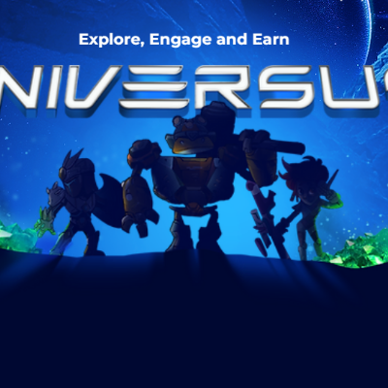
Universus (Take4Games)

Blockchain NFT Play-to-earn game.
Explore worlds and galaxies with players from all around the world.

Attributions:
- Generalist Unity Developer
- UI Specialist

Launch: 2022 Q3
Link: universus.gg

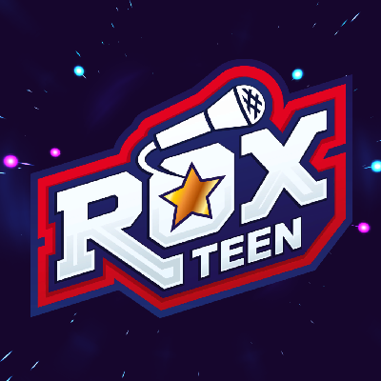
Roxteen: Roxstar (01 Digital)

Rhythm-based game using Roxteen songs. Made with Unity.

Attributions:
- Generalist Unity Developer

Launch: 2021 Q4
Link: Roxteen at Google Play

Luccas Toon App (01 Digital)

Content Hub for Luccas Toon with video streaming, content shop and free-to-play games.

Attributions:
- Generalist Unity Developer

Launch: 2020 Q4
Link: Luccas Toon Oficial


Eistein – 4 Estações (i9Ação)

Serious game for collaborator training.

Attributions:
- Generalist Unity Developer
- VFX
- Sound Design

Launch: 2020 Q3

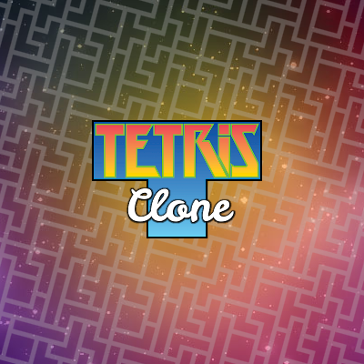
Tetris Clone

Tetris clone made with JavaScript and Phaser.js.

Attributions:
- Solo Game Developer

Launch: 2017 Q3

Featured: Staff Pick at Phaser World #90
Game: link
Phaser World: link

