**Before reprocessing**

* **Resolution:**1.90 Å
* **R-Value Free:**0.185
* **R-Value Work:**0.161
* **Bonds:** 0.011
* **Angles:** 0.987

Molprobity

|  |  |  |  |  |
| --- | --- | --- | --- | --- |
| All-Atom Contacts | Clashscore, all atoms: | 2.17 | | 99th percentile* (N=773, 1.90Å ± 0.25Å) |
| Clashscore is the number of serious steric overlaps (> 0.4 Å) per 1000 atoms. | | | |
| Protein Geometry | Poor rotamers | 6 | 0.95% | Goal: <0.3% |
| Favored rotamers | 594 | 94.29% | Goal: >98% |
| Ramachandran outliers | 0 | 0.00% | Goal: <0.05% |
| Ramachandran favored | 678 | 98.26% | Goal: >98% |
| MolProbity score^ | 0.99 | | 100th percentile* (N=12147, 1.90Å ± 0.25Å) |
| Cβ deviations >0.25Å | 0 | 0.00% | Goal: 0 |
| Bad bonds: | 0 / 5809 | 0.00% | Goal: 0% |
| Bad angles: | 0 / 7845 | 0.00% | Goal: <0.1% |
| Peptide Omegas | Cis Prolines: | 0 / 28 | 0.00% | Expected: ≤1 per chain, or ≤5% |
| Additional validations | Chiral volume outliers | 0/891 | |  |
| Waters with clashes | 12/519 | 2.31% | See UnDowser table for details |

Ligands

22 ethylene glycol, 3 PEG, 2 Citrate

**After reprocessing weight 0.08 * Happy with this**

* **Resolution:**1.90 Å
* **R-Value Free:**0.185
* **R-Value Work:**0.163
* **Bonds:** 0.0105
* **Angles:** 1.547

Molprobity

|  |  |  |  |  |
| --- | --- | --- | --- | --- |
| All-Atom Contacts | Clashscore, all atoms: | 5.13 | | 96th percentile* (N=773, 1.90Å ± 0.25Å) |
| Clashscore is the number of serious steric overlaps (> 0.4 Å) per 1000 atoms. | | | |
| Protein Geometry | Poor rotamers | 5 | 0.78% | Goal: <0.3% |
| Favored rotamers | 599 | 93.89% | Goal: >98% |
| Ramachandran outliers | 0 | 0.00% | Goal: <0.05% |
| Ramachandran favored | 678 | 98.26% | Goal: >98% |
| MolProbity score^ | 1.28 | | 99th percentile* (N=12147, 1.90Å ± 0.25Å) |
| Cβ deviations >0.25Å | 0 | 0.00% | Goal: 0 |
| Bad bonds: | 1 / 5945 | 0.02% | Goal: 0% |
| Bad angles: | 11 / 7991 | 0.14% | Goal: <0.1% |
| Peptide Omegas | Cis Prolines: | 0 / 29 | 0.00% | Expected: ≤1 per chain, or ≤5% |
| Additional validations | Chiral volume outliers | 0/900 | |  |
| Waters with clashes | 22/635 | 3.46% | See UnDowser table for details |

Ligands

48 ethylene glycol, 5 PEG, 2 Citrate, tens of waters added. 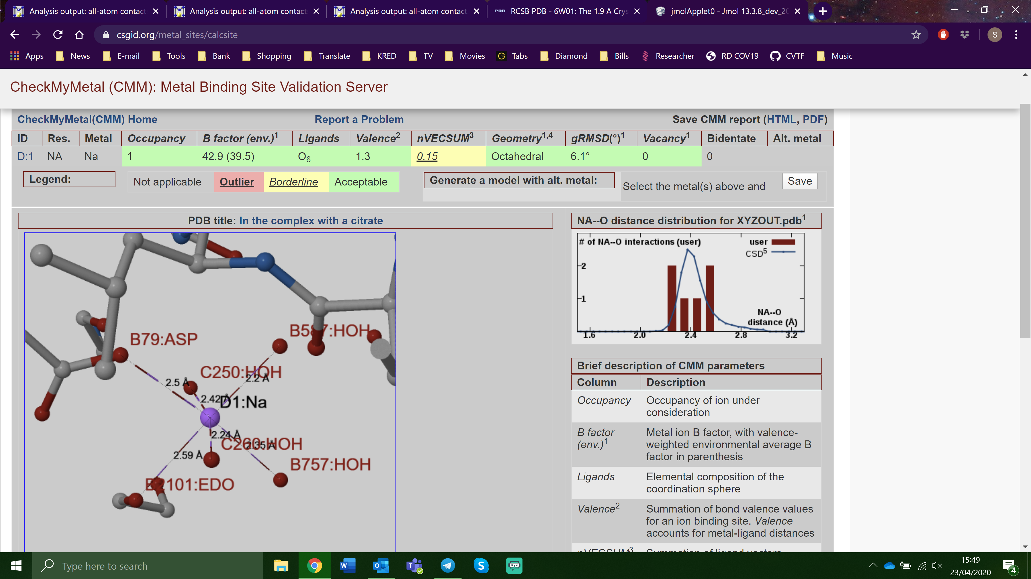

Density in blue are ethylene glycol and PEG present in the original structure. Density in green represents density of 26 additional ethylene glycol and 2 additional PEG molecules added to the reprocessed data. All density are presented at 1 sigma.