Coursework 2 — Practical Evidence
  - DevOps from Code to Application Deployment
Group 4
April 2026
Table of Contents

1 Module Information
This document constitutes the practical evidence submission for Coursework 2 of the Software Engineering and DevOps module. It presents evidence for all five required components as specified in the coursework brief: Docker evidence, Ansible terminal evidence, all Ansible playbooks, the completed Jenkinsfile, and the Jenkins console output for the final build.
The DevOps pipeline implemented follows the architecture described in the coursework specification, encompassing source control via GitHub, containerisation with Docker, infrastructure configuration via Ansible, a Kubernetes deployment managed through Minikube, and a continuous delivery pipeline orchestrated by Jenkins.

2 Docker Evidence
This section provides the Dockerfile written for the cw2-server Node.js application and screenshot evidence that the resulting image was successfully pushed to DockerHub.

2.1 Dockerfile
The Dockerfile below containerises the server.js Node.js application. The node:18-alpine base image was selected for its minimal footprint, reducing image size and potential attack surface. The application directory is set to /app, the source file is copied in, port 8081 is exposed to match the application’s listen port, and the server is started via the Node.js runtime.
FROM node:18-alpine
WORKDIR /app
COPY server.js .
EXPOSE 8081
CMD ["node", "server.js"]
The image was manually built and tagged as cw2-server:1.0 using the following command on the Build Server, prior to being pushed to DockerHub:
docker build -t seanstrcairns/cw2-server:1.0 .
docker push seanstrcairns/cw2-server:1.0

2.2 DockerHub Screenshot
The screenshot below confirms that the cw2-server image with tag 1.0 was successfully pushed to DockerHub and is available for deployment.
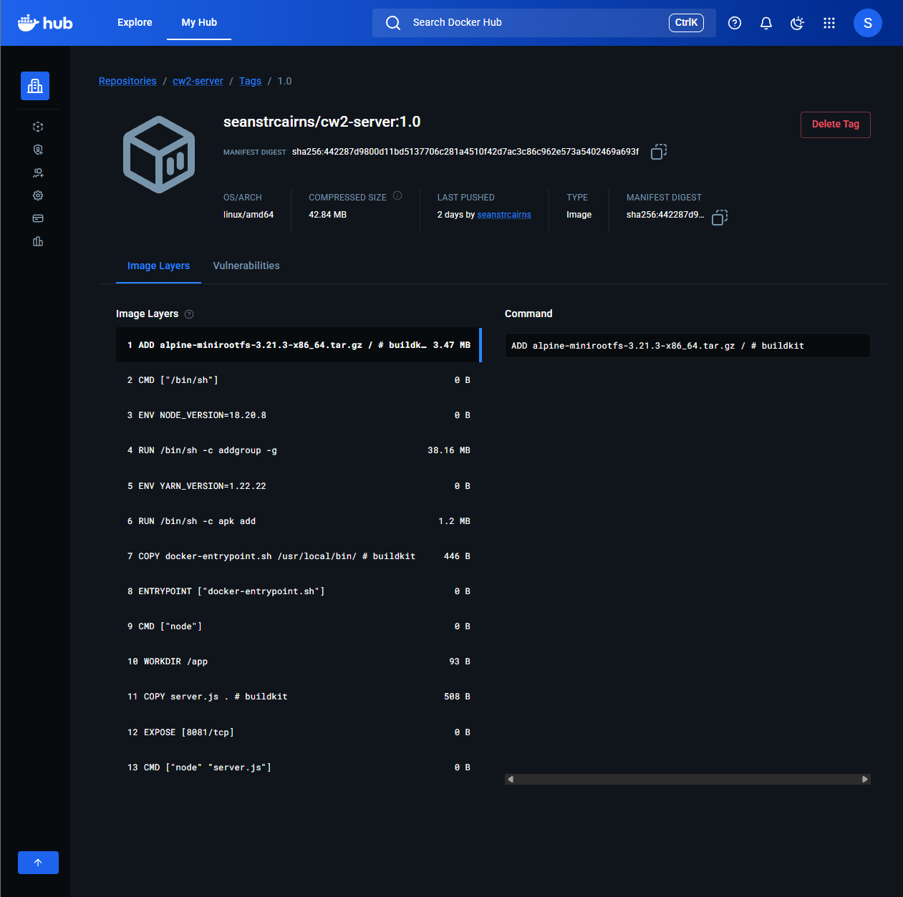
DockerHub repository showing cw2-server image with tag 1.0 successfully pushed.

3 Ansible Evidence
This section provides terminal screenshot evidence confirming that all tasks within each of the five Ansible playbooks completed successfully on the Production Server. Playbooks were executed locally on the Production Server using ansible_connection=local as defined in inventory.ini.

3.1 Playbook 01 — Install kubectl
The screenshot below shows the terminal output confirming that the kubectl binary was downloaded to /usr/local/bin/kubectl, permissions were set, and the installed version was verified successfully.
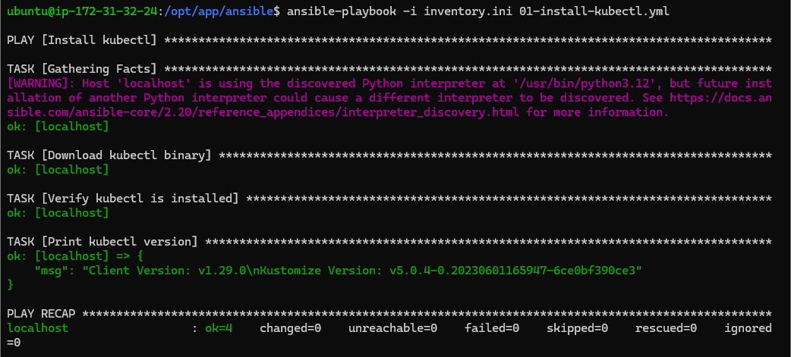
Terminal output: Playbook 01 — kubectl installed and version verified.

3.2 Playbook 02 — Install and Start Minikube
The screenshot below confirms that the Minikube binary was downloaded, Minikube was started using the Docker driver as the ubuntu user, and minikube status confirmed the cluster was running successfully.
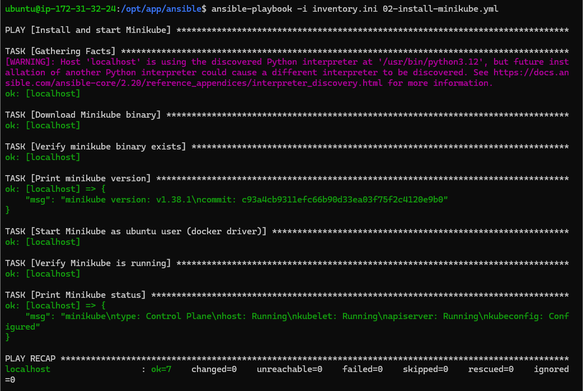
Terminal output: Playbook 02 — Minikube installed and started with Docker driver.

3.3 Playbook 03 — Deploy to Kubernetes
The screenshot below confirms that the cw2-server Kubernetes deployment was created from the DockerHub image (seanstrcairns/cw2-server:1.0) and that kubectl get deployment cw2-server returned a successful status.
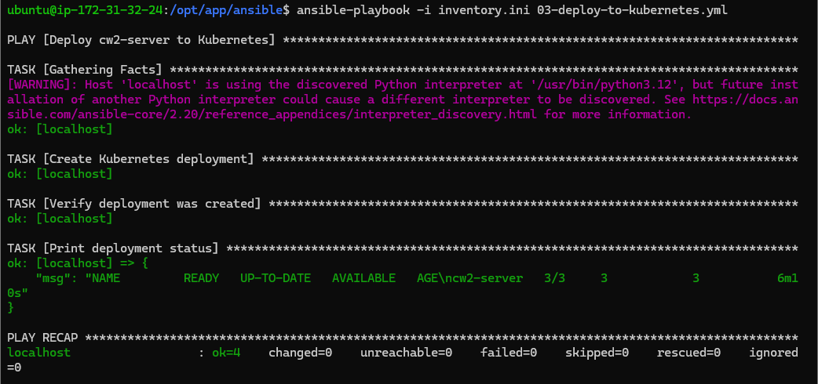
Terminal output: Playbook 03 — cw2-server deployment created in Kubernetes.

3.4 Playbook 04 — Create Kubernetes Service
The screenshot below confirms that a NodePort service was exposed for the cw2-server deployment on port 8081, and the application access URL (Minikube IP and assigned NodePort) was printed successfully.
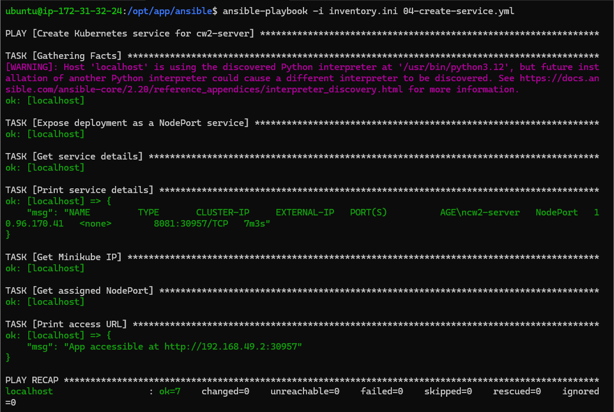
Terminal output: Playbook 04 — NodePort service created and access URL printed.

3.5 Playbook 05 — Scale Deployment for Rolling Updates
The screenshot below confirms that the deployment was scaled to 3 replicas, the rolling update strategy was patched with maxUnavailable: 1 and maxSurge: 1, and kubectl rollout status confirmed all replicas were ready. Three replicas satisfies the rolling update criteria: with maxUnavailable: 1, at least two pods remain available to serve traffic throughout any update.
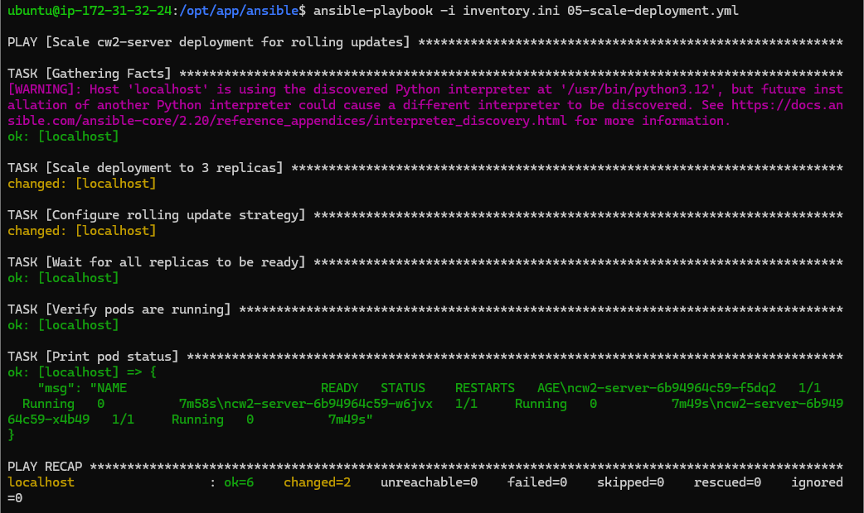
Terminal output: Playbook 05 — Deployment scaled to 3 replicas, rolling update strategy configured.

4 All Ansible Playbooks
The complete source code for all five Ansible playbooks is provided below, along with the inventory file used to target the Production Server.

4.1 Inventory File
[prod]
localhost ansible_connection=local ansible_user=ubuntu
The inventory file defines a single host group (prod) targeting localhost with a local connection, as the playbooks were executed directly on the Production Server.

4.2 Playbook 01 — Install kubectl
---
# Task 2a — Install kubectl
- name: Install kubectl
hosts: prod
become: true
tasks:
- name: Download kubectl binary
get_url:
url: "https://dl.k8s.io/release/v1.29.0/bin/linux/amd64/kubectl"
dest: /usr/local/bin/kubectl
mode: "0755"
- name: Verify kubectl is installed
command: kubectl version --client
register: kubectl_version
changed_when: false
- name: Print kubectl version
debug:
msg: "{{ kubectl_version.stdout }}"

4.3 Playbook 02 — Install and Start Minikube
---
# Task 2b — Install and start Minikube
- name: Install and start Minikube
hosts: prod
become: true
tasks:
- name: Download Minikube binary
get_url:
url: "https://storage.googleapis.com/minikube/releases/latest/minikube-linux-amd64"
dest: /usr/local/bin/minikube
mode: "0755"
- name: Verify minikube binary exists
command: minikube version
register: minikube_version
changed_when: false
- name: Print minikube version
debug:
msg: "{{ minikube_version.stdout }}"
- name: Start Minikube as ubuntu user (docker driver)
become: true
become_user: ubuntu
command: minikube start --driver=docker
args:
creates: /home/ubuntu/.minikube/profiles/minikube/config.json
- name: Verify Minikube is running
become: true
become_user: ubuntu
command: minikube status
register: minikube_status
changed_when: false
- name: Print Minikube status
debug:
msg: "{{ minikube_status.stdout }}"

4.4 Playbook 03 — Deploy to Kubernetes
---
# Task 2c — Deploy image from DockerHub to Kubernetes
- name: Deploy cw2-server to Kubernetes
hosts: prod
become: true
become_user: ubuntu
vars:
dockerhub_username: "seanstrcairns"
image_tag: "1.0"
tasks:
- name: Create Kubernetes deployment
command: >
kubectl create deployment cw2-server
--image={{ dockerhub_username }}/cw2-server:{{ image_tag }}
register: deploy_result
failed_when:
- deploy_result.rc != 0
- '"already exists" not in deploy_result.stderr'
changed_when: '"created" in deploy_result.stdout'
- name: Verify deployment was created
command: kubectl get deployment cw2-server
register: deployment_status
changed_when: false
- name: Print deployment status
debug:
msg: "{{ deployment_status.stdout }}"

4.5 Playbook 04 — Create Kubernetes Service
---
# Task 2d — Create a NodePort service for the application
- name: Create Kubernetes service for cw2-server
hosts: prod
become: true
become_user: ubuntu
tasks:
- name: Expose deployment as a NodePort service
command: >
kubectl expose deployment cw2-server
--type=NodePort
--port=8081
register: service_result
failed_when:
- service_result.rc != 0
- '"already exists" not in service_result.stderr'
changed_when: '"exposed" in service_result.stdout'
- name: Get service details
command: kubectl get service cw2-server
register: service_status
changed_when: false
- name: Print service details
debug:
msg: "{{ service_status.stdout }}"
- name: Get Minikube IP
command: minikube ip
register: minikube_ip
changed_when: false
- name: Get assigned NodePort
command: >
kubectl get service cw2-server
-o jsonpath='{.spec.ports[0].nodePort}'
register: node_port
changed_when: false
- name: Print access URL
debug:
msg: "App accessible at http://{{ minikube_ip.stdout }}:{{ node_port.stdout }}"

4.6 Playbook 05 — Scale Deployment for Rolling Updates
---
# Task 2e — Scale deployment to 3 replicas and configure rolling update strategy
# 3 replicas satisfies the rolling update requirement:
# maxUnavailable=1 means 2 pods always serving traffic during an update
- name: Scale cw2-server deployment for rolling updates
hosts: prod
become: true
become_user: ubuntu
tasks:
- name: Scale deployment to 3 replicas
command: kubectl scale deployment cw2-server --replicas=3
register: scale_result
changed_when: '"scaled" in scale_result.stdout'
- name: Configure rolling update strategy
command: >
kubectl patch deployment cw2-server
-p '{"spec":{"strategy":{"type":"RollingUpdate",
"rollingUpdate":{"maxUnavailable":1,"maxSurge":1}}}}'
register: patch_result
changed_when: '"patched" in patch_result.stdout'
- name: Wait for all replicas to be ready
command: kubectl rollout status deployment/cw2-server
register: rollout_status
changed_when: false
- name: Verify pods are running
command: kubectl get pods
register: pods_status
changed_when: false
- name: Print pod status
debug:
msg: "{{ pods_status.stdout }}"

5 Completed Jenkinsfile
The Jenkinsfile below defines the full five-stage continuous delivery pipeline. It is configured as a Jenkins Pipeline Project and is triggered automatically by changes pushed to the GitHub repository via a webhook. Each stage is described in turn below.
Stage 1 — Checkout: Pulls the latest commit from the configured GitHub repository using the checkout scm directive, ensuring the pipeline always operates on the current codebase.
Stage 2 — Build Image: Builds a Docker image from the Dockerfile in the repository root, tagging it with both the Jenkins BUILD_NUMBER (for traceability) and latest. DockerHub credentials are injected securely via a Jenkins credential binding.
Stage 3 — Build Test: Launches a test container from the newly built image, waits five seconds for the Node.js process to initialise, verifies the runtime is present using node --version, and performs an HTTP health check via curl against the container’s internal IP on port 8081. The test container is always cleaned up in the post { always } block regardless of pass or fail.
Stage 4 — Push to DockerHub: Authenticates with DockerHub using the stored credentials and pushes both the build-numbered and latest tags, making the image available for deployment.
Stage 5 — Deploy to Kubernetes: This stage runs on the prod-node Jenkins agent (the Production Server), allowing it to issue kubectl commands directly without SSH. It performs a rolling update via kubectl set image and waits for the rollout to complete cleanly using kubectl rollout status, ensuring zero-downtime deployment.
pipeline {
agent any
triggers {
githubPush()
}
environment {
DOCKERHUB_CREDENTIALS = credentials('dockerhub-creds')
IMAGE_NAME = "${DOCKERHUB_CREDENTIALS_USR}/cw2-server"
}
stages {
stage('Checkout') {
steps {
checkout scm
}
}
stage('Build Image') {
steps {
sh "docker build -t ${IMAGE_NAME}:${BUILD_NUMBER} ."
sh "docker tag ${IMAGE_NAME}:${BUILD_NUMBER} ${IMAGE_NAME}:latest"
}
}
stage('Build Test') {
steps {
sh """
docker run -d --name test-${BUILD_NUMBER} \
-p 8082:8081 ${IMAGE_NAME}:${BUILD_NUMBER}
sleep 5
docker exec test-${BUILD_NUMBER} node --version
CONTAINER_IP=\$(docker inspect \
-f '{{range.NetworkSettings.Networks}}{{.IPAddress}}{{end}}' \
test-${BUILD_NUMBER})
curl -f http://\$CONTAINER_IP:8081 || exit 1
"""
}
post {
always {
sh """
docker stop test-${BUILD_NUMBER} || true
docker rm test-${BUILD_NUMBER} || true
"""
}
}
}
stage('Push to DockerHub') {
steps {
sh "echo ${DOCKERHUB_CREDENTIALS_PSW} | \
docker login -u ${DOCKERHUB_CREDENTIALS_USR} --password-stdin"
sh "docker push ${IMAGE_NAME}:${BUILD_NUMBER}"
sh "docker push ${IMAGE_NAME}:latest"
}
}
stage('Deploy to Kubernetes') {
agent { label 'prod-node' }
steps {
sh """
/usr/local/bin/kubectl set image deployment/cw2-server \
cw2-server=${IMAGE_NAME}:${BUILD_NUMBER}
/usr/local/bin/kubectl rollout status deployment/cw2-server
"""
}
}
}
post {
always {
sh "docker logout || true"
}
success {
echo "Pipeline succeeded — build ${BUILD_NUMBER} deployed to Kubernetes."
}
failure {
echo "Pipeline failed at build ${BUILD_NUMBER}."
}
}
}

6 Jenkins Console Output
The full Jenkins console output for the final successful build is provided below. When reviewing the output, note the following key events:
- Docker image creation — evident in the Build Image stage where docker build reports each layer being processed and the image being tagged.
- Docker image push to DockerHub — evident in the Push to DockerHub stage where each layer digest is confirmed as pushed.
- Kubernetes update command — evident in the Deploy to Kubernetes stage where kubectl set image is issued and kubectl rollout status confirms the rolling update completed successfully.
Started by user admin
Obtained Jenkinsfile from git https://github.com/Cairnstew/SE_DevOps_Group_4_Coursework_2.git
[Pipeline] Start of Pipeline
[Pipeline] node
Running on Jenkins in /var/jenkins_home/workspace/SE_DevOps_Group_4_CW2
[Pipeline] {
[Pipeline] stage
[Pipeline] { (Declarative: Checkout SCM)
[Pipeline] checkout
Selected Git installation does not exist. Using Default
The recommended git tool is: NONE
using credential cw2-repo-token
Cloning the remote Git repository
Cloning repository https://github.com/Cairnstew/SE_DevOps_Group_4_Coursework_2.git
> git init /var/jenkins_home/workspace/SE_DevOps_Group_4_CW2 # timeout=10
Fetching upstream changes from https://github.com/Cairnstew/SE_DevOps_Group_4_Coursework_2.git
> git --version # timeout=10
> git --version # 'git version 2.47.3'
using GIT_ASKPASS to set credentials GitHub repo credentials
> git fetch --tags --force --progress -- https://github.com/Cairnstew/SE_DevOps_Group_4_Coursework_2.git +refs/heads/*:refs/remotes/origin/* # timeout=10
> git rev-parse refs/remotes/origin/master^{commit} # timeout=10
> git config core.sparsecheckout # timeout=10
> git checkout -f e18f3085e1909dbc93d86c80100f64b766edd325 # timeout=10
Commit message: "feat(terraform): Update prod_server init"
First time build. Skipping changelog.
[Pipeline] }
[Pipeline] // stage
[Pipeline] withEnv
[Pipeline] {
[Pipeline] withCredentials
Masking supported pattern matches of $DOCKERHUB_CREDENTIALS or $DOCKERHUB_CREDENTIALS_PSW
[Pipeline] {
[Pipeline] withEnv
[Pipeline] {
[Pipeline] stage
[Pipeline] { (Checkout)
[Pipeline] checkout
Selected Git installation does not exist. Using Default
The recommended git tool is: NONE
using credential cw2-repo-token
> git rev-parse --resolve-git-dir /var/jenkins_home/workspace/SE_DevOps_Group_4_CW2/.git # timeout=10
Fetching changes from the remote Git repository
> git config remote.origin.url https://github.com/Cairnstew/SE_DevOps_Group_4_Coursework_2.git # timeout=10
> git fetch --tags --force --progress -- https://github.com/Cairnstew/SE_DevOps_Group_4_Coursework_2.git +refs/heads/*:refs/remotes/origin/* # timeout=10
> git rev-parse refs/remotes/origin/master^{commit} # timeout=10
> git config core.sparsecheckout # timeout=10
> git checkout -f e18f3085e1909dbc93d86c80100f64b766edd325 # timeout=10
Commit message: "feat(terraform): Update prod_server init"
[Pipeline] }
[Pipeline] // stage
[Pipeline] stage
[Pipeline] { (Build Image)
[Pipeline] sh
+ docker build -t seanstrcairns/cw2-server:1 .
#0 building with "default" instance using docker driver
#1 [internal] load build definition from Dockerfile
#1 transferring dockerfile: 128B done
#1 DONE 0.0s
#2 [internal] load metadata for docker.io/library/node:18-alpine
#2 DONE 0.4s
#3 [internal] load .dockerignore
#3 transferring context: 2B done
#3 DONE 0.0s
#4 [internal] load build context
#4 transferring context: 744B done
#4 DONE 0.0s
#5 [1/3] FROM docker.io/library/node:18-alpine@sha256:8d6421d663b4c28fd3ebc498332f249011d118945588d0a35cb9bc4b8ca09d9e
#5 DONE 2.6s
#6 [2/3] WORKDIR /app
#6 DONE 0.3s
#7 [3/3] COPY server.js .
#7 DONE 0.0s
#8 exporting to image
#8 exporting layers 0.1s done
#8 exporting manifest sha256:e6386d480b03962b76ab92d72f0d77cbb75e7714bfc5367e396c1466ba4e0207 0.0s done
#8 exporting config sha256:2bb889639612f81013829b044be37dc4808d87211666f8c1fe7f2ac308b96711 0.0s done
#8 naming to docker.io/seanstrcairns/cw2-server:1 done
#8 DONE 0.3s
[Pipeline] sh
+ docker tag seanstrcairns/cw2-server:1 seanstrcairns/cw2-server:latest
[Pipeline] }
[Pipeline] // stage
[Pipeline] stage
[Pipeline] { (Build Test)
[Pipeline] sh
+ docker run -d --name test-1 -p 8082:8081 seanstrcairns/cw2-server:1
7c037818ec4c12f0aae4e41dac03adf28d9c267db8c1992e4ef45f6bfc1e1160
+ sleep 5
+ docker exec test-1 node --version
v18.20.8
+ docker inspect -f {{range.NetworkSettings.Networks}}{{.IPAddress}}{{end}} test-1
+ CONTAINER_IP=172.17.0.3
+ curl -f http://172.17.0.3:8081
100 54 0 54 0 0 6114 0 --:--:-- --:--:-- --:--:-- 6750
DevOps Coursework 2! | Running on: 7c037818ec4c | v=0
Post stage
[Pipeline] sh
+ docker stop test-1
test-1
+ docker rm test-1
test-1
[Pipeline] }
[Pipeline] // stage
[Pipeline] stage
[Pipeline] { (Push to DockerHub)
[Pipeline] sh
+ echo ****
+ docker login -u seanstrcairns --password-stdin
Login Succeeded
[Pipeline] sh
+ docker push seanstrcairns/cw2-server:1
The push refers to repository [docker.io/seanstrcairns/cw2-server]
087c97b5ad67: Pushed
752efecf1de3: Pushed
6a55c6285ab5: Pushed
1: digest: sha256:5834215cebf8b5a0439d084ab455735c9e56e2983e38cf723c550eac6eff4624 size: 856
[Pipeline] sh
+ docker push seanstrcairns/cw2-server:latest
The push refers to repository [docker.io/seanstrcairns/cw2-server]
latest: digest: sha256:5834215cebf8b5a0439d084ab455735c9e56e2983e38cf723c550eac6eff4624 size: 856
[Pipeline] }
[Pipeline] // stage
[Pipeline] stage
[Pipeline] { (Deploy to Kubernetes)
[Pipeline] node
Running on prod-node in /home/ubuntu/jenkins/workspace/SE_DevOps_Group_4_CW2
[Pipeline] {
[Pipeline] sh
+ /usr/local/bin/kubectl set image deployment/cw2-server cw2-server=seanstrcairns/cw2-server:1
deployment.apps/cw2-server image updated
+ /usr/local/bin/kubectl rollout status deployment/cw2-server
Waiting for deployment "cw2-server" rollout to finish: 1 out of 3 new replicas have been updated...
Waiting for deployment "cw2-server" rollout to finish: 2 out of 3 new replicas have been updated...
Waiting for deployment "cw2-server" rollout to finish: 2 out of 3 new replicas have been updated...
Waiting for deployment "cw2-server" rollout to finish: 2 out of 3 new replicas have been updated...
Waiting for deployment "cw2-server" rollout to finish: 1 old replicas are pending termination...
Waiting for deployment "cw2-server" rollout to finish: 2 of 3 updated replicas are available...
deployment "cw2-server" successfully rolled out
[Pipeline] }
[Pipeline] // withEnv
[Pipeline] }
[Pipeline] // node
[Pipeline] }
[Pipeline] // stage
[Pipeline] stage
[Pipeline] { (Declarative: Post Actions)
[Pipeline] sh
+ docker logout
Removing login credentials for https://index.docker.io/v1/
[Pipeline] echo
Pipeline succeeded — build 1 deployed to Kubernetes.
[Pipeline] }
[Pipeline] // stage
[Pipeline] }
[Pipeline] // withEnv
[Pipeline] }
[Pipeline] // withCredentials
[Pipeline] }
[Pipeline] // withEnv
[Pipeline] }
[Pipeline] // node
[Pipeline] End of Pipeline
Finished: SUCCESS

