# Task 1: Kelly Author, Caitlin Reviewer
rm(list=ls())

# STS3470 Project 2: Caitlin Bedway and Kelly Donovan
library(dplyr)

wald_int <- function(x, n, alpha){
phat <- x/n
moe <- qnorm(.975)*sqrt(phat*(1-phat)/n)
lower <- phat-moe
upper <- phat+moe
confint <- c(lower, upper)
return(confint)
}

wald_int(126, 570, 0.05) # 0.1869873 0.2551180

# Task 2: Kelly Author, Caitlin Reviewer
set.seed(1008)
truep <- 1/6
n <- 100
out <- rbinom(n, 1, truep)

# Use the sum() function to calculate the value of x which will indicate count
# how many of your dice rolls were 6’s.
x <- sum(out) # 18/100 rolls were 'sixes'

wald_int(x = 18, n = 100, alpha = 0.05) # LB: 0.105 UB: 0.255
# ANS: Yes, the true population proportion (1/6, 0.166667), is within
# the interval.

out_x <- replicate(1000, (sum(rbinom(n, 1, truep))))

# for-loop
CI_Wald <- matrix(NA, nrow=1000, ncol=2)
CIcount <- NULL

for(i in 1:1000){
CI_Wald[i,] <- wald_int(x = out_x[i], n = 100, alpha = 0.05)
CIcount[i] <- if_else((CI_Wald[i,1] <= 1/6 & CI_Wald[i,2] >= 1/6),
1, 0)
}
sum(CIcount)/1000

# The Wald confidence interval achieves approximately 93.8% confidence.
# This does not technically meet 95% confidence, but it is very close.
# After running through 1000 simulations with sample size 100 (generated
# with 95% confidence each time) the proportion of times that our truep,
# 1/6, fell into our confidence interval is 0.938.

# Task 3: Kelly Author, Caitlin Reviewer

set.seed(1008)
truep <- 0.94
n <- 30
out <- rbinom(n, 1, truep)

# Use the sum() function to calculate the value of x which will indicate
# count how many of your dice rolls were 6’s.

x <- sum(out) #

wald_int(x = 26, n = 30, alpha = 0.05) # LB: 0.745 UB: 0.988
# Yes, the true population proportion (0.94), is within
# the interval.

out_x <- replicate(1000, (sum(rbinom(n, 1, truep))))

# for-loop

CI_Wald <- matrix(NA, nrow=1000, ncol=2)
CIcount <- NULL

for(i in 1:1000){
CI_Wald[i,] <- wald_int(x = out_x[i], n = 30, alpha = 0.05)
CIcount[i] <- if_else((CI_Wald[i,1] <= 0.94 & CI_Wald[i,2] >= 0.94),
1, 0)
}
sum(CIcount)/1000

# The Wald confidence interval achieves approximately 82.3% confidence.
# This does not meet our 95% confidence goal, and is not close.
# After running through 1000 simulations with sample size 100 (generated
# with 95% confidence each time) the proportion of times that our truep,
# 0.94, fell into our confidence interval is 0.0.823.

# Task 4: Caitlin Author, Kelly Reviewer
agresti_int <- function(x, n, alpha) {
set.seed(1008)
x <- x #or NULL
n <- n
alpha <- alpha
zstar <- qnorm(1-alpha/2)
phat_ac <- (x + (zstar^2)/2)/(n+(zstar^2))
moe_ac <- zstar*sqrt((phat_ac*(1-phat_ac))/(n+(zstar^2)))
lower <- phat_ac - moe_ac
upper <- phat_ac + moe_ac
return(c(lower=lower, upper=upper))
}

#Red skittles proportions
agresti_int(126, 570, 0.05) # LB: 0.189 UB: 0.257
# ANS: Yes, the true population proportion (1/6, 0.166667), is within
# the interval.

# How does this interval compare to the interval you generated in Task #1
# to the new Agresti-Coull interval?
# ANS: The intervals are very similar to each other.

# Task 5: Caitlin Author, Kelly Reviewer
set.seed(1008)
truep <- 1/6
n <- 100
out <- rbinom(n, 1, truep)

# Use the sum() function to calculate the value of x which will indicate
# count how many of your dice rolls were 6’s.
x <- sum(out) # 18/100 rolls were 'sixes'

agresti_int(x = 18, n = 100, alpha = 0.05) # LB: 0.116 UB: 0.268
# ANS: Yes, the true population proportion (1/6, 0.166667), is within
# the interval.

out_x <- replicate(1000, (sum(rbinom(n, 1, truep))))

# forloop
CI_AC <- matrix(NA, nrow=1000, ncol=2)
CI_AC_count <- NULL

for(i in 1:1000){
CI_AC[i,] <- agresti_int(x = out_x[i], n = 100, alpha = 0.05)
CI_AC_count[i] <- if_else((CI_AC[i,1] <= 1/6 & CI_AC[i,2] >= 1/6),
1, 0)
}
sum(CI_AC_count)/1000

# The Agresti-Coull confidence interval achieves approximately 94.8% confidence.
# This does not technically meet 95% confidence, but it is very close.
# After running through 1000 simulations with sample size 100 (generated
# with 95% confidence each time) the proportion of times that our truep,
# 1/6, fell into our confidence interval is 0.948.

set.seed(1008)
truep <- 0.94
n <- 30
out <- rbinom(n, 1, truep)

# Use the sum() function to calculate the value of x which will indicate
# count how many of your dice rolls were 6’s.

x <- sum(out) # 26/30
x

agresti_int(x = 26, n = 30, alpha = 0.05) # LB: 0.697 UB: 0.953
# Yes, the true population proportion (0.94), is within
# the interval.

out_x <- replicate(1000, (sum(rbinom(n, 1, truep))))

# forloop
CI_AC <- matrix(NA, nrow=1000, ncol=2)
CI_AC_count <- NULL

for(i in 1:1000){
CI_AC[i,] <- agresti_int(x = out_x[i], n = 30, alpha = 0.05)
CI_AC_count[i] <- if_else((CI_AC[i,1] <= 0.94 & CI_AC[i,2] >= 0.94),
1, 0)
}
sum(CI_AC_count)/1000

# The Agresti confidence interval achieves approximately 97.2% confidence.
# This meets and goes above our 95% confidence goal.
# After running through 1000 simulations with sample size 100 (generated
# with 95% confidence each time) the proportion of times that our truep,
# 0.94, fell into our confidence interval is 0.972.

# Task 6: Kelly Author, Caitlin Reviewer

- Shiny app URL: https://kellydonovan-03.shinyapps.io/sts3470_project2_shinyapp/

Overall, it seems that Agresti-Coull confidence intervals are better, especially with smaller sample sizes and when population proportions differ from 0.5. As we can see with screen shots one and two (where p is 0.5 for both and the only difference is big vs. small n), both confidence intervals seem to do alright. The best is when we have a large sample size and a p of 0.5, and in our case, where both intervals have the same proportions of capturing our true p. When sample size decreases to 10 (with the same p), the Wald CI’s proportion of obtaining the true p drops to ~0.90, while our AC CI continues to stay high ~0.98.

When we switch to having a very HIGH p of 0.94, and comparing n = 50 and n = 10, we see some drastic changes between having a p of 0.5. The AC CI continues to be high at ~0.97, while the Wald CI drastically drops to ~0.8. Then, when we decrease to n = 10, the Wald CI proportion of obtaining our true p drops all the way to ~0.47, while AC stays high at ~0.97. Overall, we think it’s very clear that while Wald is consistent when the true p is close or equal to 0.5, the more the true p gets closer to 0 or 1, and/or the sample size is small, the accuracy of using Wald decreases, all while AC stays quite consistent!

1)
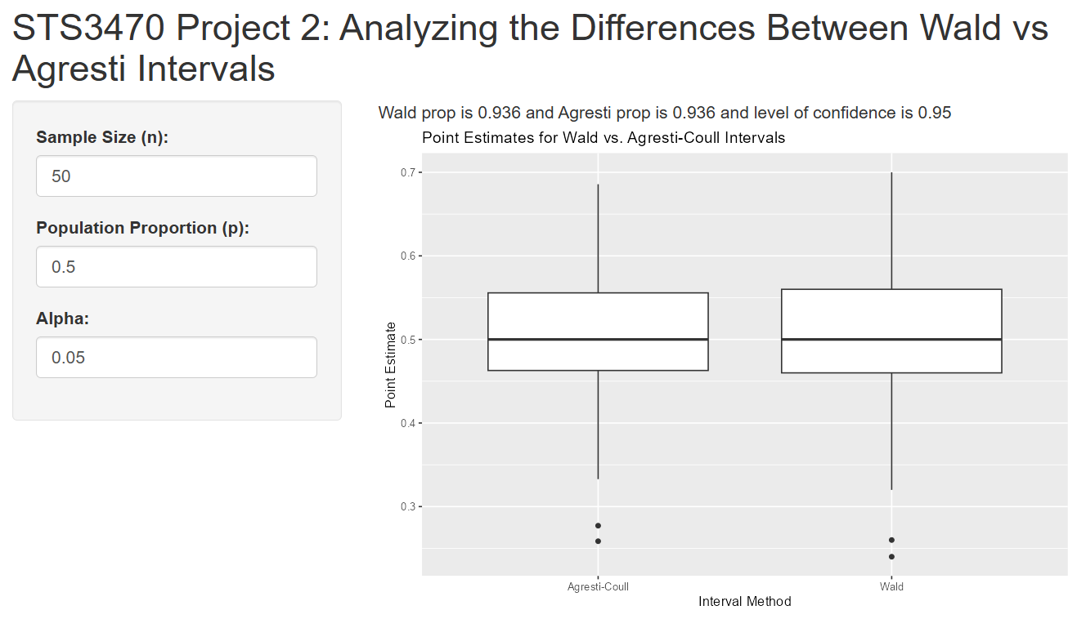
2)
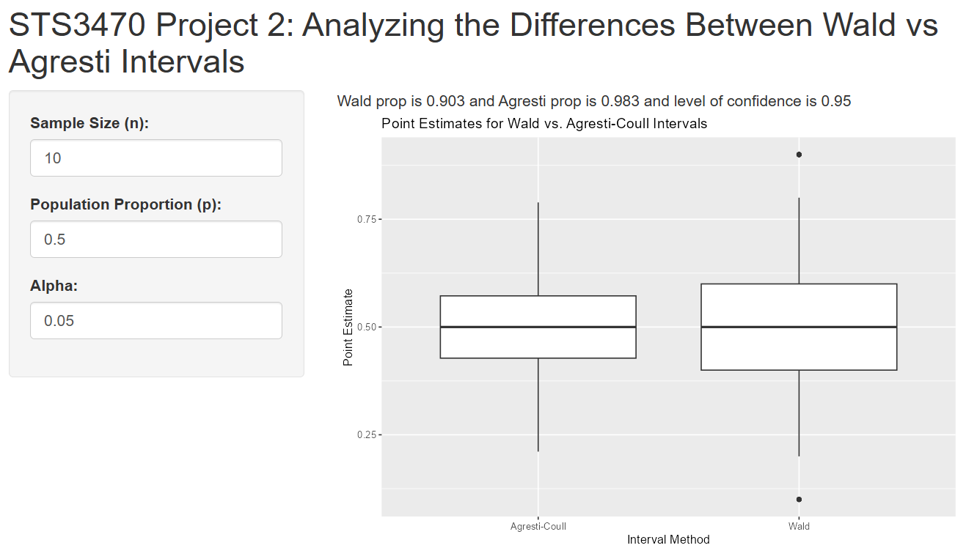

3)
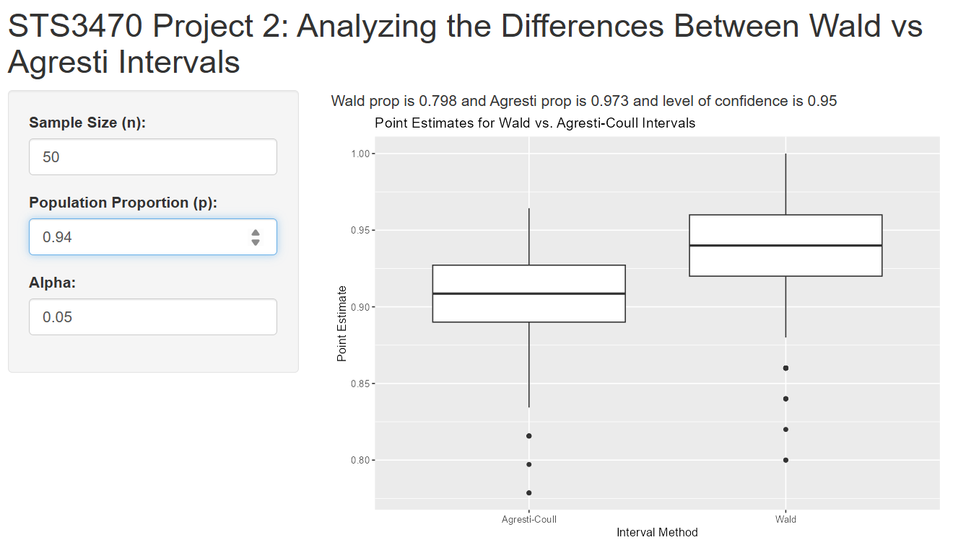

4)
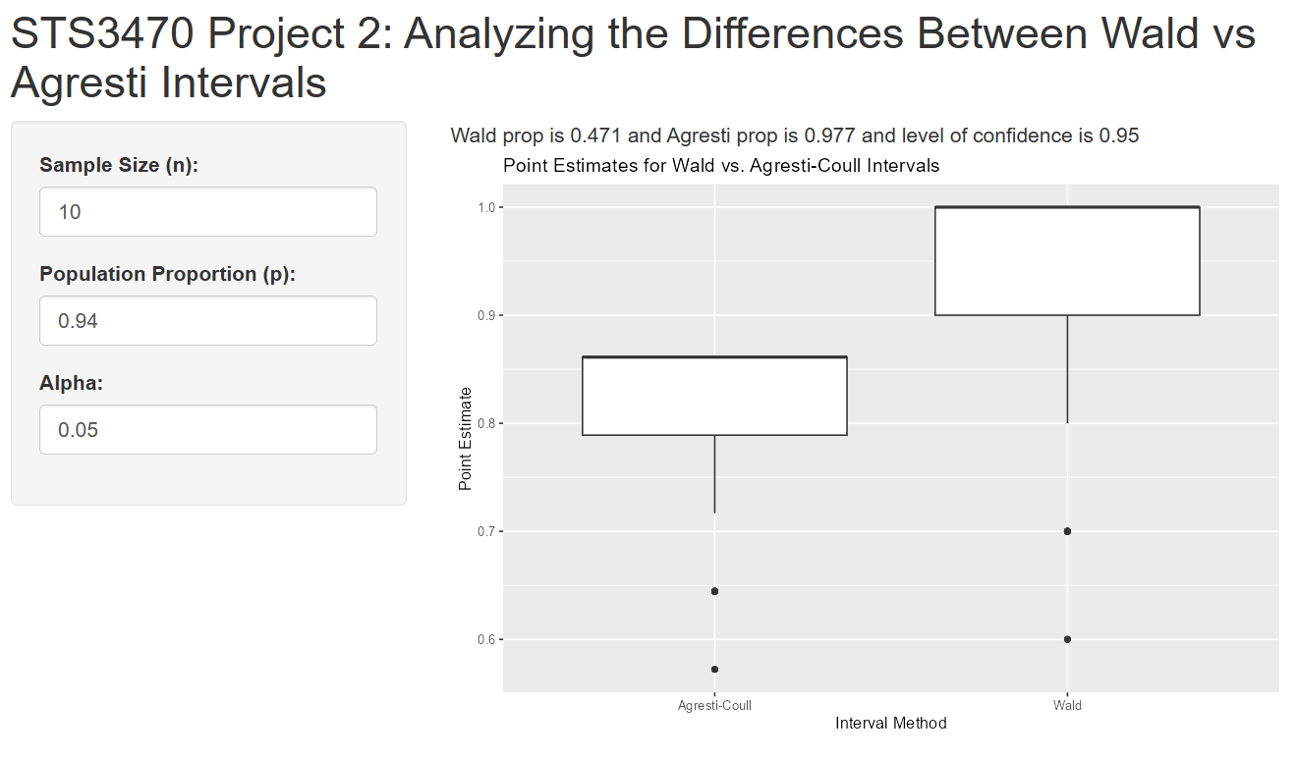

Shiny app code:
rm(list=ls())

library(shiny)
library(tidyverse)
library(ggplot2)

wald_int <- function(x, n, alpha){
phat <- x/n
moe <- qnorm(.975)*sqrt(phat*(1-phat)/n)
lower <- phat-moe
upper <- phat+moe
confint <- c(lower, upper)
return(confint)
}

agresti_int <- function(x, n, alpha){
zstar <- qnorm(1-alpha/2)
phat_ac <- (x + (zstar^2)/2)/(n+(zstar^2))
moe_ac <- zstar*sqrt((phat_ac*(1-phat_ac))/(n+(zstar^2)))
lower <- phat_ac-moe_ac
upper <- phat_ac+moe_ac
confint <- c(lower, upper)
return(confint)
}

ui <- fluidPage(

titlePanel("STS3470 Project 2: Analyzing the Differences Between Wald vs Agresti Intervals"),

sidebarLayout(
sidebarPanel(
numericInput("n",
"Sample Size (n):",
value = 100),
numericInput("truep",
"Population Proportion (p):",
value= (1/6)),
numericInput("alpha",
"Alpha:",
value = 0.05)
),

mainPanel(
textOutput("myText"),
plotOutput("myDist")
)
)
)

server <- function(input, output) {

generatedata <- reactive({
out_x <- replicate(1000, (sum(rbinom(input$n, 1, input$truep))))
#wald for-loop
CI_Wald <- matrix(NA, nrow=1000, ncol=2)
CIcount <- numeric(1000)

for(i in 1:1000){
CI_Wald[i,] <- wald_int(x = out_x[i], input$n, input$alpha)
CIcount[i] <- if_else((CI_Wald[i,1] <= input$truep & CI_Wald[i,2] >= input$truep),
1, 0)
}
#agresti for-loop
CI_AC <- matrix(NA, nrow=1000, ncol=2)
CIcount_AC <- numeric(1000)

for(i in 1:1000){
CI_AC[i,] <- agresti_int(x = out_x[i], input$n, input$alpha)
CIcount_AC[i] <- if_else((CI_AC[i,1] <= input$truep & CI_AC[i,2] >= input$truep),
1, 0)
}
list(
CI_Wald = CI_Wald,
Wald_prop = sum(CIcount)/1000,
CI_AC = CI_AC,
AC_prop = sum(CIcount_AC)/1000
)
})

output$myText <- renderText({
mydata <- generatedata()
paste0("Wald prop is ",
mydata$Wald_prop,
" and Agresti prop is ",
mydata$AC_prop,
" and level of confidence is ",
(1 - input$alpha))

})
output$myDist <- renderPlot({
mydata <- generatedata()
# point estimates
Wald_points <- (mydata$CI_Wald[,1] + mydata$CI_Wald[,2])/2
AC_points <- (mydata$CI_AC[,1] + mydata$CI_AC[,2])/2

# create proper data frame for ggplot
data <- data.frame(myx = c(Wald_points, AC_points),
mygroup = c(rep("Wald", 1000), rep("Agresti-Coull", 1000)))

# generate boxplot
ggplot(data, aes(x = factor(mygroup), y = myx)) +
geom_boxplot() +
labs(title = "Point Estimates for Wald vs. Agresti-Coull Intervals",
x = "Interval Method",
y = "Point Estimate")
})
}

# Run the application
shinyApp(ui = ui, server = server)

Task 7: Reflection, Contributions, Peer Evaluation
Your answers will be graded based on the depth and clarity of the response.
1) What did you learn about statistics in this project?
My main focus for this project was understanding the code rather than just copy pasting it. For our exam, I felt this was good practice on analyzing code and output while working with new topics. Specifically, we also learned about the Wald interval and the Agresti-Coull interval. I learned by working with the Agresti-Coull interval and comparing it to our interpretation of the Wald interval that the Agresti-Coull is more likely to meet our 95% confidence that we wanted, because it is an improvement of the Wald interval, which has coverage issues.

2) What did you learn about R coding in this project?
I feel more confident with coding and applying functions to specific examples, like we did in Task 4, where we checked our code with the proportions of red skittles. To do this, we had to actually use the function we created and I feel that I was overcomplicating it before, but it makes more sense now that we’ve used it in this project. I also feel like using forloops becomes more clear with practice, specifically when we reference the index (EX: CI_AC[i,]). I know this was something I was struggling with understanding before. Finally, coding the lower and upper bounds was confusing for me at first, then I read the description for moe and realized what it actually represented was margin of error and it made more sense to me.

3) What would you do differently if starting this project all over again and why?
I honestly believe my biggest challenge was sticking to the timelines we set for ourselves regarding the project. I was very busy with other classes and social events related to my leadership position in a club sports organization. I kept pushing it off until now, which resulted in Kelly doing more work, which I regret. Our original plan was that we would both attempt the shiny app portion, but she did the majority of the work in that section.

Teammate: Kelly Donovan
1) Which of the following best describes this teammate’s contributions?
Kelly is best describes as option a, the “Michael Jordan”/GOAT Member

2) What would you say is the greatest contribution this teammate made to the overall success of the project?
Her work with the shiny app is unmatched, she always goes above and beyond in our projects and stays on task, she’s very organized and gets her work done quickly.

3) Approximately what percent of the group work did each team member and you contribute? (This should add up to 100%!)
I did 40%, Kelly did 60%.

