**1 | INTRODUCTION**

broadest intro to subsurface life in continents

subsurface biosphere theoretically extends to depths where physicochemical limits of life exist (pressure, temperature, liquid water) and has been found as deep as 2.8km (Chivian 2008)

challenges of deep subsurface metabolisms and physiologies, minerals as growth substrates in the subsurface

description of subsurface conditions –no sunlight, limited organic carbon and oxygen, water-rock reactions generate chemical disequilibrium that provides dissolved electron donors and acceptors, host rock provides insoluble electron donors/acceptors

places where subsurface life can live (aquifers, fracture fluids, fluids in pore spaces in rocks, on rock surfaces)

continental subsurface hosts large/diverse biosphere

reference recent total continental subsurface biomass estimates including suspended + biofilm from Magnabasco and Flemming papers

reference genomic surveys from fluids from deep continental settings: Osburn 2014 (DeMMO), Woycheese 2015 (Philippines serp), Twing 2017 (CROMO), Probst 2018 (Crystal Geyser), Magnabasco 2016 (SA gold mine)

Previous studies have investigated deep continental biofilms using both laboratory based and in situ cultivation approaches. These studies were among the first to shed light on the attached fraction of the deep biosphere, noting the potential for significant diversity and biomass in biofilm communities and their implications for astrobiology:

**Lab-based:**

**Keptra 1998** - Bacterial mineralization patterns in basaltic aquifers: Implications for possible life in martian meteorite ALH84001

Incubated rock chips collected from CRB and described formation and preservation of biofilm biogenic features, related CRB to subsurface of Mars

**In situ:**

**Wanger 2006** – SA gold mine biofilms

* + - * Recognized that microbial studies of deep subsurface environments have relied primarily upon planktonic communities carried by the fluids either pumped to the surface or released from fractures during subsurface drilling, lack of studies on attached biosphere
      * provided the first direct observation of the sessile population from the terrestrial deep subsurface
      * they collected rocks from a water-bearing fracture surface (no in situ cultivation) and imaged with SEM – shows cell morphologies and EPS structures
      * mention possible timescales for biofilm development
      * suggest importance of Ca+/Mg+ ions for biofilm development (salt bridging, adsorption to surfaces)
      * they approximated biofilm cell densities and compare to cartridge experiments from Moser 2003, argue that cartridge experiments aren’t representative of system bc they resulted in much higher biomass than what was observed on fracture rock samples
        + they suggest this is possibly due to the initial exposure of the fracture fluids to oxygen when the experiment is installed, which could have coated the experiment materials in atomic scale oxides, and these are what the cells are interfacing with rather than the actual rock surface
      * “surfaces enhance bacterial growth” – their estimates of attached vs suspended biomass resulted in higher proportion of attached
    - **Moser 2003** (SA gold mine) - Temporal Shifts in the Geochemistry and Microbial Community Structure of an Ultradeep Mine Borehole Following Isolation
      * Used cartridge experiment to characterize biofilm community from fluid-filled fracture using PLFA, 16s DNA, stable isotopes, fluid chemistry, SEM, thermo modelling
      * They compared suspended to attached community composition and interpreted possible metabolisms
      * They recognize the presence of a distinct continental deep subsurface biosphere that deserved attention
    - **Henneberger 2006** (Germany)- New Insights into the Lifestyle of the Cold-Loving SM1 Euryarchaeon: Natural Growth as a Monospecies Biofilm in the Subsurface
      * Used in situ cultivation – polyethylene nets – to cultivate biofilms from sulfidic spring waters emanating from drillhole into subsurface (to unknown depth) – their experiment was at 75cm depth
      * Discovered a novel archaea that formed unique string-of-pearls biofilm in monophyletic community – this organism was later detected via metagenomic survey in Crystal Geyser system in Utah (Probst 2014). Probst 2014 dubbed the organism “Altiarchaeales”, describing the widespread nature of this subsurface biofilm-forming archaeon. It is autotrophic, important for C cycle in deep biosphere. Also forms ‘grappling hook’ structures, important for cell attachment to surfaces.
    - **Baker 2003** - Related assemblages of sulphate-reducing bacteria associated with ultradeep gold mines of South Africa and deep basalt aquifers of Washington State
      * Compared sulfate reducers between CRB aquifer and SA gold mine fractures and found to be closely related, suggested widespread nature of deep subsurface sulfate reducers

These previous studies paved the way for a more in-depth exploration of deep subsurface biofilm communities in the recently established Deep Mine Microbial Observatory (DeMMO) located in the former Homestake Gold Mine in Lead, South Dakota, USA.

DeMMO as a place and stuff we have done there

Good place to study continental deep subsurface biosphere

convenient/easy/safe access to fracture fluids spanning range of depths, making it possible to sample fluids interacting with a variety of continental rock types and track changes in fluid chemistry/microbial communities with depth.

Observatory makes long-term monitoring and experiments possible.

Location – Black Hills, SD, SURF, former Homestake Gold mine

Geology/hydrology overview – Paleoproterozoic metasediments, rich in iron and sulfur, estimated ages of fluids

Establishment of DeMMO boreholes

Description of packers, installations at holes 1,3,6 – boreholes sealed + fluids redirected through devices and out of sampling ports, minimizes contamination and disturbance to fracture fluid redox during sampling

Long-term monitoring of fluid chemistry + microbial communities at DeMMO since Dec2015 (ref Osburn 2014, Osburn 2019 geochem + microbial community papers in review + in prep, Momper 2017 metagenomics paper, Momper 2019 metagenomics paper in prep)

Summary of geochemical/community fluid trends with depth at sites included in this study: DeMMO1,3,and 6

Geochem/communities allowed time to stabilize after borehole modifications before experiments added

Data show no contamination/long-term disturbance to system from borehole modification

Knowledge gap – ecology of mineral-hosted biofilms in continental deep subsurface, specifically:

what metabolisms with minerals are energetically favorable, and do thermodynamic models align with what we observe in situ? This has been a successful way to predict microbial composition of fluid communities, but has yet to be tested for biofilm communities (Osburn 2014)

How much biofilm biomass can be supported by a given mineral type, and how does this scale to the lithology of the system? (i.e. could we constrain biofilm biomass based on estimates of percent mineral composition of host rock?) Previous work has estimated biofilm biomass in the continental subsurface (Magnabasco 2018, Flemming 2019), but these estimates are based on cell counts from fluids and assumptions of rock density and porosity. To our knowledge, [statistically sound] direct quantification of cell densities in subsurface biofilms has yet to be attempted

How quickly do biofilms form?

What community assemblage will a given mineral type support, and how do mineral-hosted communities differ from fluid communities? (i.e. is there diversity that is not being captured by fluid sampling alone?). Mineral selectivity by microbes is longstanding question in microbial ecology, and lab-based studies have shown that indeed this phenomenon occurs, but to what extent and what mechanisms are involved in natural environments remains unclear.

Microbial selectivity on mineral surfaces: possible implications for weathering processes. Fungal Biology Reviews, 23(4), pp.115-121; Lawrence, J.R., Kwong, Y.T.J. and Swerhone, G.D.W., 2009.

Murr, L.E. and Berry, V.K., 1976. Direct observations of selective attachment of bacteria on low-grade sulfide ores and other mineral surfaces. Hydrometallurgy, 2(1), pp.11-24; Hutchens, E., 2009.

Colonization and weathering of natural sulfide mineral assemblages by Thiobacillus ferrooxidans. Canadian Journal of Microbiology, 43(2), pp.178-188).

Do we see visual evidence to support potential for extracellular electron transport mechanisms? Shi et al. review details the ways in which EET can occur, includes descriptions of nanowires that conduct electrons from microbe to mineral surface. We can use electron microscopy to probe for wire-like features that could play a role in EET.

Previous studies have successfully investigated biofilms in other deep subsurface settings using in situ cultivation approaches such as slow-through cartridges (Baker 2003, Moser 2006) and CORKS (Circulation Obviation Retrofit Kits) (Orcutt 2011). These devices allow for biofilm-forming members of the deep subsurface to colonize surfaces under native conditions which can be harvested for further analyses, such as genomic and microscopy surveys. These approaches minimize geochemical disturbance to the system and potential for contamination (i.e. via collecting rock samples).

Here, we describe in situ cultivation approaches to investigate microbial ecology of biofilms inhabiting fluid-filled fractures in the continental deep subsurface to a depth of 4,850 ft.

**2 | METHODS**

**2.1 | Thermodynamic Modeling of Microbial Metabolisms**

* We used geochemical data collected between Dec 2015 and Sep 2018 in thermodynamic models to determine energetically favorable metabolic reactions with minerals under in situ conditions at DeMMO sites 1, 3, and 6.
* How we collected/analyzed geochemical data (ref Osburn 2014/2019 in review)
* Table of averaged geochemical data for each site, include explanation for acetate concentrations assumed from DOC measurements
* Equations for Q and deltaG (ref Osburn 2014)
* Software used: CHNOSZ, SPECE8
  + - * (Dick, 2008) CHNOSZ
      * Bethke 2015 GWB essentials guide
* Table of balanced reactions with minerals we modeled, including number of electrons transferred + footnote citations for K constants for reactants (i.e. Doug, citations for constants used in CHNOSZ database – these are easily obtainable in R)

**2.2 | Field Experiments**

* We used in situ colonization experiments to probe for biofilm-forming members of DeMMO fracture fluid communities at each site.
* Description of cartridges, minerals used in each experiment, rocks, internal and parallel controls, ambient background controls
* Table of dates each experiment ran
* Sample collection for downstream analyses (DNA, SEM)

**2.3 | Microbial Community Analysis**

* To identify members of the microbial communities in fracture fluids and biofilms, we extracted community DNA and sequenced community 16s rRNA genes.
* DNA extraction protocol
* Whole genomic DNA sent to Argonne for amplification of V4 hypervariable region of 16s rRNA genes using 516F and 806R universal primers for bacteria and archaea and sequencing on an Illumina MiSeq platform.
* Quality-filtering and taxonomy classification pipeline, taxonomy reference database
  + OUT picking method, why we chose it over ASV’s (Glassman & Martiny, 2018)
  + QIIME, PEAR, USEARCH (Caporaso *et al.*, 2010)(Edgar, 2013)(Zhang *et al.*, 2014)
* Statistical methods for alpha and beta diversity
  + Vegan, Ecodist packages (Goslee & Urban, 2007), Okansen 2018

**2.4 | Microbial Cell Density Estimates**

* To estimate cell densities in biofilm communities, we imaged polished mineral chip samples on a scanning electron microscope (SEM) and manually counted cells from the images.
* SEM sample prep protocol
* SEM specs
* Image protocol (# of images taken per sample, target threshold for minimum cell counts, cell counting rules)
* Reference cell counts from Osburn 2019 in prep for fluid communities

**3 | RESULTS**

* **Thermo modelling**
  + Free energy
    - The most exergonic reaction is pyrite + nitrate, then pyrolusite + the more potent e- donors acetate, H2, elemental sulfur, and CH4, followed by siderite + nitrate and the remaining reactions with pyrolusite. The rest of the reactions are either close to zero free energy or endergonic, and pyrolusite is the only mineral type that was consistently exergonic with all e- donors modeled.
  + Energy Density
    - Methane and acetate are the most energy dense dissolved reactants, while ammonia, Fe2+, and sulfate are moderately dense, and hydrogen and sulfide are least dense of the exergonic reactions.



**Figure x.** Free energy (left) and energy density (right) of reactions with minerals and dissolved electron donors and acceptors based on *in situ* geochemistry. Gaseous phase used for activities of methane and hydrogen.

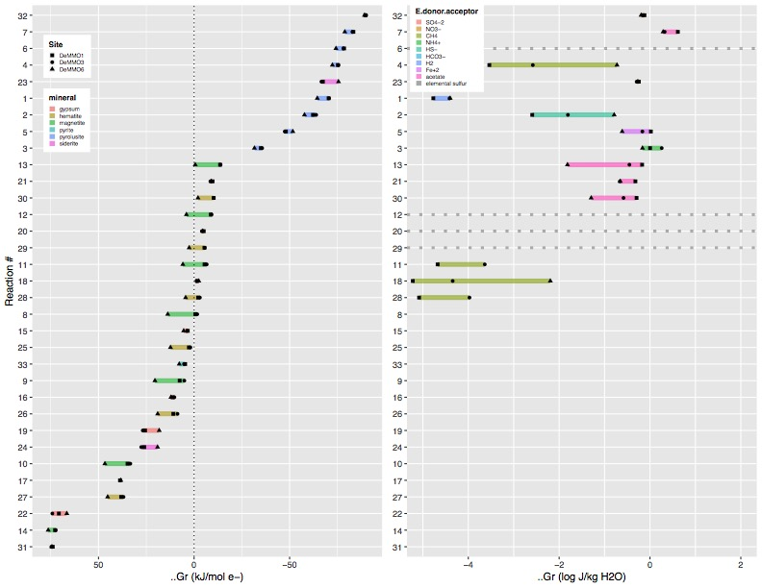

**Figure x.** Free energy (left) and energy density (right) of reactions with minerals and dissolved electron donors and acceptors based on *in situ* geochemistry. Aqueous phase used for activities of methane and hydrogen.

* **Alpha diversity**
  + rarefaction curves show that the sequencing depth we used for normalization captures the bulk of diversity from each community, although some communities, especially DeMMO1 fluids, are undersampled.
  + Describe diversity in terms of # of observed OTUs at normalized sequencing depth
    - In descending order of most diverse: D1 fluids, D3 fluids, D1 + 3 biofilms on minerals, D1+3 biofilms on controls, D6 fluids, D6 biofilms on minerals, D6 biofilms on controls, ambient controls have huge range in diversity



**Figure x.** Alpha diversity of DeMMO communities. Rarefaction curves illustrate the number of OTU observations across a range of sequencing depths.



**Figure x.** Alpha diversity of DeMMO communities. OTU abundance at a rarefaction sequence depth of 3,910.



**Figure x.** Alpha diversity of DeMMO communities. OTU abundance at a rarefaction sequence depth of 9.760.

* **Beta Diversity**
  + Dendrogram barplot figure showing selected communities to illustrate composition, binning low abundance taxa for plot simplification (supplementary data to include all taxa).
    - Desulfobulbaceae abundant in D1pyrite, D3 and D6 pyrolusite, D3 hematite
    - Thermodesulfovibrionia abundant in D1 pyrolusite
    - Omnitrophica abundant in D1 and D6 fluids, but not in any biofilms
    - Rhodocyclaceae abundant in D3 siderite + gypsum and D1 sand
    - Alphaproteobacterium (Other) abundant on D3 muscovite
    - Other taxa have similar abundances in both fluids and biofilms
  + NMDS plot of communities with vectors for each family colored by phylum illustrating contribution of each family to the ordination and how distinct each site is in terms of taxonomic composition and from ambient background controls
    - D1 and D3 biofilm communities: Significant contribution to ordination from Bacteriodetes, Chloroflexi, Latescibacteria, Betaproteobacteria, WOR-1, Nitrospirae, Actinobacteria
    - D1 and D3 fluids: Diapherotrites, Unassigned, Patescibacteria, Deltaproteobacteria
    - D6 communities: Significant contribution to ordination from Firmicutes, Chloroflexi, Acetothermia, Patescibacteria, Tenerecutes, Deltaproteobacteria

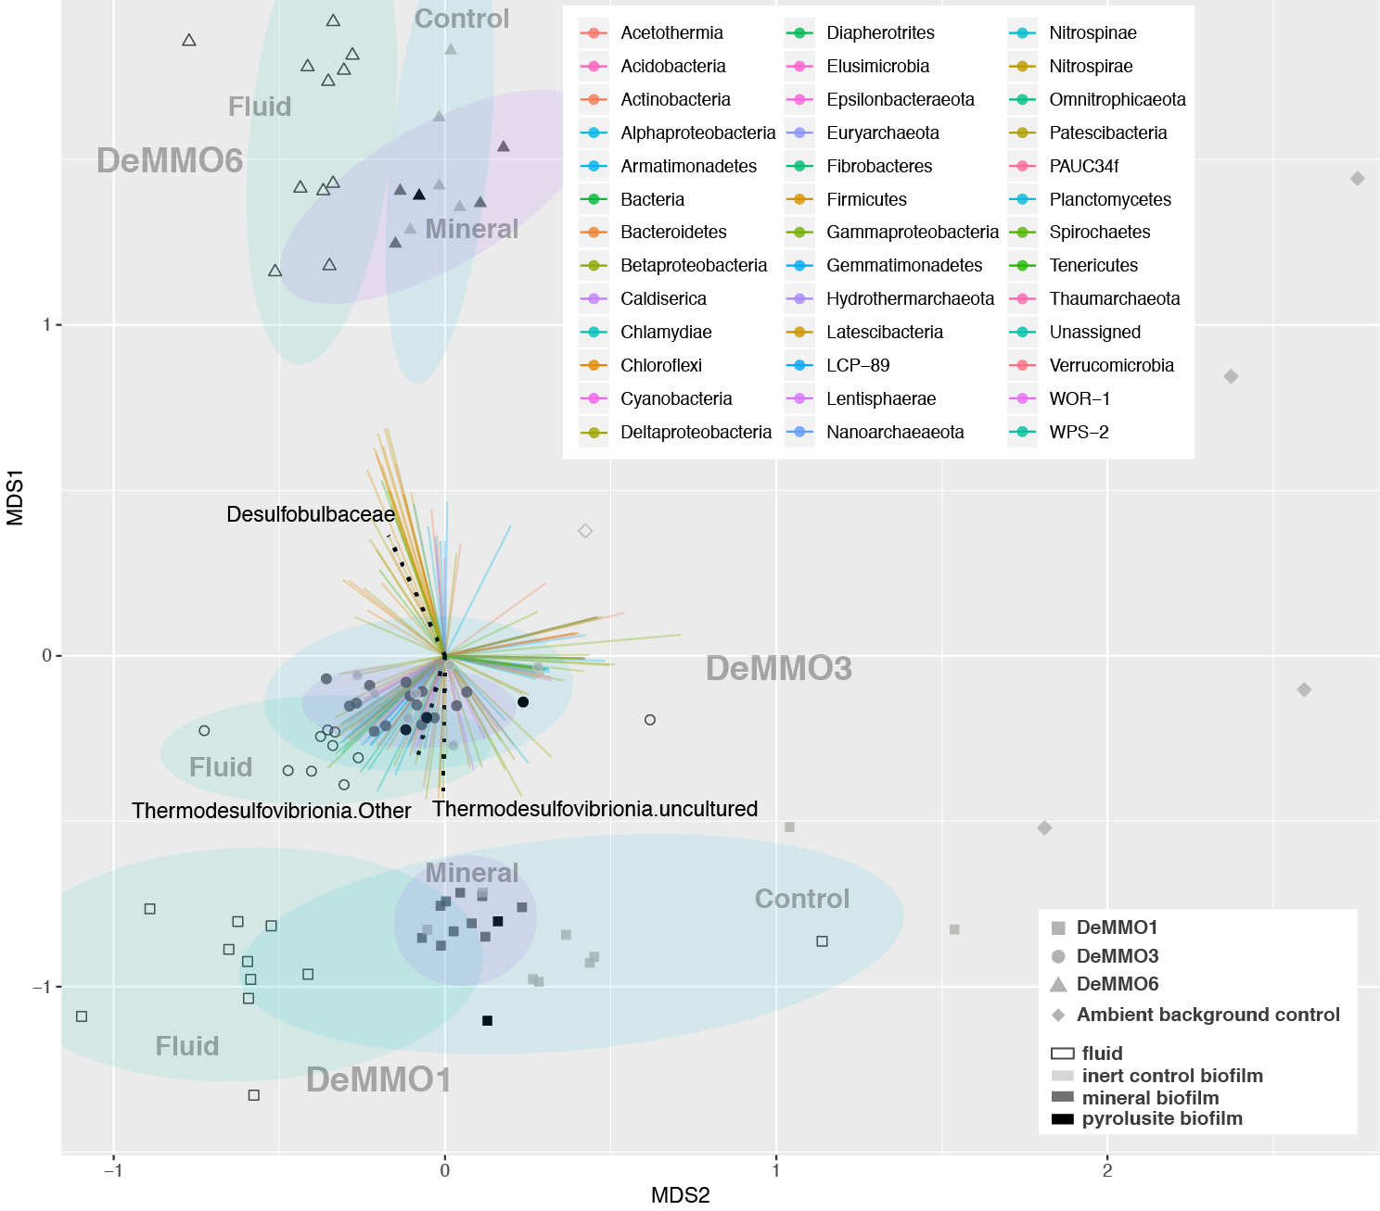

**Figure x.** NMDS plot of DeMMO fluid and biofilm communities represented as hollow and filled points, respectively. Community compositions taken from relative abundances of 16s rRNA gene sequences binned at the family level. Vectors representing each family are colored by Phylum. Vectors representing *Desulfobulbaceae* and *Thermodesulfovibrionia* are shown as black dotted lines. Biofilm communities from pyrolusite experiments are shown as opaque black points. 95% confidence ellipses encompass fluid, mineral biofillm or control biofilm communities from each site. Ambient background controls are glass slides that were placed in the mine tunnels exposed to air at depths of 800 and 4,850 ft for five months or fluid samples from open ditches in the mine tunnels.



**Figure x.** same NMDS plot as above, with 10k rarefaction depth. Similar trends as other plot, but Desulfobulbaceae and Thermodesulfovibrionia no longer have pval <= 0.05 when fitting vectors so they aren’t on this plot.



**Figure x.** same NMDS plot as above, with 10k rarefaction depth showing only min pval vectors, recolored with Maggie’s colors

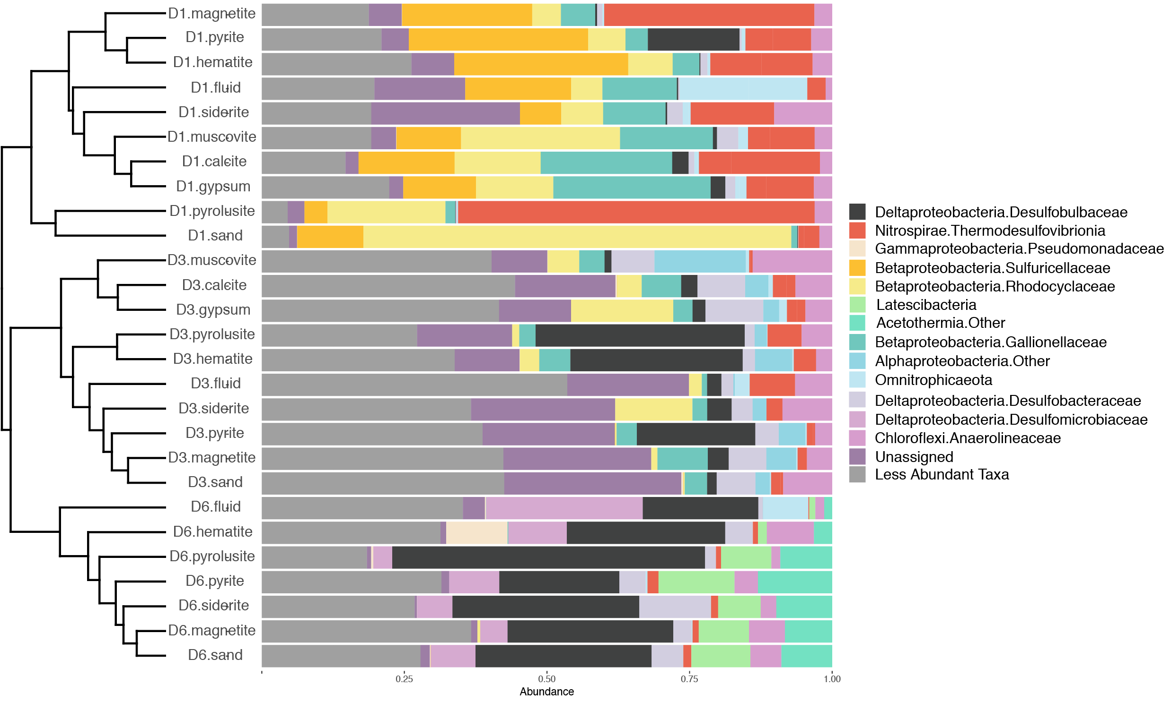

**Figure x.** Beta diversity of DeMMO communities. Relative abundances of taxa binned at the family level from selected DeMMO fluid and biofilm samples. Taxa that make up less than 10% of a community were binned as ‘Less Abundant Taxa’. Communities are organized by hierarchical clustering using Bray-Curtis similarity, visualized as a dendrogram.



**Figure x.** same fig as above at rarefaction depth of 10k reads­ – shows basically same trends

* **Biofilm cell density estimates** 
  + Overall, communities from DeMMO1 had the highest densities, and of these, the highest were in parallel control experiments
  + Of the minerals, pyrolusite had highest cell densities, lowest densities on calcite + muscovite
  + Cell densities were higher on minerals than on internal controls, with exceptions being in DeMMO1 communities on pyrite and magnetite.
  + Temporal variability in densities observed at each site, particularly at DeMMO1
  + Cell morphologies differ between minerals and controls
  + Descriptions of biogenic structures and cell morphologies

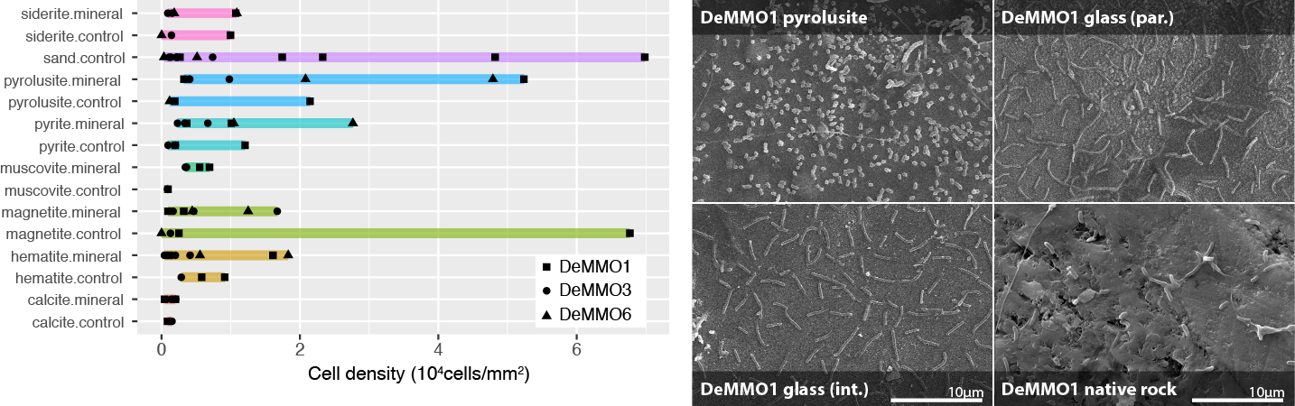

**Figure x.** Left: Cell densities estimated from cell counts from mineral chip SEM images. Glass slides were included in experiments with minerals (internal inert controls) or sand (parallel inert controls). Right: SEM images taken from pyrolusite experiments at DeMMO1. Clockwise from top left: pyrolusite, parallel sand control, native rock, internal pyrolusite control.



**Figure x.** Cell densities split by site ordered by highest density



**Figure x.** Cell densities split by site, organized by mineral type



**Figure x.** Left: Cell densities vs. sampling date for each site. Right: Cell densities vs. site over all sampling dates.

**4 | DISCUSSION**

* **Thermo modelling**
  + Free Energy
    - Pyrolusite appears to be a very favorable electron acceptor across all DeMMO sites.
    - Coupled to nitrate reduction, pyrite and siderite appear to be very favorable electron donors across all DeMMO sites.
    - Methane, H2, and elemental sulfur, and acetate are generally good e- donors for reduction of minerals.
    - Hematite, magnetite, and gypsum are good e- acceptors when coupled to H2, CH4, elem sulfur, or acetate at D3 and D6, but not D1.
  + Energy Density
    - The most favorable reactions with minerals in terms of free energy are not always the most energy dense in terms of available solute. Methane and acetate are the most available dissolved reactants; however, acetate concentrations were assumed from bulk DOC concentrations and thus may not be accurately represented here. While methane is not the most “tasty”, it may be a more representative reactant for in situ metabolisms given its abundance.
* **Alpha Diversity**
  + We acknowledge the undersampling of OTUs from DeMMO1 fluid communities; however, the choice was made to use a sequence sampling depth of 3,994 to maximize the number of samples we could include in the data comparison given the heterogeneity in total sequence reads from each community.
  + Higher diversity in fluids vs. biofilms may indicate:
    - only a subpopulation of fluid community may be capable of biofilm formation
    - competition for resources in fluid communities may drive biofilm formation in organisms capable of utilizing solid substrates for metabolisms
* **Beta Diversity** 
  + D1, 3, and 6 communities more similar within a site than between sites, indicating fluid geochemistry ultimately controls community composition
  + In experiments with pyrolusite, high enrichments of Desulfobulbaceae and Thermodesulfovibrionia were observed, suggesting these taxa may derive enegy from pyrolusite reduction.
  + NMDS separation of D1,3,6 communities from ambient background controls - therefore no indication of contamination
* **Biofilm cell density estimates** 
  + Higher cell densities on parallel controls vs. minerals suggests that in most cases, minerals promote biofilm formation, which may indicate that the minerals provide a source of energy for members of the biofilms. Minerals rich in iron and manganese promoted higher densities than calcite and muscovite, suggesting potential iron and manganese metabolisms.
  + Communities colonizing DeMMO1 pyrite and magnetite internal controls (glass) were more dense than their mineral counterparts. Mineral dissolution may provide aqueous Fe2+, a phase that may be preferred by these communities. Alternatively, a temporal shift in fluid conditions may explain this observation, given that on average cell densities were higher in DeMMO1 experiments during August 2017 than November 2017.
  + Consistent cell morphologies across glass-colonizing biofilms vs. heterogenous morphologies across minerals suggests minerals promotes colonization of distinct subpopulations
  + Wanger et al. 2006 suggested potentially long timescales for biofilm development/cell doubling time in SA gold mine, our data show that biofilms and dense EPS can form rapidly where energy-rich substrates are available
  + Possible extrapolation of densities based on percent mineral composition from Caddey 1991, could compare to densities estimated from native rock experiments
  + Biogenic structures observed in SEM images may play a role in EET

**5 | CONCLUSION**

* All data taken together suggest pyrolusite is very favorable electron acceptor at DeMMO, especially when coupled to organic carbon, elemental sulfur, or methane, which promotes the growth of Thermodesulfovibrionia and Desulfobulbaceae in dense biofilm communities.

**ACKNOWLEDGEMENTS**

* This work was supported by NASA Headquarters under the NASA Earth and Space Science Fellowship Program – “Grant 80NSSC18K1267” and Exobiology Grant “…” and Northwestern University.
* Undergrads: Bethany Ketchem, Annamarie Jedziniak
* SURF staff: Tom Regan
* This work made use of the EPIC facility of Northwestern University’s NUANCE Center, which has received support from the Soft and Hybrid Nanotechnology Experimental (SHyNE) Resource (NSF ECCS-1542205); the MRSEC program (NSF DMR-1720139) at the Materials Research Center; the International Institute for Nanotechnology (IIN); the Keck Foundation; and the State of Illinois, through the IIN.