**Mineral-hosted biofilm communities in the continental deep subsurface, Deep Mine Microbial Observatory, SD, USA**

Caitlin P. Casar1, Magdalena R. Osburn1, Theodore M. Flynn2, Brittany R. Kruger3, Andrew L. Masterson1

1Northwestern University, Department of Earth and Planetary Sciences, Evanston IL, 60208

2Argonne National Laboratory, Argonne IL

3Desert Research Institute, Division of Hydrologic Sciences, Las Vegas NV, 89113

**Abstract**

Abstract here…

**1 | INTRODUCTION**

The majority of all prokaryotic life on Earth may exist in deep subsurface biofilms (Flemming and Wuertz, 2019); however, the ecology of these communities in terms of diversity and biomass is not well constrained. Samples from marine and terrestrial deep subsurface systems have revealed abundant and diverse microbial life suspended in fluids (i.e. fracture and pore fluids); however, the same is not well described for microbial life attached to surfaces (i.e. biofilms on rock fracture and pore space surfaces). This lack of information is a function of the challenges imposed by deep subsurface settings which are challenging to collect samples from, and even more challenging settings at which to establish long-term monitoring stations. In part, these challenges are due to the complex nature of drilling to great depths without introducing surface contamination, as well as the funding and manpower needed to establish and maintain monitoring stations. Monitoring stations have been successfully established in CORKs in sea floor basalts and in terrestrial groundwater aquifers (i.e. CROMO, California), and recently in a terrestrial gold mine, the Deep Mine Microbial Observatory in Lead, South Dakota, USA. As opposed to rock sample collection from the environment via drill cores, monitoring stations offer a means to study deep subsurface biofilm communities by allowing for their *in situ* cultivation on provided substrates incubated in environmental fluids that can be harvested while minimizing contamination and permanent alteration of the environment during sample collection.

Minerals are likely an important energy source for the deep continental biosphere in which oxygen and organic carbon are limited.

The ecology of deep subsurface biofilm communities is relevant to the origin of life on Earth and the search for life on other rocky planets such as Mars.

**2 | MATERIALS AND METHODS**

**2.1 | DeMMO**

The Deep Mine Microbial Observatory (DeMMO) is a portal to the deep biosphere through which we can study the ecology of the deep subsurface. DeMMO was established in 2015 in the Sanford Underground Research Facility (SURF) in Lead, South Dakota. SURF is the former Homestake gold mine in the Black Hills, situated in an uplifted, deformed region of Paleoproterozoic metasediments and Tertiary igneous intrusions. SURF is approximately 2.15 miles wide and is currently accessible to a depth of 4,850 feet; however, previous mining operations extended to a depth of 8,000 feet (Figure x). The levels within the mine intersect three major formations: Ellison, Homestake, and Poorman. The Ellison Formation is comprised of pelitic phyllite and interbedded quartzite. The Homestake Formation is gold ore-bearing, carbonate-rich iron formation. The upper Poorman Formation is locally rich in iron sulfides with large quartz veins intersecting graphitic phyllite overlaying a lower unit of horneblende-plagioclase schist (Caddey et al., 1991). These formations host relatively young fracture fluids near the surface that are recharged on annual timescales by meteoric waters, whereas deeper fluids have estimated residence times on the order of 10,000 years (Murdoch et al., 2012).

DeMMO is a network of six legacy boreholes that intersect fluid-filled fractures spanning depths of 800-4,850 feet within SURF. Each borehole has been adapted for periodic fluid sampling and long-term experiment installations with minimal disturbance to the fracture fluids (Figure X). DeMMO fluid geochemistry and suspended microbial communities have been monitored bimonthly since December 2015 (Table 1). Sites DeMMO1, DeMMO3, and DeMMO6 are the focus of this study and are further described here. DeMMO1 is located at a depth of 800 feet, and fluids are moderately reducing with high concentrations of dissolved ferrous iron, dominated by candidate phylum *Omnitrophica* and unclassified taxa. DeMMO3 is located at a depth of 2,000 feet, with ferrous iron and sulfate-rich suboxic fluids dominated by members of *Betaproteobacteria* and *Nitrospirae*. DeMMO6 is located at a depth of 4,850 feet, with reducing, sulfate and methane-rich fluids dominated by members of *Deltaproteobacteria* and *Firmicutes*.

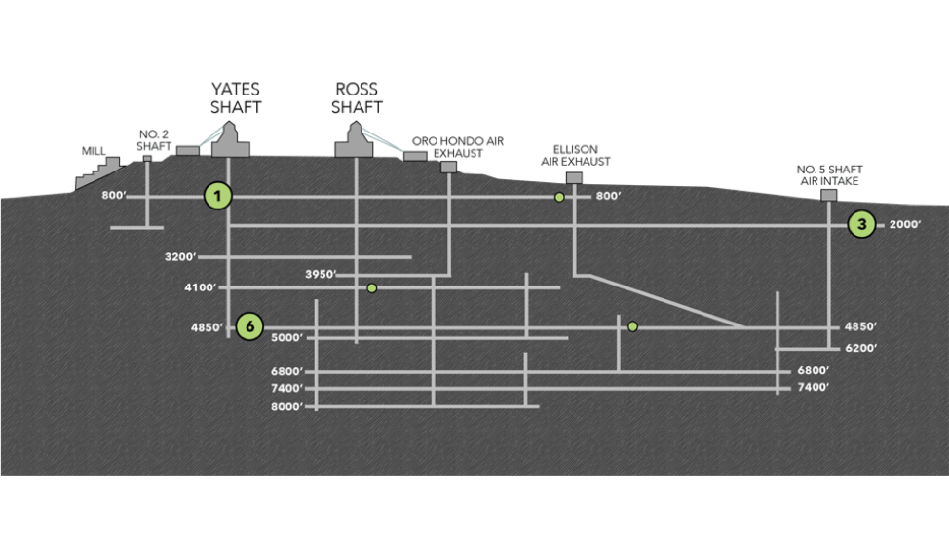

**Figure x.** Cross-sectional view of the Deep Mine Microbial Observatory (DeMMO). Grey lines are tunnels and shafts in the mine. Green circles represent locations of six DeMMO sites, larger circles represent three sites in this study: DeMMO1, DeMMO3, and DeMMO6.

**Table 1.** Averaged fracture fluid geochemistry measured at three DeMMO sites between Dec. 2015 - Sep. 2018.

|  |  |  |  |  |  |  |  |  |  |  |  |  |  |
| --- | --- | --- | --- | --- | --- | --- | --- | --- | --- | --- | --- | --- | --- |
| **Site** | **Depth**  **ft** | **Temp**  **Co** | **ORP** | **pH** | **H2**  **nM** | **CH4**  **nM** | **Fe2+**  **mg/L** | **NH4+**  **mg/L** | **NO3-**  **mg/L** | **SO42-**  **mg/L** | **S2-μg/L** | **DOC**  **mg/L** | **DIC**  **mM** |
| D1 | 800 | 10.3 | -86.8 | 7.2 | 0.12 | 0.48 | 2.4 | 0.1 | 0.3 | 336.1 | 1.7 | 0.43 | 4.2 |
| D3 | 2,000 | 16.2 | -34.5 | 7.1 | 0.27 | 4.29 | 2.5 | 0.2 | 0.3 | 1674.2 | 10.1 | 0.25 | 10.0 |
| D6 | 4,850 | 21.5 | -236.2 | 8.1 | 0.30 | 314.3 | 1.2 | 0.1 | 0.3 | 4223.3 | 66.2 | 0.25 | 2.2 |

**2.2 | Thermodynamic Modeling of Microbial Metabolisms**

We collected DeMMO fluid geochemical data 11 times between December 2015 and September 2018 (Osburn *et al.*, 2019). This robust geochemical record was used to generate averaged fluid chemistries for DeMMO1, DeMMO3, and DeMMO6 used in species activity calculations via SPECE8 in Geochemist’s Workbench (Bethke *et al.*, 2009). Species activities and average fluid temperatures were used to calculate logQ and logK, respectively, for each metabolic reaction (Table 2) in CHNOSZ. Finally, Gibbs energy yields (Gr) and energy densities (Er) of each reaction was calculated following the methods of Osburn *et al.*, 2014 (equations 1-3).

**Table 2.** Metabolic reactions with minerals in this study.

|  |  |  |  |  |  |
| --- | --- | --- | --- | --- | --- |
| **No.** | **Reaction** | **e-/rxn** | **No.** | **Reaction** | **e-/rxn** |
| **Pyrolusite as electron acceptor** | | | 21 | CaSO4*2H2O + CH3COO- ↔ HS- + 2HCO3- + Ca2+ + 2H2O | 8 |
| 1 | MnO2 + H2 + 2H+ ↔ Mn2+ + 2H2O | 2 | 22 | CaSO4*2H2O + 8Mn2+ + 10H2O ↔ HS- + 8MnOOH + Ca2+ + 15H+ | 8 |
| 2 | MnO2 + HS- + 2H+ ↔ Mn2+ + S0 + 2H2O | 2 | **Siderite as electron donor** | | |
| 3 | 3MnO2 + NH4+ + 4H+ ↔ 3Mn2+ + NO2- + 4H2O | 6 | 23 | 2FeCO3 + NO3- +3H2O ↔ 2FeOOH + NO2- + 2HCO3- + 2H+ | 2 |
| 4 | MnO2 + CH4 + 7H+ ↔ 4Mn2+ + HCO3- + 5H2O | 8 | 24 | 8FeCO3 + SO42- + 12H2O ↔ 8FeOOH + HS- + 8HCO3- + 7H+ | 8 |
| 5 | MnO2 + Fe2+ + 2H2O ↔ Mn2+ + 2FeOOH + 2H+ | 2 | **Hematite as electron acceptor** | | |
| 6 | 3MnO2 + S0 + 4H+ ↔ 3Mn2+ + SO42- + 2H2O | 6 | 25 | Fe2O3 + H2 + 4H+ ↔ 2Fe2+ + 3H2O | 4 |
| 7 | 9MnO2 + 2CH3COO- + 18H+ ↔ 9Mn2+ + 4HCO3- + 10H2O | 18 | 26 | Fe2O3 + HS- + 5H+ ↔ 2Fe2+ + S0 + 3H2O | 2 |
| **Magnetite as electron acceptor** | | | 27 | 3 Fe2O3 + NH4+ + 10H+ ↔ 6Fe2+ + NO2- + 7H2O | 6 |  |  |
| 8 | Fe3O4 + H2 + 6H+ ↔ 3Fe2+ + 4H2O | 2 | 28 | 4 Fe2O3 + CH4 + 15H+ ↔ 8Fe2+ + HCO3- + 9H2O | 8 |
| 9 | Fe3O4 + HS- + 7H+ ↔ 3Fe2+ + S0 + 4H2O | 2 | 29 | 3 Fe2O3 + S0 + 10H+ ↔ 6Fe2+ + SO42- + 5H2O | 6 |
| 10 | 3Fe3O4 + NH4+ + 16H+ ↔ 9Fe2+ + NO2- + 10H2O | 6 | 30 | 4 Fe2O3 + CH3COO- + 15H+ ↔ 8Fe2+ + 2HCO3- + 8H2O | 8 |
| 11 | 4Fe3O4 + CH4 + 23H+ ↔ 16Fe2+ + HCO3- + 13H2O | 8 | 31 | Fe2O3 + 2Mn2+ + H2O ↔ 2Fe2+ + 2MnOOH | 2 |
| 12 | 3Fe3O4 + S0 + 16H+ ↔ 9Fe2+ + SO42- + 8H2O | 6 | **Pyrite as electron donor** | | |  | |  |
| 13 | 3Fe3O4 + 2CH3COO- + 6H+ ↔ 9Fe2+ + 4HCO3- + 4H2O | 18 | 32 | FeS2 + 8NO3- ↔ Fe2+ + 2SO42- + 8NO2- | 16 |
| 14 | Fe3O4 + 2Mn2+ + 2H+ ↔ 3Fe2+ + 2MnOOH | 6 | 33 | FeS2+ 2HCO3- + 2H2O + 2H+ ↔ Fe2+ + 2SO42- + 2CH4 | 16 |
| **Gypsum as electron acceptor** | | | * Aqueous forms were used for H2 and CH4  **FeOOH and MnOOH are ferrihydrite and manganite, respectively | | |
| 15 | CaSO4*2H2O + 4H2 + H+ ↔ HS- + Ca2+ + 6H2O | 8 |
| 16 | CaSO4*2H2O + 3HS- + 5H+ ↔ S0 + Ca2+ + 6H2O | 8 |
| 17 | 3 CaSO4*2H2O + 4NH4+ ↔ 3HS- + 4NO2- + 3Ca2+ + 10H2O + 5H+ | 24 |  |  |  |
| 18 | CaSO4*2H2O + CH4 ↔ HCO3- + HS- + Ca2+ + 3H2O | 8 |  |  |  |
| 19 | CaSO4*2H2O + 8Fe2+ + 10H2O ↔ HS- + 8FeOOH + Ca2+ + 15H+ | 8 |  |  |  |
| 20 | 3CaSO4*2H2O + 4S0 ↔ 4SO42- + 3HS- + 5H+ + 3Ca2+ + 2H2O | 24 |  |  |  |

**2.3 | Field Experiments**

An array of flow through colonization reactors were connected to borehole outflows at DeMMO1, DeMMO3, and DeMMO6 for 2-8 months to allow for colonization by biofilm communities prior to harvesting. Reactors were filled with crushed and polished minerals representative of DeMMO lithology (pyrite, hematite, magnetite, siderite, pyrolusite, muscovite, gypsum, and calcite), native rock, or inert control substrates (glass beads, glass wool, and sand). Crushed minerals and rocks were mixed with sand to a ratio of ~1:2 (as was also done in previous experiments) to minimize major changes in pH (i.e. in experiments with pyrite where excess pyrite dissolution may result in extremely acidic fluids). Crushed mineral/rock or inert control material was sampled in the field into sterile tubes which were frozen on dry ice for DNA. Polished minerals and rocks or glass slides were included in each experiment for microcopy. Polished mineral and rock and glass slide samples were fixed in 4% glutaraldehyde in the field and stored at 4o C (except for polished gypsum which was not recovered due to dissolution).

**2.4 | Microbial Community Analysis**

DNA was extracted from crushed mineral/rock or inert control material using a MoBIO Biofilm DNA extraction kit following the manufacturer suggested protocol. Whole genomic DNA was sent to Argonne National Laboratory for 16s rRNA amplicon sequencing of the V4 hypervariable region using 516F and 806R universal primers. Samples were sequenced on an Illumina Miseq instrument. Paired-end reads were joined with PEAR (Zhang *et al.*, 2014) and demultiplexed with QIIME (v 1.9.1; Caporaso *et al.*, 2010). Sequences were dereplicated and binned into operational taxonomic units (OTU’s) at a threshold similarity of 97%, and chimeric sequences were removed using USEARCH (Edgar, 2013). OTU’s with an abundance less than 0.005% were discarded as likely sequencing errors or chimeric sequences (Bokulich *et al.*, 2013). Representatives from each OTU were assigned taxonomy using the uclust method in QIIME referencing the SILVA132 database (Quast *et al.*, 2012). Statistical analyses were performed on the OTU table using the Vegan (Oksanen *et al.*, 2018) and Ecodist (Goslee & Urban, 2007) packages in R.

**2.5 | Microbial Cell Density Estimates**

We documented cell morphologies and estimated cell densities on polished mineral and inert glass slides included in each experiment using scanning electron microscopy (SEM). Samples were gradually dehydrated in 200 proof ethanol and subjected to critical point drying to preserve cell structure. Finally, samples were coated with osmium tetroxide to a thickness of 15 nm to enhance sample conductivity for imaging on a FEI Quanta 650 ESEM in the EPIC facility at the Northwestern University NUANCE center. Images were collected using an operating voltage of 20 kV, 0.98 torr pressure, and working distance of ~5 mm. We collected 20 images from each sample and counted cells from a minimum of either 300 cells or 10 images. In some cases, cells were counted from all 20 images and totaled less than 300 cells. Images were also collected from polished rock (prepared as earlier described); however, we did not estimate cell densities due to rough sample topography.

**3 | RESULTS AND DISCUSSION**

**3.1 Exergonic mineral metabolisms**

Thermodynamic models reveal that pyrite oxidation with nitrate is the most exergonic metabolism at DeMMO1, 3, and 6; however, energy density calculations where limiting reactants are considered indicate that nitrate is not as available for microbial metabolisms as other dissolved substrates (Figure x). For example, pyrolusite reduction with methane is a very favorable metabolism and methane is abundant, thus this metabolism may actually be move favorable in terms of energy density. Given that all reactions with pyrolusite were exergonic at all three DeMMO sites, we expected results from experiments with pyrolusite to be distinct from experiments with other minerals. Indeed, microbial community and cell density data suggest pyrolusite may be a favorable surface for colonization by specific taxa at DeMMO. We detail these results here.

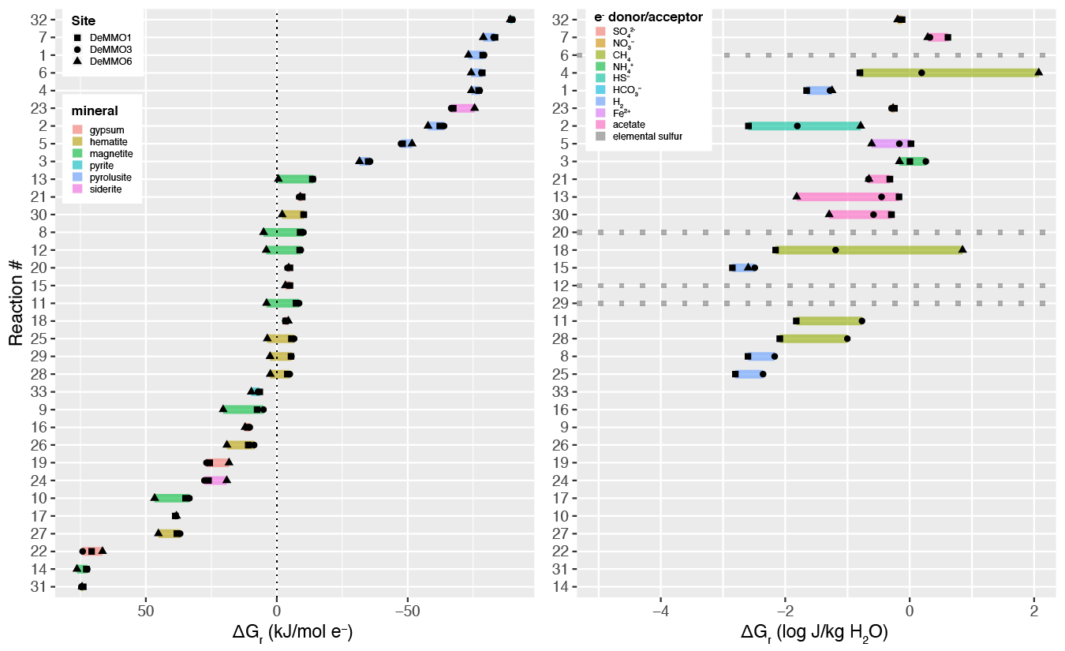

**Figure x.** Free energy (left) and energy density (right) of reactions with minerals and dissolved electron donors and acceptors based on *in situ* geochemistry.

**3.2 Microbial Communities**

DeMMO fluid and biofilm communities are diverse, indicated by 9,307 OTU’s (310 families and X phyla) after quality filtering. Microbial communities are distinct clades at each study location, where DeMMO1 communities are dominated by members of *Nitrospirae, Omnitrophica, Betaproteobacteria,* and *Chloroflexi*, DeMMO3 by *Beta-, Delta-*, and *Alphaproteobacteria* and *Chloroflexi*, and DeMMO6 communities by *Deltaproteobacteria, Chloroflexi, Acetothermia*, and *Latescibacteria* ­(Figure x). An NMDS ordination of all fluid and experimental biofilm communities reveals that these trends are consistent across replicate samples, and there is no indication of contamination from ambient background communities (Figure x). Although there are shared taxa among community types, the fluid and biofilm communities are distinct. Specifically, members of candidate phyla Omnitrophica are more abundant in fluid communities, whereas members of Pseudomondaceae, Rhodocyclaceae and candidate phylum Latescibacteria are more abundant in biofilm communities. Further, several experiments with minerals enriched for biofilm communities distinct from fluid communities or biofilm communities on inert control substrates. Most striking are the experiments with pyrolusite, which enriched for members of the *Desulfobulbaceae* at DeMMO3 and DeMMO6 and *Thermodesulfovibrionia* at DeMMO1.

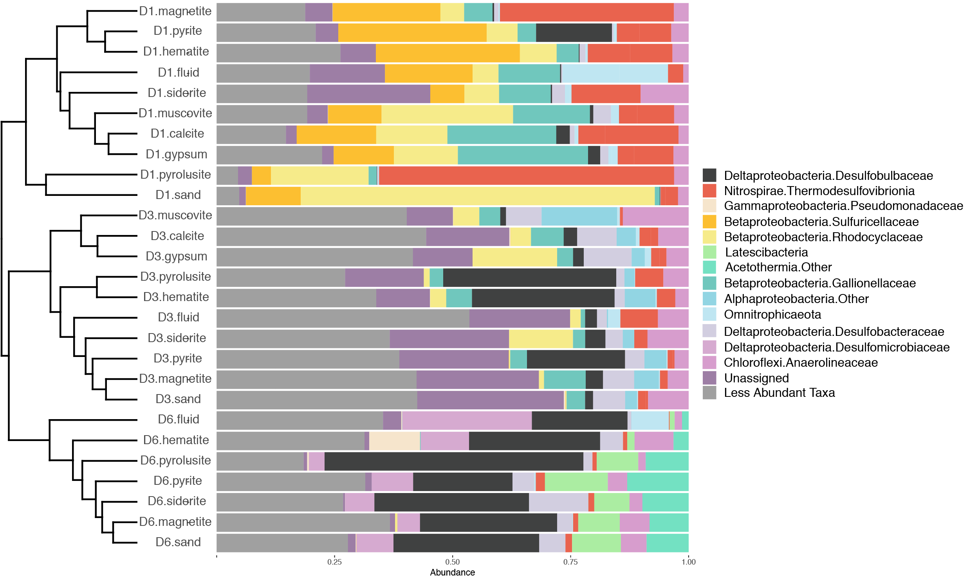

**Figure x.** Relative abundances of taxa binned at the family level from selected DeMMO fluid and biofilm samples. Taxa that make up less than 10% of a community were binned as ‘Less Abundant Taxa’. Communities are organized by hierarchical clustering using Bray-Curtis similarity, visualized as a dendrogram.

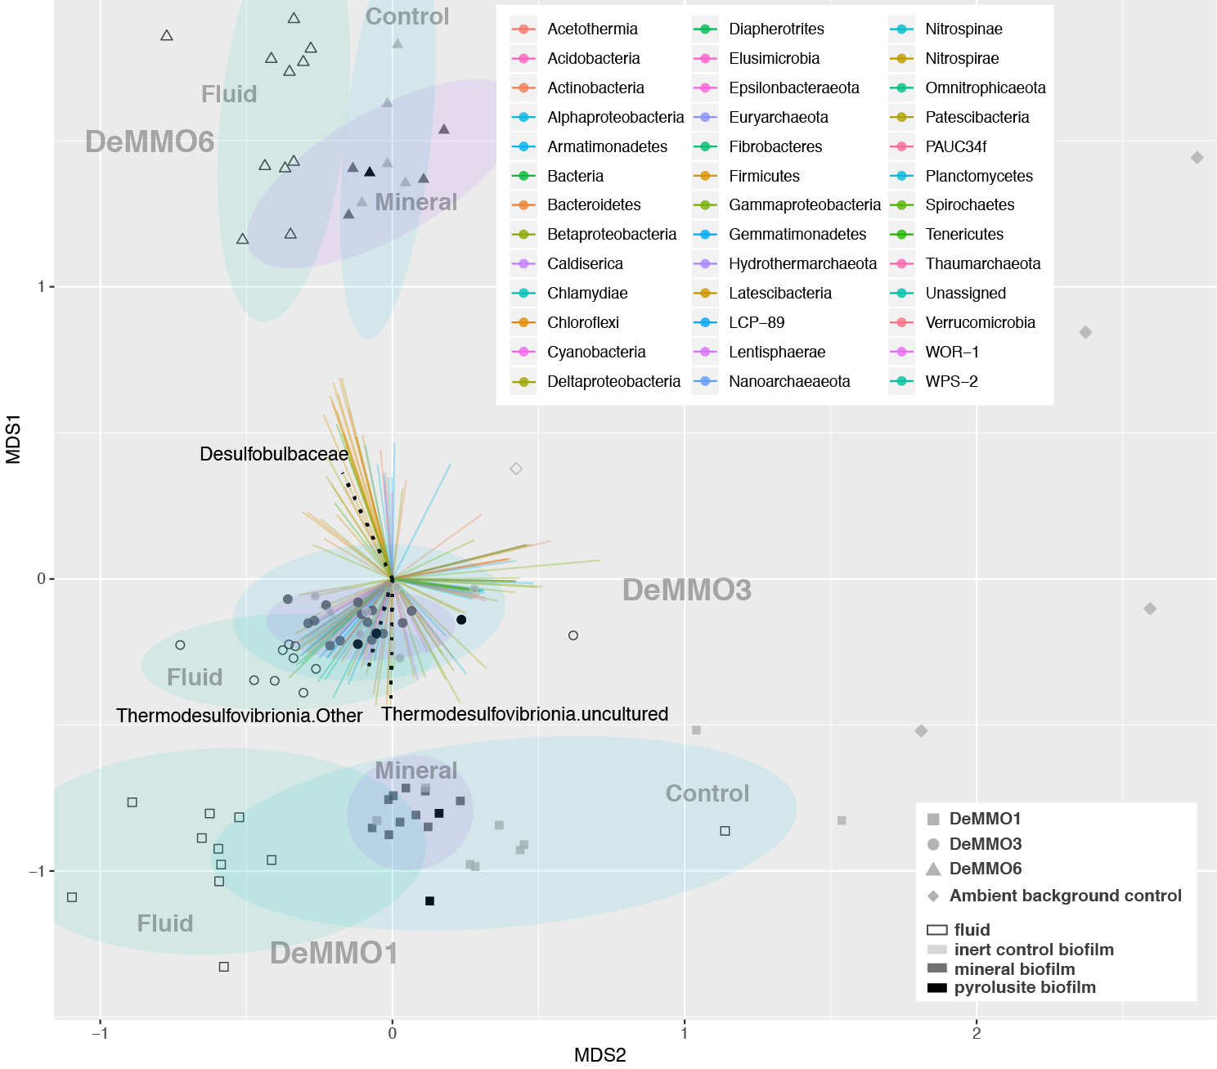

**Figure x.** NMDS plot of DeMMO fluid and biofilm communities represented as hollow and filled points, respectively. Community compositions taken from relative abundances of 16s rRNA gene sequences binned at the family level. Vectors representing each family are colored by Phylum. Vectors representing *Desulfobulbaceae* and *Thermodesulfovibrionia* are shown as black dotted lines. Biofilm communities from pyrolusite experiments are shown as opaque black points. 95% confidence ellipses encompass fluid, mineral biofillm or control biofilm communities from each site. Ambient background controls are glass slides that were placed in the mine tunnels exposed to air at depths of 800 and 4,850 ft for five months or fluid samples from open ditches in the mine tunnels.

**3.3 | Mineral-hosted biomass**

Cell density estimates from SEM images indicate that pyrolusite was most well colonized out of all mineral types, whereas calcite, a mineral with no iron or manganese, was least colonized. Cell densities estimated from internal and parallel control glass slides were highest in DeMMO1 experiments, and these biofilms shared the same cell morphologies, suggesting that glass promoted the colonization of a common taxa across these experiments. However, cell morphologies were distinct between most controls and minerals (i.e. in all pyrolusite experiments at all sites), suggesting taxonomic selection for mineral surface colonization (Figure x).

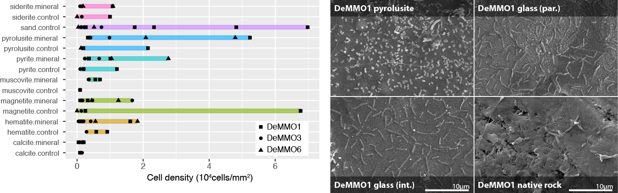

**Figure x.** Left: Cell densities estimated from cell counts from mineral chip SEM images. Glass slides were included in experiments with minerals (internal inert controls) or sand (parallel inert controls). Right: SEM images taken from pyrolusite experiments at DeMMO1. Clockwise from top left: pyrolusite, parallel sand control, native rock, internal pyrolusite control.

**4 | CONCLUSIONS**

Together, taxonomic and cell density/morphology data, along with the observation of biofilms on experiments with native rock, suggest the capacity for a mineral-hosted deep subsurface biosphere of significant biomass at DeMMO, especially where iron and manganese-bearing minerals are present.

**References**

Bethke, C., & Yeakel, S. (2009). *Geochemist's Workbench: Release 8.0 Reaction Modeling Guide*. RockWare Incorporated.

Flemming, H. C. and Wuertz, S. (2019) *Nat. Rev. Microbio.*, 1.

Oksanen, J., Blanchet, F. G., Friendly, M., Kindt, R., Legendre, P., McGlinn, D., Minchin, P. R., O'Hara, R. B., Simpson, G. L., Solymos, P., M., Stevens, H. H., Szoecs, E. and Wagner, H. (2018). vegan: Community Ecology Package. R package version 2.5-3. https://CRAN.Rproject.org/package=vegan

Osburn et al. 2019. Long-term aqueous geochemical stability of the Deep Mine Microbial Observatory (DeMMO), South Dakota USA. Frontiers in Earth Science.

**Figures and tables**

* DeMMO map
* DeMMO1,3,6 geochemistry table (or fig?)
* Experiment design
* Dendro bar plot of selected communities
* NMDS of all communities
* Cell density plot
* SEM images on pyrolusite, internal control, parallel control, native rock
* Thermo/energy density model