**Mineral-hosted biofilm communities in the continental deep subsurface, Deep Mine Microbial Observatory, SD, USA**

Caitlin P. Casar1, Brittany R. Kruger3, Theodore M. Flynn2, Andrew L. Masterson1, Magdalena R. Osburn1

1Northwestern University, Department of Earth and Planetary Sciences, Evanston IL, 60208

2Argonne National Laboratory, Argonne IL

3Desert Research Institute, Division of Hydrologic Sciences, Las Vegas NV, 89113

**Abstract**

A vast quantity of prokaryotic life on Earth is present in deep subsurface biofilms (Flemming and Wuertz, 2019); however, the ecology of these communities in terms of diversity and biomass is not well constrained. Samples from marine and terrestrial deep subsurface systems have revealed abundant and diverse microbial life suspended in fluids (i.e. fracture and pore fluids); however, the same is not well described for microbial life attached to surfaces (i.e. biofilms on rock fracture and pore space surfaces). The recently established Deep Mine Microbial Observatory is a long-term monitoring station at which we can explore the role of biofilms in fluid-filled fractures to depths of 4,850 ft. …

**1 | INTRODUCTION**

The continental deep subsurface biosphere theoretically extends to depths in Earth’s crust at which the physicochemical limits of life exist (i.e. temperature, pressure, and presence of water) (Hazael *et al.*, 2016), and has been directly observed as deep as 2.8km (Chivian *et al.*, 2008). Deep subsurface conditions pose challenges to microbial life, lacking direct energy from sunlight and offering limited organic carbon and oxygen; however, fluid-filled fractures and pore spaces are oases for microbial life. Here, electron donors and acceptors are available in both insoluble and dissolved forms via the surrounding host rock and through water-rock interactions, providing chemical disequilibrium that can support a variety of microbial metabolisms. Indeed, the continental subsurface is estimated to host a biosphere comprised of 6 x 1029 cells (Magnabosco *et al.*, 2018). Metagenomic surveys in continental deep subsurface settings have revealed that this biosphere is highly diverse (i.e. Osburn *et al.*, 2014; Magnabosco *et al.*, 2016; Probst *et al.*, 2018); however, the majority of these surveys sampled microbial communities suspended in fluids, thus missing a potentially significant contribution from communities attached to surfaces in biofilms. This potential significance is underscored by recent estimates of biomass existing in biofilms in the continental subsurface, totaling as many as 2.4 x 1029 cells, or 40% of continental deep subsurface biomass (Flemming & Wuertz, 2019).

Deep continental biofilms have been investigated using both laboratory-based (Thomas-Keprta *et al.*, 1998) and *in situ* cultivation approaches (Moser *et al.*, 2003; Lehman *et al.*, 2004; Henneberger *et al.*, 2006). These studies were among the first to shed light on the attached fraction of the deep biosphere, noting the potential for significant diversity and biomass in biofilm communities. Direct observations of biofilms on pristine fracture surfaces and *in situ* experiments with host rock incubated in native fracture fluids at 2.8-3.2 km below surface estimated cell densities ranging from 5 x 104 to 3.4 x 106 cells/mm2 (Moser *et al.*, 2003; Wanger *et al.*, 2006). Compared to the relatively low cell densities estimated from the fracture fluids, the experimental biofilm cell densities suggested a competitive advantage to cellular attachment to rock surfaces under oligotrophic conditions. Further, geochemical modelling suggested the potential for microbial metal reduction, and 16s rDNA clone sequencing revealed the presence of diverse biosphere and deeply branching lineages (Moser *et al.*, 2003). These findings, along with the advent of *in situ* cultivation approaches, paved the way for more in-depth exploration of deep subsurface biofilm communities.

The recently established Deep Mine Microbial Observatory (DeMMO) located in the former Homestake Gold Mine in Lead, South Dakota, USA, is a long-term monitoring station at which the ecology of the deep continental subsurface can be explored. DeMMO offers convenient access to fracture fluids spanning range of depths, making it possible to sample fluids interacting with a variety of continental rock types and track changes in fluid chemistry and microbial communities with depth. DeMMO is a network of six legacy boreholes that intersect fluid-filled fractures spanning depths of 800-4,850 feet, and each borehole has been adapted with borehole packer installations for periodic fluid sampling and long-term experiments with minimal disturbance to the fracture fluids. Long-term monitoring of fracture fluids here has revealed stable fluid chemistry since Dec2015 and indicated no contamination or long-term disturbance to the system from borehole modification (Osburn *et al.* 2019a *submitted*). Metagenomic surveys of communities suspended in the fracture fluids indicate the presence of distinct microbial assemblages at each DeMMO site, locally dominated by candidate phyla and unclassified taxa, that appear to be strongly influenced by fluid geochemistry (Osburn 2019b *in prep*, Momper *et al.* 2019 *in prep*). We are uniquely poised to install long-term *in situ* cultivation experiments, following methods from previous studies (i.e. Moser *et al.*, 2003; Lehman *et al.*, 2004), to address unanswered questions regarding the ecology of the attached fraction of the deep continental biosphere. Specifically, the difference in taxonomic compositions between fluid and biofilm communities is not well-resolved, thus it is unclear whether the total diversity of the subsurface is being captured by fluid sampling alone. Further, thermodynamic models of microbial metabolisms have been successful in predicting taxonomic composition of microbial communities suspended in fluids at DeMMO (Osburn *et al.*, 2014); however, it is unclear whether this can be successfully applied to biofilm communities that may derive energy from minerals in the surrounding host rock. Finally, mineral selectivity by microbes has been observed in both natural and laboratory settings, but the specific taxa and amount of biomass a given mineral type supports in continental deep subsurface environments remains unclear. Here, we describe our *in situ* cultivation approaches to investigate these questions surrounding microbial ecology of biofilms inhabiting fluid-filled fractures in the continental deep subsurface to depths of 4,850 ft.

**2 | MATERIALS AND METHODS**

**2.1 | DeMMO**

DeMMO is located in the former Homestake gold mine located in the Black Hills, situated in an uplifted, deformed region of Paleoproterozoic metasediments and Tertiary igneous intrusions. The gold mine, now known as the Sanford Underground Research Facility (SURF), is approximately 2.15 miles wide and is currently accessible to a depth of 4,850 feet; however, previous mining operations extended to a depth of 8,000 feet (Figure x). The levels within the mine intersect three major formations: Ellison, Homestake, and Poorman. The Ellison Formation is comprised of pelitic phyllite and interbedded quartzite. The Homestake Formation is gold ore-bearing, carbonate-rich iron formation. The upper Poorman Formation is locally rich in iron sulfides with large quartz veins intersecting graphitic phyllite overlaying a lower unit of horneblende-plagioclase schist (Caddey et al., 1991). These formations host relatively young fracture fluids near the surface that are recharged on annual timescales by meteoric waters, whereas deeper fluids have estimated residence times on the order of 10,000 years (Murdoch et al., 2012).

DeMMO fluid geochemistry and suspended microbial communities have been monitored bimonthly since December 2015 (Table 1). Sites DeMMO1, DeMMO3, and DeMMO6 are the focus of this study and are further described here. DeMMO1 is located at a depth of 800 feet, and fluids are moderately reducing with high concentrations of dissolved ferrous iron, dominated by candidate phylum *Omnitrophica* and unclassified taxa. DeMMO3 is located at a depth of 2,000 feet, with ferrous iron and sulfate-rich suboxic fluids dominated by members of *Betaproteobacteria* and *Nitrospirae*. DeMMO6 is located at a depth of 4,850 feet, with reducing, sulfate and methane-rich fluids dominated by members of *Deltaproteobacteria* and *Firmicutes*.

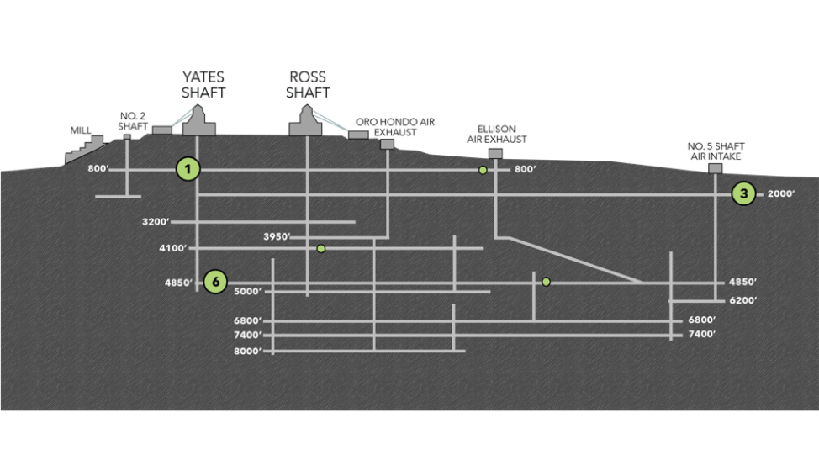

**Figure x.** Cross-sectional view of the Deep Mine Microbial Observatory (DeMMO). Grey lines are tunnels and shafts in the mine. Green circles represent locations of six DeMMO sites, larger circles represent three sites in this study: DeMMO1, DeMMO3, and DeMMO6.

**Table 1.** Averaged fracture fluid geochemistry measured at three DeMMO sites between Dec. 2015 - Sep. 2018.

|  |  |  |  |  |  |  |  |  |  |  |  |  |  |  |
| --- | --- | --- | --- | --- | --- | --- | --- | --- | --- | --- | --- | --- | --- | --- |
| **Site** | **Depth**  **ft** | **Temp**  **Co** | **ORP** | **pH** | **H2**  **nM** | **CO**  **nM** | **CH4**  **nM** | **Fe2+**  **mg/L** | **NH4+**  **mg/L** | **NO3-**  **mg/L** | **SO42-**  **mg/L** | **S2-μg/L** | **DOC**  **mg/L** | **DIC**  **mM** |
| D1 | 800 | 10.3 | -86.8 | 7.2 | 0.12 | 0.2 | 0.48 | 2.4 | 0.1 | 0.3 | 336.1 | 1.7 | 0.43 | 4.2 |
| D3 | 2,000 | 16.2 | -34.5 | 7.1 | 0.27 | 0.3 | 4.29 | 2.5 | 0.2 | 0.3 | 1674.2 | 10.1 | 0.25 | 10.0 |
| D6 | 4,850 | 21.5 | -236.2 | 8.1 | 0.30 | 0.1 | 314.3 | 1.2 | 0.1 | 0.3 | 4223.3 | 66.2 | 0.25 | 2.2 |

**2.2 | Thermodynamic Modeling of Microbial Metabolisms**

To investigate possible biofilm community metabolisms, we modeled 39 potential metabolic reactions with minerals under *in situ* conditions at DeMMO (Table 2). We collected DeMMO fluid geochemical data 11 times between December 2015 and September 2018 (Osburn *et al.*, 2019). This robust geochemical record was used to generate averaged fluid chemistries for DeMMO1, DeMMO3, and DeMMO6 (Table 1) used in species activity calculations via SPECE8 in Geochemist’s Workbench (Bethke *et al.*, 2009). Species activities and average fluid temperatures were used to calculate activity and equilibrium constants for each metabolic reaction in CHNOSZ. Finally, Gibbs energy yields (Gr) and energy densities (Er) of each reaction was calculated following the methods of Osburn *et al.*, 2014 (equations 1-3).

**Table 2.** Metabolic reactions with minerals in this study.

|  |  |  |  |  |  |
| --- | --- | --- | --- | --- | --- |
| **No.** | **Reaction** | **e-/rxn** | **No.** | **Reaction** | **e-/rxn** |
| **Pyrolusite as electron acceptor** | | | 23 | CaSO4*2H2O + CH3COO- ↔ HS- + 2HCO3- + Ca2+ + 2H2O | 8 |
| 1 | MnO2 + H2 + 2H+ ↔ Mn2+ + 2H2O | 2 | 24 | CaSO4*2H2O + 8Mn2+ + 10H2O ↔ HS- + 8MnOOH + Ca2+ + 15H+ | 8 |
| 2 | MnO2 + HS- + 2H+ ↔ Mn2+ + S0 + 2H2O | 2 | 25 | CaSO4*2H2O + 4CO + 2H2O ↔ 4HCO3- + HS- + Ca2+ + 3H+ | 8 |
| 3 | 3MnO2 + NH4+ + 4H+ ↔ 3Mn2+ + NO2- + 4H2O | 6 | **Siderite as electron donor** | | |
| 4 | MnO2 + CH4 + 7H+ ↔ 4Mn2+ + HCO3- + 5H2O | 8 | 26 | 2FeCO3 + NO3- +3H2O ↔ 2FeOOH + NO2- + 2HCO3- + 2H+ | 2 |
| 5 | MnO2 + Fe2+ + 2H2O ↔ Mn2+ + 2FeOOH + 2H+ | 2 | 27 | 8FeCO3 + SO42- + 12H2O ↔ 8FeOOH + HS- + 8HCO3- + 7H+ | 8 |
| 6 | 3MnO2 + S0 + 4H+ ↔ 3Mn2+ + SO42- + 2H2O | 6 | 28 | 6FeCO3 + CO + 11H2O ↔ 6FeOOH + 6HCO3- + CH4 + 6H+ | 6 |
| 7 | 9MnO2 + 2CH3COO- + 18H+ ↔ 9Mn2+ + 4HCO3- + 10H2O | 18 | **Hematite as electron acceptor** | | |
| 8 | MnO2 + CO + H+ ↔ Mn2+ + HCO3- | 2 | 29 | Fe2O3 + H2 + 4H+ ↔ 2Fe2+ + 3H2O | 4 |
| **Magnetite as electron acceptor** | | | 30 | Fe2O3 + HS- + 5H+ ↔ 2Fe2+ + S0 + 3H2O | 2 |
| 9 | Fe3O4 + H2 + 6H+ ↔ 3Fe2+ + 4H2O | 2 | 31 | 3 Fe2O3 + NH4+ + 10H+ ↔ 6Fe2+ + NO2- + 7H2O | 6 |
| 10 | Fe3O4 + HS- + 7H+ ↔ 3Fe2+ + S0 + 4H2O | 2 | 32 | 4 Fe2O3 + CH4 + 15H+ ↔ 8Fe2+ + HCO3- + 9H2O | 8 |
| 11 | 3Fe3O4 + NH4+ + 16H+ ↔ 9Fe2+ + NO2- + 10H2O | 6 | 33 | 3 Fe2O3 + S0 + 10H+ ↔ 6Fe2+ + SO42- + 5H2O | 6 |
| 12 | 4Fe3O4 + CH4 + 23H+ ↔ 16Fe2+ + HCO3- + 13H2O | 8 | 34 | 4 Fe2O3 + CH3COO- + 15H+ ↔ 8Fe2+ + 2HCO3- + 8H2O | 8 |
| 13 | 3Fe3O4 + S0 + 16H+ ↔ 9Fe2+ + SO42- + 8H2O | 6 | 35 | Fe2O3 + 2Mn2+ + H2O ↔ 2Fe2+ + 2MnOOH | 2 |
| 14 | 3Fe3O4 + 2CH3COO- + 6H+ ↔ 9Fe2+ + 4HCO3- + 4H2O | 18 | 36 | Fe2O3 + CO + 3H+ ↔ 2Fe2+ + HCO3- + H2O | 2 |
| 15 | Fe3O4 + 2Mn2+ + 2H+ ↔ 3Fe2+ + 2MnOOH | 6 | **Pyrite as electron donor** | | |  |  |
| 16 | Fe3O4 + CO + 5H+ ↔ 3Fe2+ + HCO3- + 2H2O | 2 | 37 | FeS2 + 8NO3- ↔ Fe2+ + 2SO42- + 8NO2- | 16 |
| **Gypsum as electron acceptor** | | | 38 | FeS2+ 2HCO3- + 2H2O + 2H+ ↔ Fe2+ + 2SO42- + 2CH4 | 16 |
| 17 | CaSO4*2H2O + 4H2 + H+ ↔ HS- + Ca2+ + 6H2O | 8 | 39 | 3FeS2 + 8CO + 16H2O ↔ 3Fe2+ + 6SO42- + 8CH4 | 48 |
| 18 | CaSO4*2H2O + 3HS- + 5H+ ↔ S0 + Ca2+ + 6H2O | 8 | * Aqueous forms were used for H2, CO, and CH4  **FeOOH and MnOOH are ferrihydrite and manganite, respectively | | |
| 19 | 3 CaSO4*2H2O + 4NH4+ ↔ 3HS- + 4NO2- + 3Ca2+ + 10H2O + 5H+ | 24 |
| 20 | CaSO4*2H2O + CH4 ↔ HCO3- + HS- + Ca2+ + 3H2O | 8 |
| 21 | CaSO4*2H2O + 8Fe2+ + 10H2O ↔ HS- + 8FeOOH + Ca2+ + 15H+ | 8 |  |  |  |
| 22 | 3CaSO4*2H2O + 4S0 ↔ 4SO42- + 3HS- + 5H+ + 3Ca2+ + 2H2O | 24 |  |  |  |

**2.3 | Field Experiments**

An array of flow through colonization reactors were connected to borehole outflows at DeMMO1, DeMMO3, and DeMMO6 for 2-8 months to allow for colonization by biofilm communities prior to harvesting. Reactors were filled with crushed and polished minerals representative of DeMMO lithology (pyrite, hematite, magnetite, siderite, pyrolusite, muscovite, gypsum, and calcite), native rock, or inert control substrates (glass beads, glass wool, and sand). Crushed minerals and rocks were mixed with sand to a ratio of ~1:2 to minimize major changes in pH (i.e. in experiments with pyrite where excess pyrite dissolution may result in extremely acidic fluids). Crushed mineral/rock or inert control material was sampled in the field into sterile tubes which were frozen on dry ice for DNA. Polished minerals and rocks or glass slides were included in each experiment for microcopy. Polished mineral and rock and glass slide samples were fixed in 4% glutaraldehyde in the field and stored at 4o C (except for polished gypsum which was not recovered due to dissolution).

**2.4 | Microbial Community Analysis**

DNA was extracted from crushed mineral/rock or inert control material using a MoBIO Biofilm DNA extraction kit following the manufacturer suggested protocol. Whole genomic DNA was sent to Argonne National Laboratory for 16s rRNA amplicon sequencing of the V4 hypervariable region using 516F and 806R universal primers. Samples were sequenced on an Illumina Miseq instrument. Paired-end reads were joined with PEAR (Zhang *et al.*, 2014) and demultiplexed with QIIME (v 1.9.1; Caporaso *et al.*, 2010). We acknowledge the growing trend of binning sequences into amplicon sequence variants (ASV’s); however, we characterize microbial communities to the family level and are not attempting to assign strain-level taxonomy to sequences here. Further, a high correlation between alpha and beta diversity metrics were found when comparing ASV and OTU binning of environmental 16s rRNA gene sequences resulting in ecologically similar interpretations between both approaches, thus we chose to bin sequences into operational taxonomic units (OTU’s) (Glassman & Martiny, 2018). Sequences were dereplicated and binned into OTU’s at a threshold similarity of 97%, and chimeric sequences were removed using USEARCH (Edgar, 2013). The OTU’s were rarefied to a sequencing depth of 3,994 reads which is the minimum number of total reads among samples. Representatives from each OTU were assigned taxonomy using the uclust method in QIIME referencing the SILVA132 database (Quast *et al.*, 2012).

Statistical analyses used to describe alpha and beta diversity were performed on the OTU table using the QIIME and the Vegan (Oksanen *et al.*, 2018) and Ecodist (Goslee & Urban, 2007) packages in R. To illustrate alpha diversity within DeMMO communities, rarefied OTU tables were generated in QIIME using the alpha_rarefaction.py script to randomly sample sequences between read depths of 0 - 30,925, the median value of total sequences among samples, at a step size of 50 and 10 permutations. Rarefaction curves showing the number of observed OTU’s across the range of sequence sampling depths were generated using the averages of the 10 permutations. The rarefaction curves indicated that the majority of diversity was captured at a sequencing depth of 10,000 reads, thus we normalized all samples to this read depth for community comparison. To illustrate beta diversity among DeMMO communities, we performed hierarchical clustering on a representative subset of the communities at the family level using the Bray-Curtis dissimilarity metric (bcdist function) in Ecodist. From this output we generated a dendrogram of DeMMO communities with stacked bar plots illustrating community composition at the family level. For the purposes of visualizing taxonomic data here, we binned taxa that comprised less than 10% of communities as “Less Abundant Taxa”. To further illustrate beta diversity using our entire dataset of DeMMO communities including all replicates and controls, we performed nonmetric multidimensional scaling (NMDS) on communities at the family level using the metaMDS function in Vegan using the Bray-Curtis metric with default parameters and a dimension size of 2. To illustrate taxonomic contribution to the resulting ordination, we used the envfit function in Vegan to fit vectors of each family using default parameters and a permutation size of 1,000. We mapped vectors with p-values less than or equal to 0.05, colored by phylum.

**2.5 | Microbial Cell Density Estimates**

We documented cell morphologies and estimated cell densities on polished mineral and inert glass slides included in each experiment using scanning electron microscopy (SEM). Samples were gradually dehydrated in 200 proof ethanol and subjected to critical point drying to preserve cell structure. Finally, samples were coated with osmium tetroxide to a thickness of 15 nm to enhance sample conductivity for imaging on a FEI Quanta 650 ESEM in the EPIC facility at the Northwestern University NUANCE center. Images were collected using an operating voltage of 20 kV, 0.98 torr pressure, and working distance of ~5 mm. We collected 20 images from each sample and counted cells from a minimum of either 300 cells or 10 images. In some cases, cells were counted from all 20 images and totaled less than 300 cells. Images were also collected from polished rock (prepared as earlier described); however, we did not estimate cell densities due to rough sample topography.

**3 | RESULTS AND DISCUSSION**

**3.1 Exergonic mineral metabolisms**

Thermodynamic models reveal that pyrite oxidation with nitrate is the most exergonic metabolism at DeMMO1, 3, and 6; however, energy density calculations where limiting reactants are considered indicate that nitrate is not as available for microbial metabolisms as other dissolved substrates (Figure x). For example, pyrolusite reduction with methane is a very favorable metabolism and methane is abundant, thus this metabolism may actually be move favorable in terms of energy density. Given that all reactions with pyrolusite were exergonic at all three DeMMO sites, we expected results from experiments with pyrolusite to be distinct from experiments with other minerals. Indeed, microbial community and cell density data suggest pyrolusite may be a favorable surface for colonization by specific taxa at DeMMO. We detail these results here.

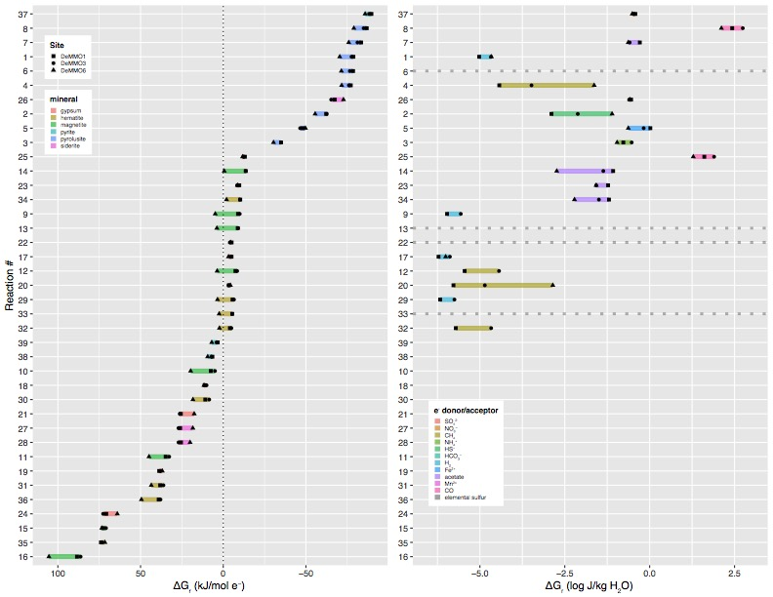

**Figure x.** Free energy (left) and energy density (right) of reactions with minerals and dissolved electron donors and acceptors based on *in situ* geochemistry.

**3.2 Microbial Communities**

DeMMO fluid and biofilm communities are diverse, indicated by 9,307 OTU’s (783 families from 66 phyla) after quality filtering. Of the three DeMMO sites, DeMMO1 fluid communities are the most diverse, followed by DeMMO3 fluids, DeMMO1 biofilms, DeMMO3 biofilms, DeMMO6 biofilms, and DeMMO6 fluids.

Microbial communities are distinct clades at each study location, where DeMMO1 communities are dominated by members of *Nitrospirae, Omnitrophica, Betaproteobacteria,* and *Chloroflexi*, DeMMO3 by *Beta-, Delta-*, and *Alphaproteobacteria* and *Chloroflexi*, and DeMMO6 communities by *Deltaproteobacteria, Chloroflexi, Acetothermia*, and *Latescibacteria* ­(Figure x). An NMDS ordination of all fluid and experimental biofilm communities reveals that these trends are consistent across replicate samples, and there is no indication of contamination from ambient background communities (Figure x). Although there are shared taxa among community types, the fluid and biofilm communities are distinct. Specifically, members of candidate phyla *Omnitrophica* are more abundant in fluid communities, whereas members of *Pseudomondaceae,* *Rhodocyclaceae* and candidate phylum *Latescibacteria* are more abundant in biofilm communities.

Several experiments with minerals enriched for biofilm communities distinct from fluid communities or biofilm communities on inert control substrates. Most striking are the experiments with pyrolusite, which enriched for members of the *Desulfobulbaceae* at DeMMO3 and DeMMO6 and *Thermodesulfovibrionia* at DeMMO1.



**Figure x.** Alpha diversity of DeMMO communities. OTU abundance at a rarefaction sequence depth of 10,000 reads.

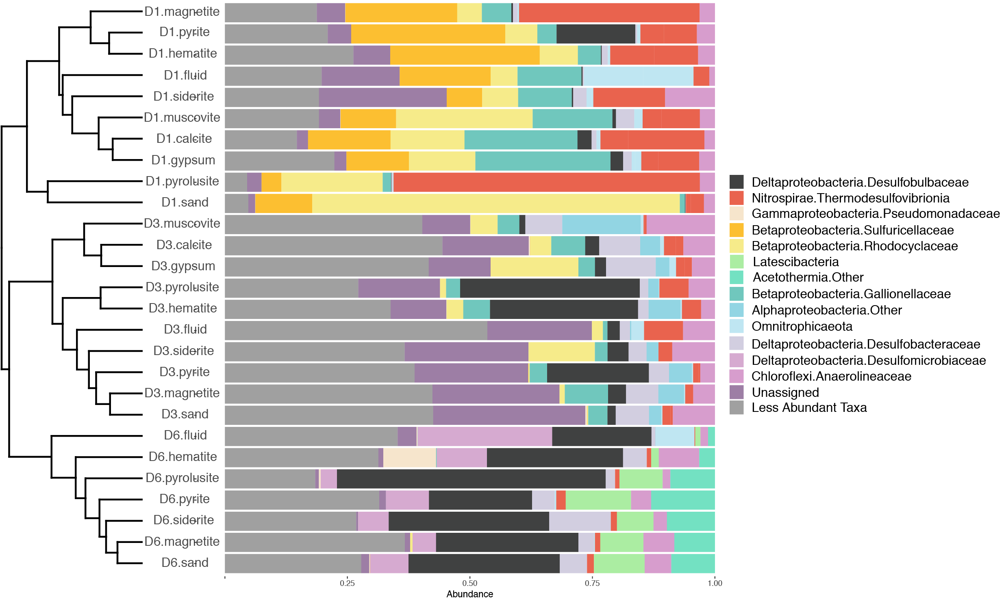

**Figure x.** Beta diversity of DeMMO communities. Relative abundances of taxa binned at the family level from selected DeMMO fluid and biofilm samples. Taxa that make up less than 10% of a community were binned as ‘Less Abundant Taxa’. Communities are organized by hierarchical clustering using Bray-Curtis similarity, visualized as a dendrogram.



**Figure x.** NMDS plot of DeMMO fluid and biofilm communities represented as hollow and filled points, respectively. Community compositions taken from relative abundances of 16s rRNA gene sequences binned at the family level. Vectors representing each family are colored by Phylum. Vectors representing *Desulfobulbaceae* and *Thermodesulfovibrionia* are shown as black dotted lines. Biofilm communities from pyrolusite experiments are shown as opaque black points. 95% confidence ellipses encompass fluid, mineral biofillm or control biofilm communities from each site. Ambient background controls are glass slides that were placed in the mine tunnels exposed to air at depths of 800 and 4,850 ft for five months or fluid samples from open ditches in the mine tunnels.

**3.3 | Mineral-hosted biomass**

Cell density estimates from SEM images indicate that pyrolusite was most well colonized out of all mineral types, whereas calcite, a mineral with no iron or manganese, was least colonized. Cell densities estimated from internal and parallel control glass slides were highest in DeMMO1 experiments, and these biofilms shared the same cell morphologies, suggesting that glass promoted the colonization of a common taxa across these experiments. However, cell morphologies were distinct between most controls and minerals (i.e. in all pyrolusite experiments at all sites), suggesting taxonomic selection for mineral surface colonization (Figure x).

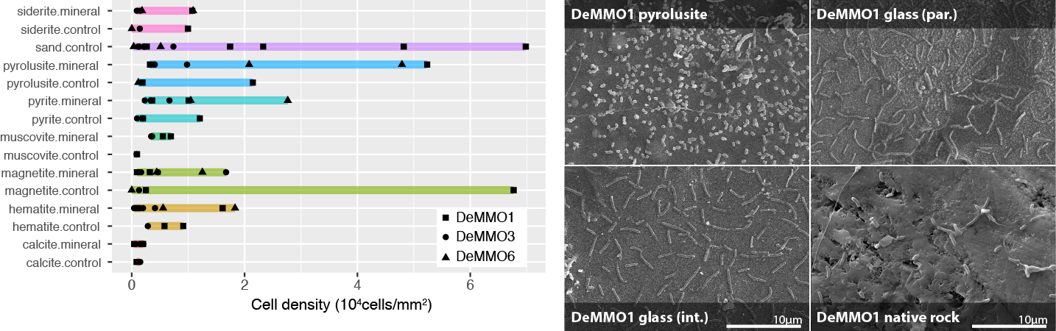

**Figure x.** Left: Cell densities estimated from cell counts from mineral chip SEM images. Glass slides were included in experiments with minerals (internal inert controls) or sand (parallel inert controls). Right: SEM images taken from pyrolusite experiments at DeMMO1. Clockwise from top left: pyrolusite, parallel sand control, native rock, internal pyrolusite control.



**4 | CONCLUSIONS**

Together, taxonomic and cell density/morphology data, along with the observation of biofilms on experiments with native rock, suggest the capacity for a mineral-hosted deep subsurface biosphere of significant biomass at DeMMO, especially where iron and manganese-bearing minerals are present.

**References**

Bethke, C., & Yeakel, S. (2009). *Geochemist's Workbench: Release 8.0 Reaction Modeling Guide*. RockWare Incorporated.

Flemming, H. C. and Wuertz, S. (2019) *Nat. Rev. Microbio.*, 1.

Oksanen, J., Blanchet, F. G., Friendly, M., Kindt, R., Legendre, P., McGlinn, D., Minchin, P. R., O'Hara, R. B., Simpson, G. L., Solymos, P., M., Stevens, H. H., Szoecs, E. and Wagner, H. (2018). vegan: Community Ecology Package. R package version 2.5-3. https://CRAN.Rproject.org/package=vegan

Osburn et al. 2019. Long-term aqueous geochemical stability of the Deep Mine Microbial Observatory (DeMMO), South Dakota USA. Frontiers in Earth Science.

**Figures and tables**

* DeMMO map
* DeMMO1,3,6 geochemistry table (or fig?)
* Experiment design
* Dendro bar plot of selected communities
* NMDS of all communities
* Cell density plot
* SEM images on pyrolusite, internal control, parallel control, native rock
* Thermo/energy density model

**Supplemental**

* Bar plot figure including all samples + ambient background communities
* Permanova table showing sig differences among all communities
* Table of relative abundances of all taxa at family level for all samples
* Rarefaction removed 115 OTU’s

**­**

**Figure x.** Alpha diversity of DeMMO communities. Rarefaction curves illustrate the number of OTU observations across a range of sequencing depths.