**Mineral-hosted biofilm communities in the continental deep subsurface, Deep Mine Microbial Observatory, SD, USA**

Caitlin P. Casar1, Brittany R. Kruger3, Theodore M. Flynn2, Andrew L. Masterson1, Magdalena R. Osburn1

1Northwestern University, Department of Earth and Planetary Sciences, Evanston IL, 60208

2Argonne National Laboratory, Argonne IL

3Desert Research Institute, Division of Hydrologic Sciences, Las Vegas NV, 89113

**Abstract**

A vast quantity of prokaryotic life on Earth is present in deep subsurface biofilms (Flemming and Wuertz, 2019); however, the ecology of these communities in terms of diversity and biomass is not well constrained. Samples from marine and terrestrial deep subsurface systems have revealed abundant and diverse microbial life suspended in fluids (i.e. fracture and pore fluids); however, the same is not well described for microbial life attached to surfaces (i.e. biofilms on rock fracture and pore space surfaces). The recently established Deep Mine Microbial Observatory is a long-term monitoring station at which we can explore the role of biofilms in fluid-filled fractures to depths of 4,850 ft. …

**1 | INTRODUCTION**

The continental deep subsurface biosphere theoretically extends to depths in Earth’s crust at which the physicochemical limits of life exist (i.e. temperature, pressure, and presence of water) (Hazael *et al.*, 2016), and has been directly observed as deep as 2.8km (Chivian *et al.*, 2008). Deep subsurface conditions pose biological challenges, lacking direct energy availability from sunlight and offering limited organic carbon and oxygen; however, fluid-filled fractures are oases for microbial life. Here, the surrounding host rock and water-rock interactions provide abundant insoluble and dissolved electron donors and acceptors, establishing chemical disequilibrium that can support a variety of chemolithotrophic microbial metabolisms. Indeed, the continental subsurface is estimated to host a massive biosphere comprised of as many as 6 x 1029 cells (Magnabosco *et al.*, 2018). Further, metagenomic surveys in continental deep subsurface settings have revealed that this biosphere is highly diverse (i.e. Osburn *et al.*, 2014; Magnabosco *et al.*, 2016; Probst *et al.*, 2018). However, the majority of cell density estimates and metagenomes from these settings are obtained from microbial communities suspended in fluids, thus missing a potentially significant contribution from communities attached to surfaces as biofilms. This potential significance is underscored by recent estimates of biofilm biomass in the continental subsurface, totaling as many as 2.4 x 1029 cells, or 40% of all continental deep subsurface biomass (Flemming & Wuertz, 2019).

Biofilm communities inhabiting the continental deep subsurface have been investigated using both laboratory-based (Thomas-Keprta *et al.*, 1998) and *in situ* cultivation approaches (Moser *et al.*, 2003; Lehman *et al.*, 2004; Henneberger *et al.*, 2006). These studies were among the first to shed light on the attached fraction of the deep biosphere, noting the potential for significant diversity and biomass in biofilm communities. Direct observations of biofilms on pristine fracture surfaces and *in situ* experiments with host rock incubated in native fracture fluids estimated cell densities ranging from 5 x 104 to 3.4 x 106 cells/mm2 (Moser *et al.*, 2003; Wanger *et al.*, 2006). Compared to relatively low cell densities estimated from the fracture fluids, these biofilm cell densities suggested a competitive advantage to cellular attachment to rock surfaces under oligotrophic conditions. Further, geochemical modelling indicated the potential for microbially-mediated metal reduction, and 16s rDNA clone sequencing revealed the presence of a diverse biosphere including deeply branching lineages (Moser *et al.*, 2003). These findings, along with the advent of *in situ* cultivation approaches, paved the way for more in-depth exploration of community composition, metabolic potential, and biomass contribution from biofilm communities inhabiting the continental deep subsurface.

The recently established Deep Mine Microbial Observatory (DeMMO) located in the former Homestake Gold Mine in Lead, South Dakota, USA, is a long-term monitoring station at which the ecology of the deep continental subsurface can be explored. DeMMO offers convenient access to fracture fluids interacting with a variety of continental rock types spanning a large range of depths, making it possible to monitor fluid chemistry and microbial communities under a variety of conditions over time. DeMMO is a network of six legacy boreholes that intersect fluid-filled fractures spanning depths of 800-4,850 feet, and each borehole has been adapted with borehole packer installations for periodic fluid sampling and long-term experiments with minimal disturbance to the fracture fluids. Long-term monitoring of fracture fluids here has revealed stable fluid chemistry since Dec2015 and indicated no contamination or long-term disturbance to the system from borehole modification (Osburn *et al.* 2019a *submitted*). Metagenomic surveys of communities suspended in the fracture fluids indicate the presence of distinct microbial assemblages at each DeMMO site, locally dominated by candidate phyla and unclassified taxa, that appear to be strongly influenced by fluid geochemistry (Osburn 2019b *in prep*, Momper *et al.* 2019 *in prep*). We are uniquely poised to install long-term *in situ* cultivation experiments, following methods from previous studies (i.e. Moser *et al.*, 2003; Lehman *et al.*, 2004), to address unanswered questions regarding the ecology of the attached fraction of the deep continental biosphere. Specifically, the difference in taxonomic compositions between fluid and biofilm communities is not well-resolved, thus it is unclear whether the total diversity of the subsurface is being captured by fluid sampling alone. Further, thermodynamic models of microbial metabolisms have been successful in predicting taxonomic composition of microbial communities suspended in fluids at DeMMO (Osburn *et al.*, 2014); however, it is unclear whether this can be successfully applied to biofilm communities that may derive energy from minerals in the surrounding host rock. Finally, mineral selectivity by microbes has been observed (Murr & Berry, 1976; Lawrence *et al.*, 1997), but the specific taxa and amount of biomass a given mineral type supports in continental deep subsurface environments remains unclear. Here, we describe our *in situ* cultivation approaches to investigate these questions surrounding microbial ecology of biofilms inhabiting fluid-filled fractures in the continental deep subsurface to depths of 4,850 ft.

**2 | MATERIALS AND METHODS**

**2.1 | DeMMO**

DeMMO is located in the former Homestake gold mine located in the Black Hills, situated in an uplifted, deformed region of Paleoproterozoic metasediments and Tertiary igneous intrusions (Caddey *et al.*, 1991). The gold mine, now known as the Sanford Underground Research Facility (SURF), is approximately 2.15 miles wide and is currently accessible to a depth of 4,850 feet; however, previous mining operations extended to a depth of 8,000 feet (Figure 1). The levels within the mine intersect three major formations: Ellison, Homestake, and Poorman. The Ellison Formation is comprised of pelitic phyllite and interbedded quartzite. The Homestake Formation is gold ore-bearing, carbonate-rich iron formation. The upper Poorman Formation is locally rich in iron sulfides with large quartz veins intersecting graphitic phyllite overlaying a lower unit of hornblende-plagioclase schist (Caddey *et al.*, 1991). These formations host relatively young fracture fluids near the surface that are recharged on annual timescales by meteoric waters, whereas deeper fluids have estimated residence times on the order of 10,000 years (Murdoch *et al.*, 2012).

Fracture fluids at sites DeMMO1, DeMMO3, and DeMMO6 are geochemically (Table 1) and taxonomically distinct. DeMMO1 is located at a depth of 800 feet, and fluids are moderately reducing with high concentrations of dissolved ferrous iron, dominated by candidate phylum *Omnitrophica* and unclassified taxa. DeMMO3 is located at a depth of 2,000 feet, with ferrous iron and sulfate-rich suboxic fluids dominated by members of *Betaproteobacteria* and *Nitrospirae*. DeMMO6 is located at a depth of 4,850 feet, with reducing, sulfate and methane-rich fluids dominated by members of *Deltaproteobacteria* and *Firmicutes*.

**Table 1.** Averaged fracture fluid geochemistry measured at three DeMMO sites between Dec. 2015 - Sep. 2018.

|  |  |  |  |  |  |  |  |  |  |  |  |  |  |  |
| --- | --- | --- | --- | --- | --- | --- | --- | --- | --- | --- | --- | --- | --- | --- |
| **Site** | **Depth**  **ft** | **Temp**  **Co** | **ORP** | **pH** | **H2**  **nM** | **CO**  **nM** | **CH4**  **nM** | **Fe2+**  **mg/L** | **NH4+**  **mg/L** | **NO3-**  **mg/L** | **SO42-**  **mg/L** | **S2-μg/L** | **DOC**  **mg/L** | **DIC**  **mM** |
| D1 | 800 | 10.3 | -86.8 | 7.2 | 0.12 | 0.2 | 0.48 | 2.4 | 0.1 | 0.3 | 336.1 | 1.7 | 0.43 | 4.2 |
| D3 | 2,000 | 16.2 | -34.5 | 7.1 | 0.27 | 0.3 | 4.29 | 2.5 | 0.2 | 0.3 | 1674.2 | 10.1 | 0.25 | 10.0 |
| D6 | 4,850 | 21.5 | -236.2 | 8.1 | 0.30 | 0.1 | 314.3 | 1.2 | 0.1 | 0.3 | 4223.3 | 66.2 | 0.25 | 2.2 |

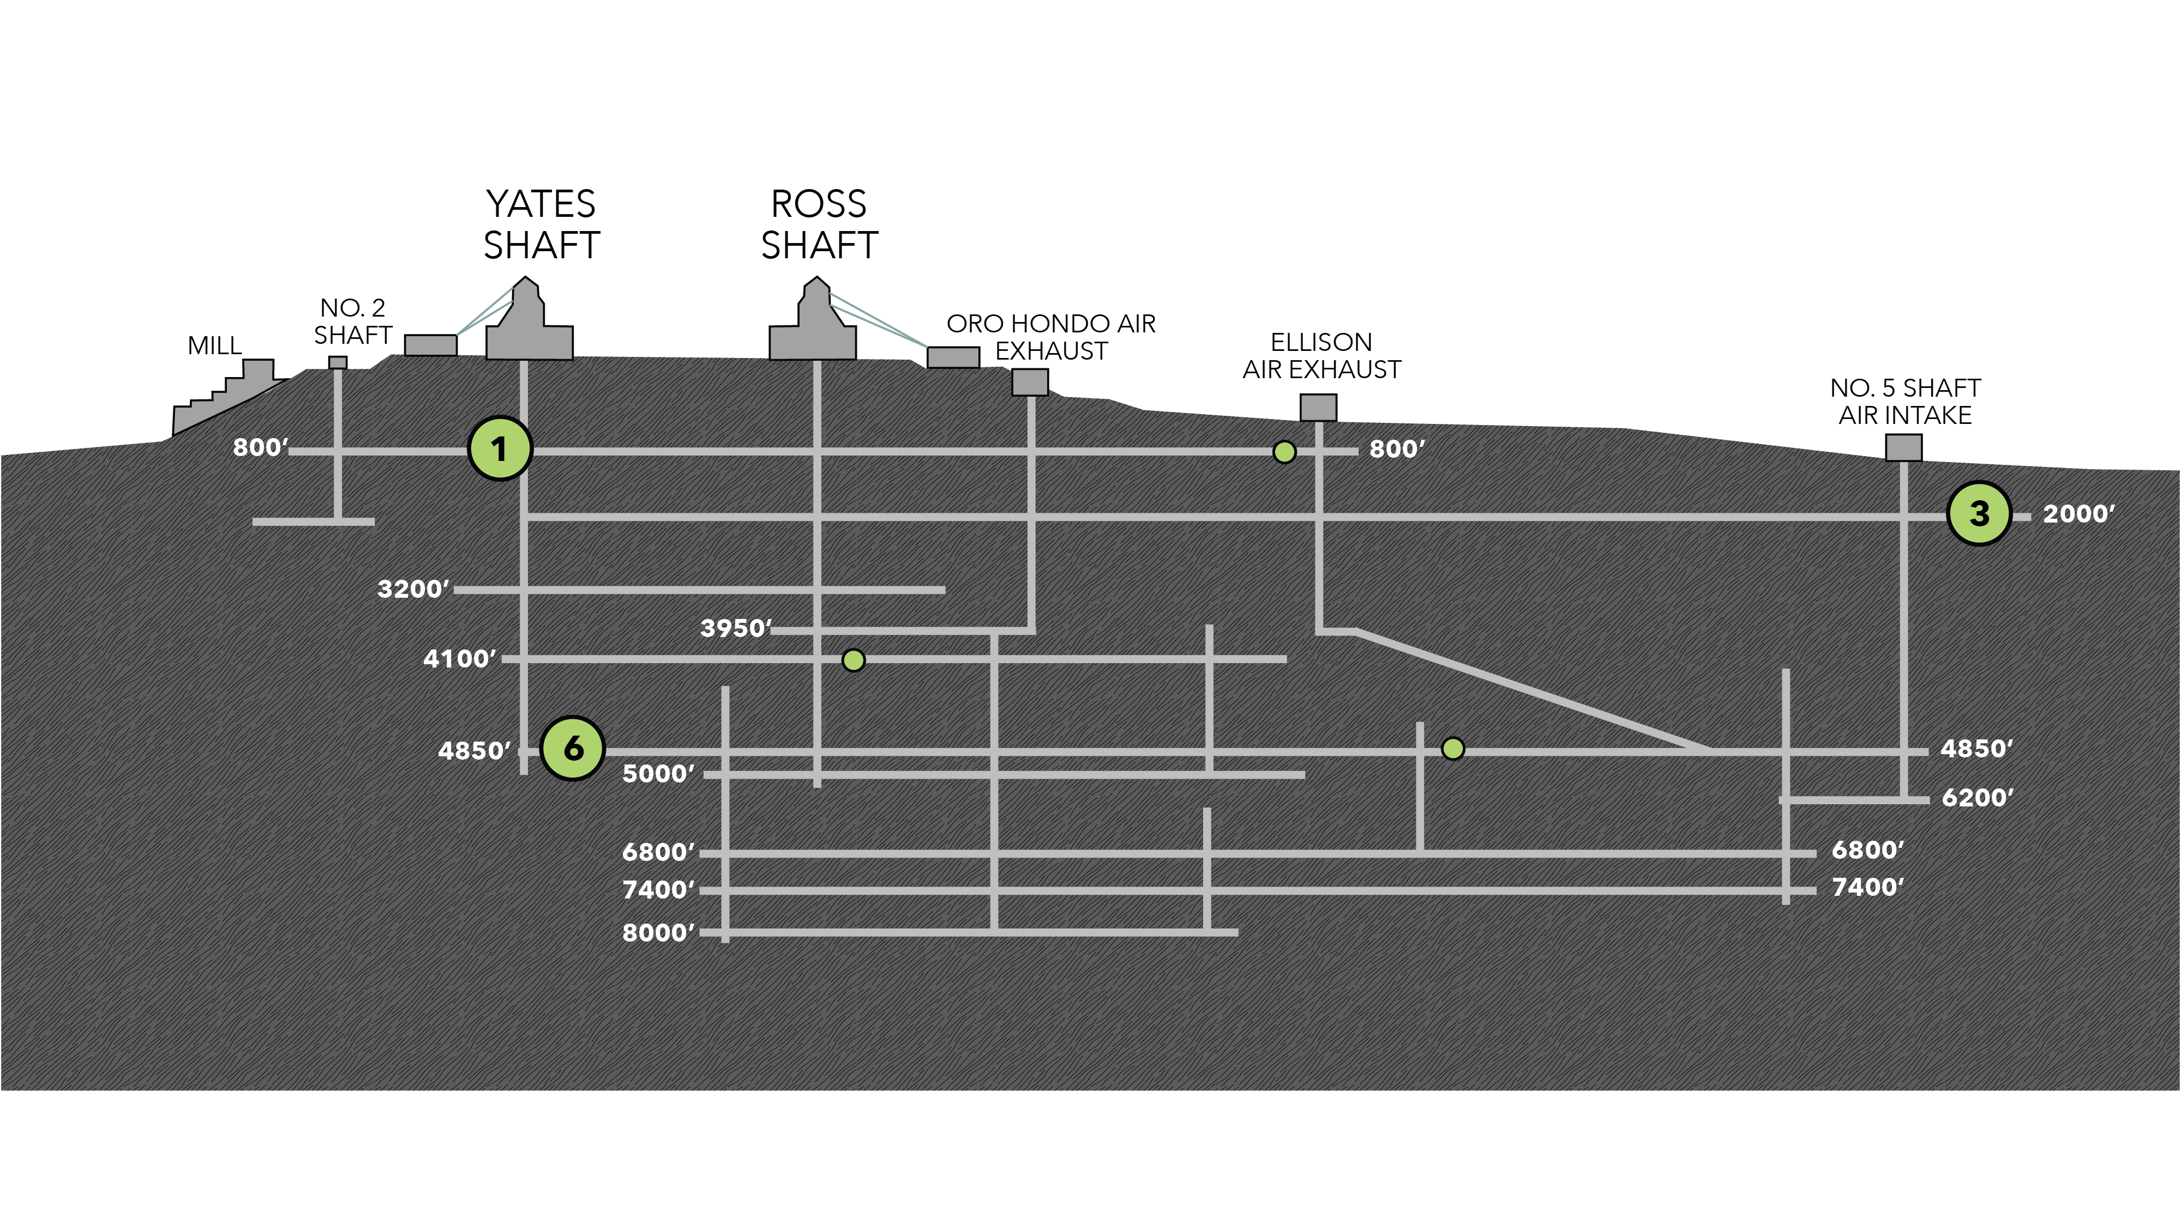**Figure 1.** Cross-sectional view of the Deep Mine Microbial Observatory (DeMMO). Grey lines are tunnels and shafts in the mine. Green circles represent locations of six DeMMO sites, larger circles represent the three sites in this study: DeMMO1, DeMMO3, and DeMMO6.

**2.2 | Thermodynamic Modeling of Microbial Metabolisms**

To investigate potential biofilm community metabolisms, we modeled 39 potential metabolic reactions with minerals under *in situ* conditions at DeMMO (Table 2). We collected DeMMO fluid geochemical data 11 times between December 2015 and September 2018 (Osburn *et al.*, 2019). This robust geochemical record was used to generate averaged fluid chemistries for DeMMO1, DeMMO3, and DeMMO6 (Table 1) used in species activity calculations via SPECE8 in Geochemist’s Workbench (Bethke *et al.*, 2009). Species activities and average fluid temperatures were used to calculate activity and equilibrium constants for each metabolic reaction in CHNOSZ. Finally, Gibbs energy yields (Gr) and energy densities (Er) of each reaction were calculated following the methods of Osburn *et al.*, 2014 (equations 1-3).

**Table 2.** Metabolic reactions with minerals in this study.

|  |  |  |  |  |  |
| --- | --- | --- | --- | --- | --- |
| **No.** | **Reaction** | **e-/rxn** | **No.** | **Reaction** | **e-/rxn** |
| **Pyrolusite as electron acceptor** | | | 23 | CaSO4*2H2O + CH3COO- ↔ HS- + 2HCO3- + Ca2+ + 2H2O | 8 |
| 1 | MnO2 + H2 + 2H+ ↔ Mn2+ + 2H2O | 2 | 24 | CaSO4*2H2O + 8Mn2+ + 10H2O ↔ HS- + 8MnOOH + Ca2+ + 15H+ | 8 |
| 2 | MnO2 + HS- + 2H+ ↔ Mn2+ + S0 + 2H2O | 2 | 25 | CaSO4*2H2O + 4CO + 2H2O ↔ 4HCO3- + HS- + Ca2+ + 3H+ | 8 |
| 3 | 3MnO2 + NH4+ + 4H+ ↔ 3Mn2+ + NO2- + 4H2O | 6 | **Siderite as electron donor** | | |
| 4 | MnO2 + CH4 + 7H+ ↔ 4Mn2+ + HCO3- + 5H2O | 8 | 26 | 2FeCO3 + NO3- +3H2O ↔ 2FeOOH + NO2- + 2HCO3- + 2H+ | 2 |
| 5 | MnO2 + Fe2+ + 2H2O ↔ Mn2+ + 2FeOOH + 2H+ | 2 | 27 | 8FeCO3 + SO42- + 12H2O ↔ 8FeOOH + HS- + 8HCO3- + 7H+ | 8 |
| 6 | 3MnO2 + S0 + 4H+ ↔ 3Mn2+ + SO42- + 2H2O | 6 | 28 | 6FeCO3 + CO + 11H2O ↔ 6FeOOH + 6HCO3- + CH4 + 6H+ | 6 |
| 7 | 9MnO2 + 2CH3COO- + 18H+ ↔ 9Mn2+ + 4HCO3- + 10H2O | 18 | **Hematite as electron acceptor** | | |
| 8 | MnO2 + CO + H+ ↔ Mn2+ + HCO3- | 2 | 29 | Fe2O3 + H2 + 4H+ ↔ 2Fe2+ + 3H2O | 4 |
| **Magnetite as electron acceptor** | | | 30 | Fe2O3 + HS- + 5H+ ↔ 2Fe2+ + S0 + 3H2O | 2 |
| 9 | Fe3O4 + H2 + 6H+ ↔ 3Fe2+ + 4H2O | 2 | 31 | 3 Fe2O3 + NH4+ + 10H+ ↔ 6Fe2+ + NO2- + 7H2O | 6 |
| 10 | Fe3O4 + HS- + 7H+ ↔ 3Fe2+ + S0 + 4H2O | 2 | 32 | 4 Fe2O3 + CH4 + 15H+ ↔ 8Fe2+ + HCO3- + 9H2O | 8 |
| 11 | 3Fe3O4 + NH4+ + 16H+ ↔ 9Fe2+ + NO2- + 10H2O | 6 | 33 | 3 Fe2O3 + S0 + 10H+ ↔ 6Fe2+ + SO42- + 5H2O | 6 |
| 12 | 4Fe3O4 + CH4 + 23H+ ↔ 16Fe2+ + HCO3- + 13H2O | 8 | 34 | 4 Fe2O3 + CH3COO- + 15H+ ↔ 8Fe2+ + 2HCO3- + 8H2O | 8 |
| 13 | 3Fe3O4 + S0 + 16H+ ↔ 9Fe2+ + SO42- + 8H2O | 6 | 35 | Fe2O3 + 2Mn2+ + H2O ↔ 2Fe2+ + 2MnOOH | 2 |
| 14 | 3Fe3O4 + 2CH3COO- + 6H+ ↔ 9Fe2+ + 4HCO3- + 4H2O | 18 | 36 | Fe2O3 + CO + 3H+ ↔ 2Fe2+ + HCO3- + H2O | 2 |
| 15 | Fe3O4 + 2Mn2+ + 2H+ ↔ 3Fe2+ + 2MnOOH | 6 | **Pyrite as electron donor** | | |  |  |
| 16 | Fe3O4 + CO + 5H+ ↔ 3Fe2+ + HCO3- + 2H2O | 2 | 37 | FeS2 + 8NO3- ↔ Fe2+ + 2SO42- + 8NO2- | 16 |
| **Gypsum as electron acceptor** | | | 38 | FeS2+ 2HCO3- + 2H2O + 2H+ ↔ Fe2+ + 2SO42- + 2CH4 | 16 |
| 17 | CaSO4*2H2O + 4H2 + H+ ↔ HS- + Ca2+ + 6H2O | 8 | 39 | 3FeS2 + 8CO + 16H2O ↔ 3Fe2+ + 6SO42- + 8CH4 | 48 |
| 18 | CaSO4*2H2O + 3HS- + 5H+ ↔ S0 + Ca2+ + 6H2O | 8 | * Aqueous forms were used for H2, CO, and CH4  **FeOOH and MnOOH are ferrihydrite and manganite, respectively | | |
| 19 | 3 CaSO4*2H2O + 4NH4+ ↔ 3HS- + 4NO2- + 3Ca2+ + 10H2O + 5H+ | 24 |
| 20 | CaSO4*2H2O + CH4 ↔ HCO3- + HS- + Ca2+ + 3H2O | 8 |
| 21 | CaSO4*2H2O + 8Fe2+ + 10H2O ↔ HS- + 8FeOOH + Ca2+ + 15H+ | 8 |  |  |  |
| 22 | 3CaSO4*2H2O + 4S0 ↔ 4SO42- + 3HS- + 5H+ + 3Ca2+ + 2H2O | 24 |  |  |  |

**2.3 | *In situ* Cultivation Experiments**

We employed *in situ* cultivation experiments to probe for the growth of biofilm communities on minerals representative of DeMMO lithology. An array of flow-through colonization reactors were connected to borehole outflows at DeMMO1, DeMMO3, and DeMMO6 for 2-8 months to allow for colonization by biofilm communities prior to harvesting. Reactors were filled with crushed and polished minerals (pyrite, hematite, magnetite, siderite, pyrolusite, muscovite, gypsum, and calcite), native rock, or inert control substrates (glass beads, glass wool, and sand). Crushed minerals and rocks were mixed with sand to a ratio of ~1:2 to minimize major changes in pH (i.e. in experiments with pyrite where excess pyrite dissolution may result in extremely acidic fluids). Crushed mineral, rock, or inert control material was collected in sterile tubes and frozen on dry ice in the field for DNA. For comparison of DNA from biofilm communities to fracture fluid communities, we collected ~1L of fracture fluids on sterivex filters from each site. Additionally, we sampled ~1L ditch fluids from mine tunnels at depths of 800 and 4,100 feet on sterivex filters as well as glass slides that were placed in the mine tunnels for 3 months as ambient background controls. Polished mineral and rock coupons or glass slides were included in each experiment for microcopy. Mineral and rock coupons and glass slides were fixed in 4% glutaraldehyde in the field and stored at 4o C (except for gypsum coupons which were not recovered due to dissolution). For comparison of biofilm communities to fluid communities via microscopy, fluids were collected into sterile PET bottles and fixed with 2% paraformaldehyde in the field.

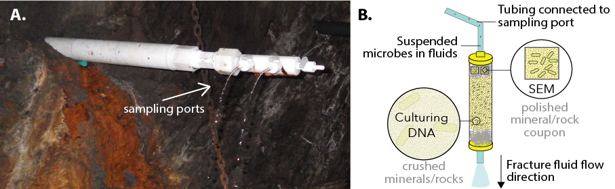

**Figure x.** A) DeMMO3 borehole installation with fracture fluids flowing from sampling ports. B) Fracture fluids flow from borehole installation sampling ports through cartridges filled with minerals, rocks, or inert sand and glass slides.

**2.4 | Microbial Community Analysis**

We extracted DNA from crushed mineral, rock, inert control, and glass slide ambient background control samples using a MoBIO PowerBiofilm DNA Isolation Kit (cat. No. 24000-50) and from sterivex filters using a MoBIO PowerWater Sterivex DNA Isolation Kit (cat no. 14600-50-NF) following the manufacturer suggested protocol. Whole genomic DNA was sent to Argonne National Laboratory for 16s rRNA amplicon sequencing of the V4 hypervariable region using 516F (GTGYCAGCMGCCGCGGTAA) and 806R (GGACTACNVGGGTWTCTAAT) universal primers. Samples were sequenced on an Illumina Miseq instrument. Paired-end reads were joined with PEAR (Zhang *et al.*, 2014) and demultiplexed with QIIME (v 1.9.1; Caporaso *et al.*, 2010). We acknowledge the growing trend of binning sequences into amplicon sequence variants (ASV’s); however, we characterize microbial communities to the family level and are not attempting to assign strain-level taxonomy to sequences here. Further, alpha and beta diversity metrics were found to be highly correlated when comparing ASV and OTU binning of environmental 16s rRNA gene sequences resulting in ecologically similar interpretations between both approaches (Glassman & Martiny, 2018), thus we chose to bin sequences into operational taxonomic units (OTU’s). Sequences were dereplicated and binned into OTU’s at a threshold similarity of 97%, and chimeric sequences were removed using USEARCH (Edgar, 2013). Rarefied OTU tables were generated in QIIME by randomly sampling sequences between read depths of 0 - 30,925, the median value of total sequence reads among samples, at a step size of 50 and 10 permutations. Rarefaction curves showing the number of observed OTU’s across the range of sequence sampling depths were generated using the averages of the 10 permutations. We chose to normalize our final OTU table for statistical analyses to a depth of 10,000 reads where rarefaction curves began to level off, indicating the read depth sufficiently captured diversity among all samples. Representatives from each OTU were assigned taxonomy using the UCLUST method in QIIME referencing the SILVA132 database (Quast *et al.*, 2012).

We performed statistical analyses on the rarefied OTU table using QIIME and the Vegan (Oksanen *et al.*, 2018) and Ecodist (Goslee & Urban, 2007) packages in R. To illustrate alpha diversity as number of observed OTU’s within each DeMMO community, we sampled the rarefaction data at a depth of 9,760 reads. To illustrate beta diversity among DeMMO communities, we performed hierarchical clustering on a representative subset of the communities at the family level using the Bray-Curtis dissimilarity metric in Ecodist (bcdist function). Using the resulting dissimilarity matrix, we generated a dendrogram of DeMMO communities with stacked bar plots illustrating community composition at the family level. For the purposes of visualizing taxonomic data here, we binned taxa that comprised less than 5% of communities as “Less Abundant Taxa”. To further illustrate beta diversity using our entire dataset of DeMMO communities including all replicates and controls, we performed nonmetric multidimensional scaling (NMDS) with Vegan on communities at the family level using the metaMDS function Bray-Curtis metric with default parameters and a dimension size of 2. To illustrate taxonomic contribution to the resulting ordination, we used the envfit function in Vegan to fit vectors of each family using default parameters and a permutation size of 1,000. We mapped vectors with p-values less than 0.006. To determine statistically different families between fluid and mineral-hosted biofilm communities, we used the Kruskal-Wallis rank sum test with a p-value threshold of 0.05 after false discovery rate correction (Steinberger, 2016).

**2.5 | Microbial Cell Density Estimates**

We documented cell morphologies and estimated cell densities on mineral coupons and inert glass slides included in each experiment using scanning electron microscopy (SEM). Samples were gradually dehydrated in 200 proof ethanol and subjected to critical point drying to preserve cell structure. Finally, samples were coated with osmium tetroxide to a thickness of 15 nm to enhance sample conductivity for imaging on a FEI Quanta 650 ESEM in the EPIC facility at the Northwestern University NUANCE center. Images were collected using an operating voltage of 20 kV, 0.98 torr pressure, and working distance of ~5 mm. We collected 20 images from each sample and counted cells from a minimum of either 300 cells or 10 images. In some cases, cells were counted from all 20 images and totaled less than 300 cells. Images were also collected from polished rock (prepared as earlier described); however, we did not estimate cell densities due to rough sample topography. To estimate cell densities, fixed fluids were filtered onto polycarbonate filters, stained with DAPI (4’,6-diamidino-2-phenylindole) for ten minutes, and mounted on glass slides with Citifluor antifade reagent before visualizing with a [insert microscope model here].

**3 | RESULTS**

**3.1 Gibb’s free energy and energy density of metabolic reactions with minerals**

Of the 39 reactions modeled, the most exergonic reaction is pyrite oxidation with nitrate, followed all pyrolusite reduction reactions and siderite oxidation with nitrate. The rest of the reactions yielded almost no Gibb’s free energy or were endergonic.

In terms of energy density, carbon monoxide is most energy dense of dissolved reactants. Moderately dense reactants include nitrate, acetate, ferrous iron, methane, and sulfide are moderately dense. Hydrogen is the least dense reactant of the exergonic reactions.

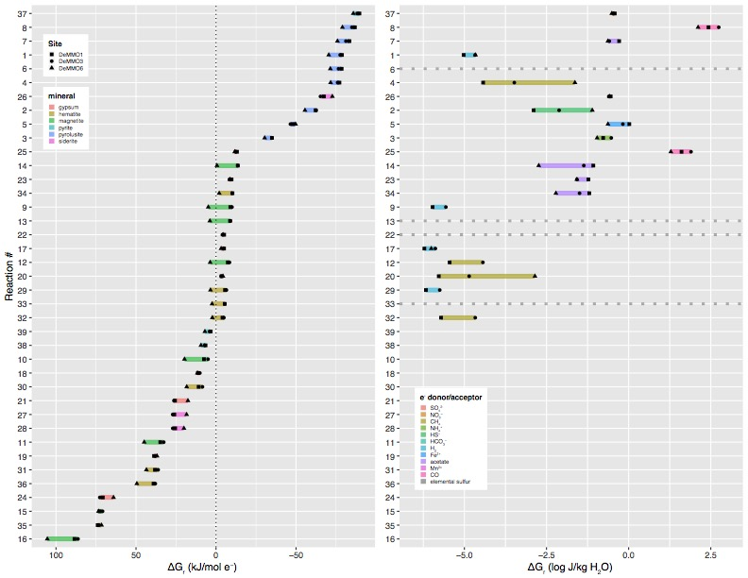

**Figure x.** Free energy (left) and energy density (right) of reactions with minerals and dissolved electron donors and acceptors based on *in situ* geochemistry.

**3.2 Microbial Communities**

DeMMO fluid and biofilm communities include 9,307 OTU’s (817 families from 68 phyla) after quality filtering and read depth normalization. In terms of the number of observed OTUs at a normalized sequencing depth of 9,760 reads, DeMMO1 fluids are the most diverse. On average, fluid communities are more diverse than their biofilm community counterparts, and mineral-hosted biofilm communities are more diverse than biofilm communities on inert controls (Figure X).



**Figure x.** Alpha diversity of DeMMO communities. OTU abundance at a rarefaction sequence depth of 9,760 reads. Teal, blue, and pink represent DeMMO 1, 3, and 6 communities, respectively. White points represent mean values within a community.

Microbial communities are distinct clades at each study location, where DeMMO1 communities are dominated by members of *Nitrospirae, Omnitrophica, Betaproteobacteria,* and *Chloroflexi*, DeMMO3 by *Beta-, Delta-*, and *Alphaproteobacteria* and *Chloroflexi*, and DeMMO6 communities by *Deltaproteobacteria, Chloroflexi, Acetothermia*, and *Latescibacteria* ­(Figure x). Likewise, communities from each site form distinct groups in NMDS space (Figure x).

Several experiments with minerals enriched for biofilm communities distinct from fluid communities or biofilm communities on inert control substrates. Most striking are the experiments with pyrolusite, which enriched for members of the *Desulfobulbaceae* at DeMMO3 and DeMMO6 and *Thermodesulfovibrionia* at DeMMO1.



**Figure x.** Beta diversity of DeMMO communities. Relative abundances of taxa binned at the family level from selected DeMMO fluid and biofilm samples. Taxa that make up less than 5% of a community were binned as ‘Less Abundant Taxa’. Communities are organized by hierarchical clustering using Bray-Curtis similarity, visualized as a dendrogram.

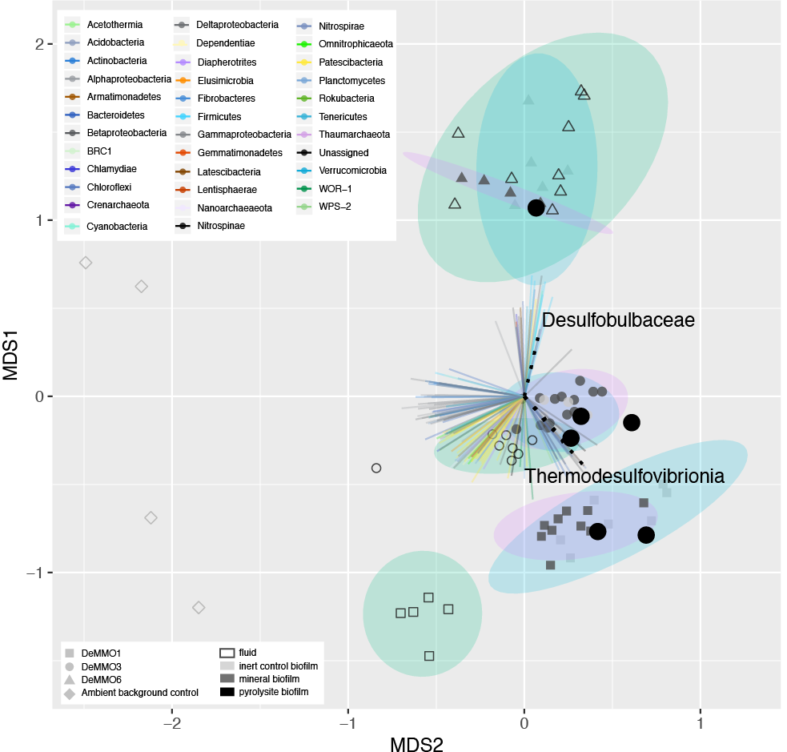

**Figure x.** NMDS plot of DeMMO fluid and biofilm communities represented as hollow and filled points, respectively. Community compositions taken from relative abundances of 16s rRNA gene sequences binned at the family level. Vectors with p-values < 0.006 representing each family are colored by Phylum. Vectors representing *Desulfobulbaceae* and *Thermodesulfovibrionia* are shown as black dotted lines. Biofilm communities from pyrolusite experiments are shown as opaque black points. 95% confidence ellipses encompass fluid (green), mineral biofilm (purple) or control biofilm (blue) communities from each site. Ambient background controls are glass slides that were placed in the mine tunnels exposed to air at depths of 800 and 4,850 ft for five months or fluid samples from open ditches in the mine tunnels.

Although there are shared taxa among community types, the fluid and mineral-hosted biofilm communities are distinct. Broadly, members of candidate phyla *Omnitrophica* are more abundant in fluid communities, whereas members of *Pseudomondaceae,* *Rhodocyclaceae* and *Thermodesulfovibrionia* are more abundant in biofilm communities (Figure x).



Figure x. Families that are significantly different between fluid and mineral-hosted biofilm communities based on the Kruskal-Wallis rank sum test. Only families where the mean relative abundance in either fluid biofilm communities was 0.75% or higher are included here. Arrows represent mean abundances of each family and point toward the compared value with greater abundance, colored by phylum.

* 1. **| Mineral-hosted biomass**

Overall, communities from DeMMO1 had the highest cell densities, and of these, the highest were in parallel control experiments. Of the minerals, pyrolusite had the highest cell densities, whereas the lowest cell densities were observed on calcite and muscovite. Generally, cell densities were higher on minerals than on internal controls, with exceptions being in DeMMO1 communities on pyrite and magnetite.

* + Temporal variability in densities observed at each site, particularly at DeMMO1
  + Cell morphologies differ between minerals and controls
  + Descriptions of biogenic structures and cell morphologies



**Figure x.** Cell densities estimated from cell counts from mineral chip SEM images. Glass slides were included in experiments with minerals (internal inert controls) or sand (parallel inert controls).

**4 | DISCUSSION**

* 1. **Exergonic mineral metabolisms**

Thermodynamic models reveal that pyrite oxidation with nitrate is the most exergonic metabolism at DeMMO1, 3, and 6; however, energy density calculations where limiting reactants are considered indicate that nitrate is not as available for microbial metabolisms as other dissolved substrates (Figure x). For example, pyrolusite reduction with carbon monoxide is a very favorable metabolism and carbon monoxide is abundant, thus this metabolism may actually be move favorable in terms of energy density. Given that all reactions with pyrolusite were exergonic at all three DeMMO sites, we expected results from experiments with pyrolusite to be distinct from experiments with other minerals. Indeed, microbial community and cell density data suggest pyrolusite may be a favorable surface for colonization by specific taxa at DeMMO.

Energy Density

* + - The most favorable reactions with minerals in terms of free energy are not always the most energy dense in terms of available solute. For example, there are highly exergonic reactions with H2, however H2 is not abundant and may therefore not be a good electron donor in terms of availability. By contrast, reactions with CO are exergonic and CO is abundant, therefore it may be a more representative reactant for in situ metabolisms given its abundance.

**4.2 Microbial Communities**

* **Alpha Diversity**
  + Higher diversity in fluids vs. biofilms may indicate:
    - only a subpopulation of fluid community may be capable of biofilm formation
    - competition for resources in fluid communities may drive biofilm formation in organisms capable of utilizing solid substrates for metabolisms
* **Beta Diversity** 
  + D1, 3, and 6 communities more similar within a site than between sites, indicating fluid geochemistry ultimately controls community composition
  + In experiments with pyrolusite, high enrichments of Desulfobulbaceae and Thermodesulfovibrionia were observed, suggesting these taxa may derive enegy from pyrolusite reduction.
  + NMDS separation of D1,3,6 communities from ambient background controls - therefore no indication of contamination

Hierarchical clustering dendrogram – distinct clades

NMDS of all fluid and experimental biofilm communities reveals that these trends are consistent across replicate samples, and there is no indication of contamination from ambient background communities

**4.3 | Mineral-hosted biomass**

* **Biofilm cell density estimates** 
  + Higher cell densities on parallel controls vs. minerals suggests that in most cases, minerals promote biofilm formation, which may indicate that the minerals provide a source of energy for members of the biofilms. Minerals rich in iron and manganese promoted higher densities than calcite and muscovite, suggesting potential iron and manganese metabolisms.
  + Communities colonizing DeMMO1 pyrite and magnetite internal controls (glass) were more dense than their mineral counterparts. Mineral dissolution may provide aqueous Fe2+, a phase that may be preferred by these communities. Alternatively, a temporal shift in fluid conditions may explain this observation, given that on average cell densities were higher in DeMMO1 experiments during August 2017 than November 2017.
  + Consistent cell morphologies across glass-colonizing biofilms vs. heterogenous morphologies across minerals suggests minerals promotes colonization of distinct subpopulations
  + Wanger et al. 2006 suggested potentially long timescales for biofilm development/cell doubling time in SA gold mine, our data show that biofilms and dense EPS can form rapidly where energy-rich substrates are available
  + Possible extrapolation of densities based on percent mineral composition from Caddey 1991, could compare to densities estimated from native rock experiments
  + Biogenic structures observed in SEM images may play a role in EET

Cell density estimates from SEM images indicate that pyrolusite was most well colonized out of all mineral types, whereas calcite, a mineral with no iron or manganese, was least colonized. Cell densities estimated from internal and parallel control glass slides were highest in DeMMO1 experiments, and these biofilms shared the same cell morphologies, suggesting that glass promoted the colonization of a common taxa across these experiments. However, cell morphologies were distinct between most controls and minerals (i.e. in all pyrolusite experiments at all sites), suggesting taxonomic selection for mineral surface colonization (Figure x).



**Figure x.** Left: Cell densities vs. sampling date for each site. Right: Cell densities vs. site over all sampling dates.

**4 | CONCLUSIONS**

* All data taken together suggest pyrolusite is very favorable electron acceptor at DeMMO, especially when coupled to organic carbon, elemental sulfur, or methane, which promotes the growth of Thermodesulfovibrionia and Desulfobulbaceae in dense biofilm communities.

Together, taxonomic and cell density/morphology data, along with the observation of biofilms on experiments with native rock, suggest the capacity for a mineral-hosted deep subsurface biosphere of significant biomass at DeMMO, especially where iron and manganese-bearing minerals are present.

**ACKNOWLEDGEMENTS**

* This work was supported by NASA Headquarters under the NASA Earth and Space Science Fellowship Program – “Grant 80NSSC18K1267” and Exobiology Grant “…” and Northwestern University.
* Undergrads: Bethany Ketchem, Annamarie Jedziniak
* SURF staff: Tom Regan
* This work made use of the EPIC facility of Northwestern University’s NUANCE Center, which has received support from the Soft and Hybrid Nanotechnology Experimental (SHyNE) Resource (NSF ECCS-1542205); the MRSEC program (NSF DMR-1720139) at the Materials Research Center; the International Institute for Nanotechnology (IIN); the Keck Foundation; and the State of Illinois, through the IIN.

**References**

Bethke, C., & Yeakel, S. (2009). *Geochemist's Workbench: Release 8.0 Reaction Modeling Guide*. RockWare Incorporated.

Flemming, H. C. and Wuertz, S. (2019) *Nat. Rev. Microbio.*, 1.

Oksanen, J., Blanchet, F. G., Friendly, M., Kindt, R., Legendre, P., McGlinn, D., Minchin, P. R., O'Hara, R. B., Simpson, G. L., Solymos, P., M., Stevens, H. H., Szoecs, E. and Wagner, H. (2018). vegan: Community Ecology Package. R package version 2.5-3. https://CRAN.Rproject.org/package=vegan

Osburn et al. 2019. Long-term aqueous geochemical stability of the Deep Mine Microbial Observatory (DeMMO), South Dakota USA. Frontiers in Earth Science.

**Supplemental**

* The OTU table and code used to perform statistical analyses and figs can be found at DOI: …

**­**

**Figure x.** Alpha diversity of DeMMO communities. Rarefaction curves illustrate the number of OTU observations across a range of sequencing depths.



Figure x. Families that are significantly different between fluid and mineral-hosted biofilm communities based on the Kruskal-Wallis rank sum test. Arrows represent mean abundances of each family and point from mineral-hosted biofilm to fluid community values, colored by phylum.

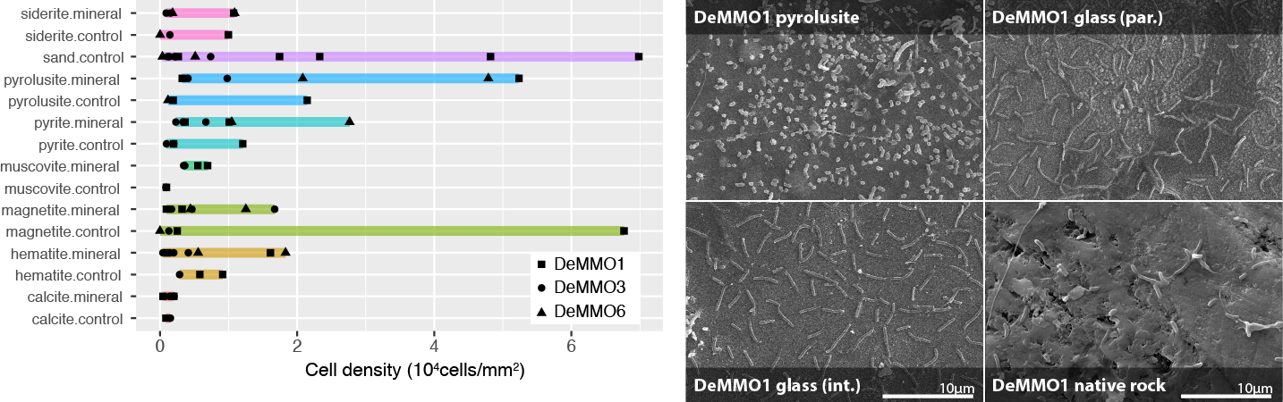

**Figure x.** Left: Cell densities estimated from cell counts from mineral chip SEM images. Glass slides were included in experiments with minerals (internal inert controls) or sand (parallel inert controls). Right: SEM images taken from pyrolusite experiments at DeMMO1. Clockwise from top left: pyrolusite, parallel sand control, native rock, internal pyrolusite control.