Figure_1_v1.pdf

**Figure 1.** Percent completeness for metagenome assembled genomes (MAGs) from DeMMO 1-6 as well as an overlying stream (White Creek) and mine service water collected at 4,850 feet below surface. The majority of reconstructed genomes are 60-100% complete. Only genomes >30% complete were included in this analysis and 334 of the 452 MAGs were >50% complete.

**Figure2_v1.pdf**

**Figure 2.** Taxonomic breakdown of metagenome assembled genomes (MAGs). A. Overall phylum level taxonomy B. Members of the Candidate Phyla Radiation (CPR) C. Members of the Proteobacteria shown at the class level D. Members of the domain Archaea shown at the class level. Note DeMMO 6, service water and White Creek had no Archaea MAGs >30% complete.

**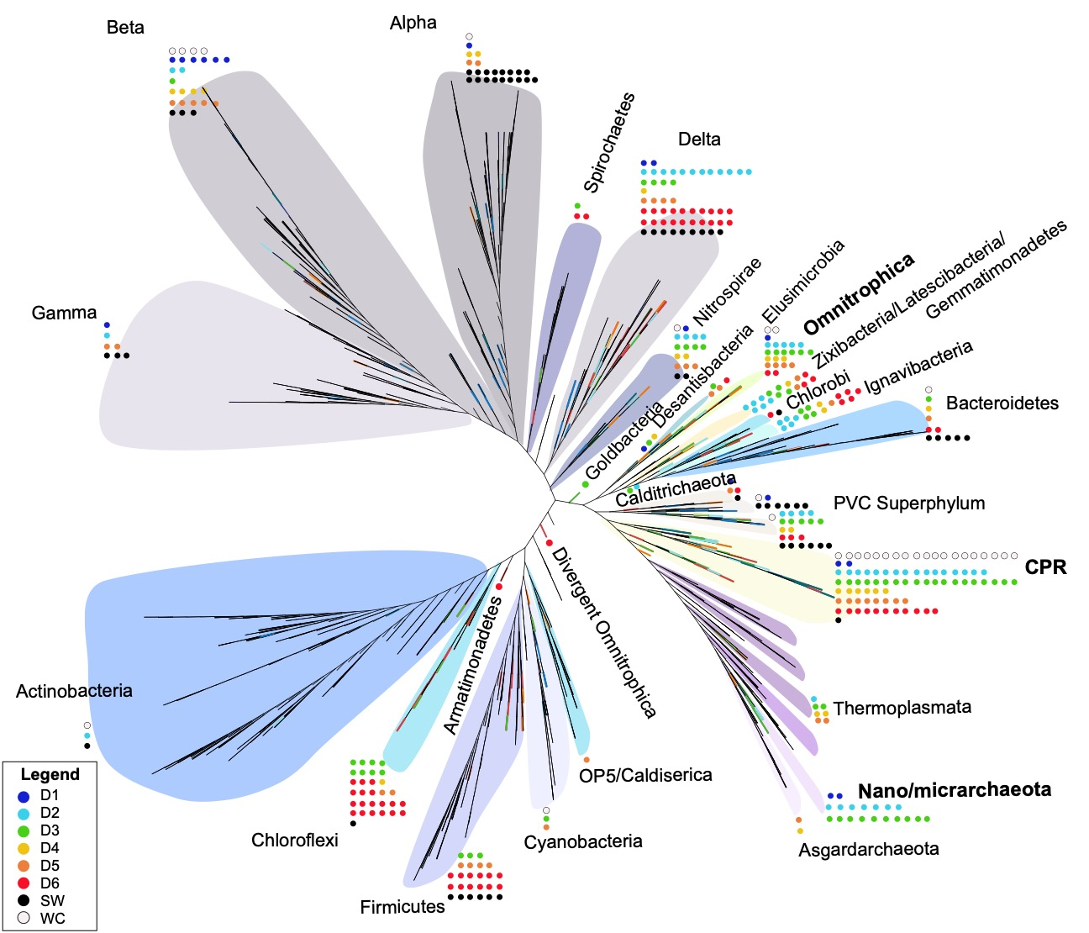**

**Figure 3.** Phylogeny of metagenome assembled genomes (MAGs) shown as a concatenated ribosomal protein tree. A set of 15 syntenic ribosomal proteins were concatenated, trimmed and aligned from MAGs analyzed in this study, along with a collection of 1,673 other genomes downloaded from the National Center for Biotechnology Information (NCBI) database to populate a diverse distribution of the microbial tree of life. MAGs are represented as dots adjacent to their respective phylogenetic groups.

**3:2020_DeMMO_ISME/gene_abundance_bubble_plot.pdf**

**Figure 4.** Metagenome assembled genomes (MAGs) were queried for a suite of known functional marker genes involved in energy yielding metabolisms and motility. Marker gene abbreviations shown on left and results are colored by metabolism in which the gene is known to be involved.