**Stress-Particle SPH input file structures**

1. **input.txt –** contains numerical solver information, including stress-point parameters, the smoothing length, the time step
2. ***filename*.dat –** contains material information, including constitutive model and parameters, initial conditions. Numerical damping techniques (such as XSPH, CSPM, artificial viscosity) are defined here
3. ***filename*.pts –** contains geometry information, including the initial material dimensions and dummy node boundary conditions (if included)

**input.txt**

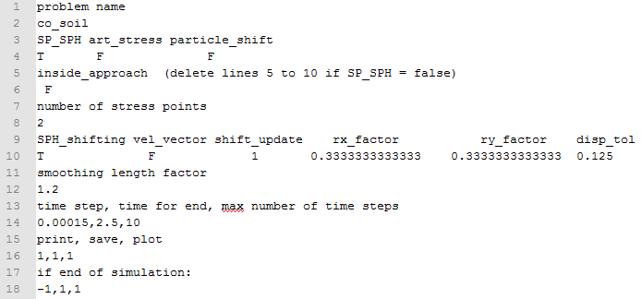

**Problem name**: *filename* (corresponding to .pts and .dat file)

**SP_SPH**: T or F. T (true) for the stress-particle method, F (false) for Standard SPH. If F, remove lines 5-10

**art_stress**: T or F. T (true) if using the artificial stress method to combat the tensile instability (Monaghan et al. 2000)

**particle_shift**: T or F. T (true) if using the particle shifting technique to combat the tensile instability (Xu et al. 2018)

**inside_approach**: T or F. T for the stress-particle inside approach, F for the stress-particle outside approach. If T, remove lines 9-10

**number of stress points**: number of stress-points (per node for the outside approach, per `virtual square’ for the inside approach)

**SPH_shifting, vel_vector, shift_update, rx_factor, ry_factor, disp_tol:** outside approach parameters

**SPH_shifting:** T or F. T for stress-points to `follow’ node every specified number of time steps

**vel_vector:** T or F. T if velocity vector approach is used to update stress-point orientation

**shift_update:** Specified number of time steps in which to update the position of the stress-points (if 1, they are updated at every time step)

**rx/ry_factor:** initial distance of stress-points to associated node (as a fraction of particle spacing dx)

**disp_tol:** velocity vector approach parameter

**smoothing length factor:** smoothing length (as a fraction of particle spacing dx)

**time step, time for end, max number of time steps:** temporal controls

**print, save, plot:** specified number of time steps in which to output results

**if end of simulation:** fix to stop simulation when time ends (will be more sophisticated in future versions)