Contained within this document are the following ekphrastic poems and the artworks which inspired them. They are presented in reverse chronological order. This reading packet is designed to be used by instructors in college and high school poetry and English language/literature courses, as described on [the project homepage.](https://cuny.manifoldapp.org/projects/ekphrasis) This packet was compiled by Caitlin Cacciatore, author of the Open Educational Resource (OER) entitled “Ekphrasis: An Exploration of Poetry Inspired by Art.” Thank you for learning with me.

1. The Man with the Hoe by Edwin Markham (1898)
2. Sonnets For Spring by Dante Gabriel Rossetti (1873)
3. Hiram Powers' "Greek Slave" by Elizabeth Barrett Browning (circa 1851)
4. On the Medusa of Leonardo Da Vinci in the Florentine Gallery by Percy Bysshe Shelley (after Autumn 1819)
5. Ode on a Grecian Urn by John Keats (May 1819)
6. Two Poems on the Elgin Marbles by John Keats (circa 1817)
7. Elegiac Stanzas Suggested by a Picture of Peele Castle in a Storm by William Wordsworth (circa 1807)
8. The Forging of the Sheild of Achilles in Book XVIII of The Iliad by Homer (8th century B.C.E.)

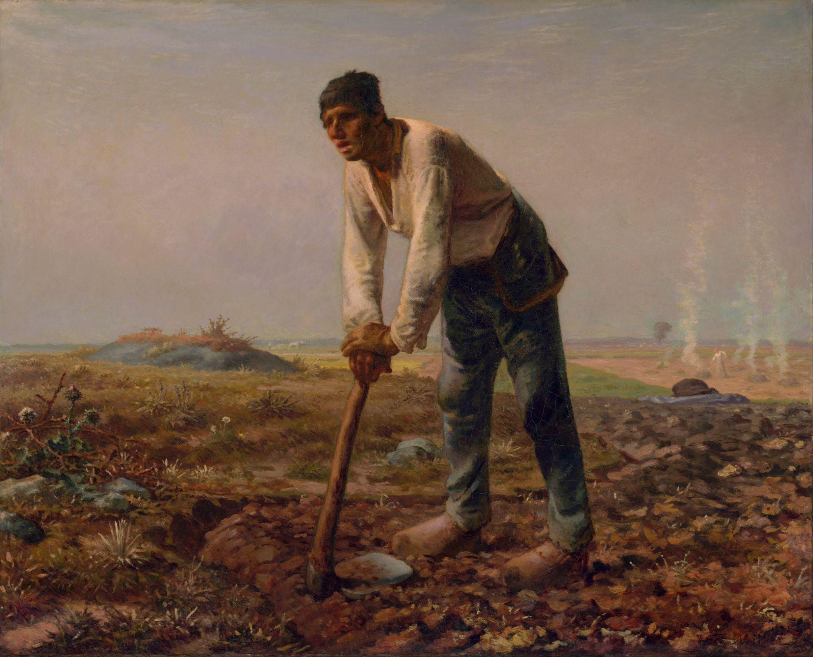

[This is a public domain image sourced from the Getty Museum Collection.](https://www.getty.edu/art/collection/object/103RGZ)

Man with a Hoe

# [Edwin Markham: “The Man with the Hoe,” as read by an unknown male speaker](https://youtu.be/dretN7WZx4w)

# 

# The Man with the Hoe

By Edwin Markham - 1852-1940

Bowed by the weight of centuries he leans  
Upon his hoe and gazes on the ground,  
The emptiness of ages in his face,  
And on his back the burden of the world.  
Who made him dead to rapture and despair,  
A thing that grieves not and that never hopes.  
Stolid and stunned, a brother to the ox?  
Who loosened and let down this brutal jaw?  
Whose was the hand that slanted back this brow?  
Whose breath blew out the light within this brain?  
Is this the Thing the Lord God made and gave  
To have dominion over sea and land;  
To trace the stars and search the heavens for power;  
To feel the passion of Eternity?  
Is this the Dream He dreamed who shaped the suns  
And marked their ways upon the ancient deep?  
Down all the stretch of Hell to its last gulf  
There is no shape more terrible than this —  
More tongued with censure of the world's blind greed —  
More filled with signs and portents for the soul —  
More fraught with menace to the universe.

What gulfs between him and the seraphim!  
Slave of the wheel of labor, what to him  
Are Plato and the swing of Pleiades?  
What the long reaches of the peaks of song,  
The rift of dawn, the reddening of the rose?  
Through this dread shape the suffering ages look;  
Time's tragedy is in the aching stoop;  
Through this dread shape humanity betrayed,  
Plundered, profaned, and disinherited,  
Cries protest to the Powers that made the world.  
A protest that is also a prophecy.

O masters, lords and rulers in all lands,  
Is this the handiwork you give to God,  
This monstrous thing distorted and soul-quenched?  
How will you ever straighten up this shape;  
Touch it again with immortality;  
Give back the upward looking and the light;  
Rebuild in it the music and the dream,  
Make right the immemorial infamies,  
Perfidious wrongs, immedicable woes?

O masters, lords and rulers in all lands  
How will the Future reckon with this Man?  
How answer his brute question in that hour  
When whirlwinds of rebellion shake all shores?  
How will it be with kingdoms and with kings —  
With those who shaped him to the thing he is —  
When this dumb Terror shall rise to judge the world.  
After the silence of the centuries?

# Further Information about the Artwork:

**Artist/Maker:** [Jean-François Millet](https://www.getty.edu/art/collection/person/103JZS) (French, 1814 - 1875)

**Date:** 1860–1862

**Medium:** Oil on canvas

**Dimensions:**

Unframed: 81.9 × 100.3 cm (32 1/4 × 39 1/2 in.)

Framed [outer dimensions]: 112.4 × 131.4 × 9.5 cm (44 1/4 × 51 3/4 × 3 3/4 in.)

Creative Commons License

This work is licensed under a [Creative Commons Attribution 4.0 International License](http://creativecommons.org/licenses/by/4.0/).

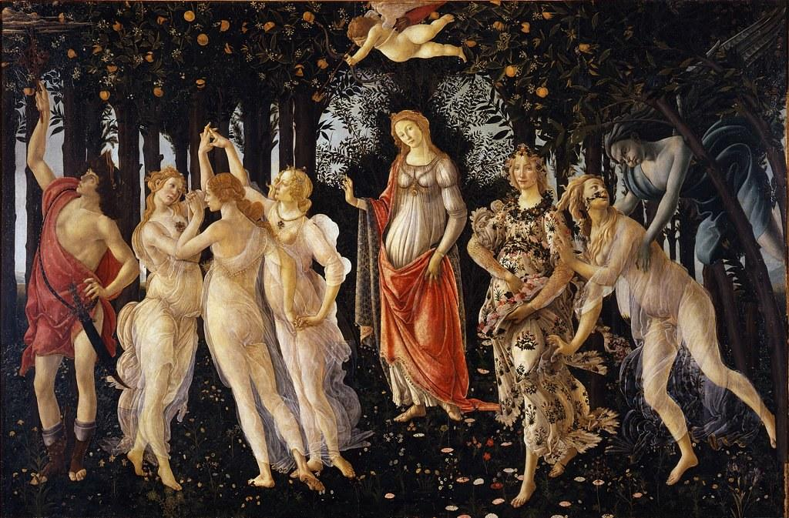

The above image is a public domain image [sourced from Wikimedia Commons.](https://commons.wikimedia.org/wiki/File:Botticelli-primavera.jpg)

Sonnets For Spring by Sandro Botticelli (In the Accademia of Florence)

By Dante Gabriel Rossetti

# 

## Sonnet For Spring by Sandro Botticelli (In the Accademia of Florence)

By Dante Gabriel Rossetti (1828 - 1882)

What masque of what old wind-withered New-Year

Honours this Lady? Flora, wanton-eyed

* For birth, and with all flowrets prankt and pied:

Aurora, Zephyrus, with mutual cheer

Of clasp and kiss: the Graces circling near,

* 'Neath bower-linked arch of white arms glorified:
* And with those feathered feet which hovering

glide

O'er Spring's brief bloom, Hermes the harbinger.

Birth-bare, not death-bare yet, the young stems

* stand,

This Lady's temple-columns: o'er her head

* Love wings his shaft. What mystery here is read

Of homage or of hope? But how command

Dead Springs to answer? And how question here

These mummers of that wind-withered New-

* Year?

## Further Information about the Artwork:

**Artist/Maker:** [Sandro Botticelli](https://artuk.org/discover/artists/botticelli-sandro-144414451510) (Italian, c. 1445 - 1510)

**Date:** circa 1480

**Medium:** Tempera grassa on wood

**Dimensions:** 207 x 319 cm

**Resides In:** [The Uffizi, Italy](https://www.uffizi.it/en/artworks/botticelli-spring)

Creative Commons License

This work is licensed under a [Creative Commons Attribution 4.0 International License](http://creativecommons.org/licenses/by/4.0/).

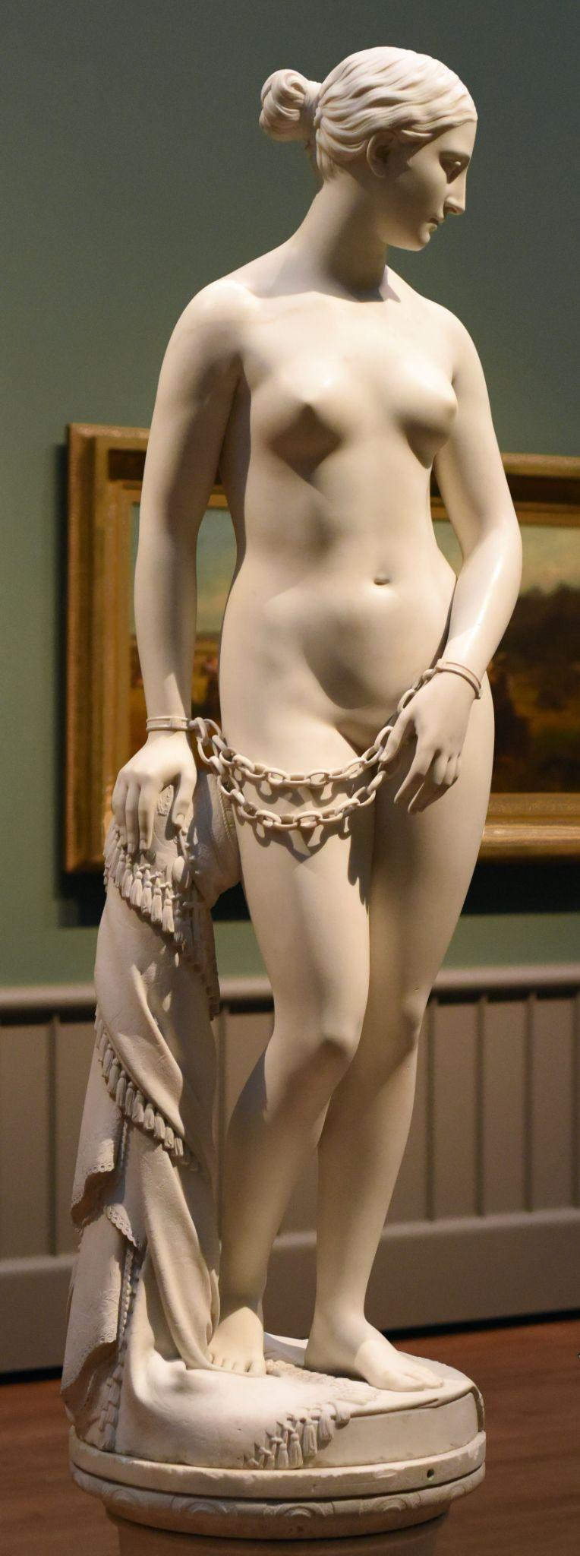

Image of Hiram Powers’ “Greek Slave,” [as photographed by Karl Thomas Moore,](https://commons.wikimedia.org/wiki/File:The_Greek_Slave_by_Hiram_Powers_at_Yale_crop.jpg) licensed under a Creative Commons Attribution-Share Alike 4.0 International license.

Hiram Powers’ “Greek Slave”

By Elizabeth Barrett Browning

# 

# Hiram Powers’ “Greek Slave”

By Elizabeth Barrett Browning (1806 - 1861)

They say Ideal beauty cannot enter

The house of anguish. On the threshold stands

An alien Image with enshackled hands,

Called the Greek Slave! as if the artist meant her

(That passionless perfection which he lent her,

Shadowed not darkened where the sill expands)

To so confront man's crimes in different lands

With man's ideal sense. Pierce to the centre,

Art's fiery finger! and break up ere long

The serfdom of this world. Appeal, fair stone,

From God's pure heights of beauty against man's wrong!

Catch up in thy divine face, not alone

East griefs but west, and strike and shame the strong,

” by thunders of white silence, overthrown.

# [Further Information about the Artwork:](https://www.nga.gov/collection/art-object-page.166484.html)

**Artist/Maker:** Hiram Powers (American, 1805-1873)

**Date:** 1869

**Medium:** Seravezza marble

**Dimensions:** 167.5 × 51.4 × 47 cm (65 15/16 × 20 1/4 × 18 1/2 in.)

**Resides In:** The National Gallery of Art, Washington D.C.

Creative Commons License

This work is licensed under a [Creative Commons Attribution 4.0 International License](http://creativecommons.org/licenses/by/4.0/).

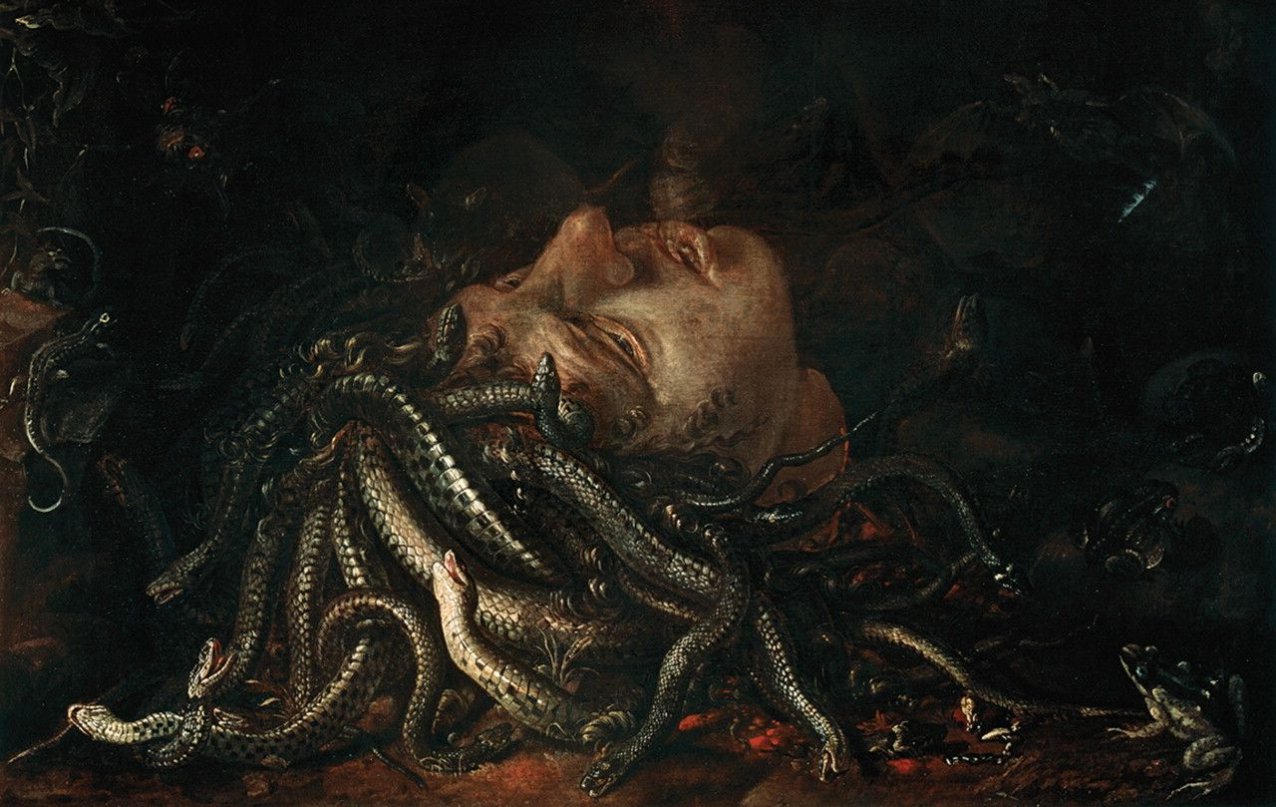

Head of Medusa by an unknown 16th or 17th-century Flemish painter; formerly attributed to Leonardo Da Vinci. This image is public domain and is [sourced from Wikimedia Commons.](https://commons.wikimedia.org/wiki/File:Medusa_uffizi.jpg)

[Percy Bysshe Shelley: “On the Medusa of Leonardo Da Vinci in the Florentine Gallery,” as read by an unknown male speaker](https://youtu.be/fcOdzJmqatQ)

# On the Medusa of Leonardo Da Vinci in the Florentine Gallery

By Percy Bysshe Shelley - 1792-1822

It lieth, gazing on the midnight sky,

Upon the cloudy mountain peak supine;

Below, far lands are seen tremblingly;

Its horror and its beauty are divine.

Upon its lips and eyelids seems to lie

Loveliness like a shadow, from which shrine,

Fiery and lurid, struggling underneath,

The agonies of anguish and of death.

Yet it is less the horror than the grace

Which turns the gazer's spirit into stone;

Whereon the lineaments of that dead face

Are graven, till the characters be grown

Into itself, and thought no more can trace;

'Tis the melodious hue of beauty thrown

Athwart the darkness and the glare of pain,

Which humanize and harmonize the strain.

And from its head as from one body grow,

As [ ] grass out of a watery rock,

Hairs which are vipers, and they curl and flow

And their long tangles in each other lock,

And with unending involutions shew

Their mailed radiance, as it were to mock

The torture and the death within, and saw

The solid air with many a ragged jaw.

And from a stone beside, a poisonous eft

Peeps idly into those Gorgonian eyes;

Whilst in the air a ghastly bat, bereft

Of sense, has flitted with a mad surprise

Out of the cave this hideous light had cleft,

And he comes hastening like a moth that hies

After a taper; and the midnight sky

Flares, a light more dread than obscurity.

'Tis the tempestuous loveliness of terror;

For from the serpents gleams a brazen glare

Kindled by that inextricable error,

Which makes a thrilling vapour of the air

Become a [ ] and ever-shifting mirror

Of all the beauty and the terror there—

A woman's countenance, with serpent locks,

Gazing in death on heaven from those wet rocks.

# Further Information about the Artwork:

**Title:** Head of Medusa

**Artist:** Flemish School, (16th century) / Flemish

**Current Location:** Galleria degli Uffizi, Florence, Tuscany, Italy

**Medium:** oil on panel

**Dimensions:** 49x74 cms

According to Romantic Circles, “The "Head of the Medusa" that inspired Shelley is now attributed to the Flemish School, circa 1620-30. The painting is owned by the Uffizi Gallery in Florence, inventory number P1472.”

Creative Commons License

This work is licensed under a [Creative Commons Attribution 4.0 International License](http://creativecommons.org/licenses/by/4.0/).

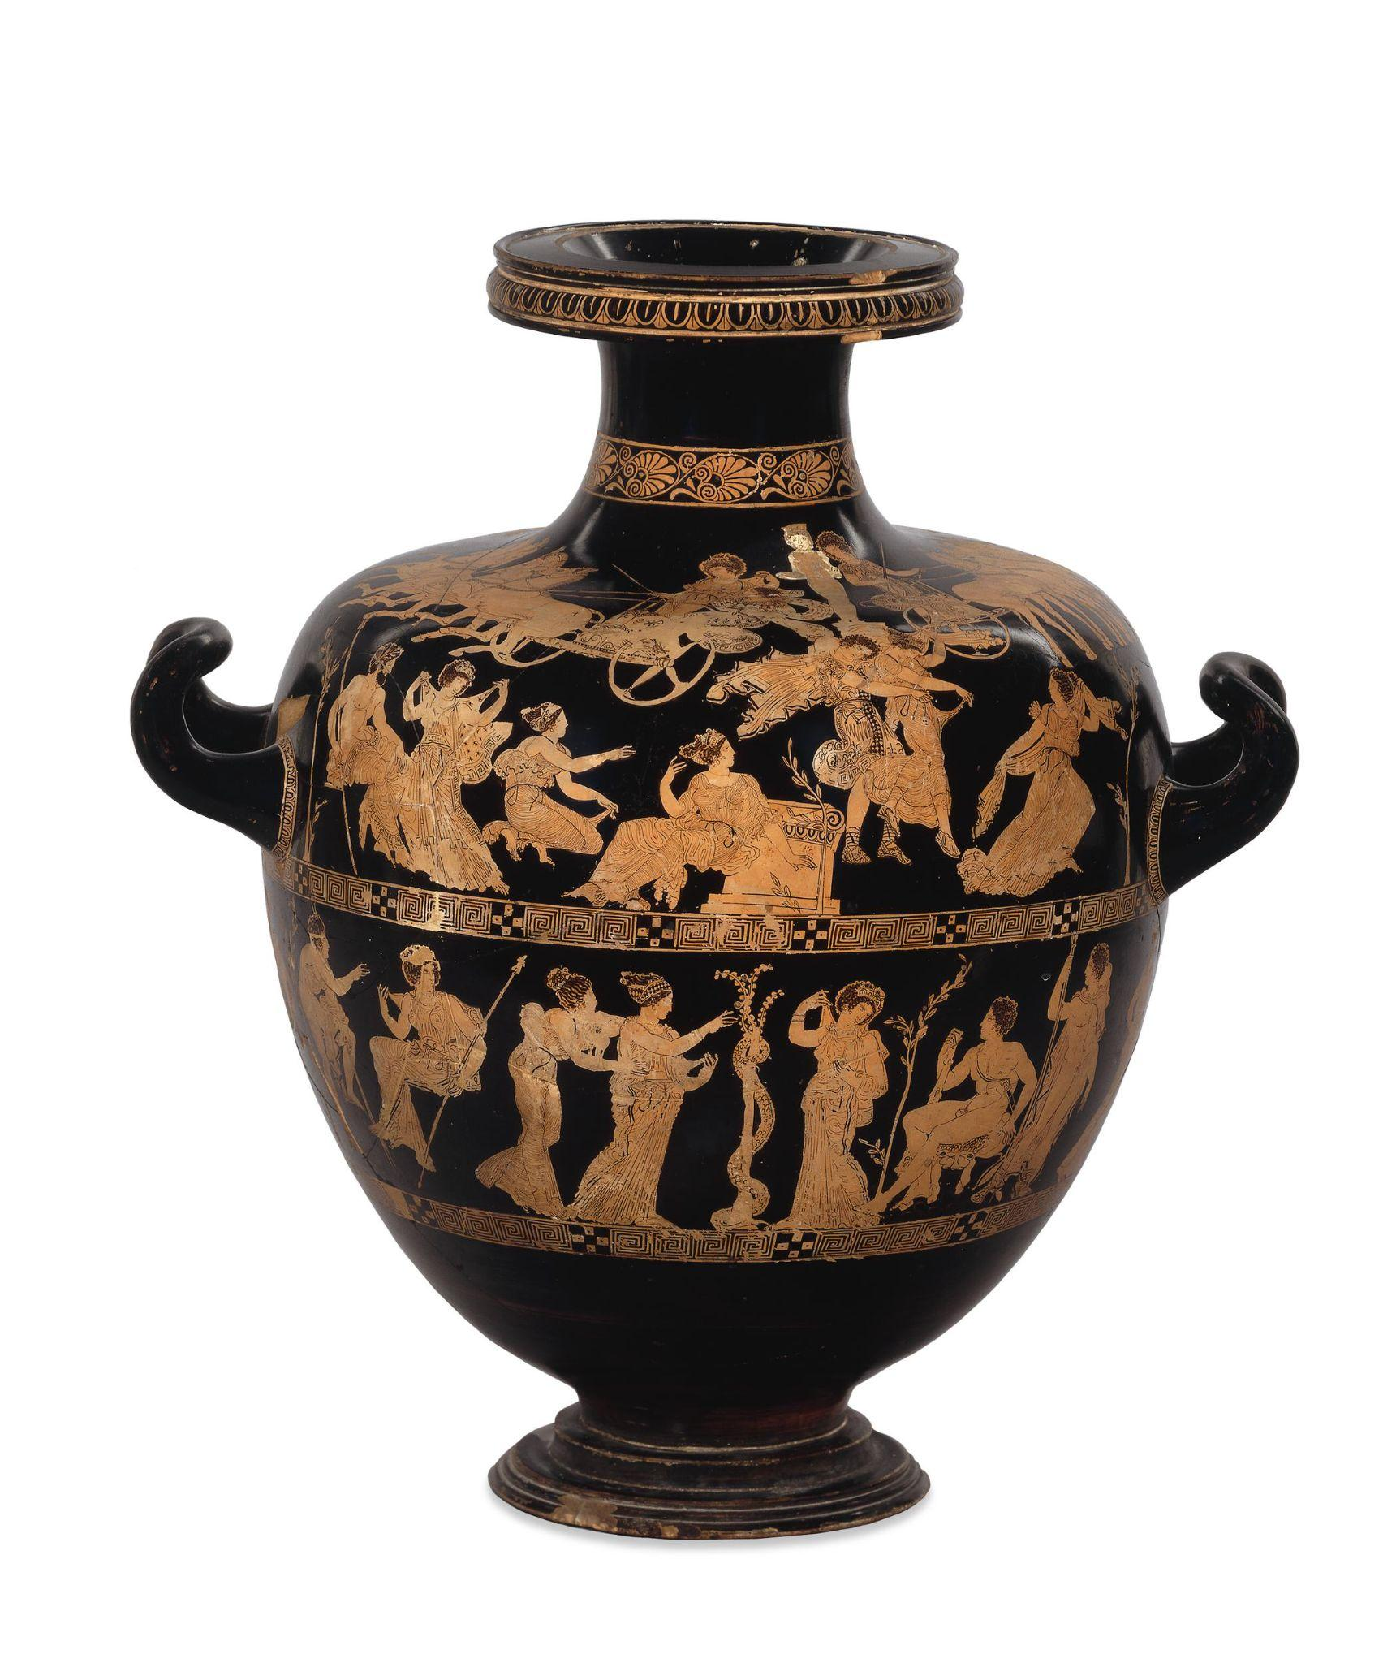

Red-Figured Water Jar (Hydria), Signed by Meidias as Potter

[© The Trustees of the British Museum](https://www.britishmuseum.org/collection/object/G_1772-0320-30-)

[John Keats: “Ode on a Grecian Urn,” as read by Matthew Coulton](https://youtu.be/iHkX67Ijuok)

# Ode on a Grecian Urn

By John Keats - 1795-1821

Thou still unravish'd bride of quietness,

Thou foster-child of silence and slow time,

Sylvan historian, who canst thus express

A flowery tale more sweetly than our rhyme:

What leaf-fring'd legend haunts about thy shape

Of deities or mortals, or of both,

In Tempe or the dales of Arcady?

What men or gods are these? What maidens loth?

What mad pursuit? What struggle to escape?

What pipes and timbrels? What wild ecstasy?

Heard melodies are sweet, but those unheard

Are sweeter; therefore, ye soft pipes, play on;

Not to the sensual ear, but, more endear'd,

Pipe to the spirit ditties of no tone:

Fair youth, beneath the trees, thou canst not leave

Thy song, nor ever can those trees be bare;

Bold Lover, never, never canst thou kiss,

Though winning near the goal yet, do not grieve;

She cannot fade, though thou hast not thy bliss,

For ever wilt thou love, and she be fair!

Ah, happy, happy boughs! that cannot shed

Your leaves, nor ever bid the Spring adieu;

And, happy melodist, unwearied,

For ever piping songs for ever new;

More happy love! more happy, happy love!

For ever warm and still to be enjoy'd,

For ever panting, and for ever young;

All breathing human passion far above,

That leaves a heart high-sorrowful and cloy'd,

A burning forehead, and a parching tongue.

Who are these coming to the sacrifice?

To what green altar, O mysterious priest,

Lead'st thou that heifer lowing at the skies,

And all her silken flanks with garlands drest?

What little town by river or sea shore,

Or mountain-built with peaceful citadel,

Is emptied of this folk, this pious morn?

And, little town, thy streets for evermore

Will silent be; and not a soul to tell

Why thou art desolate, can e'er return.

O Attic shape! Fair attitude! with brede

Of marble men and maidens overwrought,

With forest branches and the trodden weed;

Thou, silent form, dost tease us out of thought

As doth eternity: Cold Pastoral!

When old age shall this generation waste,

Thou shalt remain, in midst of other woe

Than ours, a friend to man, to whom thou say'st,

"Beauty is truth, truth beauty,—that is all

Ye know on earth, and all ye need to know."

# Further Information about the Artwork:

**Production date:** 420BC-400BC (circa)

**Made in:** Attica (Greece)

**Acquisition date**:1772

**Medium**: Pottery

**Current Location:** The British Museum

**Height**: 52.10 cm

Creative Commons License

This work is licensed under a [Creative Commons Attribution 4.0 International License](http://creativecommons.org/licenses/by/4.0/).

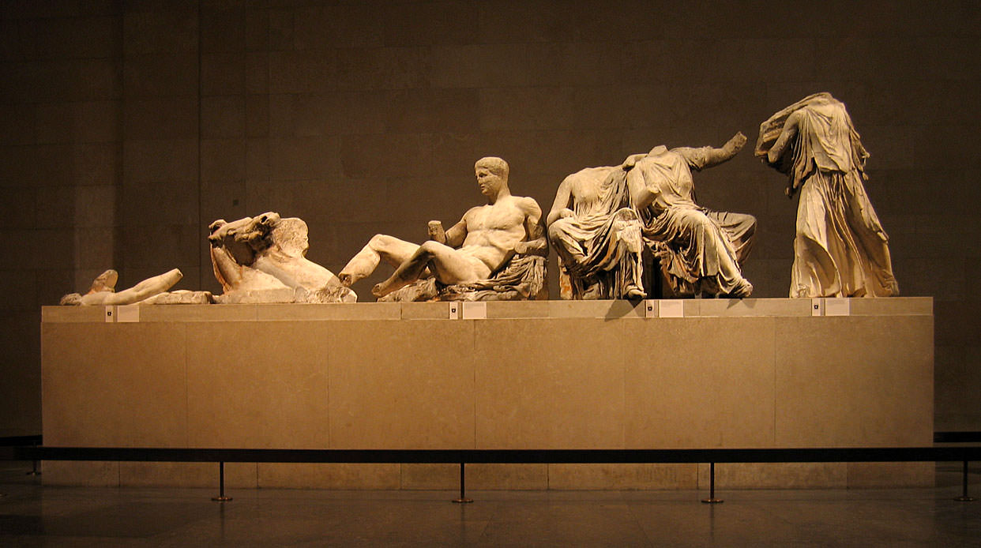

[Photograph by Solipsist](https://www.worldhistory.org/image/3303/east-pediment-of-the-parthenon/), sourced from [The World History Encyclopedia](https://www.worldhistory.org/article/780/the-parthenon-sculptures/). The image is licensed under a Creative Commons Attribution-ShareAlike license.

[John Keats: “On Seeing the Elgin Marbles,” as read by G.M. Danielson](https://youtu.be/ygZo3jscYwM)

# On Seeing the Elgin Marbles

John Keats - 1795-1821

My spirit is too weak—mortality

Weighs heavily on me like unwilling sleep,

And each imagined pinnacle and steep

Of godlike hardship tells me I must die

Like a sick eagle looking at the sky.

Yet ‘tis a gentle luxury to weep,

That I have not the cloudy winds to keep,

Fresh for the opening of the morning’s eye.

Such dim-conceived glories of the brain

Bring round the heart an indescribable feud;

So do these wonders a most dizzy pain,

That mingles Grecian grandeur with the rude

Wasting of old Time—with a billowy main—

A sun—a shadow of a magnitude.

# To Haydon with a Sonnet Written on Seeing the Elgin Marbles

John Keats - 1795-1821

Haydon! Forgive me, that I cannot speak

Definitively on these mighty things;

Forgive me that I have not Eagle's wings—

That what I want I know not where to seek:

And think that I would not be over meek

In rolling out upfollow'd thunderings,

Even to the steep of Helciconian springs,

Were I of ample strength for such a freak—

Think too that all those numbers should be thine;

Whose else? In this who touch thy vesture's hem?

For when men star'd at what was most divine

With browless idiotism—o'erwise phlegm—

Thou hadst beheld the Hesperean shine

Of their star in the East, and gone to worship them.

Creative Commons License

This work is licensed under a [Creative Commons Attribution 4.0 International License](http://creativecommons.org/licenses/by/4.0/).

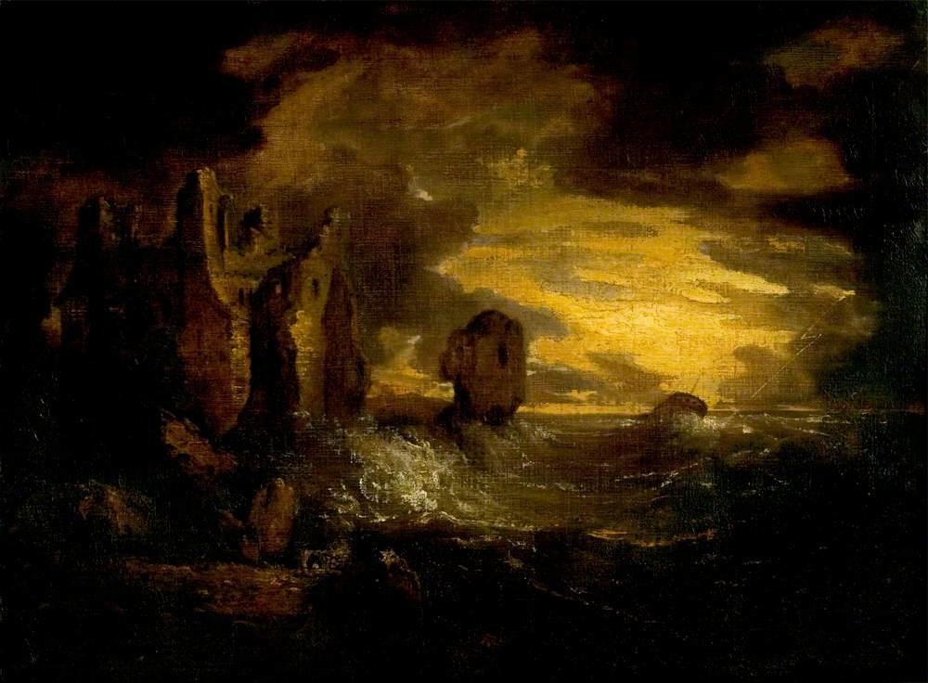

Peele Castle in a Storm, Cumbria

George Howland Beaumont (1753–1827)   
Image credit: [Leicester Museums and Galleries](https://artuk.org/discover/artworks/peele-castle-in-a-storm-cumbria-81334)

Elegiac Stanzas Suggested by a Picture of Peele Castle in a Storm, Painted by Sir George Beaumont

By William Wordsworth - 1770-1850

I was thy neighbour once, thou rugged Pile!

Four summer weeks I dwelt in sight of thee:

I saw thee every day; and all the while

Thy Form was sleeping on a glassy sea.

So pure the sky, so quiet was the air!

So like, so very like, was day to day!

Whene'er I looked, thy Image still was there;

It trembled, but it never passed away.

How perfect was the calm! it seemed no sleep;

No mood, which season takes away, or brings:

I could have fancied that the mighty Deep

Was even the gentlest of all gentle things.

Ah! *then* , if mine had been the Painter's hand,

To express what then I saw; and add the gleam,

The light that never was, on sea or land,

The consecration, and the Poet's dream;

I would have planted thee, thou hoary Pile

Amid a world how different from this!

Beside a sea that could not cease to smile;

On tranquil land, beneath a sky of bliss.

Thou shouldst have seemed a treasure-house divine

Of peaceful years; a chronicle of heaven;—

Of all the sunbeams that did ever shine

The very sweetest had to thee been given.

A Picture had it been of lasting ease,

Elysian quiet, without toil or strife;

No motion but the moving tide, a breeze,

Or merely silent Nature's breathing life.

Such, in the fond illusion of my heart,

Such Picture would I at that time have made:

And seen the soul of truth in every part,

A steadfast peace that might not be betrayed.

So once it would have been,—'tis so no more;

I have submitted to a new control:

A power is gone, which nothing can restore;

A deep distress hath humanised my Soul.

Not for a moment could I now behold

A smiling sea, and be what I have been:

The feeling of my loss will ne'er be old;

This, which I know, I speak with mind serene.

Then, Beaumont, Friend! who would have been the Friend,

If he had lived, of Him whom I deplore,

This work of thine I blame not, but commend;

This sea in anger, and that dismal shore.

O 'tis a passionate Work!—yet wise and well,

Well chosen is the spirit that is here;

That Hulk which labours in the deadly swell,

This rueful sky, this pageantry of fear!

And this huge Castle, standing here sublime,

I love to see the look with which it braves,

Cased in the unfeeling armour of old time,

The lightning, the fierce wind, the trampling waves.

Farewell, farewell the heart that lives alone,

Housed in a dream, at distance from the Kind!

Such happiness, wherever it be known,

Is to be pitied; for 'tis surely blind.

But welcome fortitude, and patient cheer,

And frequent sights of what is to be borne!

Such sights, or worse, as are before me here.—

Not without hope we suffer and we mourn.

# Further Information about the Artwork:

**Production Date**: c.1800

**Medium**: oil on canvas

**Current Location:** Leicester Museum & Art Gallery

**Dimensions:** Height: 73.6 cm x Width: 99 cm

Creative Commons License

This work is licensed under a [Creative Commons Attribution 4.0 International License](http://creativecommons.org/licenses/by/4.0/).

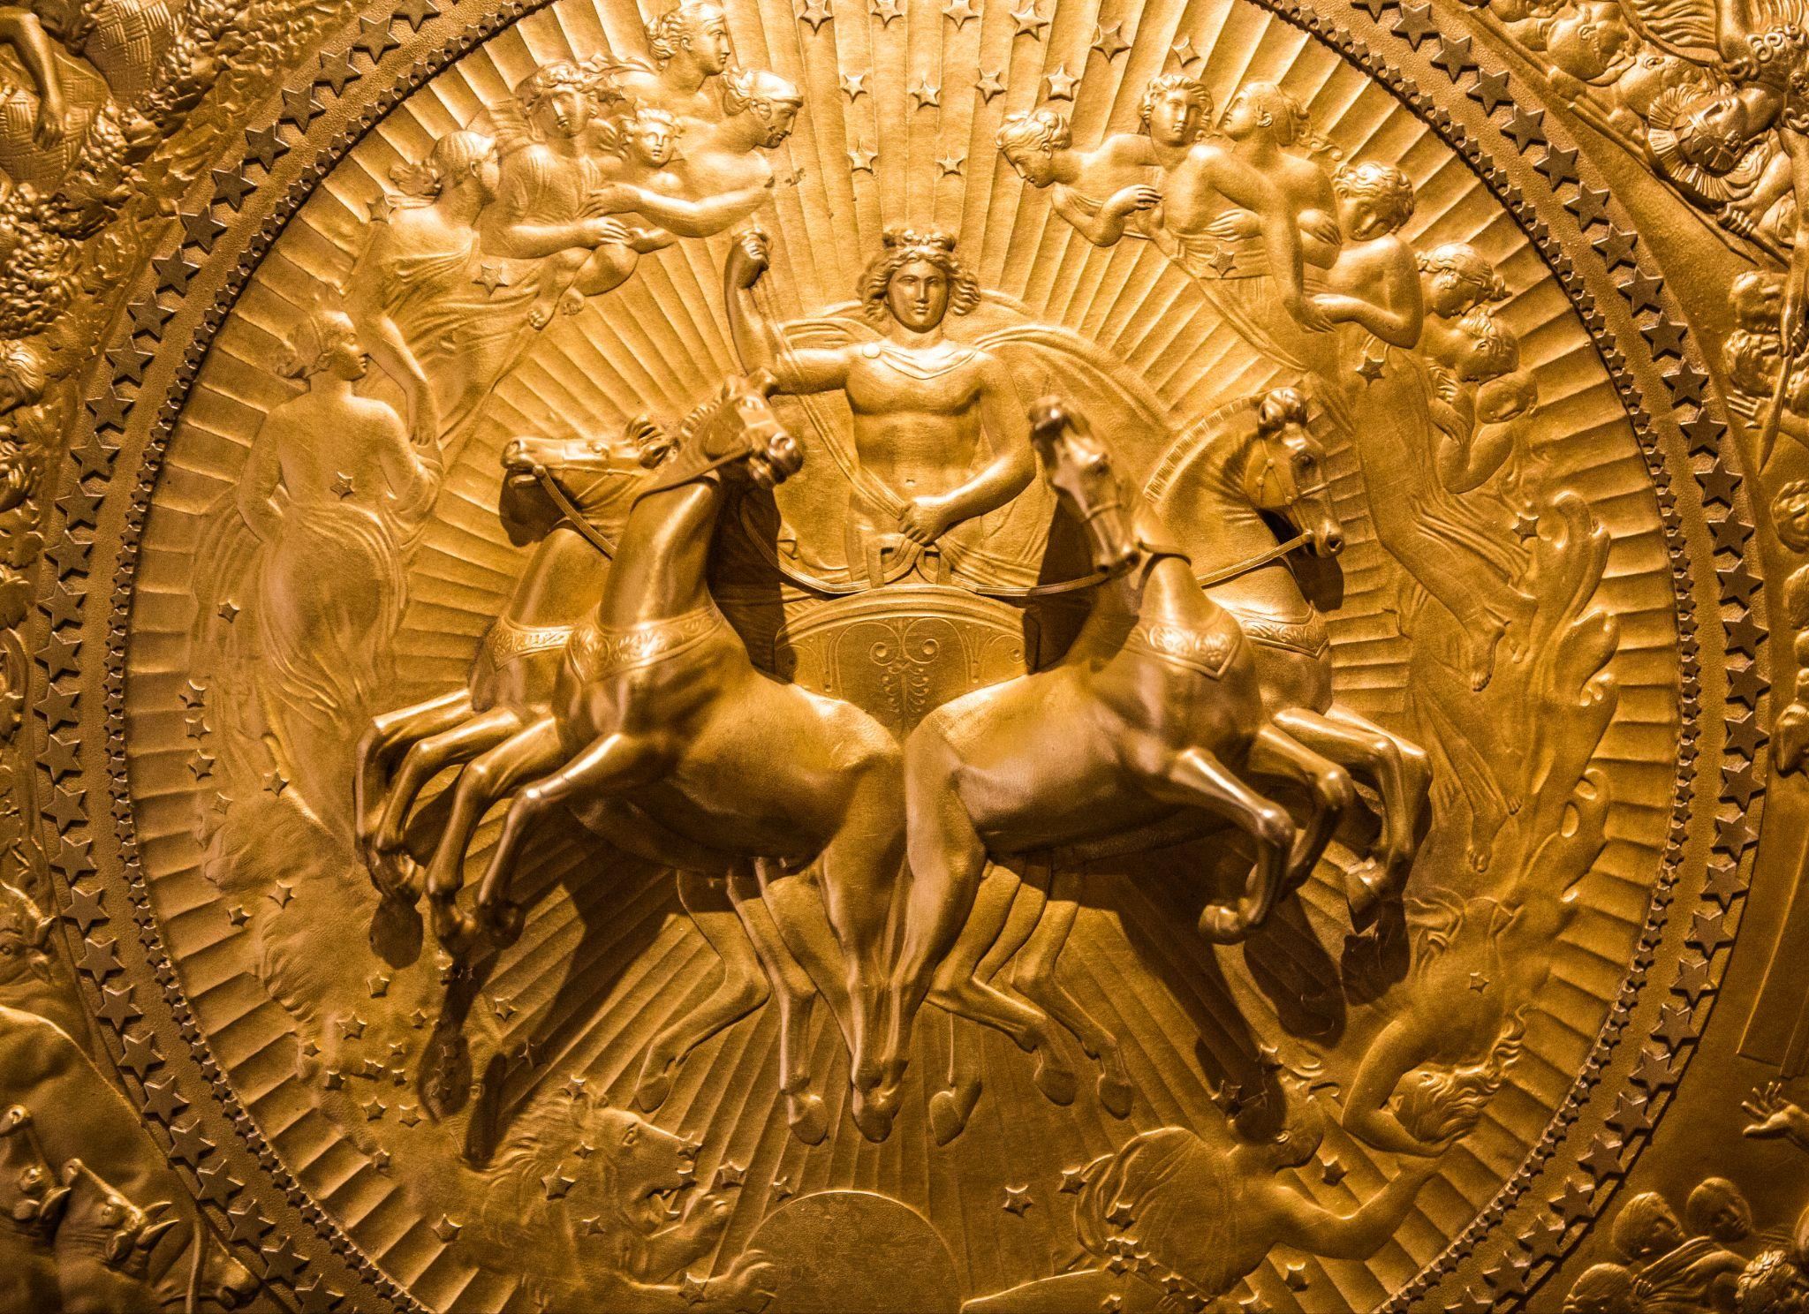

A close-up view of John Flaxman’s 1822 design of the Shield of Achilles, manufactured by Rundell, Bridge, and Rundell. [Image taken by Thomas Hawk.](https://www.flickr.com/photos/thomashawk/24612401380) Image licensed under CC BY-NC 2.0 DEED Attribution-NonCommercial 2.0 Generic.

The Iliad: The Forging of Achilles’ Shield

Original Greek by Homer

English translation by Samuel Butler, 1898

# Alexander Pope’s Poetic Version

## The Iliad, Book XVIII, The Shield of Achilles

### By Homer (8th century BCE)

### Translated into English by Alexander Pope (1688-1744)

*Thetis goes to the palace of Vulcan to obtain new arms for her son.*

"Thee, welcome, goddess! what occasion calls

(So long a stranger) to these honour'd walls?

'Tis thine, fair Thetis, the command to lay,

And Vulcan's joy and duty to obey."

To whom the mournful mother thus replies:

(The crystal drops stood trembling in her eyes:)

"O Vulcan! say, was ever breast divine

So pierced with sorrows, so o'erwhelm'd as mine?

Of all the goddesses, did Jove prepare

For Thetis only such a weight of care?

I, only I, of all the watery race

By force subjected to a man's embrace,

Who, sinking now with age and sorrow, pays

The mighty fine imposed on length of days.

Sprung from my bed, a godlike hero came,

The bravest sure that ever bore the name;

Like some fair plant beneath my careful hand

He grew, he flourish'd, and he graced the land:

To Troy I sent him! but his native shore

Never, ah never, shall receive him more;

(Even while he lives, he wastes with secret woe;)

Nor I, a goddess, can retard the blow!

Robb'd of the prize the Grecian suffrage gave,

The king of nations forced his royal slave:

For this he grieved; and, till the Greeks oppress'd

Required his arm, he sorrow'd unredress'd.

Large gifts they promise, and their elders send;

In vain--he arms not, but permits his friend

His arms, his steeds, his forces to employ:

He marches, combats, almost conquers Troy:

Then slain by Phoebus (Hector had the name)

At once resigns his armour, life, and fame.

But thou, in pity, by my prayer be won:

Grace with immortal arms this short-lived son,

And to the field in martial pomp restore,

To shine with glory, till he shines no more!"

To her the artist-god: "Thy griefs resign,

Secure, what Vulcan can, is ever thine.

O could I hide him from the Fates, as well,

Or with these hands the cruel stroke repel,

As I shall forge most envied arms, the gaze

Of wondering ages, and the world's amaze!"

Thus having said, the father of the fires

To the black labours of his forge retires.

Soon as he bade them blow, the bellows turn'd

Their iron mouths; and where the furnace burn'd,

Resounding breathed: at once the blast expires,

And twenty forges catch at once the fires;

Just as the god directs, now loud, now low,

They raise a tempest, or they gently blow;

In hissing flames huge silver bars are roll'd,

And stubborn brass, and tin, and solid gold;

Before, deep fix'd, the eternal anvils stand;

The ponderous hammer loads his better hand,

His left with tongs turns the vex'd metal round,

And thick, strong strokes, the doubling vaults rebound.

Then first he form'd the immense and solid shield;

Rich various artifice emblazed the field;

Its utmost verge a threefold circle bound;

A silver chain suspends the massy round;

Five ample plates the broad expanse compose,

And godlike labours on the surface rose.

There shone the image of the master-mind:

There earth, there heaven, there ocean he design'd;

The unwearied sun, the moon completely round;

The starry lights that heaven's high convex crown'd;

The Pleiads, Hyads, with the northern team;

And great Orion's more refulgent beam;

To which, around the axle of the sky,

The Bear, revolving, points his golden eye,

Still shines exalted on the ethereal plain,

Nor bathes his blazing forehead in the main.

Two cities radiant on the shield appear,

The image one of peace, and one of war.

Here sacred pomp and genial feast delight,

And solemn dance, and hymeneal rite;

Along the street the new-made brides are led,

With torches flaming, to the nuptial bed:

The youthful dancers in a circle bound

To the soft flute, and cithern's silver sound:

Through the fair streets the matrons in a row

Stand in their porches, and enjoy the show.

There in the forum swarm a numerous train;

The subject of debate, a townsman slain:

One pleads the fine discharged, which one denied,

And bade the public and the laws decide:

The witness is produced on either hand:

For this, or that, the partial people stand:

The appointed heralds still the noisy bands,

And form a ring, with sceptres in their hands:

On seats of stone, within the sacred place,

The reverend elders nodded o'er the case;

Alternate, each the attesting sceptre took,

And rising solemn, each his sentence spoke

Two golden talents lay amidst, in sight,

The prize of him who best adjudged the right.

Another part (a prospect differing far)(255)

Glow'd with refulgent arms, and horrid war.

Two mighty hosts a leaguer'd town embrace,

And one would pillage, one would burn the place.

Meantime the townsmen, arm'd with silent care,

A secret ambush on the foe prepare:

Their wives, their children, and the watchful band

Of trembling parents, on the turrets stand.

They march; by Pallas and by Mars made bold:

Gold were the gods, their radiant garments gold,

And gold their armour: these the squadron led,

August, divine, superior by the head!

A place for ambush fit they found, and stood,

Cover'd with shields, beside a silver flood.

Two spies at distance lurk, and watchful seem

If sheep or oxen seek the winding stream.

Soon the white flocks proceeded o'er the plains,

And steers slow-moving, and two shepherd swains;

Behind them piping on their reeds they go,

Nor fear an ambush, nor suspect a foe.

In arms the glittering squadron rising round

Rush sudden; hills of slaughter heap the ground;

Whole flocks and herds lie bleeding on the plains,

And, all amidst them, dead, the shepherd swains!

The bellowing oxen the besiegers hear;

They rise, take horse, approach, and meet the war,

They fight, they fall, beside the silver flood;

The waving silver seem'd to blush with blood.

There Tumult, there Contention stood confess'd;

One rear'd a dagger at a captive's breast;

One held a living foe, that freshly bled

With new-made wounds; another dragg'd a dead;

Now here, now there, the carcases they tore:

Fate stalk'd amidst them, grim with human gore.

And the whole war came out, and met the eye;

And each bold figure seem'd to live or die.

A field deep furrow'd next the god design'd,

The third time labour'd by the sweating hind;

The shining shares full many ploughmen guide,

And turn their crooked yokes on every side.

Still as at either end they wheel around,

The master meets them with his goblet crown'd;

The hearty draught rewards, renews their toil,

Then back the turning ploughshares cleave the soil:

Behind, the rising earth in ridges roll'd;

And sable look'd, though form'd of molten gold.

Another field rose high with waving grain;

With bended sickles stand the reaper train:

Here stretched in ranks the levell'd swarths are found,

Sheaves heap'd on sheaves here thicken up the ground.

With sweeping stroke the mowers strow the lands;

The gatherers follow, and collect in bands;

And last the children, in whose arms are borne

(Too short to gripe them) the brown sheaves of corn.

The rustic monarch of the field descries,

With silent glee, the heaps around him rise.

A ready banquet on the turf is laid,

Beneath an ample oak's expanded shade.

The victim ox the sturdy youth prepare;

The reaper's due repast, the woman's care.

Next, ripe in yellow gold, a vineyard shines,

Bent with the ponderous harvest of its vines;

A deeper dye the dangling clusters show,

And curl'd on silver props, in order glow:

A darker metal mix'd intrench'd the place;

And pales of glittering tin the inclosure grace.

To this, one pathway gently winding leads,

Where march a train with baskets on their heads,

(Fair maids and blooming youths,) that smiling bear

The purple product of the autumnal year.

To these a youth awakes the warbling strings,

Whose tender lay the fate of Linus sings;

In measured dance behind him move the train,

Tune soft the voice, and answer to the strain.

Here herds of oxen march, erect and bold,

Rear high their horns, and seem to low in gold,

And speed to meadows on whose sounding shores

A rapid torrent through the rushes roars:

Four golden herdsmen as their guardians stand,

And nine sour dogs complete the rustic band.

Two lions rushing from the wood appear'd;

And seized a bull, the master of the herd:

He roar'd: in vain the dogs, the men withstood;

They tore his flesh, and drank his sable blood.

The dogs (oft cheer'd in vain) desert the prey,

Dread the grim terrors, and at distance bay.

Next this, the eye the art of Vulcan leads

Deep through fair forests, and a length of meads,

And stalls, and folds, and scatter'd cots between;

And fleecy flocks, that whiten all the scene.

A figured dance succeeds; such once was seen

In lofty Gnossus for the Cretan queen,

Form'd by Daedalean art; a comely band

Of youths and maidens, bounding hand in hand.

The maids in soft simars of linen dress'd;

The youths all graceful in the glossy vest:

Of those the locks with flowery wreath inroll'd;

Of these the sides adorn'd with swords of gold,

That glittering gay, from silver belts depend.

Now all at once they rise, at once descend,

With well-taught feet: now shape in oblique ways,

Confusedly regular, the moving maze:

Now forth at once, too swift for sight, they spring,

And undistinguish'd blend the flying ring:

So whirls a wheel, in giddy circle toss'd,

And, rapid as it runs, the single spokes are lost.

The gazing multitudes admire around:

Two active tumblers in the centre bound;

Now high, now low, their pliant limbs they bend:

And general songs the sprightly revel end.

Thus the broad shield complete the artist crown'd

With his last hand, and pour'd the ocean round:

In living silver seem'd the waves to roll,

And beat the buckler's verge, and bound the whole.

This done, whate'er a warrior's use requires

He forged; the cuirass that outshone the fires,

The greaves of ductile tin, the helm impress'd

With various sculpture, and the golden crest.

At Thetis' feet the finished labour lay:

She, as a falcon cuts the aerial way,

Swift from Olympus' snowy summit flies,

And bears the blazing present through the skies.

# Samuel Butler’s Prose Version

## The Iliad, Book XVIII, lines 464-615:

### By Homer (8th century BCE)

### Translated into English by Samuel Butler (1835-1902)

When he had so said he left her and went to his bellows, turning them towards the fire and bidding them do their office. Twenty bellows blew upon the melting-pots, and they blew blasts of every kind, some fierce to help him when he had need of them, and others less strong as Hephaistos willed it in the course of his work. He threw tough copper into the fire, and tin, with silver and gold; he set his great anvil on its block, and with one hand grasped his mighty hammer while he took the tongs in the other.

First he shaped the shield so great and strong, adorning it all over and binding it round with a gleaming circuit in three layers; and the baldric was made of silver. He made the shield in five thicknesses, and with many a wonder did his cunning hand enrich it.

He wrought the earth, the heavens, and the sea; the moon also at her full and the untiring sun, with all the signs that glorify the face of heaven - the Pleiads, the Hyads, huge Orion, and the Bear, which men also call the Wain and which turns round ever in one place, facing. Orion, and alone never dips into the stream of Okeanos.

He wrought also two cities, fair to see and busy with the hum of men. In the one were weddings and wedding-feasts, and they were going about the city with brides whom they were escorting by torchlight from their chambers. Loud rose the cry of Hymen, and the youths danced to the music of flute and lyre, while the women stood each at her house door to see them.

Meanwhile the people were gathered in assembly, for there was a quarrel, and two men were wrangling about the blood-price for a man who had died, the one claiming to the dêmos that he had the right to pay off the damages in full, and the other refusing to accept anything. Each was seeking a limit, in the presence of an arbitrator, and the people took sides, each man backing the side that he had taken;

but the heralds kept them back, and the elders sat on their seats of stone in a solemn circle, holding the staves which the heralds had put into their hands. Then they rose and each in his turn gave judgment, and there were two measures of gold laid down, to be given to him whose judgment should be deemed the fairest.

About the other city there lay encamped two hosts in gleaming armor, and they were divided whether to sack it, or to spare it and accept the half of what it contained. But the men of the city would not yet consent, and armed themselves for a surprise; their wives and little children kept guard upon the walls, and with them were the men who were past fighting through age; but the others sallied forth with Ares and Pallas Athena at their head - both of them wrought in gold and clad in golden raiment, great and fair with their armor as befitting gods, while they that followed were smaller. When they reached the place where they would lay their ambush, it was on a riverbed to which live stock of all kinds would come from far and near to water; here, then, they lay concealed, clad in full armor. Some way off them there were two scouts who were on the look-out for the coming of sheep or cattle, which presently came, followed by two shepherds who were playing on their pipes, and had not so much as a thought of danger. When those who were in ambush saw this, they cut off the flocks and herds and killed the shepherds. Meanwhile the besiegers, when they heard much noise among the cattle as they sat in council, sprang to their horses, and made with all speed towards them; when they reached them they set battle in array by the banks of the river, and the hosts aimed their bronze-shod spears at one another. With them were Strife and Riot, and fell Fate who was dragging three men after her, one with a fresh wound, and the other unwounded, while the third was dead, and she was dragging him along by his heel: and her robe was bedrabbled in men's blood. They went in and out with one another and fought as though they were living people haling away one another's dead.

He wrought also a fair fallow field, large and thrice ploughed already. Many men were working at the plough within it, turning their oxen to and fro, furrow after furrow. Each time that they turned on reaching the headland a man would come up to them and give them a cup of wine, and they would go back to their furrows looking forward to the time when they should again reach the headland. The part that they had ploughed was dark behind them, so that the field, though it was of gold, still looked as if it were being ploughed - very curious to behold.

He wrought also a field of harvest grain, and the reapers were reaping with sharp sickles in their hands. Swathe after swathe fell to the ground in a straight line behind them, and the binders bound them in bands of twisted straw. There were three binders, and behind them there were boys who gathered the cut grain in armfuls and kept on bringing them to be bound: among them all the owner of the land stood by in silence and was glad. The servants were getting a meal ready under an oak, for they had sacrificed a great ox, and were busy cutting him up, while the women were making a porridge of much white barley for the laborers' dinner.

He wrought also a vineyard, golden and fair to see, and the vines were loaded with grapes. The bunches overhead were black, but the vines were trained on poles of silver. He ran a ditch of dark metal all round it, and fenced it with a fence of tin; there was only one path to it, and by this the vintagers went when they would gather the vintage. Youths and maidens all blithe and full of glee, carried the luscious fruit in plaited baskets; and with them there went a boy who made sweet music with his lyre, and sang the Linus-song with his clear boyish voice.

He wrought also a herd of horned cattle. He made the cows of gold and tin, and they lowed as they came full speed out of the yards to go and feed among the waving reeds that grow by the banks of the river. Along with the cattle there went four shepherds, all of them in gold, and their nine fleet dogs went with them. Two terrible lions had fastened on a bellowing bull that was with the foremost cows, and bellow as he might they haled him, while the dogs and men gave chase: the lions tore through the bull's thick hide and were gorging on his blood and bowels, but the herdsmen were afraid to do anything, and only hounded on their dogs; the dogs dared not fasten on the lions but stood by barking and keeping out of harm's way.

The god wrought also a pasture in a fair mountain dell, and large flock of sheep, with a homestead and huts, and sheltered sheepfolds.

Furthermore he wrought a green, like that which Daedalus once made in Knossos for lovely Ariadne. Here was a dance [khoros] of youths and maidens, whom all would woo, all with their hands on one another's wrists. The maidens wore robes of light linen, and the youths well woven shirts that were slightly oiled. The girls were crowned with garlands, while the young men had daggers of gold that hung by silver baldrics; sometimes they would dance deftly in a ring with merry twinkling feet, as it were a potter sitting at his work and making trial of his wheel to see whether it will run, and sometimes they would go all in line with one another, and many people was gathered joyously about the place of dancing. There was a bard also to sing to them and play his lyre, while two tumblers went about performing in the midst of them when the man struck up with his tune.

All round the outermost rim of the shield he set the mighty stream of the river Okeanos.

Then when he had fashioned the shield so great and strong, he made a breastplate also that shone brighter than fire. He made helmet, close fitting to the brow, and richly worked, with a golden plume overhanging it; and he made greaves also of beaten tin.

Lastly, when the famed lame god had made all the armor, he took it and set it before the mother of Achilles; whereon she darted like a falcon from the snowy summits of Olympus and bore away the gleaming armor from the house of Hephaistos.

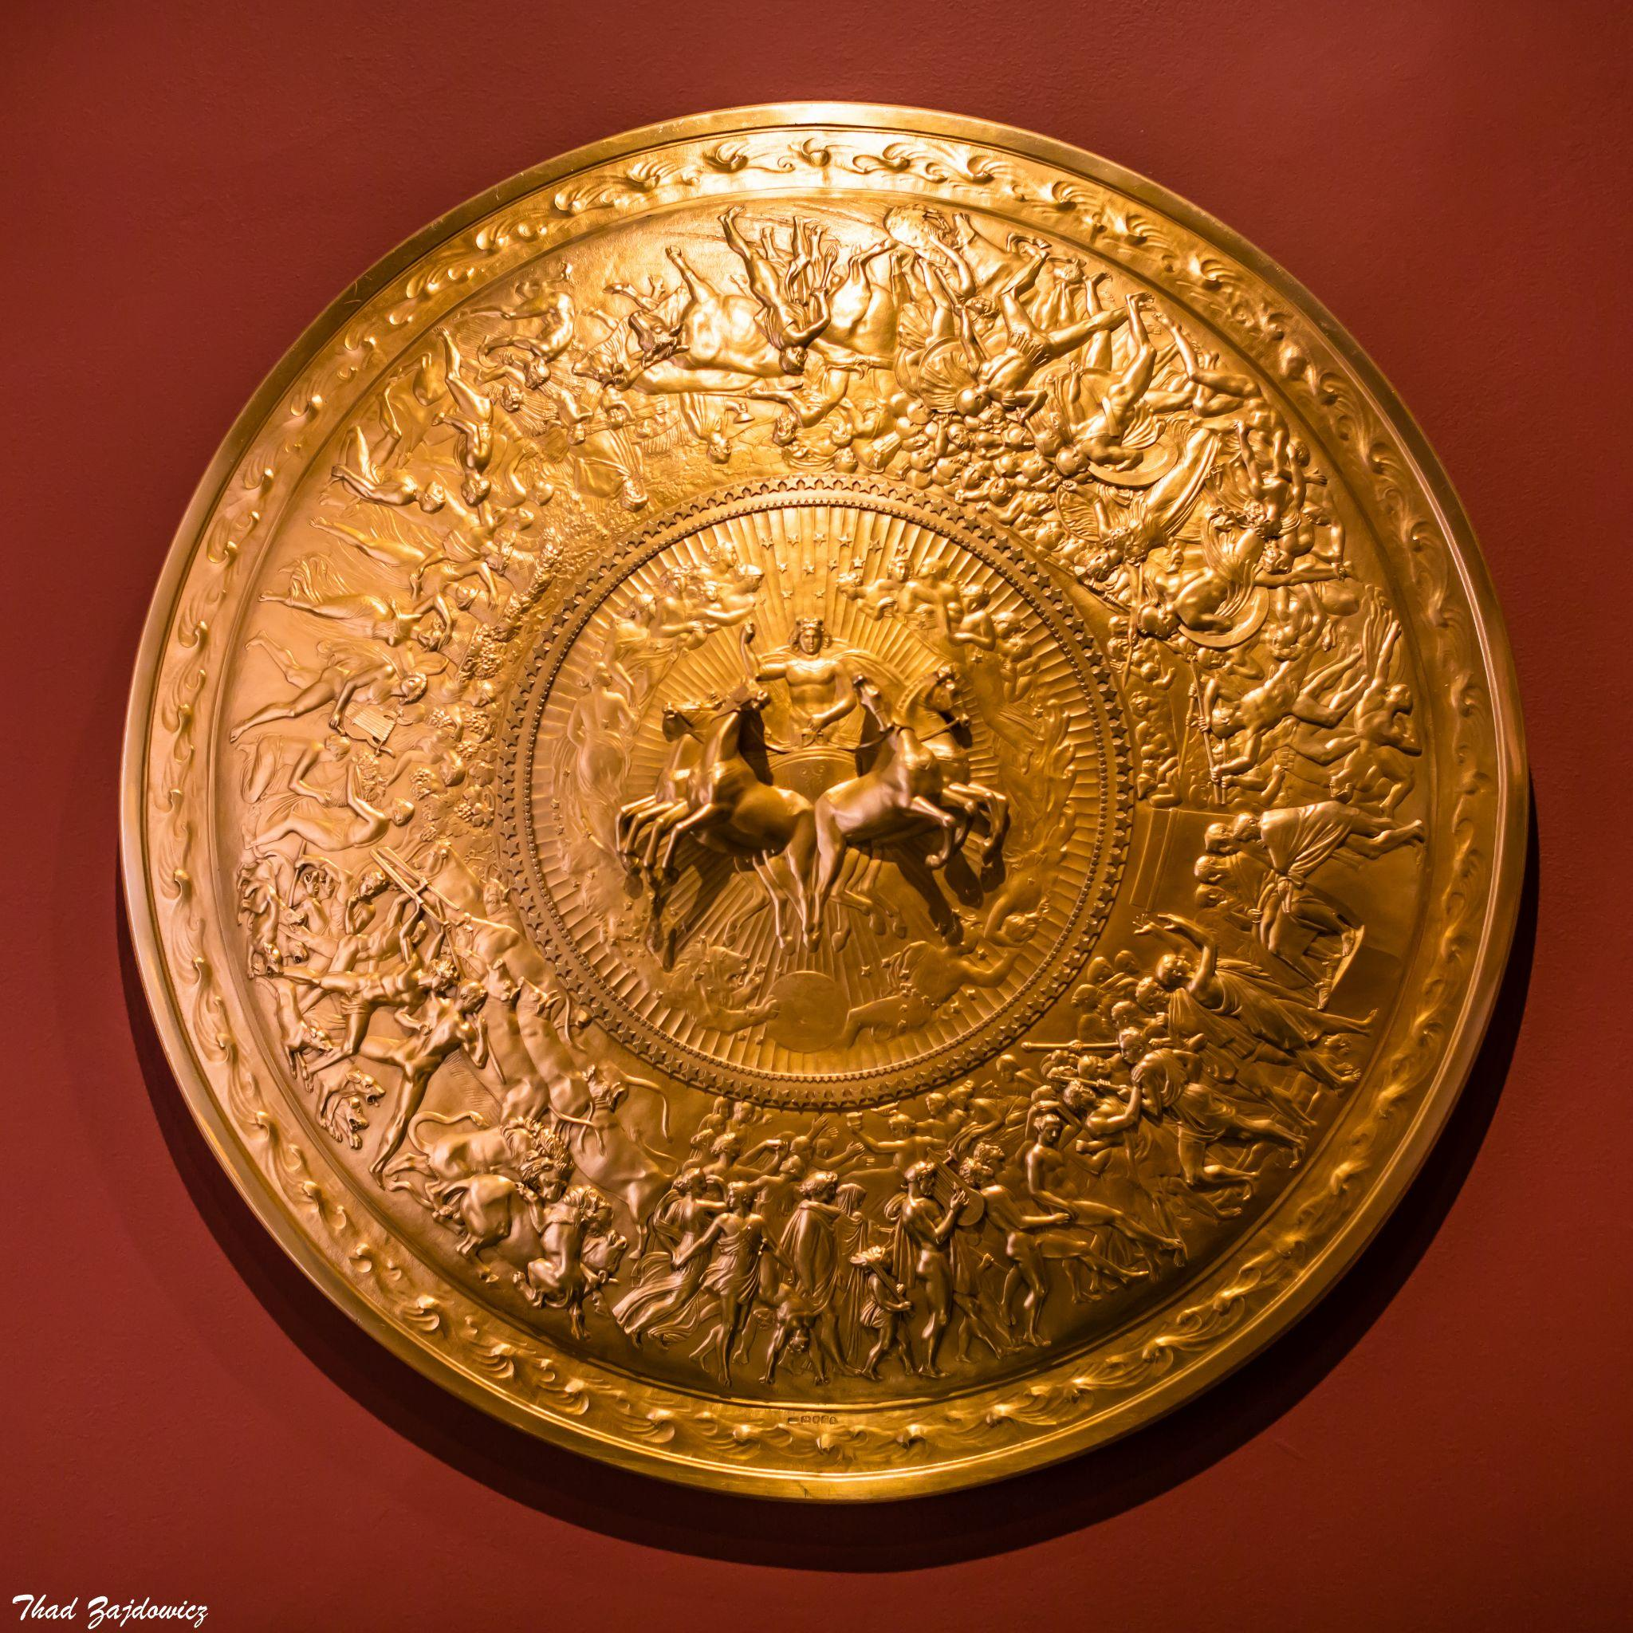

An alternative view of the entire shield, as captured by [Thad Zajdowicz](https://www.flickr.com/photos/thadz/31680177383). Image is in the public domain and licensed under CC0 1.0 DEED CC0 1.0 Universal.

# [Further Information about the Artwork:](https://www.rct.uk/collection/51266/shield-of-achilles)

**Goldsmith:** Philip Rundell (1746-1827)

**Designer:** John Flaxman (1755-1826)

**Date:** 1821-22

**Medium:** Silver gilt

**Dimensions:** 90.5 x 90.5 x 18.0 cm

**Resides In:** [The Royal Collection Trust](https://www.rct.uk/), UK

Creative Commons License

This work is licensed under a [Creative Commons Attribution 4.0 International License](http://creativecommons.org/licenses/by/4.0/).