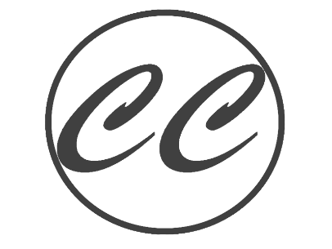

caitlyn.carver6@gmail.com

* Website: <https://caitlyncarver.github.io/PersonalWebsite/>
* App for Alzheimer’s, development at GMU
* Studying for Basic Certification for AWS
* Current Projects

**B.S. / Computational Data Science**

**Minor: Computer Science**

George Mason University,

Fairfax, Virginia, Graduate Fall 2021

* Education

**DATA SCIENCE INTERN**

*ManTech International / June 2019­–August 2019*

* Initiated an AWS EC2 instance to create a data analytics platform prototype with distributed computing
* Partook in architecture design and participated in all aspects of the Software Development cycle
* Structured big data manipulation and cleanup with Pandas
* Performed NLTK’s sentimental analysis using NumPy to place data in a myriad of data structures
* Worked with open-source API’s such as Lexicon NRC to analyze behavioral patterns within datasets
* Implement D3, HTML/CSS to visualize datasets and graphed correlations

**DATA SCIENTIST**

*Ninja Analytics / July 2020–December 2020*

* Categorized and scraped data off the web: Python Scripting with Ckan API
* Wrangling Datasets from open-source government websites
* Data Visualization with Tableau and D3
* Developed Ckan website for Tableau integration

**SOFTWARE DEVELOPER**

*Krasnow Institute GMU/ December 2020–Current*

* Developing a human spatial navigation tracking app for onset early Alzheimer’s
* Environment and Software: Native react, Expo, Firebird database, SQL, Etc.

* Experience

Profile Profile

* Java, Python, R, Scala, React, HTML/CSS/Javascript, SQL, D3, C, noSQL, MongoDB, mySQL
* PySpark, Apache, Tenserflow, Panda’s, NumPy, Sklearn-clustering, React, Git/GitHub, Docker, Node.js, Visual Studios, RStudio, Jupyter Notebook
* AWS, IBM Cloud

Skills

571-206-2041

Leesburg, VA

Contact

Up and coming Data Scientist with a passion for programing and solving real life issues.

“The Details Matter”

Caitlyn Carver

Data Scientist