Project Report
Customer Churn Analysis and Prediction Using Data Analytics and Machine Learning
AICTE | IBM SkillsBuild Data Analytics with AI Academic Internship 2026
Conducted by BharatCares in association with AICTE
Submitted by: J S Caitlyn Mary

2. Declaration
This is to certify that this project is submitted as part of the AICTE | IBM SkillsBuild Data Analytics with AI Academic Internship 2026.

3. Acknowledgement
I would like to thank AICTE, IBM, and BharatCares for providing this internship opportunity.

4. Abstract
Customer churn is a critical issue for telecommunications companies. This project explores the Telco Customer Churn dataset, visualizes key patterns, and builds a Logistic Regression model to predict customer churn based on historical data.

5. Table of Contents
1. Project Report (Cover)
2. Declaration
3. Acknowledgement
4. Abstract
5. Table of Contents
6. Introduction
7. Problem Statement
8. Objectives
9. Scope of the Project
10. Dataset Description
11. Technologies Used
12. System/Project Methodology
13. Data Preprocessing
14. Exploratory Data Analysis & 15. Data Visualization
16. Machine Learning Methodology
17. Model Training
18. Model Evaluation
19. Results
20. Key Findings
21. Conclusion
22. Future Enhancements
23. References

6. Introduction
Customer churn refers to when a customer ceases their relationship with a company. Predicting churn allows companies to intervene proactively.

7. Problem Statement
Identify the demographic and service-related factors associated with customer churn and develop a machine learning model to predict it accurately.

8. Objectives
- Analyze customer attributes to find churn associations.
- Preprocess data for machine learning.
- Train and evaluate a Logistic Regression model.

9. Scope of the Project
The project covers Data Cleaning, Exploratory Data Analysis (EDA), Feature Engineering, Model Training, and Evaluation using Python and scikit-learn.

10. Dataset Description
The dataset used is the Telco Customer Churn dataset. It includes variables such as Tenure, MonthlyCharges, TotalCharges, Contract type, and PaymentMethod.

11. Technologies Used
- Python
- Pandas, NumPy
- Matplotlib, Seaborn
- Scikit-learn
- Jupyter Notebook

12. System/Project Methodology
The project follows the standard data science lifecycle: Data Collection -> Data Cleaning -> EDA -> Preprocessing -> Model Training -> Evaluation.

13. Data Preprocessing
Categorical variables were encoded using OneHotEncoder. Numerical variables were scaled using StandardScaler. Missing values in TotalCharges were removed.

14. Exploratory Data Analysis & 15. Data Visualization
During EDA, it was observed that month-to-month contracts and higher monthly charges are associated with higher churn.
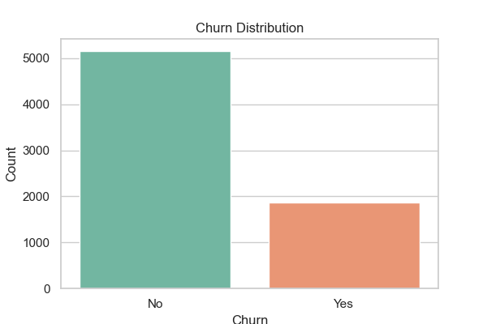
Figure 1: Customer Churn Distribution
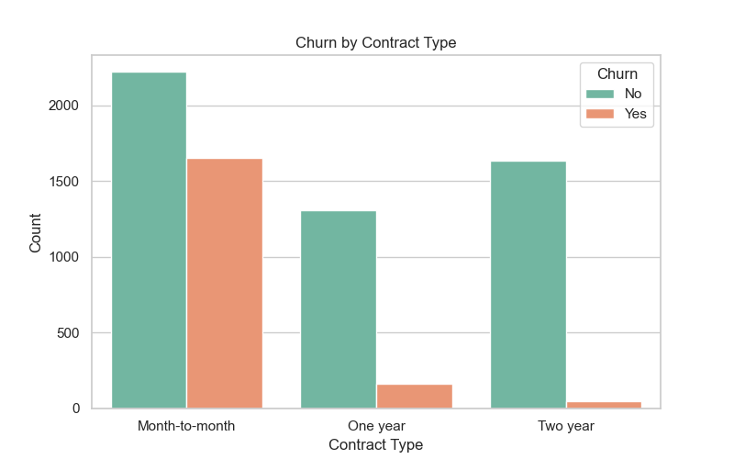
Figure 2: Customer Churn by Contract Type
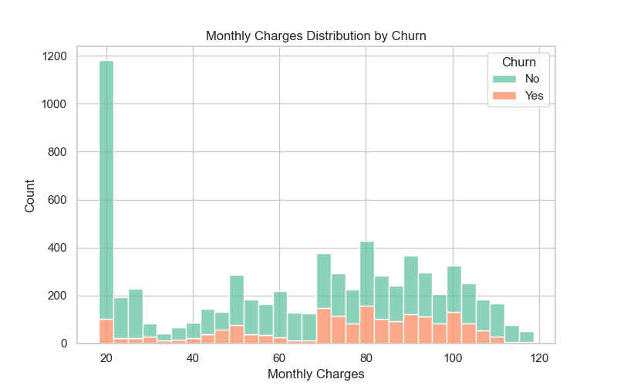
Figure 3: Monthly Charges Distribution by Churn

16. Machine Learning Methodology
Logistic Regression was selected due to its interpretability. A Pipeline was constructed to chain preprocessing and model training.

17. Model Training
The dataset was split into 80% training and 20% testing sets using stratified sampling to maintain the class distribution.

18. Model Evaluation
The model was evaluated on the test set. Key metrics are reported in the Results section.
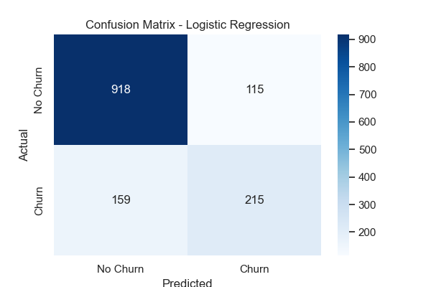
Figure 4: Confusion Matrix (Logistic Regression)
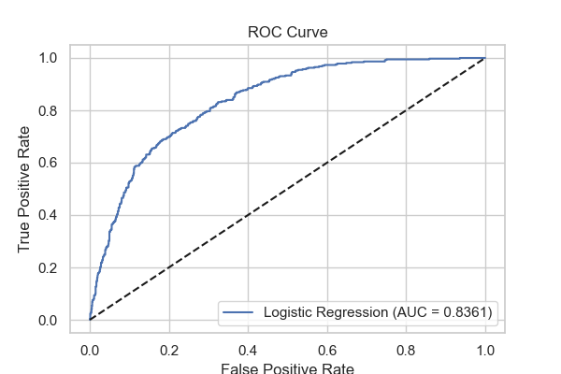
Figure 5: ROC Curve (Logistic Regression)

19. Results
- Accuracy: 0.8053
- Precision: 0.6515
- Recall: 0.5749
- F1-Score: 0.6108
- ROC-AUC: 0.8361

20. Key Findings
- Month-to-month contracts are highly associated with customer churn.
- Customers with longer tenure are less likely to churn.
- High monthly charges correspond to a higher risk of churn.
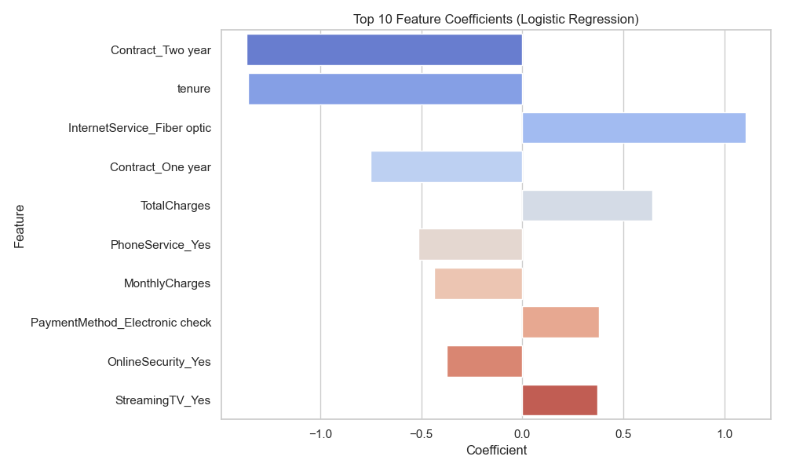
Figure 6: Top 10 Feature Importances (Coefficients)

21. Conclusion
The Logistic Regression model achieved an accuracy of 80.53%, precision of 65.15%, recall of 57.49%, F1-score of 61.08%, and ROC-AUC of 83.61% on the test dataset.

22. Future Enhancements
- Hyperparameter tuning for improved recall.
- Implementation of ensemble models like Random Forest.
- Creation of an interactive web dashboard using Flask.

23. References
- Scikit-learn Documentation: https://scikit-learn.org/
- Telco Customer Churn Dataset Source: https://raw.githubusercontent.com/IBM/telco-customer-churn-on-icp4d/master/data/Telco-Customer-Churn.csv

