Game Design Document

Fill up the Following document

1. Write the title of your project.

Alien Rush

1. What is the goal of the game?

To avoid obstacles and to answer all the questions correctly

1. Write a brief story of your game?

You are an alien sent on a mission to learn about planets. While navigating the perils of outer space, your spaceship is spotted and reported to all planets in your vicinity. Since they can't directly prevent you from reaching their planet, because of space laws, they sent out obstacles to stop and confuse you. You have to dodge whatever they send your way. But if you can't, remember, these obstacles contain questions to stall your arrival, if you choose the correct option you can move on with your journey. You can only get 3 questions wrong, otherwise you have to head back to your planet and try again later.

1. Which are the playing characters of this game?

* Playing characters are the ones which respond to the user based on the input from the user
* Cars, monkeys, dinos, wizards etc, are the playing characters in the game.

|  |  |  |
| --- | --- | --- |
| Number | Character Name | What can this character do? |
| 1 | Rocky | This character has to avoid obstacles and answer questions correctly to get safe passage to other planets |
| 2 |  |  |
| 3 |  |  |
| 4 |  |  |
| 5 |  |  |
| 6 |  |  |
| 7 |  |  |
| 8 |  |  |

1. Which are the Non Playing Characters of this game?

* Non Playing characters are the ones which don't have an action or a behaviour when the user interacts with the game.
* Hurdles, stones, bananas, coins, etc are non playing characters in the game.

|  |  |  |
| --- | --- | --- |
| Number | Character Name | What can this character do? |
| 1 |  |  |
| 2 | Bob the Alien | Contains a question for the player to answer |
| 3 | John the Alien | It deducts points and disrupts the players progress |
| 4 | Spaceship | Contains a question for the player to answer |
| 5 | Speed-up | Speeds up the obstacles making it harder for the player to dodge |
| 6 | Slow down | Slows down the obstacles allowing the player to dodge them easily |
| 7 |  |  |
| 8 |  |  |

Draw your imagination of this game. What does this game look like?

* Draw the game either on your computer or on paper,
* Add images of scenes of the game to show each of the playing and non-playing characters at least once.

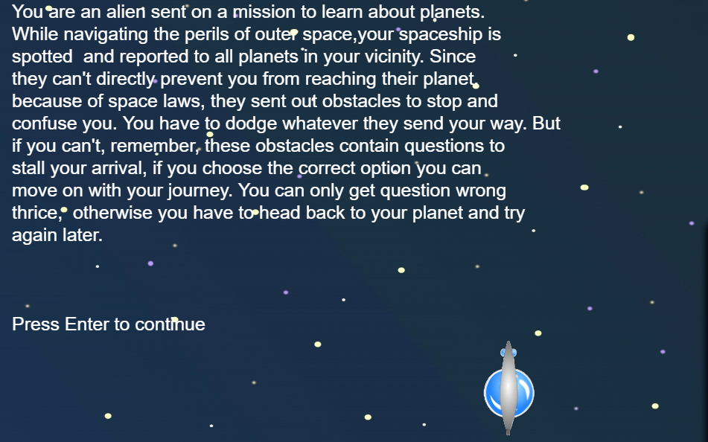

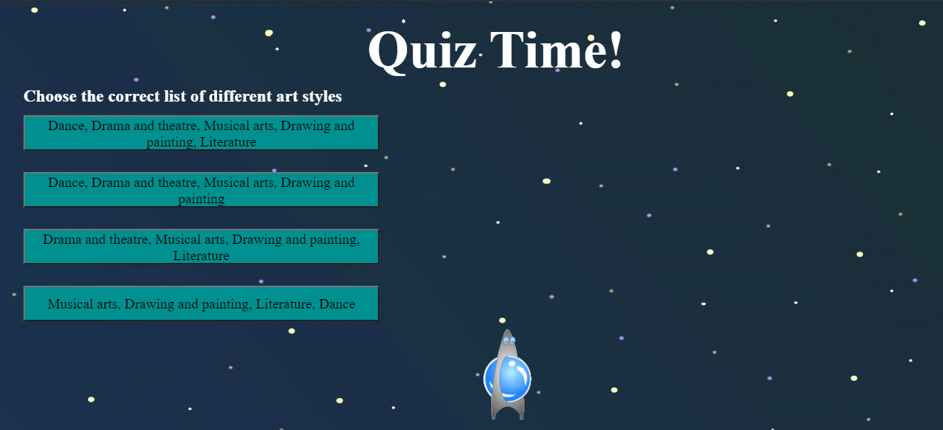

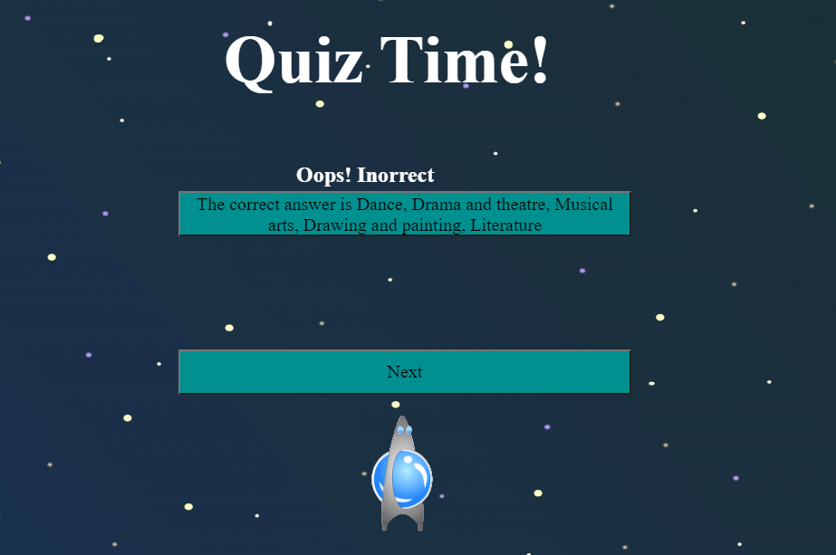

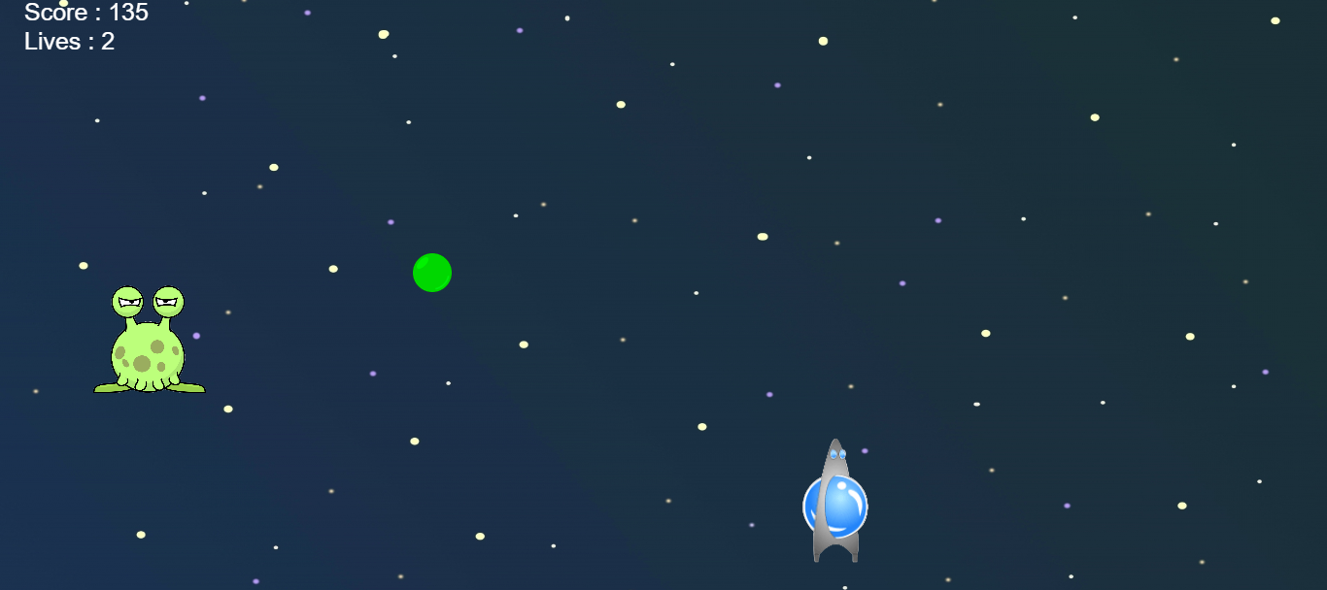



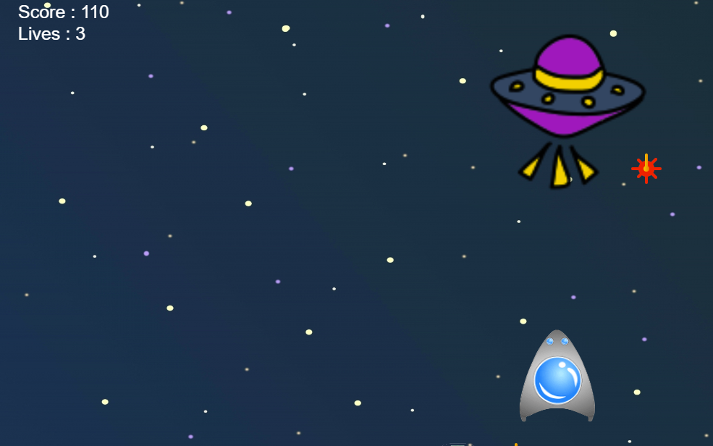

How do you plan to make your game engaging?

By adding encouragement and placing obstacles to motivate the player more. Also adding sound effects and eye-catching graphics