**INNOVATIVE IDEA PROPOSAL**

**IIC -CRCE IDEAS COMPETITION – 2019 [Team Maverick]**

**TITLE**

Implementation of Auction system to eliminate the middle man cost

**PROBLEM STATEMENT**

To create a central orchestration system which will enable the farmer to enlarge his overall value for his produce by eliminating the middle man cost that incurs due manufacturers and retailers. Thus, the auction system would enable the farmer to sell his products at a wholesale rate , enlarging profit.

**ABSTRACT**

The major reason behind farmers being economically challenged is that they do not get the right market price for their produce. Also, the price they pay for inputs considerably higher than the cost at which the inputs are manufactured. There is no application or service in the market which can help farmers come together and buy inputs in a group directly from manufacturers. Or there is no way farmers can form a group and sell their farm produce to FMCGs or other big buyers. Therefore our aim is to eliminate the middle man i.e. retailers, manufacturers and enabling the farmer to get the right value of his product through auction.

**INTRODUCTION/MOTIVATION**

* To create a app which would be profitable for the both i.e. the farmers as well as the consumers.
* The goal is to eliminate the middle man i.e. the traders, the manufacturers and retailers which increase the overall cost of the farmer’s product and the consumer has to pay a huge amount thereafter.
* On the other hand, the farmer also doesn’t get the right value of his produce because such a system.
* This goal can be achieved by implementing an auction system where the auction would be hosted by the farmers or a ‘group of farmers’ on our application which would be visible to both the farmers as well as bidders i.e. the consumers.

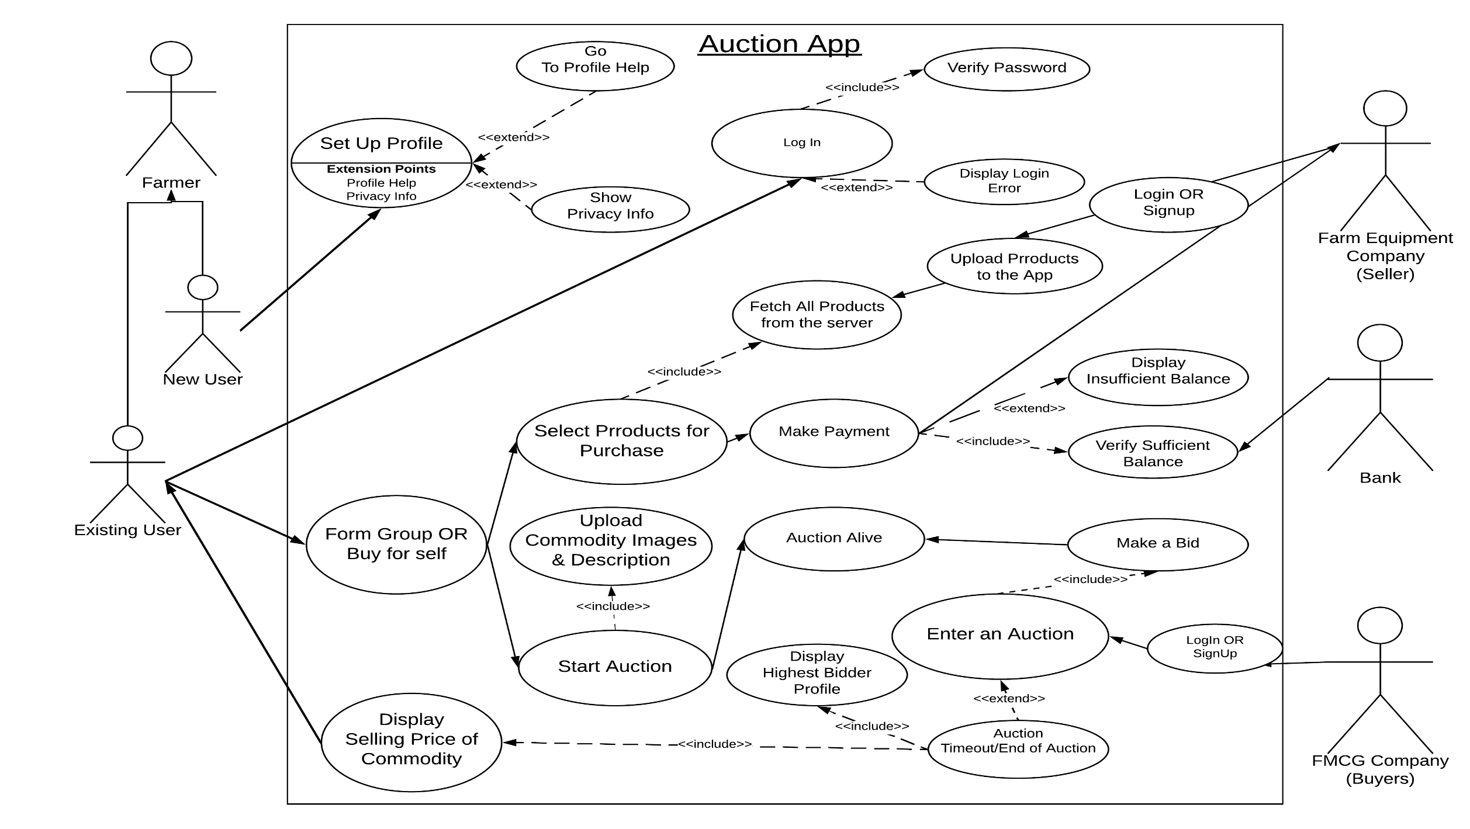**UML USE CASE DIAGRAM**

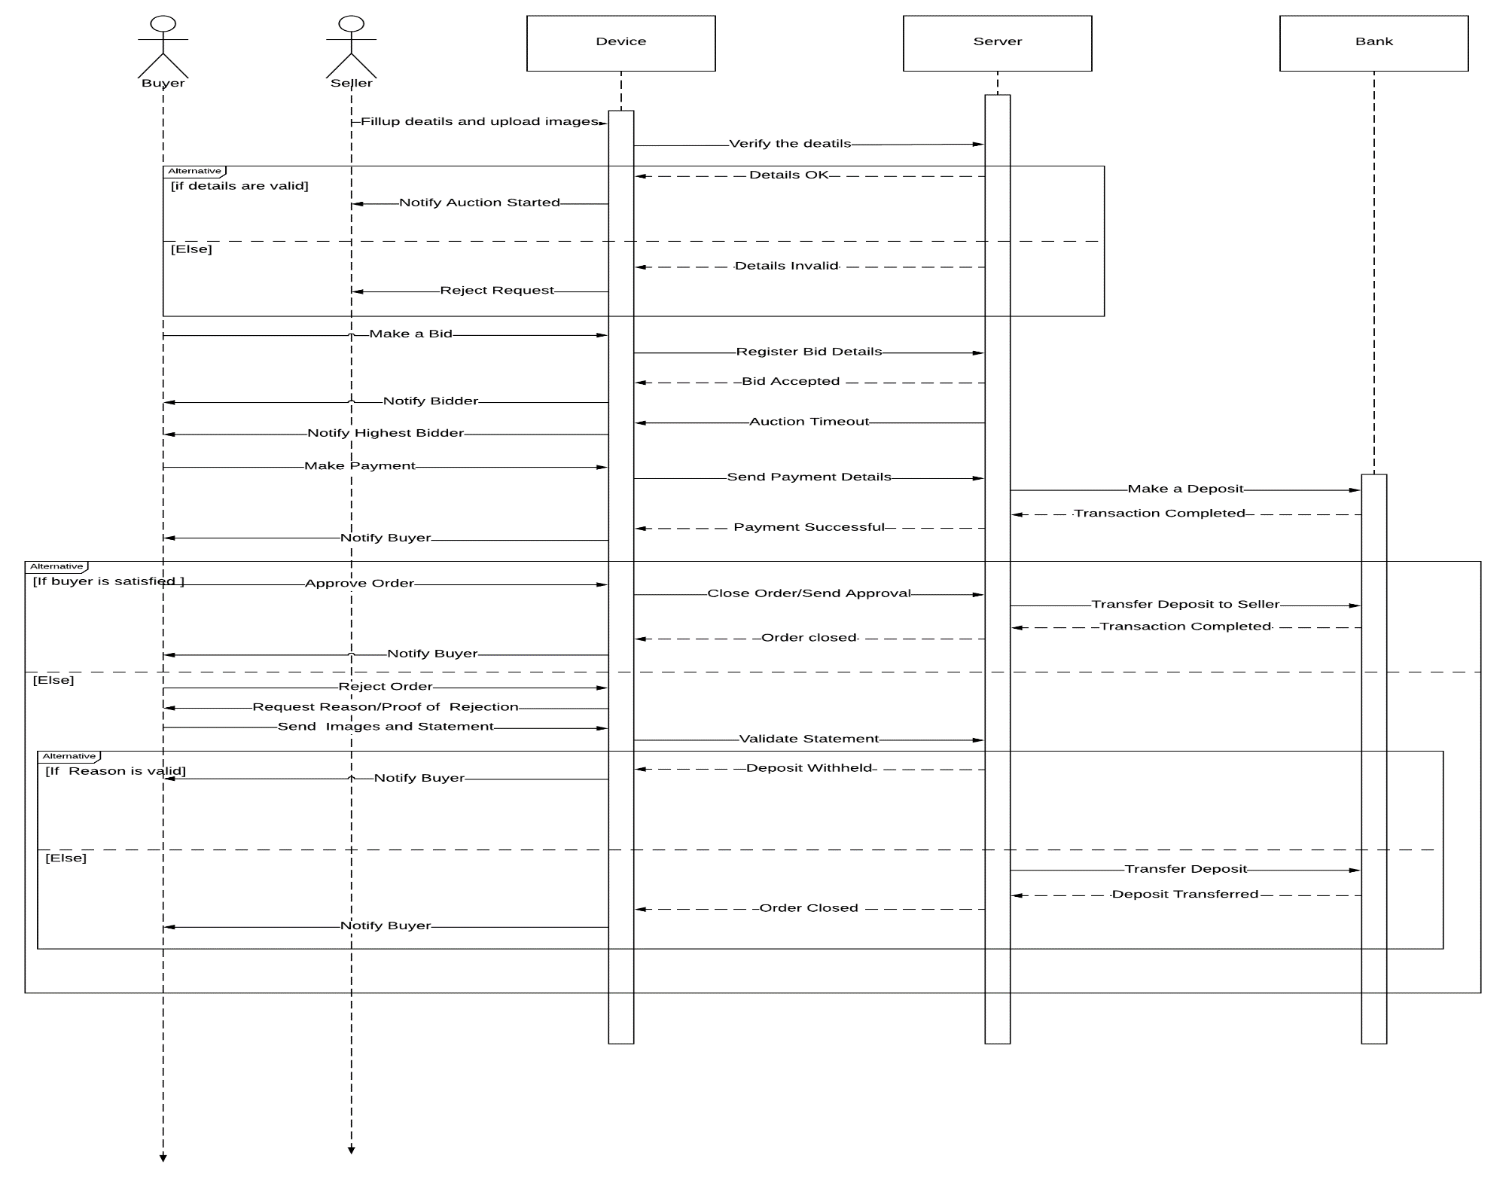**SEQUENCE DIAGRAM**

**SOFTWARE REQUIREMENTS**

**CLIENT SIDE :**

* React framework [Open source]
* Native base UI library [Open source]

**SERVER SIDE :**

* Express framework on NodeJS ecosystem
* Mongo DB

**IMPLEMENTATION**

* The main aim of our application is to benefit the farmer’s overall revenue, by eliminating the middle man cost.
* In this way, a single farmer or a group of farmers can join a group and would add a quantity of a particular commodity in bulk and would offer them for the bid in an ‘Auction’.
* The consumers(Buyer) subscribed to our app will be able to view the active auction and participate in it.
* The consumer having the highest bid will finally have the hold of the bidded product.
* The consumer has to then pay the amount once the commodity has been delivered and only if he is satisfied with the commodity, otherwise , a refund or a exchange is done based on T&C.
* Farmers can also come together as group(Or only buy for himself) to buy base commodities like crops/fertilizers from a farm product seller

**FEASIBILITY**

The auction system would benefit both the famers and the consumers by eliminating costs that incur during processing and supplying of products in between the buyers and consumers.

This system enables farmers to host an auction and buyers would bid , in such a fashion , both the buyers and farmers would get the produce at an whole sale rate.

**REFERENCES**

[1] Dr. Sarika Sharma Research Guide

<https://innovate.mygov.in/wp-content/uploads/2018/10/mygov1538944725441952.pdf>

[2] A Banerji, Neha Gupta, J V Meenakshi

<http://www.indiaenvironmentportal.org.in/files/file/Grain%20Markets.pdf>

**GROUP MEMBERS [Team Maverick]**

* **Cajetan Rodrigues**
* **Clayton Pereira**
* **Solomon Jose**