For exercise 1, the JavaWordCount.java file was added to the project as it was run on a local spark cluster.

Sample output:
spire: 10
truce: 90
Frenchman),: 10
might: 2930

For exercise 2, the JavaWordCount.java file was modified to filter and output lines containing ERROR. The input logfile was produced using journalctl –boot. Due to permission issues the application could not be run on the /var/log directory, it is also worth mentioning that some Linux systems store their logs in systemd-jourland’s databases which are binary encoded.
Sample output:

Jan 12 10:51:33 mihai-upb slack.desktop[2954]: [2954:0112/105133.192080:ERROR:browser_main_loop.cc(269)] Gtk: gtk_widget_add_accelerator: assertion 'GTK_IS_ACCEL_GROUP (accel_group)' failed
Jan 12 10:51:33 mihai-upb slack.desktop[2954]: [2954:0112/105133.192139:ERROR:browser_main_loop.cc(269)] Gtk: gtk_widget_add_accelerator: assertion 'GTK_IS_ACCEL_GROUP (accel_group)' failed
Jan 12 10:51:35 mihai-upb slack.desktop[2954]: [2954:0112/105135.221850:ERROR:browser_main_loop.cc(269)] Gtk: gtk_widget_add_accelerator: assertion 'GTK_IS_ACCEL_GROUP (accel_group)' failed
Jan 12 10:51:35 mihai-upb slack.desktop[2954]: [2954:0112/105135.256893:ERROR:browser_main_loop.cc(269)] Gtk: gtk_widget_add_accelerator: assertion 'GTK_IS_ACCEL_GROUP (accel_group)' failed
Jan 12 10:51:35 mihai-upb slack.desktop[2954]: [2954:0112/105135.256942:ERROR:browser_main_loop.cc(269)] Gtk: gtk_widget_add_accelerator: assertion 'GTK_IS_ACCEL_GROUP (accel_group)' failed

For exercise 3, the JavaWordCount.java file was modified by calculating the vowel RDDs from the count RDD. Two runs were performed, one with caching and one without. It is worth mentioning that even without Spark’s caching to RAM, Linux by default, stores recent files in it’s VFS cache.
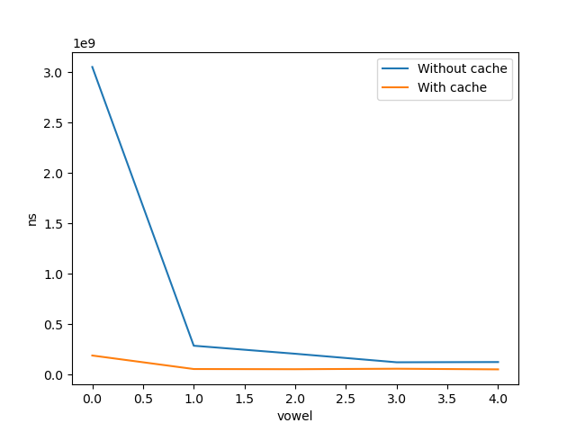

For exercise 4, the following commands were run and the output was observed:
((echo "kasdhj lakjsd lkjasd"; echo "asdasd kajkjsd") | nc -l 4444; sleep 10s) &
timeout 10s run-example org.apache.spark.examples.streaming.JavaNetworkWordCount localhost 4444

Sample output:
-------------------------------------------
Time: 1641990399000 ms
-------------------------------------------
(kasdhj,1)
(kajkjsd,1)
(lakjsd,1)
(asdasd,1)
(lkjasd,1)

Source code is available at: https://github.com/CajuM/dc

