For exercise 1, the WordCount.java file was added to the project as it was and an
attempt was made to fit the resulting histogram to Zipf's law, it does respect
Zipf's law.

the 834
of 425
and 360
in 262
to 255
a 236
was 205
The 132
by 97
for 97

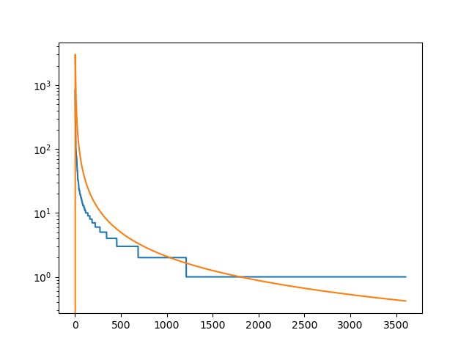

For exercise 2, WordCount2.java was a modified WordCount.java:
--- app/src/main/java/l4/WordCount.java 2022-01-11 11:14:59.004828082 +0200
+++ app/src/main/java/l4/WordCount2.java 2022-01-11 12:21:39.323795169 +0200
@@ -9,7 +9,7 @@
import org.apache.hadoop.mapred.*;
import org.apache.hadoop.util.*;

-public class WordCount {
+public class WordCount2 {

public static class Map extends MapReduceBase implements Mapper<LongWritable, Text, Text, IntWritable> {
private final static IntWritable one = new IntWritable(1);
@@ -18,9 +18,16 @@
public void map(LongWritable key, Text value, OutputCollector<Text, IntWritable> output, Reporter reporter) throws IOException {
String line = value.toString();
StringTokenizer tokenizer = new StringTokenizer(line);
+ String prev = null;
while (tokenizer.hasMoreTokens()) {
- word.set(tokenizer.nextToken());
- output.collect(word, one);
+ String token = tokenizer.nextToken();
+
+ if (prev != null) {
+ word.set(String.format("%s %s", prev, token));
+ output.collect(word, one);
+ }
+
+ prev = token;
}
}
}

The output was:
of the 124
in the 74
to the 51
Project Gutenberg-tm 44
and the 28
with the 28
for the 27
the Project 26
at the 24
by the 24

In order to calculate word pairs crossing line-boundaries, a custom InputFormat would have had to have been implemented. For example it could have passed line-pairs to the mapper, given that no word tuple may be longer than two lines.

For exercise 3, a custom Writeable was implemented, in order to hold two integers, the word cound and the total word length for each ASCII letter. It’s toString method was (ab)used in order to calculate the mean word length for each ASCII letter. Given that only 26 division operations are reuqired to calculate the mean and that map-reduce would have required separate reduce and combine classes, the simple approach was taken.

public String toString() {
return String.format("%d %d %f", this.v1.get(), this.v2.get(), ((double) this.v2.get()) / this.v1.get());
}

Source-code is available at https://github.com/CajuM/dc/l4

