person(Marka, Colour, Surname, Phone, City):-

car(Surname, Marka, Colour, _, _),

phonebook(Surname, Phone, addr(City, _, _, _)).

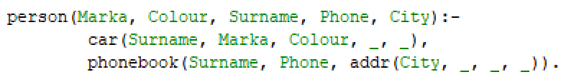

person(Marka, Colour, Surname, Phone, City) = person(m1, black, Surname, Phone, City).

|  |  |  |  |
| --- | --- | --- | --- |
| шаг | Рез ячейка | Рабочее поле | стек |
| 0 |  |  | person(Marka, Colour, Surname, Phone, City) = person(m1, black, Surname, Phone, City). |
|  |  | person(Marka, Colour, Surname, Phone, City) = person(m1, black, Surname, Phone, City). | Marka=m1  Colour= black  Surname= Surname  Phone= Phone  City= City |
|  | Marka=m1 | Marka=m1 | Colour= black  Surname= Surname  Phone= Phone  City= City |
|  | Marka=m1  Colour= black | Colour= black | Surname= Surname  Phone= Phone  City= City |
|  | Surname= Surname  Marka=m1  Colour= black | Surname= Surname |  |
|  |  |  |  |
|  |  |  |  |