HLTW7Tracey

**Linear Regression**

Linear regression is normally used in scenarios where you are primarily working with two types of variables which can be defined as independent (x axis plot) and dependent (y axis plot) and this is known as Simple Linear Regression. It is also possible to have a linear regression with more than two variables and this is known as Multiple Linear Regression This type of algorithm comes in the category of supervised algorithms as it relies on test data to create the model which can create a predictive graph. Part of what linear regression establishes is whether or not there is a relation ship between the two variables. If the line plotted is straight running at an equidistance to the axis this would imply no relationship between the variables, if the line plotted sloped upwards from left to right this would be considered a positive regression and if the plotted line sloped upwards from right to left that would be a negative regression.

Although there it is possible to plot this type of graph using programming languages such as Python, the equation used to perform this regression is y = B0 + B1X+ e

Y is the dependent variable; X is the independent variable; B0 is the predicted value of y when x is 0 and is called the intercept; B1 is how much we expect y to change as x increases and is called the regression coefficient: e is the **error** of the estimate.

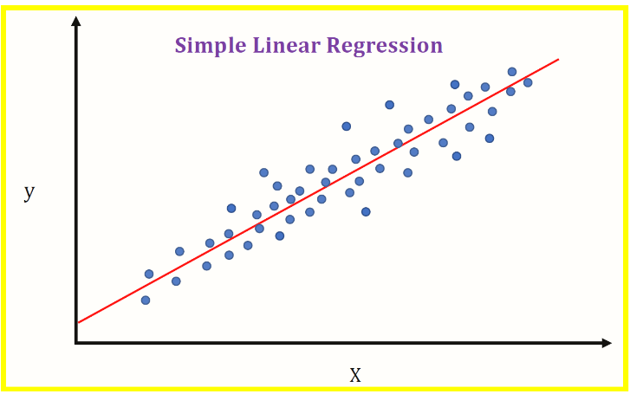

Some examples of how linear regression can be use :-

* A business could use it to track increased income against advertising spend
* A doctor could track patients blood pressure against the dosage of a specific medication
* Agricultural scientists have used linear regression to measure the effect of fertilizer and water on crop yields.