Make sure that you insert all server-side end points
at folder routes/private/api.js
How to test your private API
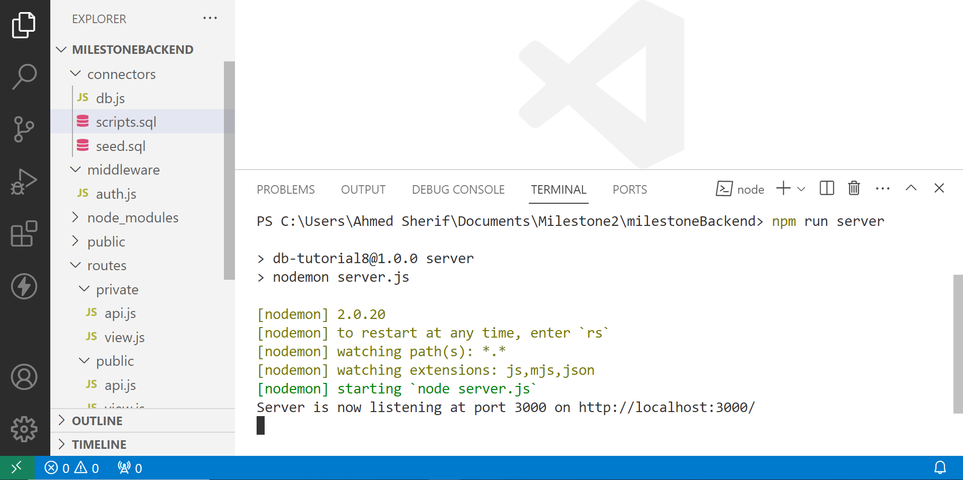
- Open terminal and run npm run server in terminal

- Type localhost:3000/register in your browser
- Fill In Registration form and click on Register

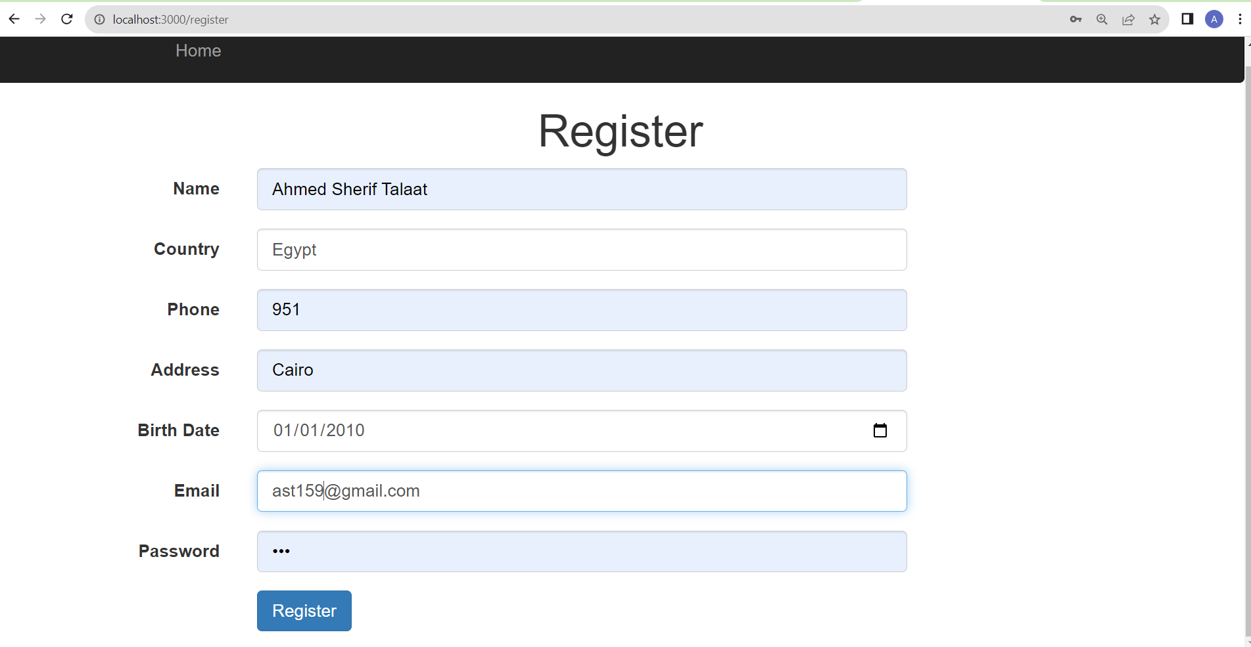

- Go to visual studio code and open extensions
- Install ThunderClient
- Open ThunderClient in visual studio code
- Click on new request
- Change request to get
- Enter http://localhost:3000/api/v1/user/login in url
- Click on Body and then select JSON
- Type Json object consists of email and password
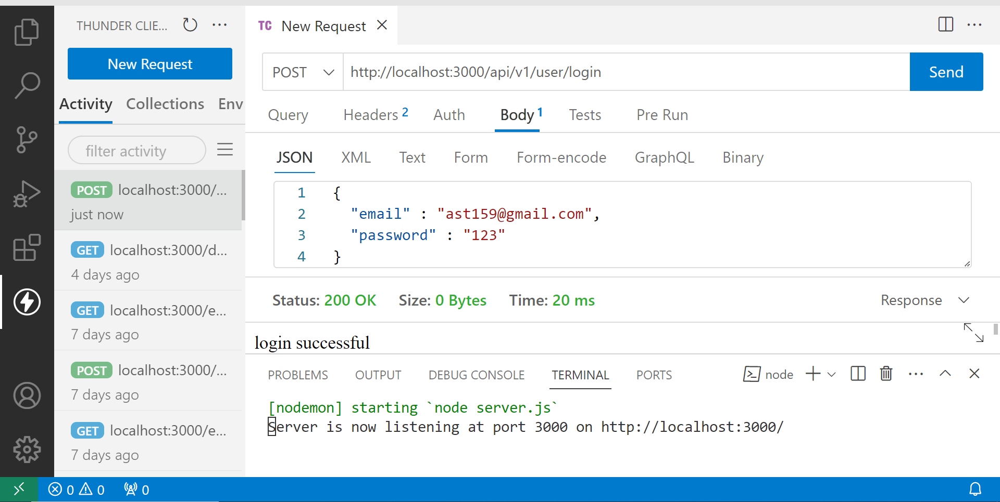
- Click on send

You need to login in using thunder client every 5 hours
Or whenever you rerun npm run server
- Change request to GET
- Enter http://localhost:3000/api/test (optional)
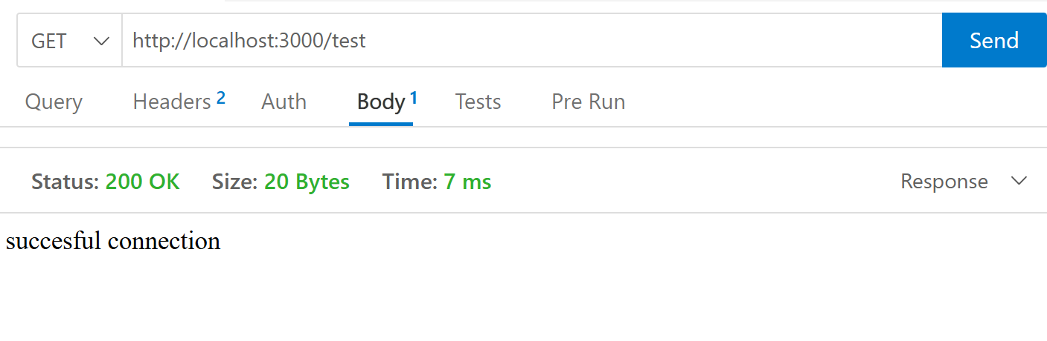
- Click on Send
Step 13, 14, and 15 are to make sure you are ready to test your server-side private end points.

