 Jahangir Shukurov | GRC Portfolio
PHASE 0 | CLIENT BASELINE
Company Fact Sheet
Single source of truth for the Orvanta GRC engagement

Client Orvanta Payments UAB
Document ID ORV-PROFILE-001
Version 1.0
Date 7 November 2026
Classification Confidential (sample)

Sample engagement — fictional company, prepared for portfolio purposes.

Document control
Field | Value
Document ID | ORV-PROFILE-001
Title | Company Fact Sheet
Version | 1.0
Date | 7 November 2026
Author | Jahangir Shukurov
Reviewer | Nino Beridze, CISO-designate
Approver | Ugnė Baltrūnaitė, CEO
Classification | Confidential (sample)

Version history
Version | Date | Author | Change
0.1 | 2 November 2026 | Jahangir Shukurov | Working draft from client intake
1.0 | 7 November 2026 | Jahangir Shukurov | Baseline issued for the engagement

Contents
1 Executive summary 3
2 How to use this document 4
3 Company profile 4
3.1 Overview 4
3.2 Products 4
3.3 Why the engagement is happening 4
4 Organization 5
4.1 Organization chart 5
4.2 Named role-holders 6
4.3 Headcount by function and location 6
5 Business processes 7
6 Technology 8
6.1 Network and cloud architecture 8
6.2 System inventory 9
6.3 Data classes 10
6.4 High-level data flows 10
7 Vendors 11
8 Regulatory landscape 11
8.1 Verification status 12
9 Current security maturity 12
9.1 Baseline observations and the attacker's view 13

Executive summary
Situation. Orvanta Payments UAB is a Vilnius-based payment institution with 120 people, most of its engineers in Baku, and EUR 3.2 billion in annual payment volume. It grew faster than its security governance. Three enterprise merchant prospects now require ISO/IEC 27001:2022 certification, and DORA already applies.
EUR 21.4M  FY2025 net revenue | EUR 85M  Average safeguarded funds | 640  Active merchants | 1.6 / 5  Indicative security maturity

Key findings from intake.
- Strong build, weak governance. Terraform, encryption and Multi-AZ are in place, but there is no ISMS and no current risk register.
- Identity is the easiest way in. Shared admin accounts, five tools without enforced MFA and a 9-day median offboarding time.
- Attacks would go unnoticed. There is no SIEM, no scheduled log review and no exercised incident plan.
- Recovery is unproven. No full restore is on record, and backups share an account with production.
- Suppliers are unassessed. None of the 20 vendors has a documented assessment, including all eight preliminary Tier 1 providers.
Risk in business terms. EUR 2.4M of annual enterprise revenue, equal to 11% of FY2025 net revenue, depends on certification by 30 November 2027. A serious credential compromise could also disrupt payments, delay regulatory reporting and put customer trust and the licence relationship under strain.
Decisions needed from the CEO and Management Board.
# | Decision | Owner | By
1 | Sponsor the ISMS program and name it a board-level priority | Ugnė Baltrūnaitė | 30 Nov 2026
2 | Move the CISO reporting line from the CTO to the CEO (OBS-12) | Ugnė Baltrūnaitė | 31 Dec 2026
3 | Include the Baku subsidiary in the ISMS scope | Tural Mammadli | 15 Jan 2027
4 | Commission a QSA review of PCI DSS scope and validation level | Nino Beridze | 31 Jan 2027

How to use this document
This fact sheet records what the engagement team knows about Orvanta on 7 November 2026. Every later project draws its names, systems, vendors and baseline facts from here. If a fact changes, it changes here first, in the machine-readable master file (data/orvanta_master.json), and the documents are rebuilt.
Prefix | Meaning | Example | Used by
R- | Role and named holder | R-CISO | All projects (owners, RACI, sign-off)
BP- | Business process | BP-05 | Projects 2 and 7 (risk, BIA)
SYS- | System | SYS-08 | Projects 1, 2, 4 and 7
D- | Data class | D-CHD | Projects 2 and 3
DF- | Data flow | DF-07 | Projects 2 and 6
VEN- | Vendor | VEN-02 | Projects 2, 6 and 8
REG- | Regulatory or contractual driver | REG-01 | Projects 1, 7 and 8
OBS- | Baseline observation from intake | OBS-05 | Projects 1, 2 and 5

Reading note. Orvanta and its named people, fictional suppliers, figures and observations are invented. Real vendors appear only as tools Orvanta uses. Nothing here describes the security of those vendors or of any real company.

Company profile

Overview
Attribute | Detail
Legal entity | Orvanta Payments UAB, founded 2018, payment institution licence since 2020
Headquarters | Vilnius, Lithuania
Engineering hub | Baku, Azerbaijan (Orvanta Engineering LLC, wholly owned subsidiary)
Supervisor | Bank of Lithuania
Production hosting | AWS eu-central-1 (Frankfurt), with no production workload outside the EU
Scale, FY2025 | EUR 3.2bn payment volume, 640 merchants, 8,200 business accounts, 31,000 active cards, 120 employees

Products
- Merchant Payment API. SEPA Credit Transfer and SEPA Instant pay-ins and payouts, plus card acceptance through a hosted payment page.
- Business accounts. IBAN accounts, statements and a web portal for small and mid-sized companies.
- Card issuing. Debit cards for account holders. Tessarin handles issuer processing and stores full card numbers.

Why the engagement is happening
- Revenue. 3 enterprise prospects worth EUR 2.4M a year made certification a contract condition.
- Regulation. DORA has applied to Orvanta since 17 January 2025, and the ICT risk framework is not yet complete.
- Scale. Headcount doubled in three years, and informal controls no longer keep pace with engineering output.

Organization

Organization chart
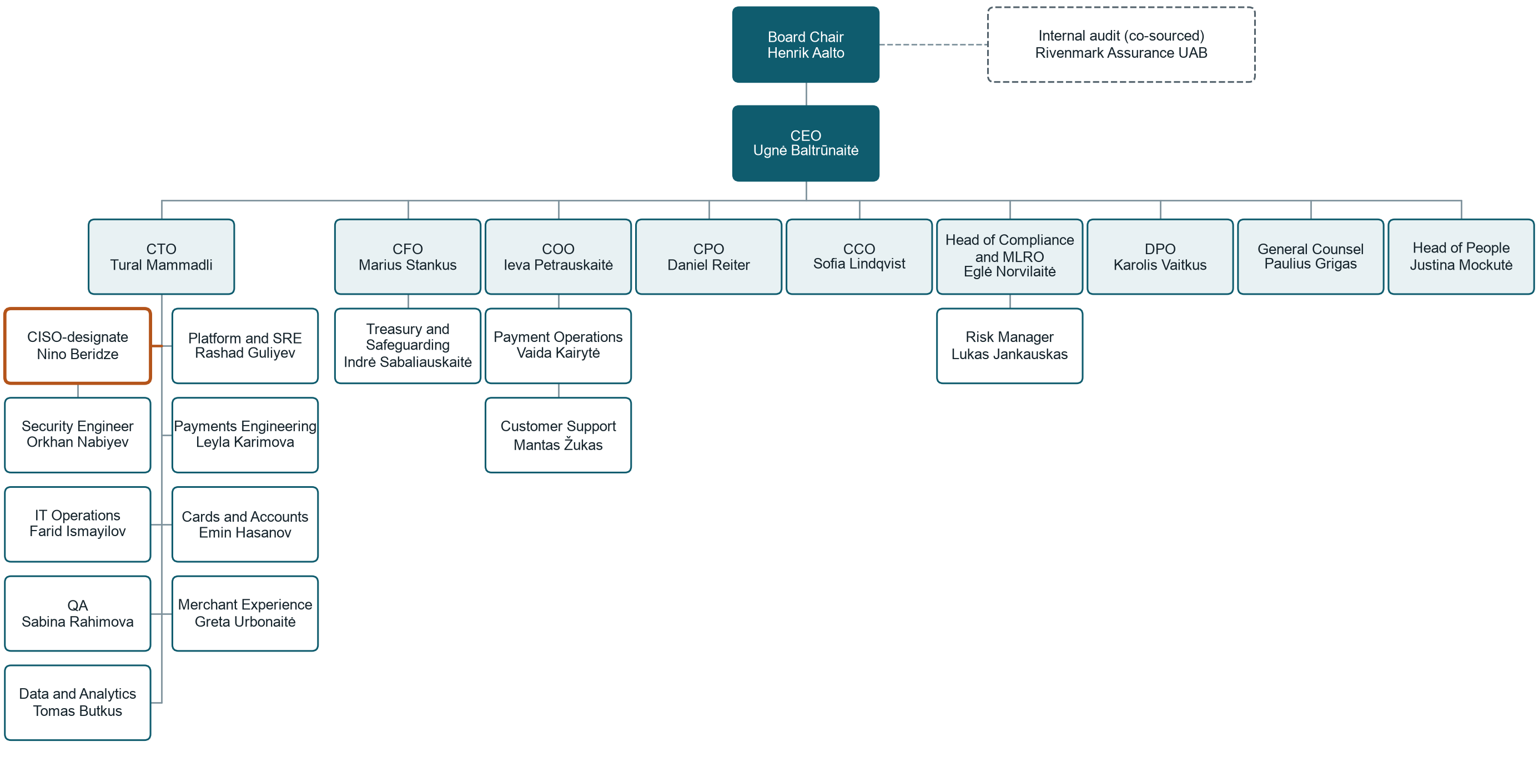
Figure 1: Orvanta reporting lines. The highlighted CISO-designate line is observation OBS-12.

Named role-holders
Role ID | Role | Holder | Location | Reports to
R-CHAIR | Chair of the Management Board (non-executive) | Henrik Aalto | Remote | Shareholders
R-CEO | Chief Executive Officer | Ugnė Baltrūnaitė | Vilnius | R-CHAIR
R-CTO | Chief Technology Officer | Tural Mammadli | Baku | R-CEO
R-CFO | Chief Financial Officer | Marius Stankus | Vilnius | R-CEO
R-COO | Chief Operating Officer | Ieva Petrauskaitė | Vilnius | R-CEO
R-CPO | Chief Product Officer | Daniel Reiter | Remote | R-CEO
R-CCO | Chief Commercial Officer | Sofia Lindqvist | Remote | R-CEO
R-HCOMP | Head of Compliance and MLRO | Eglė Norvilaitė | Vilnius | R-CEO
R-DPO | Data Protection Officer | Karolis Vaitkus | Vilnius | R-CEO
R-GC | General Counsel | Paulius Grigas | Vilnius | R-CEO
R-HPEOPLE | Head of People | Justina Mockutė | Vilnius | R-CEO
R-CISO | Head of Information Security (CISO-designate) | Nino Beridze | Vilnius | R-CTO
R-SECENG | Security Engineer | Orkhan Nabiyev | Baku | R-CISO
R-RISK | Risk Manager | Lukas Jankauskas | Vilnius | R-HCOMP
R-HSRE | Head of Platform and SRE | Rashad Guliyev | Baku | R-CTO
R-HPAY | Head of Payments Engineering | Leyla Karimova | Baku | R-CTO
R-HCARD | Head of Cards and Accounts Engineering | Emin Hasanov | Baku | R-CTO
R-HMX | Head of Merchant Experience Engineering | Greta Urbonaitė | Vilnius | R-CTO
R-ITOPS | IT Operations Lead | Farid Ismayilov | Baku | R-CTO
R-QA | QA Lead | Sabina Rahimova | Baku | R-CTO
R-DATA | Data and Analytics Lead | Tomas Butkus | Vilnius | R-CTO
R-TREAS | Treasury and Safeguarding Manager | Indrė Sabaliauskaitė | Vilnius | R-CFO
R-PAYOPS | Head of Payment Operations | Vaida Kairytė | Vilnius | R-COO
R-SUPMGR | Customer Support Manager | Mantas Žukas | Vilnius | R-COO

Headcount by function and location
Function | Lead | Vilnius | Baku | Remote | Total
Executive Office | Ugnė Baltrūnaitė | 2 | 0 | 0 | 2
Engineering and IT | Tural Mammadli | 8 | 38 | 14 | 60
Information Security | Nino Beridze | 1 | 1 | 0 | 2
Product and Design | Daniel Reiter | 2 | 3 | 2 | 7
Compliance, AML and Risk | Eglė Norvilaitė | 8 | 0 | 1 | 9
Data Protection | Karolis Vaitkus | 1 | 0 | 0 | 1
Finance and Treasury | Marius Stankus | 7 | 0 | 0 | 7
Operations | Ieva Petrauskaitė | 10 | 0 | 2 | 12
Commercial | Sofia Lindqvist | 7 | 0 | 6 | 13
People and Legal | Justina Mockutė | 5 | 1 | 1 | 7
Total |  | 51 | 43 | 26 | 120

Business processes
Twelve processes run the business. Criticality here is a working view, which the Business Impact Analysis in Project 7 tests and replaces with measured recovery objectives.
ID | Process | What it does | Owner | Key systems | Criticality
BP-01 | Merchant payment acceptance | Accepts merchant API requests and routes SEPA and card payments. | Ieva Petrauskaitė | SYS-01, SYS-02, SYS-20 | Critical
BP-02 | Payouts and settlement | Settles merchant balances and runs SEPA payout files. | Vaida Kairytė | SYS-02, SYS-23 | Critical
BP-03 | Business account operations | Opens accounts, posts balances and issues statements. | Ieva Petrauskaitė | SYS-03, SYS-02, SYS-05 | Critical
BP-04 | Card program operations | Issues, controls and disputes cards through the processor. | Ieva Petrauskaitė | SYS-04, SYS-20 | Critical
BP-05 | Safeguarding and treasury | Reconciles client funds to safeguarding accounts every day. | Indrė Sabaliauskaitė | SYS-02, SYS-23 | Critical
BP-06 | Merchant onboarding and KYC | Verifies merchants and owners before activation. | Eglė Norvilaitė | SYS-18, SYS-06, SYS-09 | High
BP-07 | AML transaction monitoring | Screens transactions and handles alerts and reports. | Eglė Norvilaitė | SYS-18, SYS-02 | High
BP-08 | Customer support | Handles customer tickets through the outsourced provider. | Mantas Žukas | SYS-19, SYS-06 | High
BP-09 | Software delivery and change | Builds, tests and deploys code and infrastructure. | Tural Mammadli | SYS-11, SYS-12, SYS-07 | High
BP-10 | Platform operations | Runs, monitors and restores production services. | Rashad Guliyev | SYS-07, SYS-08, SYS-21, SYS-22 | Critical
BP-11 | Identity and joiner-mover-leaver | Grants, changes and removes workforce access. | Farid Ismayilov | SYS-13, SYS-14, SYS-17 | High
BP-12 | Regulatory reporting | Prepares supervisory, AML and incident reports. | Eglė Norvilaitė | SYS-16, SYS-24 | High

Technology

Network and cloud architecture
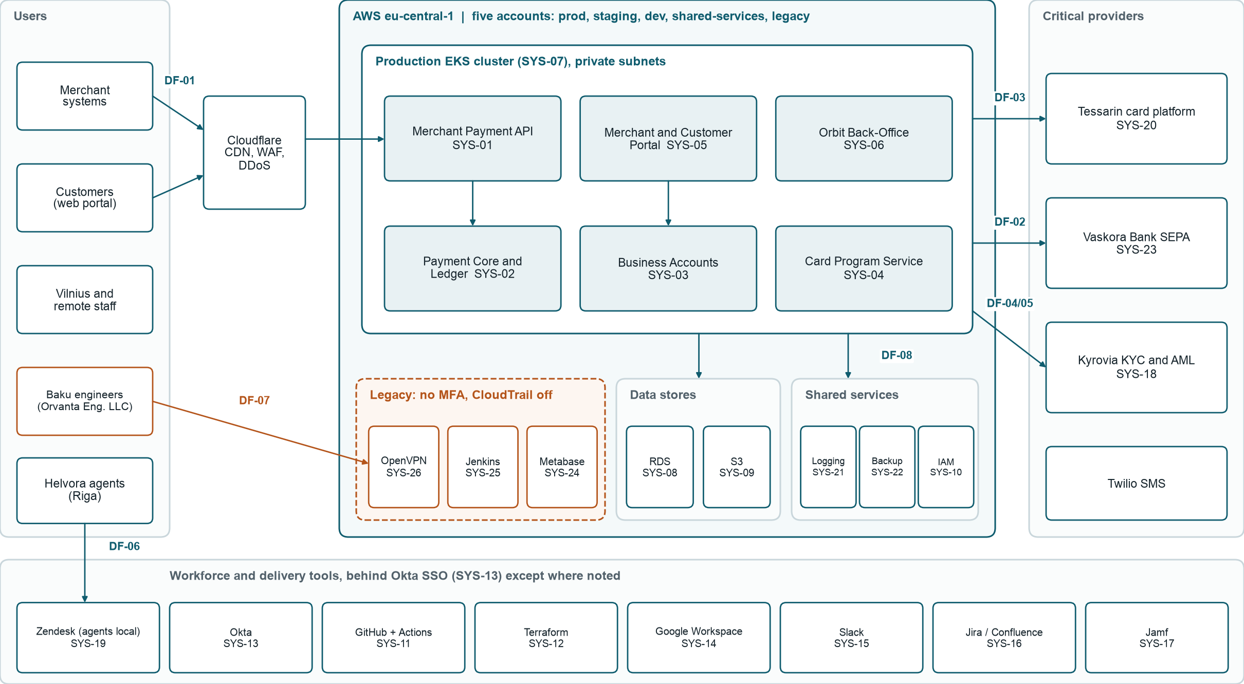
Figure 2: High-level architecture and data flows. Dashed orange marks legacy components outside Okta and the cross-border engineering path.

System inventory
ID | System | Purpose | Hosting | Owner | Criticality | Data | Access reality
SYS-01 | Merchant Payment API | Public REST API for merchant payments | AWS EKS | Leyla Karimova | Critical | D-PAY, D-PII | API keys and mTLS; staff via Okta
SYS-02 | Payment Core and Ledger | Orchestration, balances and ledger | AWS EKS and RDS | Leyla Karimova | Critical | D-PAY, D-PII | Service roles; engineer access via kubectl
SYS-03 | Business Accounts Platform | IBAN accounts and statements | AWS EKS and RDS | Emin Hasanov | Critical | D-PAY, D-PII | Customer MFA; staff via Okta
SYS-04 | Card Program Service | Integration layer to card processor | AWS EKS | Emin Hasanov | Critical | D-CHD, D-PII | Service roles; tokens and truncated PAN only
SYS-05 | Merchant and Customer Portal | Web portal for customers | AWS EKS behind Cloudflare | Greta Urbonaitė | High | D-PAY, D-PII | Customer password and TOTP
SYS-06 | Orbit Back-Office Console | Internal case, account and fee admin | AWS EKS | Ieva Petrauskaitė | Critical | D-PAY, D-PII, D-KYC | Okta, plus one shared ops-admin login
SYS-07 | EKS Production Cluster | Runs all production workloads | AWS eu-central-1 | Rashad Guliyev | Critical | D-PAY, D-CRED | AWS SSO; cluster-admin held by 14 engineers
SYS-08 | RDS PostgreSQL Production | Primary transactional databases | AWS eu-central-1 (Multi-AZ) | Rashad Guliyev | Critical | D-PAY, D-PII | Bastion and shared DBA credential
SYS-09 | S3 Document and Archive Store | KYC files, statements, log archive | AWS eu-central-1 | Rashad Guliyev | High | D-KYC, D-PAY, D-LOG | IAM roles; no object-level access review
SYS-10 | AWS Organization and IAM | Five accounts and cloud identities | AWS | Rashad Guliyev | Critical | D-CRED | AWS SSO, plus shared admin in legacy account
SYS-11 | GitHub and GitHub Actions | Source code and CI/CD | GitHub SaaS | Tural Mammadli | Critical | D-SRC, D-CRED | Okta SAML; long-lived AWS keys in 9 repos
SYS-12 | Terraform Infrastructure as Code | Defines AWS infrastructure | GitHub Actions; state in S3 | Rashad Guliyev | High | D-SRC, D-CRED | CI role; some applies from laptops
SYS-13 | Okta Workforce Identity | SSO and MFA for workforce | Okta SaaS | Farid Ismayilov | Critical | D-HR, D-CRED | Admin MFA enforced; 6 super admins
SYS-14 | Google Workspace | Email, documents and shared drives | Google SaaS | Farid Ismayilov | High | D-PII, D-HR, D-FIN | Okta SSO and MFA
SYS-15 | Slack | Internal chat and on-call channels | Slack SaaS | Farid Ismayilov | Medium | D-PII, D-CRED | Okta SSO and MFA
SYS-16 | Jira and Confluence | Work tracking and documentation | Atlassian SaaS | Tural Mammadli | Medium | D-SRC, D-PII | Okta SSO and MFA
SYS-17 | Jamf and Laptop Fleet | Manages 131 laptops (88 enrolled) | Jamf SaaS | Farid Ismayilov | High | D-CRED, D-SRC | Okta SSO; 43 laptops unmanaged
SYS-18 | Kyrovia KYC and AML Platform | ID checks, screening, monitoring | Vendor SaaS (EU) | Eglė Norvilaitė | Critical | D-KYC, D-PII, D-PAY | Local accounts with optional MFA
SYS-19 | Zendesk Support Desk | Tickets used by Helvora agents | Zendesk SaaS | Mantas Žukas | High | D-PII, D-CHD | Okta for staff; local logins for agents
SYS-20 | Tessarin Card Platform | Issuer processing and card vault | Vendor-hosted (EU) | Emin Hasanov | Critical | D-CHD, D-PAY | Vendor portal with MFA; signed API calls
SYS-21 | Logging Stack | CloudTrail, CloudWatch, OpenSearch | AWS | Rashad Guliyev | High | D-LOG | IAM roles; no SIEM or scheduled review
SYS-22 | AWS Backup and RDS Snapshots | Database and storage backups | AWS eu-central-1 | Rashad Guliyev | Critical | D-PAY, D-PII | IAM roles; same account as production
SYS-23 | Vaskora Bank Connection | SEPA files and safeguarding portal | Bank-hosted; SFTP from AWS | Indrė Sabaliauskaitė | Critical | D-PAY, D-FIN | Bank tokens; SFTP key in Secrets Manager
SYS-24 | Metabase Reporting | BI on a production read replica | Self-hosted on EC2 | Tomas Butkus | Medium | D-PAY, D-PII | Legacy: local accounts, no MFA
SYS-25 | Legacy Jenkins | Runs 7 older deployment jobs | Self-hosted on EC2 | Rashad Guliyev | Medium | D-SRC, D-CRED | Legacy: local accounts, no MFA
SYS-26 | OpenVPN Bastion | Legacy path to database subnets | Self-hosted on EC2 | Rashad Guliyev | High | D-CRED | Legacy: certificate and shared profile, no MFA

Data classes
ID | Data class | Classification | ID | Data class | Classification
D-PAY | Payment and transaction data | Confidential | D-HR | Employee data | Confidential
D-PII | Customer personal data | Confidential | D-FIN | Corporate financial data | Confidential
D-KYC | Identity documents and KYC files | Restricted | D-SRC | Source code and configuration | Confidential
D-CHD | Cardholder data | Restricted | D-LOG | Security and application logs | Internal
D-CRED | Credentials, keys and secrets | Restricted

High-level data flows
ID | From | To | Data | Protection today | Cross-border
DF-01 | Merchant systems | Merchant Payment API (SYS-01) | Payment instructions | TLS 1.2+, mTLS, Cloudflare WAF | EU and merchant locations
DF-02 | Payment Core (SYS-02) | Vaskora Bank (SYS-23) | SEPA files, statements | SFTP with key authentication | None (EU)
DF-03 | Card Program Service (SYS-04) | Tessarin (SYS-20) | Card controls, tokens | Signed API over private link | None (EU)
DF-04 | Portal and Orbit (SYS-05, SYS-06) | Kyrovia (SYS-18) | ID files, owner data | TLS API, S3 pre-signed upload | None (EU)
DF-05 | Payment Core (SYS-02) | Kyrovia (SYS-18) | Transactions for screening | TLS API with static key | None (EU)
DF-06 | Customers | Helvora via Zendesk (SYS-19) | Tickets, identity details | TLS; agent local logins | None (EU)
DF-07 | Production (SYS-07, SYS-08) | Baku engineers | Logs, database rows in support cases | AWS SSO, OpenVPN bastion | EU to Azerbaijan (Chapter V GDPR)
DF-08 | All AWS accounts | Logging Stack (SYS-21) | Audit and application logs | IAM, encrypted at rest | None (EU)

Vendors
Tiers are preliminary, based on data access and business criticality. Project 6 formalizes the criteria. "CIF" marks a vendor that appears to support a critical or important function under DORA, pending legal confirmation.
ID | Vendor | Service | Data access | Tier | CIF
VEN-01 | Amazon Web Services | Cloud hosting for all production | Hosts encrypted production data | Tier 1 | Yes
VEN-02 | Tessarin Card Services S.A. | Issuer processing and card vault | Cardholder and transaction data | Tier 1 | Yes
VEN-03 | Kyrovia Compliance Ltd | KYC, screening and AML monitoring | Identity documents, transactions | Tier 1 | Yes
VEN-04 | Vaskora Bank AB | SEPA access and safeguarding accounts | Payment and settlement data | Tier 1 | Yes
VEN-05 | Helvora Support SIA | Outsourced customer support (Riga) | Customer data via Zendesk and Orbit | Tier 1 | Yes
VEN-06 | Okta | Workforce SSO and MFA | Staff identity data | Tier 1 | Yes
VEN-07 | GitHub | Source code and CI/CD | Source code, CI secrets | Tier 1 | Yes
VEN-08 | Cloudflare | CDN, WAF and DDoS protection | Customer traffic in transit | Tier 1 | Yes
VEN-09 | Google Workspace | Email and documents | Business and staff data | Tier 2 | No
VEN-10 | Twilio | SMS for customer alerts and OTP | Phone numbers, message content | Tier 2 | No
VEN-11 | Zendesk | Support ticketing platform | Customer data in tickets | Tier 2 | No
VEN-12 | PagerDuty | On-call alerting | Staff contacts, alert metadata | Tier 2 | No
VEN-13 | Slack | Internal messaging | Business chat, incidental data | Tier 2 | No
VEN-14 | Atlassian | Jira and Confluence | Project and technical documents | Tier 2 | No
VEN-15 | Jamf | Laptop device management | Device and user metadata | Tier 2 | No
VEN-16 | Personio | HR information system | Employee personal data | Tier 2 | No
VEN-17 | Sentinela Red Team OÜ | Annual penetration testing | Findings, temporary test access | Tier 2 | No
VEN-18 | Rivenmark Assurance UAB | Co-sourced internal audit | Audit evidence on request | Tier 2 | No
VEN-19 | Xero | Accounting system | Corporate financial data | Tier 3 | No
VEN-20 | Caspian Workspace LLC | Baku office and building access | No system access; visitor records | Tier 3 | No

Regulatory landscape
The table sets out what applies and why. It deliberately omits reporting deadlines and detailed requirements, which Projects 7 and 8 cover and verify. It is a working view, not legal advice.
ID | Driver | Why it matters to Orvanta | Regulator or authority | Owner | Status
REG-01 | DORA, Regulation (EU) 2022/2554 | Orvanta is a financial entity. Covers ICT risk, incident reporting, resilience testing and ICT third parties. | Bank of Lithuania | Nino Beridze | In force
REG-02 | GDPR, Regulation (EU) 2016/679 | Controller for customer and staff data. Baku access is a restricted transfer. | State Data Protection Inspectorate | Karolis Vaitkus | In force
REG-03 | Payment services rules (PSD2, Directive (EU) 2015/2366, as transposed) | Basis of the payment institution licence, including safeguarding and strong customer authentication. | Bank of Lithuania | Eglė Norvilaitė | In force
REG-04 | AML and counter-terrorist financing rules | Customer due diligence, monitoring and suspicious activity reporting. | [verify against official source] | Eglė Norvilaitė | In force
REG-05 | PCI DSS v4.0.1 | Contractual through the card program. Vault is outsourced, yet card data has appeared in tickets. | Card schemes through Tessarin | Nino Beridze | Contractual
REG-06 | NIS2, Directive (EU) 2022/2555, and Lithuanian Law on Cyber Security | Awareness item. DORA takes precedence for matters it covers, but Baku subsidiary and group scope need legal confirmation. | National Cyber Security Centre (NKSC) | Paulius Grigas | Monitor
REG-07 | ISO/IEC 27001:2022 and Amendment 1:2024 | Commercial requirement from enterprise merchants, not a legal duty. The amendment adds a climate-change relevance check to clause 4. | Accredited certification body | Nino Beridze | Target

Verification status
Checked on 7 November 2026. Items marked [verify against official source] could not be confirmed on an official page and need checking before anyone relies on them.
ID | What was checked and the result
REG-01 | Verified: EUR-Lex. Art. 2(1)(b) lists payment institutions; Art. 64 sets application from 17 January 2025.
REG-02 | Azerbaijan absent from the European Commission adequacy list (checked 2026-11-07). [verify against official source]: Inspectorate role; official site not reachable.
REG-03 | Bank of Lithuania site lists its supervision of payment institutions. [verify against official source]: Lithuanian transposing act references.
REG-04 | [verify against official source]: competent authority and act references. Context only; outside the portfolio's security scope.
REG-05 | Verified: PCI SSC blog. v4.0.1 published June 2024; v4.0 retired 31 December 2024. Orvanta's validation level requires QSA or scheme confirmation.
REG-06 | DORA recital 16 (lex specialis) verified on EUR-Lex. [verify against official source]: Lithuanian transposition dates; secondary sources give 18 October 2024.
REG-07 | Amendment content confirmed through a national standards body's published copy and certification-body notes.

Current security maturity
The average indicative score is 1.6 out of 5. This is an intake view from interviews and a light document review, not a formal assessment. Project 1 replaces it with a control-by-control score against clauses 4 to 10 and all 93 Annex A controls.
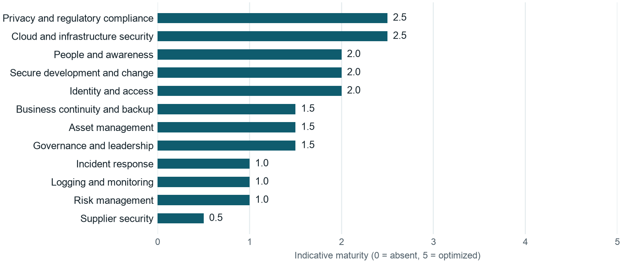
Figure 3: Indicative maturity by security domain, highest at the top.

Baseline observations and the attacker's view
Each observation is paired with how an attacker would use it, because a gap matters most when it opens a real attack path.
ID | Area | What we observed | How an attacker would use it | Owner
OBS-01 | Risk management | Risk register is one spreadsheet, last updated February 2025, with no criteria or owners. | Nobody has asked which path to the ledger is the easiest, so nobody has closed it. | Lukas Jankauskas
OBS-02 | Privileged access | Shared admin accounts remain in the AWS legacy account, Orbit and the DBA credential. | One stolen shared password gives high privilege with no named person in the logs. | Rashad Guliyev
OBS-03 | Offboarding | Last 18 leavers: median removal 9 days, worst case 37 days. | A former engineer may keep working credentials for weeks. | Farid Ismayilov
OBS-04 | MFA coverage | Okta apps have MFA. Metabase, Jenkins, OpenVPN, Kyrovia and agent Zendesk logins do not enforce it. | Phishing and credential stuffing go straight to the tools Okta does not guard. | Farid Ismayilov
OBS-05 | Backup and recovery | Daily backups run, but no full restore is on record. Backups share the production account. | Ransomware operators with account access can delete backups before encrypting data. | Rashad Guliyev
OBS-06 | Supplier security | 0 of 20 vendors have a documented security assessment. No DORA register is complete. | The weakest supplier with customer data becomes the easiest way in. | Eglė Norvilaitė
OBS-07 | Logging and detection | CloudTrail is off in 1 of 5 AWS accounts. There is no SIEM and no scheduled log review. | An intruder can stay in the environment because no one is looking. | Nino Beridze
OBS-08 | Incident response | Draft plan dates from 2023. It has no regulatory timelines and has never been exercised. | Confusion in the first hours gives attackers time to escalate and reporting clocks run. | Nino Beridze
OBS-09 | Change control | Branch protection covers 61% of repositories. 14% of Q3 2026 production deployments bypassed review. | A compromised developer account can ship malicious code to production unreviewed. | Tural Mammadli
OBS-10 | Card data handling | A March 2026 search found 11 Zendesk tickets containing full card numbers pasted by customers. | A local agent login opens a searchable store of card numbers. | Mantas Žukas
OBS-11 | International transfers | Baku engineers can view production personal data. No documented transfer impact assessment exists. | Broad remote production access widens the blast radius of any stolen laptop session. | Karolis Vaitkus
OBS-12 | Security governance | The CISO-designate, hired in September 2026, reports to the CTO, whose teams own most gaps. | Risks that slow delivery can be deprioritized before they reach the board. | Ugnė Baltrūnaitė

