 Jahangir Shukurov | GRC Portfolio
PROJECT 1 | ASSESSMENT REPORT
ISO/IEC 27001:2022 Gap Assessment
Findings, priorities and a 12-month roadmap to certification

Client Orvanta Payments UAB
Document ID ORV-GAP-001
Version 1.0
Date 27 November 2026
Classification Confidential (sample)

Sample engagement — fictional company, prepared for portfolio purposes.

Document control
Field | Value
Document ID | ORV-GAP-001
Title | ISO/IEC 27001:2022 Gap Assessment
Version | 1.0
Date | 27 November 2026
Author | Jahangir Shukurov
Reviewer | Nino Beridze, CISO-designate
Approver | Ugnė Baltrūnaitė, CEO
Classification | Confidential (sample)

Version history
Version | Date | Author | Change
0.1 | 23 November 2026 | Jahangir Shukurov | Draft for CISO-designate review
1.0 | 27 November 2026 | Jahangir Shukurov | Issued to the CEO and Management Board

Contents
1 Executive summary 3
2 Scope and method 4
2.1 Maturity scale 4
2.2 How priorities are set 4
3 Results 5
3.1 Maturity by clause 5
3.2 Climate change consideration 6
3.3 Maturity by Annex A theme 6
3.4 What already works 6
3.5 How this compares with the intake view 7
4 How an attacker would use these gaps 7
5 Top 10 priority gaps 8
6 Quick wins 9
7 12-month roadmap 10
7.1 Why the sequence works 11
7.2 Main risks to the plan 11
7.3 Limits of this assessment 11
8 Appendix: all P1 items 12

Executive summary
Situation. Three enterprise merchants worth EUR 2.4M a year require ISO/IEC 27001:2022 certification, and the target date is 30 November 2027. We assessed Orvanta against all 30 requirements of clauses 4 to 10 and all 93 Annex A controls. The goal is achievable, but only if the program starts in December 2026.
1.4 / 5  Average maturity | 16%  At target (20 of 123) | 38  P1 gaps, first 90 days | 12 months  To certificate decision

Key findings.
- The management system is missing. No clause area averages above 1.2. No scope, risk treatment, audit or management review exists, and an auditor needs all of them.
- The technology is ahead of the governance. Encryption, Multi-AZ and infrastructure as code are real strengths, and 8 of 34 technological controls already meet target.
- The most likely attack path is identity. Shared admin accounts, five tools without enforced MFA and 43 unmanaged laptops make a stolen credential the biggest concern.
- Detection and recovery are unproven. There is no SIEM and no exercised incident plan, and no full restore is on record.
Risk in business terms. Delay puts EUR 2.4M of annual revenue, about 11% of FY2025 net revenue, at risk. Separately, the same gaps leave payment continuity, customer funds records and regulatory reporting exposed under DORA.
Decisions needed.
# | Decision | Owner | By
1 | Sponsor the ISMS program as a board-level priority | Ugnė Baltrūnaitė | 30 Nov 2026
2 | Fund the roadmap, including a third security hire and a SIEM | Ugnė Baltrūnaitė | 15 Dec 2026
3 | Move the CISO reporting line from the CTO to the CEO | Ugnė Baltrūnaitė | 31 Dec 2026
4 | Include the Baku subsidiary in the ISMS scope | Tural Mammadli | 15 Jan 2027
5 | Commission a QSA review of PCI DSS scope and validation level | Nino Beridze | 31 Jan 2027

Scope and method
This assessment covers Orvanta Payments UAB and Orvanta Engineering LLC: all products, AWS production, Vilnius, Baku and remote work. Fieldwork ran from 9 to 20 November 2026.
Evidence basis. Interviews and document reviews are simulated for this portfolio sample. They comprise 13 interviews and 22 documents, listed in the workbook's Evidence sheet.

Maturity scale
Score | Label | What it means
0 | Absent | Nothing exists, or the need is not recognized.
1 | Initial | Happens ad hoc and depends on individuals. Little or no documentation.
2 | Repeatable | Done routinely by some teams, but informal, incomplete or inconsistent.
3 | Defined | Documented, approved and working across scope, with evidence. Target for certification.
4 | Measured | Performance is measured and reported, and acted on.
5 | Optimized | Continuously improved and automated where sensible.

The target is level 3 for every item. Certification tests whether a control is defined, working and evidenced; chasing level 5 everywhere would cost money without helping the audit.

How priorities are set
Each open gap receives a score from a transparent formula. Weights sit in the workbook, so leadership can challenge and change them.
Factor | Points | Why it counts
Gap size | 2 per level below target | Larger gaps take longer and carry more exposure
Certification blocker | 2 if yes | Some gaps would likely stop the audit outright
Attack relevance | High 3, Medium 2, Low 1, None 0 | Reflects how directly an attacker could exploit the gap

A score of 9 or more is P1 (start in the first 90 days), 6 to 8 is P2 (complete by mid-2027), and lower scores are P3.

Results

Maturity by clause
All 30 clause requirements are below target. Performance evaluation is the weakest area, because the ISMS has never been measured, audited or reviewed.
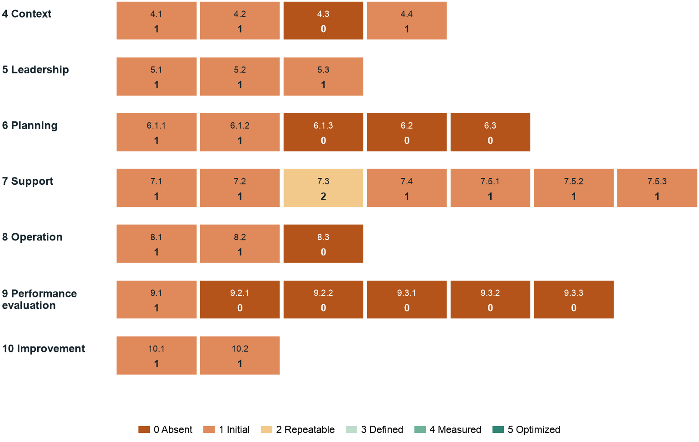
Figure 1: Maturity heat map for clauses 4 to 10. Each cell shows the requirement and its score.
The table summarizes clauses and Annex A themes together. Workbook formulas produce every figure.
Area | Items | Average | At target | P1 | P2 | P3
4 Context | 4 | 0.8 | 0 | 1 | 3 | 0
5 Leadership | 3 | 1.0 | 0 | 0 | 3 | 0
6 Planning | 5 | 0.4 | 0 | 3 | 2 | 0
7 Support | 7 | 1.1 | 0 | 0 | 7 | 0
8 Operation | 3 | 0.7 | 0 | 1 | 2 | 0
9 Performance evaluation | 6 | 0.2 | 0 | 3 | 3 | 0
10 Improvement | 2 | 1.0 | 0 | 0 | 2 | 0
Organizational | 37 | 1.1 | 2 | 15 | 12 | 8
People | 8 | 2.1 | 3 | 1 | 1 | 3
Physical | 14 | 2.3 | 7 | 1 | 1 | 5
Technological | 34 | 1.7 | 8 | 13 | 7 | 6

Climate change consideration
Amendment 1:2024 asks organizations to decide whether climate change is a relevant issue, and notes that interested parties may have related requirements. Orvanta has not yet considered this. We expect limited direct relevance, but the decision must be recorded. Points to weigh include regional disruption affecting cloud or office services and sustainability questions from enterprise merchants.

Maturity by Annex A theme
Physical and people controls score best, because offices are simple and HR practice is sound. Organizational controls score lowest because they depend on governance that does not exist yet.
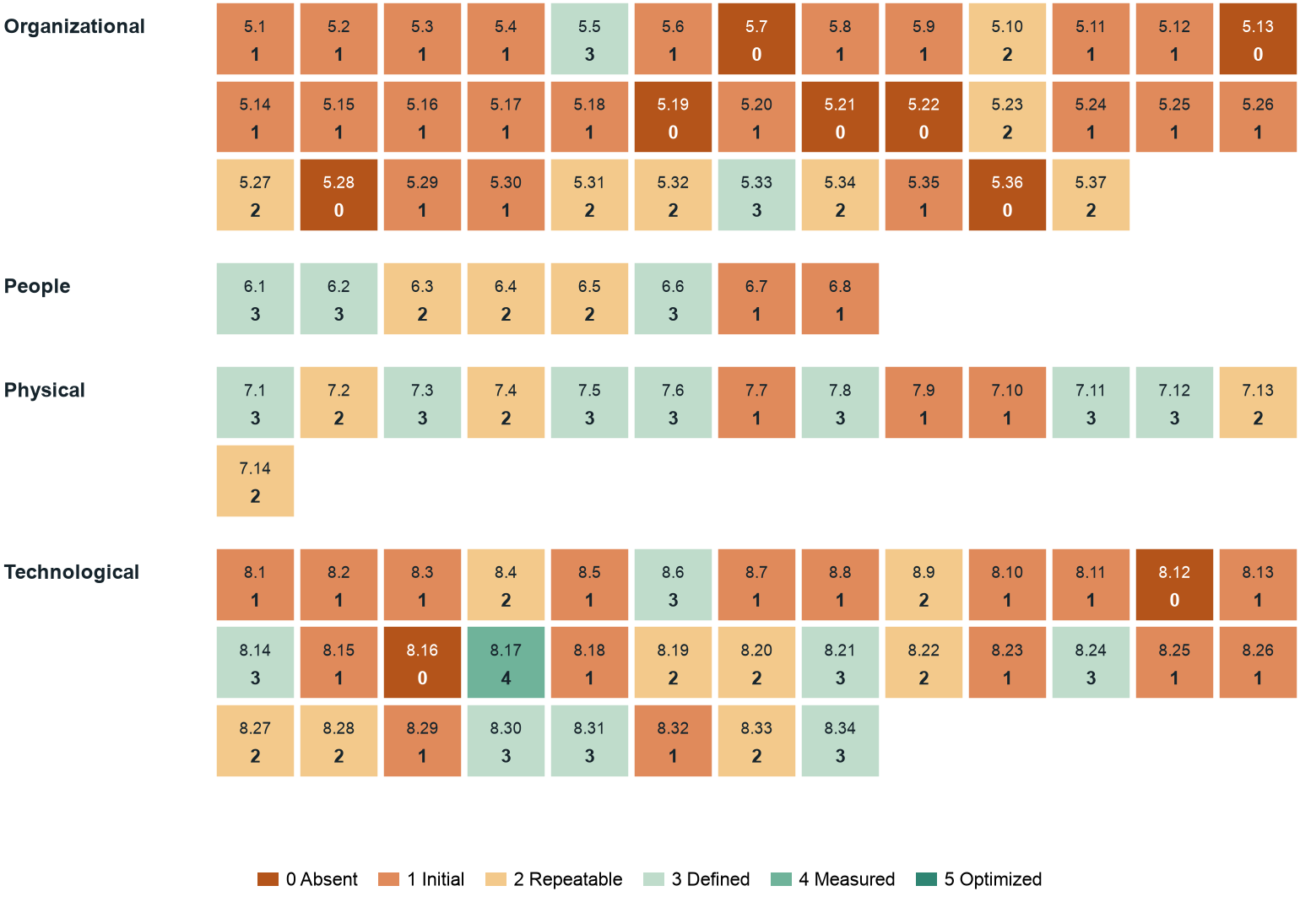
Figure 2: Maturity heat map for all 93 Annex A controls, by theme.

What already works
20 items already meet target. They matter for two reasons: the roadmap must not break them, and they show the engineering culture can run disciplined controls.
- Resilient, encrypted platform. Multi-AZ databases, KMS encryption at rest, TLS 1.2+ and synchronized clocks (A.8.14, A.8.24, A.8.17).
- Separated environments. Production, staging and development run in separate AWS accounts, defined in Terraform (A.8.31).
- Sound hiring basics. Screening, employment terms and NDAs are consistently applied (A.6.1, A.6.2, A.6.6).
- Regulatory discipline. Compliance keeps working contacts with the supervisor and retains ledger and AML records well (A.5.5, A.5.33).

How this compares with the intake view
The Company Fact Sheet recorded an indicative 1.6, based on 12 broad domains. This assessment finds 1.4. The lower score is expected: it adds the clause requirements, where almost nothing is formally in place, and it credits only what evidence supports.

How an attacker would use these gaps
A control gap matters most when it joins others into a path. The scenario below chains six gaps found in this assessment, from a phishing email to destroyed backups. Every step uses a weakness we observed, and none needs advanced skill.
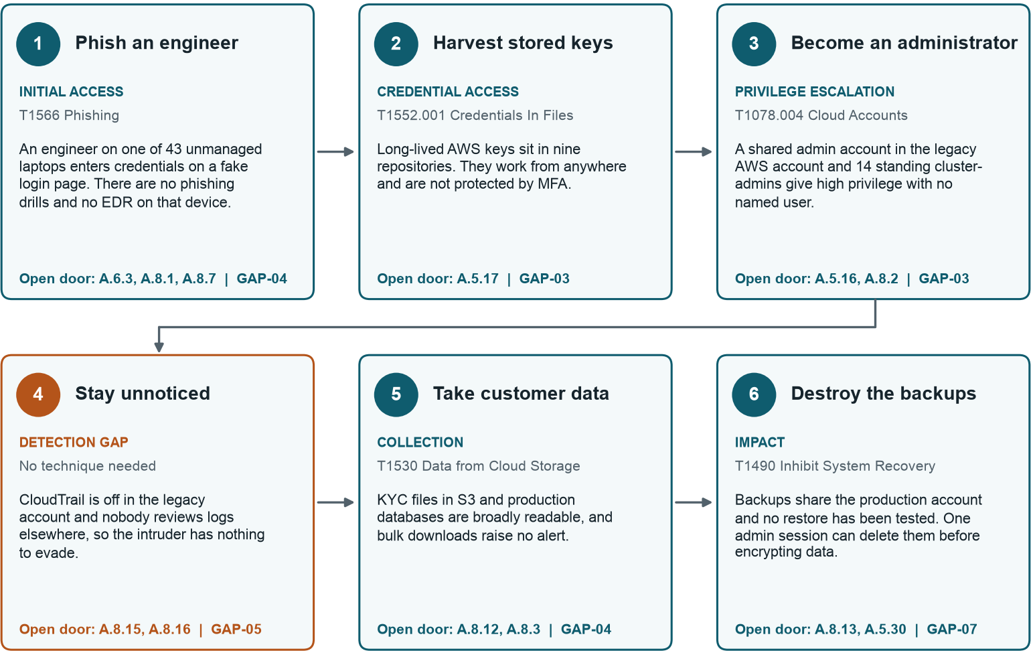
Figure 3: Illustrative attack path through current gaps. Technique IDs refer to MITRE ATT&CK.
Reading note. This is a scenario, not evidence that an attack has happened. Project 2 develops it into full attack-scenario analysis with likelihood and impact.

Breaking the path at any step stops it. The table shows which planned actions close each door. Steps 3, 4 and 6 each have a quick win that starts closing them within 30 days.
Step | Attacker's move | Controls leaving the door open | Priority gap | Closed by
1 | Phish an engineer | A.6.3, A.8.1, A.8.7 | GAP-04 | RM-08, RM-17
2 | Harvest stored keys | A.5.17 | GAP-03 | RM-07
3 | Become an administrator | A.5.16, A.8.2 | GAP-03 | QW-04, RM-07
4 | Stay unnoticed | A.8.15, A.8.16 | GAP-05 | QW-01, RM-14
5 | Take customer data | A.8.12, A.8.3 | GAP-04 | RM-12, RM-07
6 | Destroy the backups | A.8.13, A.5.30 | GAP-07 | QW-07, RM-10

This is why identity, logging and backup actions sit early in the roadmap even where their paperwork gap looks small: they sit on the shortest route to customer data and the ledger.

Top 10 priority gaps
Rows in the workbook group into ten gaps, ranked by average priority score. Each is written for leadership: what could happen, and what fixes it. The average favors tightly focused gaps, so read it with the P1 count: GAP-03 and GAP-04 have the most P1 items.

1. Attacks would go undetected (GAP-05)
An intruder could stay for weeks. Longer dwell time means bigger losses, and late discovery undermines regulatory reporting.
Fix: Turn on full logging, deploy a SIEM and start daily triage with ATT&CK-mapped detections.
Owner: Nino Beridze | Target: Jun 2027 | 3 linked items, 3 P1 | Average maturity 0.3

2. No working risk management (GAP-02)
Security money goes wherever the last customer question pointed. Orvanta cannot show the Bank of Lithuania or an auditor why it chose its controls.
Fix: Adopt a method and complete a threat-informed risk assessment and treatment plan.
Owner: Lukas Jankauskas | Target: Mar 2027 | 5 linked items, 3 P1 | Average maturity 0.6

3. Suppliers are unassessed (GAP-08)
Critical services run through vendors nobody has assessed. A supplier breach could stop payments and is Orvanta's responsibility to regulators.
Fix: Tier all 20 vendors, assess Tier 1 and complete the DORA register of information.
Owner: Eglė Norvilaitė | Target: Jun 2027 | 5 linked items, 3 P1 | Average maturity 0.6

4. No assurance cycle (GAP-10)
Certification needs evidence that the ISMS is checked and improved. With no audit, review or corrective action, Stage 2 cannot pass.
Fix: Set KPIs, audit in July 2027, hold management review in August 2027 and close actions.
Owner: Eglė Norvilaitė | Target: Aug 2027 | 10 linked items, 4 P1 | Average maturity 0.4

5. Recovery is unproven (GAP-07)
If backups fail or are deleted, Orvanta may be unable to restore ledgers, risking customer funds records and its license standing.
Fix: Isolate backups, test restores every quarter, and complete a BIA with recovery objectives.
Owner: Rashad Guliyev | Target: May 2027 | 3 linked items, 2 P1 | Average maturity 1.0

6. Identity and privileged access are too open (GAP-03)
One stolen password could give an attacker control of production, customer data and the payment flow, with shared accounts hiding who acted.
Fix: Remove shared accounts, close five MFA gaps, cut standing admin rights and deprovision within 24 hours.
Owner: Rashad Guliyev | Target: Apr 2027 | 12 linked items, 7 P1 | Average maturity 1.2

7. Incident response is untested (GAP-06)
In a real attack, confused decisions could prolong outages and put regulatory notification duties at risk.
Fix: Approve a plan and two playbooks, then run a tabletop exercise.
Owner: Nino Beridze | Target: May 2027 | 6 linked items, 3 P1 | Average maturity 1.0

8. Sensitive data and endpoints are exposed (GAP-04)
Card numbers in tickets, 43 unmanaged laptops and undocumented Baku data access create breach, PCI DSS and GDPR exposure.
Fix: Purge card data, enroll all laptops, mask data and complete the transfer assessment.
Owner: Farid Ismayilov | Target: May 2027 | 16 linked items, 7 P1 | Average maturity 1.2

9. No ISMS foundation (GAP-01)
Without an approved scope, policy and objectives, no auditor can begin certification, so EUR 2.4M of enterprise revenue stays out of reach.
Fix: Approve scope, policy, roles and objectives in the first 90 days.
Owner: Nino Beridze | Target: Feb 2027 | 22 linked items, 2 P1 | Average maturity 1.0

10. Change control can be bypassed (GAP-09)
A compromised or rushed change can reach the payment platform unreviewed, causing outages or fraud. 14% of Q3 2026 deployments bypassed review.
Fix: Protect all production repositories, enforce the CI path and add security gates.
Owner: Tural Mammadli | Target: Apr 2027 | 12 linked items, 4 P1 | Average maturity 1.4

Quick wins
These eight actions need little budget and cut real risk within 30 days. They also build momentum and give the auditor early evidence.
ID | Action | Why it pays off | Owner | Days
QW-01 | Enable CloudTrail in the legacy AWS account | Removes a blind spot in one configuration change | Rashad Guliyev | 3
QW-02 | Purge the 11 Zendesk tickets holding card numbers and turn on redaction | Reduces PCI DSS exposure and a searchable target | Mantas Žukas | 7
QW-03 | Enforce MFA on Kyrovia and on Helvora agent Zendesk logins | Closes two of five MFA gaps using existing features | Farid Ismayilov | 14
QW-04 | Cut Okta super admins from six to two, plus one break-glass account | Shrinks the highest-impact target quickly | Farid Ismayilov | 7
QW-05 | Turn on branch protection for all production repositories | Blocks the easiest route for unreviewed code | Tural Mammadli | 14
QW-06 | Set a 24-hour leaver rule, with Head of People notifying IT the same day | Cuts the nine-day median exposure right away | Justina Mockutė | 14
QW-07 | Run one full RDS restore into a clean account and record the result | Replaces assumption with evidence | Rashad Guliyev | 21
QW-08 | Create a one-page incident call list with a security report channel | Gives staff a way to raise the alarm today | Nino Beridze | 7

12-month roadmap
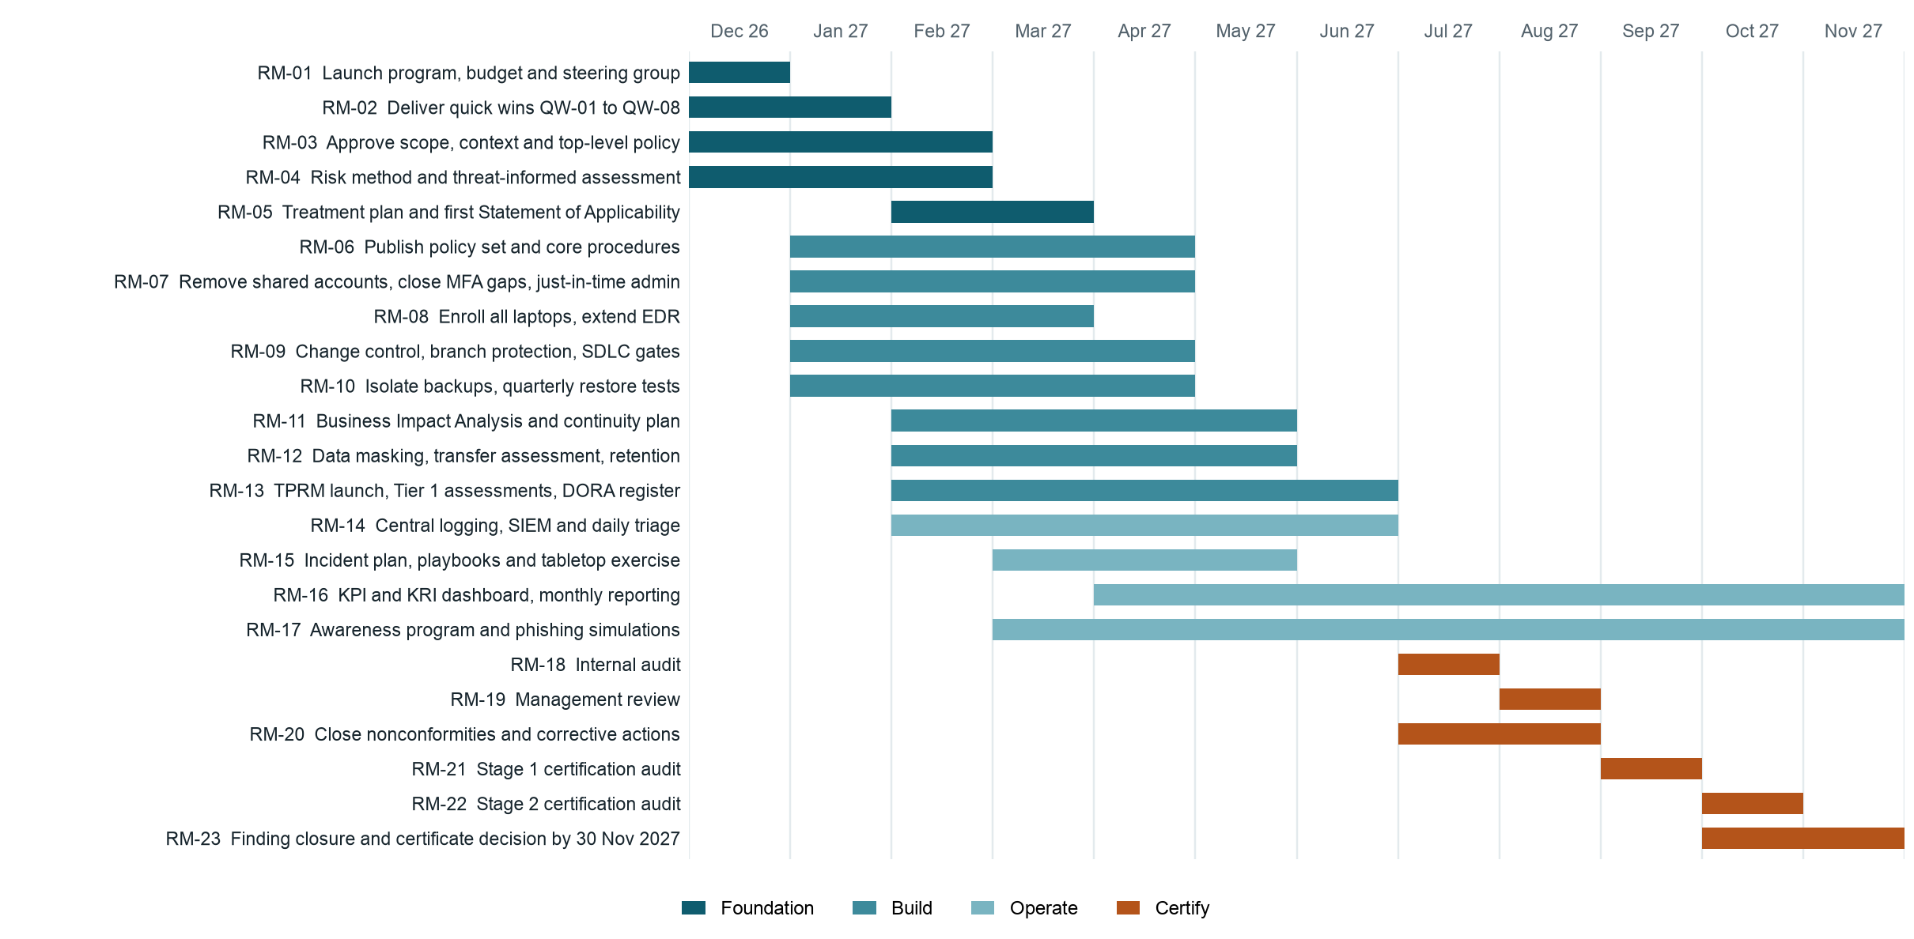
Figure 4: Roadmap from December 2026 to the certificate decision by 30 November 2027.

Why the sequence works
- Foundation first. Scope and risk results decide which controls apply, so they cannot wait.
- Attack paths next. Identity, endpoints, change control and backups are fixed early because they reduce real exposure now.
- Records need time. Controls must operate before auditors can sample them, so monitoring runs from April 2027.
- Buffer before the deadline. Stage 2 in October leaves time to close findings before 30 November 2027.

Main risks to the plan
Risk | Effect | Response
Security team stays at two people | SIEM and evidence work slip | Decide on the third hire by 15 December 2026
Feature pressure beats remediation | Roadmap items lose engineering time | Reserve capacity in each CTO team's plan
Certification body availability | Stage audit dates move | Book the auditor by March 2027
Vendors respond slowly | Tier 1 assessments run late | Start early and use existing assurance reports

Limits of this assessment
This is a point-in-time view based on interviews and sampled evidence, not a certification audit, and it does not guarantee a certification result. Applicability is settled in the Statement of Applicability, so some scored controls may change. Costs are outside its scope. Regulatory matters are not legal advice.

Appendix: all P1 items
The 38 requirements and controls rated P1, highest priority score first. The workbook holds evidence and recommendations for each.
ID | Requirement or control | Score | Priority | Effort | Owner | Gap
A.5.19 | Information security in supplier relationships | 0 | 11 | M | Eglė Norvilaitė | GAP-08
A.8.16 | Monitoring activities | 0 | 11 | L | Nino Beridze | GAP-05
4.3 | ISMS scope | 0 | 10 | S | Ugnė Baltrūnaitė | GAP-01
6.1.3 | Risk treatment and SoA | 0 | 10 | M | Lukas Jankauskas | GAP-02
8.3 | Performing risk treatment | 0 | 10 | S | Lukas Jankauskas | GAP-02
A.5.22 | Monitoring, review and change management of supplier services | 0 | 10 | M | Eglė Norvilaitė | GAP-08
6.1.2 | Risk assessment process | 1 | 9 | M | Lukas Jankauskas | GAP-02
6.2 | Objectives and planning | 0 | 9 | S | Nino Beridze | GAP-01
9.2.1 | Internal audit: general | 0 | 9 | M | Eglė Norvilaitė | GAP-10
9.2.2 | Internal audit programme | 0 | 9 | S | Eglė Norvilaitė | GAP-10
9.3.1 | Management review: general | 0 | 9 | S | Ugnė Baltrūnaitė | GAP-10
A.5.3 | Segregation of duties | 1 | 9 | M | Tural Mammadli | GAP-09
A.5.7 | Threat intelligence | 0 | 9 | M | Nino Beridze | GAP-05
A.5.9 | Inventory of information and other associated assets | 1 | 9 | M | Farid Ismayilov | GAP-04
A.5.15 | Access control | 1 | 9 | M | Nino Beridze | GAP-03
A.5.16 | Identity management | 1 | 9 | M | Farid Ismayilov | GAP-03
A.5.17 | Authentication information | 1 | 9 | M | Rashad Guliyev | GAP-03
A.5.18 | Access rights | 1 | 9 | M | Farid Ismayilov | GAP-03
A.5.21 | Managing information security in the ICT supply chain | 0 | 9 | M | Nino Beridze | GAP-08
A.5.24 | Information security incident management planning and preparation | 1 | 9 | M | Nino Beridze | GAP-06
A.5.25 | Assessment and decision on information security events | 1 | 9 | S | Nino Beridze | GAP-06
A.5.26 | Response to information security incidents | 1 | 9 | M | Nino Beridze | GAP-06
A.5.30 | ICT readiness for business continuity | 1 | 9 | M | Rashad Guliyev | GAP-07
A.5.36 | Compliance with policies, rules and standards for information security | 0 | 9 | M | Nino Beridze | GAP-10
A.6.7 | Remote working | 1 | 9 | M | Nino Beridze | GAP-04
A.7.9 | Security of assets off-premises | 1 | 9 | M | Farid Ismayilov | GAP-04
A.8.1 | User endpoint devices | 1 | 9 | M | Farid Ismayilov | GAP-04
A.8.2 | Privileged access rights | 1 | 9 | M | Rashad Guliyev | GAP-03
A.8.3 | Information access restriction | 1 | 9 | M | Rashad Guliyev | GAP-03
A.8.5 | Secure authentication | 1 | 9 | M | Farid Ismayilov | GAP-03
A.8.7 | Protection against malware | 1 | 9 | M | Farid Ismayilov | GAP-04
A.8.8 | Management of technical vulnerabilities | 1 | 9 | M | Rashad Guliyev | GAP-09
A.8.10 | Information deletion | 1 | 9 | M | Karolis Vaitkus | GAP-04
A.8.12 | Data leakage prevention | 0 | 9 | M | Nino Beridze | GAP-04
A.8.13 | Information backup | 1 | 9 | M | Rashad Guliyev | GAP-07
A.8.15 | Logging | 1 | 9 | S | Rashad Guliyev | GAP-05
A.8.25 | Secure development life cycle | 1 | 9 | M | Tural Mammadli | GAP-09
A.8.32 | Change management | 1 | 9 | M | Tural Mammadli | GAP-09

