 Jahangir Shukurov | GRC Portfolio
PROJECT 2 | ASSESSMENT REPORT
Threat-Informed Risk Assessment
Risk profile, attack scenarios and treatment plan

Client Orvanta Payments UAB
Document ID ORV-RISK-003
Version 1.0
Date 12 February 2027
Classification Confidential (sample)

Sample engagement — fictional company, prepared for portfolio purposes.

Document control
Field | Value
Document ID | ORV-RISK-003
Title | Threat-Informed Risk Assessment
Version | 1.0
Date | 12 February 2027
Author | Jahangir Shukurov
Reviewer | Lukas Jankauskas, Risk Manager
Approver | Ugnė Baltrūnaitė, CEO
Classification | Confidential (sample)

Version history
Version | Date | Author | Change
0.1 | 5 February 2027 | Jahangir Shukurov | Draft for risk owner review
1.0 | 12 February 2027 | Jahangir Shukurov | Issued to the CEO and Management Board

Contents
1 Executive summary 3
2 Scope and method 4
3 Risk profile 4
3.1 From inherent to target 4
3.2 Heat maps 5
3.3 Top 10 risks today 5
4 Attack scenarios 6
4.1 Cloud credential compromise (SCN-A) 6
4.2 Ransomware through phishing (SCN-B) 7
4.3 Insider data exfiltration (SCN-C) 8
5 Risk treatment plan 9
5.1 Accepted risk 10
5.2 What treatment does not fix 10
5.3 Next steps 10
6 Appendix: risk register summary 11

Executive summary
Situation. The gap assessment showed where Orvanta falls short of ISO/IEC 27001:2022. This assessment asks what could actually go wrong, how badly and how soon. We assessed 30 risks across 40 assets and 21 threats, using the method approved on 18 December 2026. The position is as of 29 January 2027, after the eight quick wins.
30  Risks assessed | 26  High or Critical today | 1  High after treatment | 26  Treatment actions

Key findings.
- Most risk is still above appetite. 26 of 30 risks are High or Critical today. Existing controls and the quick wins keep 12 risks out of Critical, but not within appetite.
- Two risks are Critical. Cloud administrator takeover (RSK-01) and intrusion goes undetected (RSK-05). Together they mean an attacker could take over production and not be noticed.
- Identity is the common thread. 5 risks trace back to open identity and privileged access gaps, and all three attack scenarios pass through them.
- Suppliers carry unmeasured risk. 4 risks depend on vendors nobody has assessed, including the KYC provider and the card processor.
- The plan works on paper. 26 actions bring 29 risks within appetite by August 2027. One risk needs formal acceptance.
Risk in business terms. The two Critical risks combine into one outcome: production taken over with nobody noticing. That could cost more than EUR 2M and put the licence at risk. Until treatment lands, a single stolen credential is the most likely way there.
Decisions needed.
# | Decision | Owner | By
1 | Approve the risk treatment plan of 26 actions | Ugnė Baltrūnaitė | 26 Feb 2027
2 | Accept the single-region risk (RSK-16) until 31 December 2027, with conditions | Ugnė Baltrūnaitė | 12 Feb 2027
3 | Confirm the risk appetite: scores up to 9 without formal acceptance | Management Board | 26 Feb 2027
4 | Receive a risk report each quarter, starting April 2027 | Management Board | 26 Feb 2027

Scope and method
The assessment covers the full ISMS scope: all products, AWS production, both offices, remote work and suppliers handling Orvanta data. It follows the Risk Management Methodology (ORV-RISK-001), aligned with ISO/IEC 27005:2022 and ISO/IEC 27001:2022 clause 6.1.2.
Evidence basis. Workshops and evidence are simulated for this portfolio sample. Risk owners named here are fictional role-holders from the Company Fact Sheet.

- Workshops. Nine sessions with risk owners between 11 and 29 January 2027, using the gap assessment results as the starting point.
- Two ways in. Risks were identified from the asset register and from attack scenarios, then merged into one register.
- Three scores. Inherent, current with existing controls, and target after treatment. Score is likelihood multiplied by impact, each from 1 to 5.
- Threat mapping. Adversarial threats are mapped to MITRE ATT&CK techniques, checked against the public knowledge base.
Level | Score | Required response | Who may accept
Critical | 17 to 25 | Treat immediately. Acceptance only as a time-limited exception. | Management Board
High | 10 to 16 | Treatment plan required. Acceptance needs a written record. | CEO
Medium | 5 to 9 | Within appetite. Monitor and treat where cost is reasonable. | Risk owner
Low | 1 to 4 | Within appetite. Record and review yearly. | Risk owner

Risk profile

From inherent to target
Without any controls, every risk would be High or Critical. Existing controls and the quick wins bring the average score from 17.4 to 13.6. The treatment plan is designed to reach 5.9.
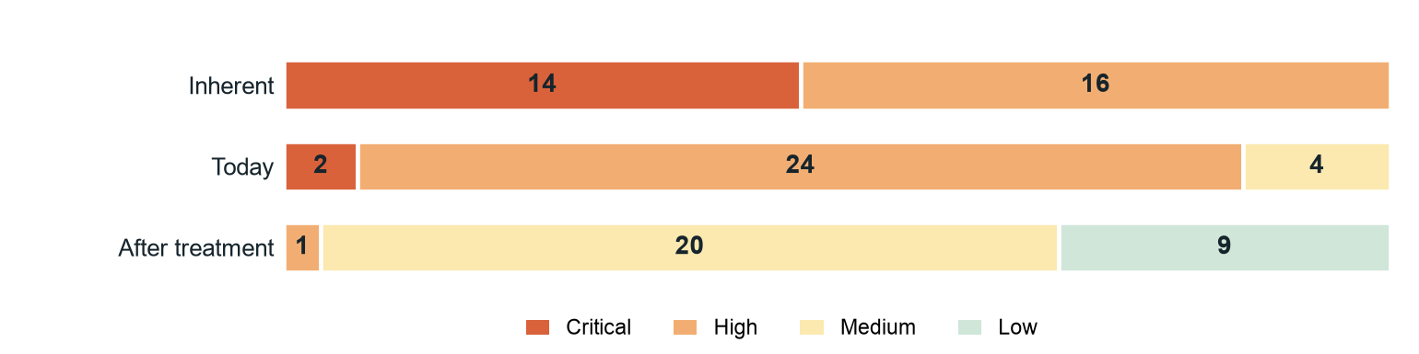
Figure 1: Number of risks at each level: inherent, today and after treatment.

Heat maps
Each number is a risk ID. Today the risks cluster at high impact with likelihood 3 or 4. Treatment mostly reduces likelihood, because it closes attack paths, and reduces impact where data is masked or backups are isolated.
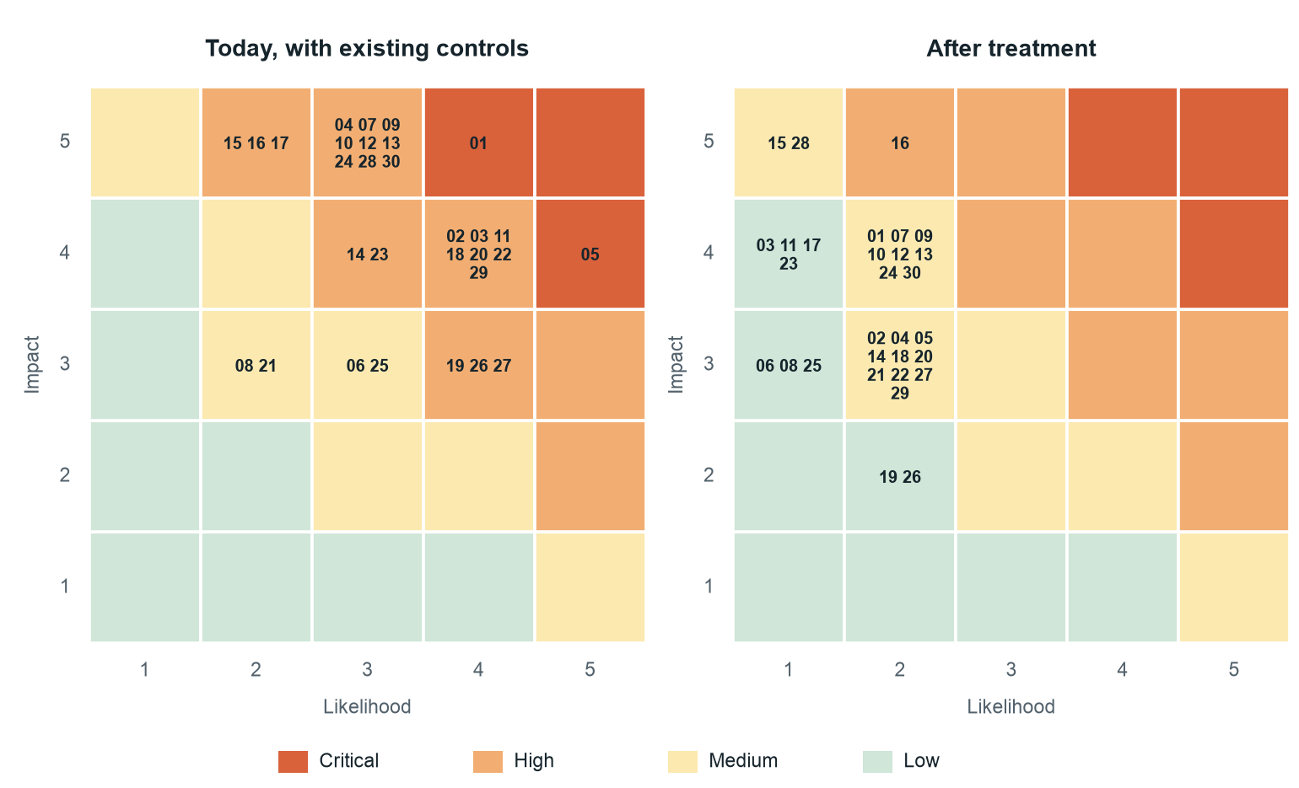
Figure 2: Risk positions today and after treatment. Numbers are risk IDs (01 is RSK-01).

Top 10 risks today
ID | Risk | Owner | Today | Level | Target
RSK-01 | Cloud administrator takeover | Rashad Guliyev | 20 | Critical | 8
RSK-05 | Intrusion goes undetected | Nino Beridze | 20 | Critical | 6
RSK-02 | Credential phishing of engineers | Nino Beridze | 16 | High | 6
RSK-03 | Password attacks on tools outside Okta | Farid Ismayilov | 16 | High | 4
RSK-11 | Exploitation of legacy internet-facing services | Rashad Guliyev | 16 | High | 4
RSK-18 | Incident mishandled and reporting duties missed | Nino Beridze | 16 | High | 6
RSK-20 | Personal data accessed from Baku without transfer safeguards | Karolis Vaitkus | 16 | High | 6
RSK-22 | Session theft from an unmanaged device | Farid Ismayilov | 16 | High | 6
RSK-29 | DORA ICT risk duties not met | Eglė Norvilaitė | 16 | High | 6
RSK-09 | Unreviewed or malicious change reaches production | Tural Mammadli | 15 | High | 8

Attack scenarios
Three scenarios test whether controls would hold against a real attack. Each follows the attacker step by step and rates the controls that should prevent, detect or respond. Ratings after treatment are by design, and Project 5 tests them through audit.

Cloud credential compromise (SCN-A)
An engineer is phished, a live session is stolen from an unmanaged laptop, and stored keys lead to cloud admin rights and customer data.
Threat actor: Financially motivated external attacker | Linked risks: RSK-01, RSK-02, RSK-05, RSK-22, RSK-30
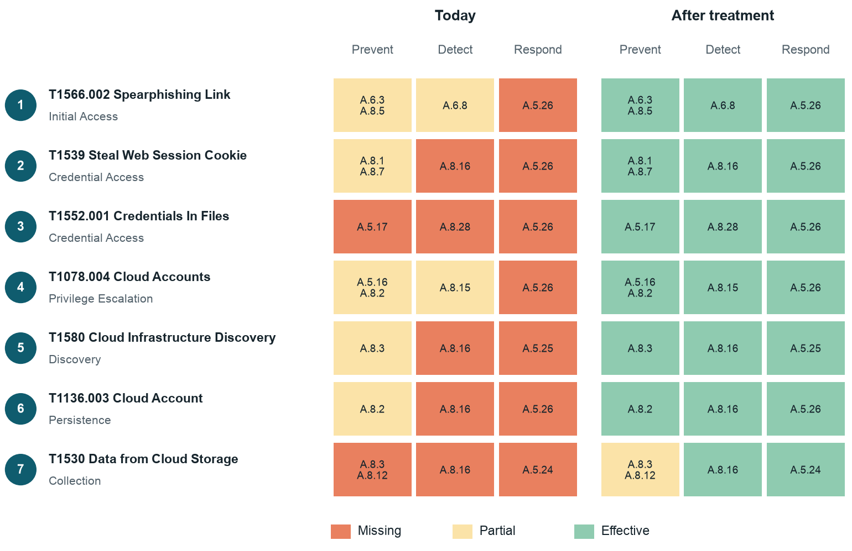
Figure 3: Cloud credential compromise: control coverage at each step, today and after treatment. Cells show Annex A control IDs.
Step | ATT&CK technique | What happens at Orvanta
1 | T1566.002 Spearphishing Link | Engineer follows a link to a fake Okta login page
2 | T1539 Steal Web Session Cookie | Session token is lifted from an unmanaged laptop, bypassing MFA
3 | T1552.001 Credentials In Files | Long-lived AWS keys are found in repositories
4 | T1078.004 Cloud Accounts | Shared admin account in the legacy AWS account is used
5 | T1580 Cloud Infrastructure Discovery | Accounts, buckets and databases are listed
6 | T1136.003 Cloud Account | A new IAM user is created to keep access
7 | T1530 Data from Cloud Storage | KYC files are copied from S3

What this shows. Today the path is open at every step, and nothing would raise an alarm before data leaves. After treatment, three independent barriers stand in the way: device trust, short-lived credentials and just-in-time admin rights.

Ransomware through phishing (SCN-B)
A malicious attachment runs on an unprotected laptop, the attacker enters AWS over the legacy VPN, deletes backups and encrypts production data.
Threat actor: Ransomware affiliate | Linked risks: RSK-02, RSK-03, RSK-04, RSK-11, RSK-17
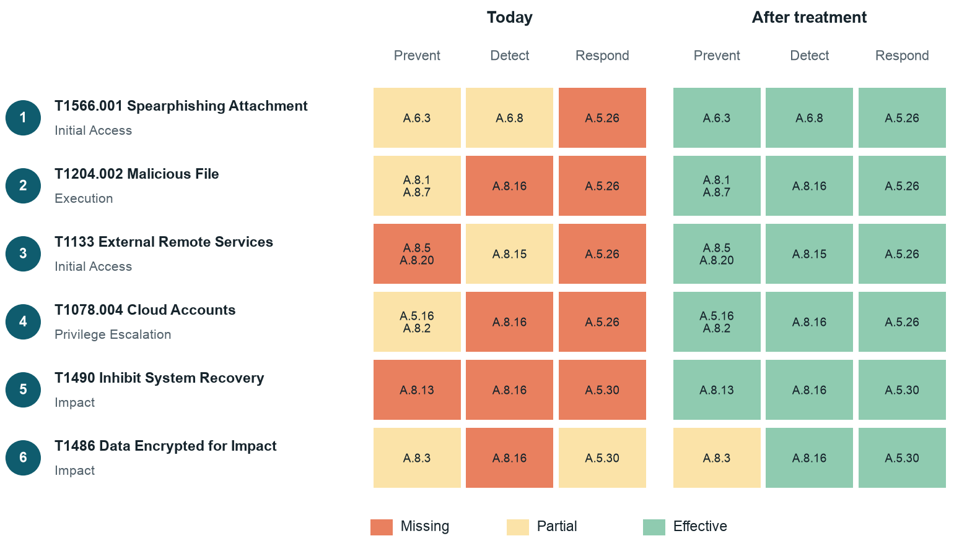
Figure 4: Ransomware through phishing: control coverage at each step, today and after treatment. Cells show Annex A control IDs.
Step | ATT&CK technique | What happens at Orvanta
1 | T1566.001 Spearphishing Attachment | Staff member receives a fake invoice attachment
2 | T1204.002 Malicious File | Attachment runs on a laptop without EDR
3 | T1133 External Remote Services | Stolen VPN profile opens the legacy path to database subnets
4 | T1078.004 Cloud Accounts | Shared database and admin credentials give full rights
5 | T1490 Inhibit System Recovery | Backups and snapshots in the same account are deleted
6 | T1486 Data Encrypted for Impact | Databases and storage are encrypted

What this shows. The decisive control is backup isolation. Even if every earlier step succeeds, immutable backups in a separate account turn a business-ending event into a recoverable outage.

Insider data exfiltration (SCN-C)
An analyst who is about to leave uses normal access to collect customer data and takes it out through a personal cloud drive and a USB stick.
Threat actor: Departing employee with legitimate access | Linked risks: RSK-06, RSK-07, RSK-25, RSK-30
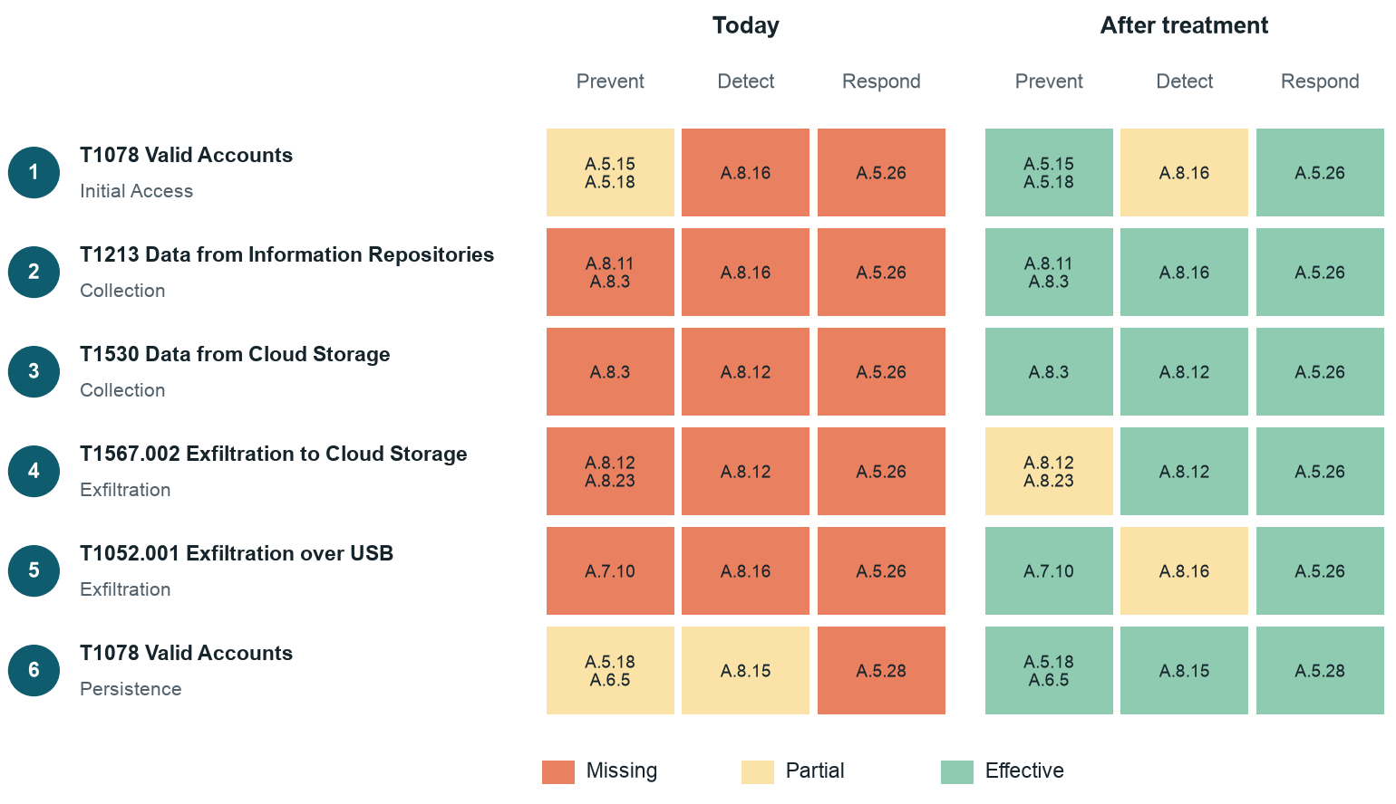
Figure 5: Insider data exfiltration: control coverage at each step, today and after treatment. Cells show Annex A control IDs.
Step | ATT&CK technique | What happens at Orvanta
1 | T1078 Valid Accounts | Analyst uses their own valid account, with more access than the role needs
2 | T1213 Data from Information Repositories | Unmasked customer data is queried in Metabase
3 | T1530 Data from Cloud Storage | KYC files are downloaded from S3
4 | T1567.002 Exfiltration to Cloud Storage | Files are uploaded to a personal cloud drive
5 | T1052.001 Exfiltration over USB | Remaining files are copied to a USB stick
6 | T1078 Valid Accounts | Access is still valid after the last working day

What this shows. Prevention can only go so far against a person with legitimate access, so this scenario depends on masking to limit what can be taken and on detection to notice it. It keeps the highest residual risk of the three.

Risk treatment plan
27 risks are mitigated, 1 is avoided by retiring legacy services, and 2 are accepted: one within appetite and one by formal record. Every action links to the certification roadmap, so there is one plan, not two.
ID | Action | Owner | Due | Status | Risks
TRT-01 | Remove shared admin accounts and move to just-in-time privileged access with monthly review | Rashad Guliyev | 30 Apr 2027 | In progress | 2
TRT-02 | Replace long-lived AWS keys in repositories with short-lived OIDC roles | Rashad Guliyev | 30 Apr 2027 | In progress | 1
TRT-03 | Issue phishing-resistant security keys to admins and block unmanaged devices in Okta | Farid Ismayilov | 31 Mar 2027 | In progress | 3
TRT-04 | Enroll all 131 laptops in Jamf with disk encryption, EDR and remote wipe | Farid Ismayilov | 31 Mar 2027 | In progress | 4
TRT-05 | Run role-based awareness training and quarterly phishing simulations | Nino Beridze | 31 May 2027 | Planned | 2
TRT-06 | Enforce MFA on Metabase and Jenkins, and replace OpenVPN with identity-aware access | Farid Ismayilov | 31 Mar 2027 | In progress | 2
TRT-07 | Move backups to an isolated, immutable account and test restores every quarter | Rashad Guliyev | 30 Apr 2027 | In progress | 2
TRT-08 | Centralize logs, deploy a SIEM with ATT&CK-mapped detections and start daily triage | Nino Beridze | 30 Jun 2027 | Planned | 1
TRT-09 | Automate deprovisioning within 24 hours and run quarterly access reviews | Farid Ismayilov | 31 Mar 2027 | In progress | 1
TRT-10 | Mask personal data by default in Metabase, Orbit and non-production, and restrict production data access by role | Tomas Butkus | 31 May 2027 | Planned | 4
TRT-11 | Add Workspace DLP rules and alerts on bulk exports and downloads | Nino Beridze | 31 May 2027 | Planned | 2
TRT-12 | Keep ticket redaction on, give agents card-handling guidance and search tickets monthly | Mantas Žukas | 31 Mar 2027 | In progress | 2
TRT-13 | Enforce the CI deployment path with a second approver and a logged emergency route | Tural Mammadli | 30 Apr 2027 | In progress | 1
TRT-14 | Generate SBOMs, add SAST and secret scanning to every pipeline and retire Jenkins | Tural Mammadli | 30 Apr 2027 | In progress | 2
TRT-15 | Adopt vulnerability SLAs and retire the legacy AWS account | Rashad Guliyev | 30 Apr 2027 | In progress | 1
TRT-16 | Launch third-party risk management: tier 20 vendors, assess Tier 1 and update contract clauses | Eglė Norvilaitė | 30 Jun 2027 | Planned | 4
TRT-17 | Complete the BIA and continuity plan, including regional failure and supplier exit options | Ieva Petrauskaitė | 31 May 2027 | Planned | 3
TRT-18 | Require dual approval for payout files, rotate the SFTP key and verify file integrity | Indrė Sabaliauskaitė | 30 Apr 2027 | Planned | 1
TRT-19 | Approve the incident plan, two playbooks and a notification matrix, then run a tabletop exercise | Nino Beridze | 31 May 2027 | Planned | 2
TRT-20 | Complete the transfer impact assessment for Baku and apply its safeguards | Karolis Vaitkus | 31 May 2027 | Planned | 1
TRT-21 | Add SDLC security gates, threat modeling for payment changes and DAST in staging | Tural Mammadli | 30 Apr 2027 | In progress | 1
TRT-22 | Create a single asset register with owners and classification | Farid Ismayilov | 31 Mar 2027 | In progress | 1
TRT-23 | Hire a third security specialist, publish the RACI and move the CISO line to the CEO | Ugnė Baltrūnaitė | 31 Mar 2027 | In progress | 2
TRT-24 | Run the ISMS program to plan: KPIs, internal audit, management review and corrective actions | Nino Beridze | 31 Aug 2027 | In progress | 1
TRT-25 | Extend the obligations list into a legal register and map DORA duties to owners | Eglė Norvilaitė | 30 Jun 2027 | Planned | 1
TRT-26 | Review cyber insurance cover for ransomware and business interruption | Marius Stankus | 31 Mar 2027 | Planned | 1

Accepted risk
RSK-16 (AWS region outage stops payments) stays at score 10 (High) after treatment. The CEO accepted it on 12 February 2027 until 31 December 2027, under record RA-01. A second live region would mean re-engineering the ledger, payment core and bank connection. At Orvanta's current scale that work would displace roadmap actions that reduce far more likely risks. Multi-AZ already protects against single data-center failure, which is the common case.

What treatment does not fix
- Insider misuse. A person with legitimate access can still take data. Masking limits the amount and detection shortens the time, but the risk stays Medium.
- Supplier breaches. Assessment and contracts improve assurance, but Orvanta cannot control a vendor's environment.
- Design ratings. Target scores assume controls work as designed. They stay provisional until the internal audit in July 2027 tests them.

Next steps
The selected controls feed the Statement of Applicability (Project 4) and the policy set (Project 3). Supplier risks drive the third-party program (Project 6), and scenarios SCN-A and SCN-B become incident playbooks (Project 7). This report is a point-in-time view, and it is not legal advice.

Appendix: risk register summary
Scores are likelihood x impact. The workbook holds full statements, assets, existing controls and Annex A controls for each risk.
ID | Risk | Owner | Threat and ATT&CK technique | Inherent | Today | Target | Option | Actions
RSK-01 | Cloud administrator takeover | Rashad Guliyev | THR-03: T1552.001 Credentials In Files; T1078.004 Cloud Accounts | 25 | 20 | 8 | Mitigate | TRT-01, TRT-02
RSK-02 | Credential phishing of engineers | Nino Beridze | THR-01: T1566 Phishing | 20 | 16 | 6 | Mitigate | TRT-03, TRT-04, TRT-05
RSK-03 | Password attacks on tools outside Okta | Farid Ismayilov | THR-02: T1110.004 Credential Stuffing | 20 | 16 | 4 | Mitigate | TRT-06
RSK-04 | Ransomware destroys production data and backups | Rashad Guliyev | THR-05: T1486 Data Encrypted for Impact; T1490 Inhibit System Recovery | 20 | 15 | 6 | Mitigate | TRT-07, TRT-04, TRT-26
RSK-05 | Intrusion goes undetected | Nino Beridze | THR-11: No technique needed | 25 | 20 | 6 | Mitigate | TRT-08
RSK-06 | Former staff retain access | Farid Ismayilov | THR-15: T1078 Valid Accounts | 16 | 9 | 3 | Mitigate | TRT-09
RSK-07 | Insider exfiltrates customer data | Karolis Vaitkus | THR-06: T1213 Data from Information Repositories; T1567.002 Exfiltration to Cloud Storage; T1052.001 Exfiltration over USB | 20 | 15 | 8 | Mitigate | TRT-10, TRT-11
RSK-08 | Card data exposed in support tickets | Mantas Žukas | THR-02: T1110.004 Credential Stuffing | 16 | 6 | 3 | Mitigate | TRT-12
RSK-09 | Unreviewed or malicious change reaches production | Tural Mammadli | THR-09: T1565.001 Stored Data Manipulation; T1657 Financial Theft | 25 | 15 | 8 | Mitigate | TRT-13
RSK-10 | Compromised dependency or build pipeline | Tural Mammadli | THR-07: T1195.001 Compromise Software Dependencies and Development Tools | 20 | 15 | 8 | Mitigate | TRT-14
RSK-11 | Exploitation of legacy internet-facing services | Rashad Guliyev | THR-04: T1190 Exploit Public-Facing Application; T1133 External Remote Services | 20 | 16 | 4 | Avoid | TRT-06, TRT-14, TRT-15
RSK-12 | Breach at the KYC provider exposes identity documents | Eglė Norvilaitė | THR-08: T1199 Trusted Relationship | 15 | 15 | 8 | Mitigate | TRT-16
RSK-13 | Card processor outage or failure | Emin Hasanov | THR-18: Not applicable | 15 | 15 | 8 | Mitigate | TRT-16, TRT-17
RSK-14 | Support provider misuse or compromise | Mantas Žukas | THR-08: T1199 Trusted Relationship | 16 | 12 | 6 | Mitigate | TRT-16, TRT-12
RSK-15 | Payment file tampering on the bank connection | Indrė Sabaliauskaitė | THR-09: T1565.001 Stored Data Manipulation; T1657 Financial Theft | 15 | 10 | 5 | Mitigate | TRT-18
RSK-16 | AWS region outage stops payments | Rashad Guliyev | THR-16: Not applicable | 10 | 10 | 10 | Accept | TRT-17
RSK-17 | Restore fails after data loss | Rashad Guliyev | THR-17: Not applicable | 20 | 10 | 4 | Mitigate | TRT-07, TRT-17
RSK-18 | Incident mishandled and reporting duties missed | Nino Beridze | THR-17: Not applicable | 20 | 16 | 6 | Mitigate | TRT-19
RSK-19 | Unmanaged laptop lost or stolen | Farid Ismayilov | THR-19: Not applicable | 12 | 12 | 4 | Mitigate | TRT-04
RSK-20 | Personal data accessed from Baku without transfer safeguards | Karolis Vaitkus | THR-20: Not applicable | 16 | 16 | 6 | Mitigate | TRT-20, TRT-10
RSK-21 | DDoS against the Merchant Payment API | Leyla Karimova | THR-12: T1498 Network Denial of Service | 16 | 6 | 6 | Accept | -
RSK-22 | Session theft from an unmanaged device | Farid Ismayilov | THR-13: T1539 Steal Web Session Cookie | 16 | 16 | 6 | Mitigate | TRT-03, TRT-04
RSK-23 | MFA fatigue attack on staff | Farid Ismayilov | THR-14: T1621 Multi-Factor Authentication Request Generation | 12 | 12 | 4 | Mitigate | TRT-03, TRT-05
RSK-24 | API logic flaw enables payment fraud | Leyla Karimova | THR-04: T1190 Exploit Public-Facing Application; T1133 External Remote Services | 20 | 15 | 8 | Mitigate | TRT-21
RSK-25 | Live personal data in test environments | Tomas Butkus | THR-17: Not applicable | 12 | 9 | 3 | Mitigate | TRT-10
RSK-26 | Unowned assets left unprotected | Farid Ismayilov | THR-17: Not applicable | 12 | 12 | 4 | Mitigate | TRT-22
RSK-27 | Key-person dependency in the security team | Ugnė Baltrūnaitė | THR-21: Not applicable | 12 | 12 | 6 | Mitigate | TRT-23
RSK-28 | Certification missed and enterprise revenue lost | Ugnė Baltrūnaitė | THR-20: Not applicable | 20 | 15 | 5 | Mitigate | TRT-24, TRT-23
RSK-29 | DORA ICT risk duties not met | Eglė Norvilaitė | THR-20: Not applicable | 16 | 16 | 6 | Mitigate | TRT-16, TRT-19, TRT-25
RSK-30 | Bulk data theft from cloud storage | Rashad Guliyev | THR-10: T1530 Data from Cloud Storage | 20 | 15 | 8 | Mitigate | TRT-01, TRT-10, TRT-11

