 Jahangir Shukurov | GRC Portfolio
PROJECT 2 | METHODOLOGY
Risk Management Methodology
How Orvanta identifies, scores, treats and accepts information security risk

Client Orvanta Payments UAB
Document ID ORV-RISK-001
Version 1.0
Date 18 December 2026
Classification Confidential (sample)

Sample engagement — fictional company, prepared for portfolio purposes.

Document control
Field | Value
Document ID | ORV-RISK-001
Title | Risk Management Methodology
Version | 1.0
Date | 18 December 2026
Author | Jahangir Shukurov
Reviewer | Lukas Jankauskas, Risk Manager
Approver | Ugnė Baltrūnaitė, CEO
Classification | Confidential (sample)

Version history
Version | Date | Author | Change
0.1 | 9 December 2026 | Jahangir Shukurov | Draft for Risk Manager and CISO-designate review
1.0 | 18 December 2026 | Jahangir Shukurov | Approved by the CEO for use

Contents
1 Summary 3
2 Purpose and scope 3
3 Roles 3
4 Process 4
5 Risk criteria 5
5.1 Likelihood 5
5.2 Impact 5
5.3 Risk levels and appetite 6
6 Threat-informed analysis 6
7 Treatment and acceptance 7
8 Monitoring and review 7

Summary
This document sets one repeatable way to assess information security risk at Orvanta. It replaces the February 2025 spreadsheet, which had no scales, owners or acceptance rules. It is aligned with ISO/IEC 27005:2022 and meets the needs of ISO/IEC 27001:2022 clauses 6.1.2, 6.1.3, 8.2 and 8.3.
- Business scales. Likelihood and impact use five levels each. Impact is defined in euros, regulatory consequence, customer effect and payment downtime.
- Threat-informed. Risks come from assets and from attack scenarios. Adversarial threats are mapped to MITRE ATT&CK, so likelihood reflects how attackers really work.
- Three scores per risk. Inherent, current with existing controls, and target after treatment. The difference shows what controls are worth.
- Clear appetite. Scores up to 9 are within appetite. Higher scores need treatment or a signed acceptance by the CEO or the Management Board.
- Named owners. Every risk has one accountable owner, and every treatment action has an owner and a date.
Who decides. The Management Board approves the appetite. The CEO approves this method and accepts High risks. Risk owners accept Medium and Low risks.

Purpose and scope
The method applies to all information and systems in the ISMS scope: Orvanta Payments UAB, Orvanta Engineering LLC, all products, AWS production, both offices, remote work and suppliers that handle Orvanta data. It covers risks to confidentiality, integrity and availability, plus related regulatory and commercial consequences. Enterprise risks without an information security cause stay in the corporate risk process run by the Risk Manager.

Roles
Role | Holder | Responsibility
Management Board | Chaired by Henrik Aalto | Approves risk appetite. Accepts Critical risks as time-limited exceptions. Reviews the risk profile each quarter.
CEO | Ugnė Baltrūnaitė | Approves this method and the treatment plan. Accepts High risks in writing.
Risk Manager | Lukas Jankauskas | Owns the method and the register. Runs workshops and checks scoring is consistent.
CISO-designate | Nino Beridze | Provides threat and control expertise. Maintains the threat catalog and attack scenarios.
Risk owners | Named per risk | Accountable for one risk each: agree scores, choose treatment, accept Medium and Low residual risk.
Asset owners | Named per asset | Rate confidentiality, integrity and availability and keep the asset record current.
DPO and Head of Compliance | Karolis Vaitkus, Eglė Norvilaitė | Advise on privacy and regulatory impact.

Process
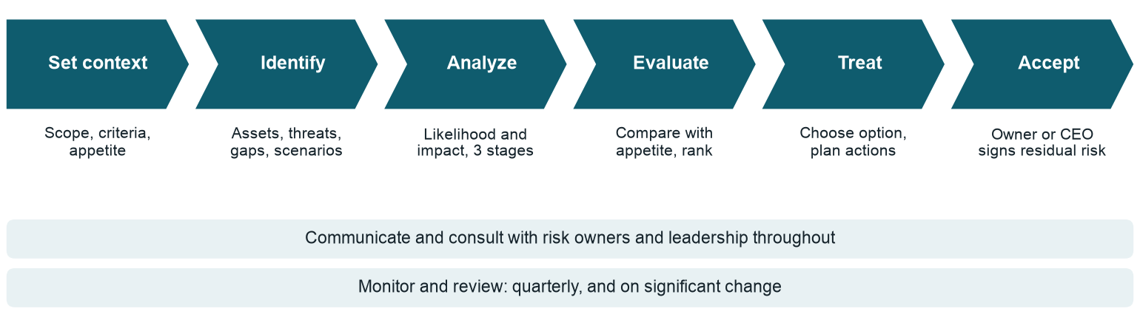
Figure 1: The risk process. Consultation and review run alongside every step.
Step | What happens | Output
Set context | Confirm scope, criteria and appetite. Refresh the asset register and threat catalog. | Approved criteria
Identify | Find risks two ways: by asset (what could go wrong with this system or data) and by event (how an attack or failure would unfold). | Risk statements with cause, event and consequence
Analyze | Score likelihood and impact at three stages. Record existing controls and their evidence. | Scored register
Evaluate | Compare scores with appetite and rank the risks. | Prioritized risk list
Treat | Choose mitigate, avoid, transfer or accept. Select Annex A controls and plan actions. | Treatment plan and input to the Statement of Applicability
Accept | The right authority signs off residual risk. | Acceptance records

Risk criteria

Likelihood
Likelihood combines expected frequency with a threat-informed test: how common the technique is and how open the path is today.
Score | Label | Expected frequency | Threat-informed test
1 | Rare | Less than once in ten years | Needs rare skill or several strong controls to fail together
2 | Unlikely | Once in five to ten years | Possible, but at least one tested control stands in the way
3 | Possible | Once in two to five years | Technique is in common use and controls are partial
4 | Likely | About once a year | Technique is in common use and the path is mostly open
5 | Almost certain | Several times a year, or already happening | Path is open today and needs little skill

Impact
Impact is rated on four dimensions, and the highest one sets the score. Financial bands are tied to FY2025 net revenue of EUR 21.4M.
Score | Label | Financial | Regulatory | Customer | Operational
1 | Negligible | Under EUR 20k | No regulatory interest | No noticeable effect on customers | Payments degraded for under 15 minutes
2 | Minor | EUR 20k to 100k | Informal query from a regulator | A few complaints; under 1% of customers affected | Payments unavailable for under 1 hour
3 | Moderate | EUR 100k to 500k | Reportable incident or formal finding | Several merchants affected, or personal data of under 1,000 people exposed | Payments unavailable for 1 to 4 hours
4 | Major | EUR 500k to 2M | Sanction or supervisory measures | Loss of an enterprise merchant, or data of thousands exposed | Payments unavailable for 4 to 24 hours
5 | Severe | Over EUR 2M (about 10% of net revenue) | Licence restricted or put at risk | Widespread loss of trust, or most customer data exposed | Outage over 24 hours, or ledger integrity lost

Risk levels and appetite
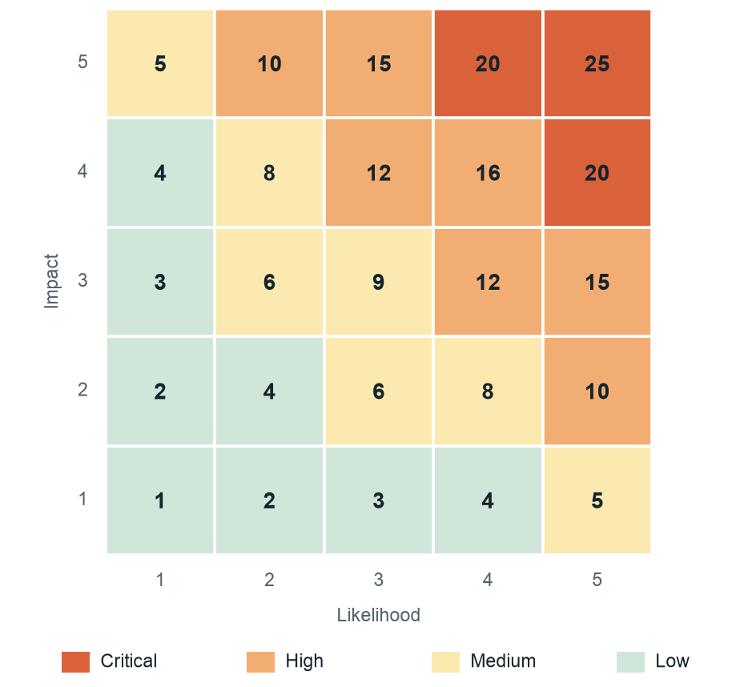
Figure 2: Risk matrix. Score is likelihood multiplied by impact.
Level | Score | Required response | Who may accept
Critical | 17 to 25 | Treat immediately. Acceptance only as a time-limited exception. | Management Board
High | 10 to 16 | Treatment plan required. Acceptance needs a written record. | CEO
Medium | 5 to 9 | Within appetite. Monitor and treat where cost is reasonable. | Risk owner
Low | 1 to 4 | Within appetite. Record and review yearly. | Risk owner

Risk appetite statement. Orvanta accepts risks scored 9 or lower when a named owner monitors them. It does not accept untreated High or Critical risks to customer funds, payment availability or customer data. Any exception is written, time-limited and reviewed.

Threat-informed analysis
Many risk registers score likelihood by instinct. Here, likelihood is tested against how an attack would actually proceed.
- Threat catalog. Each adversarial threat names the MITRE ATT&CK tactic and technique it relies on. Non-adversarial threats, such as outages and errors, are listed without a technique.
- Attack scenarios. The most serious risks are walked through step by step as a kill chain. For each step we ask which control would prevent it, detect it or respond to it.
- Coverage status. Each control at each step is rated Missing, Partial or Effective. Effective means working by design, and it stays provisional until tested by audit or exercise.
- Three scores. Inherent assumes no controls. Current counts controls that exist and work today. Target assumes the treatment plan is complete.
A step with no Effective prevent or detect control keeps likelihood at 4 or 5, whatever the paperwork says.

Treatment and acceptance
Option | When it is used | Example at Orvanta
Mitigate | Controls can reduce likelihood or impact at reasonable cost | Just-in-time admin access for AWS
Avoid | The activity or asset causing the risk can be removed | Retiring the legacy OpenVPN bastion
Transfer | Part of the financial impact can be shared | Cyber insurance for ransomware losses
Accept | The risk is within appetite, or treatment costs more than it saves | Single AWS region, accepted for a fixed period

Selected controls are compared with Annex A so that nothing necessary is missed, and the result feeds the Statement of Applicability. Acceptance above appetite needs a record stating the reason, conditions, expiry date and signatory.

Monitoring and review
- Quarterly. The Risk Manager reviews scores, action progress and expiring acceptances with each owner, and reports to the Management Board.
- Yearly. A full reassessment, including the asset register and threat catalog.
- On change. A new product, supplier, major architecture change, serious incident or new regulation triggers a targeted review.
- Indicators. Key risk indicators, such as MFA coverage and restore success, give early warning between reviews.
The workbook is the register of record. Earlier versions are kept for three years so that changes in risk can be traced.

