Programming Example – CarpetCalculator
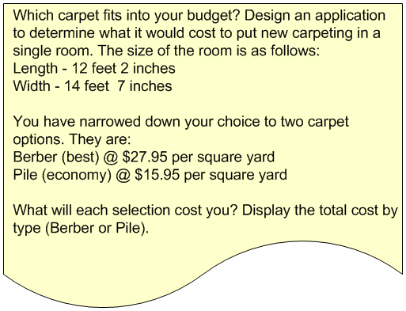

Data Needs for the CarpetCalculator

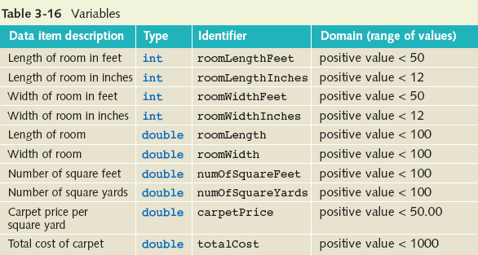

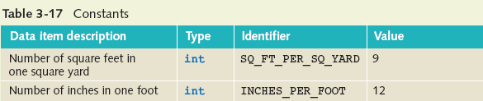
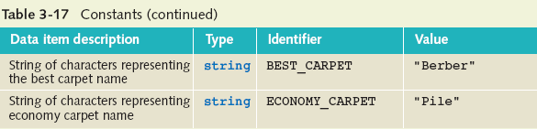

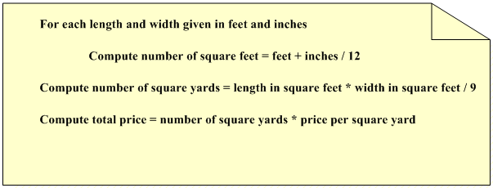
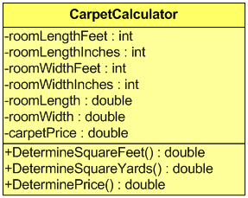

static void Main( )
{
const int SQ_FT_PER_SQ_YARD = 9;
const int INCHES_PER_FOOT = 12;
const string BEST_CARPET = "Berber";
const string ECONOMY_CARPET = "Pile";
int roomLengthFeet = 12, roomLengthInches = 2,
roomWidthFeet = 14, roomWidthInches = 7;
double roomLength, roomWidth, carpetPrice,
numOfSquareFeet,
numOfSquareYards, totalCost;

roomLength = roomLengthFeet +
roomLengthInches / INCHES_PER_FOOT;
roomWidth = roomWidthFeet +
roomWidthInches / INCHES_PER_FOOT;
numOfSquareFeet = roomLength * roomWidth;
numOfSquareYards = numOfSquareFeet /
SQ_FT_PER_SQ_YARD;
carpetPrice = 27.95;
totalCost = numOfSquareYards * carpetPrice;
//Display the cost of best carpet
carpetPrice = 15.95;
totalCost = numOfSquareYards * carpetPrice;
// Display the cost of economy carpet

} } }

