Data Science Lab 1
Coursework 1: Visualisation
By Caleb Palluotto
Link to Data: Smoking Habits in the UK 2023 (The data is the data used on figure 1 on the ONS webpage)

Visualisation 1: Line Graph
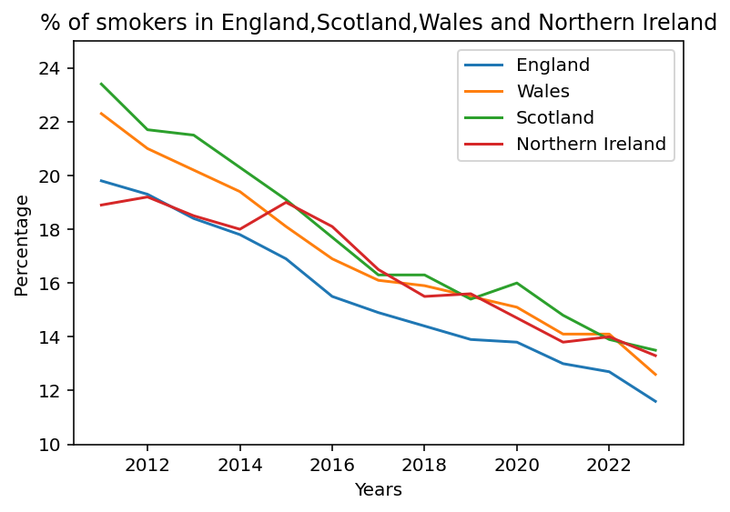
Figure 1: The percentage of adults living in the UK who smoke cigarettes from 2011-23
Observations: From the data’s starting point in 2011 we can see a downward trend in the amount of cigarette smokers in the entire UK. Apart from 2011 England has remain the lowest percentage wise from smoking population whilst Scotland, Wales and Northern Ireland weave amongst each other. Initially they range from around 19-23% in 2011 then decrease to a range around 11-14%.

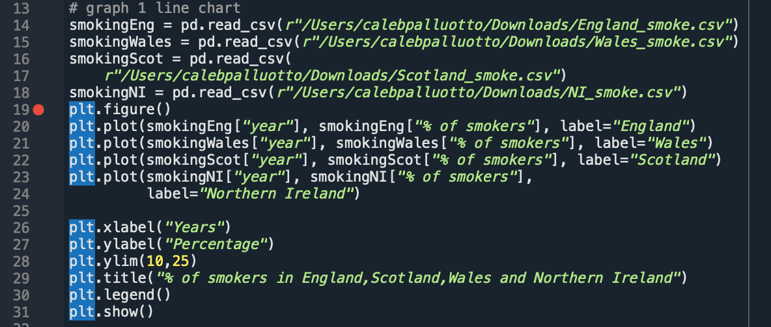
Here is the code used in the first graph. Lines 14-18 are used for reading the data in their csv file form, all named according to the country they are from. Lines 19-31 are used to build the graph, 19-24 used to plot the data from all the csv files, 26 and 27 to label the axis, 28 to give a limit to the percentages shown on the y axis so they’re not too big or small, 29 for the title, 30 for the legend so you know which lines and colours represent each country and finally 31 to display the plotted data.

Visualisation 2: Bar Graph
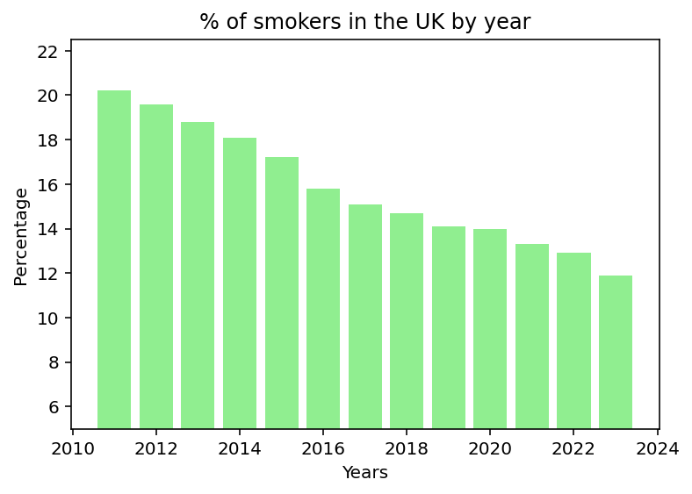
Figure 2: The percentages of Adults in the UK, as a whole, who smoke from 2011-23
Observation: From the displayed data we can see the number of smokers in the UK decreases overtime, from just above 20% in 2011 it drastically decreases over the coming years to just under 12% in 2023, almost half in the span of 12 years after our first data point.

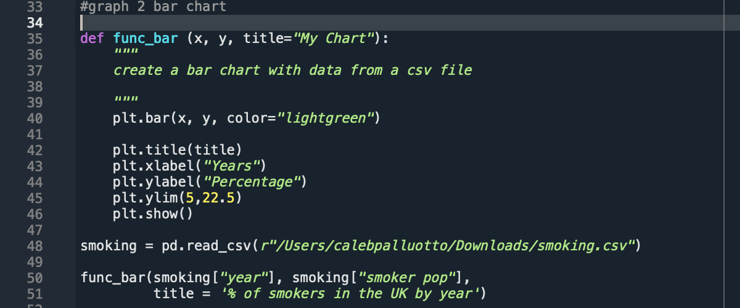
This is the code used for the second graph, for this one I used a function to plot the data. The function ‘func_bar’ is quite simple, it takes your two desired x and y values and allows you to give it a title, the function itself has preset values for the graph, which can easily be changed however if we decided to look at a larger data set for example on a bar chart we would only need to change the x and y values and your title when using the function and not the entire code, obviously you’d need to make sure your code has read another csv but that’s all that is required.
Here is an example of the England smoking data and code with the function:
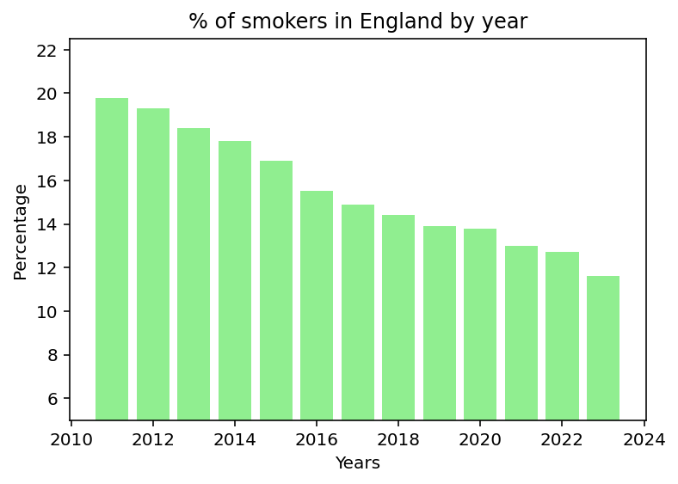
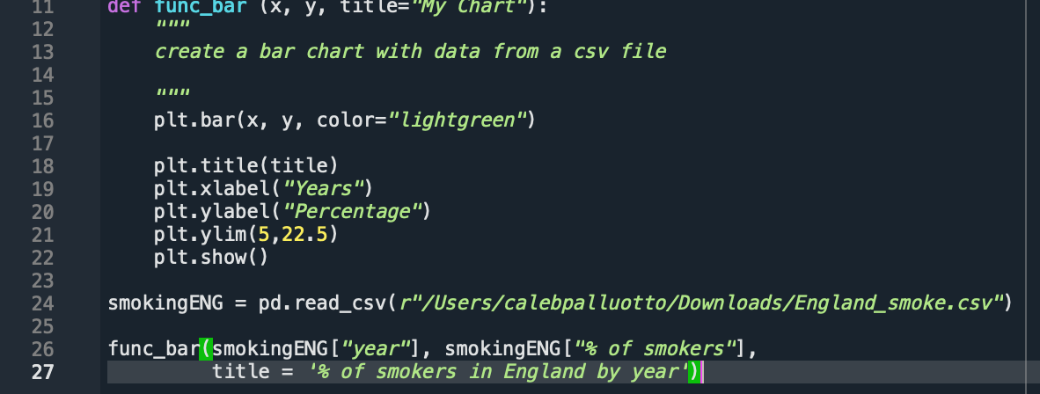
The Graph is very similar to the UK as a whole one but it is slightly lower on average, considering the first line graph we looked at this track since they had the lowest percentage one average.
The code is pretty much identical since the function doesn’t need to change but the code given to the function is now displaying just England.

Visualisation 3: Pie charts
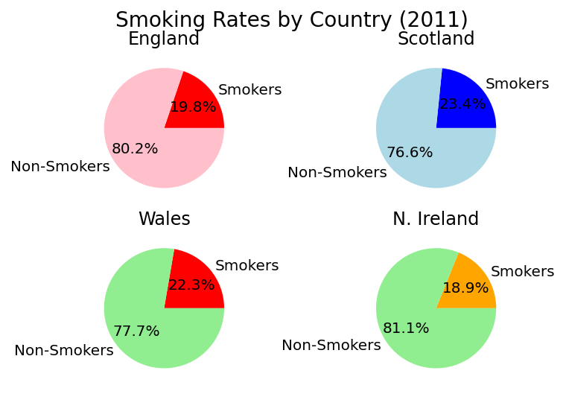
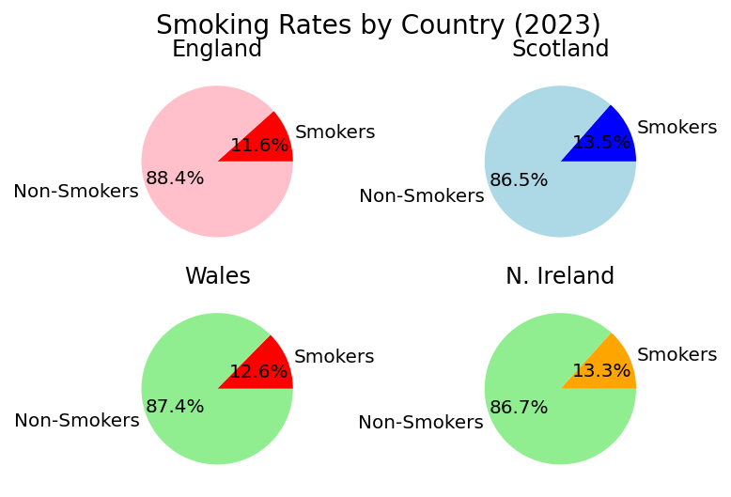
Figures 3 and 4: Pie Charts to show the percentages in the UK by country of smokers in 2011 and 2023
Observation: We can see the percentages from the start of the data set in 2011 and the end in 2023, this shows the drop amongst cigarette smokers in the UK over the given time frame. We can see that although they had the lowest rate in 2011 Northern Ireland has the second highest rate as on 2023 of smokers in the UK. Wales and Scotland had the two biggest jumps losing around 10% of their smokers from 2011-23 and as of 2023 England has the lowest percentage of smokers in the UK.

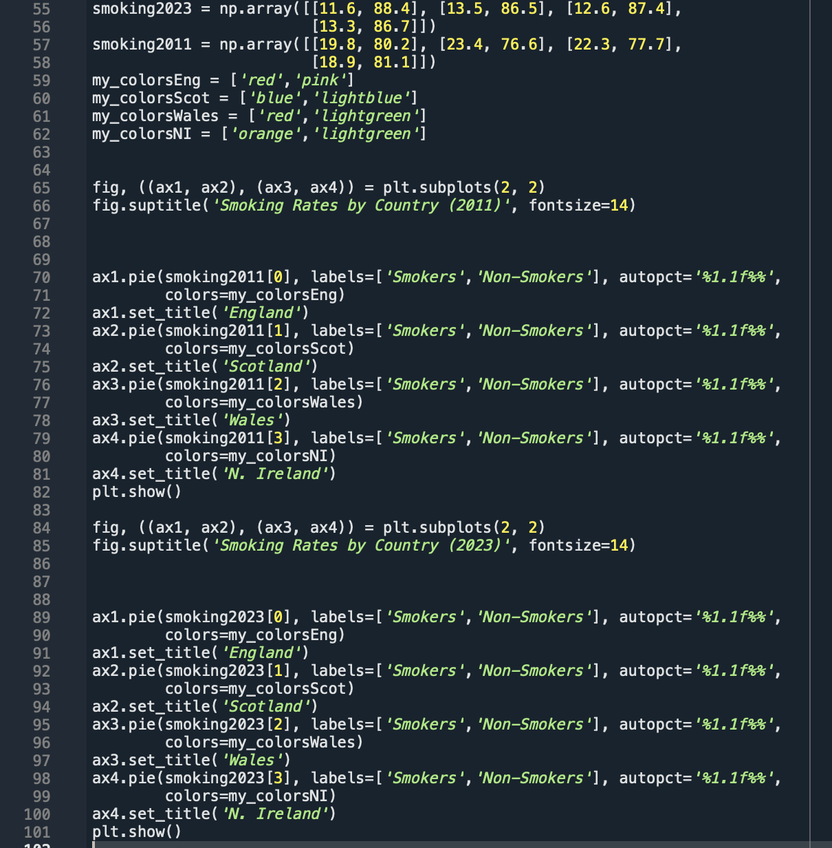
This larger chunk of code is used for the 8 pie charts in figures 3 and 4, starting from the top, Lines 55-58 are arrays with the percentages of smokers and nonsmokers, by each country as well, 59-62 are the chosen colours for each diagram, each drawing from the colours on each country’s flag (Note I decided against using white for obvious reasons so had to improvise with England and Scotland). Lines 65 and 66 explain the layout for the 2011 data, in line 55 ‘fig,’ is used to tell the computer it’s a figure and the rest of the line ‘((ax1, ax2), (ax3, ax4)) = plt.subplots(2, 2)’ tells it on the figure there is a 2 by 2 subplot, meaning we want to display 4 graphs at once with the order of ax1(left) and ax2(right) on the top and ax3(left) and ax4(right) on the bottom. Lines 70-85 are used to tell the computer what is in each of these graphs, as an explanation lines 70-72 start off by saying ‘ax1.pie’ meaning we’re in the top left corner, and it’s a pie chart, ‘smoking2011[0]’ tells us to use index 0, being the first element, of the array named ‘smoking2011’, ‘labels’ are what each slice of the pie chart will be called, ‘autopct='%1.1f%%'’ simply displays the percentage value of our data slices but since we already have our data in percentages it’s only displaying what we know, ‘colors=my_colorsEng’ tells it to go the toe variable my_colorsEng and use the colours named in the variable and finally ‘ax1.set_title('England')’ gives the pie chart a title. Lines 73-81 do the rest of the 2011 data and then presents it all together on a single figure and then lines 84-101 repeat the process but with the 2023 data.

