Caleb palluotto | 24107914
Coursework 2 | statistics and trends
exploring trends and corrulation between Co2 Emissions and GDP

Abstract
In this report I explore data from 1976 to 2024 looking specifically at Carbon Dioxide (CO2) Emissions and comparing then to Gross Domestic Product (GDP) of countries looking for correlations in the data, the rates of change (ROC) and focusing on two main time frames, those being 1976 to 1996 and 2004 to 2024, with an initial look at the global number in order to get a baseline for our data.

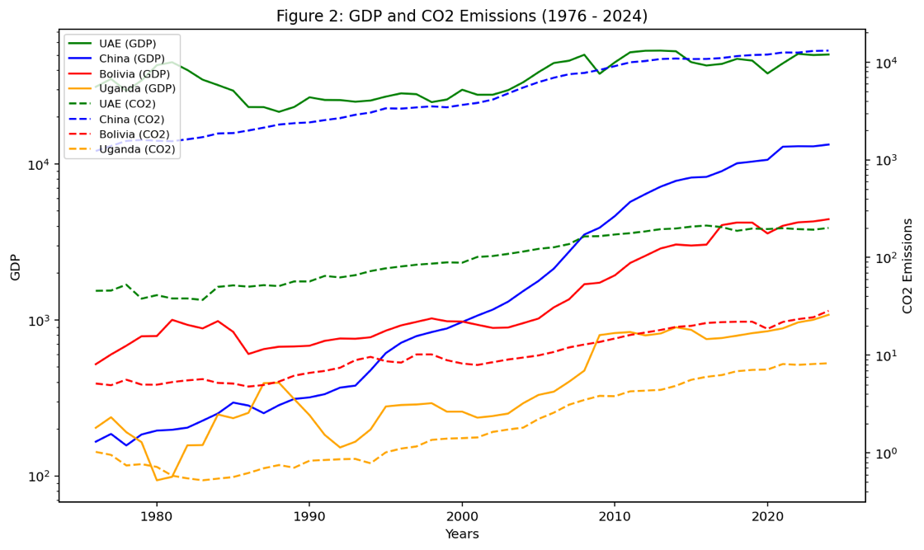
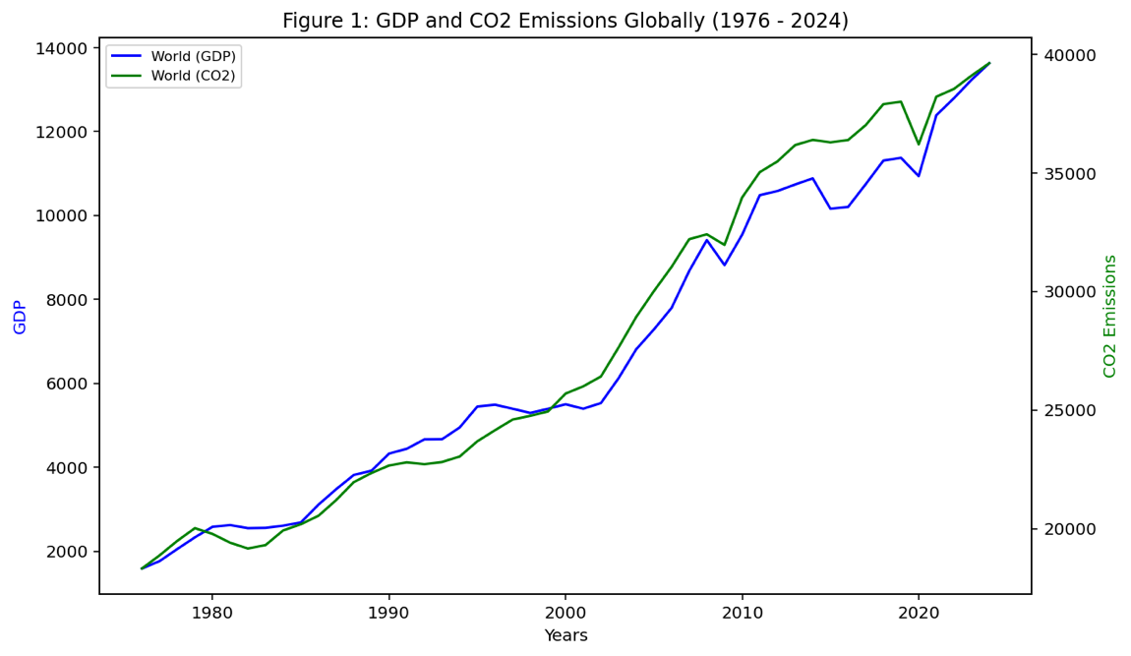
My choice of looking at GDP was due to large industrial countries, such as China, where they would have growing GDPs with an increase in CO2 Emissions so I could show an obvious correlation, this later influenced my choice in countries. Before jumping in and singling out a handful of countries to compare I looked at the Global data over the given time. As Figure 1 shows, as carbon emissions increase as does the Global GDP. We can compute the ROC and how strong the correlation over the two aforementioned time periods, in the first 20-year period the ROC for GDP is about 6.6% and for CO2 it’s 1.4%, the correlation is 0.98, in the second 20-year period has a ROC of for GDP is 3.67% and for CO2 is 1.6%, the correlation is 0.967. from this we can deduce there is a positive correlation between CO2 emissions and GDP, and the ROC for GDP has almost halved in the same time frame, yet CO2 increases ever so slightly. The data over the 50 years or so is slightly skewed at 0.14 for GDP and -0.39 for CO2 so we can assume the data is somewhat symmetrical. This gave me a good baseline for when I decided to look at my chosen countries.
The countries I chose where the United Arab Emirate (UAE) being high income, China being upper middle income, Bolivia being lower middle income and Uganda being lower income. I chose countries there were relatively spread out across the globe as to not be swayed by a particularly rich or poor region. In Figure 2 we can still see a general positive correlation but there is a bit more to it. The solid lines show GDP and the dashed lines show CO2 emissions. The UAE in their first time frame has a ROC for GDP of 0.17% and for CO2 it’s 3.6%, with a correlation of -0.62 and in the second time frame we see the ROC of 2.77% for GDP and 2.95% for CO2 with a correlation of 0.46. From the perspective of the first time frame we can see there is a negative correlation between GDP and CO2 emissions but this changes when you jump to the other time frame yet not the strongest correlation displayed. The ROC drastically increase from the first to second time frame for GDP but decrease for CO2 emissions. Moving on to our next country China, In the first 20 years their ROC for GDP and CO2 are 8.1% and 5.1% respectively and the correlation is 0.93. In the final 20 years the ROC is 11.8% and 4.5% with a correlation of 0.97. The skewness of the UAE is low, for the whole 50 year period GDP was -0.22 and CO2 was 0.24, where as China was a different story, granted their GDP was only -0.1 there CO2 was 0.5 which points towards a moderate skew, meaning that the mean is higher than the median. As displayed by figure 2 we can compare how a country who relies heavily on manufacturing good, China in this instance, has a much higher CO2 output with, as seen by the ROC in GDP, a rapidly growing economy, compared to the UAE which gains from natural resource exports such as oil. This is since the UAE has quite a stable economy that makes consistent gains whereas China has been rapidly growing as shown by both rates of change.
Moving on to our smaller economies, Bolivia and Uganda tell a much different story. Starting with Bolivia, from 1976-96 their ROCs were 3.6% and 2.8% for GDP and CO2 with a correlation of 0.19 and from 2004-24 the ROCs were 8.5% and 5.9% respectively and the correlation was 0.96. This tells us that they had a slower moving economy between the 70s and 90s with a weak positive correlation but in the latter 20 years they drastically increase and with a much stronger positive correlation almost at 1. For Uganda in the initial 20 years the ROCs are 5.4% and 1.1% for GDP and CO2 and the correlation is 0.16 and in the more recent 20-year block the ROCs are 7.7% and 8.1% with a correlation of 0.82. This is a similar case to Bolivia with lower ROCs and correlation from the 70s-90s but a jump in all the data when you look at the 00s-20s. As for the skew Bolivia was fairly symmetric with -0.14 for GDP and -0.3 for CO2 but Uganda was heavily skewed when looking at their GDP with a 1.1 meaning the mean is much higher than the median, then again, their CO2 was only -0.22. From the numbers and graphs, we can see for the poorer countries that were selected they were mostly likely later to the economic expansion then the richer two countries despite how China had a lower GDP (per capita) than Bolivia and Uganda.

To conclude CO2 emissions and GDP tend to have a strong correlation with each other, for some countries this trend is stronger such as China where CO2 emissions are very close to being directly tied to GDP, which considering there very strong manufacturing economy it make sense, whereas the UAE has had a strong economy exporting oil for a long time now and has reached a slower growth yet more stable point. Also, our two smaller economies only really started having a correlation between CO2 and GDP in recent decades showing it can help countries develop but as stated with the UAE it isn’t required.

