

**WHATSAPP integration in OMNICHANNEL**

## [Request access to enable Number for WhatsApp](https://www.twilio.com/docs/whatsapp/tutorial/connect-number-business-profile#step-1-request-access-to-enable-your-twilio-numbers-for-whatsapp)

In order to enable your number for WhatsApp, you need to give following details about your business, including your Facebook Business Manager ID.

* First name
* Last name
* Company name
* Phone number
* Business ID
* Company website
* Region for sending your WhatsApp messages (It’s may be global or your specific country)
* How many messages are you sending per month during a year?

You can Find your Facebook Business ID using this [link](https://business.facebook.com/settings/info?business_id=2404101419835622) or logging into business.facebook.com > clicking “Business Settings” > "Business Info" > Look for the Business Manager ID.

If You don’t have Facebook Business Account You can check this [link](https://www.facebook.com/business/help/1710077379203657?id=180505742745347) to create your own business manager

#### [**Using a brand name in your WhatsApp Business Profile**](https://www.twilio.com/docs/whatsapp/tutorial/connect-number-business-profile#using-a-brand-name-in-your-whatsapp-business-profile)

We need to verify your sender profile and message template along with your business profile.

You may have a brand name that you wish to use for your WhatsApp Business Profile that differs from the name of your company. If so, there must be a **clear, externally published association between your company and the brand.** This association between the brand and your business needs to be displayed on your website and on the display name itself

For example,

if your company is **Cal4care** and your brand is "**OmniChannel**", then we would recommend using the name " **OmniChannel** by **Cal4care**." This association must be published on your website so WhatsApp can verify it. This means that somewhere on the website, there must be a visible relationship between the two names. If you would like to keep the name " **OmniChannel** ", this will generally require an appeal to WhatsApp and may extend the registration process.

## [Verify your Facebook Business Manager account](https://www.twilio.com/docs/whatsapp/tutorial/connect-number-business-profile#step-4-verify-your-facebook-business-manager-account)

## If you have already verified your Facebook Business Manager account previously, you will ****not**** need to complete this step again

## You can see the [article](https://www.facebook.com/business/help/2058515294227817?id=180505742745347) that may be helpful to verification for your business or login to your business manager and go to Security Center and click the ****Start****or ****Continue**** button under in the ****Verification**** section.

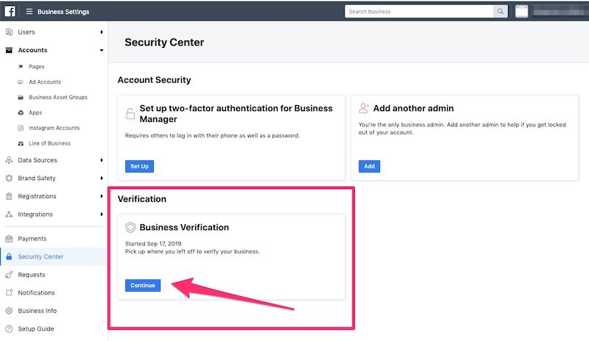

## [Approve us to send messages on your behalf](https://www.twilio.com/docs/whatsapp/tutorial/connect-number-business-profile#step-3-approve-twilio-to-send-messages-on-your-behalf)

When you receive notice that we has submitted your WhatsApp Business display name and Twilio number to WhatsApp, you need to approve us to send messages on behalf of that Business Profile. You will receive an email to your Facebook Business Messenger. This email usually has the subject "WhatsApp Profile Request.

You can find this request by [following this link](https://business.facebook.com/settings/requests/received_requests?business_id=2404101419835622) or Business Settings > Requests section. Once there, click the **Approve** button.

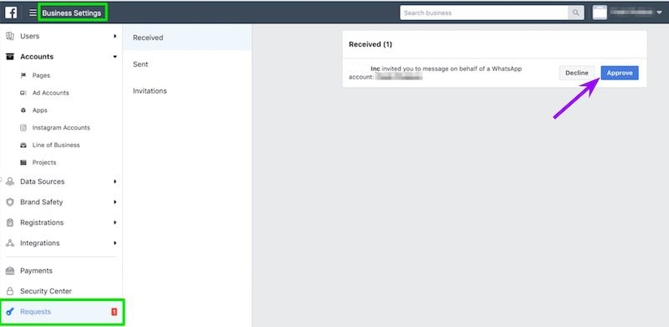

After you approve us to message on your behalf, registration process is completed and you get a new business number for your whatsap and connect your Number and your WhatsApp Business Profile. You will receive an email confirmation that has finalized the registration of your profile.

At this point, your Business Profile is ready to receive messages from customers in production