iOS Q&A

Table of Contents

Run on IOS: 1

Release on iOS: 4

Potential Issues 7

Xcode Error: Failed to prepare device for development 7

Xcode workspace file is empty 7

# Run on IOS:

1. Make sure you can run the simple app first according to the [official website](https://docs.flutter.dev/get-started/install/macos).
2. Follow second solution in this [website](https://stackoverflow.com/questions/43111501/the-bundles-info-plist-does-not-contain-a-cfbundleversion-key-or-its-value-is-n/59806545" \l "59806545) and first solution [here](https://stackoverflow.com/questions/51599686/flutter-podfile-and-pods-folders-not-created-in-ios-directory)
   1. `flutter doctor` -> Make sure all issues are fixed
   2. `flutter clean`
   3. Delete Pods, Podfile, Podfile.lock
   4. Add build number if that field is blank
   5. Erase all contents in the simulator
   6. `cd ios`
   7. `pod cache clean --all`
   8. `pod deintegrate`
   9. `pod setup`
   10. `pod repo update`
   11. `pod install` (It may take tens of minutes)
   12. `flutter build ios` (It may take tens of minutes)  
       If you encounter similar error like this  
       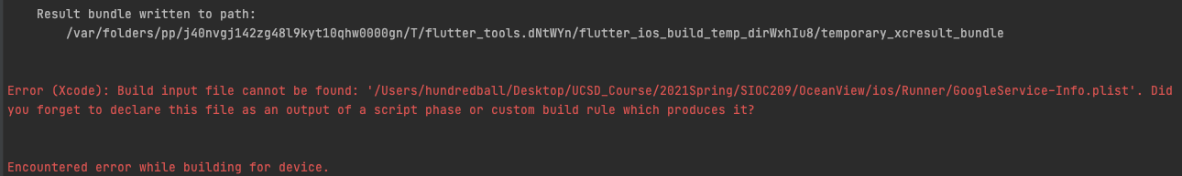  
       Open `Runner.xcworkspace`, drag `GoogleService-info.plist` into Runner folder and then delete the old one  
       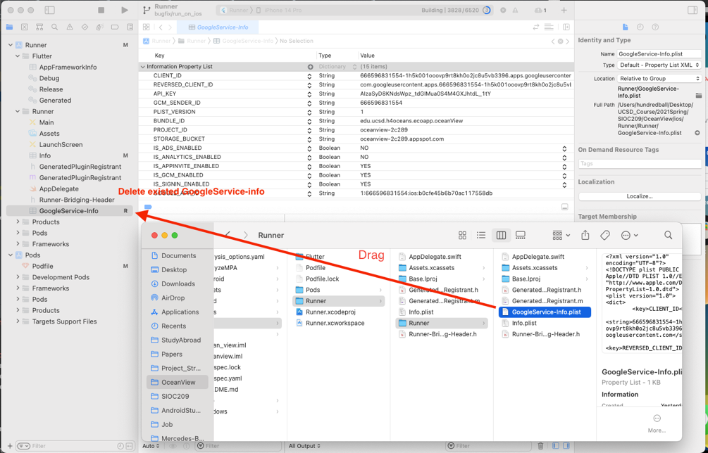
3. Set target to simulator or physical device and then press start button (It may take around 30 minutes in the first time)  
   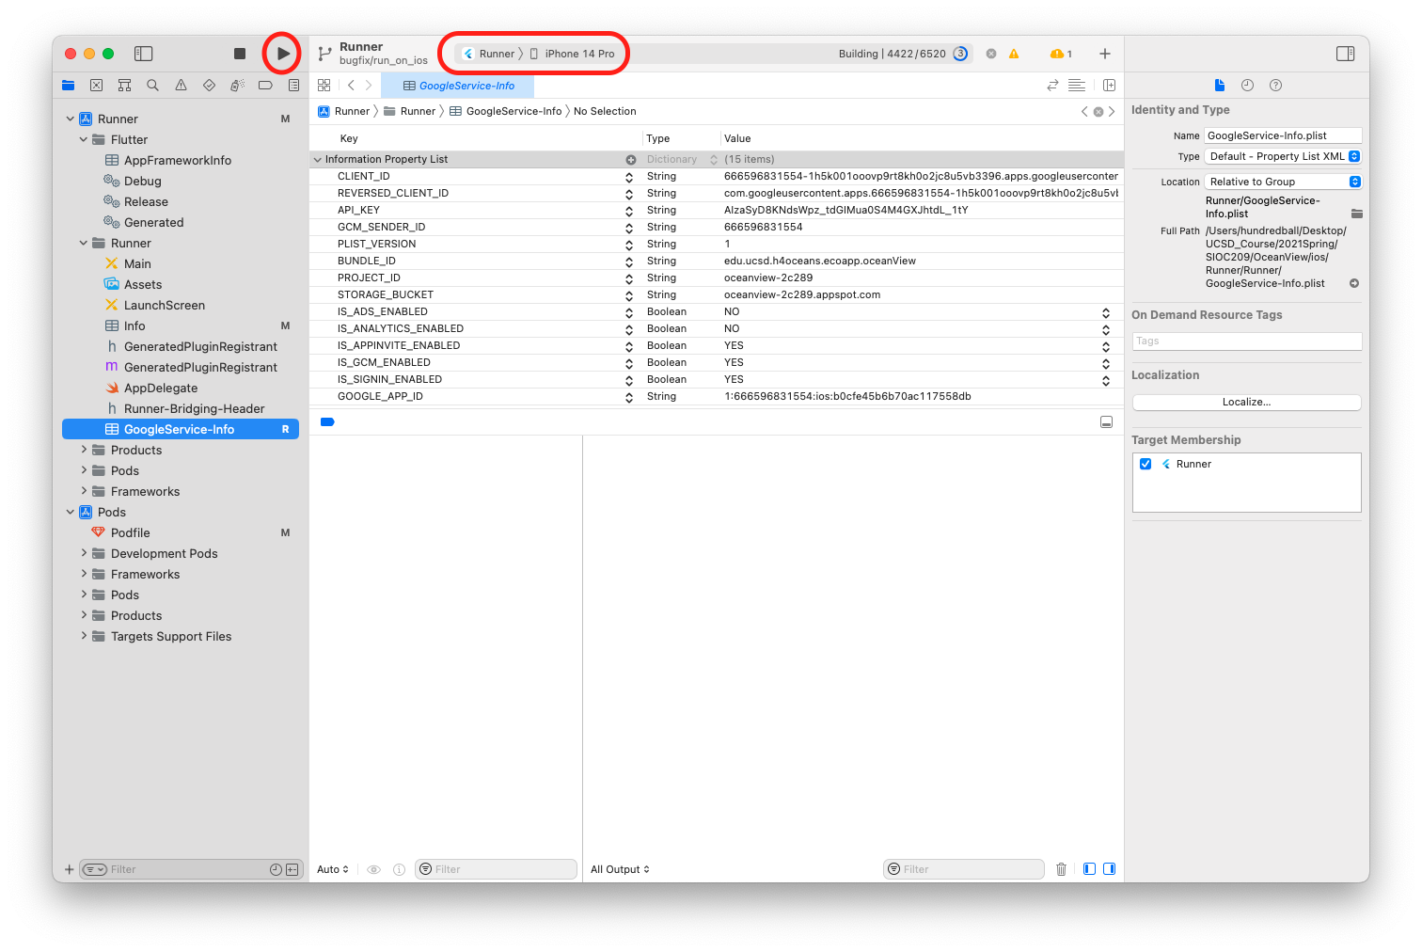  
   1. On the phone, Settings/General/Profiles & Device Management/  
      Trust the app here so you can open the app   
      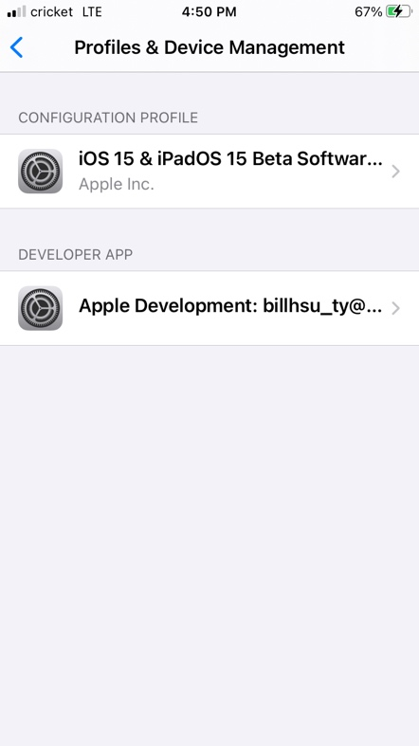
   2. If you want to run the app without connecting to Xcode, long-press the start button and choose Profile.

# Release on iOS:

1. Open `Runner.xcworkspace`
2. Change to release settings for `Signing & Capabilities` and `Build Settings` as follows  
   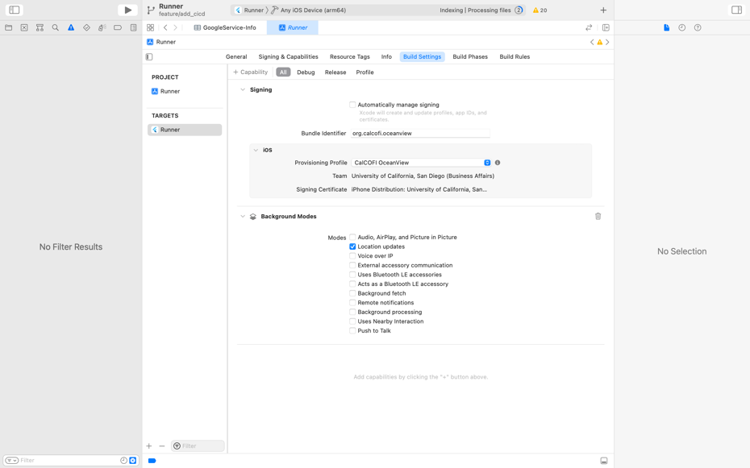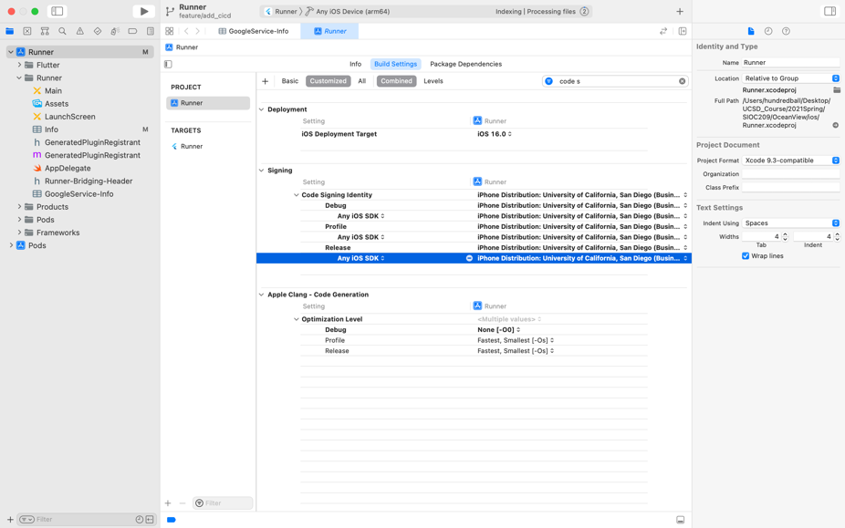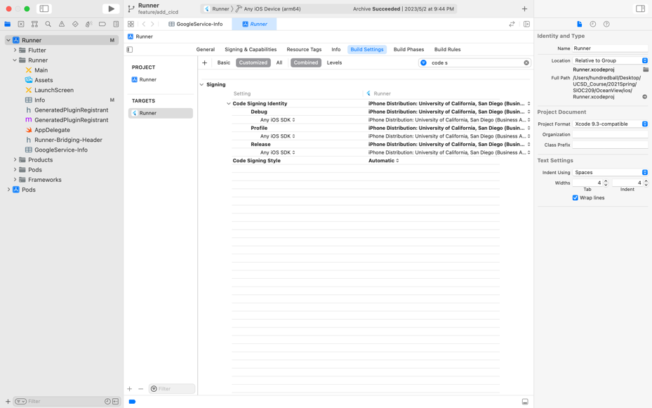
3. Click `Product > Archive` in status bar
4. Click Distribute App  
   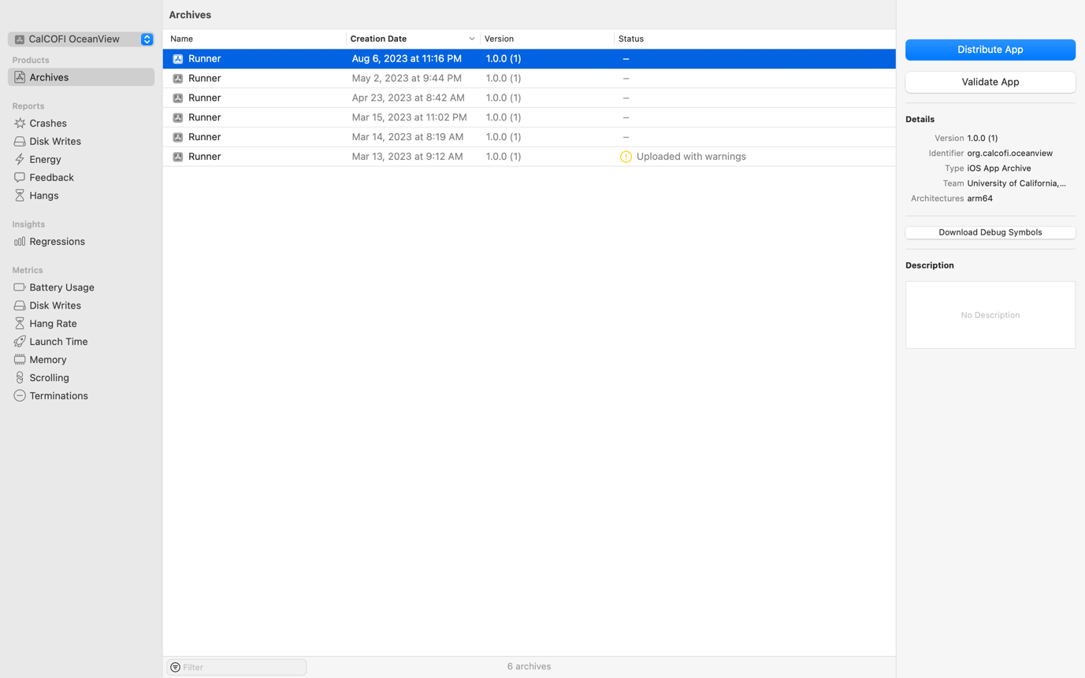
5. App Store Connect > Export > Multiple Nexts… -> Export .ipa file to a folder
6. Grab .ipa file to Transporter (downloaded from App Store) and press deliver  
   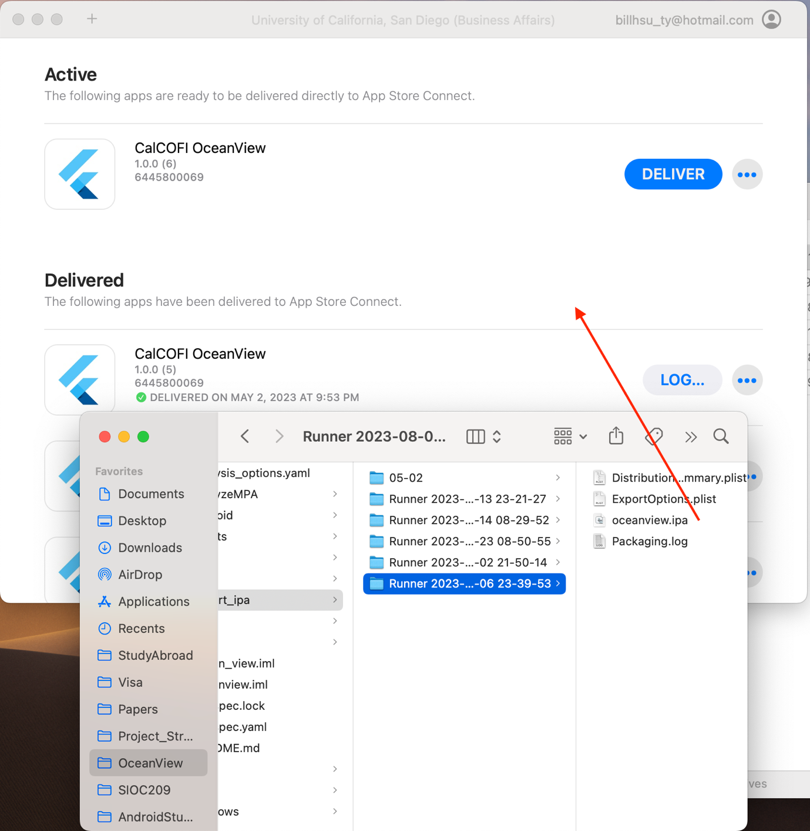

# Potential Issues

## Xcode Error: Failed to prepare device for development

Restarting Mac and iPhone might solve the issue. However, this [solution](https://stackoverflow.com/a/71701826/14653030) to add device support in Xcode better solve my problem.

## Xcode workspace file is empty

It seems that we need to always open .xcworkspace since we are using cocoapods in Flutter. Without opening .xcworkspace, we cannot reference other projects which might be result in the bug of `No such module …` when building iOS app.

[Xcode Project vs. Xcode Workspace - Differences](https://stackoverflow.com/questions/21631313/xcode-project-vs-xcode-workspace-differences)

[Xcode workspace file is empty](https://stackoverflow.com/questions/50508357/xcode-workspace-file-is-empty)