TITLE:

A Quantitative Analysis of Labor Force Participation Rates and Medical Marijuana Laws in the United States

Calvin Colson

Submitted to Princeton University
Department of Economics
In Partial Fulfillment of the Requirements for the A.B. Degree

April 8, 2020

Abstract
Acknowledgements
Table of Contents
List of Tables and Figures

Figure 1: 5
Figure 2: 8

Table A1: appendix

1. Introduction

There is no dearth of scientific, political, psychological, economic, cultural, or recreational discussion when it comes to the topic of a certain plant in modern conversations. I am referring to the genus of plants known as Cannabis. Alternately, depending on strain and location, these plants may be known by a variety of other names, including Cannabis indica, Cannabis sativa, Cannabis americanus, Indian hemp, marijuana, weed, and so on. The variety of names for this plant is not particularly surprising when the variety of its uses over thousands of years is also considered. As early as the twenty-eighth century B.C. in China, the plant had been farmed as a fiber crop, and in India the plant was being used for medicinal purposes prior to 1000 B.C., and by 650 B.C. its intoxicating properties had been documented in the Middle East (Mikuriya, 1969). From a more modern perspective, there has been much fascination as well as controversy surrounding the plant as well as the politics and legislation that have resulted in several American states adopting it as a legal medical treatment. The motivation of this paper stems from one of these pertinent controversies.
Shortly after the onset of the 21st century, the United States experienced a sharp decline in multiple labor force metrics. Among those metrics, the labor force participation rate, or the ratio between the labor force (both the employed and the unemployed actively seeking employment) and the total population, was particularly affected experiencing nearly a 5% decrease from peak to low point (Krueger, 2017; “Civilian Labor Force Participation Rate.”, 2020). While it is important to note that the drops are correlated with the 2001 and 2007-2009 recessions, the decrease cannot be entirely explained by these economic events. Evidence for this can be seen in the same study by Krueger, cited above, where a breakdown of the trends of the labor force participation rate by age and gender are presented and discussed. Most notably, the drop in the labor force participation rate of ‘prime age workers’, or those between the ages of 25 to 54, has been the focus of attention. This paper will attempt to analyze one of the conjectured potential causes of the decline in the labor force participation rate in recent years, namely, that of medical marijuana legalization.
In light of recent legislation legalizing marijuana and marijuana-derived products (both those with and without psychoactive properties) (Marijuana Policy Project, 2019), it is no surprise that there is much speculation as to the effects that this substance has on both individual behavior and macro-scale systems, including the labor force. The constituents of the cannabis plant, called cannabinoids, are considered by several to be therapeutic in the treatment of various disorders and diseases, including treating chronic pain, nausea, and spasticity of multiple sclerosis. However, there is also data suggestive of adverse effects and risks associated with consumption of cannabinoids (and especially their principal psychoactive component, delta-nine-tetrahydrocannabinol (THC)). In addition to the cardio-vascular risks of chronic smoking, which is one of the most preferred forms of consumption, akin to other psychoactive drugs labeled as “central nervous system depressants”, consumption of THC has been purported to be linked to “weakness, mood changes, and dizziness” (Benbadis et al., 2014) (See Section 3.2 for more detailed discussion as to the beneficial and adverse effects of marijuana consumption). Extrapolating these symptoms out further, One of the more common and long-standing speculations is to make a causal link between the consumption of marijuana and a psychological disorder known as the amotivational syndrome. Despite the existence of some studies producing equivocal results on the matter, other studies, such as one by Creason and Goldman (1981) and another by Lac and Luk (2018) have shown results that support a correlation between “heavy” intake of marijuana and lower initiative and persistence that could result in decreased “general self-efficacy”. The implications of these results are important to the focus of this paper, because it might lead one to believe that increased usage of marijuana could significantly cause a negative impact on the economy, and specifically the labor market. The reverse side of this argument is also worth noting. That is, that proper treatment of disorders and diseases through the use of medical marijuana may create a positive effect on the labor force due to increased health of potential workers. Individuals that would otherwise be unable to manage both their illnesses and their employment may be empowered to do so through the assistance of medical marijuana treatments. Additionally, it is quite possible that in many cases, marijuana intake is not causative of amotivational syndrome, but rather that those with amotivational syndrome are more likely to use marijuana. Clearly, there are a lot of factors at work in understanding the connection between the labor force and marijuana legalization and usage. In an attempt to quantitatively assess aspects of this relationship, this paper compares data between the aforementioned and partially-contemporaneous events of the recent decline of the labor force participation rate and the national-wide state-level legalization of marijuana in the United States.
In order to accomplish this goal the remainder of this paper will have the following structure. Section II will present a background on the trends in both the labor force participation rate and the legislation of medical marijuana laws (MMLs). It will also give a brief review on the possible factors involved in causing these trends, and the distinctions between state differences in MMLs. Section III’s purpose is to give an overview and discuss previously published literature that is relevant to this topic. In doing so, it will become clear how this paper makes a unique contribution to the existing literature, and where its conclusions might differ from those that came before it. Section IV gives information on the data that was used to construct this study. This paper will provide information on both the structure and manipulation of the data-sets in order that the results arrived at in Section VI may be accurately reproduced or otherwise modified to investigate other aspects of the relationships between the variables. Section V gives insight into the methodology of the research. It includes the equations of the regressions used in this study, as well as justifications for the specific structures of these models. Limitations of this methodology are also briefly mentioned here where it is relevant. Section VI includes the results of the regressions, as well as an interwoven discussion and analysis of their implications. Here, comparisons will be made between the outcomes of this study and those of previous related studies. This section will attempt to provide explanations for the differences and similarities between the respective results. Lastly, Section VII is a conclusion that attempts to concisely reiterate the key points of the study and its results. Additionally, limitations and the reasoning behind them will be touched upon, as well as suggestions for how future studies may overcome them, or offer additional insight into the relationship between labor force participation and medical marijuana legislation.

2. Background
2.1. Labor Force Trends
From the period of 1999-2018 in the U.S., the employment-to-population ratio experienced a fall of almost 4% (Abraham and Kearney, 2019). Likewise, in approximately the same time frame, the labor force participation rate made a similar but even greater overall drop in magnitude. As can be seen in Figure 1 below (data to construct this graph was obtained from the Bureau of Labor Statistics, see references), which presents annualized averages of the national labor force participation rate and employment-to-population ratio from 1948 to 2020, from its peak in January of 2000 of 67.3%, the national labor participation dropped to 62.4% in September of 2015, a percentage lower than the country had experienced since the seventies (Krueger, 2017; “Civilian Labor Force Participation Rate.”, 2020).
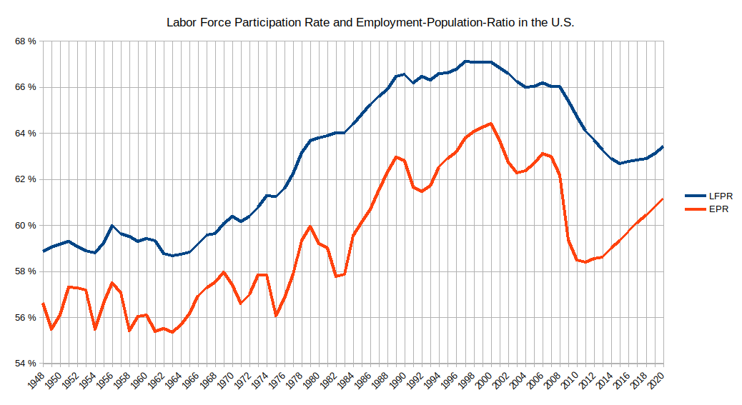
Figure 1
Since that 2015 low, labor force participation has only improved marginally, averaging in the high 62%’s. These two measures of the labor force are closely related, but differ in that the employment-to-population ratio measures the proportion between employed individuals and the total working-age population, whereas the labor force participation rate measures the proportion between the entire labor force (this includes those people actively seeing employment, but not yet employed) and the total population. Historically, these two measures tend to move together in response to relevant factors, and while this is largely true in this interval as well, the increased magnitude of the labor force participation rate in their relative changes (since 2000) provides interest for study. Namely, the portion of the labor force not accounted for in the employment-to-population ratio, that is, the unemployed portion of the labor force, had a greater proportionate drop than the employed portion of the labor force. This points to a different factor in the decreasing of the labor force metrics besides just the economic recession and its typical lower supply of suitable/desirable employment opportunities. That factor is likely concerned with aspects more closely related to the individuals that comprise (or formerly comprised) the labor force, and less so to external market conditions. This assumption is strengthened even further by analyzing the graph around the regions of recent recessions (2001 and 2007-2009). During and following these years, it can be seen that the employment-to-population ratio experiences much steeper declines than that of the labor force participation rate, following the state of the overall economy closer and more quickly. The decline of the labor force participation rate is more drawn out however, and continues to decline (especially relative to the employment-to-population ratio) in spite of the recovering economical conditions following the recessions.
The most prominent factors analyzed by Krueger (2017) in his study “Where Have All the Workers Gone? An Inquiry into the Decline of the U.S. Labor Force Participation Rate” are increased retirement rates due to the aging of workers, and a “secular decline in the labor force participation of prime age men”. More generally speaking, these factors can also be described by breaking the change in the labor force participation rate into two components: one due to the change in rates of participation within certain groups of the population, and the other due to changes in the population shares of those groups as a part of the total population (see equation 2 in Krueger, 2017). The aspect of the aging of workers falls into the second of these components. Krueger shows that the percentage of the labor force age 55 and over increased from 26.3% to 35.6% from 1997 to 2017. The population share for ages 25-54 has correspondingly fallen from 57.5% to 49.3%. This means that the composition of the population has shifted more heavily towards a group with lower labor force participation rates, and this explains “well over half” of the drop in labor force participation rates since the start of the century. This conclusion is also heavily supported by prior research which the Council of Economic Advisors provides a survey of (CEA 2014). The other component of the change in labor force participation rates, that of changes in rates within certain groups, is the main focus of Krueger’s article. In addition to other factors, including the decline in labor force participation for young men and women offset by higher college enrollment rates, he speculates that a substantial part of this secular decline is related to “a significant supply-side barrier of prime age men, namely, health-related problems.” Many of those individuals not in the labor force report experiencing pain and taking pain medication for it. Specifically, Krueger focuses on opioid pain medications and prescriptions and their role in affecting the labor force status of these individuals. It is a possibility that the effect could be depressive and keeping individuals out of the labor force, as Krueger’s data seems to imply. Just as the American opioid crisis is largely temporally concurrent with the decline of the labor force participation rate, so is the legalization of medical marijuana. This provides a parallel and alternative explanation of a particular aspect of the decline of the labor force participation rate.

2.1. Progress of Medical Marijuana
While it is true that government-sponsored legal medical marijuana could be attained in some counties or programs prior, the first state to legalize medical marijuana on a state-wide basis was California on November 5, 1996 (“Historical Timeline - Medical Marijuana”). Since that date to the time that this paper is being written, nearly every year, additional states have followed in passing state-wide legislation to oversee the prescription and usage of marijuana. As a result, currently there are a majority of states that have passed laws allowing for legal medical use of marijuana. For an excellent graphic on the legal condition of cannabis in the U.S. by state, see the Wikipedia article, Timeline of cannabis laws in the United States. Additionally, I have included this graphic below as Figure 2.
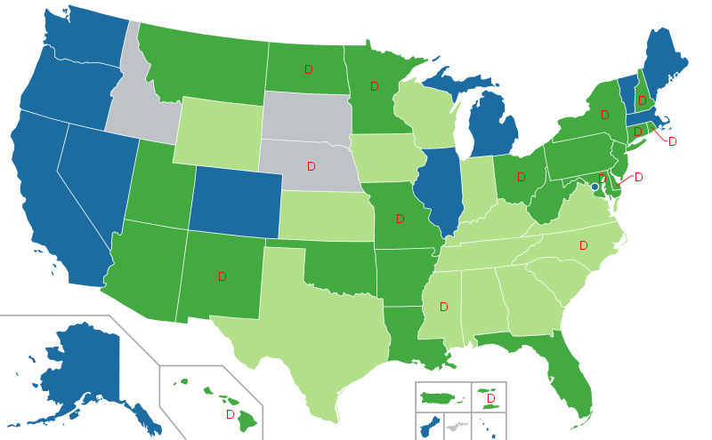
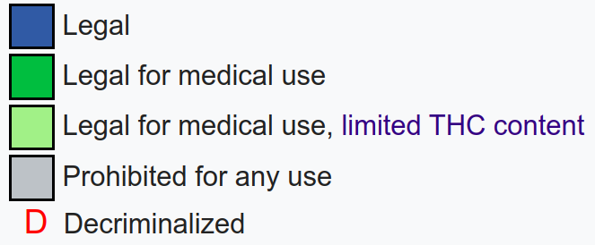
Figure 2
(Source: Timeline of Cannabis laws in the United States, Wikipedia)
In the above graphic, blue colored states of which there are 12 (including Washington D.C.) represent states which have legalized recreational marijuana usage, and thus also medical marijuana usage. Dark-green colored states have legalized medical marijuana usage, but not recreational; there are 22 of these. This means that there are a total of 33 states (and Washington D.C.) that allow legal medical marijuana use. Furthermore, the light-green states have legalized some form of marijuana for medical use, but with restrictions on the amount of THC that the product contains. These restrictions range anywhere from no THC content at all (Kentucky), to up to 5% of THC content (Georgia and Virginia) (Hanson and Garcia, 2020). Lastly, the states marked with the letter ‘D’ have passed legislation that decriminalizes possession and usage of small amounts of marijuana. Due to the open and editable nature of Wikipedia, it is important to note that the statuses of states shown in the graphic were confirmed through cross-reference with the Marijuana Policy Project statuses listed on their website. As can be seen solely from this information, there is a lot of variation in legislation overseeing marijuana prescription, usage, and possession. In addition to the classes of legality listed above, there are also various punitive measures and cultivation regulations specific to different states that require consideration. These factors all ultimately contribute to public sentiment about marijuana in addition to usage statistics. Lastly, in order to present a timeline and intuition of the frequency in which these MMLs were passed, Table A1 in the appendix presents the effective dates in which the MMLs were enacted (the state laws with limited THC are not presented here) in their respective states, as well as additional dates showing the enactment of laws regulating collective cultivation of marijuana, dispensary oversight, non-specific pain as a qualifying condition, and mandatory registration for medical marijuana receiving patients.

3. Literature Review
3.1. Marijuana Usage and MMLs
From a rational perspective, the first step in examining a potential causal relationship between MMLs and labor force outcomes does not actually involve the labor force at all. That is, we first need to establish the connection between the passage of MMLs and the change in usage that results from it. According to Sabia & Nguyen (2018), using information from the National Survey on Drug Use and Health (NSDUH) from the years 2002 and 2014, in that time frame, “consumption among adults ages 18 and older rose from 6.0 to 8.5%” They also note that the most significant increase occurred during the year 2008. However, I was unable to verify this information fully, as the Substance Abuse and Mental Health Services Administration (SAMHSA) which publishes the NSDUH currently only provides the detailed table information cited by Sabia & Nguyen ranging back to 2004 and not 2002. Furthermore, it is not exactly clear what Sabia & Nguyen mean by “consumption” in this case. It could imply marijuana use in any specific time frame, but much more likely, in the past month.
Because this is the primary literature establishing a link between labor market outcomes and MMLs, I have also followed the pattern of providing marijuana usage trend analysis from the NSDUH for the available (and more modern dates). To elaborate, analyzing data from the 2003 & 2004 surveys, the tables (Substance Abuse and Mental Health Services Administration, 2005) report that 6.0% of Persons surveyed aged 18 or older had used marijuana in the last month at the time of the survey in 2003. In the last year, since the question was answered, that percentage was 10.1%, and in answer to the question of ever having used marijuana in their lifetime, 43.1% of the persons interviewed answered positively. As stated by Sabia & Nguyen, over time these number have increased significantly. In illustration the ‘Detailed Tables’ produced by SAMHSA following the 2018 NSDUH (Substance Abuse and Mental Health Services Administration, 2019) report the following percentages for marijuana usage for persons aged 18 and older: 10.5% in the last month since question was answered, 16.2% in the last year, and 48.3% in regards to having ever used. In terms of monthly usage, the percentage has almost doubled since 2003.
The demographic breakdowns of these trends also prove interesting. For these demographic breakdowns, I have specifically focused on the data for usage in the past month, as it would be the closest approximation of regular usage within this particular set of data. In 2003 twice as many males reported using marijuana in the past month than females did (8% and 4% respectively). In 2018 the survey showed that 12.9% of males reported past month usage relative to 8.2% of females. This is a 21.3% reduction in the ratio between male and female monthly usage. When it comes to breakdown of the statistics by age, unfortunately, the tables do not provide too discrete of data. The age divisions that do not overlap are ages 12-17, 18-25, and 26+. We will ignore the youngest division at this time, because although the progress of MMLs is very likely to affect even the usage statistics of members of this age range through public sentiment and other mechanisms, the overlap between them and members of the labor force is relatively small, so it will not be applicable to later discussion. In 2003, 17% of persons aged 18-25 reported using marijuana in the past month, compared to 22.1% in 2018. Likewise, for persons aged 26+, 4% reported using marijuana in the past month, compared to 8.6% in 2018. Again we see a moderate proportionate increase in one group relative to a large increase in another. There is not too much disparity in the increases in monthly usage along racial lines with the largest exception being the Asian population which has over tripled its usage (from 1.8% to 5.8%) in the time frame, whereas most other racial groups have approximately doubled their percentage of users in the statistic. These reports show that the groups least likely to use marijuana in 2003 are the same groups that experienced the largest proportional increase in marijuana usage by 2018. It is quite possible that this effect could be partially explained by the normalizing nature (see section 3.2) of MMLs on mainstream culture and its opinion about marijuana. That is, that groups which were most adverse to marijuana usage in the past were also most susceptible to having their aversions allayed by the public acceptance of medical marijuana usage demonstrated by the passing of MMLs. Lastly, as a more concrete tie-in to the issue of the labor force, in 2003 the percentages of persons older than 18 who reported using marijuana in the past month by employment status were: 6.3%, 8.4%, and 13.8% for full-time, part-time, and unemployed populations respectively. These percentages increased to 11.1%, 13.4%, and 20.4% (respectively) for the year of 2018. Here, we see the similar trend of the smallest percentage groups experiencing the greatest proportional increase. We also see the pronounced difference in the percentage of users who are unemployed relative to the other two groups. This larger magnitude of non-employed users will be seen to also appear when analyzing the pain-medication prescription rates (of which medical marijuana can fall into) by labor-force status (Krueger, 2017) (see section 3.2). The data makes an important distinction here to list these ‘unemployed’ individuals as being the unemployed portion of the labor force. It is also important to note, that as with any data about potentially illicit substances, anonymous or not, there is likely a degree of underestimation of usage. While marijuana is less susceptible to this effect than other perhaps more stigmatized drugs, the effect could still be substantial on the reported numbers. Additionally because many of the questions in the NSDUH contain topics relevant to the span of a year are longer, there is also potential recall bias at play (Volkow et al., 2019).
With this understanding of the trends of marijuana usage since 2003, we can now analyze the role that MMLs have played in contributing to them. Wen et al. (2015) finds that the implementation of an MML “leads to a relative 14 percent increase in the probability of past-month marijuana use and a 15 percent increase in the probability of almost daily/daily marijuna use among adults aged 21 or above. This same study also found a correlation between MML implementation and binge drinking for this same age group, but no significant correlation between MML passage and usage of harder drugs, thereby not supporting the argument of a ‘gateway’ effect of MMLs. Anderson and Rees (2011) also find that implementation of MMLs are correlated with a “2.2 to 5.4 percentage” increase in marijuana use for populations aged over 18, in the states of Montana and Rhode Island. While MMLs are focused on the legal prescriptive effects of marijuana, it is very unlikely that their enactments solely impact legal marijuana usage. One study shows that the passage of MMLs is accompanied by a 15-20 percent increase in marijuana arrests for adult males, and a 10-20 percent increase in marijuana-related admissions to reabilitation centers (Chu, 2014). This implies that there is a very substantial ‘spillover’ effect of MMLs into the non-medical marijuana market. It is speculated that this effect is primarily driven by changes in public sentiment towards marijuana due partially to MMLs, as well as to the direct effect on the supply-side of the market for marijuana due to increased availability from dispensaries. In fact, Anderson et al. (2013) finds that MMLs are correlated with “9.8 to 26.2 percent decline in the street price of high-grade marijuana). These studies provide a comprehensive picture that the enactment of MMLs increases marijuana usage in a substantial manner throughout several groups of marijuana users, both medical and recreational.

3.2. Mechanisms in which MMLs Affect Labor Participation
asdf
3.3. MML and others*** and Labor Force Studies
Using data from the CDC National Health Interview Survey, Krueger shows that among prime age men, the percentage reporting pain in the last 3 months is directly correlated with their labor force status, with those not in the labor force being the most likely to report pain, at a margin of close to 20% greater than that of employed prime age men.

Appendix
Appendix Table A1: Effective Dates of MMLs
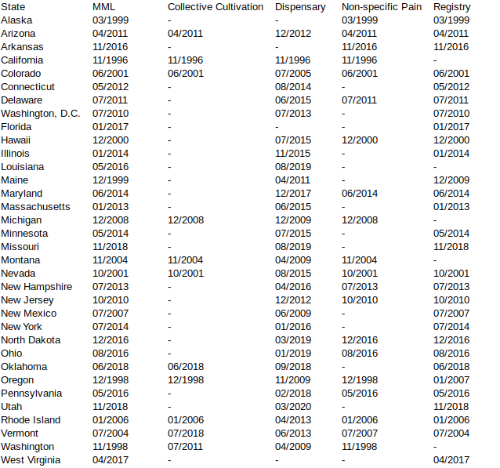
Notes: This table was created primarily from information from Appendix Table 1 of Sabia & Nguyen (2018), which used infromation from Anderson et al. (2013) and Wen et al. (2015). I then updated more recent dates and legislations through information form the Marijuana Policy Project (2019)

References
Abraham, K., & Kearney, M. (2019). Explaining the Decline in the U.S. Employment-to-Population Ratio: A Review of the Evidence (No. w24333; p. w24333). https://doi.org/10.3386/w24333
Anderson, D. Mark, and Daniel I. Rees. 2011. "Medical marijuana laws, traffic fatalities, and alcohol consumption." IZA working paper no 6112. Available at: http://ftp.iza.org/dp6112.pdf
Anderson, D. Mark, Benjamin Hansen, and Daniel I. Rees. 2013. "Medical marijuana laws, traffic fatalities, and alcohol consumption." Journal of Law and Economics 56(2):333-369.
Benbadis, S. R., Sanchez-Ramos, J., Bozorg, A., Giarratano, M., Kalidas, K., Katzin, L., ... & Zesiewicz, T. (2014). Medical marijuana in neurology. Expert review of neurotherapeutics, 14(12), 1453-1465. https://doi.org/10.1586/14737175.2014.985209
CEA (Council of Economic Advisers) Report. Washington: White House; 2014. The Labor Force Participation Rate since 2007: Causes and Policy Implications. https://obamawhitehouse. archives.gov/sites/default/files/docs/labor_force_participation_report.pdf.
Chu, Yu-Wei Luke. 2014. “The effects of medical marijuana laws on illegal marijuana use.” Journal of Health Economics 38: 43-61.
“Civilian Labor Force Participation Rate.” U.S. Bureau of Labor Statistics, U.S. Bureau of Labor Statistics, Feb. 2020, www.bls.gov/charts/employment-situation/civilian-labor-force- participation-rate.htm.
Creason, C. R., & Goldman, M. (1981). Varying levels of marijuana use by adolescents and the amotivational syndrome. Psychological Reports, 48(2), 447-454. https://doi.org/10.2466/pr0.1981.48.2.447
“Employment-to-Population Ratio.” Labor Force Statistics from the Current Population Survey, U.S. Bureau of Labor Statistics, Feb. 2020, https://data.bls.gov/timeseries/LNS12300000
Hanson, Karmen and Garcia, Alise. “State Medical Marijuana Laws.” NCSL - Research - Health, National Conference of State Legislatures, 10 Mar. 2020, www.ncsl.org/research/health/state- medical-marijuana-laws.aspx.
“Historical Timeline - Medical Marijuana” Medical Marijuana, Procon.org, 24 Sept. 2019, medicalmarijuana.procon.org/historical-timeline/.
Krueger, A. B. (2017). Where Have All the Workers Gone?: An Inquiry into the Decline of
the U.S. Labor Force Participation Rate. Brookings Papers on Economic Activity,
2017(2), 1–87. https://doi.org/10.1353/eca.2017.0012
“Labor Force Participation Rate.” Labor Force Statistics from the Current Population Survey, U.S. Bureau of Labor Statistics, Feb. 2020, https://data.bls.gov/timeseries/LNS11300000
Lac, A., & Luk, J. W. (2018). Testing the amotivational syndrome: Marijuana use longitudinally predicts lower self-efficacy even after controlling for demographics, personality, and alcohol and cigarette use. Prevention Science, 19(2), 117-126.
https://doi.org/10.1007/s11121-017-0811-3
Marijuana Policy Project. 2019. “Medical Marijuana Program Implementation Timelines.” Available at: https://www.mpp.org/issues/medical-marijuana/state-by-state-medical-marijuanalaws/medical- marijuana-program-implementation-timeline/
Mikuriya, T. H. (1969). Marijuana in medicine: past, present and future. California medicine, 110(1), 34-40. https://www.ncbi.nlm.nih.gov/pmc/articles/PMC1503422/pdf/califmed00019-0036.pdf
Sabia, J. J., & Nguyen, T. T. (2018). The effect of medical marijuana laws on labor market outcomes. The Journal of Law and Economics, 61(3), 361-396. https://doi.org/10.1086/701193
Substance Abuse and Mental Health Services Administration. 2005. “Results from the 2004 National Survey on Drug Use and Health: Detailed Tables.” Retrieved from https://www.samhsa.gov/data/report/2004-nsduh-detailed-tables
Substance Abuse and Mental Health Services Administration. 2019. “Results from the 2018 National Survey on Drug Use and Health: Detailed Tables.” Retrieved from https://www.samhsa.gov/data/report/2018-nsduh-detailed-tables
Volkow ND, Han B, Compton WM, McCance-Katz EF. Self-reported Medical and Nonmedical Cannabis Use Among Pregnant Women in the United States. JAMA. 2019;322(2):167–169. doi:10.1001/jama.2019.7982
Wen, Hefei, Jason M. Hockenberry, and Janet R. Cummings. 2015. "The effect of medical marijuana laws on adolescent and adult use of marijuana, alcohol, and other substances." Journal of Health Economics 42(3): 64-80.
Wikipedia contributors. (2020, March 13). Timeline of cannabis laws in the United States. In Wikipedia, The Free Encyclopedia. Retrieved 13:49, March 16, 2020, from https://en.wikipedia.org/w/index.php?t itle=Timeline_of_cannabis_laws_in_the_United_States&oldid=945370904

