Healed or Hindered?

A Quantitative Analysis of Labor Force Participation Rates and Medical Marijuana Laws in the United States

Calvin Colson

Submitted to Princeton University
Department of Economics
In Partial Fulfillment of the Requirements for the A.B. Degree

April 8, 2020

Abstract
Acknowledgments
Table of Contents
List of Tables and Figures

Figure 1: 5
Figure 2: 8
Figure 3: 29
Figure 4: 30

1. Introduction

There is no dearth of scientific, political, psychological, economic, cultural, or recreational discussion when it comes to the topic of a certain plant in modern conversations. I am referring to the genus of plants known as Cannabis. Alternately, depending on strain and location, these plants may be known by a variety of other names, including Cannabis indica, Cannabis sativa, Cannabis americanus, Indian hemp, marijuana, weed, and so on. The variety of names for this plant is not particularly surprising when the variety of its uses over thousands of years is also considered. As early as the twenty-eighth century B.C. in China, the plant had been farmed as a fiber crop, and in India the plant was being used for medicinal purposes prior to 1000 B.C., and by 650 B.C. its intoxicating properties had been documented in the Middle East (Mikuriya, 1969). From a more modern perspective, there has been much fascination as well as controversy surrounding the plant as well as the politics and legislation that have resulted in several American states adopting it as a legal medical treatment. The motivation of this paper stems from one of these pertinent controversies.
Shortly after the onset of the 21st century, the United States experienced a sharp decline in multiple labor force metrics. Among those metrics, the labor force participation rate, or the ratio between the labor force (both the employed and the unemployed actively seeking employment) and the total population, was particularly affected experiencing nearly a 5% decrease from peak to low point (Krueger, 2017; “Civilian Labor Force Participation Rate.”, 2020). While it is important to note that the drops are correlated with the 2001 and 2007-2009 recessions, the decrease cannot be entirely explained by these economic events. Evidence for this can be seen in the same study by Krueger, cited above, where a breakdown of the trends of the labor force participation rate by age and gender are presented and discussed. Most notably, the drop in the labor force participation rate of ‘prime age workers’, or those between the ages of 25 to 54, has been the focus of attention. This paper will attempt to analyze one of the conjectured potential causes of the decline in the labor force participation rate in recent years, namely, that of medical marijuana legalization.
In light of recent legislation legalizing marijuana and marijuana-derived products (both those with and without psychoactive properties) (Marijuana Policy Project, 2019), it is no surprise that there is much speculation as to the effects that this substance has on both individual behavior and macro-scale systems, including the labor force. The constituents of the cannabis plant, called cannabinoids, are considered by several to be therapeutic in the treatment of various disorders and diseases, including treating chronic pain, nausea, and spasticity of multiple sclerosis. However, there is also data suggestive of adverse effects and risks associated with consumption of cannabinoids (and especially their principal psychoactive component, delta-nine-tetrahydrocannabinol (THC)). In addition to the cardio-vascular risks of chronic smoking, which is one of the most preferred forms of consumption, akin to other psychoactive drugs labeled as “central nervous system depressants”, consumption of THC has been purported to be linked to “weakness, mood changes, and dizziness” (Benbadis et al., 2014) (See Section 3.2 for more detailed discussion as to the beneficial and adverse effects of marijuana consumption). Extrapolating these symptoms out further, One of the more common and long-standing speculations is to make a causal link between the consumption of marijuana and a psychological disorder known as the amotivational syndrome. Despite the existence of some studies producing equivocal results on the matter, other studies, such as one by Creason and Goldman (1981) and another by Lac and Luk (2018) have shown results that support a correlation between “heavy” intake of marijuana and lower initiative and persistence that could result in decreased “general self-efficacy”. The implications of these results are important to the focus of this paper, because it might lead one to believe that increased usage of marijuana could significantly cause a negative impact on the economy, and specifically the labor market. The reverse side of this argument is also worth noting. That is, that proper treatment of disorders and diseases through the use of medical marijuana may create a positive effect on the labor force due to increased health of potential workers. Individuals that would otherwise be unable to manage both their illnesses and their employment may be empowered to do so through the assistance of medical marijuana treatments. Additionally, it is quite possible that in many cases, marijuana intake is not causative of amotivational syndrome, but rather that those with amotivational syndrome are more likely to use marijuana. Clearly, there are a lot of factors at work in understanding the connection between the labor force and marijuana legalization and usage. In an attempt to quantitatively assess aspects of this relationship, this paper compares data between the aforementioned and partially-contemporaneous events of the recent decline of the labor force participation rate and the national-wide state-level legalization of marijuana in the United States.
In order to accomplish this goal the remainder of this paper will have the following structure. Section 2 will present a background on the trends in both the labor force participation rate and the legislation of medical marijuana laws (MMLs). It will also give a brief review on the possible factors involved in causing these trends, and the distinctions between state differences in MMLs. Section 3’s purpose is to give an overview and discuss previously published literature that is relevant to this topic. In doing so, it will become clear how this paper makes a unique contribution to the existing literature, and where its conclusions might differ from those that came before it. Section 4 gives information on the data that was used to construct this study. This paper will provide information on both the structure and manipulation of the data-sets in order that the results arrived at in Section 5 may be accurately reproduced or otherwise modified to investigate other aspects of the relationships between the variables. Section V gives insight into the methodology of the research. It includes the equations of the regressions used in this study, as well as justifications for the specific structures of these models. Limitations of this methodology are also briefly mentioned here where it is relevant. Section 6 includes the results of the regressions, as well as an interwoven discussion and analysis of their implications. Here, comparisons will be made between the outcomes of this study and those of previous related studies. This section will attempt to provide explanations for the differences and similarities between the respective results. Lastly, Section 7 is a conclusion that attempts to concisely reiterate the key points of the study and its results. Additionally, limitations and the reasoning behind them will be touched upon, as well as suggestions for how future studies may overcome them, or offer additional insight into the relationship between labor force participation and medical marijuana legislation.

2. Background
2.1. Labor Force Trends
From the period of 1999-2018 in the U.S., the employment-to-population ratio experienced a fall of almost 4% (Abraham and Kearney, 2019). Likewise, in approximately the same time frame, the labor force participation rate made a similar but even greater overall drop in magnitude. As can be seen in Figure 1 below (data to construct this graph was obtained from the Bureau of Labor Statistics, see references), which presents annualized averages of the national labor force participation rate and employment-to-population ratio from 1948 to 2020, from its peak in January of 2000 of 67.3%, the national labor participation dropped to 62.4% in September of 2015, a percentage lower than the country had experienced since the seventies (Krueger, 2017; “Civilian Labor Force Participation Rate.”, 2020).
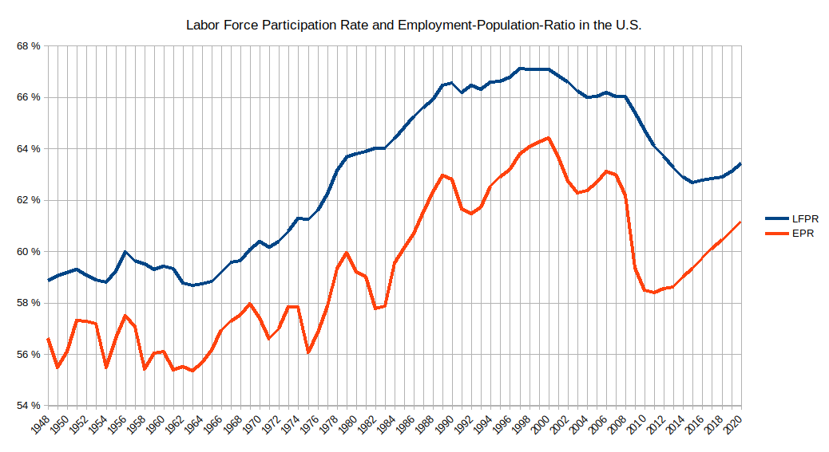
Figure 1
Since that 2015 low, labor force participation has only improved marginally, averaging in the high 62%’s. These two measures of the labor force are closely related, but differ in that the employment-to-population ratio measures the proportion between employed individuals and the total working-age population, whereas the labor force participation rate measures the proportion between the entire labor force (this includes those people actively seeking employment, but not yet employed) and the total population. Historically, these two measures tend to move together in response to relevant factors, and while this is largely true in this interval as well, the increased magnitude of the labor force participation rate in their relative changes (since 2000) provides interest for study. Namely, the portion of the labor force not accounted for in the employment-to-population ratio, that is, the unemployed portion of the labor force, had a greater proportionate drop than the employed portion of the labor force. This points to a different factor in the decreasing of the labor force metrics besides just the economic recession and its typical lower supply of suitable/desirable employment opportunities. That factor is likely concerned with aspects more closely related to the individuals that comprise (or formerly comprised) the labor force, and less so to external market conditions. This assumption is strengthened even further by analyzing the graph around the regions of recent recessions (2001 and 2007-2009). During and following these years, it can be seen that the employment-to-population ratio experiences much steeper declines than that of the labor force participation rate, following the state of the overall economy closer and more quickly. The decline of the labor force participation rate is more drawn out however, and continues to decline (especially relative to the employment-to-population ratio) in spite of the recovering economical conditions following the recessions.
The most prominent factors analyzed by Krueger (2017) in his study “Where Have All the Workers Gone? An Inquiry into the Decline of the U.S. Labor Force Participation Rate” are increased retirement rates due to the aging of workers, and a “secular decline in the labor force participation of prime age men”. More generally speaking, these factors can also be described by breaking the change in the labor force participation rate into two components: one due to the change in rates of participation within certain groups of the population, and the other due to changes in the population shares of those groups as a part of the total population (see equation 2 in Krueger, 2017). The aspect of the aging of workers falls into the second of these components. Krueger shows that the percentage of the labor force age 55 and over increased from 26.3% to 35.6% from 1997 to 2017. The population share for ages 25-54 has correspondingly fallen from 57.5% to 49.3%. This means that the composition of the population has shifted more heavily towards a group with lower labor force participation rates, and this explains “well over half” of the drop in labor force participation rates since the start of the century. This conclusion is also heavily supported by prior research which the Council of Economic Advisors provides a survey of (CEA 2014). The other component of the change in labor force participation rates, that of changes in rates within certain groups, is the main focus of Krueger’s article. In addition to other factors, including the decline in labor force participation for young men and women offset by higher college enrollment rates, he speculates that a substantial part of this secular decline is related to “a significant supply-side barrier of prime age men, namely, health-related problems.” Many of those individuals not in the labor force report experiencing pain and taking pain medication for it. Specifically, Krueger focuses on opioid pain medications and prescriptions and their role in affecting the labor force status of these individuals. It is a possibility that the effect could be depressive and keeping individuals out of the labor force, as Krueger’s data seems to imply. Just as the American opioid crisis is largely temporally concurrent with the decline of the labor force participation rate, so is the legalization of medical marijuana. This provides a parallel and alternative explanation of a particular aspect of the decline of the labor force participation rate.

2.2. Progress of Medical Marijuana
While it is true that government-sponsored legal medical marijuana could be attained in some counties or programs prior, the first state to legalize medical marijuana on a state-wide basis was California on November 5, 1996 (“Historical Timeline - Medical Marijuana”). Since that date to the time that this paper is being written, nearly every year, additional states have followed in passing state-wide legislation to oversee the prescription and usage of marijuana. As a result, currently there are a majority of states that have passed laws allowing for legal medical use of marijuana. For an excellent graphic on the legal condition of cannabis in the U.S. by state, see the Wikipedia article, Timeline of cannabis laws in the United States. Additionally, I have included this graphic below as Figure 2.
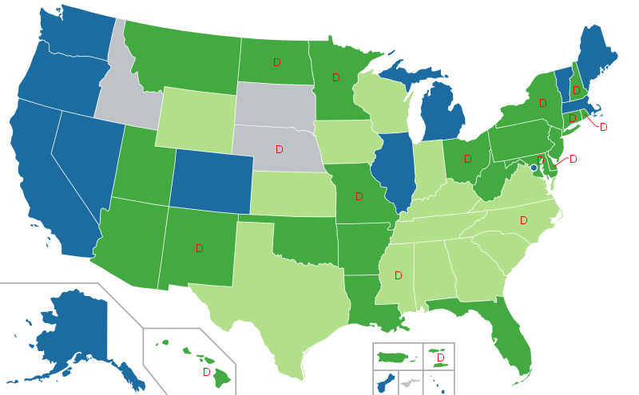
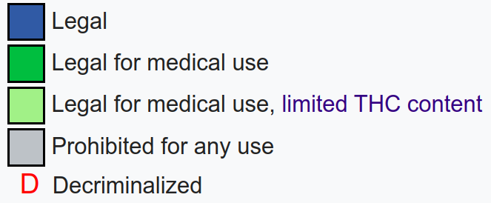
Figure 2
(Source: Timeline of Cannabis laws in the United States, Wikipedia)
In the above graphic, blue colored states of which there are 12 (including Washington D.C.) represent states which have legalized recreational marijuana usage, and thus also medical marijuana usage. Dark-green colored states have legalized medical marijuana usage, but not recreational; there are 22 of these. This means that there are a total of 33 states (and Washington D.C.) that allow legal medical marijuana use. Furthermore, the light-green states have legalized some form of marijuana for medical use, but with restrictions on the amount of THC that the product contains. These restrictions range anywhere from no THC content at all (Kentucky), to up to 5% of THC content (Georgia and Virginia) (Hanson and Garcia, 2020). Lastly, the states marked with the letter ‘D’ have passed legislation that decriminalizes possession and usage of small amounts of marijuana. Due to the open and editable nature of Wikipedia, it is important to note that the statuses of states shown in the graphic were confirmed through cross-reference with the Marijuana Policy Project statuses listed on their website. As can be seen solely from this information, there is a lot of variation in legislation overseeing marijuana prescription, usage, and possession. In addition to the classes of legality listed above, there are also various punitive measures and cultivation regulations specific to different states that require consideration. These factors all ultimately contribute to public sentiment about marijuana in addition to usage statistics. Lastly, in order to present a timeline and intuition of the frequency in which these MMLs were passed, Table 5 in one of the latter sections of this study presents the effective dates in which the MMLs were enacted (the state laws with limited THC are not presented here) in their respective states, as well as additional dates showing the enactment of laws regulating collective cultivation of marijuana, dispensary oversight, non-specific pain as a qualifying condition, and mandatory registration for medical marijuana receiving patients.

3. Literature Review
3.1. Marijuana Usage and MMLs
From a rational perspective, the first step in examining a potential causal relationship between MMLs and labor force outcomes does not actually involve the labor force at all. That is, we first need to establish the connection between the passage of MMLs and the change in usage that results from it. According to Sabia & Nguyen (2018), using information from the National Survey on Drug Use and Health (NSDUH) from the years 2002 and 2014, in that time frame, “consumption among adults ages 18 and older rose from 6.0 to 8.5%” They also note that the most significant increase occurred during the year 2008. However, I was unable to verify this information fully, as the Substance Abuse and Mental Health Services Administration (SAMHSA) which publishes the NSDUH currently only provides the detailed table information cited by Sabia & Nguyen ranging back to 2004 and not 2002. Furthermore, it is not exactly clear what Sabia & Nguyen mean by “consumption” in this case. It could imply marijuana use in any specific time frame, but much more likely, in the past month.
Because this is the primary literature establishing a link between labor market outcomes and MMLs, I have also followed the pattern of providing marijuana usage trend analysis from the NSDUH for the available (and more modern dates). To elaborate, analyzing data from the 2003 & 2004 surveys, the tables (Substance Abuse and Mental Health Services Administration, 2005) report that 6.0% of Persons surveyed aged 18 or older had used marijuana in the last month at the time of the survey in 2003. In the last year, since the question was answered, that percentage was 10.1%, and in answer to the question of ever having used marijuana in their lifetime, 43.1% of the persons interviewed answered positively. As stated by Sabia & Nguyen, over time these numbers have increased significantly. In illustration the ‘Detailed Tables’ produced by SAMHSA following the 2018 NSDUH (Substance Abuse and Mental Health Services Administration, 2019) report the following percentages for marijuana usage for persons aged 18 and older: 10.5% in the last month since question was answered, 16.2% in the last year, and 48.3% in regards to having ever used. In terms of monthly usage, the percentage has almost doubled since 2003.
The demographic breakdowns of these trends also prove interesting. For these demographic breakdowns, I have specifically focused on the data for usage in the past month, as it would be the closest approximation of regular usage within this particular set of data. In 2003 twice as many males reported using marijuana in the past month than females did (8% and 4% respectively). In 2018 the survey showed that 12.9% of males reported past month usage relative to 8.2% of females. This is a 21.3% reduction in the ratio between male and female monthly usage. When it comes to breakdown of the statistics by age, unfortunately, the tables do not provide too discrete of data. The age divisions that do not overlap are ages 12-17, 18-25, and 26+. We will ignore the youngest division at this time, because although the progress of MMLs is very likely to affect even the usage statistics of members of this age range through public sentiment and other mechanisms, the overlap between them and members of the labor force is relatively small, so it will not be applicable to later discussion. In 2003, 17% of persons aged 18-25 reported using marijuana in the past month, compared to 22.1% in 2018. Likewise, for persons aged 26+, 4% reported using marijuana in the past month, compared to 8.6% in 2018. Again we see a moderate proportionate increase in one group relative to a large increase in another. There is not too much disparity in the increases in monthly usage along racial lines with the largest exception being the Asian population which has over tripled its usage (from 1.8% to 5.8%) in the time frame, whereas most other racial groups have approximately doubled their percentage of users in the statistic. These reports show that the groups least likely to use marijuana in 2003 are the same groups that experienced the largest proportional increase in marijuana usage by 2018. It is quite possible that this effect could be partially explained by the normalizing nature (see section 3.2) of MMLs on mainstream culture and its opinion about marijuana. That is, that groups which were most adverse to marijuana usage in the past were also most susceptible to having their aversions allayed by the public acceptance of medical marijuana usage demonstrated by the passing of MMLs. Lastly, as a more concrete tie-in to the issue of the labor force, in 2003 the percentages of persons older than 18 who reported using marijuana in the past month by employment status were: 6.3%, 8.4%, and 13.8% for full-time, part-time, and unemployed populations respectively. These percentages increased to 11.1%, 13.4%, and 20.4% (respectively) for the year of 2018. Here, we see the similar trend of the smallest percentage groups experiencing the greatest proportional increase. We also see the pronounced difference in the percentage of users who are unemployed relative to the other two groups. This larger magnitude of non-employed users will be seen to also appear when analyzing the pain-medication prescription rates (of which medical marijuana can fall into) by labor-force status (Krueger, 2017) (see section 3.2). The data makes an important distinction here to list these ‘unemployed’ individuals as being the unemployed portion of the labor force. It is also important to note, that as with any data about potentially illicit substances, anonymous or not, there is likely a degree of underestimation of usage. While marijuana is less susceptible to this effect than other perhaps more stigmatized drugs, the effect could still be substantial on the reported numbers. Additionally because many of the questions in the NSDUH contain topics relevant to the span of a year are longer, there is also potential recall bias at play (Volkow et al., 2019).
With this understanding of the trends of marijuana usage since 2003, we can now analyze the role that MMLs have played in contributing to them. Wen et al. (2015) finds that the implementation of an MML leads to a relative 14 percent increase in the probability of past-month marijuana use and a 15 percent increase in the probability of almost daily/daily marijuana use among adults aged 21 or above. This same study also found a correlation between MML implementation and binge drinking for this same age group, but no significant correlation between MML passage and usage of harder drugs, thereby not supporting the argument of a ‘gateway’ effect of MMLs to harder substances. Anderson and Rees (2011) also find that implementation of MMLs are correlated with a “2.2 to 5.4 percentage” increase in marijuana use for populations aged over 18, in the states of Montana and Rhode Island. While MMLs are focused on the legal prescriptive effects of marijuana, it is very unlikely that their enactments solely impact legal marijuana usage. One study shows that the passage of MMLs is accompanied by a 15-20 percent increase in marijuana arrests for adult males, and a 10-20 percent increase in marijuana-related admissions to rehabilitation centers (Chu, 2014). This implies that there is a very substantial ‘spillover’ effect of MMLs into the non-medical marijuana market. It is speculated that this effect is primarily driven by changes in public sentiment towards marijuana due partially to MMLs, as well as to the direct effect on the supply-side of the market for marijuana due to increased availability from dispensaries. In fact, Anderson et al. (2013) finds that MMLs are correlated with “9.8 to 26.2 percent decline in the street price of high-grade marijuana). These studies provide a comprehensive picture that the enactment of MMLs increases marijuana usage in a substantial manner throughout several groups of marijuana users, both medical and recreational.

3.2. Mechanisms in which MMLs Affect Labor Participation
The overall effect of MMLs on labor participation is theoretically ambiguous because there are mechanisms at work which could influence the labor participation rate in positive and negative directions. First, concerning the positive aspect of MMLs on labor participation, some studies suggest improvement of pain symptoms, especially those connected to rheumatic diseases when treated with herbal medical marijuana or cannabinoids. Theoretically, if MMLs are increasing marijuana usage and resulting in the successful treatment of debilitating disorders, then the labor force will be healthier and more people will be actively seeking employment, thereby raising the labor force participation rate.
Much of this research is centered around fibromyalgia, as there are not many effective treatments for the main complaint of this disorder: pain. Fiz, J., Durán, M., Capellà, D., Carbonell, J., & Farré, M. (2011) concluded that the administering of cannabis (both smoked, oral, and combined) was “associated with beneficial effects on some FM symptoms”. More specifically, in the study (N=56), after only two hours of marijuana usage, visual analogue scales showed a statistically significant (p<0.001) “reduction of pain and stiffness, enhancement of relaxation, and an increase in the feeling of well being”. Additionally, there was a significant but slight increase in cannabis users’ mental health component summary scores (Short Form 36 Health Survey) relative to the non-users. Bonn-Miller, Marcel O., Michael J. Zvolensky, and Amit Bernstein (2007) additionally support the claim of marijuana treatment improving mental health through potential reduction of anxiety. Habib, G., & Artul, S. (2018) also report that a sample (N = 26) of patients in two Israeli hospitals, unanimously reported “significant improvement” in all parameters related to pain after commencing medical marijuana treatment for fibromyalgia. However, there are also studies that argue against the efficacy and even safety of prescribing cannabinoids for treatment of rheumatic diseases. Stockings, Campbell, Hall, et al. (2018) offer a review on cannabis as a treatment for chronic non-cancer pain conditions (CNCP) which included a wide range of disorders, among which are fibromyalgia, rheumatoid arthritis, multiple sclerosis-related pain, and other CNCPs. This review concludes with the opinion that it is “unlikely that cannabinoids are highly effective medicines for CNCP”, due to limited effectiveness and potential of adverse effects. This same review however, also shows that the reduction in pain experienced by cannabis users relative to placebo users is significant, but with a small magnitude (29% self-reported reduction vs. 25.9% for placebo). Fitzcharles, M., Baerwald, C., Ablin, J. et al. (2016) found no consistent “superiority of cannabinoids over controls (placebo, amitriptyline)” and additionally some participants reported side effects including sleep problems, fatigue, limitations of quality of life. In fact, this reporting of side effects is common to all of the sections above-cited studies, with drowsiness and fatigue being especially prevalent.
The results of these studies draw a conflicted picture of the efficacy of marijuana in treating disorders, but if the significant reductions in pain and anxiety are considered, it is reasonable to believe that treating patients with medical marijuana could result in a larger supply of labor and a more efficient labor force that is less impeded by medical complications. To cap off this point, Bradford and Bradford (2016) also note the possibility of medical marijuana serving as a substitute for other drugs, especially opioids, in pain management. These substitutions could relieve adverse effects caused by more harmful drugs and usage habits, thereby also increasing labor force participation and efficacy. On the same note, Crost, B., & Guerrero, S. (2012) provide findings that marijuana and alcohol are substitute goods, evidenced by a sharp drop-off of marijuana usage in individuals who turn 21 years of age, the US minimum legal drinking age. There are conflicted findings as to the potential effects of this supposed substitution on labor force outcomes. For instance, Mullahy, J., & Sindelar, J. (1996) found that “problem drinking” is associated with higher unemployment. Renna, F. (2008) also finds that regular alcohol consumption can reduce multiple labor force outcomes including hours worked. However, several other studies find a positive correlation between alcohol consumption and positive labor market outcomes. Lye, J., & Hirschberg, J. (2010) offer a good review of these, as well as possible shortcomings in methodology that might compromise the integrity of their findings. Furthermore, of critical importance in the direction and intensity of this effect is frequency and volume of the drinking, of which the literature often does not establish discrete standardization.
Conversely, there is also evidence suggesting opposite, negative effects of MMLs on the labor force participation rate. In addition to the side effects mentioned in the previous paragraph, there is substantial evidence of cannabis usage increasing the possibility of mental health problems. Van Ours, J. C., & Williams, J. (2009) offer an empirical causality study on the association between cannabis use and mental illness, in which their results suggest usage to have an negative effect on mental health, “with frequent current use having a larger effect than infrequent current use or past use.” The same authors also published an overview (2015) of the literature surrounding cannabis use and health, education, and labor market effects. They conclude that while there are no major harmful health effects of moderate cannabis use, there is evidence of reduced mental well-being for heavy users, especially those predisposed to mental health issues. They also note robust evidence (Lynskey and Hall, 2000; Macleod et al., 2004) that early cannabis is correlated with lower levels of educational attainment. Strengthening these findings, Volkow et al. (2016) find associations with heavy/frequent marijuana usage and diminished learning, poorer memory, and attention issues.
Tying into the potential reasons for this association, for a physical aspect, Irons et al. (2014) shows an association between low physical activity and likelier usage of cannabis from past/quitting cannabis users, however, to be fair, this research more likely suggests lower physical activity resulting in cannabis usage instead of the other way around. Pesta et al. (2013) argues a general belief that marijuana usage has ergolytic effects, with the most relevant explanation for this study being an “achievement of maximum heart rate at reduced workloads”. This paired with adverse effects to standing steadiness, reaction time, psycho-motor performance, and deficits in general performance could contribute to a cannabis user getting physically exhausted more quickly, and performing less competently in a professional context than a non-user. These two studies are used by Sabia & Nguyen (2018) to argue a lethargy association with marijuana usage.
Perhaps more convincing, in “Testing the Amotivational Syndrome”, Lac, A., & Luk, J. W. (2018) find strong evidence that marijuana use often predicts lower initiative and persistence in college students (N = 505). This study was conducted while excluding several baseline covariates “including demographics, personality traits, alcohol use, tobacco use, and self-efficacy subscales.” The study not only showed the association between marijuana usage and the adverse mental effects, but also the temporal direction; the lower initiative and persistence were “significantly and longitudinally prompted” by marijuana usage, and notably not by alcohol or tobacco usage. Conversely, the reverse temporal direction, or lower initiative and persistence prompting marijuana usage was not upheld by the data. Initiative and persistence are arguably critical prerequisites for both employment attainment, as well as prolonged job searching. It is not difficult to envision how the debilitation of these factors could negatively impact the labor force participation rate.
In contrast with the potentially positive substitution effect of marijuana and other drugs discussed above, there is also a possible negative, complementing effect between some of these substances. Williams, J., Liccardo Pacula, R., Chaloupka, F. J., & Wechsler, H. (2004) using data from 1993, 1997, and 1999 argue that alcohol and marijuana are economic complements, at least among college students. They arrive at this conclusion from analyzing relationships between marijuana and alcohol usage and shifts in the price of alcohol. Policies that raise the price of alcohol also result in a decrease in marijuana usage. If these findings hold among the general population, depending on the effects on the labor market (discussed in the next section) of both increased marijuana usage and consequently increased alcohol consumption (discussed above in this section), the passage of MMLs could either magnify or lessen (through competing factors) the total impact of substance usage on labor outcomes. In the case of complement goods in the drug market, alcohol is the main standout for a potential complementary relationship with marijuana. Most “harder drug[s]” studied do not have as significant a link to increasing marijuana usage (Wen et al., 2015; Sabia & Nguyen, 2018).

3.3. The Effects of Marijuana (and other drugs) on Labor Force Outcomes
The research done on the associated effects of marijuana usage and various labor force outcomes is unfortunately not too extensive. However, this section will attempt to summarize the key points. Van Ours, J. C., & Williams, J. (2015) offers a brief section devoted to overviewing “Cannabis Use and Labor Market Success” as part of a tripartite study on cannabis and its relationship to health, education, and labor market outcomes. Here are introduced the main problems associated with research in this topic, namely, potential endogeneity through reverse causality and omitted variables. In reference to the former of these two inroads for endogeneity, reverse causality is an inherent problem to be considered in models because for most individuals, labor market earnings are a primary element of personal income. If we assume marijuana to be a normal good, an assumption that has conflicting evidence (Roy, S., 2005; Saffer, H., & Chaloupka, F. 1998), then as an individual’s income increases (potentially through joining the labor force and employment), the demand for marijuana will also increase. Conversely, if marijuana is an inferior good, with increased income, the demand will decline. Due to these relationships it becomes difficult to discern which variable (labor force outcomes or MML/marijuana usage) is driving the other in a particular instance, and as a result, inferred models of causality become muddled. Our other mechanism for endogeneity in the relationship is omitted variable bias. Potential omitted variables that could be important in this relationship include individual level variables (such as a person’s health, their age, their education, etc), regional variations (cultural factors and wage/price differences among regions), and time-dependent variables (depending on the length of the study) which often mirror regional variable effects. All of these variables have a potential to impact a person’s employment or earnings, and also could influence an individual’s marijuana usage habits. In this way, a correlation might appear between labor force outcomes and marijuana usage that in fact is not a causal relationship between either of these variables, but truly driven by a third variable that was omitted from the study.
In order to tackle these problems of endogeneity, there have been three main approaches in the literature. Chronologically, the first method employed by researchers to investigate causality between cannabis (and drugs in general) usage was an Instrumental Variables (IV) approach. This “first wave” of studies, as described by Van Ours et al. (2015), was completed from 1991-1994 and primarily uses data for 18-27 year olds from the 1984 National Longitudinal Survey of Youth (NLSY). The instruments used in these studies’ estimation equations for the effect of marijuana usage had a wide range: nonwage income, frequency of religious attendance in 1979, the number of delinquent acts in 1980, and current number of dependents (Kaestner, 1991); parents’ education, a dummy variable for being raised in a Baptist or Methodist household, attending religious services at least weekly, recent divorces, and living in a large city (Register and Williams, 1992); frequency of going to bars recently, a dummy variable for alcohol relapse after declared abstinence, income from illegal activities in 1980, and legal charges in 1980 (Gill and Michaels, 1992). Besides the possibility of the integrity of several of these instruments suffering from potential bias in self-reporting, the instrumental link between many of these variables and marijuana usage is tenuous at best, especially when coupled with the knowledge that the justification for their usage is often sparse or nonexistent. A good instrumental variable in IV analysis is one in which there is a strong correlation between that variable and the explanatory variable in the equation, and additionally, the instrumental variable has little to no independent effect on the independent variable. In the case of each of the following variables: a parent’s education, illegal activity, number of dependents, residence location, and religious involvement, one of two issues is always present; either that variable does not have a strong proven link to marijuana usage, or if there is evidence that it does, it could also be argued that there is an effect of the variable (for example, a parent’s education) on labor force outcomes that is independent of an effect caused through the associated marijuana usage. Despite the dubious nature of the methodologies of these studies, their results are of interest in the laying of the foundation for this area of research. In terms of wages Kaestner (1991) showed that a male having used marijuana in his lifetime is estimated to earn 18% more than one who has not used marijuana. Gill and Michaels (1992) show that drug users (cannabis or cocaine) earn approximately 4% in hourly wages more than nonusers, and Register and Williams (1992) shows similar results of a 5% increase in hourly wages for those who use cannabis at least monthly (although an opposite effect for long-term and on-the-job users). These results run counter to the theory of the mentally debilitating nature of marijuana, but echo the results related earlier in this review as to the higher wages of alcohol consumers relative to abstainers. Additionally, and closer to the context of this paper, Gill and Michaels and Register and Williams also show that an individual’s probability of being employed is estimated lower if they are cannabis users. Register and Williams goes further and reports that the higher the usage, the less likely employment is. They provide three possible explanations for this finding: 1) marijuana usage can lead to friction with employers which creates problematic work history that hinders new employment, 2) marijuana usage increases the taste for leisure, thus lowering labor supply and 3) marijuana may reduce productivity which may show in work history analysis for potential new employment. The latter two reasons relate closely with our earlier psychological and medical review. The first explanation perhaps has greater implication in more modern times with the increases in pre-employment drug testing since the time of this study’s publication. The results during this wave of research that did not show higher wages, and lower employment for cannabis users, showed no effect on these dependent variables, with no studies showing an inverse effect (lower wages or higher employment).
The second wave of studies discussed in our review were constructed between 1998 and 2010. From a methodological standpoint, these studies differ in that they rely on alternate econometric approaches in estimating labor outcomes relative to drug usage (as opposed to using IV analysis). Moreover, there is also more of an effort to distinguish aspects of drug use that might have characteristic effects on labor outcomes (i.e. frequency, length of usage, age of individual during onset of usage, potency of the drug, etc). To summarize the findings, the general consensus among the results of these studies is that “non-problematic use of drugs” a term defined by Van Ours (2015) to mean “light to moderate use, or the use of soft drugs” has little to no impact on labor supply; “heavy use, or the use of hard drugs” does have a negative effect on both employment and wages. There are several studies supporting this conclusion (Burgess and Propper, 1998; MacDonald and Pudney, 2000; French et al., 2001; DeSimone, 2002; Van Ours, 2007), with the Van Ours study specifically noting that the strength of the negative wage effect is dependent on the age of the individual when they began using marijuana. It is also important to note that several of these studies also report results that disagree with this conclusion. Among these are Van Ours (2006) which while acknowledging a negative effect of both marijuana and cocaine usage on the employment rate for males (no such effect for females), finds that after correcting for certain individual-level variables, the negative effect of both drugs on employment rates disappears. This finding of Van Ours is partially in response to the DeSimone (2002) study which uses an IV analysis to show a negative employment effect with a magnitude of 15% for males using cannabis and/or cocaine. Van Ours highlights complications of this approach, both in the instruments used, and also in the confounding drug effects of the large amount of users who use both cocaine and cannabis. Conti (2010) offers an opposing view in showing a positive relationship between cannabis usage and wages, however, she then acknowledges that the results are somewhat spurious as it is likely that marijuana usage in the data is acting as a proxy for cognitive ability. Among this wave of studies, the main two alternate (to the criticized IV analyses) methodological approaches to reducing the endogeneity problem of drug use and labor outcomes, are timing of events and fixed effects analyses, and discrete multivariate mixed proportional hazard frameworks. In fact, a recent study by Williams and Van Ours (2017) uses the latter named model to show that usage of cannabis for longer than a year prior to leaving school leads to individuals having a higher probability of accepting jobs sooner and at lower wages. This could perhaps explain a mechanism for some of the results on the association between marijuana usage and lower wages, but would also imply greater employment rates as individuals spend less time looking for a job.
As far as literature directly linking MMLs (and not a direct analysis of marijuana or other drug use effects) to labor force outcomes, the literature is unfortunately very sparse. The primary source for the field is Sabia & Nguyen (2018). In addition to showing the increase in usage of marijuana as a result of MML passages (discussed in section 3.1.), they go on to show a 2.3% decline in hourly wages for males between the ages of 20-29. This decline in hourly wages grows slightly in magnitude when considering a dynamic nature of MMLs (with statistically significant values for male 20-29 year-olds being -3.5% and -4.7%, for year of law change and 2 years after respectively). Sabia & Nguyen arrive at these conclusions using data from the Current Population Survey Outgoing Rotation Groups (CPS-ORG) for labor data, and the data they used for MML effective dates was compiled using sources described in section 2.2 of this paper. From a methodological perspective, a difference in differences model was used to analyze a binary employment statistic, hours worked, and wages earned for a variety of individuals in a sample which delineated characteristics including age, gender, race, marital status, etc. However, the focus of this particular study is primarily centered on age and gender. Specifically, the regressions used are a probit model for the employment variable, and Heckman selection-corrected least squares model for the hours worked and wages variables. They also go further to show that there are some significant effects on earnings relative to what kind of MML is present in a specific state (different types are outlined in Table 5), as well as different wage effects of MMLs vs. MDLs (Marijuana Decriminalization Laws) vs. MLLs (Marijuana Legalization Laws). The type of MML results show that the presence of dispensaries can result in larger decreases in wage, especially for males, and that the presence of registries can result in a protective result, correlating with relatively higher wages, especially for women ages 30-39. The MML/MDL/MLL analysis shows that MLLs have the strongest wage effects of the three, with the strongest effect centring on young (18-19) males.
Outside of this study by Sabia & Nguyen, Ullman (2016) is the only other study of which I could find focusing on MMLs and some aspect of employment. Ullman reports an 8% reduction in employee absences due to illness if that state has an active MML. The author also notes that states with more relaxed medical mairuana regulations show a more pronounced reduction. I could not find any research examining a direct link between MMLs and labor force participation rate analysis.

3.4. Contribution to the Literature
My study is important to the current state of MML and labor literature because despite the mechanisms described in Section 3.2 there is currently no research directly linking changes in the labor force participation rate to MMLs. While there are some studies that examine the relationship between MMLs and employment, they tend to focus either directly on employment rates (unemployment rates/employment-to-population ratio) or binary representations of individual employment statuses. In doing so, they fail to focus on a subgroup of the population that might be significantly affected by the effects that cannabis prescription results in. This subgroup is the unemployed portion of the labor force participation rate, or those individuals who are unemployed but actively seeking a job. As described before, in Section 2.1, this is the group that experienced the larger proportionate decline in the last two decades. The reciprocal of this decline is captured in the increase of the reciprocal of the labor force participation rate, and particularly those unemployed individuals who stopped actively searching for employment and thereby dropped out of the labor force. Using data from the CDC National Health Interview Survey, Krueger (2017) shows that among prime age men, the percentage reporting pain in the last 3 months is directly correlated with their labor force status, with those not in the labor force being the most likely to report pain, at a margin of close to 20% greater than that of employed prime age men. It is a plausible assumption that many of these individuals outside of the labor force reporting pain are either self-medicating with marijuana or being prescribed marijuana by a doctor for their pain symptoms. We have explored that both of these situations (prescribed marijuana usage and spillover recreational or illegal usage) result from the passage of MMLs (see Section 3.1). If there is a causal link between marijuana usage and amotivational syndrome (or other debilitating mental illnesses), then MMLs could be an explanation for the distinctive drop in the labor force participation rate, especially when compared with the employment-to-population ratio. Therefore, this study takes a unique approach to the widely speculated upon topic of drug use and labor outcomes. Furthermore, in using a differences-in-differences model with fixed-effects analysis, this study avoids some of the potential biases that have been criticized in prior drug use and labor force studies that use an instrumental variable approach. Lastly, in using more recent data (up to 2020) this study will give a more accurate picture of the current trends in the effect being analyzed. This recency and larger chronological sample of data also provides more room for analysis of dynamic effects of MMLs, in the event that enactment requires a substantial lag period before its repercussions can be observed sufficiently.

4. Data
4.1. Marijuana Use and Individual Data
The first logical step in the analysis of the relationship between MMLs and labor force participation rate is also the first link in the chain of supposed mechanisms discussed earlier: the effect of MML enactment on marijuana usage. In order to quantitatively analyze this relationship, I use information from the National Survey on Drug Use and Health (NSDUH) directed by the Substance Abuse and Mental Health Services Administration (SAMHSA), a division of the U.S. Department of Health and Human Services. The NSDUH provides a leading source of individual-level statistical data on both illegal and legal drug use, as well as mental health issues, and demographic information of the participants. The survey’s participants are designed to be representative of the U.S. civilian, non-institutional population aged 12 or older.
The specific study in the series that I am using is the NSDUH-2002-2018 concatenated public-use file, which combines the results of multiple years of surveys and attaches the appropriate weights for multi-year data analysis. These weights are quite complex in their calculation, and because the data is based on sample survey data rather than complete data for the population, they should be used in analysis in order to be representative of the population without bias. The weight for each respondent of the survey can be viewed as the number of sampling units in the target population that are represented by that respondent. Thus, the sum of all the respondents’ weight values is representative of the total target population value. For more information on how these survey weights are calculated, refer to the codebooks on the SAMHSA site corresponding to the NSDUH-2002-2018 study (as well as the codebooks for the specific years this study is comprised of). The weights used in this analysis are coded under the ANALWC17 variable.
This particular file is a more recent publication than the 2002-2014 survey used by Sabia & Nguyen (2018). The NSDUH is available in two formats, public-use data files and restricted-use data files, with the distinction being that the restricted-use files have additional variables, including geographic identifiers, whose public availability could potentially compromise the level of confidentiality the program desires. These geographic identifiers would have been useful for this study’s analysis (linking discrete state MML data with marijuana usage responses), but due to limited availability, I was unable to use the restricted data for this purpose. However, this source would provide a good option for follow-up studies.
Alternatively, and fortunately for the purposes of this study, the public-use data files include a binary variable representative of whether the state that the individual is in has passed an MML at time of the interview. In this initial usage analysis, I use this variable as a stand-in for the more detailed MML information that I use for later regressions involving labor force data. The other notable right-hand variables derived from the data-set that I use in my analysis are primarily individual demographic identifiers that are used to protect against potential omitted variable bias of factors affecting marijuana usage. In choosing these identifiers, I followed the base example of Sabia & Nguyen with some modifications to account for the differences in our data-sets (namely that Sabia & Nguyen had access to the more specific restricted-use data). For example, as I did not have access to the integer age of the survey respondents, but rather an age range representative of their discrete age, in calculating the value for linear-age and age-squared control variables, I used a weighted (by population proportion) average of the values within the range to be representative of the age for each individual within that range. The age ranges I selected also differ from Sabia & Nguyen, due both to differences in data, as well as a desire to focus in on specific demographics of individuals. The age ranges that are evaluated (and shown in Appendix Table A2) are: 16-18, representative of high-school age individuals; 18-23, representative of college-age individuals; 24-29, representative of graduate student-age individuals and those who are still in the early stages of their careers; 30-49, an approximate representation of those in their prime-working ages; 50-64, representative of individuals in their later working years, and those who might be experiencing more medical issues; 65+, representative of the retired and elderly population. While the NSDUH contains data for individuals under 16 years of age, 16 is our lower range as this is the minimum age to be considered a member of the labor force. The following individual-level control variables were used: linear-age and age-squared, level of education attained, marital status, race/ethnicity, and whether the individual was enrolled in school at the time of the survey or not. That last variable differs from the prior research of Sabia & Nguyen, in that they focused specifically on college enrollment. The reason why this could be problematic is that the data associated with this variable specifically only includes individuals aged 18-22 enrolled in college (with distinction of full-time and part-time). This particular data would not include individuals who might be experiencing similar social influences related to marijuana usage but do not fall within this age range, or are attending an academic institution that is not a college (e.g. high-school). Additionally, I included a control variable for the individual’s gender (which was not included in Sabia & Nguyen’s analysis). I think the gender of an individual can be an important factor in marijuana usage, as we have seen from trends in others’ research (described in section 3.1) that there are significant differences in usage statistics between males and females; males are much more likely to have smoked marijuana both in recent and lifetime intervals. As for the left-hand variables in the NSDUH data, this study follows the example of Wen et. al. (2015) and examines marijuana use in the last month, coded as ‘Marijuana Use’, and marijuana use in at least 20 of the last 30 days, coded as ‘Near daily Marijuana Use’.
In Table 1a and Table 1b, I have presented the summary statistics for past month use and near daily use of marijuana (the dependent variables) broken down by gender and age groups. The most notable trends that can be seen in this data are: 1) The male respondents to the survey report higher proportions of both past month marijuana use as well as near daily marijuana use than do their female counterparts. 2) The margin is rather significant, comprising approximately a 2:1 ratio in many of the age groups, although notably, this difference is not nearly as strong between the sexes when referring to the past-month use for 16-18 year olds. In fact, as the ages of the respondents increases, there is a marked increase in the proportionate difference between male and female past month use and near daily use numbers, with the largest difference proportional difference being in the 65+ group. 3) There is a general trend of lower use percentages (both past month and near daily) for the older age groups. However, this trend is contradicted in the younger age groups, as those that are college-age (19-23) have higher percentages of use than the youngest age group (16-18). This holds true for both males and females, as well as both categories of use. In Table 1c I also chose to present the target population estimates for the NSDUH data using survey weights that accompanied the data. This is meant to give a more accurate depiction (by gender and age) of the population represented by the survey data, as the surveys’ respondents do not match the population in their raw frequency (with notably more females and less older individuals participating). Lastly in Table 2, I present frequencies for the main control variables that are derived from the NSDUH data. These frequencies are calculated from the raw data, and not weighted to the population. A description of each of these tables along with clarifying notes can be found beneath each of the corresponding tables. I did not include a full frequency table with demographic breakdowns for the independent variable (State MML passed at the time of interview), as there should be no meaningful trends between gender and age demographics relative to this variable. Additionally, its presentation is quite simple: 52.45% of respondents live in a state where an MML had been passed, while 47.55% live in a state where no MML had been passed. This statistic has 337,063 associated observations. As an unfortunate caveat, the MML data is only available in the NSDUH beginning in the year 2013. This means that the first decade of archived surveys cannot be used in this analysis, and it greatly impedes the chronological scope of the panel data. This is part of the reason why access to the restricted-use data would be very beneficial in expanding the implications of this research, as independent state data (such as effective dates of MML enactments) could be linked to the data in the NSDUH, as is done in the labor force regressions done later in this study. However, while the effects of the earlier years of MML history cannot be analyzed here, the span of available data does offer insight into a pivotal period of the timeline in question. That is, the years surrounding the transition of the majority of people living in states that have passed an MML. This statement remains true whether considering number of survey participants, or when considering the target population of the NSDUH (roughly equivalent to the United States population older than 12 years of age) as a whole. Below I have included two figures that demonstrate this transition. The first, Figure 3, is the raw frequency values by year of the number of individuals in the survey who lived in a state which had passed an MML, or did not. The second, Figure 4, is that same tabulation, but weighted by the survey’s analysis weights to be representative of the true target population frequencies. As you can see, in both cases, some time between the 2015 and 2016 surveys, the majority passes to the individuals residing in a state with an MML.

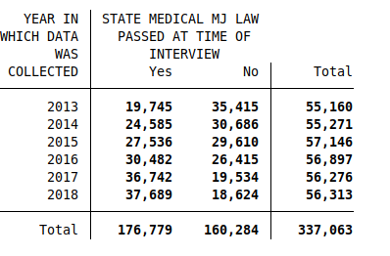

Figure 3

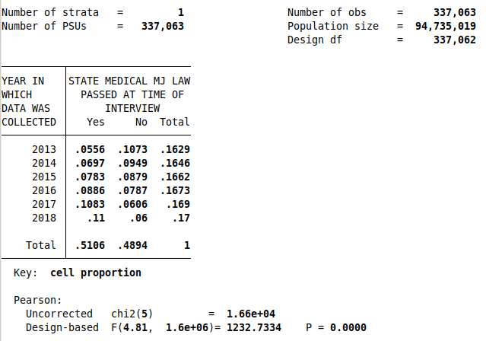
Figure 4
4.2. Labor Force and MML Data
Whereas the first part of this study’s analysis used data from a single source, the NSDUH, this second part compiles data from multiple sources. Another important distinction between the data of the previous section and the current one is that the data to be analyzed here is state-level data as opposed to the individual-level data focused on prior. The first source of data that we will examine corresponds to the dependent variable in the regression, the Labor Force Participation Rate (LFPR). While national data for the LFPR is available through the Bureau of Labor Statistics (refer to Figure 1 in Section 2.1 for a look at the history of this rate on a national scale), I obtained the Labor Force Participation by State data from the Federal Reserve Economic Data, better known as FRED. FRED is a database maintained by the research division of the Federal Reserve Bank of St. Louis, and it is very commonly used in modern economic analysis. This is largely due to its reputation for consistently maintaining and updating its data to reflect current economic realities, which is important in trusting the data for making real-time inferences. FRED covers a multitude of economic and financial topics throughout its data, and fortunately for our purposes, employment and labor statistics also fall under this umbrella.
Specifically, they provide LFPR by state data, and while it is still sourced from the U.S. Bureau of Labor Statistics, it is packaged through FRED in a more easily digestible manner, and does not need to be parsed manually by state. FRED offers data files for LFPR for each state and additionally for Washington D.C. In reference to each state (and D.C.), there is a file representing the raw LFPR values, and another file representing those that have been seasonally adjusted. For the purposes of this study, I will be using the raw values for my regressions, but using these seasonally-adjusted values could also prove useful in a follow-up study. However, if month fixed effects are included in the analysis, it is possible that these seasonally-adjusted values could prove problematic (depending on methodology of calculation), since the month effects should be related to seasonal effects.
The format of the LFPR by state data is thus 51 separate data files with monthly reports of LFPR ranging from 1976-2019 (528 months or 44 years). I merged these files into one file containing all of the data, with each observation (row) representing the LFPR values for all of the states for a specific month. This is known as a wide format of data, which is incompatible with running the required regressions. Consequently, I reshaped the data into a “long format” consisting of 528*51 (26,928) observations, or one for each month-state LFPR cross-section. This however, was not the final observation count used in the analysis, as I decided to adopt the starting point of Sabia & Nguyen’s labor force analyses timeline, and dropped the data for dates prior to 1990, resulting in 360 months and 18,360 observations. I chose this range for two main reasons. The first is to more easily compare my LFPR results with the labor outcomes studied by Sabia & Nguyen (employment, hours worked, and wages), and discuss possible relationships between them. The second is that it gives a nice span of time prior to the adoption of the first state MML (California in 1996).
In Table 4, I present the summary statistics, by state, for the LFPR data used in this study. The aspect that stands most in this table is that there is a rather large range between the values for the LFPRs of the different states. Minnesota has the highest mean LFPR with a value of 72.77%, while West Virginia is an outlier, with a mean LFPR of 54.93%. This is a range of 17.84%. The next lowest mean LFPR values come from Mississippi, Alabama, and Louisiana with LFPRs of 59.89%, 60.82%, and 60.92% respectively. There appears to be a regional correlation between LFPR with the lowest rates being in the South, and the higher rates being in the Midwest. While this is not a clear-cut trend, it does raise some questions about the factors at work here, and points to the importance of state and regional level effects in analyzing relationships concerning LFPR.
Next, regarding the independent variable in our analysis, the MML effective dates used in this study were compiled primarily using two different sources. The first source was Sabia & Nguyen’s (2018) Appendix Table 1 which I mirrored the structure of my presentation from. Sabia & Nguyen pulled from a variety of sources to produce this table, including Appendix Table 2A of Anderson et al. (2013) and Table 1 of Wen et al. (2015). Some of these sources used other sources in obtaining their data as well. I used this table as a starting point, and then updated the values using information from the Marijuana Policy Project mostly focusing on inputting data for new enactments of laws. While this study does not specifically use the dates for the different categories of provisions for MMLs, I did include them in my presentation, and they could prove valuable in further analyses. The end product of this compilation of effective dates is presented in Table 5.
The next source of data that was drawn from in this study is that of the time-varying state-level explanatory control. The control that I chose to use in this study is one that I refer to as the “effective minimum wage”. This variable considers both the federal minimum wage and the state minimum wage and then adopts the value of the higher of the two for a specific state. Both the federal minimum wage data and the state minimum wage data are, just like the LFPR data, retrieved from FRED. For the federal minimum wage, data ranges back to 1938, whereas the date ranges for state minimum wages vary, as states have adopted initial minimum wages at various times, with some states not having a state minimum wage at all. However, the time-span covered by the available data was more than sufficient for the 1990-2018 range focused on in this study. Almost all of the data for state minimum wages is annual, with one monthly exception (Georgia). However, this annual data perfectly suits our purposes, because all of the wage changes took place on the start of a new year, so only annual data is important in this context. There is data for a minimum wage in every state, except in Alabama, Louisiana, Mississippi, South Carolina, and Tennessee; they do not have state minimum wages. These states simply obey federal minimum wage mandates. As a final note on the minimum wages, the data for these wages are all in nominal, not real amounts. This would prove to be a serious problem if we were not using panel data in our analysis. However, because we are using time fixed effects, which control for state-invariant time factors, the impairments are mitigated since inflation is one such factor. In Table 6, I have presented summary statistics by state for this effective minimum wage variable. In this table, one can visually see a correlation present between the state LFPR and effective minimum wage for individual states. It appears that many of the states with relatively high LFPRs (although not the highest) also have relatively high minimum wages. Conversely, the states with the lowest LFPRs have relatively low minimum wages (generally following the federal minimum wage). This lends credence to the choice of an effective minimum wage as an explanatory variable for LFPR.
Before concluding this section, I feel that it is important to note that there are many other potential time-varying state-level controls that could have proved beneficial to utilize in this analysis. However, due to time constraints related to the submission of this paper, I was not able to fully explore them. I want to use this paragraph to mention a few of these possible controls. The first, and the one I looked into most extensively, is state-level GDP. Data on state GDP is provided both by FRED as well as the Bureau of Economic Analysis (BEA). From both of these sources, the most-detailed and easier to manipulate data is from 1997 to 2019, but there is also older data available as well (only accessible from the BEA). It would fit well into this study for similar as those explained for the effective state minimum wage, although it is likely of a more continuous nature than the minimum wage, and as a result, some of the explanatory variance may be picked up in the state time trends. Other considered variables were college enrollment rates and retirement rates, which according to other studies have significantly contributed to declines in LFPR in recent times, and the cost of living, which would be important for similar reasons to the minimum wage (if differing changes in cost of living occur in various states, there would be effects on LFPR, through demand for employment, that would be important to this analysis).

5. Methodology
5.1. Marijuana Use and MMLs
The first (and most basic) regression equation to be utilized in this study is a baseline ordinary-least-squares difference-in-differences regression fitting a linear relationship between the prior passage of an MML in the state where an individual lives (independent variable) and the corresponding past month marijuana usage or near daily marijuana usage (dependent variable) of that individual. This usage variable is binary, for past month use, the value presents as 1 if the individual did use marijuana in the past month, and as a 0 if they did not use marijuana in the past month. Likewise, for near daily use, the variable presents as a 1 if the individual reported using marijuana in at least 20 of the last 30 days, and as a 0 if they reported using marijuana in less than 20 (including 0 days) of the last 30 days. The choice to begin with this most simple version of the research question is explained by an incremental approach to analyzing this relationship. In starting with a baseline and incrementally adding methods and controls to more fully explain the relationship and reduce bias, we can perhaps gain insight into which methods (and their underlying components) contribute most strongly to the relationship between the variables. In this same vein, we can also see which components contribute the most bias in their absence. Below is this baseline equation:

M_{iqt} = β₀ + β₁MML_{iqt} + ε_{iqt} (1a)

This equation is slightly versatile in that the dependent variable M_{iqt} is representative of the two different marijuana use outcomes. This variable is representative of either past month marijuana use for individual i in quarter q of year t or it can be representative of near daily use of marijuana for individual i in quarter q of year t, depending on which data is being discussed at the given moment. β₀ represents the constant in the equation, that is, if there is no MML passed in the state that individual i resides in (at the time of responding to the survey), then β₀ is equal to the proportion of individuals who fall into either the past month use or near daily use of marijuana categories. The MML_{iqt} variable represents whether or not an MML has been passed in the state individual i resides in prior to calendar quarter q of year t. The associated β₁ coefficient represents the marginal effect on the marijuana use variable if individual i resided in a state where an MML had been passed at the time of the interview. Lastly, the error term, ε_{iqt}, encapsulates the difference between the predicted effect (based on the survey data) of prior MML passage in a state on the marijuana use variables and the true effect on the target population. In an ideal model, this error term is heteroscedastic, it is uncorrelated from the other variables (and subsequent observations of itself), has a population mean of zero, and the equation is unbiased as a result. However, in the case of this equation, these assumptions would be incredibly naive, as there are no control variables present and the relationship being analyzed is a rather complex one. Nevertheless, this model will still have an error term with a mean of zero, but that is because of the compensation from the constant term forcing the mean of the residuals to zero, and not because of an actual lack of bias in the model. The expanded versions of this equation attempt to reduce some of this bias through addressing endogeneity between control variables and the error term, but from a practical standpoint, the bias from omitted variables, (as well as reverse causality and measurement error) cannot be entirely removed. The next iteration of the equation is seen below:

M_{iqt} = β₀ + β₁MML_{iqt} + Z’_{iqt}β₂ + ε_{iqt} (1b)

This equation attempts to address some of the endogeneity in the model by adding individual-level explanatory control variables to the equation. Specifically, Z’_{iqt} represents a vector of such controls, consisting of the quantitative variables of linear-age and squared-age (in the potential case that age has an exponential relationship with marijuana use), and the following categorical variables from the NSDUH data: gender, level of education attained, marital status, race/ethnicity, and current enrollment in any school. These variables are all recorded as of the time that individual i took the survey (at quarter q of year t), and the possible values for the categorical variables can be seen towards the end of this paper in Table 2. In order to effectively regress marijuana use on these categorical variables, I transformed each of them into multiple dummy variables (or a single dummy variable if possible, as in the case of gender and school enrollment), each dummy variable representative of a specific categorical outcome or lack of that specific outcome. E.g. for the education variable, there are dummy variables for ‘some high school [or less]’, ‘high school graduate’, ‘some college’ ‘college graduate’. The β₂ coefficient is a condensed representation of the cumulative effect of the coefficients of each of these individual control variables. The coefficients of the individual control variables are then representations of the effects of the presences of each of the outcomes, for the categorical variables, and the effects of a marginal increase of one year (for the quantitative age variables). It is also important to note here that there was some missing data for certain years among these individual-level variables. In order to avoid potential bias or affecting the representativeness of the results, the missing data was substituted with a value derived from a substitution imputation. If the data that was missing was quantitative data, a simple mean substitution was used. If the data that needed to be imputed was categorical, the imputation took the form of replacing missing values with a number of categorical values that corresponded to the proportion that that category constituted of the total known values. I also made sure that the proportions were correct relative to the year in which the missing data was found in. In this way, there should be no effect from the imputation on the absorbing of the fixed time effects that are seen in the next equation. I chose this method of imputation, because although it will reduce the strength of the meaning of the coefficient for the specific control variable with the imputed value (as well as that variable’s standard deviation), it should have a more conservative effect on the end results of the regression (in reference to the results for the independent variable). While adding these additional explanatory controls should help in reducing some of the endogeneity that the model suffers from, it is far from a total solution. There are still plenty of plausible individual-level explanatory variables that are unavailable in the NSDUH data that might prove helpful in eliminating bias if they were not omitted, however, I believe this to be a good start. Furthermore, there are state-level (both time-varying and time-invariant) explanatory controls that are likely important in this relationship (and in fact, some of these controls are investigated by Sabia & Nguyen (2018)), but as discussed before limitations of the data made it difficult to take advantage of their usefulness. So, without access to explicit data on the geographic location of the respondents, the next iteration of the equation focuses on a different, important facet of the relationship, the effect of time on marijuana usage. The final equation in this section of the study is presented below:

M_{iqt} = β₀ + β₁MML_{iqt} + Z’_{iqt}β₂ + κ_{q} + ω_{t} + ε_{iqt} (1c)

Here, two additional control variables are added to the equation to represent the fixed effect of time on predicted marijuana usage values. κ_{q} is the quarter fixed effect, and it captures possible effects that variations of time within a year might cause. For example, this might include effects caused by changes in seasons and their accompanying characteristics (weather, holidays, vacation times, etc). Secondly, ω_{t} is added to represent the year fixed effect. It represents possible effects that variations in years in which the survey was distributed might have on marijuana use. This might partially include such things as time-dependent cultural shifts in acceptability of marijuana use and changes in macroeconomic conditions over time. It is important to note that both of these fixed effects specifically capture only the effects of their respective variable (quarter and year), and do not capture time effects that vary across the other variables, including each other. That is, κ_{q} and ω_{t} are time effects that are individual-invariant, and are also invariant with respect to each other (κ_{q} is a year-invariant quarter effect, and ω_{t} is a quarter-invariant year effect). The results of these three equations are discussed in section 6.1. Also included in each of these regressions is the use of the survey weight to more accurately represent the population.

5.2. Labor Force Participation Rate and MMLs
With the first set of regressions in this study, I attempt to establish a causal relationship through a difference-in-differences analysis between the enactments of MMLs and variations in usages of marijuana. With this second set of regressions, I now assume that this prior relationship is the primary mechanism for a potential causal relationship between the enactment of MMLs and variations in LFPRs. To investigate this latter relationship, I follow a similar model to that investigated in the first set of regressions. That is, an OLS Difference-in-Differences model with analysis along each step as the level of complexity in regression equations increases. Because many of the techniques used in these regressions mirror those of the former set of regressions, less time will be expended in explaining the motivations unless there is a novel aspect to them. The baseline equation that represents the raw relationship in the data between LFPR and the presence of an active MML in a state is given below in equation 2a.

LFPR_{smt} = β₀ + β₁MML_{smt} + ε_{smt} (2a)

This equation is identical to equation 1a except for the dependent variable being analyzed. Additionally, the distinction must be made that instead of analyzing individual-level data, in these regressions I am now focusing on state-level data (at times composed of aggregate individual-level data). Furthermore, the time variables have become more discrete, with the substitution of quarter data for month data. The most novel (relative to the prior equations) of the variables in this equation is LFPR_{smt} which represents the labor force participation rate for state s, during month m, of year t. It is presented in the data as a percentage rounded to tenth’s place (e.g. 63.5%). In this regression, the MML variable, MML_{smt} (presence of an active MML in state s, during month m, of year t), may look similar to that of the MML variable in the past regressions, and while they serve a similar function, there is an important distinction in their sources and calculation. In the prior regressions, the data for the MML variable was sourced from a rather vague variable within the NSDUH data. That variable did not reveal the state which had passed the MML, only that an MML had been passed in a state which survey respondent resided. In these regressions, the MML value is calculated using the effective dates of MMLs in Table 5, and the state and time values of the specific LFPR datum being analyzed. This variable is once again, a dummy variable with a value of 1 representing an active MML, and a value of 0 representing no MML having been passed (in state s, at month m, time t, of course). In this way, more confidence can be placed behind the value calculated here than the one in the prior regressions. It also allows this part of the study to connect more state-level explanatory controls to the analyses. The beta coefficient, constant, and the error term in this equation have already functionally been discussed in the methodology section for the prior set of regressions (Section 5.1). The next addition to the model can be seen in equation 2b.

LFPR_{smt} = β₀ + β₁MML_{smt} + X’_{smt}β₂ + ε_{smt} (2b)

Added here is a vector of time-varying state-level explanatory controls. Ideally, this vector should include a range of controls that vary among states as well as over time, but have an explanatory and causal effect on LFPR. Unfortunately, as described in the data section for these regressions, Section 4.2, due to time constraints, I was only able to include one such explanatory variable. Please refer to the aforementioned section for possible additional variables to explore if a follow-up to this study were to be pursued. The description of these variables as “time-varying” and “state-level” is important here, because as will be seen later, this analysis uses time and state fixed effects, and thus, time-invariant state-level relationships are controlled for, whereas the time-varying ones are still subject to omitted variable bias. The particular variable that represents this vector in the actual regressions is what I have called “effective minimum wage” (the higher of the state and federal minimum wages for a particular state). This is an important variable to consider as it has a significant causal impact on LFPR through influencing the demand for gaining employment (more benefits from working a minimum-wage job), and conversely increasing the labor supply. It is also important that this variable does not follow a linear trend, but rather changes are discrete increases, and thus its effects are not controlled for in the state time trends absorbed in the regression (as seen in equation 2d).

LFPR_{smt} = β₀ + β₁MML_{smt} + X’_{smt}β₂ + κ_{m} + ω_{t} + ε_{smt} (2c)

This equation adds two new variables to the equation. In parallel with equation 1c, the added variables are representative of the time fixed effect absorption in the model. However, in this instance, we have κ_{m} instead of κ_{q} because we are analyzing month data and not quarter data. This month effect will control for state-invariant effects that vary from month to month (similar to the quarter effect which controlled for seasonal effects, etc, but more discrete in this case). The ω_{t} variable once again represents the state-invariant year effect.

LFPR_{smt} = β₀ + β₁MML_{smt} + X’_{smt}β₂ + κ_{m} + ω_{t} + v_{s} + v_{s}*t + ε_{smt} (2d)
Lastly, I have added two additional variables, both of which are related to state-level data. The first, v_{s}, is a time-invariant state effect. This variable controls for possible effects on the dependent variable that variations in state without respect to time might have. Examples of such effects might include cultural attitudes within each state that remain static throughout the time-frame being analyzed, or economic conditions or policies that likewise remain static. The second added variable, v_{s}*t, is a state-specific linear time trend. This variable controls for effects caused by time-varying state-specific controls, that follow a linear trend. This control should be especially helpful in this analysis due to the small number of time-varying state-level explanatory controls included in the model. An example of an effect that might fall under this category would be state-level GDP which often follows a semi-linear upward trend during certain spans of time. All of the above regressions were ran with both clustering standard errors by state, as well as not clustering. It is important to the assumptions of OLS regressions that the error terms have an expected mean of 0, in addition to being homoscedastic. Without clustering standard errors by state, we are ignoring a theoretically recognizable pattern within our standard errors that contributes to the violation of this assumption, and thus, it is important to our model’s integrity to include this clustering. However, including the clustering of standard errors by state, also substantially increases the standard errors of the regressions, and diminishes the significance of our results. Consequently, in analyzing both scenarios, we see the extent of the state correlation relationship throughout the residuals.
To finish this section, I would like to list here a couple of additional transformations to the model that could provide further insight into the relationship studied here, but that were unable to be presented in this paper due to time and/or other constraints. The first would be implementing a first-differences model of analysis by introducing the first lag of the dependent variable (LFPR) as a control on the right side of the regression. This would provide a look at the one-period change effect of time on the dependent variable. This is important because it is likely that the effects of enacting an MML are delayed and take a certain amount of time to affect the LFPR. We would gain more insight on this potential delay with this technique. Moreover, in some iterations of the model listed above (specifically those without the time-invariant state fixed effect), there is covariance between the error term of the regression and the independent variable (MML) through time-invariant state-level explained factors. While using a first-differences model precludes the use of state fixed effects (because they are time-invariant), and thus removes possibly enlightening data from the results, it also solves the problem of endogeneity related to this covariance. One other potential cost to using a first-differences model is that if there is a only small amount of variation between one-year periods of change in the independent variable, which is the case for the MML variable as it only shifts from 0 to 1 once for each state, this can lead to relatively high standard errors which will lower the significance of the results. The other additional transformation to the model that could prove insightful is an event study around the effective dates of MML enactments for the different states. In such a study, additional state-specific time dummies would be added to the right side of the equation that gain a value of 1 when they are a specified number of years (or months) before or after the enactment of the MML (when the MML_{smt} variable changes from 0 to 1). In examining the coefficients for these new dummies, we could examine when the effects of MML enactment become measurable, and at what magnitude. As mentioned before, it is quite likely that the effects are delayed, but it is also possible that events (such as cultural shifts) occur prior to the enactment of the MML that affect the LFPR.

6. Results and Discussion
6.1. Marijuana Use and MMLs
I will start the discussion of the results off with a parallel approach to that of the methodology of section 5.1. That is, we will begin with the baseline regression and iteratively increase the complexity of the regressions in an attempt to reduce potential bias. Because of the rather detailed nature of this step-wise coverage, I have chosen to present the figure for the baseline regression, and the ones following it as a representation of the entire set of observations, without breaking the coefficients of the variables down into those corresponding to specific groups (i.e. age groups and genders). In this way, the below figures are generalizations for individuals aged 16 and older of both genders. In the final iteration of the regression, I will include these breakdowns to give insight into the demographics of the relationships between the variables using the regression model I believe to have the least amount of bias. These more detailed results will be seen in Table 3 near the end of this paper. The results of the first regression, referred to as equation 1a in section 5.1 are seen below in Figure 5.

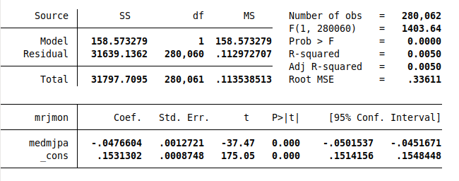
Figure 5
As can be seen from this regression output, there is a relatively small negative relationship between the dependent variable (coded here as mrjmon) and the independent variable (medmjpa). That is, if the individual resides in a state in which an MML had been passed at the time of the interview, they were approximately 4.7% less likely to have reported to the survey that they had used marijuana in the past month. The implication of these initial results might be surprising if taken at face value, especially given the significance of the explanatory variable and the regression as a whole (evidenced by the F-statistic), however, there is a lot of bias in this model, and as seen by the low R-squared statistic, the relationship is far from being linear. Next, in Figure 6 is the read out from equation 1b, accounting for the addition of the individual-level explanatory variables.
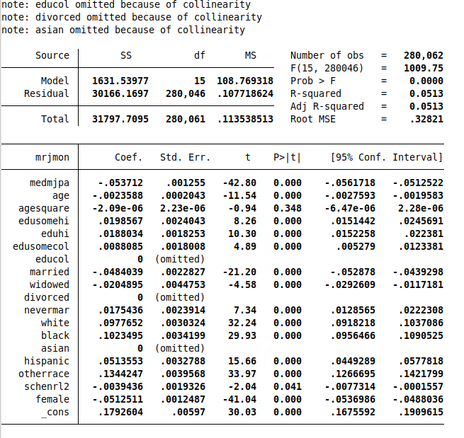
Figure 6
Between the first and second regressions, the negative relationship between past month marijuana use and state MML presence has persisted, and the magnitude has even slightly grown. This growth could be explained by multicollinearity between the MML variable and one or more of the added control variables. Aside from this, the first thing to notice here is that we have an increased R-squared value and an increased model sum of squares. This means that as expected, a significantly larger amount of the variation in the relationship is being explained by the regression model. Secondly, as can be seen in the readout from Stata, three of the variables that I generated from the categorical data were “omitted because of collinearity”. This is a convenient function employed by Stata to recognize and remove a variable from groups of variables that have perfect collinearity, as such a situation violates one of the fundamentals of OLS results. In this particular case, this is a limitation of the categorical data being used in the analysis, and each of those categorical outcomes being used as independent variables in the regression. Since each of the observations has to conform to one of the categorical outcomes, each of those outcomes can be perfectly predicted by the presence or the lack of the other variables that are outcomes of that category. To solve this issue, one of those categorical outcomes must be dropped from each category. The outcomes dropped in the above image are arbitrarily chosen by Stata, however, after manually dropping alternate outcomes, there were no largely significant changes in the values for the independent variable. Because the coefficients of all of the right hand variables are significant at a 5% level (with the exception of the age-squared variable which has a very small predicted effect regardless), there can be some confidence that a significant portion of the variance in the relationship is being explained by the variables, and not just by the natural variation within them. Lastly, below, Figure 7 is the readout for the final iteration of this particular regression, equation 1c.
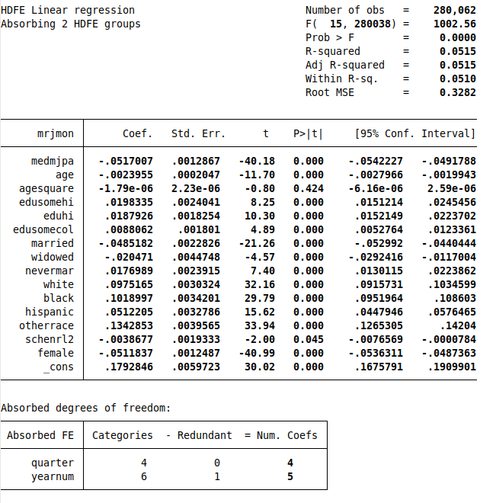
Figure 7

This regression slightly decreased the magnitude of the negative relationship between the independent and dependent variables after absorbing the effects of the two time-related variables in the data (quarter and year). The significance of the relationship was maintained. Interestingly, however, there was not a significant increase in the amount of explained variation attributed to the model. Although Sabia & Nguyen (2018) did a similar regression, using the same individual-level variables and time fixed effects as controls, they did not present their data with coefficients for the total population of their observations, so it is difficult to directly compare their results with mine from this perspective. Rather, their results are presented relative to gender and specific age-ranges (differing slightly from the ones used in this study). However, the general trend among their statistically significant results is a positive correlation between MML presence and past month marijuana use. This difference in results could be attributed to the gap between the two methodologies employed in the regressions, namely, the the usage of restricted-use data by Sabia & Nguyen, which included state residence information that could then be tied to independently gathered MML enactment date data. Such data was also used by Sabia & Nguyen to introduce time-varying state-level control variables and state fixed effects to the model, as well as to cluster standard errors by state. In doing so, the model used by Sabia & Nguyen appears to be more theoretically comprehensive and vulnerable to less bias than the model used here. Alternately, the difference could be explained partially by difference in time frame in the data being analyzed. While Sabia & Nguyen’s data was from 2002-2014, the data in this study hardly overlapped chronologically (being from 2013-2018). It is possible that there were time-related changes in the relationship that are manifesting in the differences of the results. In an effort to more closely present my data for comparison to that of Sabia & Nguyen’s, in Table 3a, I have compiled the results of the regression by gender and age range as well. The results from the age and gender specific regressions echo the results of the aggregate regressions, showing every cell with a significant (at a 1% level) negative coefficient on the MML variable. If these results are theoretically sound (this is a big “if” due to the limitations of the data addressed earlier), it would imply that from this data, in this time span, the presence of an MML in a state actually reduced marijuana usage among all of the age groups studied here. This is counter-intuitive, as the presence of MMLs in a state allow for a higher supply of legal marijuana as well as create a spill-over effect into the illegal/recreational market. Perhaps this kind of data could be explained by the novelty of medical marijuana fading, or an effect that reduces the premium on individual use of marijuana as a result of the action being illegal (i.e. a thrill from breaking the law). What is also interesting about the data in Table 3a, is that it follows the same general trends across age and gender as the results from Sabia & Nguyen in terms of magnitude, but the sign of the relationship is flipped, and the magnitude itself is higher than that of Sabia & Nguyen’s results. To be more specific, both sets of results show a stronger effect on males relative to females, and also a diminishing effect with regards to age (although there is a spike in the coefficient for college-age individuals, and a relatively lower effect for high school-age individuals). In regards to the uniform high significance of the dependent variable across all of these regressions, this is likely caused by the lack of clustering standard errors by state (data limitations). If this additional facet had been included in the model, it is very likely that standard errors would have increased for these coefficients, and consequently, p-values would have increased as well, lowering significance. It is also notable that many of the coefficients on the control variables lost significance during the gender/age-specific regressions. This is likely partially (if not entirely) due to the smaller number of observations for each age/gender group. As a final note on this point, these results were ran with and without the survey weights, and there as would be inferred from the age/gender breakdown results, there was no change in the relationship between the variables, only an increase in the magnitude of the coefficients for the unweighted regressions, as a result of more representation for older individuals in the weighted data.
The methodology for computing the results of the regressions for near-daily marijuana use mirror those of the regressions discussed for past-month marijuana use. Because of this, instead of walking through the process step-by-step, as before, I will skip presenting the read-outs and figures, and simply report the coefficient results of each step, along with any particularly notable observations. To begin, the coefficient for the dependent variable baseline equation, equation 1a, is about -0.0170 with a standard error value of 0.0010. Based on the earlier results for past-month use, these results make intuitive sense, as they should follow a similar relationship in sign, with a lesser magnitude. Additionally, these results mirror those of the past-month use in regards to significance and amount of explained variation. Equation 1b gives us the following results of an MML coefficient of approximately -0.0204 with the same standard error. Once again, we are seeing the same trend emerge among the two marijuana use variable regressions, and likely caused by the same mechanisms. Here, the negative effect of an MML being present in the state has slightly increased between the two subsequent equations, and additionally the amount of variation explained by the model has substantially increased. Finally, we will look at the results of equation 1c; calculated here is a coefficient value of -0.0191 and standard error that is still approximately 0.0010. This is still the same relative trend seen with the past-month regressions; the addition of the fixed time effects slightly reduced the coefficient on the dependent variable. Once again, this is likely due to the same mechanism of collinearity and some of the omitted variable bias from the previous equation being spread out into the more appropriate variables introduced in the new equation (as opposed to being explained by the smaller number of variables present before). To finish off this section, I present the final results of this regression broken into gender and age categories to mirror the presentation of Sabia & Nguyen once more. These results can be seen in Table 3b. It should be no surprise at this point, but the trends of these results also mirror the results in the past-month use analysis regressions. However, there is one significant demographic difference between the two. This difference is that while the spike in relative magnitude of the negative effect occurred in the 19-23 age range for past-month use, in the near-daily use regression, it manifests in both the 19-23 age range as well as the 24-29 age range for males (not for females). In fact, it is even more pronounced in the latter range. This is particularly interesting because of the implication that there is a more pronounced MML effect on marijuana use for male individuals in their twenties, which also happens to only make up a small percentage of medical marijuana patients (Fairman 2016). This same relationship was also noted by Sabia & Nguyen in their data. This is further evidence implying that there is a substantial non-medical spillover effect of MMLs on marijuana usage. As a final note to this section, for completeness sake, I ran the regressions unweighted to check if the expected effect of increased magnitude would occur for near-daily use as it did for past-month use. The results were in fact increased in magnitude through this method, as explained prior with the past-month use results. This offers support that the weights are functioning as they should be.

6.2. Labor Force Participation Rate and MMLs

Tables
Table 1a: Summary Statistics for Past Month Marijuana Use
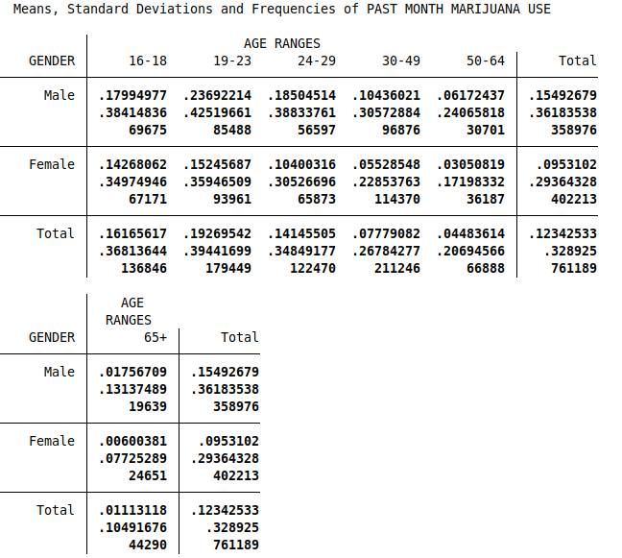
* As can be seen, these numbers are arranged in groups of 3 for each gender/age-range cross-section. The first value is the mean value for that subgroup of the data (in this case, the variable is binary with 0 representing no usage of marijuana in the past month, and 1 representing usage of marijuana in the past month; the mean value can be interpreted as the percentage of individuals in the subgroup that used marijuana in the past month), the second value is the standard deviation, and the third value is the number of observations. It is important to note that these are raw values from the survey data and they are not weighted to represent the target population without bias.

Table 1b: Summary Statistics for Near Daily Marijuana Use in Past 30 Days
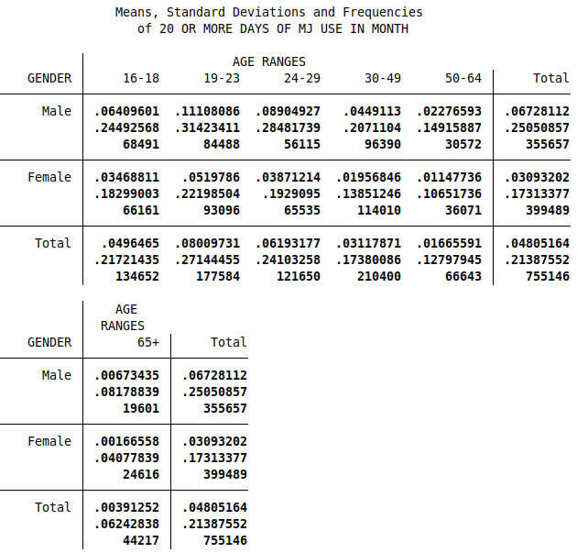

* As can be seen, these numbers are arranged in groups of 3 for each gender/age-range cross-section. The first value is the mean value for that subgroup of the data (in this case, the variable is binary with 0 representing no “near daily” usage of marijuana in the past month, and 1 representing “near daily usage of marijuana in the past month; the mean value can be interpreted as the percentage of individuals in the subgroup that used marijuana “near daily” in the past month), the second value is the standard deviation, and the third value is the number of observations. It is important to note that these are raw values from the survey data and they are not weighted to represent the target population without bias.

Table 1c: Target Population Estimates of NSDUH Data
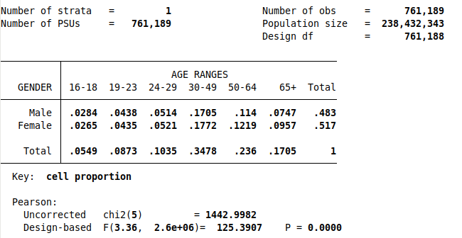

* This table is included as an additional reference for tables 1a and 1b, in order to give a more accurate representation of population breakdown by gender and age (especially age, as older participants in the survey are very underrepresented relative to their proportion in the target population). These proportions were arrived at by using the analysis survey weights included in the NSDUH data.

Table 2: Frequency Statistics of Control Variables (NSDUH Data)
Male:
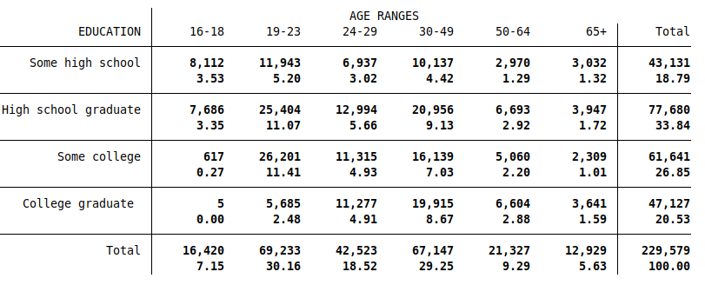
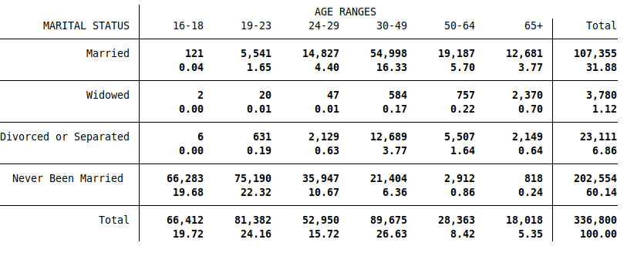

* Table continued on next page
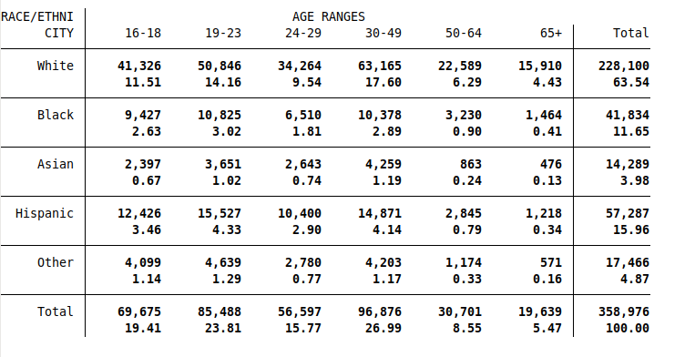
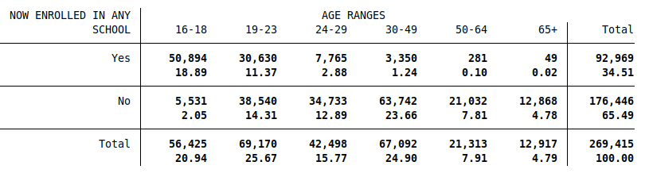

* Table continued on next page

Female:
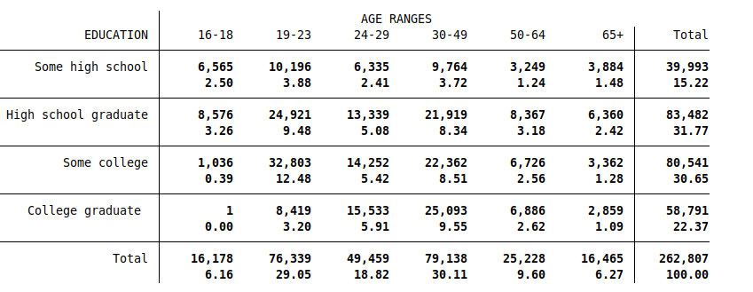
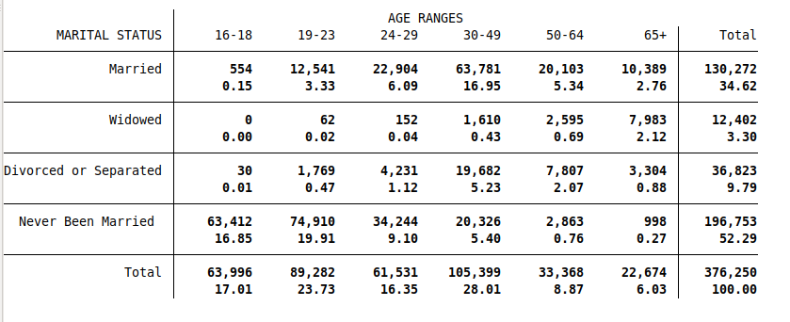

* Table continued on next page
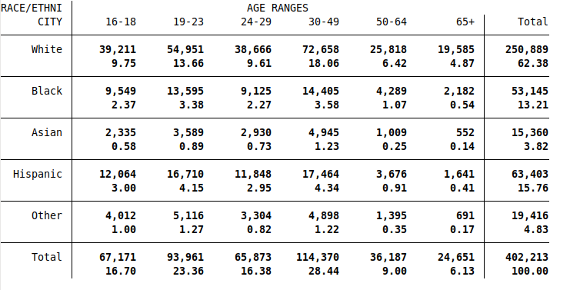
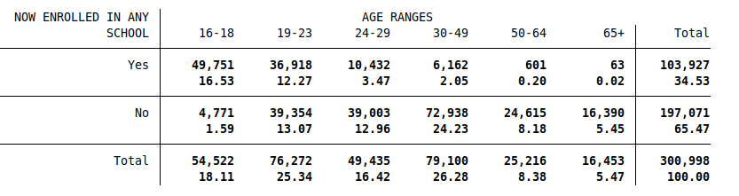
* The eight images presented above are meant to represent an analogue to Sabia & Nguyen’s (2018) Online Appendix Table 1. In their table they list the frequencies of the control variables from the NSDUH data (as well as the standard deviations and some means). In my presentation, I separated the control variables into their own groups to allow for better readability. The first number in each two-number cell in the images above is the raw frequency (number of observations) of the particular subgroup being represents. The second number is the percentage that subgroup represents of the total number of observations in the entire group shown. I chose to show frequencies and not to show means or standard deviations, as the variables represented above are all categorical, so number value means have diluted meanings, as do standard deviations. I did not include age and gender frequencies, as those can be seen in tables 1a-1c, and inferred in the above images as well. Lastly, for the education variable, the ‘some high school’ category (despite the name) is also inclusive of less than high school education.

Table 3a: Estimates of the Effect of MMLs on Past-Month Marijuana Use, NSDUH
Males:
Ages | 16-18 | 19-23 | 24-29 | 30-49 | 50-64 | 65+
Coefficients | -.0520156 | -.0809835 | -.0717039 | -.0572374 | -.0474617 | -.0244197
Standard Errors | .0054537 | .0055871 | .0058334 | .0032965 | .0048919 | .0036059
Observations | 20,638 | 25,473 | 20,464 | 41,834 | 13,591 | 9,382

Females:
Ages | 16-18 | 19-23 | 24-29 | 30-49 | 50-64 | 65+
Coefficients | -.0487774 | -.0638371 | -.0623826 | -.035283 | -.02467 | -.0096979
Standard Errors | .0052131 | .0047498 | .0044372 | .0024061 | .0033772 | .0019621
Observations | 19,781 | 27,682 | 24,296 | 49,363 | 16,039 | 11,519

* The above values were calculated using data from the NSDUH, years 2013-2018. They are all significant at a 1% level, however, this is without clustering standard errors by state, which would likely raise the p-values of the coefficients through higher standard errors. The regressions were performed on panels distinguished by gender and age range, with the total number of observations being 280,062. Controls for education, race/ethnicity, marital status, and school enrollment were included, as well as fixed time effects for year and quarter data and appropriate survey weights.
Table 3b: Estimates of the Effect of MMLs on Near-Daily Marijuana Use, NSDUH
Males:
Ages | 16-18 | 19-23 | 24-29 | 30-49 | 50-64 | 65+
Coefficients | -.0289218 | -.0362125 | -.0482377 | -.0284574 | -.0193545 | -.0126793
Standard Errors | .0044383 | .0056015 | .0063103 | .0028218 | .0035923 | .0034905
Observations | 20,293 | 25,129 | 20,274 | 41,616 | 13,519 | 9,354

Females:
Ages | 16-18 | 19-23 | 24-29 | 30-49 | 50-64 | 65+
Coefficients | -.0101178 | -.0265036 | -.0189073 | -.0124181 | -.0079201 | -.0047492
Standard Errors | .0034013 | .0041518 | .0036951 | .0018253 | .0026673 | .0017165
Observations | 19,437 | 27,393 | 24,155 | 49,193 | 15,972 | 11,495

* The above values were calculated using data from the NSDUH, years 2013-2018. They are all significant at a 1% level, however, this is without clustering standard errors by state, which would likely raise the p-values of the coefficients through higher standard errors. The regressions were performed on panels distinguished by gender and age range, with the total number of observations being 277,830. Controls for education, race/ethnicity, marital status, and school enrollment were included, as well as fixed time effects for year and quarter data and appropriate survey weights.

Table 4: Summary Statistics for Labor Force Participation Rate by State

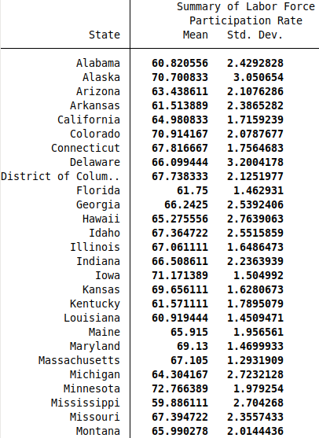
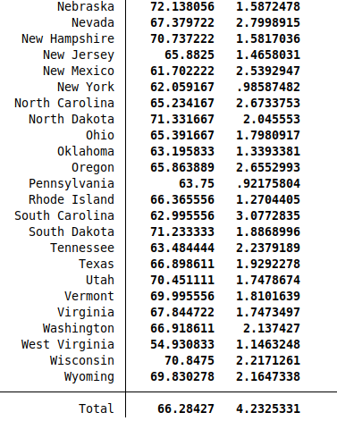

* The data used to calculate these values was sourced through FRED via the US Bureau of Labor Statistics. They show the means and standard deviations of the Labor Force Participation Rate broken down by state, across the years 1990-2019. Each state has 360 observations, one for each month in the time range, summing to 18,360 observations in total.

Table 5: Effective Dates of MMLs
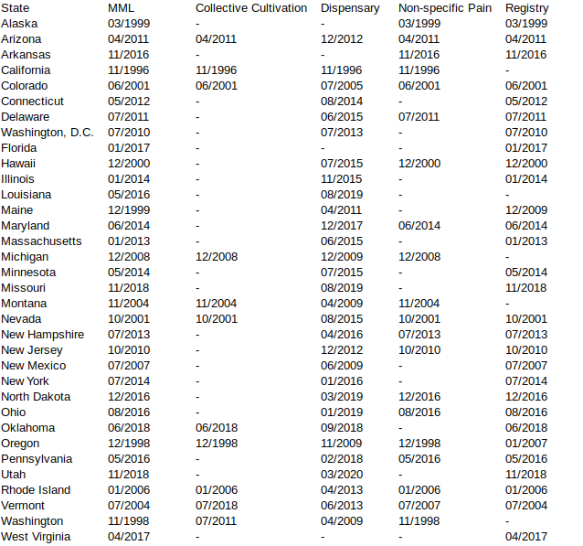
Notes: This table was created primarily from information from Appendix Table 1 of Sabia & Nguyen (2018), which used information from Anderson et al. (2013) and Wen et al. (2015). I then updated more recent dates and legislations through information form the Marijuana Policy Project (2019). The information here should be up-to-date as of March 2020.

Table 6: Summary Statistics for Effective Minimum Wage by State

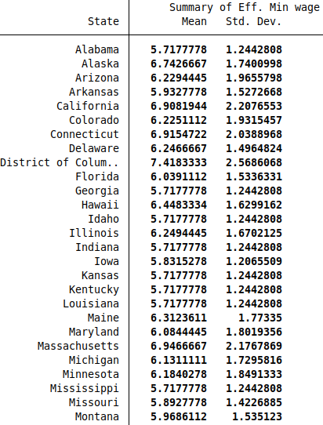
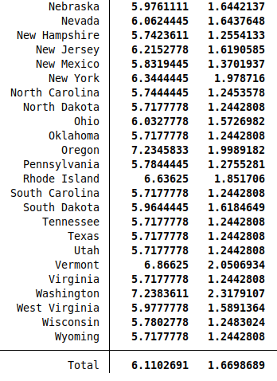
* The data used to calculate these values was sourced through FRED via the US Department of Labor. They show the means and standard deviations of the “effective minimum wage” (the higher of the federal minimum wage and/or state minimum wage for each specific state) broken down by state, across the years 1990-2019. Each state has 360 observations, one for each month in the time range, summing to 18,360 observations in total.

References
Abraham, K., & Kearney, M. (2019). Explaining the Decline in the U.S. Employment-to-Population Ratio: A Review of the Evidence (No. w24333; p. w24333). https://doi.org/10.3386/w24333
Anderson, D. Mark, and Daniel I. Rees. 2011. Medical marijuana laws, traffic fatalities, and alcohol consumption. IZA working paper no 6112. Available at: http://ftp.iza.org/dp6112.pdf
Anderson, D. Mark, Benjamin Hansen, and Daniel I. Rees. 2013. Medical marijuana laws, traffic fatalities, and alcohol consumption. Journal of Law and Economics 56(2):333-369.
Benbadis, S. R., Sanchez-Ramos, J., Bozorg, A., Giarratano, M., Kalidas, K., Katzin, L., ... & Zesiewicz, T. (2014). Medical marijuana in neurology. Expert review of neurotherapeutics, 14(12), 1453-1465. https://doi.org/10.1586/14737175.2014.985209
Bonn-Miller, Marcel O., Michael J. Zvolensky, and Amit Bernstein. 2007. Marijuana use
motives: Concurrent relations to frequency of past 30-day use and anxiety sensitivity among
young adult marijuana smokers. Addictive Behaviors, 32(1): 49-62.
Bradford, Ashley C., and W. David Bradford. 2016. Medical marijuana laws reduce
prescription medication use in Medicare Part D,"Health Affairs, 35(7): 1230-1236.
Burgess, S.M. and Propper, C. (1998) Early health related behaviours and their impact on later life chances: evidence from the US. Health Economics 7(5): 381–399.
CEA (Council of Economic Advisers) Report. Washington: White House; 2014. The Labor Force Participation Rate since 2007: Causes and Policy Implications. https://obamawhitehouse. archives.gov/sites/default/files/docs/labor_force_participation_report.pdf.
Chu, Yu-Wei Luke. 2014. The effects of medical marijuana laws on illegal marijuana use. Journal of Health Economics 38: 43-61.
“Civilian Labor Force Participation Rate.” U.S. Bureau of Labor Statistics, U.S. Bureau of Labor Statistics, Feb. 2020, www.bls.gov/charts/employment-situation/civilian-labor-force- participation-rate.htm.
Conti, G. (2010) Cognition, cannabis and wages. Mimeo.
Creason, C. R., & Goldman, M. (1981). Varying levels of marijuana use by adolescents and the amotivational syndrome. Psychological Reports, 48(2), 447-454. https://doi.org/10.2466/pr0.1981.48.2.447
Crost, B., & Guerrero, S. (2012). The effect of alcohol availability on marijuana use: Evidence from the minimum legal drinking age. Journal of health economics, 31(1), 112-121.
DeSimone, J. (2002). Illegal drug use and employment. Journal of Labor Economics, 20(4), 952-977. https://doi.org/10.1086/342893
“Employment-to-Population Ratio.” Labor Force Statistics from the Current Population Survey, U.S. Bureau of Labor Statistics, Feb. 2020, https://data.bls.gov/timeseries/LNS12300000
Fairman, Brian J. 2016. Trends in registered medical marijuana participation across 13 US
states and District of Columbia. Drug & Alcohol Dependence 159: 72-79.
Fitzcharles, M., Baerwald, C., Ablin, J. et al. Efficacy, tolerability and safety of cannabinoids in chronic pain associated with rheumatic diseases (fibromyalgia syndrome, back pain, osteoarthritis, rheumatoid arthritis). Schmerz 30, 47–61 (2016). https://doi.org/10.1007/s00482-015-0084-3
Fiz, J., Durán, M., Capellà, D., Carbonell, J., & Farré, M. (2011). Cannabis use in patients with fibromyalgia: effect on symptoms relief and health-related quality of life. PloS one, 6(4).
French, M.T., Roebuck, M.C. and Alexandre, P.K. (2001) Illicit drug use, employment & labour force participation. Southern Economic Journal 68(2): 349–368.
Gill, A. and Michaels, R.J. (1992) Does drug use lower wages? Industrial and Labor Relations Review 45(3): 419–434.
Habib, G., & Artul, S. (2018). Medical cannabis for the treatment of fibromyalgia. JCR: Journal of Clinical Rheumatology, 24(5), 255-258. doi: 10.1097/RHU.0000000000000702
Hanson, Karmen and Garcia, Alise. State Medical Marijuana Laws. NCSL - Research - Health, National Conference of State Legislatures, 10 Mar. 2020, www.ncsl.org/research/health/state- medical-marijuana-laws.aspx.
“Historical Timeline - Medical Marijuana” Medical Marijuana, Procon.org, 24 Sept. 2019, medicalmarijuana.procon.org/historical-timeline/.
Irons, Jessica G., Kimberly A. Babson, Cecilia L. Bergeria, and Marcel O. Bonn Miller. 2014.
Physical activity and cannabis cessation. The American Journal on Addictions 23(5): 485-492.
Kaestner, R. (1991) The effect of illicit drug use on the wages of young adults. Journal of Labor Economics 9(4): 381–412.
Kaestner, R. (1994a) The effect of illicit drug use on the labor supply of young adults. Journal of Human Resources 29(1): 126–155.
Krueger, A. B. (2017). Where Have All the Workers Gone?: An Inquiry into the Decline of
the U.S. Labor Force Participation Rate. Brookings Papers on Economic Activity,
2017(2), 1–87. https://doi.org/10.1353/eca.2017.0012
“Labor Force Participation Rate.” Labor Force Statistics from the Current Population Survey, U.S. Bureau of Labor Statistics, Feb. 2020, https://data.bls.gov/timeseries/LNS11300000
Lac, A., & Luk, J. W. (2018). Testing the amotivational syndrome: Marijuana use longitudinally predicts lower self-efficacy even after controlling for demographics, personality, and alcohol and cigarette use. Prevention Science, 19(2), 117-126.
https://doi.org/10.1007/s11121-017-0811-3
Lye, J., & Hirschberg, J. (2010). Alcohol consumption and human capital: a retrospective study of the literature. Journal of Economic Surveys, 24(2), 309-338.
Lynskey, M. and Hall, W. (2000) The effects of adolescent cannabis use on educational attainment: a review. Addiction 95: 1621– 1630.
MacDonald, Z. and Pudney, S. (2000) Illicit drug use, unemployment and occupational attainment. Journal of Health Economics 19(6): 1089–1115.
Macleod, J., Oakes, R., Copello, A., Crome, I., Egger, M., Hickman, M., Oppenkowski, T., Stokes‐ Lampard, H. and Smith, G. (2004) Psychological and social sequelae of cannabis and other illicit drug use by young people: a systematic review of longitudinal, general population studies. Lancet 363: 1579– 1588.
Marijuana Policy Project. 2019. “Medical Marijuana Program Implementation Timelines.” Available at: https://www.mpp.org/issues/medical-marijuana/state-by-state-medical-marijuanalaws/medical- marijuana-program-implementation-timeline/
Mikuriya, T. H. (1969). Marijuana in medicine: past, present and future. California medicine, 110(1), 34-40. https://www.ncbi.nlm.nih.gov/pmc/articles/PMC1503422/pdf/califmed00019-0036.pdf
Mullahy, J., & Sindelar, J. (1996). Employment, unemployment, and problem drinking. Journal of health economics, 15(4), 409-434.
Pesta, Dominik H., Siddhartha S. Angadi, Martin Burtscher, and Christian K. Roberts. 2013.
The effects of caffeine, nicotine, ethanol, and tetrahydrocannabinol on exercise performance.
Nutrition and Metabolism, 10(1): 71.
Register, C. and Williams, D. (1992) Labor market effects of marijuana and cocaine use among young men. Industrial and Labor Relations Review 45(3): 435–448.
Renna, F. (2008). Alcohol abuse, alcoholism, and labor market outcomes: looking for the missing link. ILR Review, 62(1), 92-103.
Roy, S. (2005). Are Illegal Drugs Inferior Goods? (No. 05-01old Classification-JEL: H51, I12).
Sabia, J. J., & Nguyen, T. T. (2018). The effect of medical marijuana laws on labor market outcomes. The Journal of Law and Economics, 61(3), 361-396. https://doi.org/10.1086/701193
Saffer, H., & Chaloupka, F. (1998). Demographic differentials in the demand for alcohol and illicit drugs (No. w6432). National Bureau of Economic Research.
Stockings, E., Campbell, G., Hall, W. D., Nielsen, S., Zagic, D., Rahman, R., ... & Degenhardt, L. (2018). Cannabis and cannabinoids for the treatment of people with chronic noncancer pain conditions: a systematic review and meta-analysis of controlled and observational studies. Pain, 159(10), 1932-1954.
Substance Abuse and Mental Health Services Administration. 2005. “Results from the 2004 National Survey on Drug Use and Health: Detailed Tables.” Retrieved from https://www.samhsa.gov/data/report/2004-nsduh-detailed-tables
Substance Abuse and Mental Health Services Administration. 2019. “Results from the 2018 National Survey on Drug Use and Health: Detailed Tables.” Retrieved from https://www.samhsa.gov/data/report/2018-nsduh-detailed-tables
Ullman, Darin F. 2016. The effect of medical marijuana on sickness absence. Health
Economics, doi: 10.1002/hec.3390.
Van Ours, J. C. (2006). Cannabis, cocaine and jobs. Journal of Applied Econometrics, 21(7), 897-917.
van Ours, J.C. (2007) The effect of cannabis use on wages of prime age males. Oxford Bulletin of Economics and Statistics 69: 619–634.
Van Ours, J. C., & Williams, J. (2009). Cannabis use and mental health problems.
Van Ours, J. C., & Williams, J. (2015). Cannabis use and its effects on health, education and labor market success. Journal of Economic Surveys, 29(5), 993-1010.
Volkow ND, Han B, Compton WM, McCance-Katz EF. (2019) Self-reported Medical and Nonmedical Cannabis Use Among Pregnant Women in the United States. JAMA. 2019;322(2):167–169. doi:10.1001/jama.2019.7982
Volkow, N. D., Swanson, J. M., Evins, A. E., DeLisi, L. E., Meier, M. H., Gonzalez, R., ... & Baler, R. (2016). Effects of cannabis use on human behavior, including cognition, motivation, and psychosis: a review. JAMA psychiatry, 73(3), 292-297.
Wen, Hefei, Jason M. Hockenberry, and Janet R. Cummings. 2015. The effect of medical marijuana laws on adolescent and adult use of marijuana, alcohol, and other substances. Journal of Health Economics 42(3): 64-80.
Williams, J., Liccardo Pacula, R., Chaloupka, F. J., & Wechsler, H. (2004). Alcohol and marijuana use among college students: economic complements or substitutes?. Health economics, 13(9), 825- 843.
Williams, J., & van Ours, J. C. (2017). Hazardous or Not? Early Cannabis Use and the School to Work Transition of Young Men.
Wikipedia contributors. (2020, March 13). Timeline of cannabis laws in the United States. In Wikipedia, The Free Encyclopedia. Retrieved 13:49, March 16, 2020, from https://en.wikipedia.org/w/index.php?t itle=Timeline_of_cannabis_laws_in_the_United_States&oldid=945370904

