ISO/CD 19160-6(E)
ISO/TC 211/WG 7
Secretariat: SN
Addressing — Digital interchange models

Adressage — Modèles d’échange numérique

CD stage

Warning for WDs and CDs
This document is not an ISO International Standard. It is distributed for review and comment. It is subject to change without notice and may not be referred to as an International Standard.
Recipients of this draft are invited to submit, with their comments, notification of any relevant patent rights of which they are aware and to provide supporting documentation.

COPYRIGHT PROTECTED DOCUMENT
© ISO 2020
All rights reserved. Unless otherwise specified, no part of this publication may be reproduced or utilized otherwise in any form or by any means, electronic or mechanical, including photocopying, or posting on the internet or an intranet, without prior written permission. Permission can be requested from either ISO at the address below or ISO’s member body in the country of the requester.
ISO copyright office
Ch. de Blandonnet 8 • CP 401
CH-1214 Vernier, Geneva, Switzerland
Tel. + 41 22 749 01 11
Fax + 41 22 749 09 47
Email: copyright@iso.org
Website: www.iso.org
Published in Switzerland
Contents
Foreword v
0 Introduction vi
0.1 Purpose vi
0.2 Relationship with other parts of the ISO 19160 standards family vi
0.3 Address as entered data vi
0.4 Relationship to the addressable object vii
1 Scope 1
2 Normative references 1
3 Terms and definitions 1
4 Conformance 3
4.1 General 3
4.2 Address profile register 3
4.3 AddressProfile 3
4.4 AddressClassProfile 4
4.5 AddressComponentProfile 4
4.6 ProfileCompliantAddress 4
4.7 ProfileCompliantAddressComponent 4
4.8 InterchangeAddressClassProfile 4
4.9 FormTemplate 4
4.10 DisplayTemplate 4
5 Address profile registry 4
5.1 General 4
5.2 Roles and responsibilities in the management of an address profile registry 4
5.3 Unmodified ISO 19135-1:2015 requirements 5
5.4 Modified ISO 19135-1:2015 requirements 6
5.5 Specific requirements 6
5.6 Content requirements from ISO 19135-1:2015 6
6 Process of address profile and address interchange 7
6.1 General 7
6.2 Address profiles 8
6.2.1 General 8
6.2.2 Creating address profiles and address class profiles 8
6.2.3 Publishing address profiles 9
6.2.4 Updating address profiles 9
6.2.5 Using address profiles 9
6.2.6 Retiring address profiles 9
6.3 Interchange address 10
6.3.1 General 10
6.3.2 Creating a profile-complaint address 10
6.3.3 Interchange of an interchange address 11
6.3.4 Displaying an interchange address 11
6.3.5 Adding address features 11
6.3.6 Adding associated data to an interchange address 11
6.3.7 Discarding an interchange address 11
7 Address profile model overview 11
8 Data types 13
8.1 Primitive and core data types 13
9 Common models 13
10 Address profile 14
11 Profile compliant address 15
12 InterchangeAddressClassProfile overview 16
13 Address feature 16
14 Layout template 17
15 LayoutLine 17
16 Display template 18
17 Form template 18
Annex A (informative) Abstract test suites 19
A.1 Introduction 19
A.2 Conformance class: Address profile register 19
A.3 Conformance class: AddressProfile 19
A.4 Conformance class: AddressClassProfile 21
A.5 Conformance class: AddressComponentProfile 23
A.6 Conformance class: ProfileCompliantAddress 25
A.7 Conformance class: ProfileCompliantAddressComponent 27
A.8 Conformance class: InterchangeAddressClassProfile 29
A.9 Conformance class: FormTemplate 31
A.10 Conformance class: DisplayTemplate 32
Annex B (informative) Usage 34
B.1 Accuracy and verification 34
B.2 Address as identity 34
B.3 Address as destination 34
Annex C (informative) Examples of objects specified in this document 35
C.1 AddressProfile 35
C.2 AddressClassProfiles 35
C.3 Validity 35
C.4 PublisherInformation 36
C.5 Localization 36
C.6 Signature 36
C.7 AddressClassProfile 36
C.8 User Defined Data Types 36
C.9 Data Type Constraints 36
C.10 AddressComponentClass 36
C.11 ProfileCompliantAddress 37
C.12 AddressComponent 37
C.13 AddressFeature 37
C.14 DisplayTemplate 37
C.15 FormTemplate 37
Annex D (informative) Examples 38
D.1 Example of address profiles defined in ISO 19160-1 38
D.1.1 ISO 19160-1 C.2 Example 1: Minimal address profile 38
D.1.2 ISO 19160-1 C.3 Example 2: Sample address profile 40
Bibliography 47

Foreword
ISO (the International Organization for Standardization) is a worldwide federation of national standards bodies (ISO member bodies). The work of preparing International Standards is normally carried out through ISO technical committees. Each member body interested in a subject for which a technical committee has been established has the right to be represented on that committee. International organizations, governmental and non-governmental, in liaison with ISO, also take part in the work. ISO collaborates closely with the International Electrotechnical Commission (IEC) on all matters of electrotechnical standardization.
The procedures used to develop this document and those intended for its further maintenance are described in the ISO/IEC Directives, Part 1. In particular the different approval criteria needed for the different types of ISO documents should be noted. This document was drafted in accordance with the editorial rules of the ISO/IEC Directives, Part 2 (see www.iso.org/directives).
Attention is drawn to the possibility that some of the elements of this document may be the subject of patent rights. ISO shall not be held responsible for identifying any or all such patent rights. Details of any patent rights identified during the development of the document will be in the Introduction and/or on the ISO list of patent declarations received (see www.iso.org/patents).
Any trade name used in this document is information given for the convenience of users and does not constitute an endorsement.
For an explanation on the voluntary nature of standards, the meaning of ISO specific terms and expressions related to conformity assessment, as well as information about ISO’s adherence to the World Trade Organization (WTO) principles in the Technical Barriers to Trade (TBT) see the following URL: www.iso.org/iso/foreword.html.
This document was prepared by Technical Committee ISO/TC 211, Geographic information / Geomantics.
A list of all parts in the ISO 19160 series can be found on the ISO website.
This is the first edition of this document.

0 Introduction

0.1 Purpose
Addresses are among the most commonly exchanged information on the Internet, and the interchange of them is crucial to a number of Internet applications, such as electronic commerce, contact exchange, non-postal deliveries, as well as location scheduling.
Yet, addresses can mean much more than just geolocation information:
- as an identity, such as an office address;
- as reference points (waypoints) in routing information; and
- as a delivery point.
The interchange of address information requires a common structure of address data.
For instance, if a software application needs a user to input address information, in order to produce a machine readable address that is interoperable with other systems, the user would need assistance from the application to enter the address in the correct format and structure.
This document specifies a set of data models that focuses on enabling software applications to digitally interchange address profiles, address instances and instructions for their input and display suitable for machine encoding of address information. These models are called the “Address Interchange Object” (“AXO”) models.
Furthermore, a registry mechanism is defined to ensure the address profiles can be made publicly available.

0.2 Relationship with other parts of the ISO 19160 standards family
This standard complements the other parts in the family of ISO 19160 standards:
- ISO 19160-1:2015 describes conceptual models for addressing that allow specification of international address profiles. This document further provides methods to utilize these models in a way suitable for digital interchange and storage.
- ISO 19160-4:2017 defines key terms for postal addressing, postal address components and constraints on their use. It focuses on use cases for postal applications, specifying the methods to write or detect addresses on mail items. This document adapts models from ISO 19160-1:2015 as address interchange models, to facilitate interchange and interaction of addresses between humans and applications, and between applications, and for applications to interact and interchange international addresses, while supporting human input and human-machine interaction, without loss of fidelity.
- ISO 19160-5 focuses on the rendering of addresses for different devices with a focus on their representations on maps, virtual and augmented reality. This document focuses on providing an interoperable data model for the interchange and storage of address profiles and addresses, as well as the input and rendering of compliant addresses in a normalized manner. This approach results into a scheme that can be understood across the spectrum of address consumers, including humans, applications, devices and systems.

0.3 Address as entered data
The lifecycle of an address entry exchanged on the Internet typically starts with manual input of a human actor. This data, structured or unstructured, is then submitted to an Internet-connected application, and the application may in turn transmit this information to other applications or external parties on behalf of the user who provided the address.
This transmission is usually performed to fulfil service delivery to the user. Within the process, there may be machine-human interactions that require display of the address in human-readable form, as well as machine-to-machine interactions on the address, such as for data validation.
Additional caution shall be placed on the accuracy (or lack thereof) of human input addresses. While an address specified by a human actor may unambiguously distinguish a location, there may be intention or unintentional omissions or additions to an “official” address (if there was one).

0.4 Relationship to the addressable object
Attributes of the object which the address points to are considered out of scope of this document, including the AddressableObject model specified in ISO 19160-1:2015.
While considered orthogonal to the AXO models, AddressableObject and other simliar models can easily be used together with the AXO models.
EXAMPLE In a navigation map, an AXO address can point to an addressable object, which provides a list of its extant facilities.

Addressing — Digital interchange models

1 Scope
This document specifies a set of data models suitable for machine encoding of address information, called the “Address Interchange Object” (“AXO”) models, and the use of them.
Specifically, this document provides:
- data models for digital storage and interchange of address profiles conforming to ISO 19160-1:2015;
- data models for digital storage and interchange of addresses conforming to a specific address profile;
- data models for entry and display templates for entering and displaying addresses conforming to the profile and encoding rules above; and
- the management and operations of a register of address profiles conforming to this document.
Addressability, and features provided within the object which the address points to, is not described in this document. Specifically, the AddressableObject from ISO 19160-1:2015 is considered out of scope.

2 Normative references
The following documents are referred to in the text in such a way that some or all of their content constitutes requirements of this document. For dated references, only the edition cited applies. For undated references, the latest edition of the referenced document (including any amendments) applies.
ISO 19160-1:2015, Addressing — Part 1: Conceptual model
ISO 19160-3:2020, Addressing — Part 3: Address data quality
ISO 19103:2015, Geographic information — Conceptual schema language
ISO 19106:2004, Geographic information — Profiles
ISO 19115-1:2014, Geographic information — Metadata — Part 1: Fundamentals
ISO 19135-1:2015, Geographic information — Procedures for item registration — Part 1: Fundamentals

3 Terms and definitions
For the purposes of this document, the terms and definitions given in ISO 19160-1:2015 and the following apply.
ISO and IEC maintain terminological databases for use in standardization at the following addresses:
- ISO Online browsing platform: available at http://www.iso.org/obp
- IEC Electropedia: available at http://www.electropedia.org
3.1
address interchange object
AXO
digital objects for address interchange defined in ISO 19160-6
3.2
lineage
provenance, source(s) and production process(es) used in producing a resource
[SOURCE: ISO 19115-1:2014, 4.9]
3.3
profile
set of one or more base standards or subsets of base standards, and, where applicable, the identification of chosen clauses, classes, options and parameters of those base standards, that are necessary for accomplishing a particular function
[SOURCE: ISO 19106:2004, 4.5]
3.4
data type
specification of a value domain with operations allowed on values in this domain
[SOURCE: ISO 19103:2015, 4.14]
3.5
primitive data type
data type (3.4) that has no super type
Note 1 to entry: The primitive data type of a data type is the data type itself, if the data type has no super type, and otherwise the primitive data type of the super type of the data type.
[SOURCE: ISO/IEC 10179:1996, 4.23, modified — removal of initial “A”, moved second sentence into Note to entry.]
3.6
interchange address
address data compliant to an interchange address (3.6) class profile
3.7
address feature
marking on an interchange address to indicate what it is capable of
3.8
address layout template
specification of layout and positioning of address components for interchange addresses
3.9
address display template
address layout template (3.8) for the display of interchange addresses
3.10
address form template
address layout template of an input form for the entry of interchange addresses
3.11
address processor
entity that processes interchange addresses
3.12
address profile distributor
entity that distributes interchange address profiles
3.13
digital signature
signature
data appended to, or a cryptographic transformation of, a data unit that allows the recipient of the data unit to verify the source and integrity of the data unit
[SOURCE: ISO/IEC 9798-3:2019, 3.3]
3.14
private signature key
private key which defines the private signature transformation
Note 1 to entry: This is sometimes referred to as a secret signature key.
[SOURCE: ISO/IEC 9798-1:2010, 3.23]
3.15
public verification key
public key which defines the public verification transformation
[SOURCE: ISO/IEC 9798-1:2010, 3.28]
3.16
object identifier
OID
globally unique value associated with an object to unambiguously identify it
[SOURCE: ISO/IEC TR 29149:2012, 2.11]
3.17
language identifier
language symbol
symbol that uniquely identifies a particular language
[SOURCE: ISO 639-3:2007, 3.3]
3.18
script
set of graphic characters used for the written form of one or more languages
[SOURCE: ISO 15924:2004, 3.7]
3.19
script code
combination of characters used to represent the name of a script (3.18)
[SOURCE: ISO 15924:2004, 3.8]
3.20
Uniform Resource Identifier
URI
unique identifier for a resource, structured in conformance with IETF RFC 2396
Note 1 to entry: The general syntax is <scheme>::<scheme-specific-part>. The hierarchical syntax with a namespace is <scheme>://<authority><path>?<query> — see RFC 2396.
[SOURCE: ISO 19136-1:2020, 3.1.62]

4 Conformance

4.1 General
This part of ISO 19160 defines four classes of requirements and conformance. Annex A specifies how conformance with these classes shall be tested.

4.2 Address profile register
To conform to this standard, an address profile register shall satisfy all of the requirements specified for a register in ISO 19135-1:2015. See A.2.

4.3 AddressProfile
Any machine-readable description of an ISO 19160-6 AddressProfile for which conformance is claimed shall pass all the requirements described in the abstract test suite in A.3.

4.4 AddressClassProfile
Any machine-readable description of an ISO 19160-6 AddressClassProfile for which conformance is claimed shall pass all the requirements described in the abstract test suite in A.4.

4.5 AddressComponentProfile
Any machine-readable description of an ISO 19160-6 AddressComponentProfile for which conformance is claimed shall pass all the requirements described in the abstract test suite in A.5.

4.6 ProfileCompliantAddress
Any machine-readable description of an ISO 19160-6 ProfileCompliantAddress for which conformance is claimed shall pass all the requirements described in the abstract test suite in A.6.

4.7 ProfileCompliantAddressComponent
Any machine-readable description of an ISO 19160-6 ProfileCompliantAddressComponent for which conformance is claimed shall pass all the requirements described in the abstract test suite in A.7.

4.8 InterchangeAddressClassProfile
Any machine-readable description of an ISO 19160-6 InterchangeAddressClassProfile for which conformance is claimed shall pass all the requirements described in the abstract test suite in A.8.

4.9 FormTemplate
Any FormTemplate in InterchangeAddressClassProfile model for which FormTemplate conformance is claimed shall pass the requirements described in the abstract test suite in A.9.

4.10 DisplayTemplate
Any DisplayTemplate in InterchangeAddressClassProfile model for which DisplayTemplate conformance is claimed shall pass the requirements described in the abstract test suite in A.10.

5 Address profile registry

5.1 General
The ISO address profile registry will be managed with version control software, publicly available with an API and a graphical user interface, such as a web-based interface, to satisfy both programatic and human use for the dissemination, display and management of the registry.
The ISO address profile register is a non-hierarchical register. References to principal registers and sub-registers are excluded from this document.
This address profile registry follows the requirements specified in ISO 19135-1:2015, and additional requirements specified in this standard.
Rules for managing a register of geographical information items, including the submission of information, are found in ISO 19135-1:2015, Clause 6.
NOTE Reference to a corresponding ISO 19135-1:2015 requirement is explicitly denoted.

5.2 Roles and responsibilities in the management of an address profile registry
The roles and responsibilities of the register owner, register manager, submitting organizations, control body, registry manager and register user are set out in ISO 19135-1:2015.
Requirement 1 (ISO 19135-1:2015, Requirement 1): The register owner shall set terms and conditions regarding different levels of access to the register and making the contents available to the public. In addition, the register owner shall specify the time period in which the approval process shall be completed.
Requirement 2 (ISO 19135-1:2015, Requirement 2): The register owner shall appoint a register manager. A register owner may serve as the register manager for any register that it has established or it may appoint another organization to serve as the register manager.
Requirement 3 (ISO 19135-1:2015, Requirement 3): The register owner shall decide whether a control body is required for the register and if so appoint the control body. The register owner may serve as the control body for any register that it has established or it may delegate that role to a subgroup within the organization or to the register manager.
Requirement 4 (ISO 19135-1:2015, Requirement 4): A register owner shall specify the criteria that determine which organizations may act as submitting organizations.
Requirement 5 (ISO 19135-1:2015, Requirement 5): The register owner shall clarify the process for a submitting organization to appeal decisions of the control body (if such a body is appointed). The register owner may establish a procedure for such a process. The specification of this procedure shall include appropriate time limits for completion of the process. An alternative solution may be for a submitting organization to resubmit a new proposal with changes or a better justification.
Requirement 6 (ISO 19135-1:2015, Requirement 6): A register manager shall manage a register in conformance with ISO 19135-1:2015, Clause 6.
Requirement 7 (ISO 19135-1:2015, Requirement 7): Upon request, the register manager shall distribute an information package containing a description of the register and how to submit proposals for changes to the content of the register. The information package shall describe what proposed changes to the content may be considered to be substantive.
Requirement 8 (ISO 19135-1:2015, Requirement 8): The register manager shall accept proposals from submitting organizations and manage the proposals as specified in ISO 19135-1:2015, 6.4. The register manager shall pass proposals to the control body for decisions as to acceptability and shall serve as the point of contact between the control body and the submitting organization for negotiations regarding changes to the proposal.
Requirement 9 (ISO 19135-1:2015, Requirement 9): The register manager shall determine whether a submitting organization is qualified in accordance with the criteria established by the register owner.
Requirement 10 (ISO 19135-1:2015, Requirement 10): If a control body is appointed, it shall accept proposals from the register manager and render a decision regarding each proposal within the time limits specified by the register owner.
Requirement 11 (ISO 19135-1:2015, Requirement 11): A registry manager shall ensure the integrity of any register held in the registry and shall provide means for electronic access to the registry for register managers, control body members, and register users.
Requirement 12 (ISO 19135-1:2015, Requirement 12): Register managers shall consider the requirements of different categories of users in selecting methods for publishing the content of a register.
Requirement 13: The ISO address profile register shall have a publicly available record of changes where historical content shall remain publicly available.
Submitting organizations for the ISO address profile register consist of organizations and/or persons responsible for defining and maintaining address profiles.

5.3 Unmodified ISO 19135-1:2015 requirements
The unmodified ISO 19135-1:2015 requirements are as follows:
Requirement 14 (ISO 19135-1:2015, Requirement 13): Every register shall have a technical document describing the item classes to be registered.
NOTE For the ISO address profile register that technical document is this document.
Requirement 15 (ISO 19135-1:2015, Requirement 14): Items shall be individually managed, moving through a set of well-defined states. Information about the temporal history of each item shall be maintained.
Requirement 16 (ISO 19135-1:2015, Requirement 16): A clarification shall not cause any substantive semantic or technical change to a registered item.
Requirement 17 (ISO 19135-1:2015, Requirement 17): Clarification shall be accomplished by updating the existing item in the register. The clarification shall be recorded with a justification of the change and the date on which the register transaction was made.
Requirement 18 (ISO 19135-1:2015, Requirement 19): Retirement shall be accomplished by leaving the item in the register, having its status changed to retired, and including the date on which the register transaction was made.
Requirement 19 (ISO 19135-1:2015, Requirement 21): The register manager shall review proposals received from third parties for completeness and return proposals to the submitting organization if the proposal is incomplete or if the submitting organization is not qualified, else initiate the approval process.
Requirement 20 (ISO 19135-1:2015, Requirement 22): The approval process shall be completed within the time period specified by the register owner.
Requirement 21 (ISO 19135-1:2015, Requirement 23): A registry manager shall ensure that information about valid, invalidated, superseded, or retired items in the register is readily available to users.

5.4 Modified ISO 19135-1:2015 requirements
The ISO 19135-1:2015 requirements modified for this document are as follows:
Requirement 22 (ISO 19135-1:2015, Requirement 15): If an item is superseded by another item, the date the succession occurred shall be captured, along with references to and from the item that superseded it. At any given time, only one item in the series should be “valid”.
NOTE 1 The requirement that only one item in the series is “valid” is removed.
Requirement 23 (ISO 19135-1:2015, Requirement 20): If a register item is deemed to be no longer suitable for the use in the production of new data and has been superseded by a new register item, the original item shall remain in the register, shall have its status changed to superseded, have a reference to the item(s) that superseded it, including the date on which the register transaction was made.
NOTE 2 The option of removing a superseded item from the register is removed.
Requirement 24 (ISO 19135-1:2015, Requirement 18): If an item in a register is found to have substantive error, it shall be left in the register, have its status changed to invalid, have a reference to the item(s) that replaced it, and have the date when the register transaction was made.
NOTE 3 The option of removing an invalidated item from the register is removed.

5.5 Specific requirements
Requirement 25: The ISO address profile registry shall follow ISO 19160-1:2015, Clause 6 in the management of address profiles, including the submission of information.

5.6 Content requirements from ISO 19135-1:2015
The ISO address profile register shall conform to the core register schema in ISO 19135-1:2015, Clause 7. This clause sets out specific requirements as follows:
Requirement 26 (ISO 19135-1:2015, Requirement 24): The core register shall conform to the register schema as specified in UML in ISO 19135-1:2015, Clause 7.
Requirement 27 (ISO 19135-1:2015, Requirement 25): The attribute identifier that designates an item class held in a register that conforms to ISO 19135-1:2015, Clause 7, shall uniquely denote the item class within the context of the register.
Requirement 28 (ISO 19135-1:2015, Requirement 26): The attribute itemIdentifier is represented as a CharacterString that is used to uniquely denote that item within an item class and is intended for information processing. Once a value has been assigned, it shall not be reused. The class/identifier union shall be unique within the register.

6 Process of address profile and address interchange

6.1 General
Practical usage of AXO models relies on the establishment of an address profile registry.
This clause sets out specific requirements in relation with ISO 19135-1:2015.
The roles and responsibilities of the register owner, register manager, submitting organizations, control body, registry manager and register user are set out in ISO 19135-1:2015, Clause 5.
Data structures that are shared on the address profile registry include address profiles and their metadata in machine-readable format.
A control body is setup to manage creation of and changes to registered items at the registration authority.

6.2 Address profiles

6.2.1 General
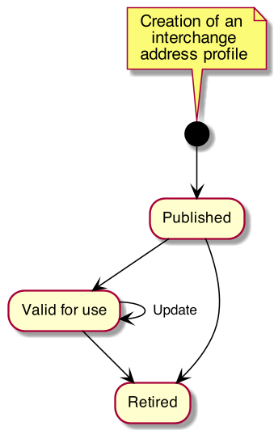
Figure 1 — Lifecycle of an address profile

6.2.2 Creating address profiles and address class profiles
Address class profiles that comply with ISO 19160-1:2015, Annex B, ISO 19106:2004 Conformance class 1, and requirements specified in Clause 10 are created. Address class profiles are created in accordance with requirements specified in Clause 10. Address class profiles are associated with the corresponding address profile in accordance with requirements specified in Clause 10.

6.2.3 Publishing address profiles
Submitting organizations distribute their address profiles to others through direct exchange or through a registry.

6.2.4 Updating address profiles
Submitting organizations can update an address profile and profiles associated with it, and re-distribute it by publishing using a new version number that supersedes the previously published one.

6.2.5 Using address profiles
Applications retrieve suitable address class profiles associated with corresponding address profiles to:
- render address input forms according to the profile-specified form template; or
- display addresses according to the profile-specified display template.
Applications shall consider the validity period of an address class profile, and shall periodically check with the submitting organization (or the registry that the submitting organization distributes via) the latest version of the address profile.

6.2.6 Retiring address profiles
Submitting organizations can indicate the validity period of an address class profile in the profile itself, which if the validity end date has passed, would indicate that the profile is retired.
To immediately retire an address class profile, the submitting organization shall distribute a new version of the address profile with an expired validity period.

6.3 Interchange address

6.3.1 General
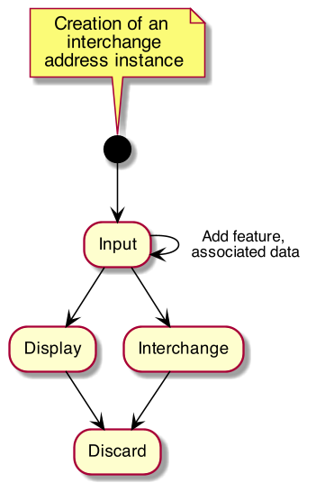
Figure 2 — Lifecycle of an interchange address

6.3.2 Creating a profile-complaint address
This clause describes how a profile-compliant address is created. The desired address class profile shall be already retrieved for creating a profile-compliant address that conforms to it.
Typically, a user enters an address through an application interface that implements an input format that conforms to the interchange address class profile’s form template, such as an application that runs on an operating system or an Internet application. Such input interface may or may not provide a graphical form.
Conforming applications should not expect general users to be able to input an address with a fully-deduced structure. Immediately after input no features are marked on the interchange address.

6.3.3 Interchange of an interchange address
After a user inputs an address into a structured address form, the user submits this address to the designated recipient, which could be an e-retailer, an electronic business card, or a calendar event.

6.3.4 Displaying an interchange address
The recipient or service that receives an interchange address instance either already has the interchange address class profile or should obtain the interchange address class profile definition. With the interchange address class profile, it could then display the interchange address according to the address class profile’s display template.

6.3.5 Adding address features

6.3.5.1 Improving quality of an interchange address
The recipient or service could process the address, such as to further clean up the address by improving the conformance level by fully deducing the address structure, which would add an address feature https://standards.isotc211.org/19160/-6/features/specified to the address instance.
To ensure that the resulting interchange address with a fully-specified structure is correct, the processor may wish to confirm with the user the resulting address, such as in the case where the address is used for shipping information. This would add the AddressFeature https://standards.isotc211.org/19160/-6/features/confirmed to the address instance.

6.3.5.2 Verifying an interchange address
The recipient or service could further validate the address, such as with a postal or addressing authority. This would add the AddressFeature https://verifyingauthority/verified to the interchange address written by the verifying authority.

6.3.6 Adding associated data to an interchange address
A processor of an interchange address could add extra information such as delivery instructions or routes as associated data.
If the user already has a verified, structured address, then the service could save the effort for verifying the address. Custom address features could be added into the interchange address.

6.3.7 Discarding an interchange address
When a service no longer needs an address, the address should be disposed of.

7 Address profile model overview
The address profile model defined in this document consists of three major layers:
- the AddressProfile model as a container of profiles of addresses and address components,
- the profiles of addresses and address components, and
- the addresses and address components conforming to the profiles of addresses and address components.
The AddressProfile model acts as a container of AddressClassProfiles and AddressComponentProfiles. In general, an AddressProfile contains the AddressClassProfiles and AddressComponentProfiles of a single country or region, which can be represented as country code in ISO 3166-1:2020.
For addresses to conform to this standard, they and their associated address components shall conform to their corresponding AddressClassProfiles and AddressComponentProfiles.
The association between an address and an address components shall also conform to the AddressComponentSpecification defined in between the AddressClassProfile and AddressComponentProfile. Those conforming addresses and address components are ProfileCompliantAddresses and ProfileCompliantAddressComponents.
As ProfileCompliantAddress and ProfileCompliantAddressComponent extend from Address and AddressComponent respectively, their instances will be compliant to ISO 19160-1:2015 without any compatibility issues.
This document further defines InterchangeAddressClassProfile for defining AddressClassProfiles which can be claimed as interchangeable. Addresses compliant to InterchangeAddressClassProfile will be interchangeable among humans, devices and systems with interoperability.
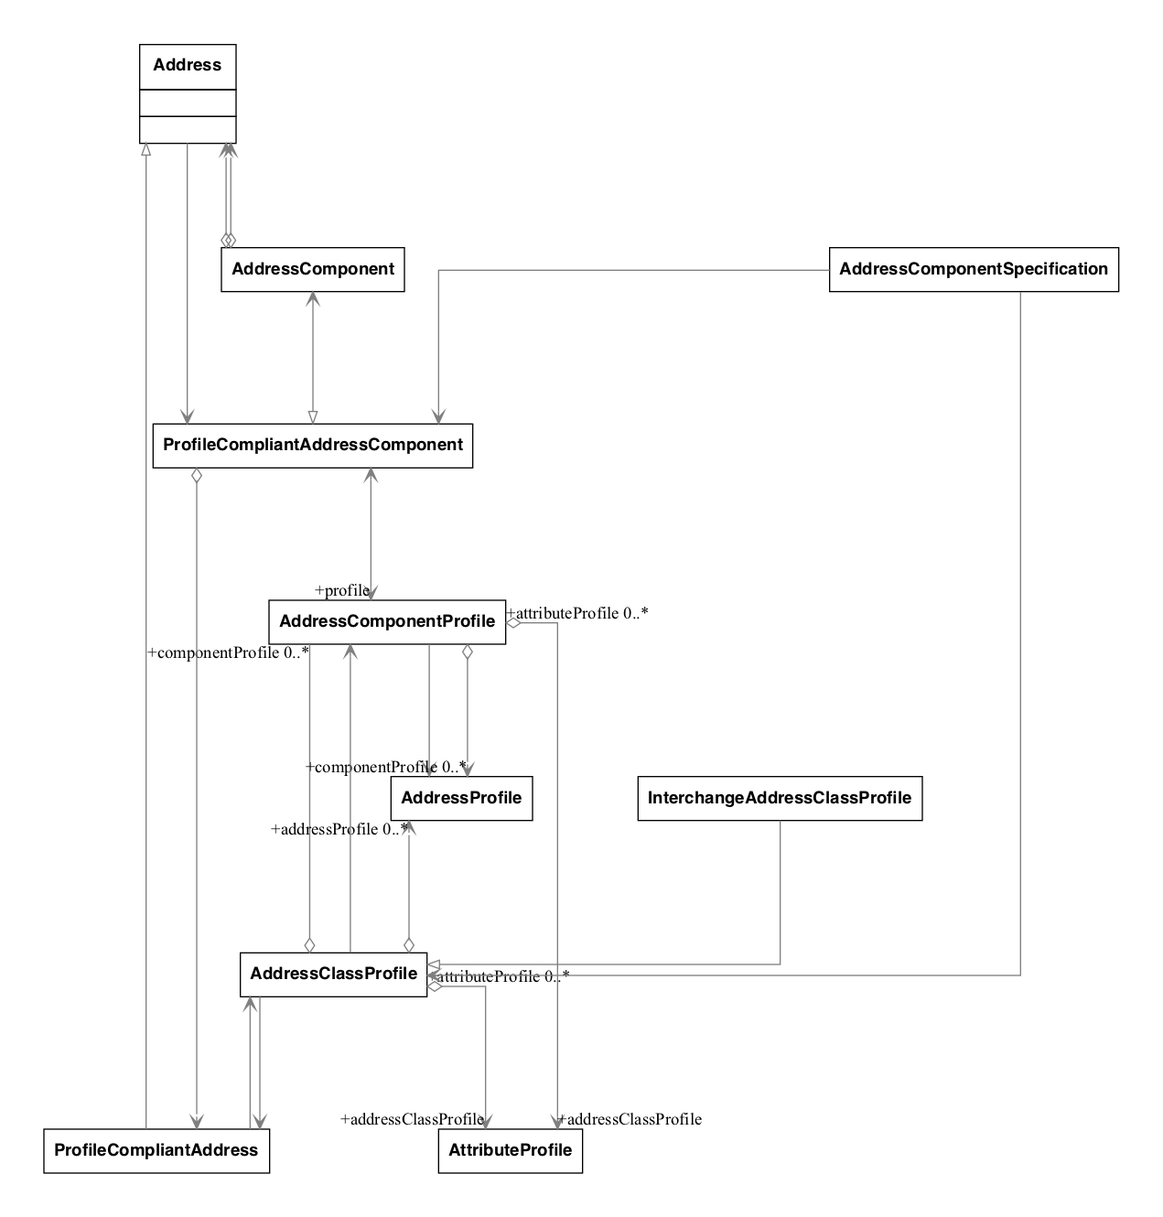
Figure 3 — Address profile model overview in UML
NOTE This clause defines a number of composite data models, integrates and thereby requires coordination between complex precedent standards, including ISO 19115-1:2014, ISO 19160-1:2015 amongst others.

8 Data types

8.1 Primitive and core data types
These are the common data types used within this document.
Primitive data types (PrimitiveTypes) are defined in ISO 19103:2015, 7.2, including:
- CharacterString
- DateTime, Date, Time
- Number, Integer, Decimal, Real
- Vector
- Boolean
Core data types (CoreTypes) are defined in ISO 19103:2015, A.2.
Figure 4 — Data types to be used in this standard

9 Common models
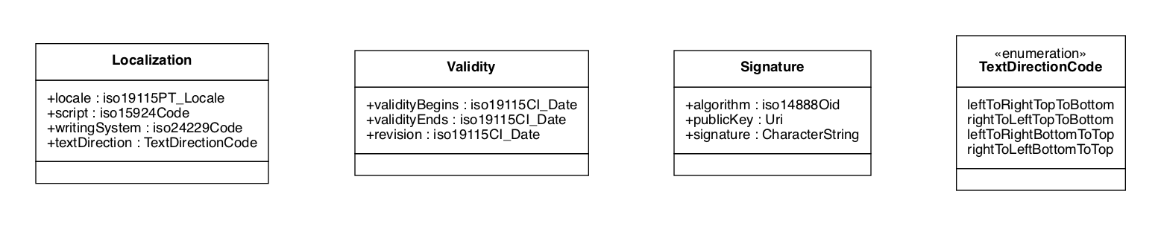
Figure 5 — Common models to be used in this standard

10 Address profile
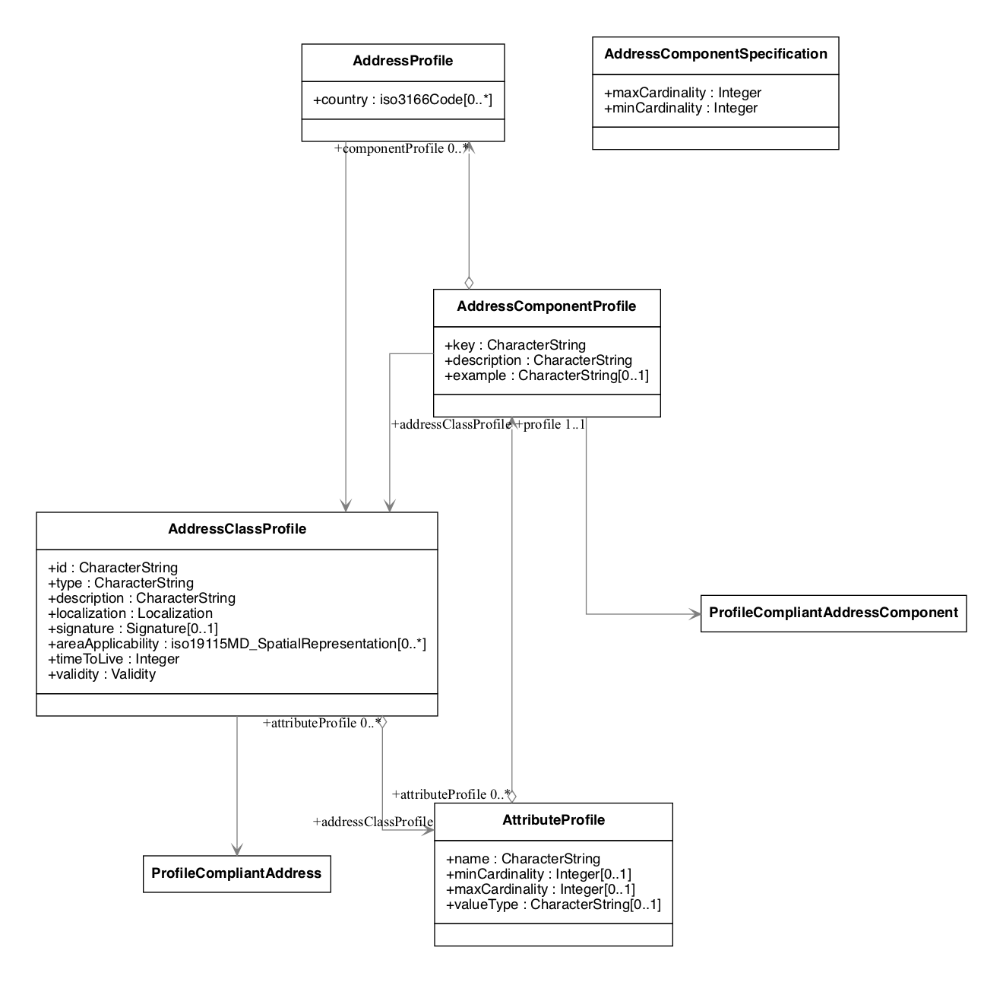
Figure 6 — Address profile data model

11 Profile compliant address
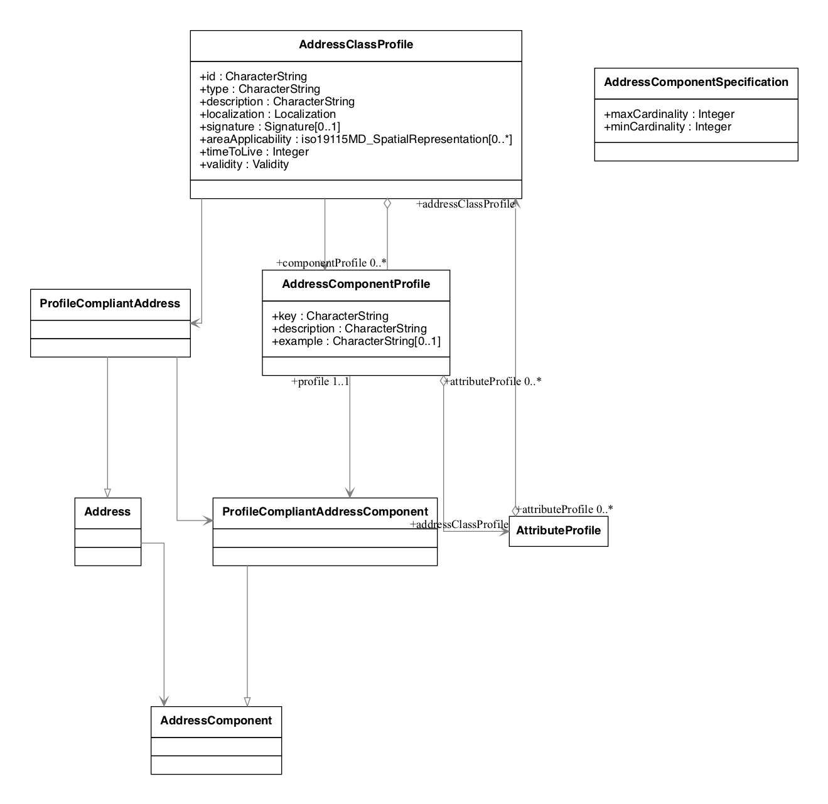
Figure 7 — Profile compliant address data model

12 InterchangeAddressClassProfile overview
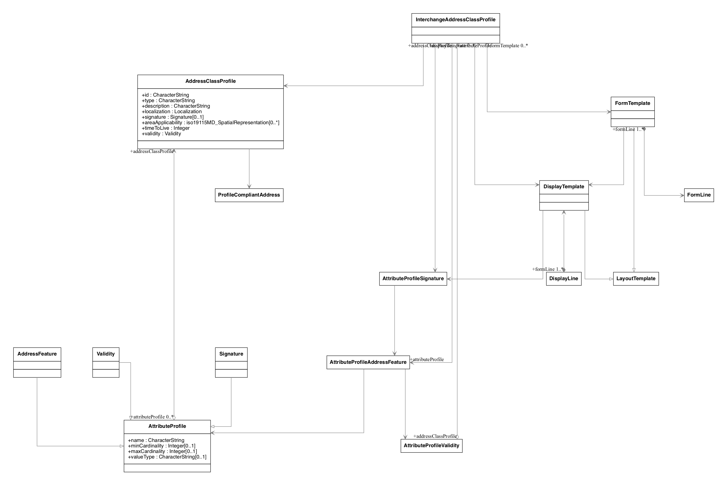
Figure 8 — InterchangeAddressClassProfile model

13 Address feature
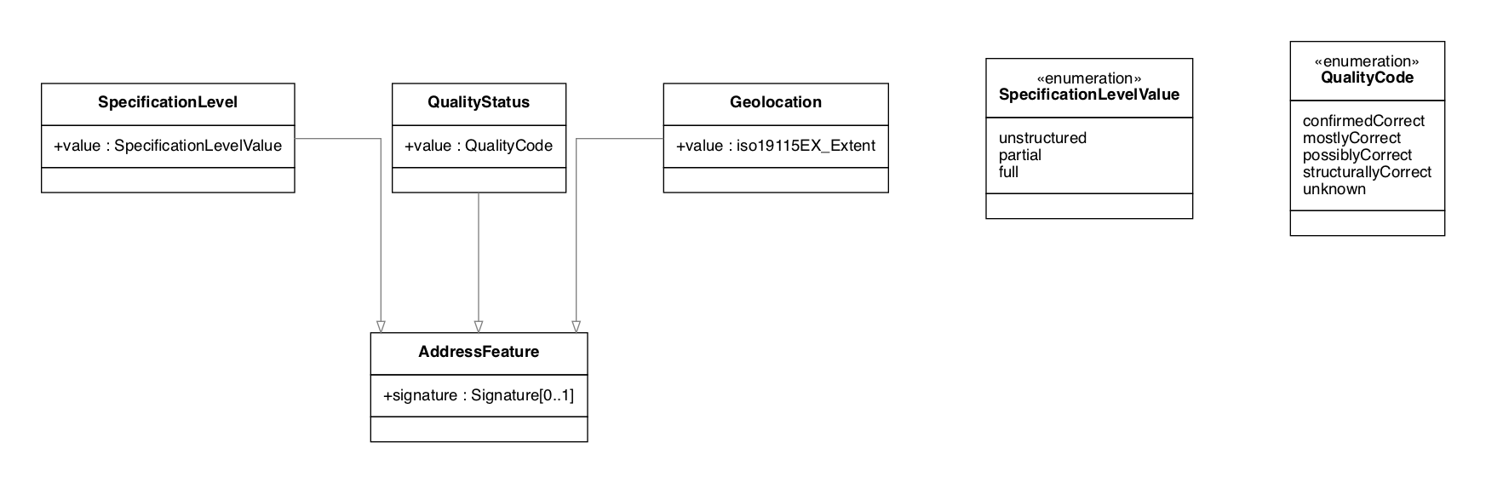
Figure 9 — Address feature data model

14 Layout template
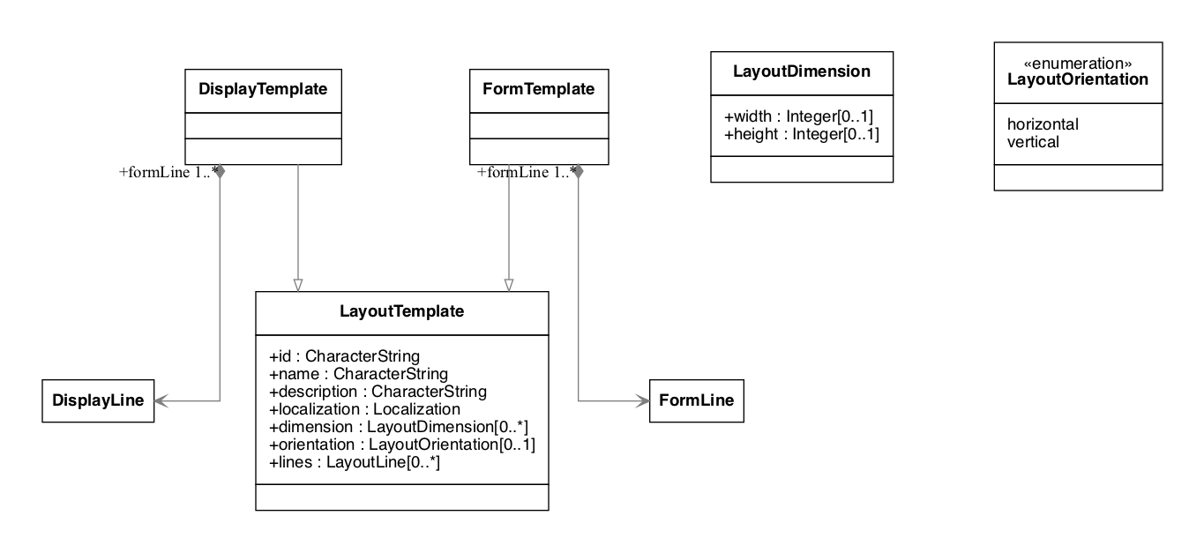
Figure 10 — Layout template data model

15 LayoutLine
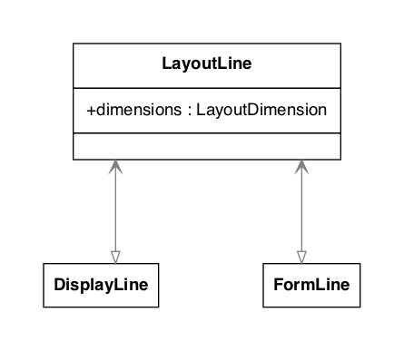
Figure 11 — Layout line data model

16 Display template
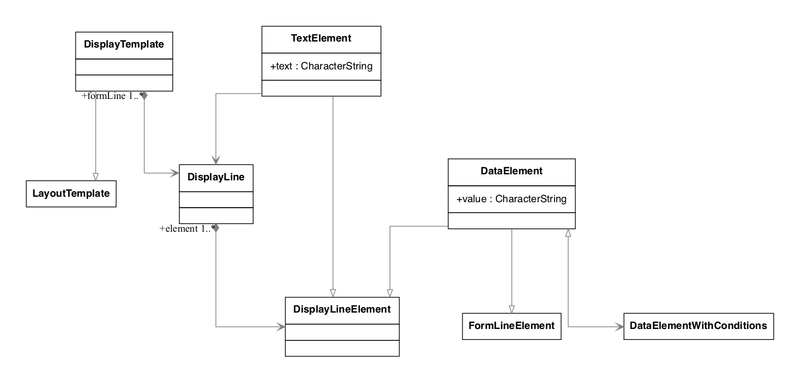
Figure 12 — Display template data model

17 Form template
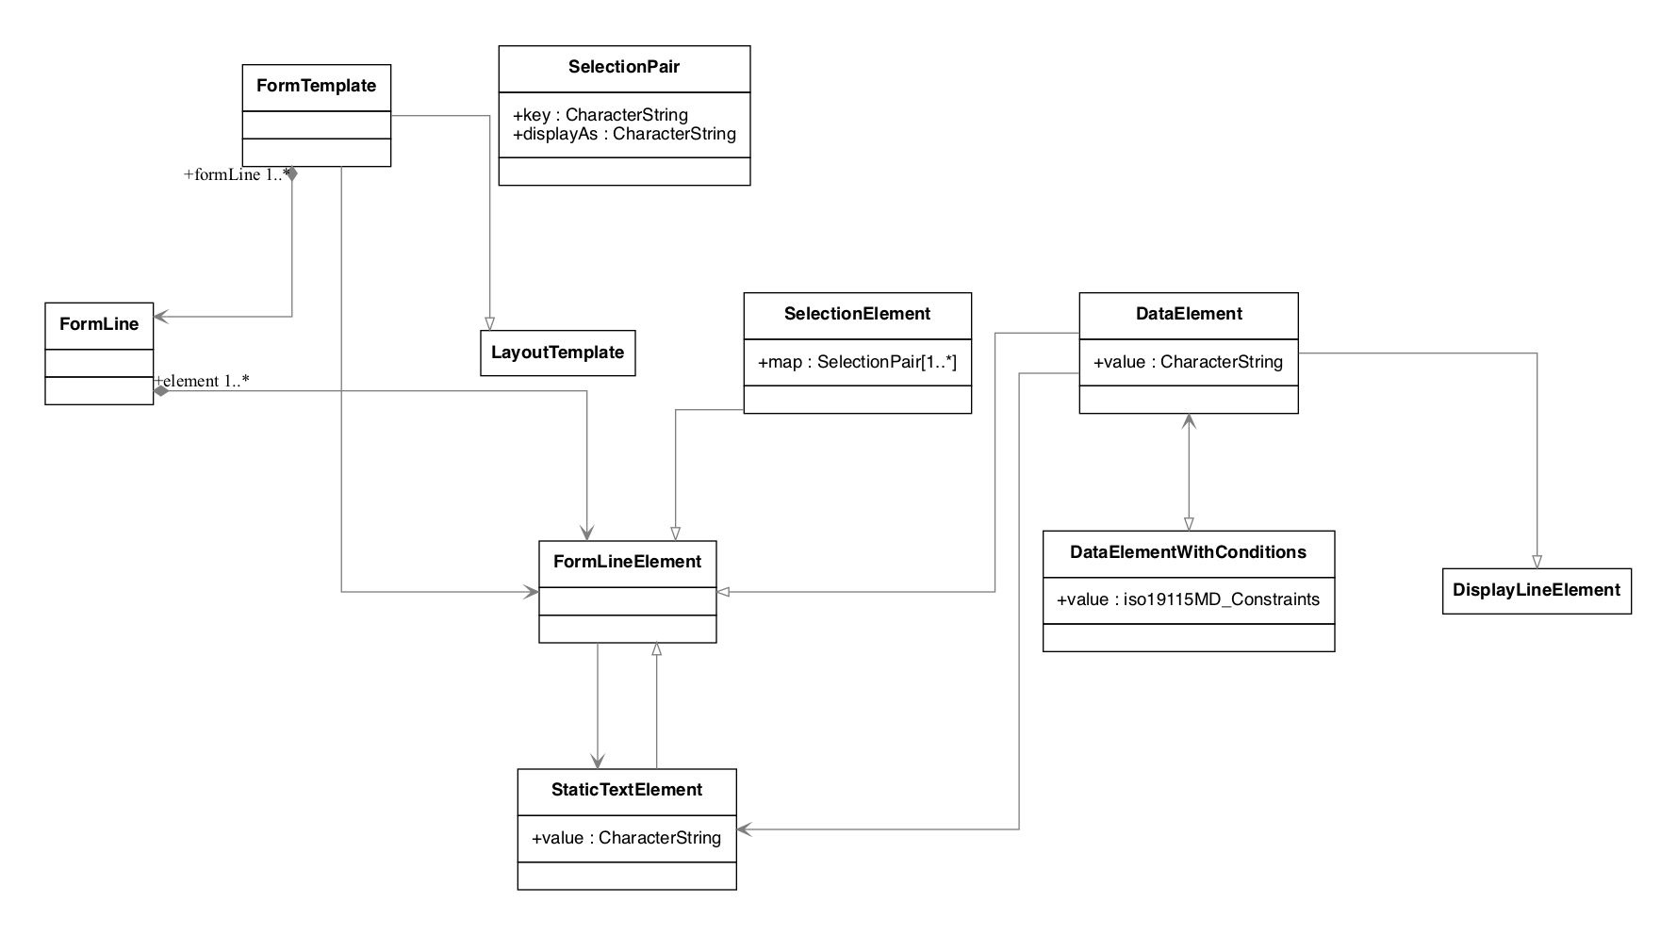
Figure 13 — Form template data model

- (informative)
Abstract test suites

A.1 Introduction
The abstract test suites for the conformance classes defined by this part of ISO 19160 are presented in A.3 to A.10.

A.2 Conformance class: Address profile register
Refer to ISO 19135-1:2015 for requirements.

A.3 Conformance class: AddressProfile
Table A.1 — AddressProfile test 1: Associations
Test purpose | Check that the model contains the associations as specified.
Test method | Inspect the model
Reference | Clause 10
Test type | Basic
Table A.2 — AddressProfile test 2: Attributes
Test purpose | For each instance in the class, check that the instance appropriately includes the mandatory, optional and conditional attributes.
Test method | Inspect the model
Reference | Clause 10
Test type | Basic

A.4 Conformance class: AddressClassProfile
Table A.3 — AddressClassProfile test 1: Associations
Test purpose | Check that the model contains the associations as specified.
Test method | Inspect the model
Reference | Clause 10
Test type | Basic
Table A.4 — AddressClassProfile test 2: Attributes
Test purpose | For each instance in the class, check that the instance appropriately includes the mandatory, optional and conditional attributes.
Test method | Inspect the model
Reference | Clause 10
Test type | Basic

A.5 Conformance class: AddressComponentProfile
Table A.5 — AddressComponentProfile test 1: Associations
Test purpose | Check that the model contains the associations as specified.
Test method | Inspect the model
Reference | Clause 10
Test type | Basic
Table A.6 — AddressComponentProfile test 2: Attributes
Test purpose | For each instance in the class, check that the instance appropriately includes the mandatory, optional and conditional attributes.
Test method | Inspect the model
Reference | Clause 10
Test type | Basic

A.6 Conformance class: ProfileCompliantAddress
Table A.7 — ProfileCompliantAddress test 1: Associations
Test purpose | Check that the model contains the associations as specified.
Test method | Inspect the model
Reference | Clause 11
Test type | Basic
Table A.8 — ProfileCompliantAddress test 2: Attributes
Test purpose | For each instance in the class, check that the instance appropriately includes the mandatory, optional and conditional attributes.
Test method | Inspect the model
Reference | Clause 11
Test type | Basic

A.7 Conformance class: ProfileCompliantAddressComponent
Table A.9 — ProfileCompliantAddressComponent test 1: Associations
Test purpose | Check that the model contains the associations as specified.
Test method | Inspect the model
Reference | Clause 11
Test type | Basic
Table A.10 — ProfileCompliantAddressComponent test 2: Attributes
Test purpose | For each instance in the class, check that the instance appropriately includes the mandatory, optional and conditional attributes.
Test method | Inspect the model
Reference | Clause 11
Test type | Basic

A.8 Conformance class: InterchangeAddressClassProfile
Table A.11 — InterchangeAddressClassProfile test 1: Associations
Test purpose | Check that the model contains the associations as specified.
Test method | Inspect the model
Reference | Clause 12
Test type | Basic
Table A.12 — InterchangeAddressClassProfile test 2: Attributes
Test purpose | For each instance in the class, check that the instance appropriately includes the mandatory, optional and conditional attributes.
Test method | Inspect the model
Reference | Clause 12
Test type | Basic

A.9 Conformance class: FormTemplate
Table A.13 — FormTemplate test 1: Attributes
Test purpose | For each class and type in the model, check that the model appropriately includes the mandatory, optional and conditional attributes.
Test method | Inspect the model
Reference | Clause 17
Test type | Basic

A.10 Conformance class: DisplayTemplate
Table A.14 — DisplayTemplate test 1: Attributes
Test purpose | For each class and type in the model, check that the model appropriately includes the mandatory, optional and conditional attributes.
Test method | Inspect the model
Reference | Clause 16
Test type | Basic

- (informative)
Usage

B.1 Accuracy and verification
An authority, such as the local post office, could “verify” a structured address that it is confirmed that this address instance is a “deliverable address” through an AddressFeature.
The owner of the address, such as the tenant of an office, could provide its signed, structured address on an electronic business card. This allows the recipient of the business card to know whether the senders address is authentic. If this address is verified to be a “deliverable address”, the recipient will know that items sent to this address will very likely be deliverable.
Extra steps need to be taken here to allow this.

B.2 Address as identity
Addresses do not only specify a location, in some cases they are part of the identity. For example, in business cards, an address can mean more than just an address, such as with vanity value.
This document shall support this functionality for it to be useful in contact exchange.
This address represents a complete textual address instance.
EXAMPLE 1 — Fully expanded sample address Suite 1109, Floor 11, Central Building, 1-3 Pedder Street, Central, Central & Western District, Hong Kong Island, Hong Kong
And this address represents the identical address as above, with a reduction of information that is already implied, which that does not reduce its correctness. This can be achieved by supplying a displayTemplate in the interchange address.
EXAMPLE 2 — Shortened sample address Suite 1109, 1 Pedder Street, Central, Hong Kong

B.3 Address as destination
In certain cases, an address is expected to be reachable either by person and/or post.
An address instance should support being used in conjunction with routing information, acting as a waypoint, and/or supporting a source-defined route.
EXAMPLE Written instructions on how to deliver to a place can be unambiguous, but terribly difficult to locate. For instance, some buildings have split floors — rooms may have the same floor identifier, but is actually inaccessible from the same floor.

- (informative)
Examples of objects specified in this document
Models specified in this document can be represented in various object structures, including in XML ISO/TS 19139:2007 and in JSON.

C.1 AddressProfile
{
"id": "http://standards.isotc211.org/19160/-6/tc211-sample.adp",
"type": "iso-19160-address-profile",
"publisher": "http://standards.isotc211.org/19160/-6/",
"signature": "...",
"name": "TC 211 Minimal Address Profile",
"localization": {
"language": "en",
"script": "Latn"
},
"area": {
"countries": ["uk"]
},
"valueTypes": {
"addressedObjectIdentifier": {
"primitiveType": "Integer"
}
},
"addressComponents": { ... },
"addressClassProfiles": { ... }
}
Figure C.1

C.2 AddressClassProfiles
"addressClassProfiles": {
"streetAddress": {
"description": "Street Address",
"addressComponentSpecifications": [ (AddressComponentSpecification) 1..* ... ]
"displayTemplate": { ... },
"formTemplate": { ... }
}
}
Figure C.2

C.3 Validity
"validity": {
"validFrom": "20171129Z000000",
"validTo": "20191129Z000000"
}
Figure C.3

C.4 PublisherInformation
"publisher": {
"publisherName": "UK Post Office",
"publisherUri": "https://www.postoffice.co.uk"
}
Figure C.4

C.5 Localization
"localization": {
"language": "en",
"script": "Latn"
}
Figure C.5

C.6 Signature
"signature": {
"algorithm": "1.2.3.4.5.6.7.8.9",
"publicKey": "https://www.postoffice.co.uk/profile-signature.key",
"signature": "BOLVMNoGNM1TLglnlxgm0a9t"
}
Figure C.6

C.7 AddressClassProfile
"addressClassProfile": {
"id": "streetAddress",
"description": "A typical street address",
"addressComponentSpecifications": [ ... ],
"displayTemplate": { ... },
"formTemplate": { ... },
}
Figure C.7

C.8 User Defined Data Types
"valueTypes": [{
"name": "addressNumberValue",
"coreType": "Integer",
"constraints": [ ... ],
}]
Figure C.8

C.9 Data Type Constraints
"constraints": [{
"maxValue": 10000,
"minValue": 1
}]
Figure C.9

C.10 AddressComponentClass
"addressComponentClass": {
"key": "addressNumber",
"description": "Street number",
"datatype": "addressNumberValue"
}
Figure C.10

C.11 ProfileCompliantAddress
"address": {
"profileId": "https://standards.isotc211.org/19160/-6/profiles/uk.adp",
"components": [ ... ],
"signature": { ... },
"features": [ ... ]
}
Figure C.11

C.12 AddressComponent
"addressComponent": {
"type": "addressNumber",
"values": [ 1001 ]
}
Figure C.12

C.13 AddressFeature
"addressFeature": {
"feature": "https://standards.isotc211.org/19160/-6/features/specified",
"signature": [ ... ]
}
Figure C.13

C.14 DisplayTemplate
"DisplayTemplate": {
...
}
Figure C.14

C.15 FormTemplate
"FormTemplate": {
...
}
Figure C.15

- (informative)
Examples

D.1 Example of address profiles defined in ISO 19160-1

D.1.1 ISO 19160-1 C.2 Example 1: Minimal address profile

D.1.1.1 Address profile (JSON)
{
"id": "http://standards.isotc211.org/19160/-6/tc211-minimal.adp",
"type": "iso-19160-address-profile",
"publisher": "http://standards.isotc211.org/19160/-6/",
"signature": "...",
"name": "TC 211 Minimal Address Profile",
"locale": {
"language": "en",
"script": "Latn"
},
"addressComponents": {
"addressLine": {
"dataType": "CharacterString",
"minCardinality": 1
},
},
"addressClassProfiles": {
"minimalAddress": {
"addressComponentSpecifications": [
{
"componentType": "addressLine",
"description": "Address line",
"require": true
}
],
"displayTemplates": [
{
"id": "basic",
"name": "Basic",
"description": "Rendering of the minimal address profile",
"orientation": "horizontal",
"localization": {
"script": "Latn",
"language": "en"
},
"lines": [
{
"componenet": "addressLine",
"cardinality": "*"
}
]
}
],
"formTemplates": [
{
"id": "basic",
"name": "Basic",
"description": "Address input form for the minimal address profile",
"orientation": "horizontal",
"localization": {
"script": "Latn",
"language": "en"
},
"formLines": [
{
"fields": [
{ "component": "addressLine" }
],
"cardinality": "*"
}
]
}
]
}
}
}
Figure D.1

D.1.1.2 Profile-compliant address (ISO 19160-1, Figure C.3, South African street address) (JSON)
{
"profile": "http://standards.isotc211.org/19160/-6/tc211-minimal.adp",
"components": [
{
"type": "addressLine",
"value": "14 Church Street"
},
{
"type": "addressLine",
"value": "Hatfield"
},
{
"type": "addressLine",
"value": "South Africa"
}
]
}
Figure D.2

D.1.1.3 Profile-compliant address (ISO 19160-1, Figure C.4, US landmark address) (JSON)
{
"profile": "http://standards.isotc211.org/19160/-6/tc211-minimal.adp",
"components": [
{
"type": "addressLine",
"value": "Statue of Liberty"
},
{
"type": "addressLine",
"value": "Liberty Island"
},
{
"type": "addressLine",
"value": "New York"
},
{
"type": "addressLine",
"value": "NY"
}
]
}
Figure D.3

D.1.1.4 Profile-compliant address (ISO 19160-1, Figure C.5, UK address) (JSON)
{
"profile": "http://standards.isotc211.org/19160/-6/tc211-minimal.adp",
"components": [
{
"type": "addressLine",
"value": "Multi-storey car park at Southampton Magistrates Court"
},
{
"type": "addressLine",
"value": "Carlton Crescent"
},
{
"type": "addressLine",
"value": "Southampton, Bevois"
},
{
"type": "addressLine",
"value": "S017 1EY"
},
{
"type": "addressLine",
"value": "United Kingdom"
}
]
}
Figure D.4

D.1.2 ISO 19160-1 C.3 Example 2: Sample address profile

D.1.2.1 Address profile (JSON)
ISO 19160-1, Table C.4 (Address component type) is also incorporated in this profile.
{
"id": "http://standards.isotc211.org/19160/-6/tc211-sample.adp",
"type": "iso-19160-address-profile",
"publisher": "http://standards.isotc211.org/19160/-6/",
"signature": "...",
"name": "TC 211 Minimal Address Profile",
"locale": {
"language": "en",
"script": "Latn"
},
"valueTypes": {
"addressedObjectIdentiferValue": {
"primitiveType": "Integer",
"maxValue": 10000,
"minValue": 1
},
"thoroughfareNameValue": {
"type": "Object",
"value": {
"prefix": {
"primitiveType": "CharacterString"
},
"name": {
"primitiveType": "CharacterString"
},
"suffix": {
"primitiveType": "CharacterString"
},
"type": {
"primitiveType": "CharacterString"
}
}
}
}
"addressComponents": {
"addressNumber": {
"dataType": "addressedObjectIdentiferValue",
"description": "Address number"
},
"boxNumber": {
"dataType": "addressedObjectIdentiferValue",
"description": "PO Box number"
},
"thoroughfareName": {
"dataType": "thoroughfareNameValue",
"description": "Thoroughfare name"
},
"localityName": {
"dataType": "CharacterString",
"description": "Locality name"
},
"postOfficeName": {
"dataType": "CharacterString",
"description": "Post office name"
},
"postCode": {
"dataType": "CharacterString",
"description": "Post code"
},
"countryName": {
"dataType": "CharacterString",
"description": "Country"
}
},
"addressClassProfiles": {
"streetAddress": {
"description": "Street Address",
"addressComponentSpecifications": [
{
"componentType": "addressNumber",
"minCardinality": 1,
"maxCardinality": 1,
"required": true
},
{
"componentType": "thoroughfareName",
"minCardinality": 1,
"maxCardinality": 1,
"required": true
},
{
"componentType": "placeName",
"dataType": CharacterString,
"minCardinality": 1,
"maxCardinality": 1,
"required": true
},
{
"componentType": "postCode",
"minCardinality": 1,
"maxCardinality": 1,
"required": true
},
{
"componentType": "countryName",
"minCardinality": 1,
"maxCardinality": 1,
"required": false,
},
],
"displayTemplates": [
{
"id": "basic",
"name": "Basic",
"description": "Rendering of the minimal address profile",
"orientation": "horizontal",
"localization": {
"script": "Latn",
"language": "en"
},
"lines": [
{
"type": "template",
"value": "{{ addressNumber }} {{ thoroughfareName.name }} {{ thoroughfareName.type }}"
},
{
"type": "template",
"value": "{{ placeName }} {{ postCode }}"
},
{
"type": "component",
"value": "countryName"
}
]
}
],
"formTemplates": [
{
"id": "basic",
"name": "Basic",
"description": "Address input form for the sample address profile",
"orientation": "horizontal",
"localization": {
"script": "Latn",
"language": "en"
},
"formLines": [
{
"fields": [
{ "component": "addressNumber" },
{ "component": "thoroughfareName" }
]
},
{
"fields": [
{ "component": "placeName" },
{ "component": "postCode" }
]
},
{
"fields": [
{ "component": "countryName" }
]
}
]
}
]
},
"boxAddress": {
"description": "Box Address",
"addressComponentSpecifications": [
{
"componentType": "boxNumber",
"minCardinality": 1,
"maxCardinality": 1,
"required": true
},
{
"componentType": "postOfficeName",
"dataType": "CharacterString",
"minCardinality": 1,
"maxCardinality": 1,
"required": true
},
{
"componentType": "postCode",
"minCardinality": 1,
"maxCardinality": 1,
"required": true
},
{
"componentType": "countryName",
"minCardinality": 1,
"maxCardinality": 1,
"required": false
},
],
"displayTemplates": [
{
"id": "basic",
"name": "Basic",
"description": "Rendering of the minimal address profile",
"orientation": "horizontal",
"localization": {
"script": "Latn",
"language": "en"
},
"lines": [
{
"type": "template",
"value": "PO Box {{ boxNumber }}"
},
{
"type": "component",
"value": "postOfficeName"
},
{
"type": "component",
"value": "postCode"
},
{
"type": "component",
"value": "countryName"
}
]
}
],
"formTemplates": [
{
"id": "basic",
"name": "Basic",
"description": "Address input form for the minimal address profile",
"orientation": "horizontal",
"localization": {
"script": "Latn",
"language": "en"
},
"formLines": [
{
"fields": [
{ "component": "boxNumber" }
]
},
{
"fields": [
{ "component": "postOfficeName" }
]
},
{
"fields": [
{ "component": "postCode" }
]
},
{
"fields": [
{ "component": "countryName" }
]
}
]
}
]
}
}
}
Figure D.5

D.1.2.2 Profile-compliant address (representation of ISO 19160-1, Figure C.14, Street address) (JSON)
{
"profile": "http://standards.isotc211.org/19160/-6/tc211-sample.adp#streetAddress",
"components": [
{
"type": "addressNumber",
"value": "99"
},
{
"type": "thoroughfareName",
"value": {
"name": "Lombardy",
"type": "Street"
}
},
{
"type": "placeName",
"value": "The Hills"
},
{
"type": "postCode",
"value": "0039"
},
{
"type": "countryName",
"value": "South Africa"
}
]
}
Figure D.6

D.1.2.3 Profile-compliant address (representation of ISO 19160-1, Figure C.15, Box address) (JSON)
{
"profile": "http://standards.isotc211.org/19160/-6/tc211-sample.adp#boxAddress",
"components": [
{
"type": "boxNumber",
"value": "345"
},
{
"type": "postOfficeName",
"value": "Orlando"
},
{
"type": "postCode",
"value": "2020"
},
{
"type": "countryName",
"value": "South Africa"
}
]
}
Figure D.7

Bibliography
[1] ISO 639-3:2007, Codes for the representation of names of languages — Part 3: Alpha-3 code for comprehensive coverage of languages
[2] ISO 3166-1:2020, Codes for the representation of names of countries and their subdivisions — Part 1: Country code
[3] ISO/IEC 9798-1:2010, Information technology — Security techniques — Entity authentication — Part 1: General
[4] ISO/IEC 9798-3:2019, IT Security techniques — Entity authentication — Part 3: Mechanisms using digital signature techniques
[5] ISO/IEC/IEEE 9945:2009, Information technology — Portable Operating System Interface (POSIX®) Base Specifications, Issue 7
[6] ISO/IEC 10179:1996, Information technology — Processing languages — Document Style Semantics and Specification Language (DSSSL)
[7] ISO/IEC 14888-3:2018, IT Security techniques — Digital signatures with appendix — Part 3: Discrete logarithm based mechanisms
[8] ISO 15924:2004, Information and documentation — Codes for the representation of names of scripts
[9] ISO 19136-1:2020, Geographic information — Geography Markup Language (GML) — Part 1: Fundamentals
[10] ISO/TS 19139:2007, Geographic information — Metadata — XML schema implementation
[11] ISO 19160-4:2017, Addressing — Part 4: International postal address components and template language
[12] ISO/DIS 24229), Information and documentation — Codes for written language conversion systems
[13] ISO/IEC TR 29149:2012, Information technology — Security techniques — Best practices for the provision and use of time-stamping services
[14] ISO/IEC/IEEE 31320-2:2012, Information technology — Modeling Languages — Part 2: Syntax and Semantics for IDEF1X97 (IDEFobject)

) Under preparation. (Stage at the time of publication ISO/DIS 24229). Under preparation. (Stage at the time of publication ISO/DIS 24229).

