# Selection of date and time

## General

A time scale component can be replaced with selection rules to specify matching criteria of certain time scale unit values. This clause builds upon the “explicit” syntax of time scale components specified in Part 1, 4.3.

[selection] may include zero or more selection rules.

*selection* = [selection-rule-1]…[selection-rule-n]

Generally, selection rules should be placed in the order where the higher-order time scale components are placed on the left, and the lower-order ones placed on the right.

While it is possible to translate the selection rules specified in this document to RFC 5545 “RECUR” syntax in most cases; exceptions and limitations are noted within context of the rules specified below.

## Selection of calendar months

This selection rule specifies a set of calendar months of the calendar year.

Representation:

*monthSR* = [monthE]

Valid values are [1] to [12], corresponding to the ordinal number of the calendar month.

EXAMPLE ‘3M’ represents the third month, i.e. March.

Note: In Part 1 this “explicit” form is used for duration only, thus ‘3M’ means “three months”. Part 2 extends the explicit form to apply to components as well.

## Selection of calendar weeks

This selection rule specifies a set of ordinals specifying calendar weeks of the calendar year.

Representation:

*weekSR* = [weekE]

Valid values are [1] to [53] and [-53] to [-1]. This corresponds to the number of calendar weeks of a year according to week numbering as defined in Part 1.

This rule should only be specified when the frequency of the repeat rule is set to yearly (9.3.2 a)).

EXAMPLE The third week of the calendar year is represented by the expression ‘3W’ in this part.

Note 1: Week 53 can only occur when Thursday is January 1 or if it is a leap calendar year and Wednesday is January 1, in accordance with Part 1, 4.2.2.

Note 2: Refer to 4.4.3 for negative values of weeks.

Note 3: Definitions of the calendar week and the week number are provided in Part 1.

## Selection of calendar month days

This selection rule specifies a set of days of the calendar month.

Representation:

*daySR* = [dayE]

Valid values are [1] to [31] and [-31] to [-1]. This corresponds to the maximum number of calendar days of a calendar month.

EXAMPLE ‘-10D’ represents the tenth to the last calendar day of the calendar month.

When the frequency part is set to weekly (9.3.2 c)), this selection rule must not be specified.

## Selection of week days

This selection rule specifies a set of days of the week.

Representation:

*daykSR* = [daykE]

Valid values are [1] to [7].

EXAMPLE Within a monthlyrule, “1K” represents all Mondays within the calendar month.

## Selection of calendar week days with position

This selection rule indicates the n-th occurrence of a specific week day within a yearly (9.3.2 a)) or monthly (9.3.2 b)) intervals.

Representation:

daykR = [!][“-”][n][“j”][daykE]

This representation should be used only with repeating rules with intervals of a higher order time scale unit than “week”, such as “yearly” or “monthly”. Valid values of [n] range from [1] to [53] and [-53] to [-1].

The numeric value [n] in this rule corresponds to an offset within a given scope:

— when the frequency is yearly, and when there is a rule for selection of calendar month, then the offset corresponds to an offset within the calendar month specified in the selection of month rule;

— when there is a rule for selection of week or for selection of calendar month, then the offset corresponds to an offset within the calendar year.

EXAMPLE 1 When specified in a monthlycontext, ‘+1j1K’ represents the first Monday within the calendar month, whereas ‘{1,-2}j1K’ represents the first and the second last Monday of the calendar month.

EXAMPLE 2 When specified in a yearlycontext, ‘+52j1K’ represents the 52th Monday within the calendar year, whereas ‘-21j1K’ represents the 21st Monday counted from the last week of the calendar year.

## Selection of ordinal days in calendar year

This selection rule specifies a set of ordinal days of the calendar year, and should only be specified when the interval of the repeat rule is set to yearly (9.3.2 a)), monthly (9.3.2 b)) or daily (9.3.2 d))*.*

Representation:

*dayoSR* = [dayoE(m)]

Valid values are [1] to [366] and [–366] to [-1].

Note: The values of [366] and [-366] are used to match a calendar leap year

EXAMPLE 1 ‘-1’ represents the last day of the calendar year (December 31st)

EXAMPLE 2 ‘-306’ represents the 306th to the last day of the calendar year (March 1st)

## Selection of hours

This selection rule specifies a set of hours of the calendar day.

Representation:

*hourSR* = [hourE]

Valid values are [0] to [23].

## Selection of minutes

This selection rule specifies a set of minutes within an hour.

Representation:

*minSR* = [minE]

Valid values are [0] to [59].

## Selection of seconds

This selection rule specifies a set of seconds within a minute.

Representation:

*secSR* = [secE]

Valid values are [0] to [60].

Note 1: The value of [60] is used to match a leap second of the calendar year

Note 2: The value of [60] should be changed to [59] on conversion the rule to RFC 5545 “BYSECOND” since it does not support a value of [60].

## Selection of position

The positional part is an optional part in a selection rule. It specifies a set of values that corresponds to the n-th occurrence within selected occurrences.

Particularly, it operates on a set of recurrence instances in one interval of the repeating rule.

A set of recurrence instances starts at the beginning of the interval defined by the frequency part.

The selection of position should only be used when there is at least one selection rule is specified.

*positionSR* = [position][“I”]

Valid values for [position] = [!][“-”][n] are [1] to [366] or [-366] to [-1].

Each position value can include a positive (+n) or negative (-n) integer. If present, this indicates the n-th occurrence of the specific occurrence within the set of occurrences specified by the rule.

EXAMPLE 1 In a repeating rule with a weekly frequency, the interval would be one week.

EXAMPLE 2 “The last work day of the calendar month” can be represented as the repeating rule ‘F1ML{1,2,3,4,5}K-1I’

# Recurring time intervals with repeat rules

## General

This clause extends Part 1, 5.4 “Recurring Time Interval”, by adding a rule part that defines the repeat pattern. The rule part is appended to the recurring time interval structure.

The clause is based on the mechanisms provided in [4], which describes a repeat rule syntax interchangeable with the syntax specified in IETF RFC 5545. The implementation of this feature depends on 8.2.

## Method of specification

A recurring time interval is represented as follows:

— Optionally, a number of occurrences. If absent, the number of occurrences is unbounded. Each occurrence is called an “event”.

— Followed by a time interval, as specified in 5.4.1 of Part 1.

— Followed by a repeat rule.

## Repeat rule

### General

A repeat rule identifies a set of matching instants according to specification of a repeating cycle used together with selection rules.

*repeat-rule* = [“F”][eligible-time-intervals][“L”][selection-rules]

The frequency designator [“F”] precedes the identification of a series of repeating time intervals (“repeating intervals”). Within each repeating interval, one sub-interval is distinguished, called an “eligible time interval”.

### Eligible time intervals

Within each eligible time interval, one or more events occur, as determined by [selection-rules], which are optional. If [selection rules] is omitted, a single event occurs at the end of the eligible time interval.

[eligible-time-intervals] in the repeat rule above is one of the following:

1. Time interval of one or more years: [yearE]
2. Time interval of one or more months: [monthE]
3. Time interval of one or more weeks: [weekE]
4. Time interval of one or more days: [dayE]
5. Time interval of one or more hours: [hourE]
6. Time interval of one or more minutes: [minE]
7. Time interval of one or seconds: [secE]

— The duration of each repeating interval is the value of [eligible-time-intervals].

EXAMPLE 1 If the value of [eligible-time-intervals] is ‘8Y’, the length of each repeating time interval is 8 years.

— The duration of each eligible time interval is one-unit of the chosen time scale component in which the duration of [eligible-time-intervals] is expressed.

EXAMPLE 2 If the value of [eligible-time-intervals] is ‘8Y’, then the time scale component is year, there are eight eligible intervals, each of length 1 year.

— Each eligible time interval begins x-1 units of the selected time scale component following the beginning of its repeating interval, where x is the coefficient of the unit.

EXAMPLE 3 If the value of [eligible-time-intervals] is ‘8Y’, the eligible time interval is the 7th year within the 8-year repeating interval.

EXAMPLE 4 The expression ‘F2Y’ in the frequency part means that the eligible periods are the second year of each 2-year repeating interval.

EXAMPLE 5 The expression ‘F8D’ in the frequency part means that the eligible periods are the 8th day of each 8-day interval.

### Selection part

The selection designator [“L”] identifies a list of selection rules, which specify conditions of matching one or more instants within one or more time intervals.

*selection-rules* = [“L”][selection-rule-1]…[selection-rule-n]

Representations for selection rules are specified in 8.

In a repeating rule, if the selection part is present but does not specify selection rules for all time scale components provided in the “time interval start”, all lower order values from “time interval start” value should be used to fill in the missing component values in the selection part.

EXAMPLE 1 When the selection part ‘L3DT’ is used with the time interval start value ‘2018-08-01T01:02:03’, the selection part is treated as ‘L3D’ ‘F1DL1M’ reduces the number of repeat instances from all days (when the selection rule was not specified) to all days in January.

For a detailed explanation of interactions between eligible time intervals and the selection part, please refer to Annex B.

For issues dealing with compatibility with RFC 5545, please refer to Annex C.

## Complete representations

### General

A complete representation of a recurring time interval with repeat rules, shall be in accordance with 8 and 9.3, combining any complete recurring time interval representation as defined in Part 1, 5.4.3 with the repeat rule.

A recurring time interval is expressed according to the following representation:

[“R”][n][“/”][time-interval][“/”][repeat-rule]

Where,

— [“R”] is the recurring time interval designator;

— [n] is the number of recurrences (optional);

— [time-interval] is a valid time interval;

— [repeat-rule] is a repeat rule defined in 9.3.

### Basic formats

The basic format time intervalis specified as [timeInterval] of one of these three representations described in Part 1:

— [date][“T”][time][“/”][date][“T”][time]

— [date][“T”][time][“/”][duration]

— [duration][“/”][date][“T”][time]

The representation of a basic format recurring time interval is therefore:

[“R”][n][“/”][timeInterval][“/”][repeat-rule]

EXAMPLE 1 ‘R12/20150929T140000/20150929T153000/F2W’ is of the first form

EXAMPLE 2 ‘R12/20150929T140000/P1H30M0S/F2W’ is of the second form

EXAMPLE 3 ‘R12/P2H30M0S/20150929T153000/F2W’ is of the third form

### Extended formats

The extended format time intervalis specified as [timeIntervalX] of one of these three representations described in Part 1:

— [dateI][“T”][timeI][“/”][dateI][“T”][timeI]

— [dateI][“T”][timeI][“/”][duration-complete]

— [duration-complete][“/”][dateI][“T”][timeI]

The representation of a basic format recurring time interval is therefore:

[“R”][n][“/”][timeIntervalX][“/”][repeat-rule]

EXAMPLE 1 ‘R12/2015‑09‑29T14:00:00/2015‑09‑29T15:30:00/F2W’ is of the first form

EXAMPLE 2 ‘R12/2015‑09‑29T14:00:00/P1H30M0S/F2W’ is of the second form

EXAMPLE 3 ‘R12/P1H30M0S/2015‑09‑29T15:30:00/F2W’ is of the third form

### Explicit formats

The explicit format time intervalis specified as [timeIntervalE] (7.1.4), the representation of a basic format recurring time interval is therefore:

[“R”][n][“/”][timeIntervalE][“/”][repeat-rule]

EXAMPLE 1 ‘R12/2015Y9M29DT14H0M0S/2015Y9M29DT15H30M00S/F2W’ is of the first form

EXAMPLE 2 ‘R12/2015Y9M29DT14H0M0S/P1H30M0S/F2W’ is of the second form

EXAMPLE 3 ‘R12/P1H30M0S/2015Y9M29DT15H30M00S/F2W’ is of the third form

## Representations other than complete

A representation other than complete of a recurring time interval with repeat rule shall be an expression in accordance with 8 and 9.3, where the time interval is represented in accordance with Part 1, 4.4.5.

## Time scale unit precision

The resulting occurrences of a repeat rule after evaluation will use a time scale unit resolution equal to the lowest order time scale unit specified in the repeat rule.

EXAMPLE 1 In the expression ‘R/2018Y1M/P1M/F3M’, the lowest order time scale unit specified is month, hence the resolution is month precision. This expression resolves to the set { 2018-01/2018-02, 2018-04/2018-05 … }

EXAMPLE 2 In the expression ‘R/2018Y1M1D/P1D/F3M’, the lowest order time scale unit specified is day, hence the resolution is day precision. This expression resolves to the set {2018-01-01/2018-01-02, 2018-04-01/2018-04-02 … }

EXAMPLE 3 In the expression ‘R/2018Y1M/PT10M/F1M’, the lowest order time scale unit specified is minute, hence the resolution is minute precision. This expression resolves to the set { 2018-01-01T00:00/2018-01-01T00:10, 2018-02-01T00:00/2018-02-01T00:10, … }

## Evaluation of a repeat rule

A repeat rule specifies a set of occurrences where each occurrence is a time interval.

The resulting occurrences of a repeat rule are calculated by the following steps:

— enumerate all eligible time intervals;

— apply all selection rules to the eligible time intervals; and

— obtain the overlapping instants specified by both the eligible time intervals and the selection rules.

The resulting overlapping instants are the occurrences specified by evaluating the repeat rule.

EXAMPLE ‘R/20150104T083000/PT15M00S/F2YL1M1KT{8,9}H30M’ expresses a recurring interval (number of occurrences is unspecified) whose first occurrence is January 4, 2015, 8:30-8:45 AM, and subsequent occurrences, all of the same duration (15 minutes), are determined by the repeat cycle for which the following evaluation sequence is provided:

— the character ‘F’ indicates that the formula for determining eligible time intervals follows;

— the expression ‘2Y’ indicates that the eligible time intervals have a repeating cycle of two years, and each eligible time interval is 1 year in length, the second year within its repeating interval;

— From this information together with the specification of the first occurrence, it is calculated that:

— the first eligible time interval is the calendar year 2015 (the year during which the first occurrence takes place)

— the first repeating interval is the two-year period comprising calendar years 2014 and 2015;

— the subsequent recurring intervals are then determined by the selection part;

— the character ‘L’ indicates that selection parts follow;

— the expression ‘1M’ indicates that the matching occurrences are limited to January only;

— the expression ‘1K’ indicates that the matching occurrences are limited to Sundays only;

— the expression ‘T’ indicates that intraday time scale components follow;

— the expression ‘{8,9}H’ indicates that the matching occurrences have clock hours 8 or 9;

— the expression ‘30M’ indicates that the matching occurrences have a clock minute value of 30, combined with specified clock hours, the starting times are determined to be 8:30AM and 9:30 AM;

— since the selection rules lacks specified values for clock seconds, in accordance with 9.3.3, they should be obtained from the clock seconds value of the “time interval start” of ‘20150104T083000’, hence the clock seconds selection rule is specified as value ‘00’;

— the recurrent occurrences therefore resolve to the rule “in the last year of every two years, for every Sunday in January at both 8:30:00 AM and 9:30:00 AM, create a 15 minutes event.”

1. (informative)   
   Interactions between eligible time intervals with the selection part
   1. General

The interaction between eligible time intervals and selection rules specified within a repeating rule give rise to interesting properties that users should be aware of.

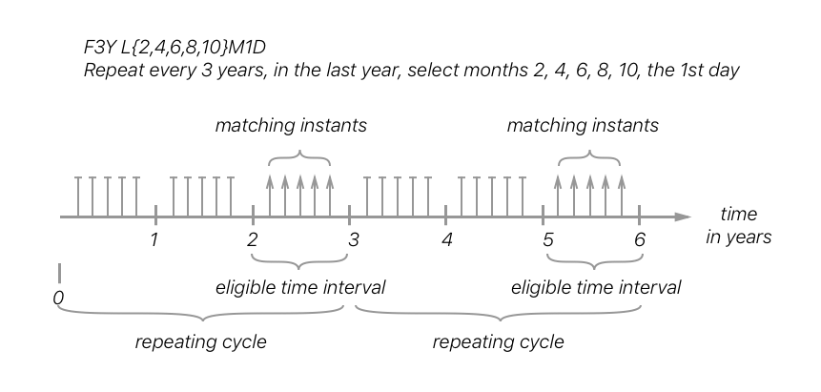

Figure 1. Resulting occurrences of the rule F3YL{2,4,6,8,10}M1D

Figure 1 demonstrates that the repeating cycle denotes how often the eligible time intervals be evaluated. Within the eligible time intervals, the selection rules are applied. It is the overlap between the selection rules and eligible time intervals that produce the resulting occurrences.

* 1. Special case when the repeating cycle uses value 1

When the repeating cycle is defined with a value 1 for any time unit (e.g. calendar year, calendar month, calendar day, calendar hour, etc.), the effect on the resulting occurrences are identical – the repeating cycle fully covers all instants of the time scale. Therefore, the resulting occurrences are fully described by the selection rules that apply.

* 1. Orders of the repeating cycle and selection rules
     1. Repeating cycle of higher order than selection rules

It is common in natural expressions and in calendar implementations that the repeating cycle uses a time scale unit of a higher order than that of the selection rules. The resulting occurrences are generally as expected by the creator of these rules.

EXAMPLE Figure 2 provides such a case; where the resulting occurrences happen once every three years, matching a single date of September 10th.

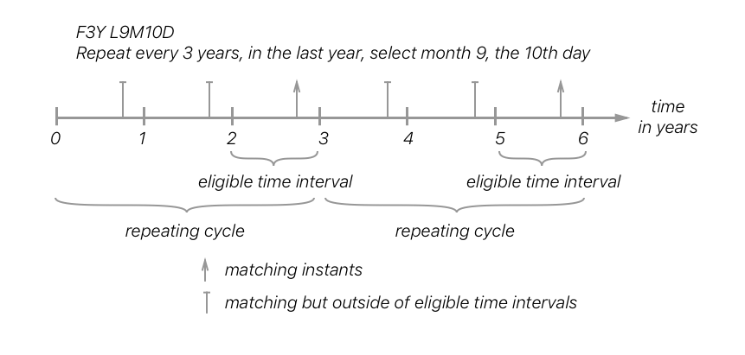

Figure 2. When the repeating cycle is of a higher order than the selection part

* + 1. Repeating cycle of same order with selection rules

When a time scale unit of the same order is used for both the repeating cycle and the selection rules, the following properties arise:

— The effect of A.2 applies;

EXAMPLE 1: A repeating rule of 1 month repeating cycle, with selection rules that are of the highest order of “month”, has the same effect as the repeating cycle of 1 calendar year because every calendar month in the calendar year will be evaluated

— A repeating rule with an n time unit repeating cycle, matched with selection rules of the same time unit, will provide occurrences that depend on the start instant of the repeating cycle.

EXAMPLE 2: A repeating cycle starting in April every 6 months will only match a monthly selection rule that contains April or October

EXAMPLE 3: Figure 3 demonstrates an instance of the second case where the repeating cycle does not overlap with eligible time intervals, resulting in no occurrences.

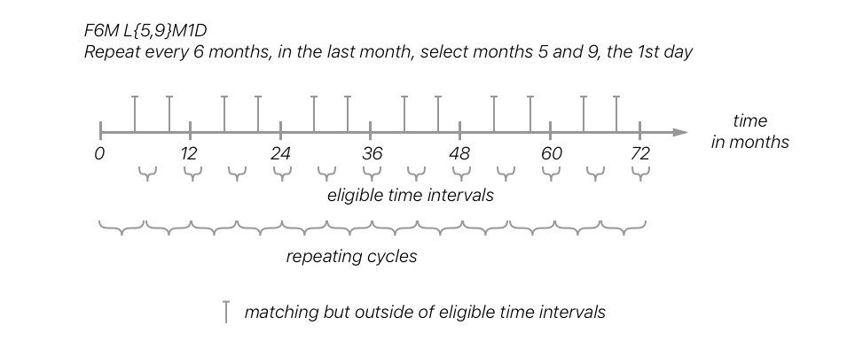

Figure 3. When the repeating cycle is of the same order as the selection part and mismatches

* + 1. Repeating cycle of lower order than selection rules

When a time scale unit of a lower order is used for the repeating cycle than that of the selection rules, the following should be of note:

— The effect of B.2 applies;

— A repeating rule with an n time unit repeating cycle, matched with selection rules of a lower order time unit, will provide occurrences that depend on the start instant of the repeating cycle.

EXAMPLE Figure 4 demonstrates this interaction of the second case, where the repeating cycle is of day order and a selection rule of calendar month order. Notice that there are no matches outside calendar month 3 due to the application of the selection rule.

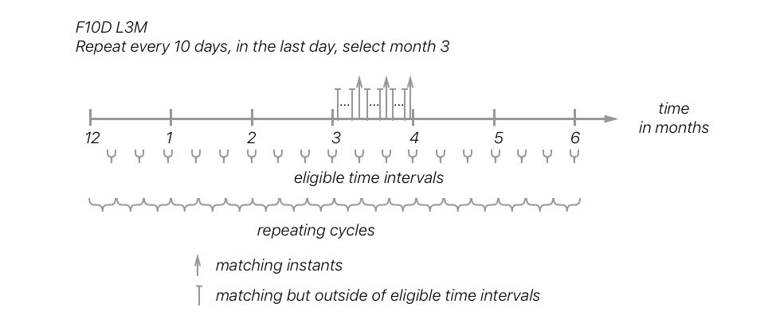

Figure 4. When the repeating cycle is of a lower order than the selection part

1. (informative)   
   Compatibility considerations of repeat rules with RFC 5545 recurrences
   * 1. Evaluation of repeat rules

In this document, the evaluation of repeat rules (see 2.3) rely on explicit specification of selection rules (see Clause 1) and the direct inheritance of time scale component information from the initial start date.

* + 1. Inheritance of time scale component information

In the evaluation of repeat rules within this document as well as in RFC 5545, a number of time scale components can be directly inherited from the initial start date.

In terms of RFC 5545 specifically:

— when the ‘FREQ’ parameter is set to ‘SECONDLY’, but without a ‘BYSECOND’ parameter, the ‘BYSECOND’ selection is directly inherited from the clock seconds value from the initial start date;

— when the ‘FREQ’ parameter is set to ‘MINUTELY’, but without a ‘BYMINUTE’ parameter, the ‘BYMINUTE’ selection is directly inherited from the clock minutes value from the initial start date;

— when the ‘FREQ’ parameter is set to ‘HOURLY’, but without a ‘BYHOUR’ parameter, the ‘BYHOUR’ selection is directly inherited from the clock hours value from the initial start date.

* + 1. Implicit selection rules of RFC 5545

In RFC 5545, however, the evaluation of certain repeat rules also relies on implicit selection rules inherited indirectly from the initial start date.

Specifically,

— when the ‘FREQ’ parameter is set to ‘WEEKLY’, but without a ‘BYDAY’ parameter, the ‘BYDAY’ selection is inherited from the calendar day of week value from the initial start date (note that the calendar day of week value is not directly specified in the initial start date, but it has to be inferred);

— when the ‘FREQ’ parameter is set to ‘MONTHLY, but without both ‘BYMONTHDAY’ and ‘BYDAY’ parameters, the ‘BYMONTHDAY’ selection is inherited from the calendar month of year value from the initial start date;

— when the ‘FREQ’ parameter is set to ‘YEARLY’ but without a ‘BYYEARDAY’ parameter,

— if no ‘BYMONTH’ or ‘BYWEEKNO’ parameter is set:

— if the ‘BYMONTHDAY’ parameter is provided, then the ‘BYMONTH’ selection is inherited from the calendar month of year value from the initial start date;

— if the ‘BYDAY’ parameter is not set, then the ‘BYMONTH’ selection is inherited from the calendar month of year value from the initial start date;

— if no ‘BYMONTHDAY’, ‘BYWEEKNO’ or ‘BYDAY’ parameter is set, the ‘BYMONTHDAY’ selection is inherited from calendar day of month of the initial start date;

— if there is a ‘BYWEEKNO’ parameter set but no ‘BYMONTHDAY’ or ‘BYDAY’, the ‘BYDAY’ selection is inherited from the calendar day of week of the initial start date.

EXAMPLE In evaluating a simplified example expression from RFC 5545, with ‘DTSTART’ set to ‘19970902T090000’ and ‘RRULE’ set to ‘FREQ=WEEKLY;INTERVAL=2’, will result in the instance series of “1997 September 2, 16, 30; October 14…”. This resulting instance series relies on an implicit understanding that ‘FREQ=WEEKLY’ always requires selection of the ‘BYDAY’ parameter, which is not specified in the original selection rule. In this case, ‘BYDAY’ is implicitly set to Tuesdays as originally obtained from the ‘DTSTART’ value being a Tuesday.

* + 1. Achieving equivalent selection rules in ISO 8601-2

Using mechanisms described in this document, implicit selection rules are not allowed. In order to convert a RFC 5545 recurrance rule into a ISO 8601-2 repeat rule, the implicit selection rules based on indirect inheritance must be made into explicit selection rules.

EXAMPLE Following the example in B.1.3, the value of Tuesday is considered to be indirectly inferred from the initial start date since it is not explicitly specified. To achieve the same effect using mechanisms of this document, the ‘BYDAY’ selection rule in RFC 5545 must be explicitly set as a selection rule, such as in ‘L1K’.

1. (informative)   
   Ambiguities inherent in exact duration calculations
   1. General

Described in Note 3 to entry of the definition of “duration” (ISO 8601-1:2018, 3.1.1.8), the exact duration between two instants on a time scale depends on the time scale used and is dependent on where these marks occur.

In a Gregorian calendar, for example, a calendar month can have a duration of 28, 29, 30, or 31 days depending on the month and whether the year is a leap year. Given UTC depends on the leap second mechanism for synchronicity with UT1, in a 24-hour clock, the last clock minute of the year may have a duration of 59, 60, or 61 seconds.

These examples demonstrate that time scales can be disjoint by nature. For example, a Gregorian calendar only contains the “instant” February 29 on a leap year. A time shift change can also cause a rift in the time scale, such as on the application or revocation of daylight savings time, where the instants are relabeled in bulk.

The calculation of exact duration poses a problem for recurring instances. For example,

— A repeating rule that repeats every year starts on February 29. Should the next instance be February 29 of the next leap year, or Feburary 28 of the next year?

— July 31 is to be incremented by one month. Should the result be August 30 (30 days from July 31) or September 1 (31 days from July 31)?

This section explains the cause of ambiguity and provides an algorithm for resolution.

* 1. Cause of rift

The overflow of time scale component values occurs, when the duration specifies a value increment of a higher order time scale component, but this higher order time scale component does not have the corresponding mark in its lower order time scale.

* 1. Algorithm to resolve overflows
     1. General

This section provides an algorithm that calculates a consistent date given an origin date (*date*) and a duration time scale component (*duration*) to apply. This algorithm is noted as “*resolve(date, duration)*” or “*date + duration*” in the text below.

* + 1. Prerequisites

An overflow is defined as number exceeding the maximum value accepted by the time scale component. For example, an increase of ‘P1M’ (*duration*) to ‘2018Y12M’ (*date*) will result in the expression ‘2018Y13M’, where the month component is overflowed with value ‘13’.

An overflow is considered resolved once the overflowed time scale unit has transferred its excess to the immediate higher order time scale component. For example, the overflowed expression ‘2018Y13M’ is resolved to ‘2019Y1M’.

An overflow can cause multiple carry-overs when the overflow not only causes the immediate higher order time scale component to overflow, but also subsequent higher order components. For example, the overflowed expression ‘2018Y12M366D’ can be resolved to ‘2018Y24M1D’ (which still contains an overflow), can be resolved to ‘2019Y12M1D’ (where there is no more overflow).

— Split *duration* according to its time scale components, obtaining a set of split duration elements *duration_i*, where each element is of a different time scale unit called *unit_i* for order *i* (the highest order time scale unit is denoted as *unit_max*, the lowest order time scale unit is denoted as *unit_min)*.

— Starting from the value of the lowest order time scale unit *unit_min* to the highest order unit *unit_max*, consider each *duration_i* of *unit_i*:

— Increment *date* with *duration_i*

EXAMPLE 1 Given a duration P2M to be incremented on a date 2018Y1M, the resulting expression is 2018Y3M.

EXAMPLE 2 Given a duration P2M1DT3H to be incremented on a date, first increment the date with PT3H, then with P1D, at last with P2M.

— If the time scale component at *unit_i* of date is overflowed due to the increase of *duration_i* (which is also of the same order), resolve by performing the following:

— Carry the overflowed excess of the value at *unit_i* to the immediate higher order time scale component, and reset *unit_i*. Repeat this step with *unit_{i+1}* until there is no more overflow at time scale components from *unit_i* to *unit_max*.

— If a time scale unit in *date* of a lower order than *unit_i* has overflowed, truncate that overflow to the maximum valid value. Repeat this step with *unit_{i-1}* until there is no more overflow at time scale components from *unit_i* to *unit_min.*

EXAMPLE 3 To increment a duration of P1M on a date, first resolve overflows at the month unit via carry (which may carry over to the year unit, the immediate higher order unit), then resolve overflows at the day unit via truncate (which may cause reduction in days, the immediate lower order unit of the month unit).

The rule for resolving a lower order unit is demonstrated in detail in D.4 EXAMPLE 10.

* + 1. Algorithm demonstration

EXAMPLE 1 (“2018-01-23” + “P1M”) resolves to “2018-02-23”. There was no overflow to be resolved.

EXAMPLE 2 Incrementing “2018-12-01” by “P1M” gives “2018-13-01”. The month component has overflowed (13 > 12) and according to the resolve process, the excess should be carried to year, and the month should be reset. Results in “2019-01-01”.

EXAMPLE 3 Incrementing “2018-01-31” with “P1M” gives “2018-02-31”. The month component has no overflow but the day component has. Since the day component is of a lower order, the day component is resolved by truncation considering “MM-DD", “02-31” is truncated to “02-28”, as 2018 Feb has only 28 days. Results in “2018-02-28”.

EXAMPLE 4 Incrementing “2018-01-23” with “P2M2D” is calculated as (“2018-01-23” + “P2D”) + “P2M”. The next step becomes “2018-01-25” + “P2M” and results in “2018-03-25”.

EXAMPLE 5 Incrementing “2018-01-31” with “P2M2D” is calculated as (“2018-01-31” + “P2D”) + “P2M”. The next step gives “2018-01-33” + “P2M”, then “2018-02-02” + "P2M”, and finally “2018-04-02”.

EXAMPLE 6 Incrementing “2018-01-29” with “P1M2D” is calculated as (“2018-01-29” + “P2D”) + “P1M”. The next step gives “2018-01-31” + “P2M”, which results in “2018-02-31”, and is resolved to “2018-02-28" via lower order truncation.

EXAMPLE 7 Incrementing “2018-01-29” with “P2M4D” is calculated as (“2018-01-29” + “P4D”) + “P2M”. The next step gives “2018-01-33” + “P2M”, resulting in “2018-02-02” + “P2M” and finally “2018-04-02".

EXAMPLE 8 Incrementing “2018-12-01” with “P2M2D” is calculated as (“2018-12-01” + “P2D”) + “P2M”. Calculation gives “2018-12-03” + “P2M” and then “2018-14-02”, which is finally resolved to be “2019-02-02" via carry over.

EXAMPLE 9 Incrementing “2018-12-31” with “P2M” results in “2018-14-31”, which has to be resolved via carry over to “2019-02-31”, and finally resolved via truncation to “2019-02-28".

EXAMPLE 10 Incrementing “2018-12-31” with “P5Y3M1D” results in ((“2018-12-31” + “P1D”) + “P3M”) + “P5Y”. It is calculated to be (“2018-12-32” + “P3M”) + “P5Y “, which is then resolved to (“2019-01-01” + “P3M”) + “P5Y” via carry over, and it becomes “2019-04-01” + “P5Y” and finally “2024-04-01".

* 1. Resolution of leap seconds

There is no universal rule to calculate leap seconds in advance, since the decision to insert a leap second is driven by astronomy and only known when announced by the BIPM.

For example, it is unclear whether 2085 will or will not have a leap second until a closer date, when BIPM makes such an announcement.

To resolve issues that relate to the leap second, in calculations prior to knowledge of the leap second, we assume that no leap second will be in place. Such that, “59” is always the last second of the year.

EXAMPLE 1 “2018-12-31T23:59:59” + PT1M => “2018-12-31T23:60:59” => “2018-12-31T24:00:59” => “2018-12-32T00:00:59” => “2018-13-01T00:00:59” => “2019-01-01T00:00:59” (applies identically with or without leap second)

EXAMPLE 2 (at a leap second) “2018-12-31T23:59:60” + PT1M => (resolve minutes unit first) “2018-12-31T23:60:60” => “2018-12-31T24:00:60” => “2018-12-32T00:00:60” => “2018-13-01T00:00:60” => “2019-01-01T00:00:60” => (resolve seconds unit) “2019-01-01T00:00:59”

EXAMPLE 3 (when a year has a leap second) “2018-12-31T23:59:59” + PT1S => “2018-12-31T23:59:60"

* 1. Handling duration with fractions

It is not always clear what a duration with fractional numbers mean. For example, the expression “P0.5M” (“half a month”) is ambiguous because the exact duration of a calendar month depends on its context and that the context for which “P0.5M” is anchored to is unclear.

The cause of this uncertainty is due to the ambiguity of duration of a time scale component. Generally, the exact duration of a calendar month is context-dependent, but that of a calendar day is not. The strategy is to calculate the fractional duration after knowing the exact duration of the unit, such that, the exact duration for the duration unit in whole (e.g. “P1M”) can be calculated given a context.

The algorithm from D.3 can be used to first calculate the exact duration of the next whole duration of the fractional duration, and subsequently the fractional duration can be calculated.

Let the functions:

— *unit(duration)* be the value of a single unit used in the duration;

— *value(duration)* be the fractional value used with the duration.

— *duration(date1, date2)* is the function to calculate the duration between two dates or times.

The calculation of a “date + duration” can be rephrased into:

*date* + *duration = duration(resolve(date, unit(duration))), date)* × *value(duration)* + *date*

Given that “resolve(date, unit(duration))” can be calculated, this formula will always produce a value with consistency.

EXAMPLE Given the increment of “2018-01-23” with “P0.5M”, it can be rephrased as duration(resolve(“2018-01-23”, “P1M”), “2018-01-23”) × 0.5 + “2018-01-23”. It is reduced to duration( “2018-02-23”, “2018-01-23”) and then “P31D” × 0.5 + “2018-01-23”, and hence “P15.5D” + “2018-01-23”. Since “P15.5D” is an exact duration, “P15.5D” + “2018-01-23” is resolvable and gives us the final result as "2018-02-07T12:00:00”.