Ruinfall
Game Design document
Realistic solutions

Contents
Concept 2
Overview 2
Platforms 2
Target Audience 2
Goals 2
Game Objective 2
Mechanics 2
Overview 2
Controls 3
Statistics 3
List of Powerups 3
Major Powerups 3
Minor Powerups 4
Trade Off Powerups 4
Armour Powerups 4
Bleed Powerups 5
Combustion Powerups 5
Slow Powerups 5
Frostbite Powerups 6
Cauterise Powerups 6
Art 6
User Interface 6
Testing & Feedback 6

Concept

Overview
Ruinfall is a roguelike first-person shooter game with a relatively arcade-like feel to it. The player experiences hardcore one-life sessions where they shoot to kill hordes of enemies granting them access to enhancements via a level up system detailed more in the Mechanics section of this document.
There are no permanent upgrades in the game however, there is a leaderboard which logs their current and 10 best runs based on score and survival time. Score is calculated based off how many enemies die and how difficult they were at the time of their death.

Platforms
The game is built for PC, not for consoles or mobile. The main targeted operating systems are Windows and Linux with distributions available for both.

Target Audience
This game is designed for more casual gamers who want to spend a bit of time blowing off some steam and are just looking to relax in a game.
There is slight catering to competitive players via the leaderboard however, the core game mechanics or gameplay loop will not be designed around them.

Goals

Game Objective
The aim of the game is to provide a replayable experience offering a wide variety of methods to tackle the puzzles presented by the game. The main puzzle of the game is to kill as many enemies as possible before they inevitably overwhelm the player.

Mechanics

Overview
The player will control a character armed with a gun which is used for shooting at enemies. Enemies spawn at set intervals and seek to attack the player, reducing their health to zero and ending the run. As enemies die, they grant experience, this contributes to levelling up. Levelling up grants the player a selection for on powerup between three choices. Each powerup grants them a benefit to their capabilities which lasts until the run ends. There are four temporary pick-up buffs located around the map, each granting an increase to a major player stat, such as gun damage, for a limited time. Throughout all of this, killing enemies grants score, a metric used to evaluate the player’s performance. The total amount of score an enemy will give on death is based off of their difficulty. Enemy difficulty rises at slightly variable intervals, every 25 to 35 seconds, throughout the game and is announced by a horn sound. Health pickups will also randomly spawn around the player during the game, walking over one will restore health to the player.

Controls
The player can move using the WASD keys for forward, left, backwards and right movement. The player can jump using the spacebar. The player can dash forward using the left shift key. The player can shoot using the left mouse button. The player can aim their gun using the mouse.

Statistics
Statistics control the capabilities of the player, as an example, the gun range statistic will dictate how far the player can reach enemies with their shots. Each run there are a set of base statistics interacting with the player from the get go. Many major powerups also come with their own statistics. The following table shows which statistics relate to what mechanic:
Mechanic | Statistics
Default | Health, Speed, Dash Count, Dash Recovery, Damage Reduction, Gun Damage, Gun Range, Fire Rate, Critical Chance, Critical Damage, Multishot Count, Close Range Damage, Far Range Damage
Evasion | Evasion Chance, Evasion Limit
Bleed | Bleed Damage, Bleed Duration, Multiple Bleed Multiplier
Slow | Aura Size, Slow Potency, Slow Frequency, Slow Stack Limit
Combustion | Combustion Damage, Combustion Size, Multiple Combustion Stack Application Chance
Armour | Maximum Armour, Recharge Rate, Recharge Amount, Delay Before Recharging
Cauterise | Cauterise Damage Multiplier
Ricochet | Ricochet Maximum Targets, Ricochet Damage Loss, Ricochet Range
Frostbite | Frostbite Damage Multiplier

List of Powerups
When levelling up, the player will be met with a choice between three powerups which last for their entire run. They only get to pick one per level but they have the option to reroll these powerups a limited amount of times per game. This limit starts with five rerolls with an additional reroll granted every five levels.

Major Powerups
These powerups all add a new mechanic to the game which will also have their own powerups associated with them.
Name of Powerup | Description
Armour | Adds a secondary health bar which can recharge over time, damage is taken from armour before health.
Bleed | Causes bullets to deal an additional damage over time effect on hit which scales off of weapon damage.
Combustion | Hitting an enemy causes them to gain a stack of combustion. An enemy that dies under the effect of combustion explodes dealing damage in an area based on the number of stacks applied.
Slow | The player gains a circular aura around them. Whenever an enemy enters this aura they get a stack of slow which decreases their movement speed. The maximum amount of stacks on an enemy is limited.
Cauterise | Whenever a combustion explosion hits a bleeding enemy it causes the bleed to deal its remaining damage instantly.
Evasion | Gives the player the chance to not take damage from an attack. The chance of this happening is limited to 75%.
Frostbite | Whenever a slow stack is applied to an enemy it deals damage.
Ricochet | Causes each shot to bounce to another enemy but splits the damage up between each enemy hit.
Dash Damage | Causes dash to deal damage to enemies it hits and to knock them back away from the player.
Thorns | When an enemy deals damage to player armour, they take a portion of that damage back.

Minor Powerups
These powerups modify mechanics available by default.
Name of Powerup | Description
Critical Chance | Increases the chance of hit dealing a critical strike which deals more damage based on the critical damage multiplier.
Critical Damage | Increases the multiplier which increases the damage dealt from a critical strike.
Damage Reduction | Reduces the damage the player takes when being hit by an enemy.
Gun Damage | Increases the damage done when firing the gun.
Close Range Damage | Increases gun damage when enemies are close to the player.
Long Range Damage | Increases gun damage when enemies are far away from the player.
Dash Charges | Increase the amount of dashes that can be used before needing to recharge.
Dash Cooldown Reduction | Reduces the time it takes for dash to come off cooldown.
Double Jump | Allows the player to jump an extra time while mid air from a jump.
Fire Rate | Increases the speed at which the gun can fire.
Gun Range | Increases the length at which gun shots can hit enemies.
Health | Increases the player’s maximum health.
Kill Momentum | After killing an enemy, the next shot a player does will do increased damage.
Movement Speed | Increases how fast the player can move.
Multishot | Causes the player to fire an additional bullet every shot.
XP | Increases experience points earned by killing enemies.
Health Pickup Spawn Time | Decreases the time it takes for health pickups to spawn.
Lifesteal | Hitting an enemy for the first time heals the player for 1 (or 1 additional) health.

Trade Off Powerups
These powerups sacrifice one statistic to boost another. Some trade off powerups are instead listed in other tables and will be referred to as “[Statistic Increased]/[Statistic Decreased] Trade Off”.
Name of Powerup | Description
Critical Damage/Health | Reduces total health by a small amount to increase critical damage by a large amount.
Damage/Range | Reduces the gun range by half to increase gun damage by double.
Range/Fire Rate | Reduces fire rate by half to increase gun range by double.

Armour Powerups
Armour is a secondary health bar which has the ability to recharge if the player has not been hit recently. All damage affects armour before it affects health, when armour reaches zero then health will take damage.
Name of Powerup | Description
Armour Increase | Increases the maximum amount of armour.
Armour Delay | Reduces the time it takes for armour to start recharging after being hit by an enemy.
Armour Recovery | Increases the amount of armour recovered every tick.
Armour Recovery Time | Increases how frequently armour recovers, each time armour is added it is regarded as a tick.

Bleed Powerups
Bleeds are applied in addition to regular damage each hit. The bleed will deal damage over time to an enemy and scales off of gun damage.
Name of Powerup | Description
Multiple Bleed Multiplier | Increases all damage from the player based on the amount of different targets that are actively bleeding.
Bleed Potency | Increases the amount of damage dealt by bleeds.
Bleed Slow Chance | Gives bleed damage a chance to apply a stack of slow to an enemy.
Bleed/Damage Trade Off | Slightly reduces gun damage but greatly increases bleed damage (the difference is big to create a net positive gain for bleed despite the reduction in gun damage that it scales off of).

Combustion Powerups
Combustion causes hits to build combustion stacks on an enemy. When an enemy dies with active combustion stacks they will explode dealing damage in an area. This damage is based off of how many combustion stacks were applied.
Technical note: Total combustion damage = ((base damage (b) + (gun damage (g) / 10)) * combustion multiplier (c)) * number of stacks (s)
Also written as: T = ((b+(g/10))*c)*s
Name of Powerup | Description
Combustion Potency | Increases the damage dealt by combustion.
Combustion Extra Stack Chance | Increases the chance to apply multiple combustion stacks from a single shot.
Combustion Radius | Increases the size of the combustion explosion.
Combustion Stack Limit | Increases the maximum amount of stacks of combustion that can be applied to an enemy.
Combustion Damage/Size Trade Off | Increases the damage dealt by combustion but reduces the size of it’s explosion.
Combustion Size/Damage Trade Off | Increases the size of combustion’s explosion but reduces the damage dealt by combustion.

Slow Powerups
The slow powerup grants the player a circular aura around them. Whenever enemies step into this aura, they gain a stack of slow. Each stack of slow reduces the enemy’s movement speed. Slow stacks are limited per enemy.
Name of Powerup | Description
Slow Potency | Increases how much each stack of slow reduces the enemy’s movement speed by.
Slow Aura Size | Increases the size of the aura that applies slow.
Slow Bleed Refresh | Slow refreshes the remaining duration of any active bleeds when it is applied to a bleeding enemy.
Slow Stack Rate | Increases the rate at which slow stacks are applied to the enemy
Slow Stack Limit | Increases the maximum number of slow stacks that can be applied to an enemy.

Frostbite Powerups
Frostbite deals damage to an enemy whenever a slow stack is applied.
Name of Powerup | Description
Frostbite Potency | Increases the damage dealt by frostbite.
Frostbite/Bleed Trade Off | Doubles the damage of frostbite but halves the damage of bleed (technical note: a modifier is used to stop this powerup from interfering with the scaling of frostbite thus meaning it’s damage is not decreasing due to the bleed damage decreasing).

Cauterise Powerups
Cauterise will cause bleeding enemies to take their remaining bleed damage instantly when hit by combustion.
Name of Powerup | Description
Cauterise Potency | Increases the damage cauterise does (technical note: this can mean it deals more damage than the remaining bleed damage due to a multiplier).

Dash Damage Powerups
Name of Powerup | Description
Dash Damage | Increases the damage dealt by dash.
Dash Knockback | Increases the effect of the knockback caused by dashing into enemies.
Dash Damage Trade Off | Increases the damage of dash but reduces the knockback from dash.
Dash Knockback Trade Off | Increases the knockback from dash but increases the cooldown of dash.

Thorns Powerups
Name of Powerup | Description
Thorns Damage | Increases the amount of damage reflected by thorns.
Thorns/Move Speed Trade Off | Increases the damage dealt by thorns is increased by a lot but movement speed is slightly decreased.

Art
Stylised graphics have been chosen for this game as it can produce visually pleasing effects whilst also being cheap on resources, a quality highly desirable given the target audience are not dedicated gamers and thus may not be running this game on high end machines.
The game has been themed around a dark forest housing ruins to create an eerie yet hostile environment. Orcs have been chosen as a representation of an enemy due to their vast popularity amongst gamers and general consumers of fantasy content.

User Interface
Thematics of the user interface (UI) have been set to match the theme of the art style. Many elements are grey with green highlights in resemblance to mossy stone, a texture found quite commonly in the game.
The UI is designed to be minimalistic yet informative by giving clear indicators to the player of all information they need. Details which are not necessary to the player but is still nice for them to have are displayed in other menus such as a statistics list in the pause menu.

Testing & Feedback

Feedback Adjustments
Who | When | Feedback Given | Actions Taken
Anonymous Casual Gamer | 2/5/2026 | One player was surprised at how fast enemies could move and became overwhelmed early in the game | Starting speed of enemies reduced and added functionality to increase enemy speed over time up until a hard limit

Test Logs

General
Issue | Goal | Fixed
When clicking fast, players can misclick on a powerup depriving them the option to select what they want | When the powerup menu opens, the cursor should be sent to the middle of the screen, away from accept buttons | True
When gaining multiple levels, the powerup selection can create an instance that does not leave the screen | Levelling up should give the player a selection of powerups per level, after selection, the powerup widgets should be removed from the screen especially during gameplay | True
Powerups regarding enemies in x range give y% damage increase do not give said increase | Enemies either within 20% gun range or 80% gun range away should take extra damage based on the powerups selected by the player | True

Enemy
Issue | Goal | Fixed
Enemies can get stuck halfway through the ground in the ruins | All enemies should be walking on the ground | True
Attacks without delay can one shot a player but with delay can crash the game with an infinite loop | Create a delay for enemy attacks so that it only deals damage once per animation where said delay does not trigger an infinite loop | True
Enemies can spawn in an area where they cannot move | Enemies in such a case should despawn without causing other enemies that could be playable to despawn | True
Enemies are falsely being placed into a roaming state | Enemies should only affected by roam in any capacity when they cannot see the player | True

Armour
Issue | Goal | Fixed
Armour would not regenerate | Armour should slowly regenerate by a fixed number at fixed intervals based on powerup modifiers after not taking damage for a fixed amount of time | True
Armour would not regenerate past the first tick | Armour should regenerate for as many ticks as it takes for it to become full again or until the player takes another hit | True
Thorns will not deal damage to the enemy | When the enemy deals damage to the player’s armour they should take damage equal to a % of the damage they dealt | True

Rerolling
Issue | Goal | Fixed
Every level up the player would get 5 + level/5 rerolls regardless of how many they spent last level | The player should start with 5 rerolls and gain a new one every fifth level. Each reroll spent should be deducted permanently from their remaining reroll charges | True

Difficulty
Issue | Goal | Fixed
As enemy difficulty rises, so does their movement speed, this has caused an infinite loop to trigger and thus crashes the game | Every 25-35 seconds the enemy difficulty increases which increases enemy speed up to a limit, when that limit is reached then the speed should stop rising and be set to a hard cap | True
Enemy health was getting lower as the difficulty increased over time due to an alteration in calculating enemy health in regards to difficulty | Enemy health should increase every time the difficulty increases | True

Dash
Issue | Goal | Fixed
The cooldown of dash would be restarted every time the player landed after jumping | The dash cooldown should only start from landing after using a dash, there should be no restart condition | True
Dash damage does not deal damage or knockback enemies on collision | While dashing, all enemies that come in contact with the player should take damage and get knocked back | True
Dash damage deals low damage compared to other mechanics | Allow dash damage to scale off of the player’s weapon damage so that no matter when the player picks it up it will deal meaningful damage | True
Dash damage causes enemies to be unable to move after being hit | Dash damage should knock back enemies, when they land they should be free to move again | True
When the player has multiple dash charges, using 1 allows the player to gain full benefit of dash damage without dashing | Dash damage should only be able to be triggered during a dash | False

Slow Aura
Issue | Goal | Fixed
Frostbite is not dealing damage to enemies when a new slow stack is applied | Frostbite should cause an enemy to take damage as soon as a new slow stack is applied | True
Frostbite deals low damage compared to other mechanics | Allow frostbite damage to scale off of the player’s weapon damage so that no matter when the player picks it up it will deal meaningful damage | True
When slow stacks are removed they are not removed from the enemy health bar | The slow stack indicator above enemy health bars should stay accurate in showing how many slow stacks an enemy has | True
Visual does not increase in size with the aura | When the aura size is increased the visual for the aura should also increase | False

Combustion
Issue | Goal | Fixed
The explosion from combustion was dealing no damage to any enemies | Combustion’s AoE explosion should deal damage to all enemies within it’s radius | True
Combustion damage to enemies would not display as a damage number | Whenever an enemy is damaged by combustion, a number should appear near said enemy’s healthbar to show how much damage they took | True
Chance to apply an extra combustion stack is instead applying no stacks | When the player gets lucky, they should be able to apply 1 extra stack of combustion with their chances based off of their chosen powerups | True

Lifesteal
Issue | Goal | Fixed
Lifesteal was active from the start of a new session | Lifesteal should only be activated by selecting the corresponding powerup | True

Bleed
Issue | Goal | Fixed
Multiple bleeding enemies was not providing a damage increase | The player should deal increased damage based on how many enemies they have applied bleed to | False*
* The multiple bleeding enemies mechanic has been removed due to it being awkward to play around, this will remain unfixed.

Ricochet
Issue | Goal | Fixed
Reducing the ricochet damage split is buffing player damage | Ricochet damage split reductions should only increase the damage dealt by shots hitting multiple enemies and not increase the damage dealt to a single enemy | True

Statistic List
Issue | Goal | Fixed
Stats needing a suffix had their suffix missing | Suffixes are needed on various statistics like dash cooldown (‘s’ for seconds) or movement speed (‘%’ to show how much above the baseline) to convey important information to the player | True
Movement speed was being displayed at an incorrect value | Movement speed should be shown as the % change from the default movement speed the player gets on game start | True
Multiple stats are being displayed incorrectly in relation to their defining variables | Stats have variables attached which will determines properties like if they are rounded to an integer, to two decimal places, etc. | False

Build Testing
Mechanic | Status
Basic Combat
Movement
Aiming
World Design
Temporary Powerups
Evasion
Bleed
Combustion
Slow
Frostbite
Cauterise
Armour
Multi Shot
Dash
Health
Powerups

Appendix

Test Log

Slow Aura
- radius
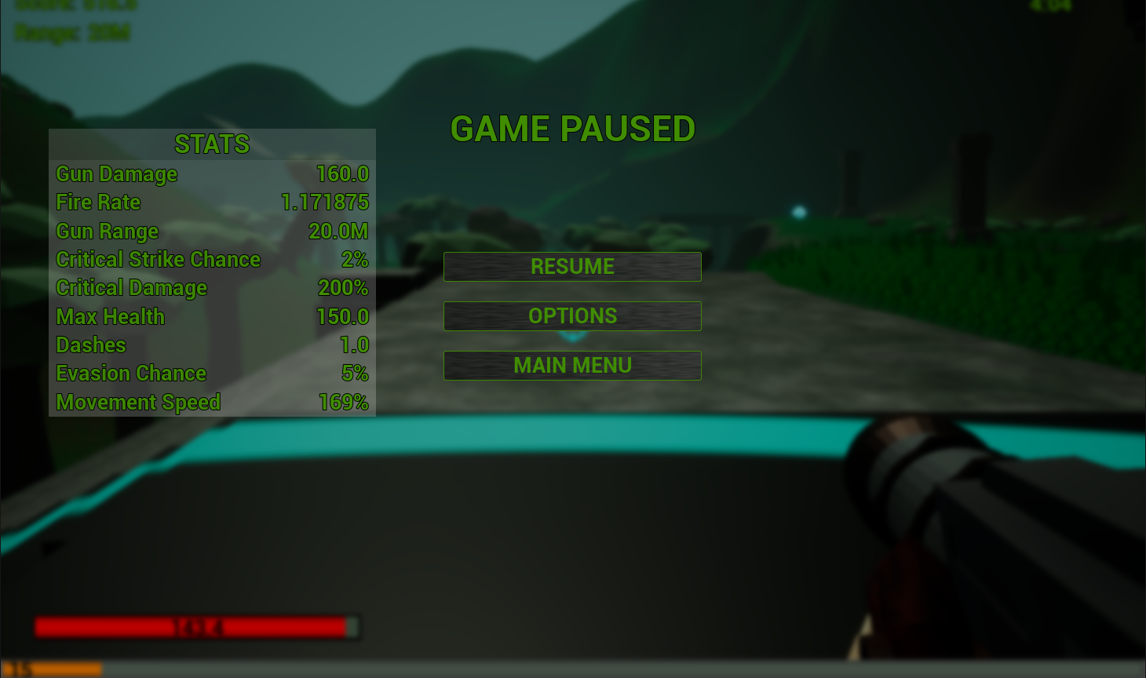
0.5 radius
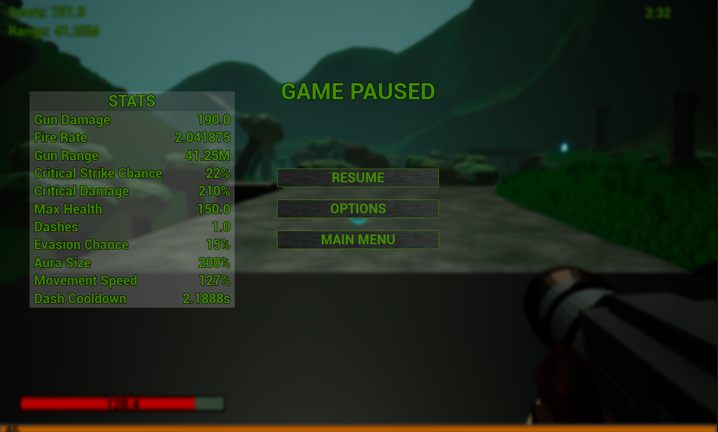
2.0 radius
