CPConnect *Enabling Interdisciplinary Project-based Learning*

**Request for Funding of Project Proposal**

**Application Form**

**Title of Project: _ IGVC- the Autonomous Golf Cart Project _**

**Faculty Advisor: _ Dr. John Seng _ Department: _ CPE __**

**Faculty Advisor email: jseng@calpoly.edu Telephone: _ (805)756-5536 __**

**Anticipated Start Date: _ 9/23/2013 _**

**Anticipated End Date: _ 6/21/2013 _**

|  |  |  |
| --- | --- | --- |
| Michael Roberts – CPE | Ramon Santos – ME | Zach Eagan – CPE |
| Tim Jung – ME | Jordan Lin – CSC | Matthew Ng – CPE |
| Kyle Kruse – ME | Joe Leija – CSC | Louie Thiros – CPE |
| Eliot Kahn – ME | Justin Ng – EE | Robert Hulbert – CPE |
| Eli Rogers – ME | Ian Wilson – CPE | Eric Dreischerf – ME |
| Drew Schulz – CSC |  |  |

**Student Team Members & Departments:**

**Total Funds Requested ($): _ 5,000.00 _**

**Signature of Faculty Advisor: ____________________ Date: __________________**

# Overview

This project proposal seeks to acquire funding in order to continue the IGVC project for the 2013-2014 school year. The IGVC project is an attempt to create an autonomous ground vehicle capable of navigating safely in an urban environment. The project makes use of extensive modifications to a standard golf cart chassis to allow the user to choose between normal golf cart controls and a fully autonomous, point-to-point computer navigation system. The project is based out of the Cal Poly Robotics Club and incorporates members from numerous backgrounds and majors.

# Background

The IGVC project started in 2012 as a robot for the Intelligent Ground Vehicle Competition (IGVC). The goal of the IGVC was to navigate an obstacle course with a small robot using a variety of sensors. The chosen platform was originally going to be sponsored by Synbotics, plans for which fell through when Synbotics decided to focus on producing their existing technologies for the military. Rather than disbanding the team and discarding the research developed, the IGVC team decided to refocus their efforts on a new project: an autonomous golf cart. This project would allow the IGVC team to continue working on an in-depth, cutting-edge project.

# Objectives

To create a fully autonomous, electric golf cart, capable of object avoidance, obstacle course navigation, and GPS waypoint pathing. The key to accomplishing these goals is the implementation of new technologies such as LIDAR, computer vision, and integrated electromechanical control systems.

# Project Description

The IGVC project, when completed over the next few years, will be a fully autonomous golf cart capable of driving itself without any human input. It will retain the ability to function as a standard golf cart, and at the touch of a button, the driver will be able to release control and allow the golf cart to be automatically navigated by a computer. The project’s long-term goal is to give the golf cart object detection and avoidance capabilities, and to eventually make the golf cart street-legal and capable of intelligently navigating standard vehicle roadways.

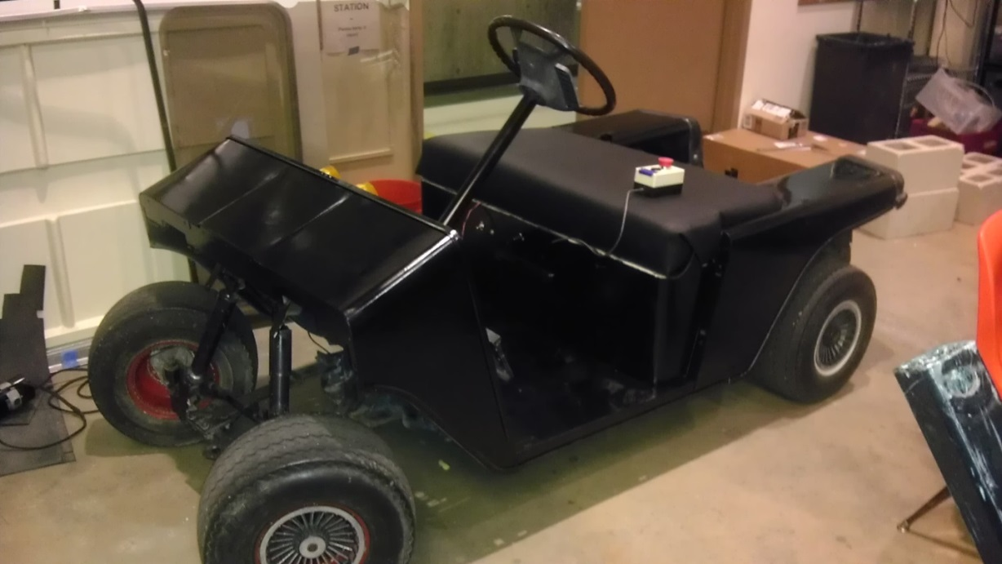

Figure 1: The IGVC Vehicle

The autonomous golf cart is undergoing some major mechanical revisions. The base of the vehicle is a standard golf cart. The chassis will be modified to accommodate an array of sensors, actuators, and microprocessors. The front bumper has been completely removed, and the mechanical team is in the process of engineering and fabricating a new framework, capable of housing the sensors we need for navigation. The dashboard of the golf cart will house a laptop, Beaglebone Black microcontroller, and a custom-designed center console. This console will house golf cart controls during human operation, as well as the toggle between human and autonomous modes.

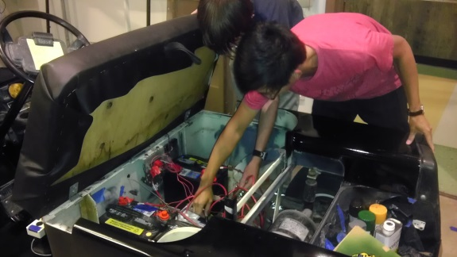The control systems on the golf cart have also been extensively modified. The original drum brakes will be replaced by an electronically-driven, servo-controlled hydraulic brake system. The design of the new brake system improves safety by defaulting to braking when power is off, as well as streamlining control. The original, mechanical forward-reverse switch has been completely overhauled to an electronic switching system, designed to include computer as well as human controlled forward/reverse shifting, easy toggling between manual and automatic control, and an emergency stop button (E-stop).

Figure 2: Team members working on internal electronics.

Computer control will be accomplished by networking an Arduino Mega, a Beagleboard, and a laptop into one powerful processing center. The Arduino Mega will aggregate huge amounts of data from the sensor array and relay commands to our electromechanical control systems. The Beagleboard will receive the data and act as the primary decision-making unit, sending back commands to the Arduino. The laptop will handle the processing-intensive LIDAR unit as well as computer vision. It will also provide test logging and user feedback.

The sensor array will include hall-effect sensors and IMU for speed and orientation, ultrasonic rangefinders for close range detection, and LIDAR for general detection. This LIDAR will be the primary means of obstacle avoidance for the golf cart, as it is the only sensor powerful enough to deliver accurate, detailed data about any objects within a 98-foot, 180-degree cone in front of the golf cart.

# Timeline

* Fall Quarter 2013
  + Establish full computer control of the golf cart’s acceleration, braking, and steering.
  + Milestone 1: The Orange Cone Test
    - Confirm that the golf cart’s sensor array is capable of detecting a simple object blocking its intended path, and is capable of stopping before contact.
    - Successfully navigate between and around detected objects using primarily LIDAR, with ultrasonic support.
* Winter Quarter 2014
  + Program the golf cart to be able to navigate increasingly complex obstacle courses.
  + Develop the foundation of optical detection that could be used by the golf cart to recognize signs and objects.
  + Milestone 2: The Parking Lot Test
    - Have the golf cart successfully navigate an obstacle course consisting of an empty parking lot and obstacles such as vehicles, pedestrians, curbs, and lamp posts.
* Spring Quarter 2014
  + Enable the system to function in a dynamic environment with moving variables such as humans or other vehicles.
  + Integrate automated waypoint to waypoint navigation, using the systems developed over the past year.
* Fall Quarter 2014
  + Begin developing the systems required for the golf cart to navigate simple one-lane road systems.

# Team Skillsets

The IGVC project is inherently interdisciplinary, within and outside of engineering. Although the primary team consists of mechanical, electrical, computer, and software engineers, we recruit short-term members from other engineering majors, clubs, and operate in teams on public relations, business and engineering management, and even language and graphic arts.

* **Michael Roberts (**4th year, CPE) has led and completed many different interdisciplinary projects within the College of Engineering. He acts as the principal advisor and to manage project progress from a systems perspective.
* **Tim Jung** (4th year, ME) and the overall project lead. His knowledge of all aspects of the project allows him to effectively direct team members of various sub-projects. He manages progress on various systems and provides design input for all teams.
* **Kyle Kruse** (3rd year, ME) is the lead of the mechanical team. He is responsible for fabricating custom parts for the vehicle and oversees the design of the golf cart.
* **Eliot Kahn** (3rd year, ME) is skilled in the machine shop as well as with welding and soldering. He will be helping out both the hardware and software sides of the project.
* **Eli Rogers** (3rd year, ME) has experience with SolidWorks and welding. He created the upholstery for the vehicle and designed various mounting systems for the project.
* **Drew Schulz** (3rd year, CSC) is a new member of the robotics club. He has experience programming in Java and C and will be working on object detection for this project.
* **Ramon Santos** (3rd year, ME) works with the safety of the vehicle. He designates safe zones and is responsible for vehicle maneuverability issues.
* **Jordan Lin** (2nd year, CSC) works with the software team and has experience with Java, C, and C++. He is develops and tests the close range object detection system.
* **Joe Leija** (2nd year, CSC) works with the software team and has experience with C, C++, AVR, and Java. He is developing and testing the long range object detection system.
* **Justin Ng** (2nd year, EE) leads the hardware team. He is experienced with digital, analog, and power systems. He is engineering the electrical control systems.
* **Ian Wilson** (2nd year, CPE) major and works with the software team and has experience with C++, Java, and AVR. He handles computer networking and serial communication.
* **Zach Eagan** (1st year, CPE) works with the hardware team and is responsible for troubleshooting hardware systems. He also provides design input and general research.
* **Matthew Ng** (1st year, CPE) works with both the hardware and software team. He is experienced with Java and C. He is working on the steering system of the golf cart.
* **Louie Thiros** (1st year, CPE) works on the software team. He has experience with C, C++, and Java. He will be working on networking and the LIDAR.
* **Robert Hulbert** (1st year, CPE). He has experience programming in C++ and Java. He is working on the logic team and sensor team of the golf cart.
* **Eric Dreischerf** (1st year, ME) He has experience in AutoCad, Inventor, and 3ds Max. He is working on the front bumper sensor array as a part of the mechanical team.

# Budget breakdown

The scope of the IGVC project means that a single entity would be unlikely to fund the entire project. To this end, the IGVC project is cultivating multiple sources for funding and material donations. A $5,000 grant from CP Connect would allow IGVC to continue towards the current year’s goals. Any money granted will be channeled towards purchasing the critical components of the project, such as the LIDAR, sonar, and hydraulic brake systems.

* LIDAR
  + **Description**: The keystone of our sensor array, LIDAR (light radar) uses a laser, rotating mirror, and photodetector system to measure distance to obstacles in a large cone with high speed and precision. The LIDAR module will be the most expensive sensor on the robot at $1100 - $5500.
  + **Purpose**: The LIDAR will be the primary method of forward object detection. It will be used to detect cars, pedestrians, cones, and other obstacles that the vehicle may encounter during operation.
* Sonar
  + **Description**: The IGVC project requires the use of a minimum of six to eight MB7092 ultrasonic sensors for close range object detection. By emitting and receiving ultrasonic waves, these sensors are able to detect objects up to 80 feet away.
  + **Purpose**: These sensors provide a secondary method of object detection to locate obstacles that other sensors may have missed.
* Webcams
  + **Description**: High-resolution webcams record video to the onboard laptop and provide a steady stream of visual information for computer logic to process. These cameras will also be critical to the implementation of advanced computer vision and navigation systems.
  + **Purpose**: Utilizing computer vision, the laptop will be able to detect obstacles and signs with a greater range than any of the other sensors.
* Hydraulic brakes
  + **Description**: A joint project with the Quarter Scale Tractor Pull Team, hydraulic brakes allow for safe, simple human or computer control.
  + **Purpose**: The existing brakes are old, cable-actuated calipers that work very poorly. They are difficult to actuate with small electromechanical devices and provide uneven braking. New hydraulic brakes will resolve all these issues.
* Arduino Mega
  + **Description**: The Arduino Mega is an easy-to-use microcontroller with 54 input/output pins, three serial communication channels, and analog/digital capabilities.
  + **Purpose**: The Arduino Mega will process the majority of the sensors’ data and control many electromechanical systems. It will use serial communication to stream sensor data to higher level processors such as the Beagleboard and the laptop.

Table 1: Budget Breakdown Table

|  |  |  |  |  |  |
| --- | --- | --- | --- | --- | --- |
| **Product** | **Vendor** | **Part Number** | **Quantity** | **Price per Unit** | **Price Total** |
| Sonar | Jameco | MB7092 | 6 | $85 | $510 |
| Beagle Bone Black | Digi-Key | Beaglebone Black | 2 | $100 | $200 |
| Onboard Laptop | Amazon | G55VW-DH71 | 1 | $1,250 | $1,250 |
| Webcam | Tristar Security | M1014 | 2 | $250 | $500 |
| LIDAR | Hokuyo | UTM-30LX | 2 | $1,200 | $2,400 |
| PCBs | Oshpark | n/a | 1 | $300 | $300 |
| Batteries | Autozone | T-105 | 6 | $175 | $1,050 |
| Additional Power Parts | Castle | CSE010-0004-01 | 1 | $40 | $40 |
| Hydraulic Brakes | In-house | Custom-built | 1 | $500 | $500 |
| Arduino Mega | Arduino | Arduino Mega | 1 | $50 | $50 |
| Misc. | n/a | n/a | 1 | $100 | $100 |
|  |  |  |  | Total: | $6,860 |

# 

# Information Dissemination and Engineering Community Support

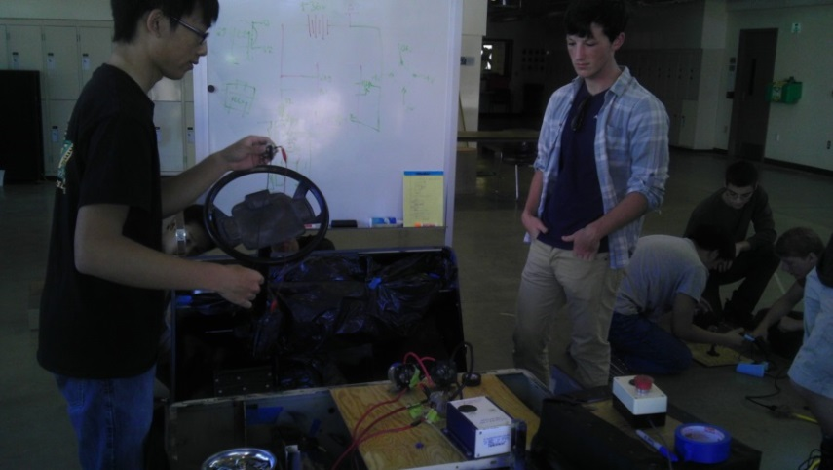The primary supporter of the IGVC is the Cal Poly Robotics Club, providing financial and material support, as well as supporting the project with with its facilities and technical expertise. In return for the support provided by the Robotics Club, the IGVC project has already returned enough value to demonstrate that it is a worthwhile investment. Even in its relatively short lifespan, IGVC has emerged as a showcase project for the Cal Poly Robotics Club, attracting new members, providing an easy and effective means of gaining publicity, garnering the interest of students and faculty, building relations with other Cal Poly Clubs, and increasing the experience and expertise of club members. Since this project promotes robotics within Cal Poly’s learn by doing environment, the Cal Poly Robotics Club will continue to be a long-term supporter of IGVC.

Figure 3: Pursuing multiple projects on an IGVC build day.

IGVC is currently reaching out to, and being supported by, several entities in addition to the Robotics Club. The Electric Vehicle Club donated the original golf cart chassis that became the foundation of the autonomous golf cart, arguably the project’s single largest donation received. Cal Poly’s ground fleet maintenance facilities have also been extremely supportive of the IGVC project, providing a valuable supply of usable parts. The maintenance facilities personnel have also been a valuable resource for the project, sharing knowledge of the electrical and mechanical operation of the golf cart. Finally, the Cal Poly Quarter Scale Tractor Pull Team and the Cal Poly Robotics Club are currently engaging in an exchange of technologies that came about due to the IGVC project. Most notably, the Quarter Scale Team is providing their expertise for the design and construction of the servo-controlled, hydraulic braking system, which is crucial to the safety and controllability of the golf cart. While the contributions made by the listed entities are not comprised of direct financial support, the amount of material and technological contributions made demonstrate that the IGVC project has generated interest as well as a support network within the Cal Poly Engineering Community.

As the autonomous golf cart develops from a basic electric vehicle to an impressive, automated system, it becomes immediately possible to market the project to outside interests for additional funding. Some of the areas in which the technology developed by IGVC can be used include pre-crash accident avoidance, driverless valeting, and autonomous cars. As the IGVC project develops, we will begin marketing it to these projects and corporations in order to develop our own network of sponsors.

Once the golf cart reaches a state of maturity, Dr. Seng will reach out to the following companies in order to obtain further external support: General Atomics, Raytheon, and Lockheed Martin.