BRAIN Setup Guide

# Introduction

The BRAIN is CalSol’s Arduino-compatible microcontroller platform used in our previous car, Impulse. It differs from the standard Arduinio in that it is socketable (can be plugged into a socket on a “skeleton” board), breadboardable, and includes onboard CAN functionality. The one provided to your station should already be on a breadboard. **Please do not attempt to remove the BRAIN from the breadboard – when done improperly, this leads to pin damage. BRAINs are neither cheap nor easily replaceable.**

The pin diagram is as follows:

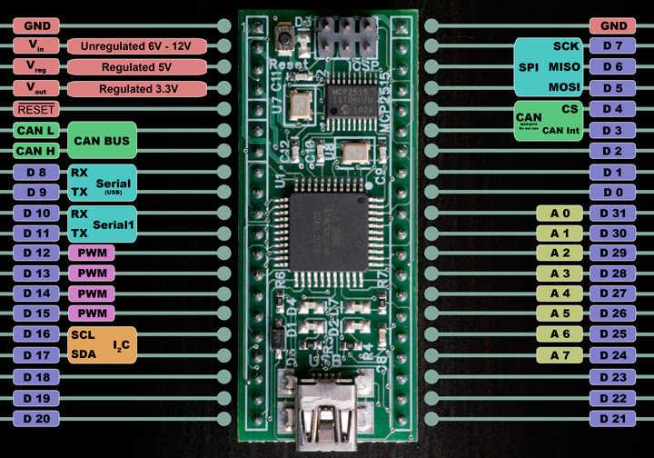

# Development Environment Setup

The BRAIN requires special setup differing from the normal Arduino setup – the BRAIN software is not compatible with the latest Arduino version. You must use version 0023, available here:

**Windows**: <http://arduino.googlecode.com/files/arduino-0023.zip>

**Mac OS X**: <http://arduino.googlecode.com/files/arduino-0023.dmg>

**Linux 32**: <http://arduino.googlecode.com/files/arduino-0023.tgz>

**Linux 64**: <http://arduino.googlecode.com/files/arduino-0023-64.tgz>

Then, you will need to download the BRAIN extensions, and unzip the contents into your   
arduino-0023/hardware/ folder

**BRAIN Extensions**: <https://calsolbrain.googlecode.com/files/brain_v0025.zip>