Basic Electronics Lab

Introduction to Electronics

Michael Chang, Devan Lai, Richard Lin, Adam Resnick

**Application**: These electronics basics provide the foundation to understanding how circuits work.

Contents

[Revision History 2](#_Toc334712419)

[Introduction to Electronics 3](#_Toc334712420)

[Current and Voltage 3](#_Toc334712421)

[Electrical Safety 4](#_Toc334712422)

[I-V Curves 5](#_Toc334712423)

[Basic Electronic Components 5](#_Toc334712424)

[Resistors 5](#_Toc334712425)

[Capacitors 7](#_Toc334712426)

[Diodes 8](#_Toc334712427)

[Transistors 8](#_Toc334712428)

[Physical Switches 9](#_Toc334712429)

[Reading Schematics 10](#_Toc334712430)

[Multimeters and Measurement 10](#_Toc334712431)

[How to Read a Datasheet 12](#_Toc334712432)

[Lab: Building the Circuit 14](#_Toc334712433)

[Objectives 14](#_Toc334712434)

[Lab Manual 14](#_Toc334712435)

[Part I: Setup 14](#_Toc334712436)

[Part II: Simple LED Circuit 16](#_Toc334712437)

[Part III: Dual LED Circuit 18](#_Toc334712438)

[Part IV: Controlled LED Circuit 19](#_Toc334712439)

[Part V: Extra for Experts: Blinking LED Circuit 20](#_Toc334712440)

[Sneak Peek at Lab 2 21](#_Toc334712441)

[References 21](#_Toc334712442)

# Revision History

|  |  |  |
| --- | --- | --- |
| **Version** | **Date** | **Changelist** |
| 1.0 | Fall 2011 | Initial release |
| 1.1 | Fall 2011 | Unknown |
| 1.2 | 06 Sep 2012 | * Reformatting * Various fixes * Updated pictures * Added section on preferred numbers |
| 1.3 | 09 Sep 2012 | * Clarified breadboard diagrams |
| 1.4 | 09 Sep 2012 | * Fixed component values on 555 schematic |
| 1.5 | 09 Sep 2012 | * Fixed pinout diagram for 555 * Added switch and potentiometer schematic representations |
| 1.6 | 09 Sep 2012 | * Removed potentiometer from Extra for Experts – does not work for new resistor values |

# Introduction to Electronics

## Current and Voltage

1. This section mainly reviews AP Physics E&M or Physics 7B.
2. Voltage and current are how we characterize all electric circuits
3. **Current** is the flow of electric charge through a material.

|  |  |
| --- | --- |
| **DEVICE** | **CURRENT** |
| LED | 0.020 A |
| 9V Battery | 0.300 A |
| Lethal DC Current | 0.400 A |
| Laptop Power Supply Output | 4.5 A |
| Average Positive Lightning Bolt | 400,000 A |

* 1. Charge usually carried by very small, negatively charged particles known as electrons.
  2. Think of current just like water flowing down a river.
     1. If the river splits in two, and you total the amount of water in both forks, it is equal to the amount of water that flowed before the split.
     2. Same is true for current – sum of current going into a junction = sum of current going out of a junction
  3. Current needs a closed loop to flow
  4. Current represented by or in equations
  5. Measured in amperes (aka amps)

1. **Voltage** makes current flow
   1. Analogue of pressure in river analogy

Figure 1: Average current in different devices.

* + 1. Water falls down a waterfall because of difference in gravitational potential energy between top and bottom of waterfall
  1. Voltage is difference in electric potential energy between two points
  2. Need two points to define voltage
     1. No absolute voltages, only relative voltages
     2. Reference point is called “ground” and is set to 0 volts
  3. Don’t need a closed loop for a voltage difference to form
  4. Voltage represented by in equations
  5. Voltage measured in terms of energy per unit charge (Volts)

## http://www.physics.ohio-state.edu/~p616/safety/fatal_current.gifElectrical Safety

1. Current is what kills you, not voltage
   1. High voltage presents opportunity for large currents
   2. Current may prevent you from letting go of what is shocking you
2. Current above 15 to 100mA AC is lethal
   1. Between 60 and 200 mA AC your heart enters ventricular fibrillation – heart is twitching uncoordinatedly instead of normal sinus rhythm
   2. 200mA and above will stop your heart
3. Still can get burned without getting electrocuted
   1. Short circuits draw far more current than the circuit was designed for
   2. The result is that the component gets hot enough to burn you (components do other things besides  
      blowing up)
4. Ensure whatever shocked the person has been shut off and that the area is safe before administering necessary first aid
5. Don’t allow yourself to become the connection between a live wire and ground
   1. More dangerous when current path is through your heart instead of through the thumb and index finger of the same hand
   2. When working with high voltages, it is advised to keep one hand behind your back to reduce the risk of your heart becoming part of a live circuit

Figure 2: Differing amounts of AC current and their effects on the human body.

1. See Figure 2 for better feel of how much “a lot” of current is
2. Circuits can also be damaged by too much current or voltage
   1. **Electrostatic discharge (ESD)** is similar to the shock you get when rubbing feet on carpet and then touching metal
      1. Will damage or destroy sensitive circuit components like integrated circuits (chips)
      2. Very high voltage, but very low current, so not dangerous to humans
      3. Design/build in ESD protection
      4. Be aware of what is connected to what
   2. Polarized components may explode if reversed

## I-V Curves

1. 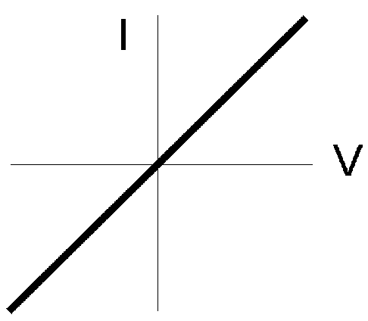Common way of characterizing electrical elements is by applying a voltage across the element and recording the current going through the element
2. Record a lot of these points and graph the result to get an I-V curve
3. Can then develop equations that relate current and voltage, allowing for mathematical models of components
4. Simplest I-V curve is for a resistor: a straight line with equation (Ohms Law)

Figure 3: A simple I-V curve characterized by the equation I = V/R

1. The inverse of the slope (Fig 3),R, is known as the resistance
2. Resistance has units of ohms (Ω)
3. If voltage across the element is held constant, increasing the resistance will limit the current going through the element.

# Basic Electronic Components

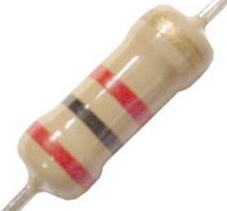A brief overview of basic components, their symbols, and basic purposes.

## Resistors

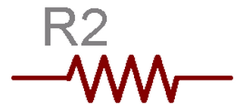Resistors are kind of like mischievous elves. Their only purpose in life is to slow the current down. Or in the water analogy, rocks that slow down water. And, just like elves, they are quite useful.

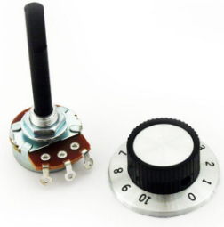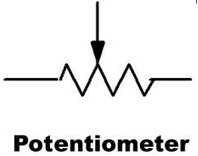Resistors are classified by resistance in units of Ohms and follow the equation . The colors on them denote how much resistance they have. There are usually four bands. The first two indicate the tens and ones digit of a number. Then you take this number and multiply it by the multiplier indicated by the third band. The fourth stripe states tolerance, which is the maximum amount of deviation from the stated resistance. Do not worry about memorizing this – few people do. We usually look up the color codes online, like the chart to the right. For example, the resistor in Figure 4 has bands red-black-red-gold, which is (2(10)+0) \* 100 Ohms with a 5% tolerance.

Figure 4: Picture of a resistor and its schematic representation

) There are many different kinds of resistors. There are small ones and extremely large ones. There are those that vary resistance depending on the mechanical force you apply on them or the temperature they are at. There are also ones that vary depending on how much you turn a knob. These last ones are called potentiometers and are everywhere! Many dials, like on your car radio or volume dial are potentiometers. These can be rotary or even linear and are used to measure movement precisely. They have three pins and we measure voltage from the middle pin. In fact, we use it for our pedals! They get a special symbol as seen in Figure 5.

Figure 5: Picture of a potentiometer and its schematic symbol

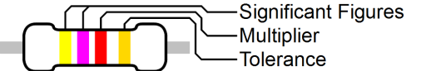

|  |  |  |  |
| --- | --- | --- | --- |
| **Color** | **Value** | **Multiplier** | **Tolerance** |
| **Black** | **0** | ×100 | --- |
| **Brown** | **1** | ×101 | 1% |
| **Red** | **2** | ×102 | 2% |
| **Orange** | **3** | ×103 | --- |
| **Yellow** | **4** | ×104 | --- |
| **Green** | **5** | ×105 | 0.5% |
| **Blue** | **6** | ×106 | 0.25% |
| **Violet** | **7** | ×107 | 0.1% |
| **Gray** | **8** | ×108 | 0.05% |
| **White** | **9** | ×109 | --- |
| **Gold** | --- | ×10-1 | 5% |
| **Silver** | --- | ×10-2 | 10% |
| **None** | --- |  | 20% |

Figure 6: Resistor color chart

You may also have noticed that resistors come in weird values like 330Ω and 4.7kΩ instead of more “normal” numbers. Resistors (and many other electronic components) generally have values speced to **preferred numbers**, like the E6 and E12 series. The idea is that these set of numbers cover the set of all numbers when you add a 20% (E6), 10% (E12) or 5% (E24) tolerance. In other words, if you wanted an arbitrary resistor, you could find a resistor no more than 5% away (if you had a set of E24 series resistors). These numbers repeat once per decade (order of magnitude), so you would have 3.3Ω, 33Ω, 330Ω, 3.3kΩ, 33kΩ, etc.

|  |  |  |  |  |  |  |  |  |  |  |  |  |
| --- | --- | --- | --- | --- | --- | --- | --- | --- | --- | --- | --- | --- |
| **E6** | 10 | | 15 | | 22 | | 33 | | 47 | | 68 | |
| **E12** | 10 | 12 | 15 | 18 | 22 | 27 | 33 | 39 | 47 | 56 | 68 | 82 |

The E6 (20%) and E12 (10%) series of preferred numbers

## Capacitors

Capacitors are essentially two metal plates separated by space. Because of E and M and a law we won’t go into, called Gauss’s Law, these plates store charge. They’re great for keeping voltage constant. Their equation is Q=CV where Q is the charge stored on the cap and V is the voltage across the capacitor. C is a measure of their capacity, named, you guessed it! Capacitance! There’s a bunch of theory that goes into deriving a capacitor’s capacitance, but we don’t have to go into that here. That is because we buy our caps and they come with a labeled capacitance. However, you do need to know how to use them and how not to hurt yourself.

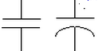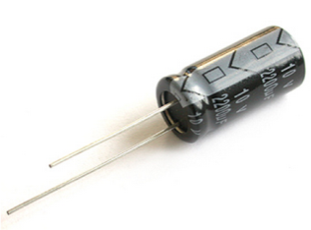First of all, here is how they look in schematic form and as a picture. Those two on the right are actually both capacitors. The only difference is that the one with two straight lines is non-polarized, while the one with the curved line is polarized. Polarization just means that direction matters. If you hook a polarized capacitor up the opposite way, the device will fail, and possibly explode. So be careful! Luckily, the capacitors are labeled so we can avoid this messy issue. The one on the right has a white strip to indicate the negative side. The positive side is also the longer of the two leads.

Figure 7: Picture of a capacitor and its schematic representation

Capacitors are used to store energy and keep voltage stable. They are also great EE midterm material! Consider yourself warned. They also have the nice property of exponential voltage and current decay. That means they can be used for timing applications.

Polarized capacitors are known was electrolytic capacitors because one of their plates is actually a liquid electrolyte. This gives them a higher energy density. They are often used in high-current and low-frequency applications such as steadying the voltage of a power rail.

Non-polarized capacitors are usually ceramic capacitors. They are usually physically smaller than electrolytic capacitors and usually can’t store as much energy. They are used in low-power, medium and medium-high frequency applications, such as filtering signals.

## Diodes

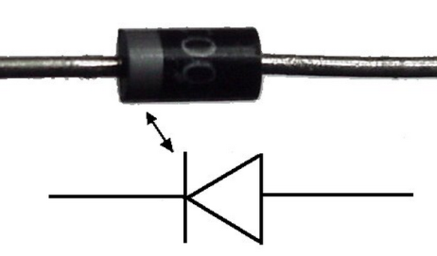Diodes essentially make sure that current goes one way. They follow the arrow’s direction. The silver strip indicates the end of the arrow. The other purpose of them is protection (remember ESD?). All diodes have a current rating, above which they will fail. If you haven’t noticed, LEDs are also diodes. LEDs always need some sort of current control, like a resistor. Diodes are also special in that they do not have a linear IV curve and are described by a special equation taught in EE105. But this simplified one-way current valve model is good enough for our purposes.

Figure 8: Picture of a diode and its schematic representation

## Transistors

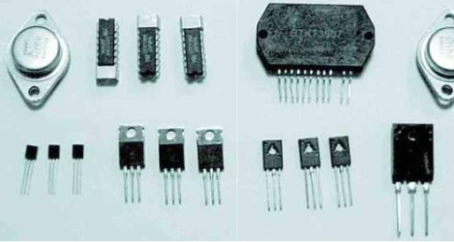Transistors are electrical switches which are controlled by voltage applied to a third terminal. These devices usually have three leads, and often come either in half cylindrical shapes or small black rectangular with metal. I know the description is a bit vague, so I have provided a picture to the right. Beware! Even though transistors may look like this, this does not mean that all items that look similar are transistors. There are many things that use the same package.

Although transistors can be used for much more advanced applications such as filtering and amplifying, we primarily use transistors called MOSFETs (Metal Oxide Semiconducting Field Effect Transistors) for switching moderate power items using a low voltage signal. These are controlled by the voltage on the gate terminal, which is always measured with respect to the source terminal. The other two terminals are known as the source and the drain. Example: we power the lights and control them through MOSFETs.

Figure 9: Different transistors

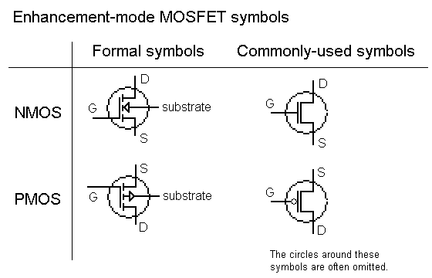There are two main types of MOSFETs. The first type is known as NMOS. If you apply a voltage above a threshold voltage to the gate, the NMOS is considered to be on, allowing current to flow between the source and drain. However, if the gate voltage is below the threshold voltage, no current flows. The threshold voltage for a given MOSFET is given in its datasheet, often with the symbol (see the Datasheet section of this document).

Figure 11: Schematic representation for MOSFETs. There are many other symbols for the various other types of transistors.

The other type of MOSFET is known as a PMOS. It behaves exactly the same thing as an NMOS, except that it is on when the gate voltage is below the threshold level and off when it is above the threshold voltage.

## Physical Switches

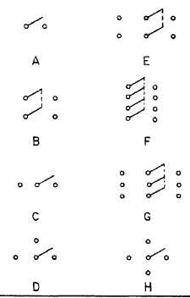This is just like your average light switch. However although switches seem easy, there are quite a few terms to remember. A switch is either normally on (**normally closed**, aka NC) or normally off (**normally open**, aka NO). What does this mean? It just means what state the switch is in if no one has pressed it yet. Normally closed means that the switch is connected normally and normally open means the opposite. Switches can be momentary, meaning they do not lock in position when you press it. It will usually spring back. There are emergency switches that are usually pretty large. Their special characteristic is that once they are engaged, you have to twist the knob to disengage the switch.

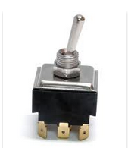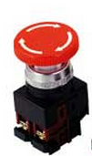Switches also have a special classification of their own. We typically think of a switch as a device with two contacts that either shorts the two contacts or separates them. However, there exist many other varieties of switches classified by the pole and throw system. A **pole** is a set of contacts. For example, your light switch has one pole. **Throw** refers to the number of positions the switch can go into and be on. The turn signal in your car is for example a double throw. Commonly you will hear a switch called SPST or DPST or something similar. All that means is single pole single throw.

Figure 12: How switches may look on a schematic

Luckily, though there are many different kinds of switches, they all share a common purpose: to make or break a circuit. Now this can be used as a human interaction tool, a limit switch, an emergency switch, a bump sensor, power switch, etc. If you ever need to use it to control a device, place it in series with the device.

Figure 13: Different types of switches

# nodes-cross.pngReading Schematics

1. Schematics are an abstract drawing of a circuit that shows what’s connected to what
2. The circuit’s components and connections between components define the circuit, not how it physically gets laid out
3. A line from one component to another is an electrical connection – the two pins will be at the same voltage.

Figure 14: Four resistors connected at a central node

1. 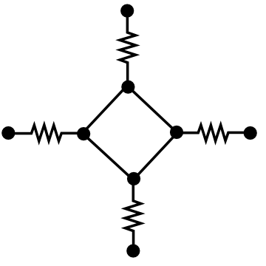Multiple lines coming together form a node – all of the lines connected to that node are at the same voltage relative to ground
2. How the lines in a node are connected is unimportant – all of the components connected to a node are connected to all of the other components
3. Circles like in figure 15 mark where overlapping lines are connected to each other. In general, overlapping lines are not connected to each other
4. When drawing schematics by hand, make sure that it’s clear which lines are meant to be connected to each other

Figure 15: This circuit is completely equivalent to the one above; all four resistors are still connected to each other.

1. Components that share a common **node** (an electrical connection) on both sides are said to be **in parallel** – they have the same voltage across each of them
2. 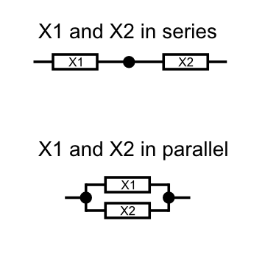Components chained together are said to be **in series** – they have the same current flowing through each of them

# Multimeters and Measurement

1. Multimeters can measure resistance, voltage, current and continuity
2. Continuity checks if the two points to which your probes are connected to are electrically connected
   1. 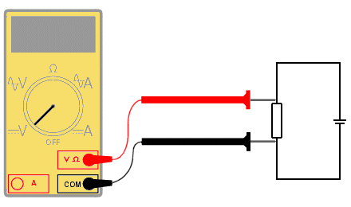Turn multimeter knob to the continuity mode C:\Users\Ducky\Desktop\calsol-training\ee1\images\inline_meter_continuity.png (if available), otherwise diode mode C:\Users\Ducky\Desktop\calsol-training\ee1\images\inline_meter_diode.png
   2. When points are connected, multimeter will beep
   3. Circuit that you are measuring must be unpowered
   4. Doesn’t matter if you switch the probes
3. To measure resistance, turn the knob to the Ω symbol
   1. Circuit must be unpowered
   2. Doesn’t matter if you switch the probes

Figure 16: Multimeter measuring voltage, although if the knob was changed, it would measure resistance.

1. 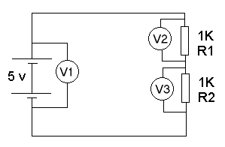Measuring resistance is just like measuring continuity, except that it tells you the resistance between two points, instead of whether or not they are connected
   1. If the measured resistance between two points is quite low, the points are probably connected
2. To measure voltage across a component, put leads in parallel with component that you wish to measure
3. Turn the knob to the V to measure voltage
   1. C:\Users\Ducky\Desktop\calsol-training\ee1\images\inline_meter_vdc.pngis for DC voltage

Figure 17: Schematic of multimeters measuring voltage across a battery and some resistors.

* 1. C:\Users\Ducky\Desktop\calsol-training\ee1\images\inline_meter_vac.pngis for AC voltage
  2. If you switch the probes, you will flip the sign of the voltage you are measuring
  3. Circuit should usually be powered

1. 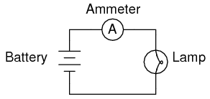To measure current through a component, you must put the multimeter in series with the component
2. To measure current, turn knob to A
   1. C:\Users\Ducky\Desktop\calsol-training\ee1\images\inline_meter_adc.pngis for DC current
   2. C:\Users\Ducky\Desktop\calsol-training\ee1\images\inline_meter_aac.pngis for AC current
   3. Circuit should be on
   4. Switching probes will switch sign of measured current

Figure 18: Schematic of a multimeter measuring current through a simple circuit.

1. Pay attention to current limits written on your multimeter – if you put in too much current, your multimeter will fry!!
2. Use multimeters to debug circuits
   1. Based on the schematic, you can tell which points should be connected, what the voltages between two points should be etc
   2. Try to narrow the problem down to one component by comparing what the schematic says with what your multimeter is telling you

# How to Read a Datasheet

1. Datasheets are like the user’s manual for a component
   1. Explains what the component is/uses for it
   2. Describes what each pin on the component does
   3. Gives examples of how to use it in a circuit
2. Finding the part’s datasheet
   1. 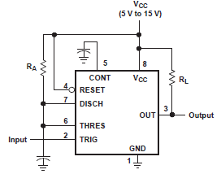Check the place you bought it from
      1. Digikey/Mouser often have links to the datasheet on the catalog page
   2. Google the part number + “datasheet”
   3. For larger components, part number is often written across the top or on the side
   4. It’s probably written on the bag it came in
   5. Sometimes you won’t get an exact match on the number
   6. Some parts are made by lots of manufacturers
   7. LM555/TLC555/NE555 are really all the same design.

Figure 19: An example of a high-level schematic view. Pins are arranged for convenience, not according to the physical layout

1. Reading a pinout
   1. There are usually two diagrams for a component with more than two pins
   2. 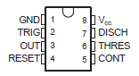High-level functional diagram that conceptually describes what pins there are/what they do
   3. Pin mapping that shows where each pin is on the actual component
   4. For larger integrated circuits, sometimes there’s a table of pin numbers and their functions instead
   5. By convention, the top-left pin (as viewed from the top with a semicircle or dot on the top) is pin 1.

Figure 20: An example of a pinout. It describes the function of each pin on the physical layout

* 1. The pin numbers increase running down the left side and wrap around the bottom and increase running up the right side.

1. Understanding electrical parameters
   1. Absolute limits like maximum supply voltage are usually listed in their own table. Going beyond these limits will cause device failure.
   2. Some limits are relative to Vcc, which is another term for supply voltage. Vcc + 0.5V means that some value shouldn’t exceed Vcc by more than 0.5V
   3. Vss means ground (for historical reasons), not supply voltage
   4. Other properties are listed in a table of electrical characteristics – these give a range of typical values for things like input current, operating temperature, gain, etc
   5. When multiple conditions are specified in the table, the range of values only holds if you use the component under those conditions (ie, max current of 200mA only if you have a supply voltage of 15V)
   6. Pay close attention to maximum supply voltage, current draw, power dissipation, operating temperature, input/output signal voltage.
   7. Exceeding these will usually break your component
   8. Supply voltage, I/O signal voltage will break it quickly, power dissipation/temperature will make it fail in less obvious ways

# Lab: Building the Circuit

## Objectives

* To learn how to use a breadboard, a common electrical prototyping tool.
* To become familiar with basic components such as LEDs, resistors, potentiometers, and switches.
* To be able to read circuit schematics, and be able to build a circuit when given its schematic representation.

## Lab Manual

### Part I: Setup

1. First, grab a lab kit.
2. Your lab kit should have a breadboard, several resistors, a potentiometer, several capacitors, a switch (button), two LEDs, and a 555 timer chip.
3. You should know what all the components except the 555 timer chip and breadboard are. If not, quickly review the previous section on components.
   1. The **breadboard** is a common prototyping tool used to quickly build circuits. It looks something like this:  
      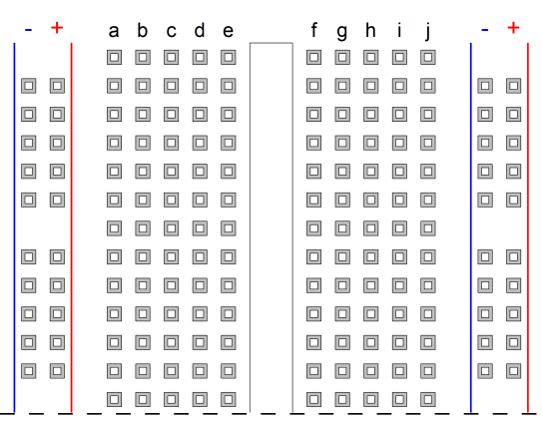  
      This is a standard breadboard profile, although individual breadboards may vary by length and labeling. Cheaper breadboards might not have the nice red and blue stripes or letter column labeling. Transparent breadboards also exist, where you can see the internal connections.
   2. Internally, the breadboard is connected like this:  
      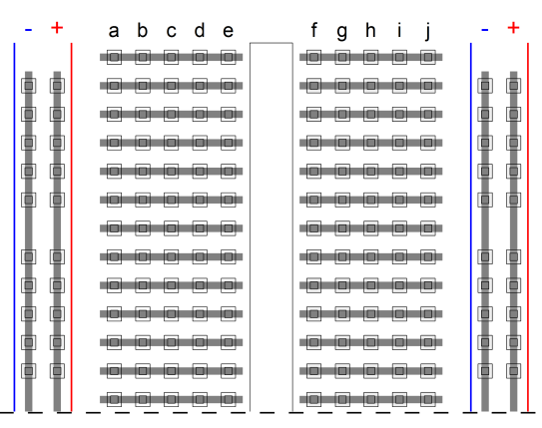  
      The columns on the side are connected down the length of the breadboard, and these are typically used for power, with the blue side being the negative supply and the red side being the positive supply.  
      Row connections are also shown - this is where components (such as resistors and LEDs) are typically placed.
   3. Warning: Some breadboards have the terminal blocks broken down the middle. If this is the case, along the midsection the internal connection would look like this:  
      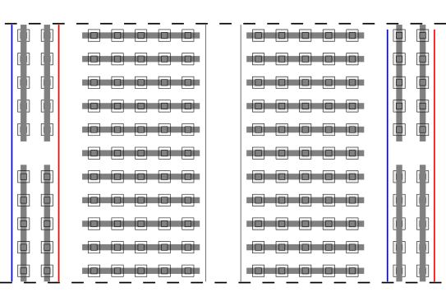  
      You can then use the different power "quadrants" for different supply voltages. However, if you want a continuous power connection down the column, you would need to jumper past the broken connections.

### Part II: Simple LED Circuit

1. Take a look at the following schematic:  
   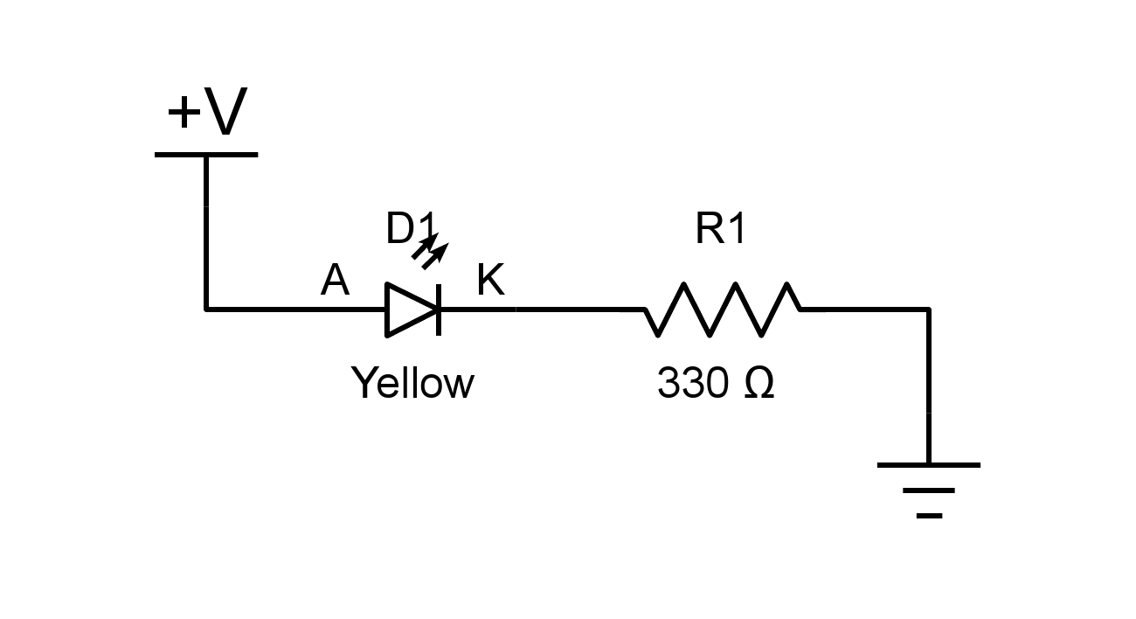
2. You may be asking, "where is the battery?!" Well, as circuits get more complex, routing power lines everywhere only further complicates the schematic. Instead, symbols are used to indicate power supplies.
   1. The C:\Users\Ducky\Dropbox\10 CalSol Impulse - Electronics\Training Documents\EE1\circuits\inline_+v.png symbol indicates a **connection the positive voltage source**.
   2. The C:\Users\Ducky\Dropbox\10 CalSol Impulse - Electronics\Training Documents\EE1\circuits\inline_gnd.png (ground) indicates a **connection to the negative voltage source**.
3. The **LED** C:\Users\Ducky\Dropbox\10 CalSol Impulse - Electronics\Training Documents\EE1\circuits\inline_led.png (light-emitting diode) does exactly what you think it does - it emits light when current flows across it.
   1. LEDs are **polarized** devices, that is, they only work when voltage is applied in the right direction. At low voltage levels (< 5v), reversing a LED won't permanently damage it, but it won't light up either.
      1. The A terminal means "**anode**," or the positive side.
      2. The K terminal means "**cathode**," or the negative side.
         1. On 5mm LEDs (like the ones in your lab kit), this side (the cathode) is the part of the LED with the flat part on the flange.
   2. LEDs also have a **maximum current rating**, typically 20mA for indicators LEDs. Exceeding this could cause a (permanent!) drop in brightness or complete device failure[[1]](#footnote-1). And no, it won't explode spectacularly - don't bother trying.
4. But don't worry, the **resistor** C:\Users\Ducky\Dropbox\10 CalSol Impulse - Electronics\Training Documents\EE1\circuits\inline_resistor.png will limit current going through the LED to reasonable levels!
   1. If you know your power supply's voltage , diode forward voltage drop , and series resistance , you can calculate the current going through the LED using **Ohm's law**, .
   2. In the lab, the power supply voltage will be , the yellow diode's forward voltage drop will be around , and the resistance will be . Using Ohm's law, you will obtain a current of , which is within the device's maximum ratings.
5. Let's make some light now. Build the LED circuit (reproduced below):  
   
6. One possible way to structure your circuit on a breadboard is:  
   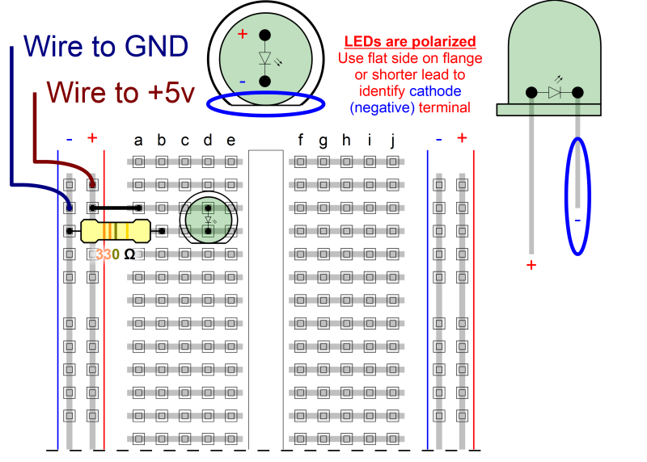
   1. Plug in the LED so that the leads are on two different rows.
   2. Connect a wire from the positive terminal strip to the column with the positive side of the LED. This is the side without the flat on the flange.
   3. Plug in a resistor such that one lead is on the negative terminal strip and the other lead is on the same column as the negative side of the LED. This is the side with the flat on the flange.
   4. Then, plug in power to the positive and negative supply strips. Your LED should turn on now.
   5. If your LED isn't turning on, check that your power supply is actually supplying voltage, that the LED is correctly polarized, and that everything is connected properly. If it still doesn't work, you might have a dead component (it happens). Ask for a new one - we'll have extras.

### Part III: Dual LED Circuit

1. One LED isn't much fun - let's make some more light:  
   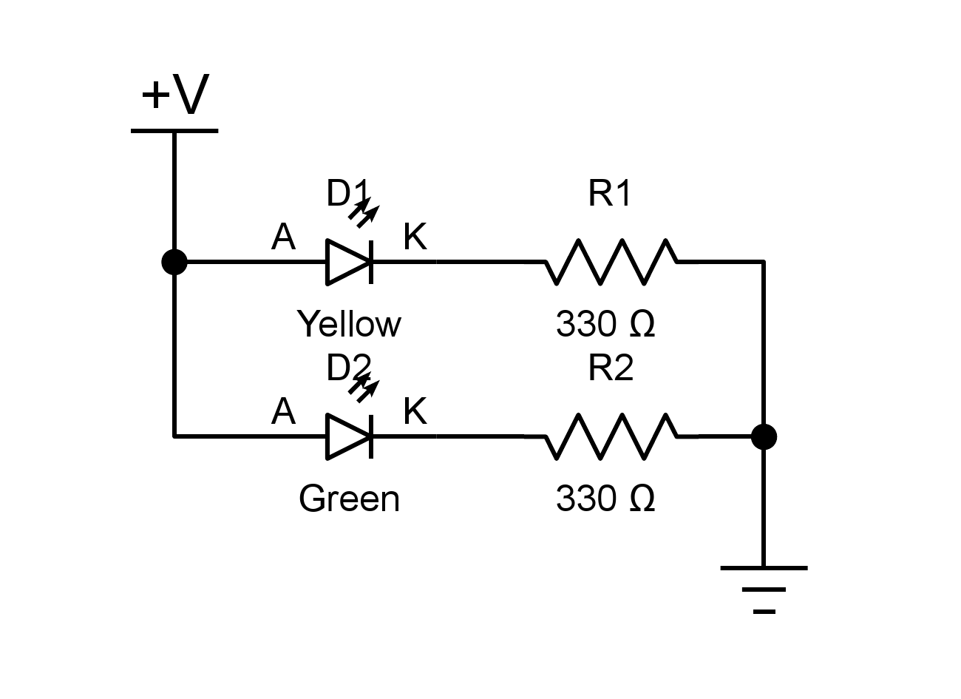
2. Add the green LED and another resistor to the breadboard circuit. You should be able to figure this out.
   1. When you are done, both LEDs should light up.

### Part IV: Controlled LED Circuit

1. Constantly-on LEDs aren't too much fun, either. Let's add some control:

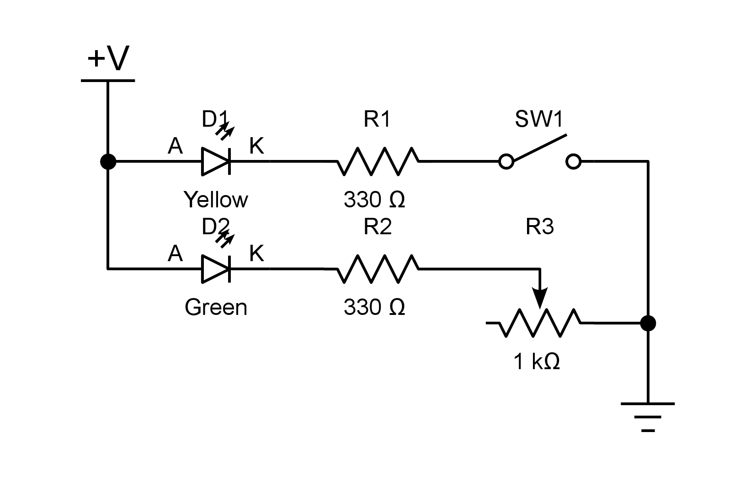

1. The **potentiometer** C:\Users\Ducky\Dropbox\10 CalSol Impulse - Electronics\Training Documents\EE1\circuits\inline_pot.png is a 3 terminal device. The resistance between the two outermost terminals is constant, but turning the knob varies the resistance between the outer terminals and center terminals between nothing () and the full resistance of the device (, as shown the schematic).  
   One possible pinout for a potentiometer is:  
   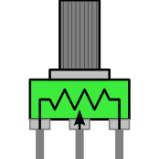
2. As shown in the schematic, it's always best to ensure that device maximum ratings are never exceeded. That is why there is a resistor in series with the potentiometer - no matter now close to you turn the potentiometer, the total series resistance does not drop below . Consequently, the current through the LED will never reach unsafe levels.
3. The **switch** C:\Users\Ducky\Dropbox\10 CalSol Impulse - Electronics\Training Documents\EE1\circuits\inline_switch.png is a component which either makes or breaks an electrical connection.
   1. The switch shown in the diagram is a **SPST-NO** (single pole, single throw, normally open) switch. This means it switches one circuit (single pole), has one connected position (single throw), and is a normally open-circuit (no electrical connection).  
      One possible pinout for a dual SPST-NO and SPST-NC combined switch is:  
      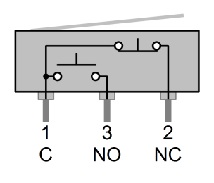

### Part V: Extra for Experts: Blinking LED Circuit

1. Well, you can control the LED manually, but it still doesn't do anything on its own. Let’s fix that: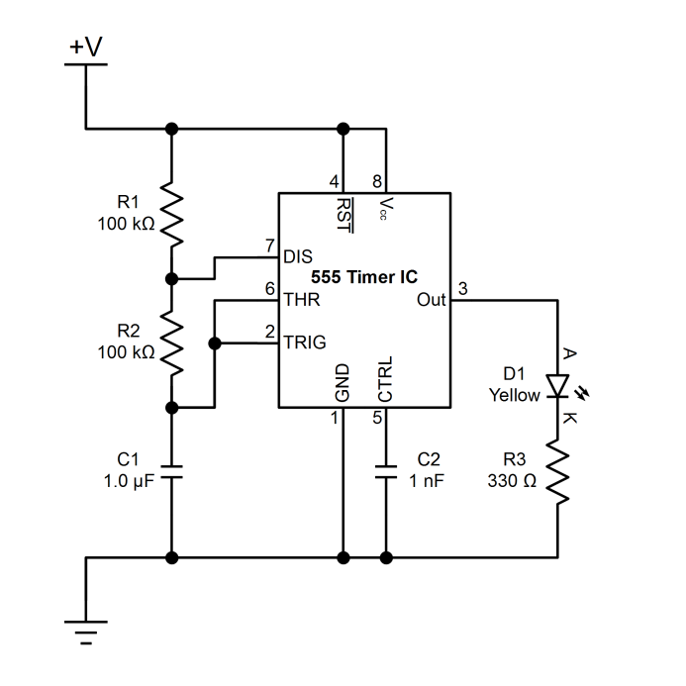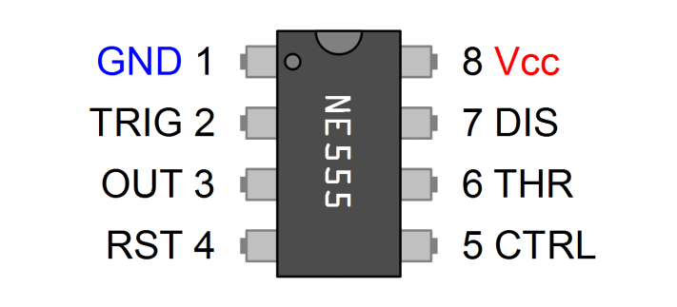
2. You're probably wondering, "what is the big block in the center of the schematic?" It's an **integrated circuit** (also called a **chip**), and many different varieties of these exist providing every imaginable function - from simple logic gates and counters to full microprocessors.
3. The particular chip C:\Users\Ducky\Dropbox\10 CalSol Impulse - Electronics\Training Documents\EE1\circuits\inline_555.png in this diagram is nothing too fancy - it is just a **555 timer**.
   1. You might also notice that the component's schematic diagram representation does not match the pins on the actual device. You will need to look up the device datasheet online to find the corresponding pins on the device.
      1. Yes, this is a common practice. Schematics are drawn in a way to maximize readability, and do not need to correspond to the actual device pinning.
      2. Notice how all the inputs are cleanly on the left while all the outputs are on the right. This is also a common convention. Things "flow" from left to right.
   2. The voltage on the output is either high (equal to ) or low (equal to GND) depending on the voltage at the THR pin. This is known as a **digital output** - it only takes on one of several possible values, instead of varying over a continuous range. You'll learn about this more in the next lab.
   3. The actual circuit (and chip) operation is beyond the scope of this lab (you'll learn when you take EE40 or EE100, or, alternatively you can ask one of us if you want to know now), but it toggles the output based on the resistances of the resistors R1 and R2 and the capacitance of the capacitor C1.
4. If you built it correctly, the green LED should blink on and off.
5. ~~If you have some extra time, replace one (or both) of the resistors R1 and R2 with a potentiometer in a variable resistor configuration. See how the frequency varies as you turn the knob.~~ This no longer works when the resistor changed to 100kΩ.
   1. The actual on time and off time of the LED are determined by the charging and discharging time of the capacitor C1 through resistors R1 and/or R2. There are equations for this which you will learn in EE40 or EE100, but we won't cover those in this lab.

## Sneak Peek at Lab 2

You've built a flashing LED today, and while cool, it isn't absolutely epic. Next time, you'll control the LED through software you write by connecting it to a microcontroller - make it turn on, turn off, and blink however you want all through code!

# References

For further information on basic electronic circuits please see the following:

1. <http://www.sparkfun.com/tutorials>
2. <http://www.adafruit.com/tutorials>
3. <http://www.electronics-tutorials.ws/>
4. <en.wikipedia.org>

1. A blown LED is sometimes (humorously) called a DED (“dark-emitting diode”, pronounced “dead”). [↑](#footnote-ref-1)