Microcontrollers I

BRAIN Addendum

# Introduction

## Rationale

We don’t have enough Arduino microcontroller boards for everyone, and they aren’t cheap enough that we can justify purchasing more of them to use once per year. Therefore, some lab stations have a BRAIN instead of an Arduino.

## The BRAIN

The BRAIN is CalSol’s Arduino-compatible microcontroller platform, currently used in Impulse. It differs from the standard Arduinio in that it is socketable (i.e. can be plugged into a socket in a “skeleton” board), breadboardable, and includes onboard CAN functionality. The one provided to your station should already be in a breadboard. **Please do not attempt to remove the BRAIN from the breadboard – when done improperly, this leads to pin damage. BRAINs are neither cheap nor easily replaceable.**

# Development Environment Setup

The BRAIN requires special setup differing from the normal Arduino setup.

**You will need an old version of the Arduino software, specifically Arduino 0023, available here:**

**Windows**: <http://arduino.googlecode.com/files/arduino-0023.zip>

**Mac OS X**: <http://arduino.googlecode.com/files/arduino-0023.dmg>

**Linux 32**: <http://arduino.googlecode.com/files/arduino-0023.tgz>

**Linux 64**: <http://arduino.googlecode.com/files/arduino-0023-64.tgz>

**IMPORTANT: The latest Arduino version, 1.0.1, is NOT compatible!**

Then, you will need to download the BRAIN extensions, and unzip the contents in your arduino-0023/hardware/ folder

**BRAIN Extensions**: <https://calsolbrain.googlecode.com/files/brain_v0025.zip>

# BRAIN Code for Lab

**The code snippets in the lab document are written for the Arduino. It will NOT work for the BRAIN – you will need to get the relevant code snippets here:**

<http://calsol.berkeley.edu/training/fa12/ee2/>

# BRAIN Pin Diagram

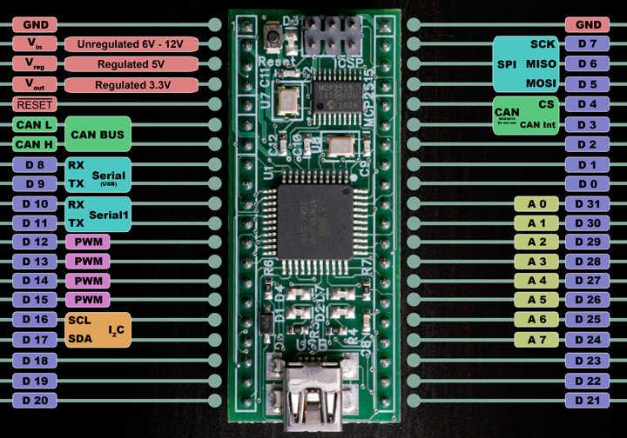

# BRAIN Connections for Lab

Since the BRAIN has a different pin structure, the circuit connections and code changes slightly. Uses these pins instead of those specified in the lab document:

|  |  |  |  |
| --- | --- | --- | --- |
| **Lab Part** | **Device** | **Arduino Pin** | **BRAIN Pin** |
| Lab 2 | Single LED | 13 | D 12 |
| Lab 3 | Switch 1 | 2 | D 0 |
| Lab 4 | Potentiometer | AN0 | A 0 / D 31 |
| Lab 5 | RGB LED | 9, 10, 11 | D13, D14, D15 |
| Extra | Switch 2 | 3 | D 1 |

**Don’t forget to connect +5v and GND to the rest of the circuit!**

The circuit diagram for all parts is:

