Digital Communications

BRAIN Addendum

# Introduction

## Rationale

We don’t have enough Arduino microcontroller boards for everyone, and they aren’t cheap enough that we can justify purchasing more of them to use once per year. Therefore, some lab stations have a BRAIN instead of an Arduino.

## The BRAIN

The BRAIN is CalSol’s Arduino-compatible microcontroller platform, currently used in Impulse. It differs from the standard Arduinio in that it is socketable (i.e. can be plugged into a socket in a “skeleton” board), breadboardable, and includes onboard CAN functionality. The one provided to your station should already be in a breadboard. **Please do not attempt to remove the BRAIN from the breadboard – when done improperly, this leads to pin damage. BRAINs are neither cheap nor easily replaceable.**

# Development Environment Setup

The BRAIN requires special setup differing from the normal Arduino setup.

**You will need an old version of the Arduino software, specifically Arduino 0023, available here:**

**Windows**: <http://arduino.googlecode.com/files/arduino-0023.zip>

**Mac OS X**: <http://arduino.googlecode.com/files/arduino-0023.dmg>

**Linux 32**: <http://arduino.googlecode.com/files/arduino-0023.tgz>

**Linux 64**: <http://arduino.googlecode.com/files/arduino-0023-64.tgz>

**IMPORTANT: The latest Arduino version, 1.0.1, is NOT compatible!**

Then, you will need to download the BRAIN extensions, and unzip the contents in your arduino-0023/hardware/ folder

**BRAIN Extensions**: <https://calsolbrain.googlecode.com/files/brain_v0025.zip>

# BRAIN Code for Lab

**The code snippets in the lab document are written for the Arduino. It will NOT work for the BRAIN – you will need to get the relevant code snippets here:**

<http://calsol.berkeley.edu/training/fa12/ee3/>

# BRAIN Pin Diagram

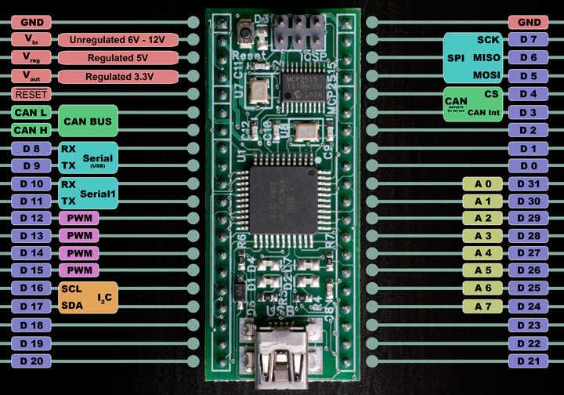

# BRAIN Connections for Lab

Since the BRAIN has a different pin structure, the circuit connections and code changes slightly. Uses these pins instead of those specified in the lab document:

|  |  |  |  |
| --- | --- | --- | --- |
| **Lab Part** | **Device** | **Arduino Pin** | **BRAIN Pin** |
| Lab 0 | LED | 9 | D 12 |
| Lab 0 | LED | 10 | D 13 |
| Lab 0 | Switch | 2 | D 18 |
| Lab 0 | Potentiometer | AN0 | A 0 / D 31 |
| Lab 1 | (TX output wire) | 1 | D 10 |
| Lab 2 | (RX input wire) | 0 | D 11 |

**Don’t forget to connect +5v and GND to the rest of the circuit!**

The circuit diagram for Lab 0 is:

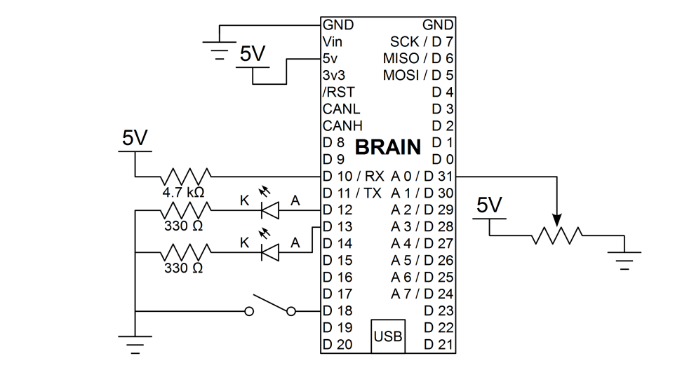

The circuit diagram for Lab 1 is:

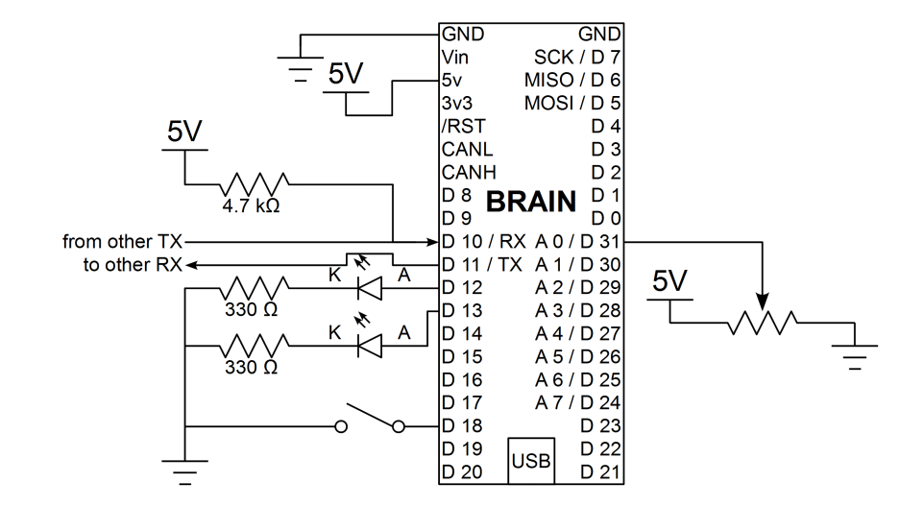

# BRAIN Code Differences

There are significant differences between the BRAIN code and the Arduino code due to the differences in the UART – USB Serial Monitor circuit. On the Arduino, the circuit is designed so that both the USB Serial Monitor and Pins 0, 1 share the same UART port. In the event of a data conflict, the data from Pins 0, 1 will win.

However, on the BRIAN, no such circuitry exists, and data conflicts are not handled gracefully. Therefore, we must use the secondary serial port, pins 10 and 11. In the code, this is Serial1.

To make Lab 0 work properly, the code has been modified so that it will read and write on both UART ports.