Steam Games Data
Title Page
- Dataset Name: Steam Games Dataset
- Team Members: Isaac Darlington, Alex Solomon, Diego Tevino
Introduction
Dataset description: This dataset includes data on over 110,000 different games on the steam gaming platform that includes things like the release date, estimated owners, peak concurrent players (CCU), price, DLC, game reviews, and supported languages. Some of the things we could explore with this data set might include stuff like what game was the most popular during certain years with the peak CCU, how popular games were during the first month of their initial release compared to now, or how having more supported languages might influence how many players downloaded and/or played the game.
Results
[Part1: Genres and Tags] for Isaac Darlington
[Question1]: What genre categories have the highest average user playtime? (Average Playtime Forever vs. Average playtime Last 2 Weeks).
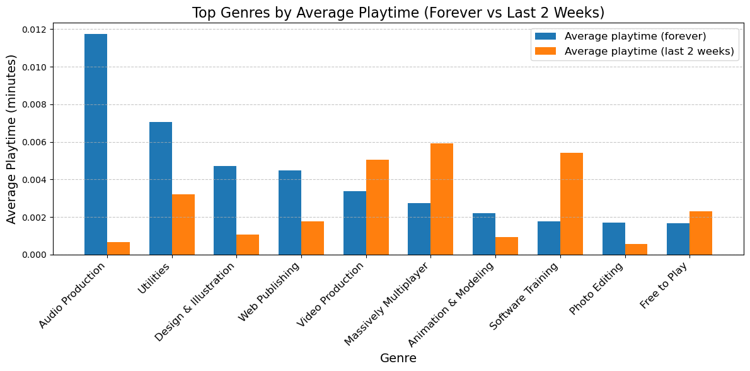

[Your explanation: 1. Purpose, 2. Methodology, 3. Explain the graph (e.g. what is x axis, what is y axis), 4. Harvest Highlights.]
- The purpose of this question is to see what genres of games and/or software have the highest playtime.
- I did this by first taking the data from the column “Average playtime (forever)” and “Average playtime (last 2 weeks)” and then determining the top 10 genres to plot them onto a bar graph.
- The bar graph in question has the x-axis as the genres, this includes the genres Audio Production, Utilities, Design & Illustration, Web Publishing, Video Production, Massively Multiplayer, Animation & Modeling, Software Training, Photo Editing, and Free to Play. The y-axis shows off the average playtime in minutes.
- For harvest highlights when we look at the graph the highest average play time is Audio production followed by Utilities for the Average playtime (forever), while the highest for Average playtime (last 2 weeks) is Massively multiplayer followed closely by software Training.
[Question2]: Are there common combinations of genres or tags that frequently appear together?
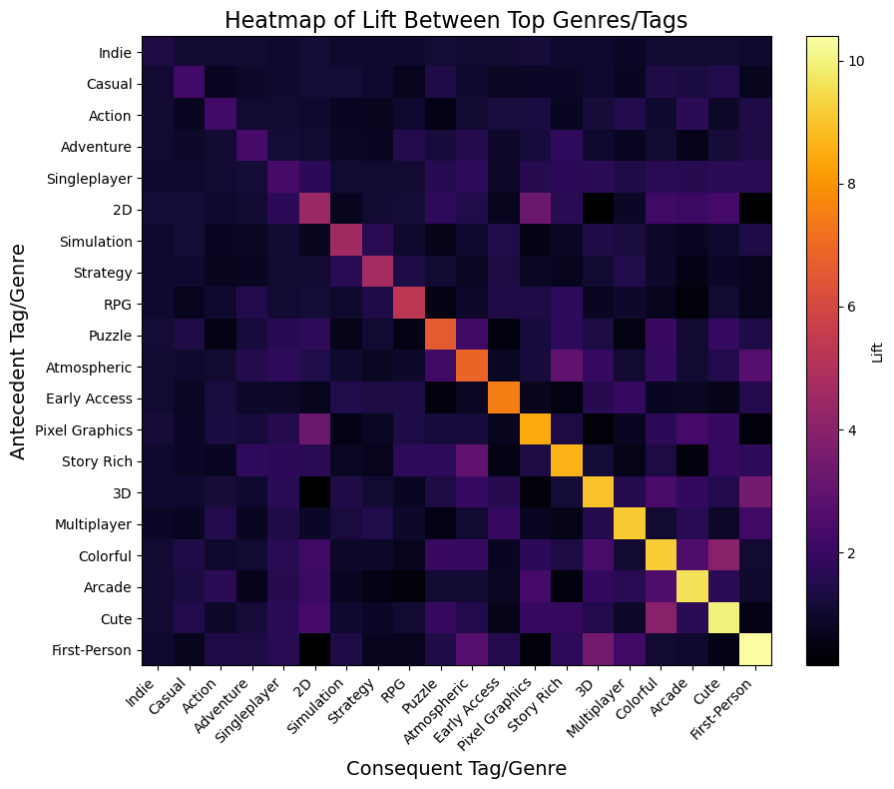
[Your explanation: 1. Purpose, 2. Methodology, 3. Explain the graph (e.g. what is x axis, what is y axis), 4. Harvest Highlights.]
- The purpose of this question was to determine what patterns with genres/tags show up when they are paired together.
- To do this I listed the top 20 tags on the steam dataset sorted by most used and then used the association rule to compare them to each other.
- The visual I ended up choosing to display the results was a heatmap because in my opinion they look cool. The x-axis displays the Consequent Tag/Genre while the y-axis displays the Antecedent Tag/Genre
- Regarding the results, there are several situations in which the same 2 tags end up together, we also get to see other situations in which groups of tags tend to end up being used together. Some notable instances were the tags colorful and cute, 3D and First-Person, Pixel Graphics and 2D, and Story Rich with Atmospheric. One notable group of tags often being put together were Singleplayer with the tags First-Person, Cute, Arcade, Colorful, 3D, Story Rich, Pixel Graphics, Atmospheric, Puzzle, and 2D, these all being tags that are often put together with singleplayer games. Another notable instance of grouped tags was 2D with cute, arcade, colorful, and Pixel graphics.
[Question3]: Can we classify whether a game receives positive reviews based on its features? (utilizing Naïve Bayes and a Decision tree)
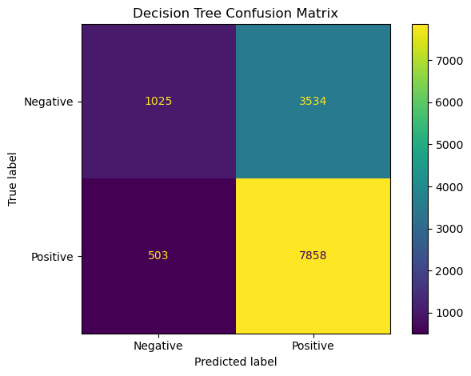
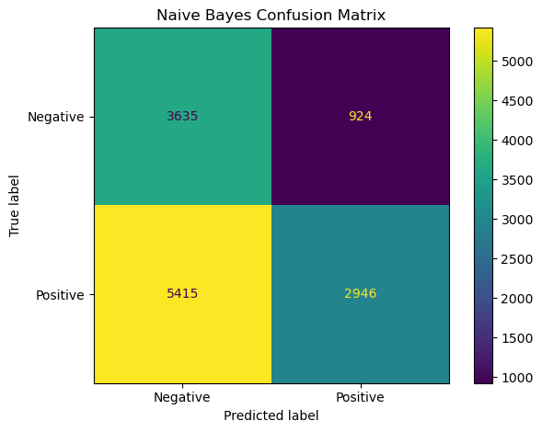
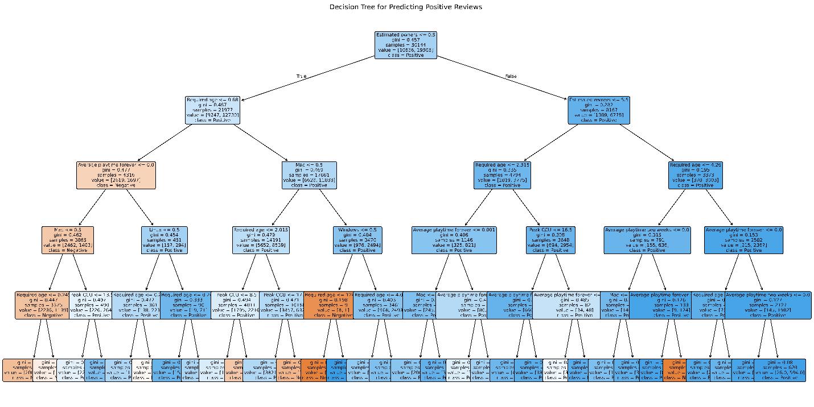
[Your explanation: 1. Purpose, 2. Methodology, 3. Explain the graph (e.g. what is x axis, what is y axis), 4. Harvest Highlights.]
- The purpose of this question was to see what factors might end up causing someone to leave a negative review on the game.
- In order to get the results of this question I first determined what features might affect someone’s chances of leaving a negative review, the features I chose were Price, Estimated Owners, Peak CCU, Required age, Average playtime forever, Average playtime two weeks, Windows, Mac, and Linux. After defining those features in the code I created a confusion matrix for the decision Tree and a confusion matrix for the naïve bayes algorithm to determine false positives/negatives. I then finally created the figure for the decision tree which ended up showing some pretty interesting results.
- Unfortunately the decision tree was pretty big so it’s a bit hard to see but that’s no big deal, obviously for the confusion matrix’s the x-axis’s are the predicted labels, and the y-axis’s are the true labels.
- Moving on to the results we can see that according to the decision tree there are a few instances that should be looked at. The first split is done via the feature “Estimated Owners”, and this is where we see the main changes when it comes down to positive or negative reviews. Mostly all the instances of negative reviews are on the side that has less estimated owners with the minor exception of the one orange rectangle on the bottom right. The next split to look at is done on the feature “Required Age” Now so far reviews have been mostly positive but after required age they seem to fall into the negative reviews, this is most likely due to age gated games typically having more thought put in to them along with the market of adults meaning that they actually have to put effort into their game or no one will play them. After required age is “Average Playtime Forever” This is where it starts dipping into the negatives, if it has a lower than average playtime it reaches a negative, it then moves onto support for mac, and Linux, if it doesn’t have support for mac it automatically turns negative, if it does it turns slightly more positive, however if it does have support for Linux the reviews turn really positive, but not too much negative if it doesn’t.
Regarding the Confusion Matrix’s, the decision tree leans heavily toward predicting “positive,” which increases true positives but also generates a high number of false positives. This suggests the tree may be biased toward the majority class or that the features used strongly correlate with positive reviews.
Naive Bayes is much more conservative. It avoids predicting “positive” unless very confident, which reduces false positives but causes it to miss many true positives. This suggests that Naive Bayes may not handle the feature distribution assumptions well for this dataset.

[Part2: Game Popularity and Player Engagement] for Alex Solomon
[Question4]: Which game genres have the highest and lowest average estimated owners?
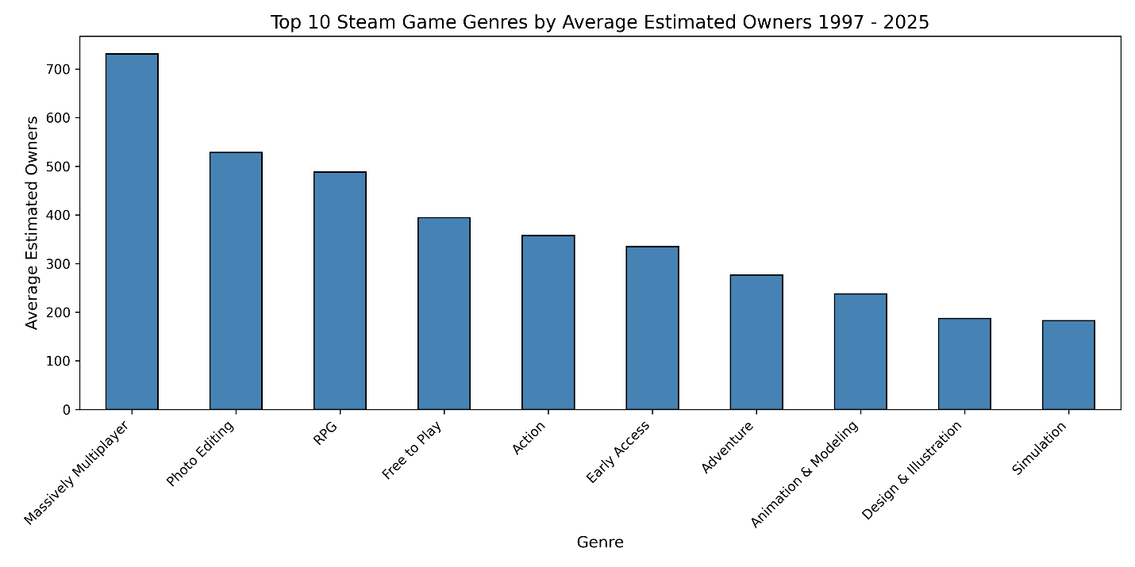
Top 10 Steam Game Genres by Ownership

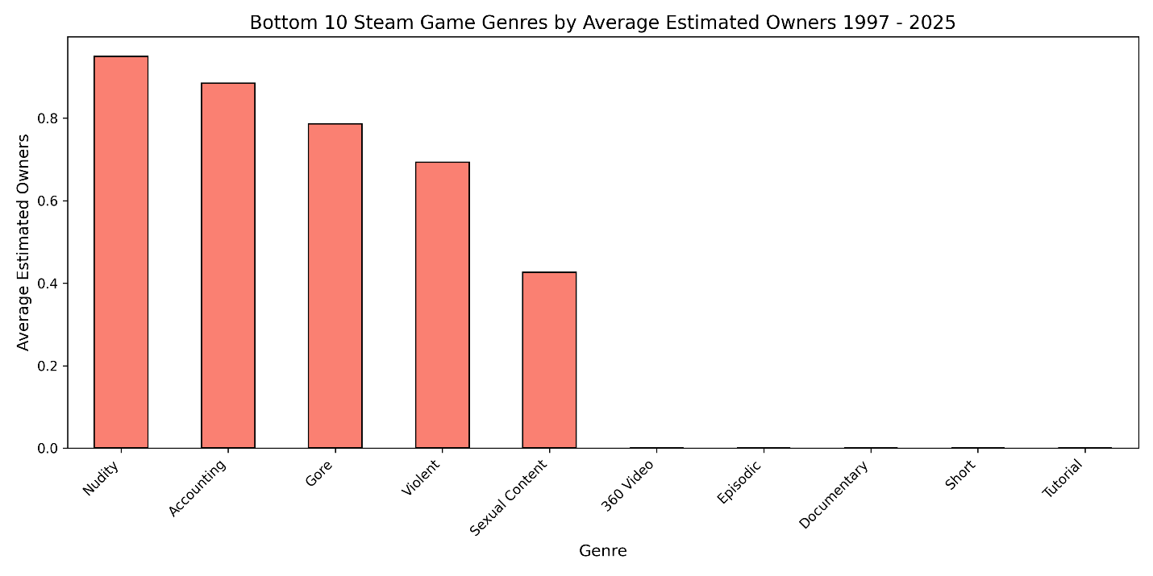
Bottom 10 Steam Game Genres by Ownership

1. Purpose: The purpose of this first analysis was to determine which Steam game genres attract the most players by average estimated owners. By finding both the highest-performing and lowest-performing genres, we can estimate which genres are most sought after (potentially profitable to market to), and which genres are more likely to perform poorly.

2. Methodology: To analyze genre popularity, the dataset first had to be cleaned so that each game’s genre information could be processed consistently. The raw dataset had genres stored as strings, so I converted these values into Python lists and removed empty or badly formed entries. After cleaning, I had to split the DataFrame so that each genre appeared in its own row, allowing every game to contribute just one record per associated genre. This was so games that fell under multiple genres could be measured as a separate entity per genre. This restructuring made it possible to analyze the genres independently!

Next, I grouped the expanded dataset by the “Genres” column and calculated the average estimated owners for each genre. This produced a list of genres along with their mean ownership counts. Lastly, I sorted these results in descending and ascending order to identify the top ten and bottom ten genres. I then visualized the results using bar charts to show the differences in player reach among different genre categories.

3. Explain the graph(s) (e.g. what is x axis, what is y axis): The first chart shows the top 10 Steam game genres ranked by average estimated owners. The X-Axis is Genre Names, The Y-Axis are the Average Estimated Owners. Each bar represents how many players on average own games in that genre. The first chart shows that the genres with the highest suggested player reach are “Massively Multiplayer”, “Photo Editing”, and “RPG.”

The second chart shows the bottom 10 Steam game genres ranked by average estimated owners. The X-Axis is Genre Names, The Y-Axis are the Average Estimated Owners. Each bar represents how many players on average own games in that genre. The bars in this chart are much shorter than the first, and suggest that genres like “Tutorial”, “Short”, and “360 Video” have extremely small/limited player bases.

4. Harvest Highlights: The results of my analysis show a big difference between most and least popular Steam game genres. We see that genres Massively Multiplayer, Photo Editing, RPG, and Free to Play games have higher average estimated owners according to this dataset. This suggests that games categorized as any of these are likely to have a stronger audience reach. On the other hand, our results suggest that genres like Tutorial, Short, Documentary, or 360 Video have much lower ownership averages. These are likely to have smaller or even niche audiences. Overall, these results help developers narrow down target game genres for greater visibility and market success!

[Question5]: Can group Steam games meaningfully based on price, playtime, and review activity? (K-Means)
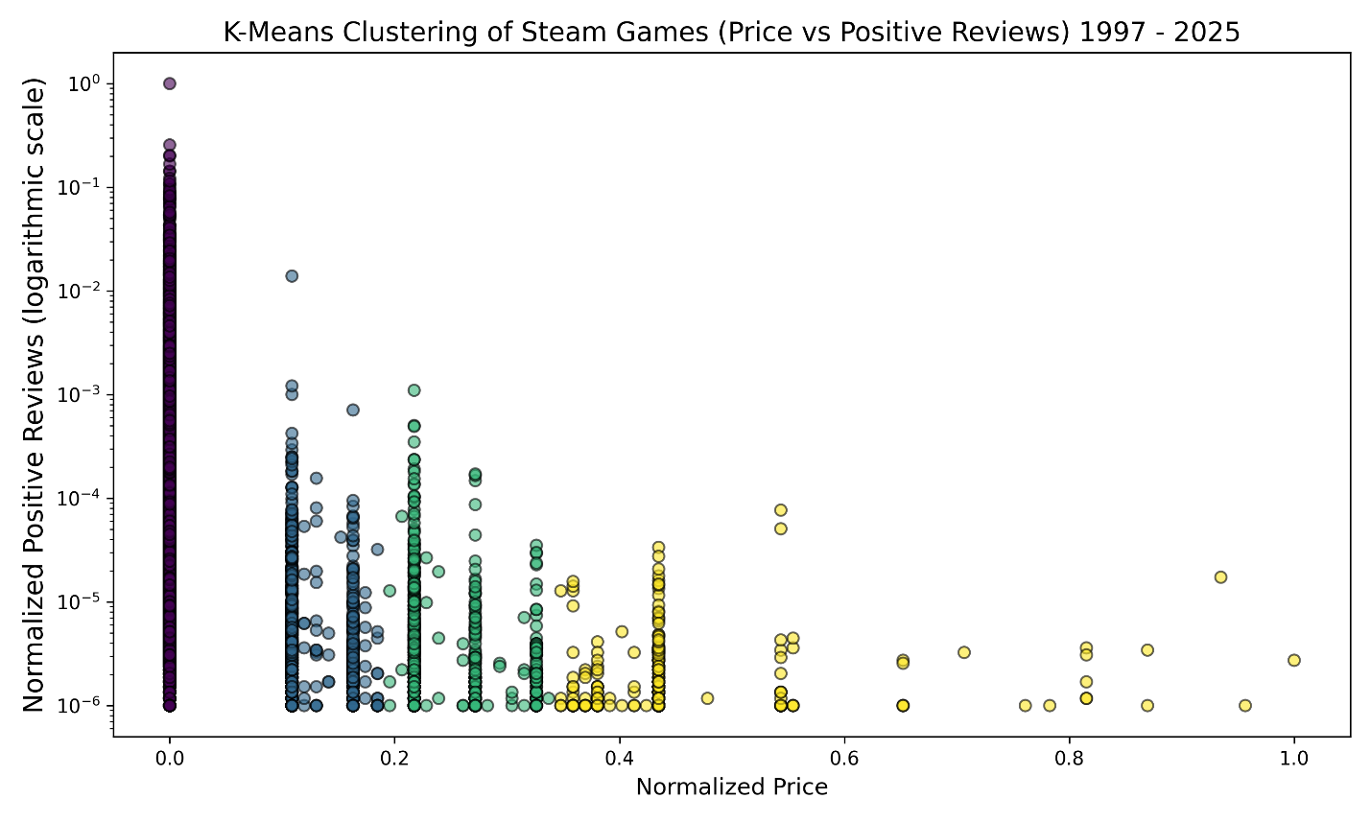
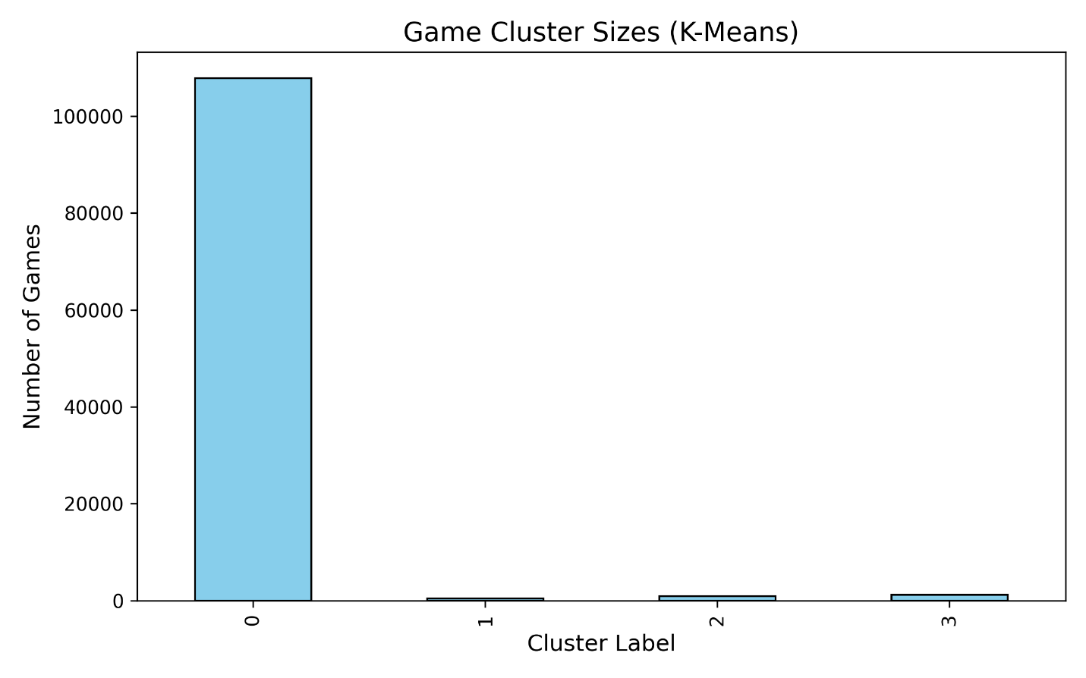

1. Purpose: The purpose of this analysis was to determine whether Steam games in this dataset could be grouped meaningfully by categories such as price and player engagement. I applied K-Means clustering to numeric features with the aim of discovering groups in the dataset, such as clusters of games with low-engagement, mildly successful games, or titles with higher prices. The goal of this was to help understand patterns in the Steam game market and how features like price affect player interaction with certain game types.

2. Methodology: Before I did any clustering, I first picked relevant numeric features in the dataset. These were already normalized when we cleaned up the dataset before any analysis. I made a new copy of the dataframe for this analysis to avoid disrupting the original. I applied K-Means using 4 clusters. I then fitted the model with the chosen data. I used a scatter plot to visualize the results, and a bar chart to better show the cluster sizes. Each cluster is represented by a different color.

3. Explain the graph (e.g. what is x axis, what is y axis): This analysis produced two visuals. The cluster scatter plot has the X-axis as the normalized game price, and the Y-axis as the normalized positive reviews is logarithmic scale to better display the heavily skewed data. The clusters differ by color. The bar chart’s X-axis are the cluster labels. The Y-axis are the number of games in each cluster. The bar chart helps us appreciate how many games belong to each cluster. We can see that the first cluster dominates because there are a lot of low-engagement games in this dataset.

4. Harvest Highlights: The results of this analysis show a big skew in this Steam dataset. One cluster has most games representing lower priced or free titles with very high player engagement. The other three clusters represent clusters of higher player engagement or prices and make up much smaller parts of the dataset. We can conclude from this that most of the steam games in this dataset get very little overall player interaction. Only a few categories show higher player engagement.

[Question6]: Which features correlate most strongly with estimated owners? (Correlation matrix)
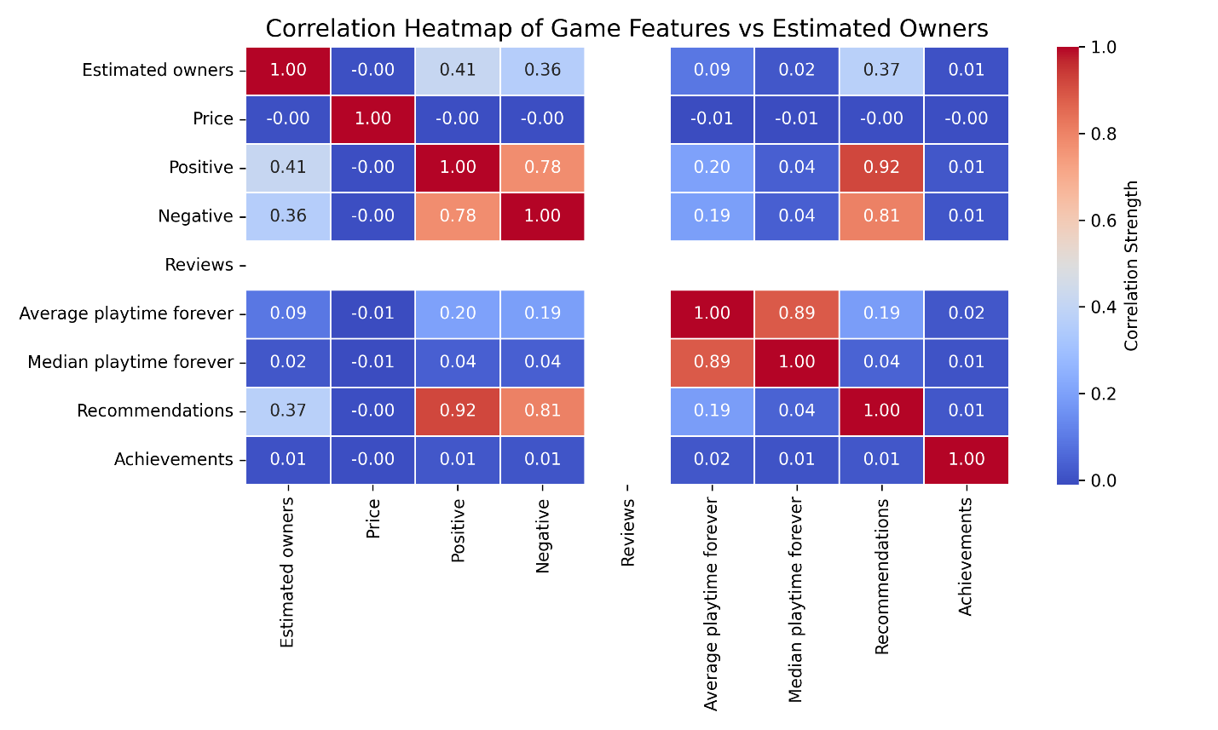

1. Purpose: The reason for this analysis was to see if we could find which game features correlate the most to estimated game ownership. For this, I chose to use estimated owners, price, positive reviews, negative reviews, total reviews, average playtime, median playtime, recommendations, and achievements. The missing values were filled with zeros to make sure we had a complete dataset. Slightly more cleaning was needed for this.

2. Methodology: Like the previous K-means analysis, I started with a new copy of the cleaned dataframe using only the selected features I listed in purpose. I computed the correlation matrix using the .corr() function in the Pandas API. I then plotted the results using a heatmap from the Seaborn API.

3. Explain the graph (e.g. what is x axis, what is y axis): Our X-axis are numerical feature names, and our Y-axis is the same. Darker red indicates strong positive correlation, light blue indicates weak or negative correlation, and white is none or nearly no correlation. The reviews column in our dataframe is actually populated entirely with NULL values, and this all squares are white.

4. Harvest Highlights: In our heatmap, the tiles corresponding to positive reviews, recommendations, and negative reviews display the strongest red coloration against the “Estimated owners” row. This supports that these specific features are the most influential predictors of game ownership. In contrast, features like price, achievements, and playtime appear in pale or neutral colors, showing weak or minimal correlation. This makes it easy for us to distinguish which attributes meaningfully impact Steam game ownership patterns and which contribute little to predicting game popularity.

[Part3: XXX] for Student C
[Question7]: [Define your data mining question]
[Your Figure]

[Your explanation: 1. Purpose, 2. Methodology, 3. Explain the graph (e.g. what is x axis, what is y axis), 4. Harvest Highlights.]

[Question8]: [Define your data mining question]
[Your Figure]

[Your explanation: 1. Purpose, 2. Methodology, 3. Explain the graph (e.g. what is x axis, what is y axis), 4. Harvest Highlights.]

[Question9]: [Define your data mining question]
[Your Figure]

[Your explanation: 1. Purpose, 2. Methodology, 3. Explain the graph (e.g. what is x axis, what is y axis), 4. Harvest Highlights.]

Overview
[Summarize at least three findings that you feel are most worth reporting.]
Contributions
[Student A, describe your responsibility in this project with details, mention what the methodology you use, what the big challenge you meet.]

[Student B, describe your responsibility in this project with details, mention what the methodology you use, what the big challenge you meet.]

[Student C, describe your responsibility in this project with details, mention what the methodology you use, what the big challenge you meet.]

