ASP.NET Core Architecture
  - Middleware pipeline
  - Dependency Injection (DI)
  - Routing system
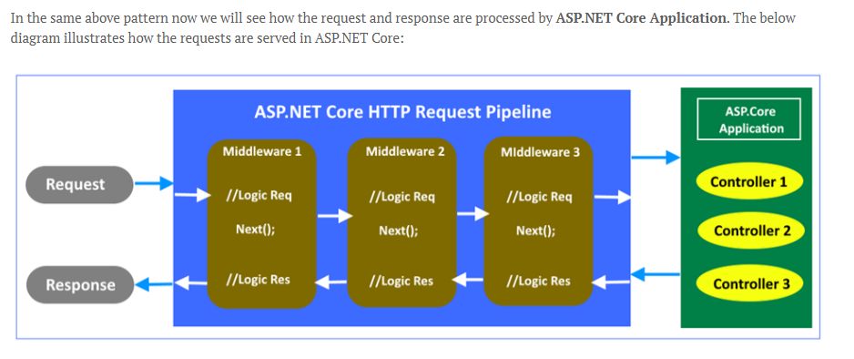

Middleware Pipeline

What it is:
- Middleware are components that process HTTP requests and responses.
- They are arranged in a pipeline. Each middleware can:
  - Handle the request itself.
  - Pass the request to the next middleware.
  - Modify the response before sending it back.

Key points:
- Middleware runs in the order they are registered in Program.cs (or Startup.cs in older versions).
- Common built-in middleware:
  - UseRouting() → sets up routing.
  - UseAuthentication() → handles authentication.
  - UseAuthorization() → enforces authorization.
  - UseEndpoints() → maps endpoints.

Example 1: Custom Middleware
public class RequestLoggingMiddleware
{
private readonly RequestDelegate _next;

public RequestLoggingMiddleware(RequestDelegate next)
{
_next = next;
}

public async Task Invoke(HttpContext context)
{
Console.WriteLine($"Request: {context.Request.Method} {context.Request.Path}");
await _next(context); // pass to next middleware
}
}

// Register in Program.cs
app.UseMiddleware<RequestLoggingMiddleware>();

Example 2: Built-in Middleware Order
app.UseRouting();
app.UseAuthentication();
app.UseAuthorization();
app.UseEndpoints(endpoints =>
{
endpoints.MapControllers();
});

Core Middleware Methods

1. Use
Purpose: Adds middleware to the pipeline and allows execution both before and after the next middleware.
Behavior: Calls the next middleware in the chain unless explicitly short-circuited.
Example:
app.Use(async (context, next) =>
{
// Do something before
await next.Invoke();
// Do something after
});

2. Run
Purpose: Terminates the pipeline with a final middleware.
Behavior: Does not call the next middleware; it’s the endpoint.
Example:
app.Run(async context =>
{
await context.Response.WriteAsync("Hello World!");
});

3. Map
Purpose: Branches the pipeline based on request path.
Behavior: Creates a sub-pipeline for specific routes.
Example:
app.Map("/api", apiApp =>
{
apiApp.Run(async context =>
{
await context.Response.WriteAsync("API endpoint");
});
});

Middleware Execution Flow
- Middleware components are executed in the order they are added.
- Each middleware can:
  - Inspect or modify the request before passing it on.
  - Inspect or modify the response after the next middleware has run.
- Common built-in middleware: Static Files, Routing, Authentication, Authorization, Exception Handling, Logging

Comparison Table
Method | Calls Next Middleware? | Typical Use Case | Example
Use | Yes (unless short-circuited) | Logging, authentication, response modification | app.Use(...)
Run | No | Final response handler | app.Run(...)
Map | Branches pipeline | Route-specific logic | app.Map("/api", ...)

Key Considerations
- Order matters: Placing Run too early will block later middleware.
- Branching with Map: Useful for modular apps (e.g., separating API vs. UI routes).
- Custom middleware: Developers can implement reusable classes with Invoke or InvokeAsync methods for complex scenarios .

Dependency Injection (DI)

Dependency:- is a object /service that is going to be used by other object /service.

Injection:- It is a process of passing the dependency object to the dependent object. It’s a new instance of the class along with required dependencies.

What it is:
- A design pattern where dependencies (services) are provided to classes instead of being created inside them.
- ASP.NET Core has built-in DI container.

Benefits:
- Loose coupling.
- Easier testing (mock services).
- Centralized configuration.

Example 1: Registering Services
public interface IMessageService
{
string GetMessage();
}

public class HelloService : IMessageService
{
public string GetMessage() => "Hello from DI!";
}

// Program.cs
builder.Services.AddScoped<IMessageService, HelloService>();

Example 2: Using DI in Controller
public class HomeController : Controller
{
private readonly IMessageService _messageService;

public HomeController(IMessageService messageService)
{
_messageService = messageService;
}

public IActionResult Index()
{
ViewBag.Message = _messageService.GetMessage();
return View();
}
}

Routing System

What it is:
- Routing maps incoming requests (URLs) to controller actions.
- ASP.NET Core supports:
  - Conventional Routing (default pattern).
  - Attribute Routing (decorating controllers/actions with route attributes).

Example 1: Conventional Routing
app.UseRouting();

app.UseEndpoints(endpoints =>
{
endpoints.MapControllerRoute(
name: "default",
pattern: "{controller=Home}/{action=Index}/{id?}");
});
- URL /Books/Details/5 → BooksController.Details(int id=5).

Example 2: Attribute Routing
[Route("api/[controller]")]
public class BooksController : Controller
{
[HttpGet("{id}")]
public IActionResult GetBook(int id)
{
return Ok($"Book with ID = {id}");
}
}
- URL /api/books/10 → returns book with ID 10.

Summary
- Middleware Pipeline: request/response processing chain.
- Dependency Injection (DI): inject services for loose coupling.
- Routing System: maps URLs to controllers/actions.
Together, these form the core architecture of ASP.NET Core MVC applications.

Would you like me to also prepare a diagram-style summary (like a flowchart of middleware → routing → controller → view) so you can use it as a teaching aid or quick revision sheet?

