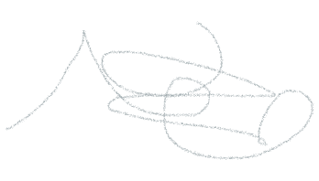aoisndaisndoaisndoaisndoasndoiasd

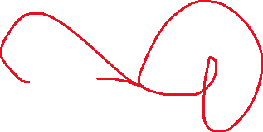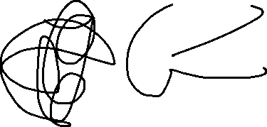

|  |  |  |  |  |
| --- | --- | --- | --- | --- |
| Probando | Una | Test | Sodmfo | Moasdmfo |
|  | Sodmfi | Osdmf |  | Samdfom |
|  | Sdmfsd |  | Sadmfo |  |
| Sadfmomf |  | Poqpwoei |  |  |
|  |  |  |  |  |

