Having access to more brass than I could ever use, I choose recently manufactured cases, of whatever caliber, for my general reloading. Occasionally I'm either forced to use, want to use, or experiment with older cases. Here's what I do to determine the age of the cases by determining the date the Winchester ammunition boxes they came in rolled off the production line, with the help of examples from my modest collection, and being able to equate their lot numbers to a specific date.

Example: Three Winchester 20-round 45 Colt boxes. How old are they?

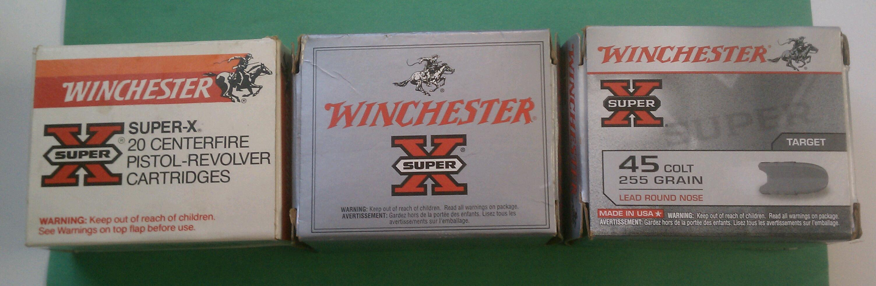

First, all have the "WARNING: Keep out of reach of children" which became mandatory for commercial ammunition (but not components or primers) in 1962. So all are no older than 1962. The white boxes with orange-red Winchester banner were produced between 1983 and 1996. This box has white paperboard tray with holes, which further narrows the date to 1994-1996. Earlier boxes of this design contain a red plastic tray with white foam insert. The 45 Colt cases are headstamped W-W. Its lot number 86KM72 equates to production line 86, 27 November 1995.

The plain grey boxes were produced between 1997 and 2011. It contains a styrofoam tray holding WINCHESTER-headstamped cases. It's lot number 56YA42 equates to production line 56, 24 January 2007.

The busy grey boxes are the present design which began in late 2011. It, too, contains a styrofoam tray holding WINCHESTER-headstamped cases. Its lot number 16FA61 equates to line 16, 16 January 2012.

Bare in mind: Production efficiency demands that you use up all your old boxes before your newer boxes. So in high-production calibers like 38 S&W Special (introduced in 1902), 9mm Luger, 30-06, and 45 Auto, changeover to new design boxes will occur soon after the new design is adopted. In low production calibers, such as the 38 S&W (introduced in 1877) the changeover may occur years later, after all the old 38 S&W boxes are used up. Similarly, headstamps won't changeover to a new design until all the old bunters -- the die that impresses the headstamp -- wear out. In the above examples, 45 Colt cases from 1995 production were still headstamped W-W years after 9mm Luger, 38 Special, and 30-06 had changed over to WIN or WINCHESTER.

I. Dating Boxes by Lot Numbers

1. Western Since 1928 and Winchester Since 1958

Since 1958 the lot numbers used on Winchester boxes are in the same format as used by Western since about 1928, and repeat every twenty years. The lot number will have a letter-letter-number or letter-letter-number-number series that indicated the date. The first letter indicates the year, the second letter the month. If followed by a single digit, that equates to a single digit day; if followed by two digits, the numbers are reversed to equate with a two digit day or dingle digit day with a leading zero. Examples: 10=01, 60=06, 21=12, 61=16, 82=28, 13=31.
Hence the series DA82 will equate to 28 January 1930 or 1950 or 1970 or 1990 or 2010, depending on the box design. Additional numbers and/or letters equate to production lines, operator or inspector numbers.

1.1 Years

To repeat every 20 years using our 26-letter alphabet, six letters were skipped: A, I, J, O, Q, and Z.

B 1928 1948 1968 1988 2008
C 1929 1949 1969 1989 2009
D 1930 1950 1970 1990 2010
E 1931 1951 1971 1991 2011
F 1932 1952 1972 1992 2012
G 1933 1953 1973 1993 2013
H 1934 1954 1974 1994 2014
K 1935 1955 1975 1995 (2015)
L 1936 1956 1976 1996 (2016)
M 1937 1957 1977 1997 (2017)
N 1938 1958 1978 1998 (2018)
P 1939 1959 1979 1999 (2019)
R 1940 1960 1980 2000
S 1941 1961 1981 2001
T 1942 1962 1982 2002
U 1943 1963 1983 2003
V 1944 1964 1984 2004
W 1945 1965 1985 2005
X 1946 1966 1986 2006
Y 1947 1967 1987 2007

1.2 Months

A - January G - July
B - February H - August (I and J skipped)
C - March K - September
D - April L - October
E - May M - November
F - June N - December

1.3 Example

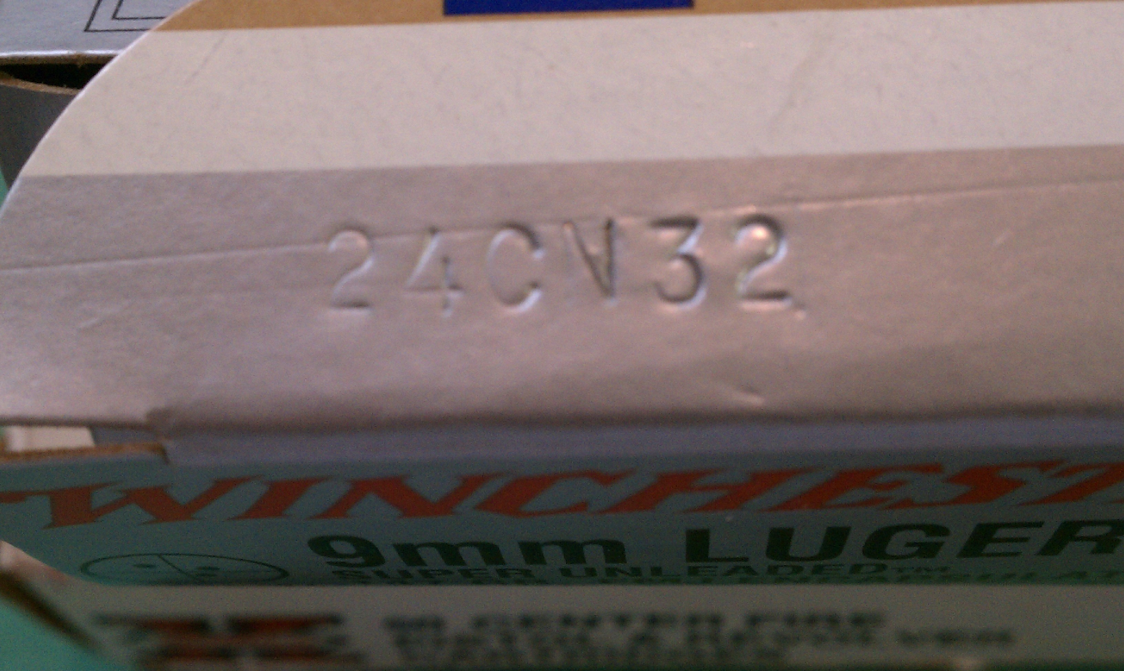

Production line 24, 23 December 2009 (C=2009, N=December, 32=23)

2. Winchester 1928-1958

Prior to 1959, Winchester had its own lot number system in which the dates repeated every ten years, making understanding the chronology of box design years even more necessary. The Winchester format was all numbers, month (1-12), year (1-0) and day (1-31), which might come after or before a number and/or a letter. So a Winchester ammo box with Winchester format lot number 123 23 equated to 23 December 1933 or 1943 or 1953.

2.1 Example

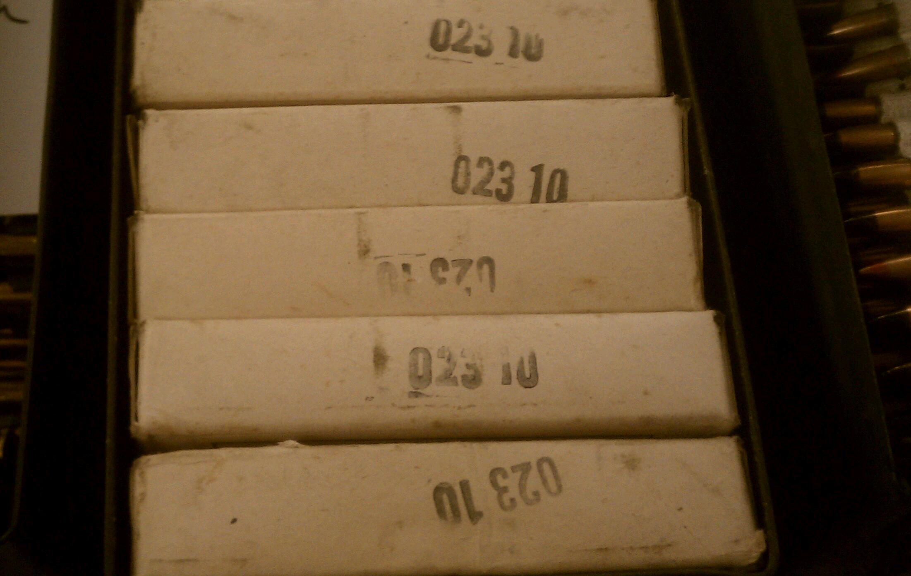

Boxes of Winchester military contract 30-06, headstamp is WRA (over) 53. Lot number equates to 10 February 1953.

II. Dating Boxes by Box Design

1.0 Pre-1959:

I have only limited examples of pre-1959 Western or Winchester boxes:

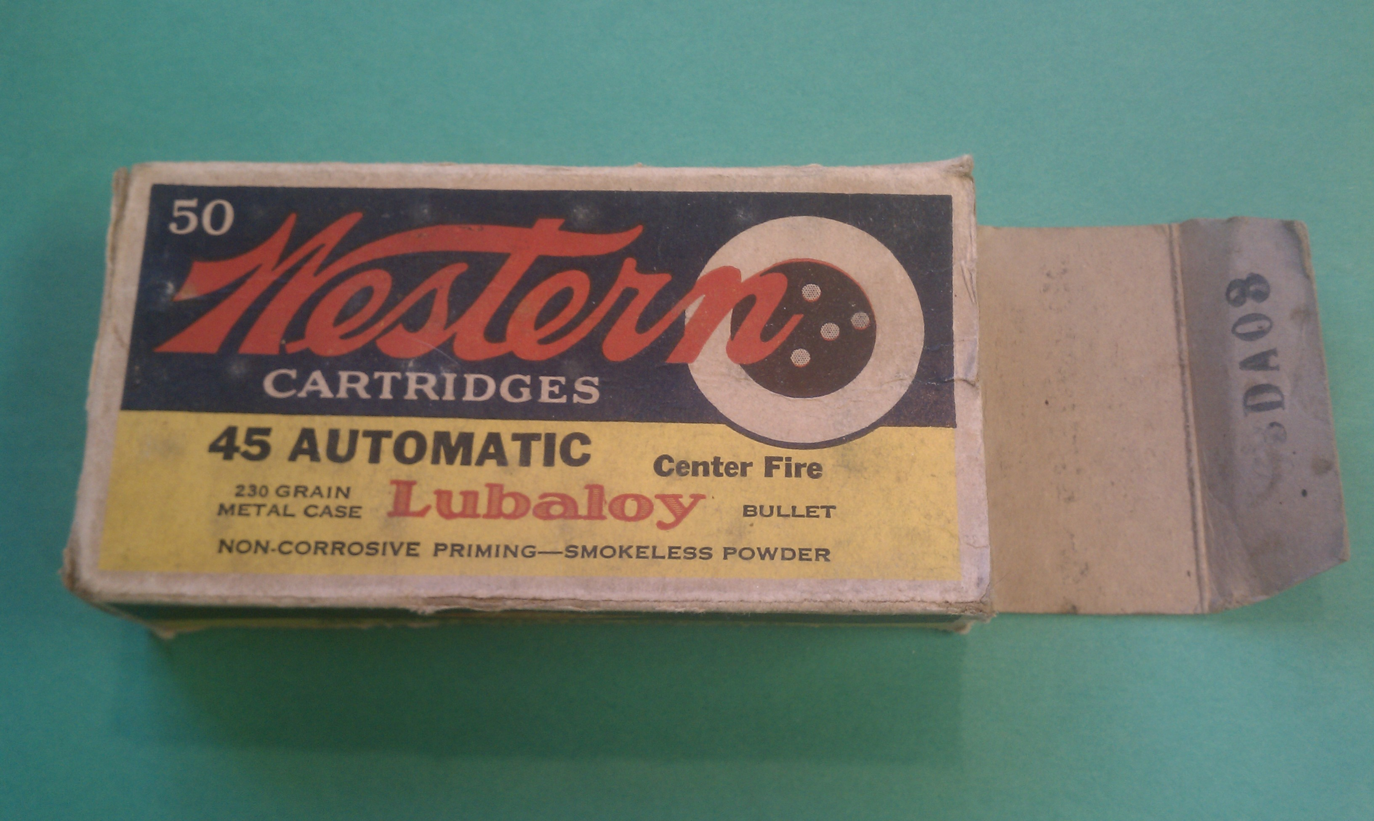

1.1 Above is a Western late bullseye box from 30 January 1950 (DA03). Variations of this design were used from about 1928.
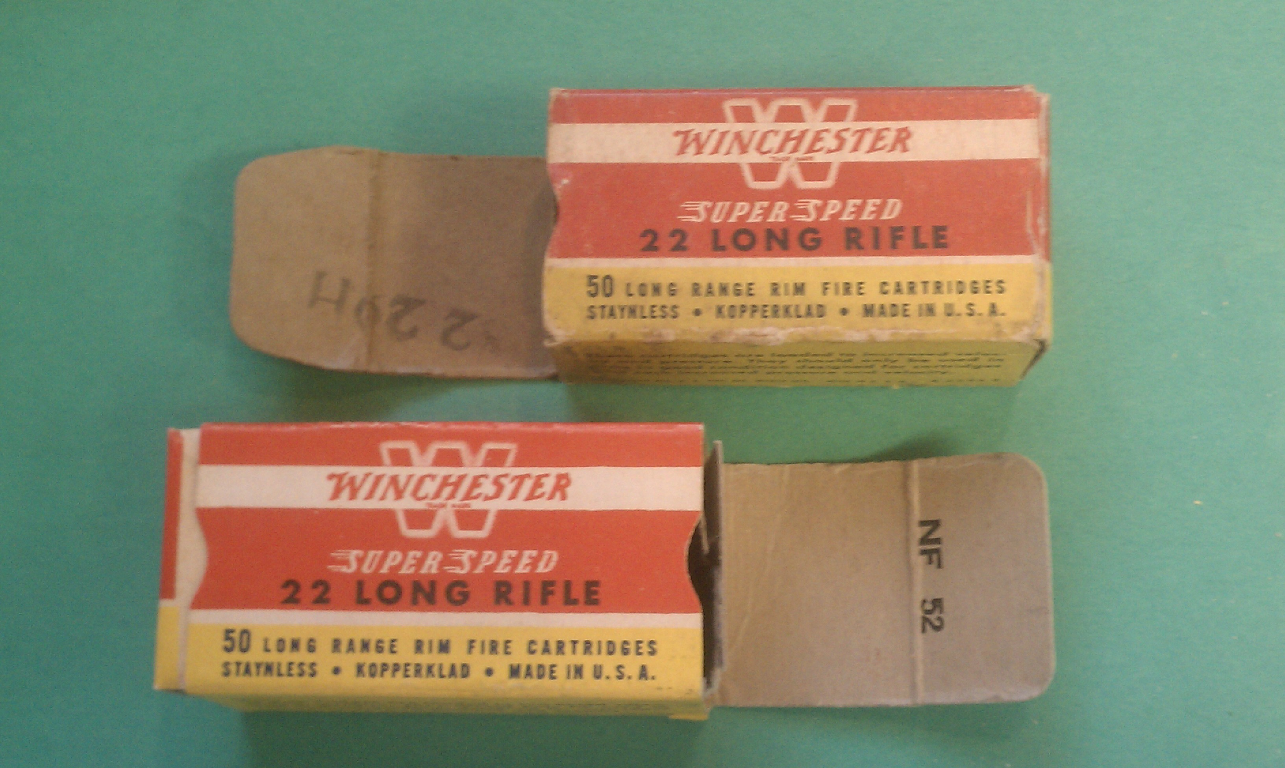

1.2 Winchester's initial post-war (1946) redesign red and yellow 22 long rifle boxes. The top with Winchester-format lot number 8 2 29H, equates to 29 August 1952. The bottom with Western-format lot number NF 52 equates to 25 June 1958 and identifies Winchester as a division of Olin-Mathieson Chemical Corporation (1954 thru 1968).

