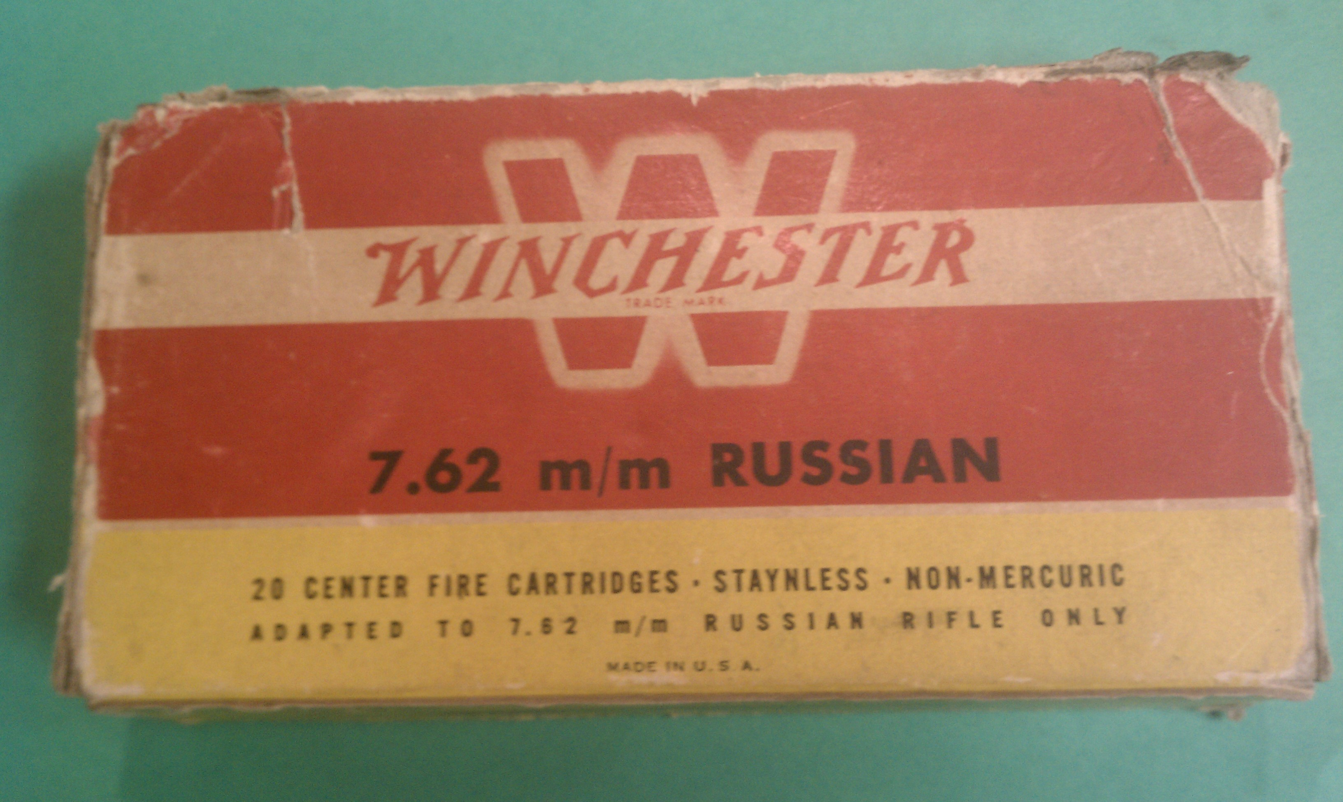

1.3 Another Winchester 1946 style box with lot number 2G69 8, probably equating to 8 June 1949.

2.0 1961-1972 The Yellow Boxes

Winchester's ammunition production relocated from New Haven, Connecticut, and merged with Western Cartridge Company in East Alton, Illinois, by 1958, and Winchester production adopted the Western lot numbering system thereafter. At some point during this timeframe some 50-round pistol caliber trays changed from one-up-one-down open trays to white styrofoam. Whether in Winchester or Western boxes, and unlike those used starting in 1997, these styrofoam trays have the Winchester logo in bas relief molded into the bottom. WRA and WESTERN headstamped cases are found in 38 Special boxes dated 1964 but by 1965 38 Special cases in both brands' boxes are headstamped W-W. The headstamp on 30-06 SPRG cases changed from the SUPER-X to W-W SUPER between 20 December 1961 and 18 March 1968; 308 WIN cases changed from SUPER-X to W-W SUPER between 20 December 1966 and 11 December 1969. Altho the red-yellow (1946 style) box was reportedly used until 1961, I have no yellow ammo boxes prior to 1961, but I do have W-W yellow primer boxes with lot numbers in 1959.

2.1 Winchester

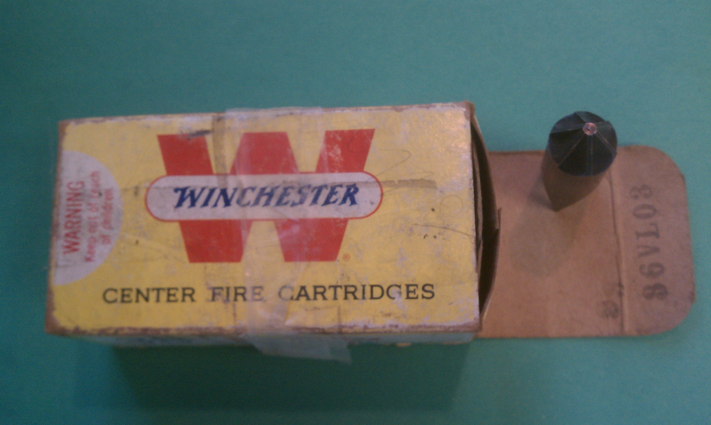

In the lot number, VL03 equates to 30 October 1964.

2.2 Western

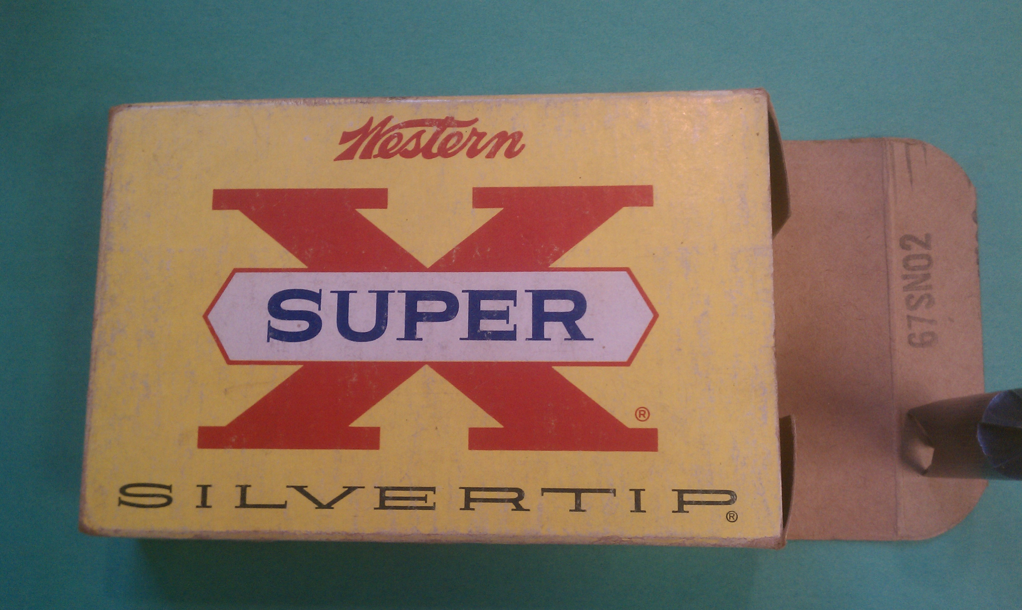

Pre-1962/lacks "WARNING: Keep out of reach of children". In lot number, SN02 equates to 20 December 1961.

